Hall C Target Configuration
For Gep Nov 2007
David Meekins
November 26, 2007

Target Positions
The following table gives a list of target positions and materials. (Listed BDS positions are pre corrections for cryo and vacuum motion). The home position will NOT remove the entire target stack from the beam. The configuration is valid from 11/26/07 to 12/23/07.

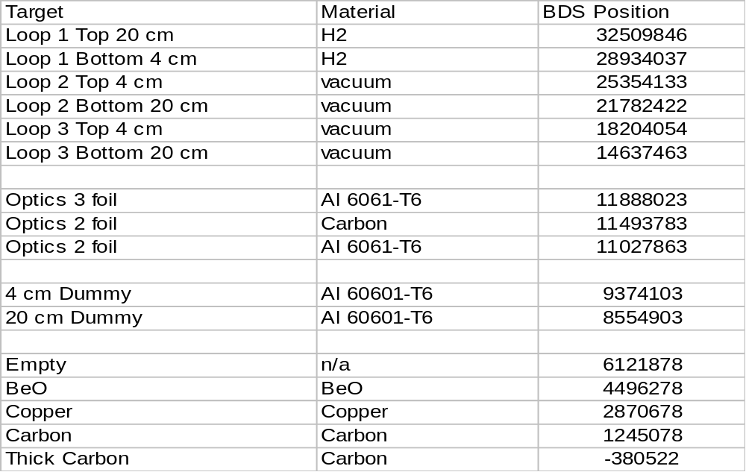

Vacuum and Cryo Motion
The vacuum and cryo motion for the target was measured in aggregate. There were two complete vacuum and cryo cycles before the final number was measured. This should be the total motion after the survey. The following table gives the recorded total motion after the survey on 10/24/07
Scope | Total motion (mm)
Beam Left Scope | 1.5 up
 | 3.4 beam left
Beam Right Scope | 1.1 up
 | 1.2 beam left

Solid Target Ladder
The following table gives the target foil position, thicknesses and chemical purities.

Target Position | Target | Purity | Thickness g/cm²
Empty | n/a | n/a | n/a
BeO | Ta | 99.0% | 0.2918 ± 0.0003
Copper | Copper | 99.95% | 0.17775 ± 0.00015
Thin Carbon | Carbon | 99.95% | 0.8879 ± 0.0010
Thick Carbon | Carbon | 99.95% | 2.6547 ± 0.0017

Error in thickness is from measurement of area and mass only. Outside thickness (measured with micrometers) variations in the foils are less than the reported error. Error also does not include possible voids in materials.

Fluid Targets
There are three loops, each with two cells, on the current cryotarget stack. The loop 1 is configured with 15 and 4 cm conflat style cells. Loops 2 and 3 are configured with a new helicoflex style gasket on the exit window side of the block. The upper cell on each block is 4 cm and the lower cell is 20 cm. The 20 cm cell is offset 38.39 mm downstream to accommodate large angle scattering. The following table give the cell and radiator thicknesses for each position on the stack. All cells are made of Al 7075-T6 aluminum alloy. The 4 cm conflat flange was installed after the initial cool down produced a leak in loop 3. The original 15 cm cell with radiator in the bottom spot was removed.
Target Position | Entrance window thickness (mm) | Exit window thickness (mm) | Wall thickness (mm) | Radiator Thickness (g/cm^2)
Loop 1 top 20 cm | 0.122 ± 0.005 | 0.163 ± 0.012 | 0.157 ± 0.017 | n/a
Loop 1 bottom 4 cm | 0.127 ± 0.005 | 0.151 ± 0.006 | 0.118 ± 0.008 | n/a
Loop 2 top 4 cm | 0.133 ± 0.009 | 0.153 ± 0.009 | 0.145 ± 0.011 | n/a
Loop 2 bottom 20 cm | 0.138 ± 0.008 | 0.104 ± 0.009 | 0.138 ± 0.014 | n/a
Loop 3 top 4 cm | 0.115 ± 0.008 | 0.142 ± 0.010 | 0.146 ± 0.011 | n/a
Loop 3 bottom 20 cm | 0.136 ± 0.008 | 0.130 ± 0.009 | 0.150 ± 0.011 | n/a

Optics Targets
The optics target has 3 positions. The first position has 3 foils on each at z = ± 7.5 cm and 0; the second has positions at z = ± 2 cm; the third has positions at z = ± 3.8 cm. The following table gives the foil thickness and positions. Carbon foils are 99.95% carbon. Positions less than 0 are upstream from the nominal target center.

Position | Z position | Material | Thickness (g/cm²)
3 foil | Z = -7.5 cm | Al 6061-T6 | 0.2651 ± 0.0020
3 foil | Z=0 | Al 6061-T6 | 0.2658 ± 0.0020
3 foil | Z = 7.5 cm | Al 6061-T6 | 0.2672 ± 0.0020
2 foil z = ± 2 | z = + 2 | Carbon | 0.1659 ± 0.0012
2 foil z = ± 2 | z = +-2 | Carbon | 0.1654 ± 0.0012
2 foil z = ± 3.8 | z = +-3.8 | Al 6061-T6 | 0.2663 ± 0.0020
2 foil z = ± 3.8 | z = +-3.8 | Al 6061-T6 | 0.2600 ± 0.0019

Each of these targets is 25 mm wide at the beam interaction point. Please see picture to get a better view of the configuration.
Dummy Targets
The dummy targets consists of 2 aluminum alloy foils aligned with the end caps of a given cell (i.e. the 4 cm dummy has two foils placed at z = ± 2 cm). The foils are 0.8 cm wide (beam transport x direction). The following table gives the positions and thicknesses of these foils. The alloy is Al6061-T6.

Target | Foil Number | Position | Thickness (g/cm²)
4 cm Dummy | Foil 1 | Upstream foil | 0.2658 ± 0.0035
 | Foil 2 | Downstream foil | 0.2549 ± 0.0034
20 cm Dummy | Foil 3 | Upstream foil | 0.2628 ± 0.0035
 | Foil 4 | Downstream Foil | 0.2650 ± 0.0035

Pictures


