Tom Charley
Wire Tension Finding Magnets
Summer 2010

This project was done in an effort to double-check the high voltage wires in the Central Drift Chamber being made at Carnegie Mellon University for use in the new Hall-D at Jefferson Labs.

When building a complex detector such as the Central Drift Chamber (CDC), which needs to be accurate to less than a thousandth of an inch, everything needs to be checked and double checked multiple times over to make sure each section is perfect. The detector is made up of 3500 straw-like tubes with high voltage wires running down the center of each one. Each of these straw tubes are about 1.5 meters long, so the wire needs to be pulled taut so that it doesn't sag in the middle under its own weight. The wires that will be used in this drift chamber will be .0007 inch diameter gold plated tungsten, which is strong enough to easily hold over .3 Newtons of tension. They will be held in place at the radial center of each straw tube by a smaller tube called a crimp pin that can be clamped shut at the end to hold on to the wire. When the wires are threaded into the chamber, a 30 gram weight will be hung from the bottom of each one so that, when the crimp pins are clamped shut, each wire will be at about the same tension.
The problem is, even though the same weight is being hung from each wire, there will always be a bit of friction in the crimp pin, or the person that clamps the pin shut may push on it a bit, or the wire could slip back through the crimp when the weight is taken off, so there is a fair amount of variation in the actual wire tension. In one previously produced prototype of the CDC, there was a noticeable difference between the tensions of wires that were strung by two different groups of workers. While a difference of a few grams may not seem like a big deal at first, remember that there are 3500 of these wires that will be strung. Even a difference of only a few grams from a third of the wires will mean several kilograms of tension difference. Since all of the straw tubes and wires are connected to a pair of endplates, this could create torque on the endplates, which could possibly throw off the accuracy of the whole detector.
In order to check the tension of each wire once the crimp pins are closed, a magnetic field is set up around the wire and a periodic current generator is hooked up across the wire. The current generator provides a current and then stops at an adjustable rate. Since charged particles moving through a magnetic field experience a force perpendicular to the field lines and their velocity, the wire is pushed to the side when the current is going through it, and then allowed to relax when the current goes away. Of course when the wire relaxes it moves back into place because it is in tension, and this movement of the electrons in the wire induces a current in the other direction. If the wire is hooked up to an oscilloscope, one can tell when the wire is vibrating at its fundamental frequency when the current being produced by the generator is the same as the current that the relaxing wire induces in itself. On the oscilloscope, the current from the generator shows up on the x-axis, and the current due to induction is shown on the y-axis, so when they are equal, a diagonal line will be displayed.
To get the wire to vibrate at its fundamental frequency, the frequency of the signal output from the generator must be varied until the wire is vibrating with its anti node midway between the two crimp pins. This will be indicated on the oscilloscope by the aforementioned diagonal line. After getting the frequency at which the generator is providing the current, it can be plugged into the equation:
where Mass is the mass that created the tension (hopefully 30 g), g is gravity, L is the length of the wire, f is the fundamental frequency, and μ is the mass per unit length for the wire.
In the case of the CDC, the wire tension tolerance will be about 10%, so the wires should all have from 27 to 33 grams of tension on them. However, if there is any pattern to the weight distribution that might skew the detector, such as one side averaging a much higher tension then the other, the wires may need to be restrung.

The Pretests:
The primary objective of the pretests was to find out what kind of magnet strength we require. If the magnetic field around the wire was not strong enough, the wire would not vibrate enough to register an intelligible reading on the oscilloscope. This was an important factor to consider because if we did not have a magnet that was powerful enough to spread a field through the entire CDC, then there would be no way to test the tension of the innermost wires once the whole chamber had been built.
In order to test this, a 71 centimeter wire was put in tension and tested beside a magnet, and the fundamental frequency was found. The magnet was then moved further and further away with the fundamental frequency being found at each new point. Since nothing about the wire was changing, this frequency stayed the same, but the signal on the oscilloscope got harder and harder to read as the magnet moved further away.
The magnetic field strength was found for three different types of magnet; a permanent brick-shaped magnet, a horseshoe magnet, and a set of Helmholtz coils. The Gaussmeter found the field strength at 5cm intervals for the brick and horseshoe magnets, and at 10cm intervals in between the Helmholtz coils (along their central axis). After comparing the field strength data and the observations about the difficulty of reading the oscilloscope, it was decided that at least a 10 Gauss field was needed to accurately read the oscilloscope.
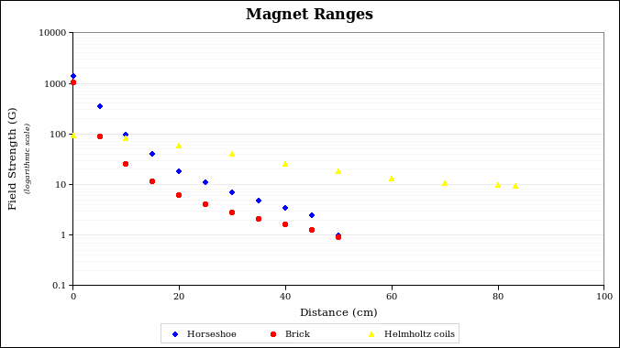
While the horseshoe magnet was the most powerful at short range (about 1.4kG at 0cm), the Helmholtz coils' size helped them propagate a much stronger field overall (especially when they were at full power). When the coils were 166.5cm apart (a random distance decided by how long the pole I had to act as an axis support was) and were at full power with 55.1 Amps running through them, the field went from 93G at 0cm to 9.5G at 83.25cm (along their center axis). The brick and horseshoe magnet were only able to produced about .9G and 1G, respectively at a distance of 50cm.

The only problem with the coils was that they heat up very quickly (about 10°C per minute) when at full power. However, we do not need them at full power to check the wires in the CDC, since the field they produce is more than strong enough, so the next task was to figure out what the lowest power we could get away with was.
Since the CDC itself is only 120cm wide, the coils were placed 128cm apart to account for each coils' width and some clearance room. The power was increased until the field strength at the center (64cm from either coil) was 10G. For this the coils only needed 29.5A of current, and it reduced the heat increase to only 2°C per minute (starting at 20°C).
The magnet wire used in the coils has an unknown type of insulation covering it, but after looking up the different types of magnet wire insulation, the weakest among them seems to be able to withstand about 155°C while the strongest can withstand temperatures up to 250°C. Since the coils usually sit at room temperature and the highest temperature that we would run them at is about 120°C, we have about 50 minutes to check wire tension before they have to be shut off. However, this assumes that the 2°C per minute increase is constant, and since the coils will undoubtedly take longer to heat up as they reach higher temperatures, we will probably have well over an hour to check wires. If more time is needed for some reason, a cooling system could probably be devised to slow the heating process further.

Wire Testing:
To try out the magnetic tension tester, a number of 71cm wires were strung and hooked up to the oscilloscope and current generator so that the method could be shown to be reliable. The wire used was the same .0007 inch diameter gold plated tungsten wire that will be used in the CDC. One end was held between a washer and a spacer which kept the wire away from the board that served as the base. The other end was threaded through a crimp pin which was held at the bottom of the board by a similar washer-spacer holder. After the 30g weight was hung underneath the crimp pin, the pin was tapped lightly so that, if the wire was caught inside the crimp pin, it would be knocked loose. This made sure there was no friction involved that would change the tension. After this a pneumatic crimper was used to crush the pin to exactly the right size. If the crimp was too loose, the wire could slide out, but if the pin was crushed too tightly, it could just cut the wire in two. After the weight was removed, the magnet was moved close enough to the wire to create a usable field and the current generator was hooked up.
The generator that was used displayed the period of the signal that it produced, and for the wire that we were using, a period of about 5712μs was needed. The last digit of this period was never really relevant unless very fine adjustments were made. Five very careful measurements were taken in which the wire was not altered, and the adjustments that were made to the frequency of the generator were only made based on oscilloscope observations (the frequency was reset after each measurement). In that case all of the measurements were within 1μs of each other, but this kind of accuracy is not necessary. The test was done to find out if it was even possible to make measurements this fine. When the chamber is tested, the most efficient method to conduct these tests would be to set the generator at the desired frequency/period before hooking it up to the wires, and then just altering the period quickly to get the diagonal line on the oscilloscope before writing down the period and passing on to the next wire. This will save on time and will be accurate enough for the purposes of this tension test.
These tests seem to produce consistent results, but there is a bias towards a lighter weight (about 28g). We do not know for sure why this is happening, but since the results are consistent and consistency is what is desired in the CDC, we are willing to overlook this problem. It can also be noted that 28g is within the 10% tolerance level for the CDC.
There are a few hypotheses as to why the results have this bias. One is that the length of the wire is difficult to measure accurately since it is tough see where the wire is clamped at the washer-spacer end. We are also unsure as to whether or not the wire is free to vibrate in the crimp pin (above the crimp but still in the pin). This gives us an uncertainty of just over a centimeter in our length measurement, which translates into about a ¾g variation in the tension weight. Another factor is the diameter of the wire. When measured with a micrometer, readings varied from
.00065” to .00075” (partially because the micrometer is only accurate to ± .00005), which changes the tension weight from 25.15g to 33.48g (assuming a 71cm wire). This reinforces the idea that overlooking the bias and focusing on maintaining consistency in the input frequency will give us the desired results.
In conclusion, the best course of action would be to mount the Helmholtz coils on opposite sides of the fully strung CDC (this will be easier with the chamber still vertical) with the coils midway between the endplates. Make sure that each wire produces the proper oscilloscope image while using a current period within about 200μs of the average period of the previously measured wires. The tension weight that this gives in the equation is not as important as the fact that all wires are strung within a 10% deviation (about 3g) from the average. This should be relatively easy as much less deviation is expected.

Instructions for Testing Tension in the Completed CDC:
- Mount the Helmholtz coils on opposite sides of the CDC, about midway between the endplates
- Set up the current generator up by plugging them in to the wall and attaching the current generator's X, Y, and Z wires to Channel 1, Channel 2, and the external Z axis port of the oscilloscope, respectively (the Z axis port is in the rear of the oscilloscope)
- Turn on the current generator and oscilloscope and set the current period to about 5800μs
- Attach the generator leads to the crimp pins at either end of one of the straws
- Turn on the power supply for the Helmholtz coils, turn the voltage knob the whole way up, and turn the current knob until you have at least 29.5A being supplied (the generator will show about 19.2V)
- Turn on thermometer attached to thermistors (check periodically to make sure they are under 120°C)
- Fine tune the period of the generator for the wires until the oscilloscope shows the desired diagonal line (shown in picture of oscilloscope)
- Mark down the corresponding period
- Repeat steps 7 and 8 for about 10 random wires in the chamber, and average the periods to get the desired target period
- Methodically repeat steps 7 and 8 for the rest of the wires in the CDC. If a wire has a period that is more than 4% off of the average, mark that straw tube for restringing (4% period difference is about 10% tension weight difference)
- If temperature of thermistors reaches over 120°C (should take just over an hour), turn off the Helmholtz coils and let them cool

(Optional)
- To be more accurate in choosing which wires should be restrung, a different method can be employed in which a range of acceptable periods is calculated
  - You can also convert your average period to a wire tension weight using the equation
where g is gravity, μ is the mass per unit length of the wire, and L is the wire length
  - Since there is some error in the other measurements that go into the equation, adjust the value of “L” to get the desired weight (whatever size mass was hung from the wire during stringing)
  - Reverse the equation to find the periods corresponding to a 10% variation from the desired weight
  - Use these periods as your criteria for marking straws for restringing

- If all else fails, knock on door 8406 since he knows what he's doing

Materials Used:
- .0007” Au plated W wire (4% Au)
- Brick-shaped magnet of unknown material or power
- Horseshoe magnet of unknown material or power
- Set of 2 Helmholtz coils
  - Coil frame diameter of 72cm
  - Wire wrap diameter of 66.5cm (to center of wrap)
  - .1” Cu wire with unknown insulation type
  - Tested up to 100°C with no visible changes
  - Capable of up to 55.1A
  - Unknown number of turns (~100)
  - Aluminum frame
- Pneumatic crimper (crushes pins to .04” width)
- Straight crimp pins (same pins to be used in CDC)
- Current generator for Au-W wire was called “Wire Monitor II”
- Tektronix 2465 300MHz Oscilloscope
- Model LT-824 Regulated Power Supply used to power Helmholtz coils
- Lutron Thermometer used to read temperature at the center of each coil via imbedded thermistors
- LakeShore Model 410 Gaussmeter

References:
Schumacher, Reinhard A. Single-Wire Tension Measuring Unit. Pittsburgh: Carnegie Mellon University, 1995.
Schumacher, Reinhard A., and Stephan A. Roth. A Computer-Controlled Tension Monitoring System for Drift Chamber Wires. Pittsburgh: Carnegie Mellon University, 1995.

Pictures:
Magnets tested (brick, horseshoe, and Helmholtz coils):
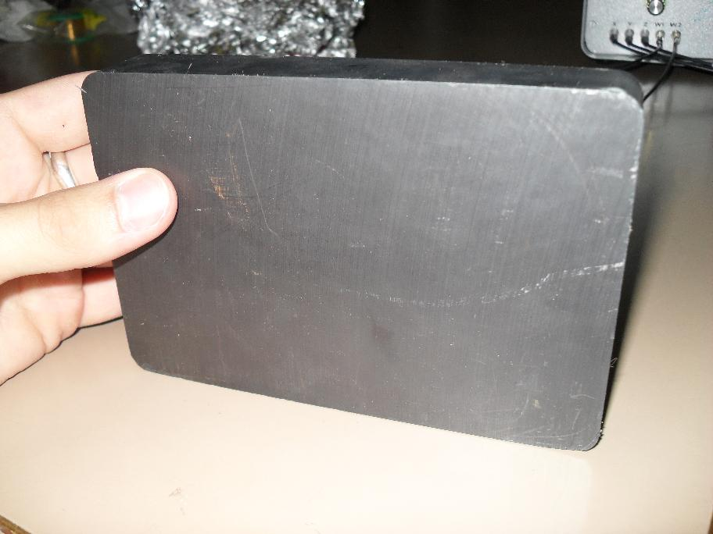
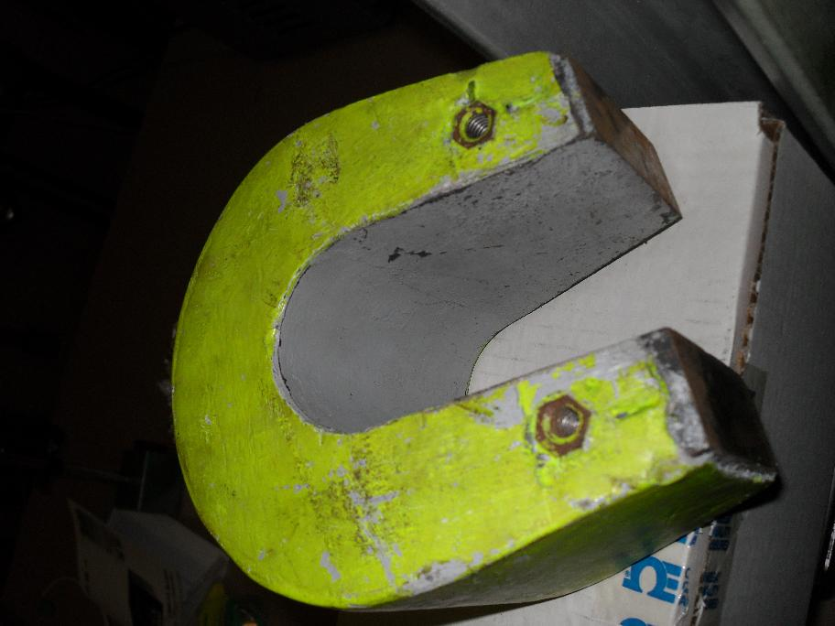
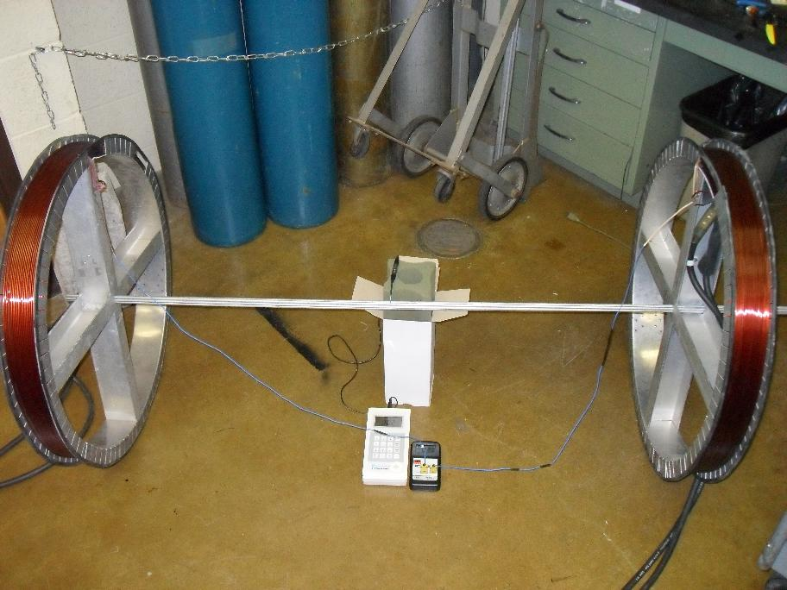

Illustration of Experiment Set-up:
Picture of Oscilloscope when period is correct:
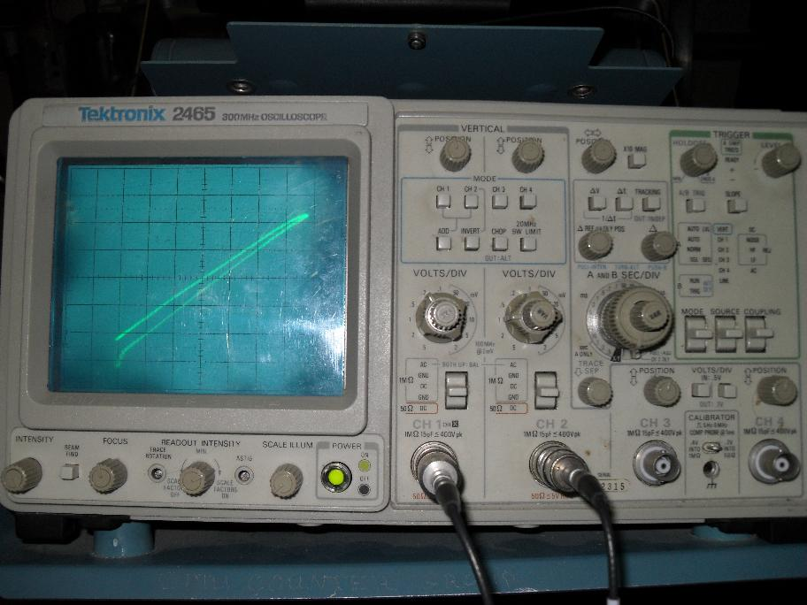
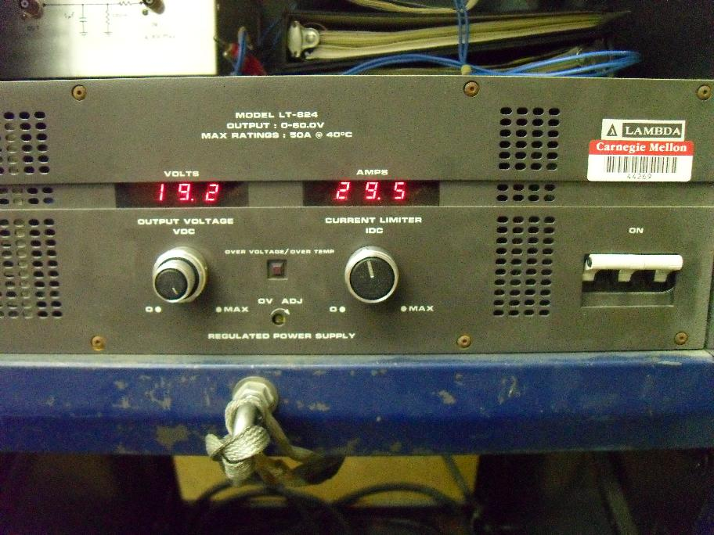
Various Experimental Equipment/Set-up:
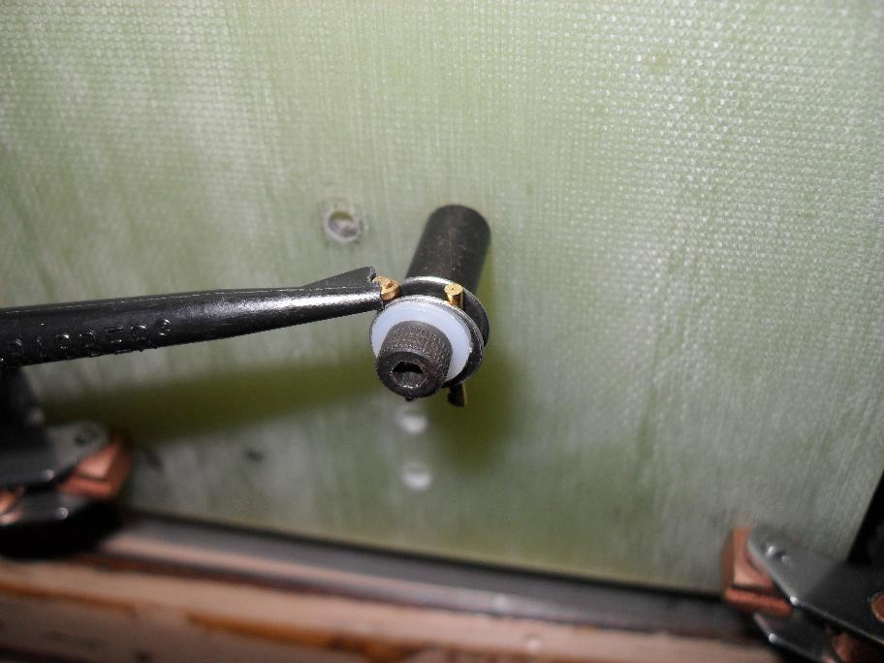
Helmholtz power source Wire in crimp pin

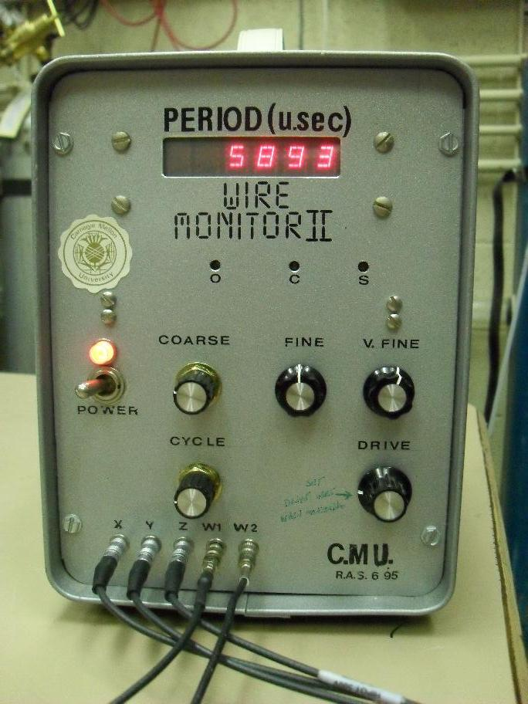
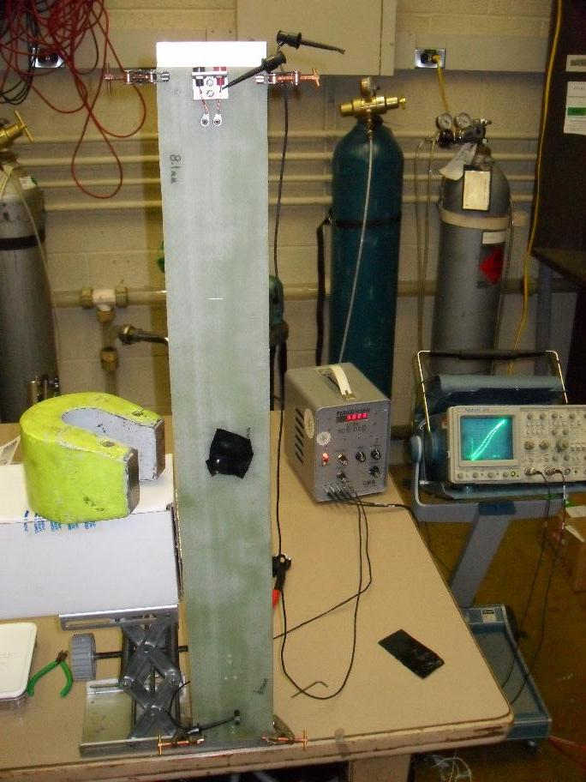
Wire current source Wire, magnet, current source, and oscilloscope

