CDC Noise Tests
FJ Barbosa, N. Sandoval
9/4/2014

Baseline
Tests conducted around C6 HVB (C6 “noisy”, C5 “clean”). Adjacent HVBs are B5, B6, C5, C7, D7, D8 and D9. All CDC HV ON.
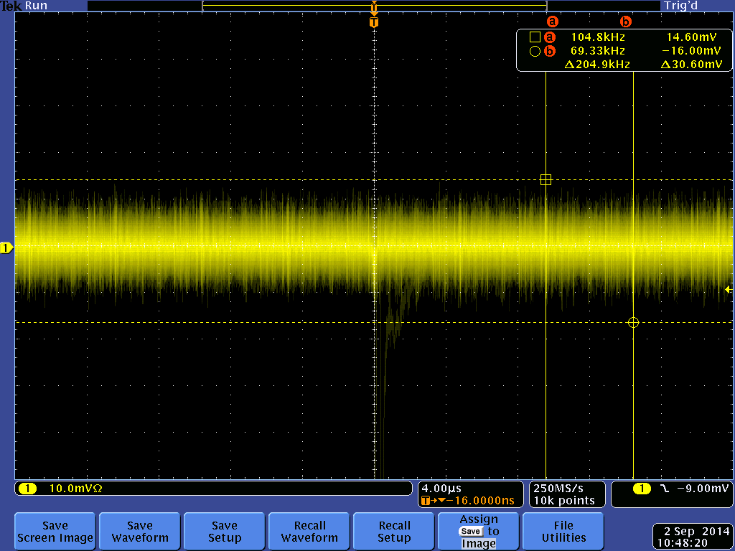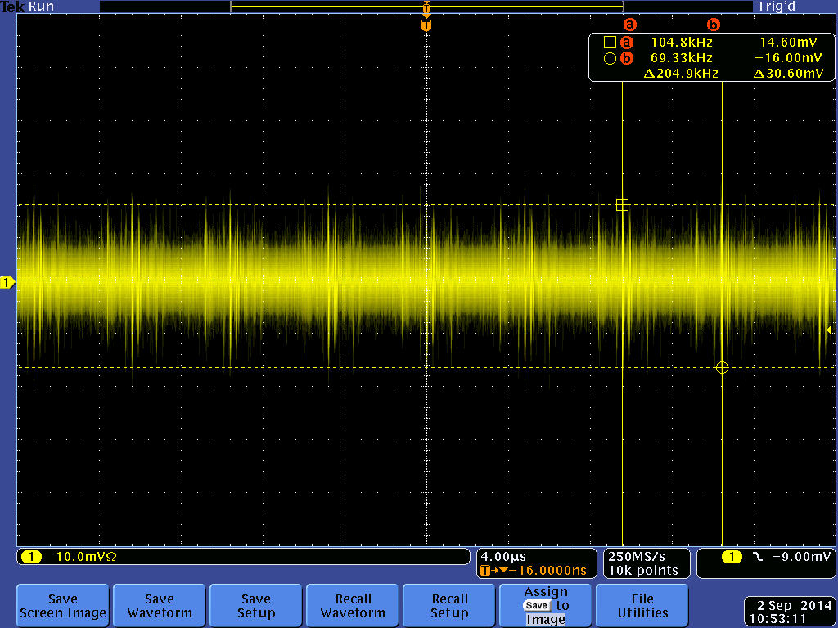
B5 B6
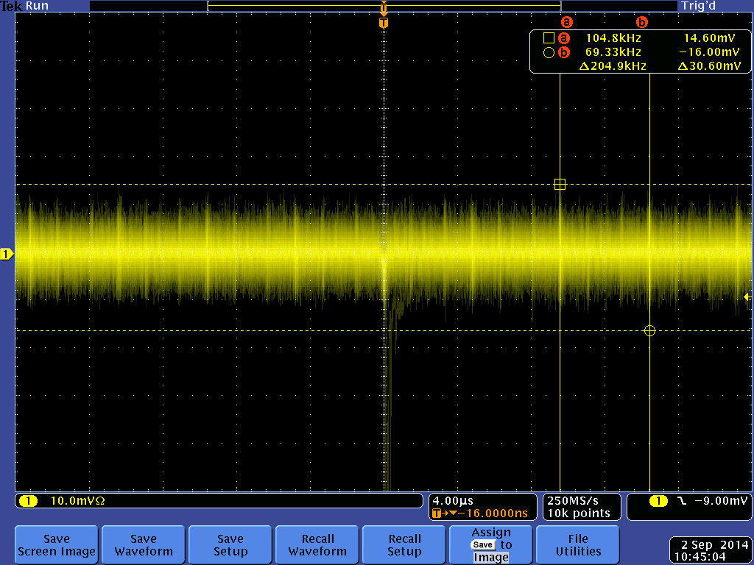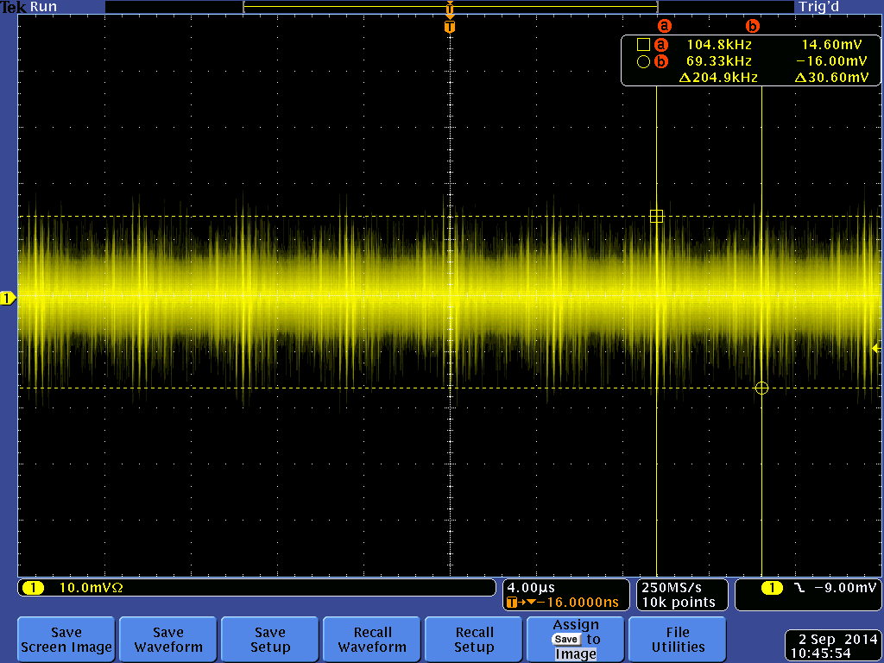
C5 C6
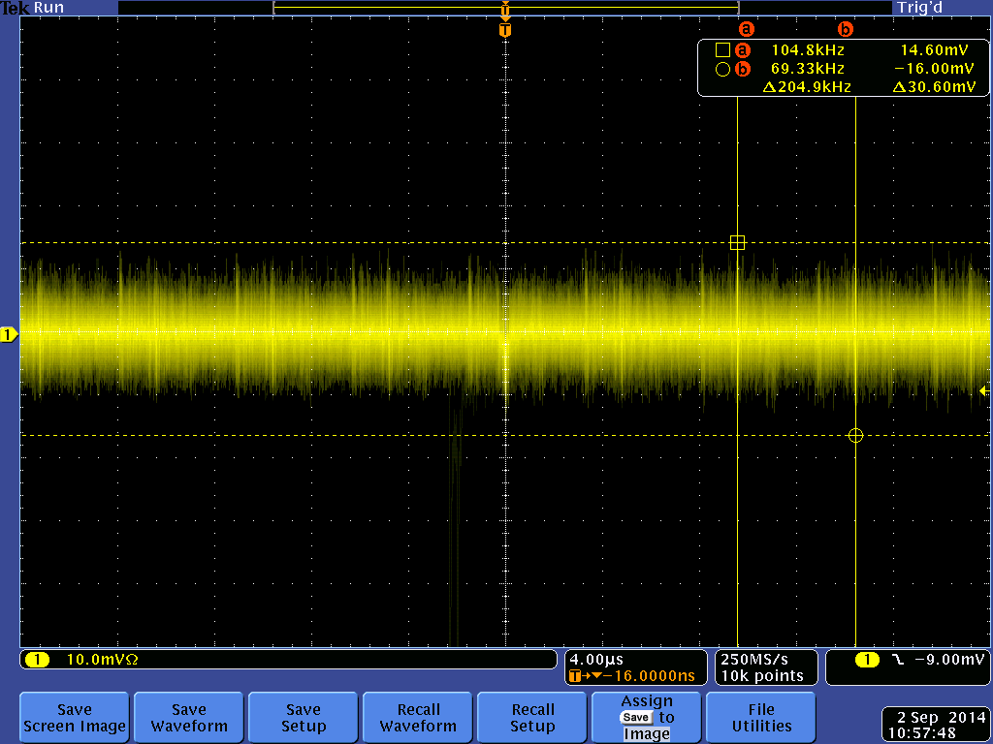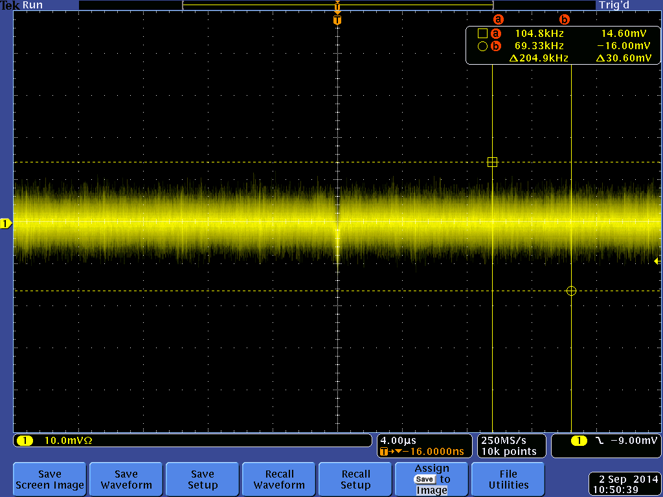
C7 D7
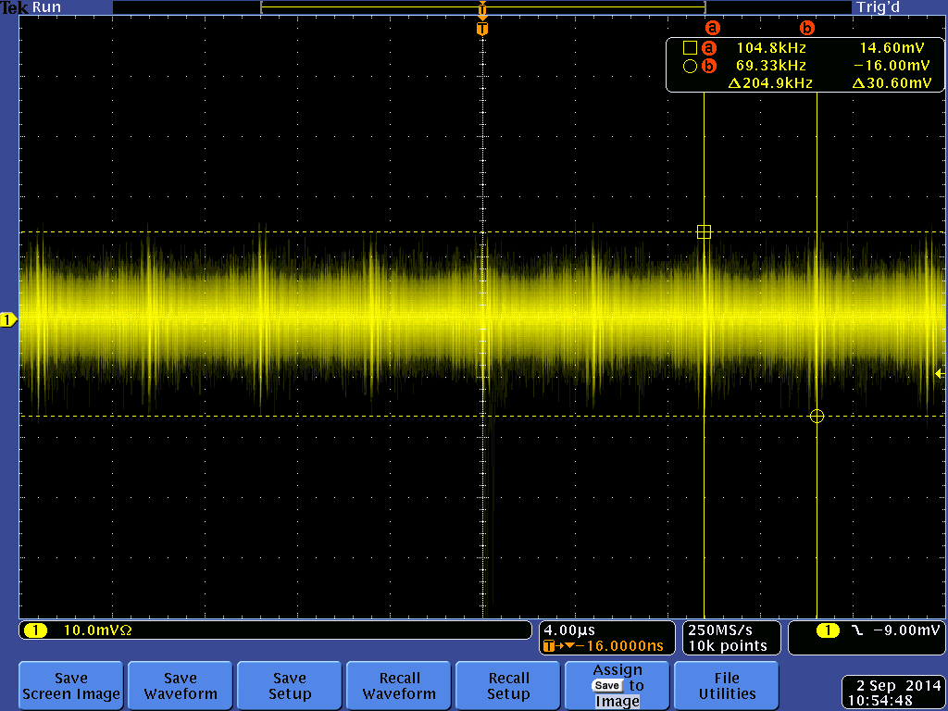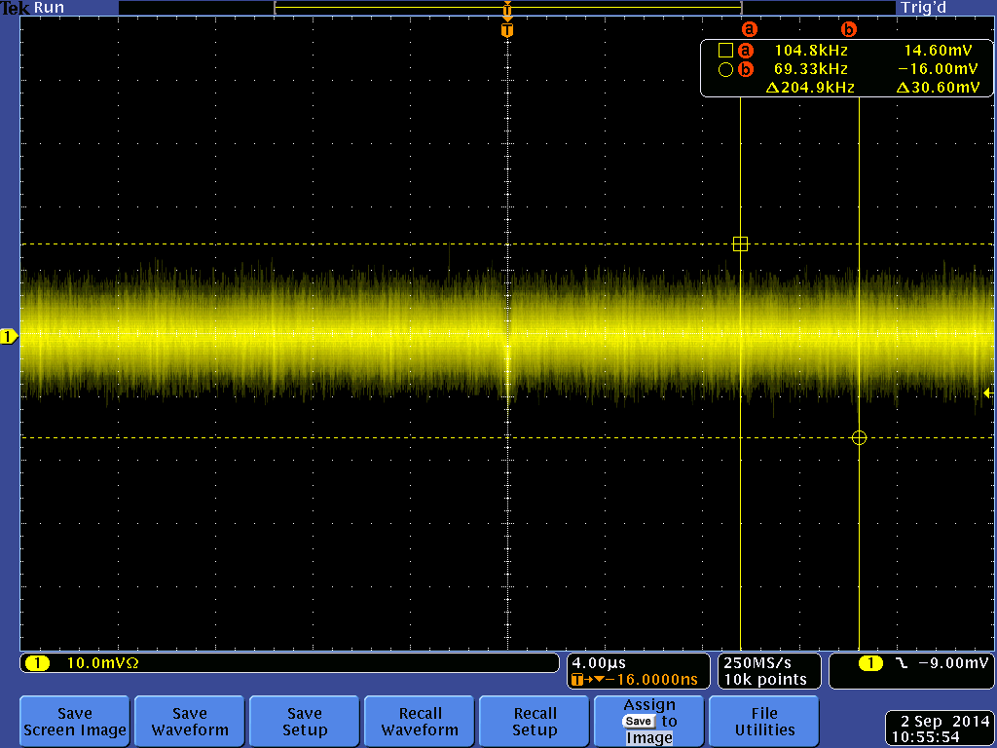
D8 D9

C6 Tests, Combinations with HV ON/OFF and New Wire Route
Tested CDC with various combinations of HV ON and OFF. New HV wire route implemented by moving adjacent HV wires from gas plenum to outside of HVBs but these wires are not secured for now
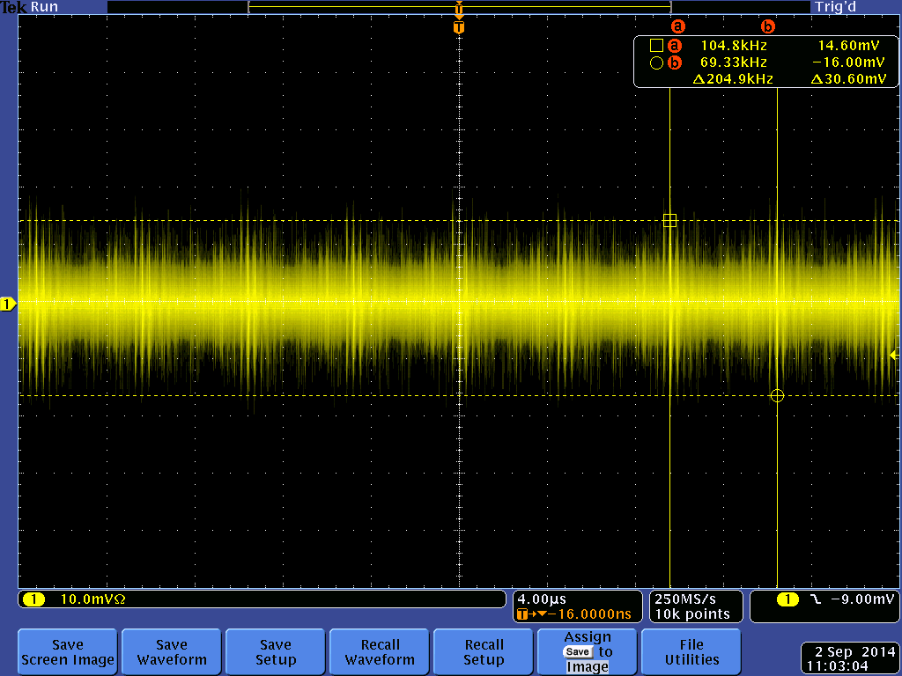
C6, all others HV ON C6 HV OFF, all others HV ON
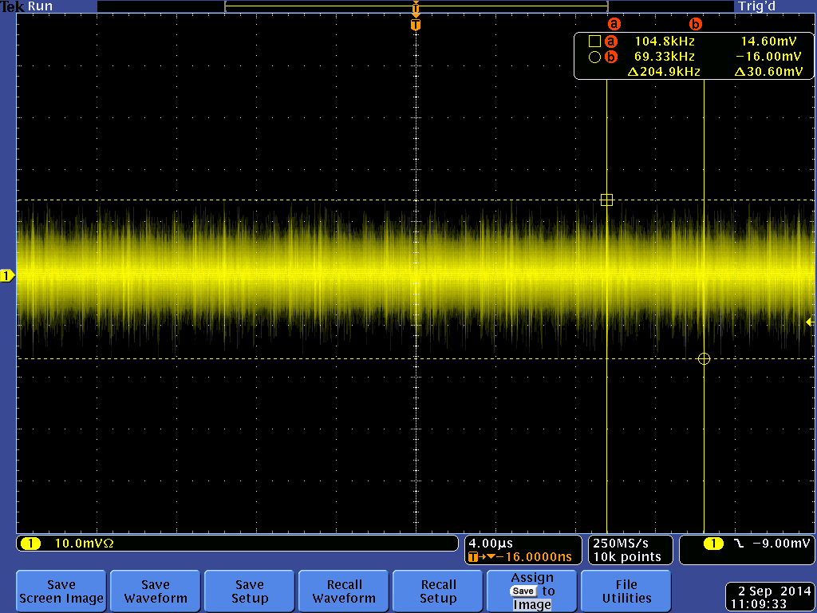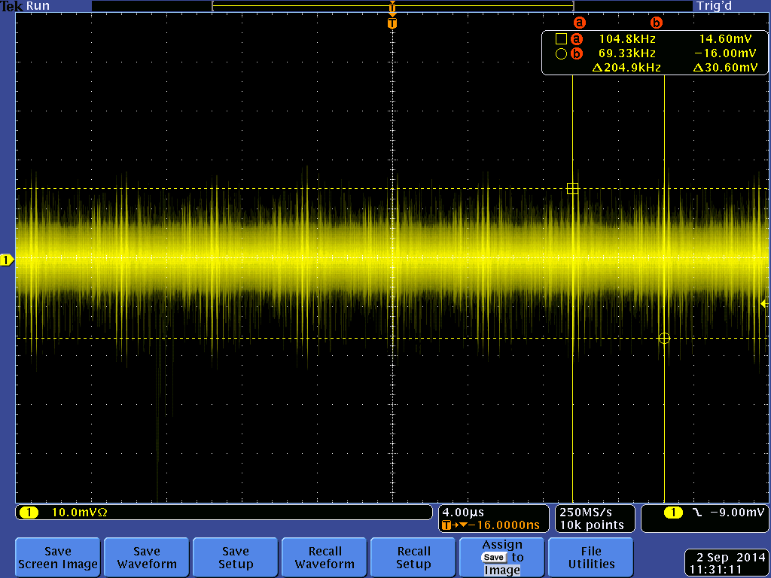
C6, C5C7B5B6D7D8D9 HV OFF, all others HV ON C6, C5 HV ON, all others HV OFF
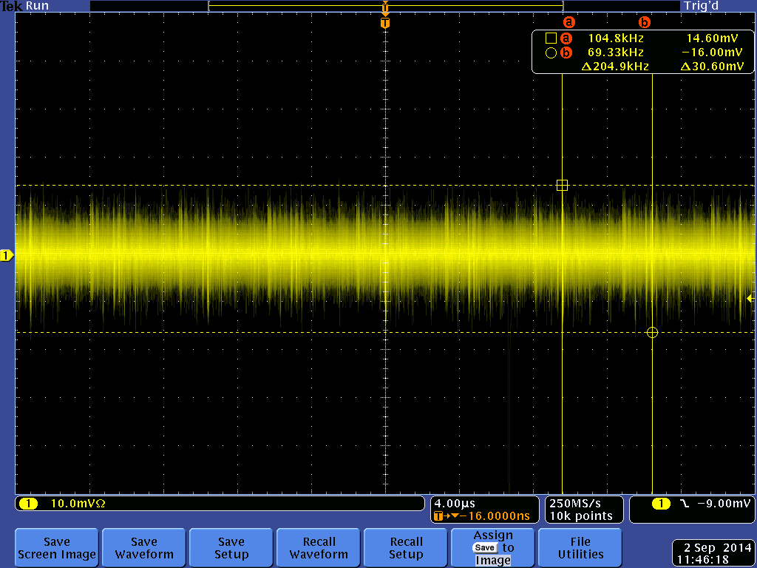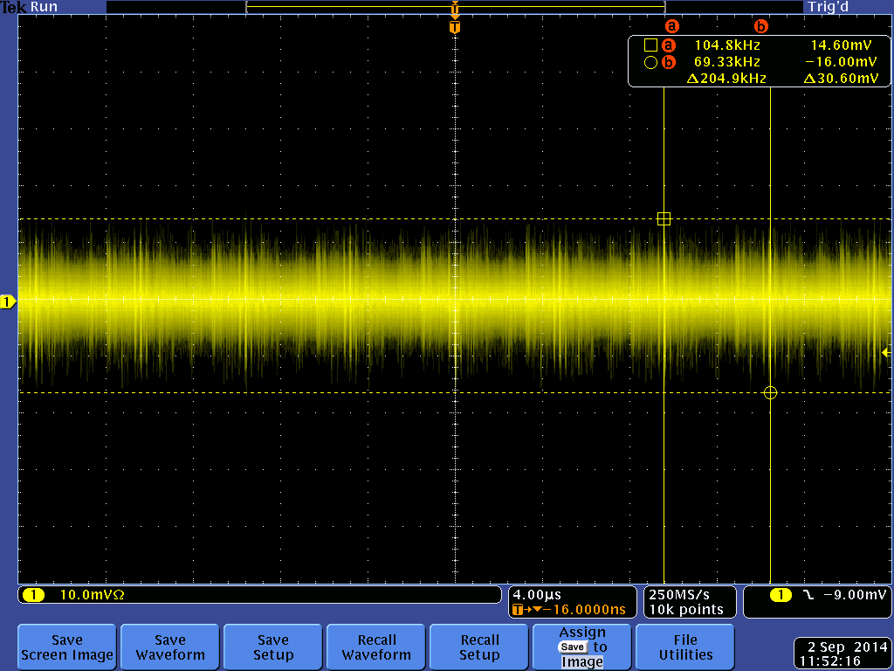
C6, D8 HV ON, all others HV OFF C6, D9 HV ON, all others HV OFF
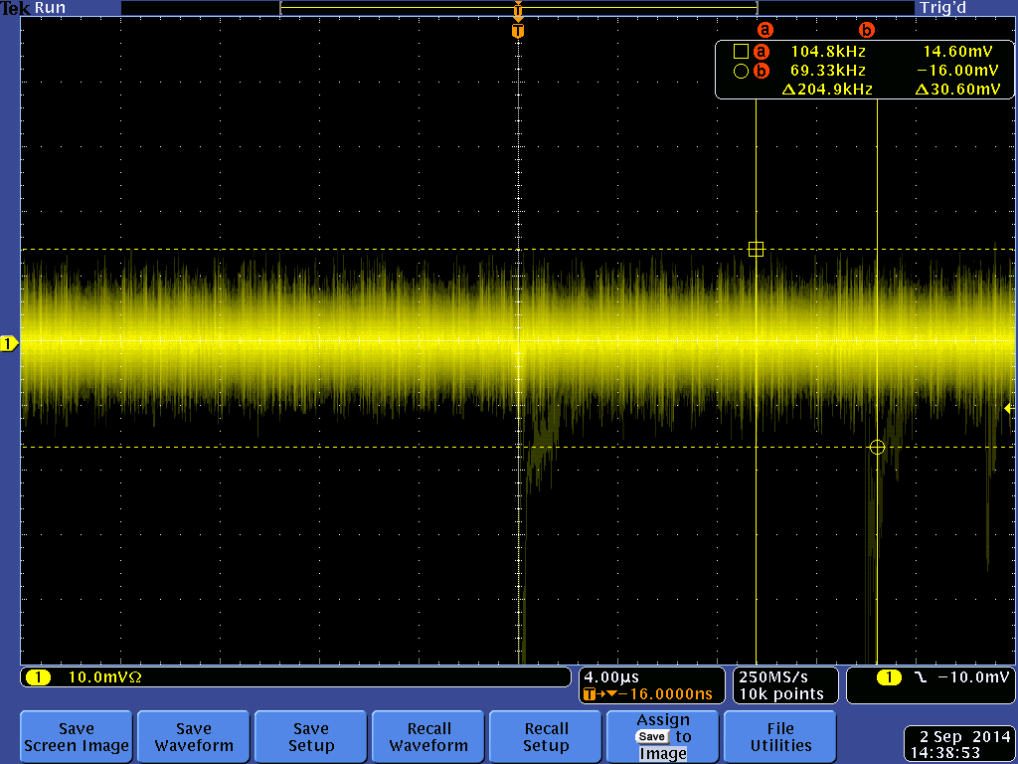
C6, all others HV ON, before C6, all others HV ON, New HV Wire Route
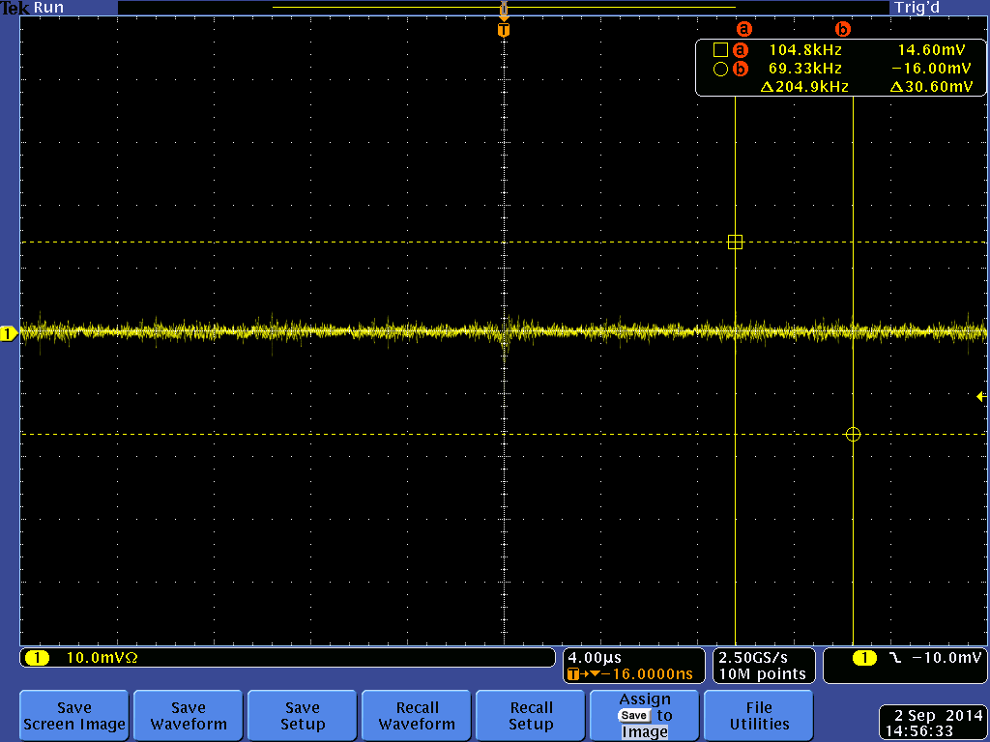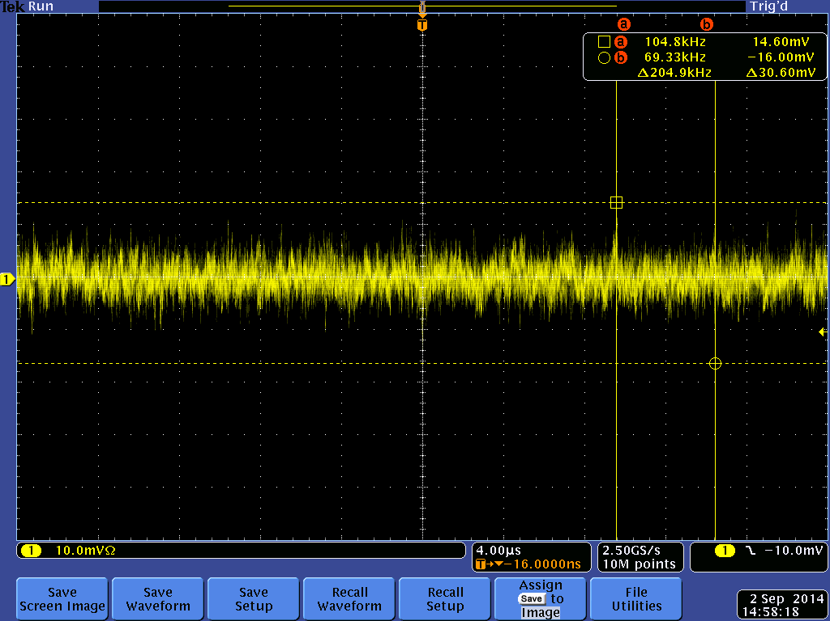
C6, all others HV ON, New HV Wire Route – Average C6, all others HV ON, New HV Wire Rte -HiRes

Before and After New HV Wire Routes
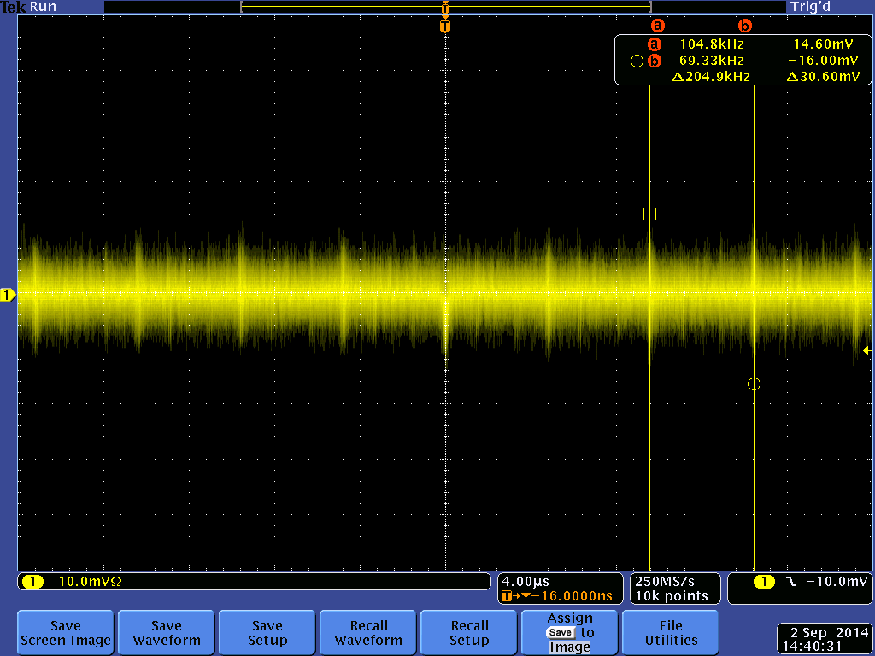
C5 Before C5 New HV Wire Route
C6 Before C6 New HV Wire Route

Noise & EMI from CAEN Supplies
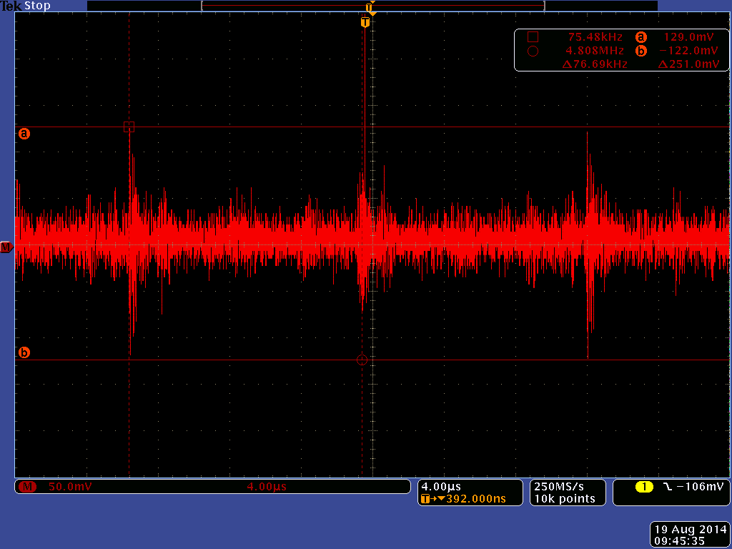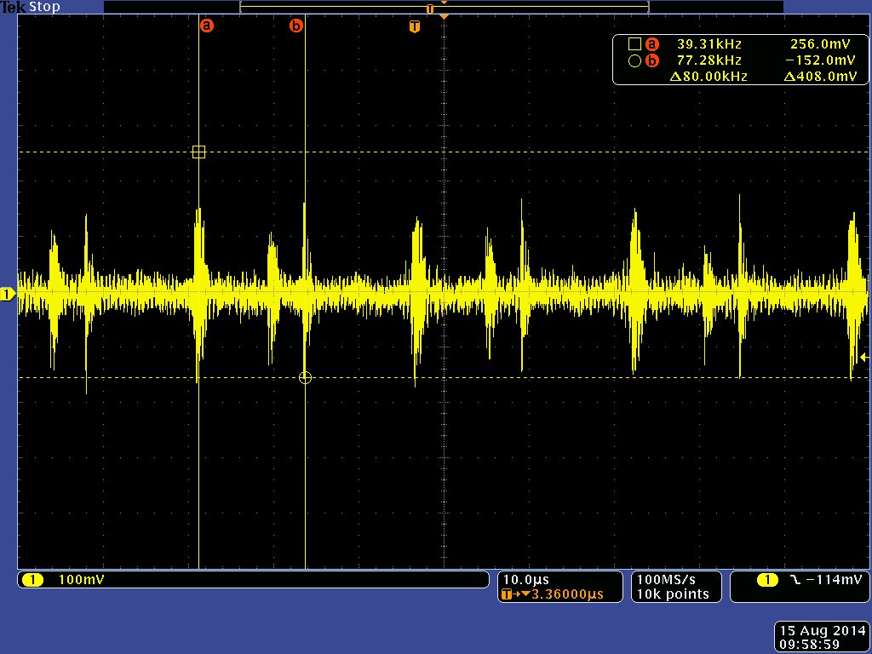
CAEN 1550s, Noise across output, Key ON (out,Return) CAEN 1550s, Noise on Return (Return, GND)

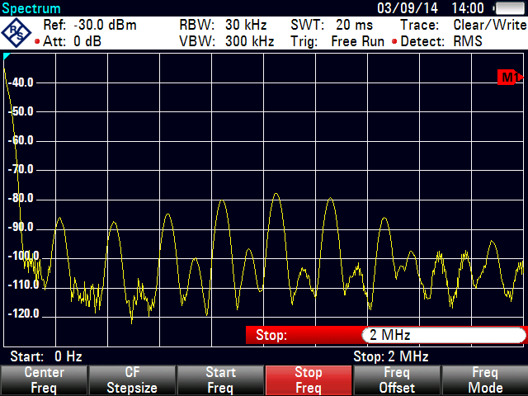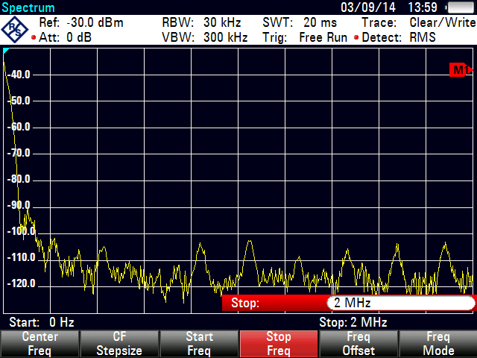
CAEN 1550s EMI, rear or module EMI on HV cable, 1 meter from module
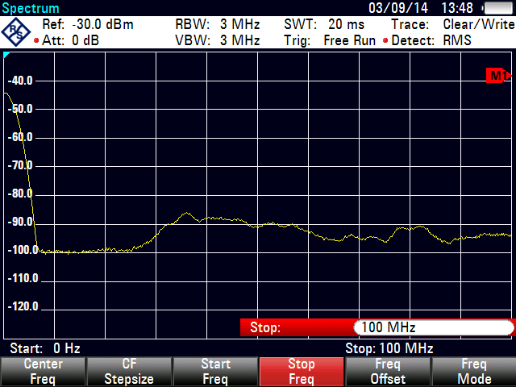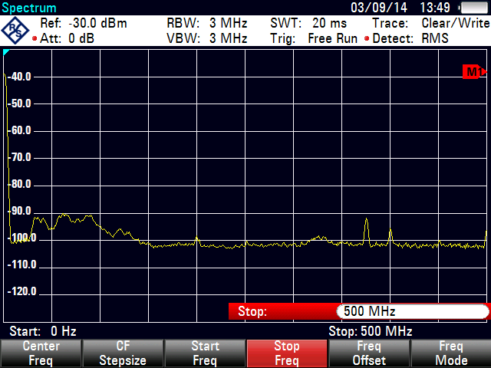
EMI on HV wire at CDC (100MHz Span) EMI on HV wire at CDC (500MHz Span)

