Experiment of accelerated copper aging.

The goal of this experiment is calculate a roughly lower limit on the operation period of cathode copper traces used as part of read-out in Forward Drift Chambers. The idea is put samples with copper traces and O-ring materials into a extreme condition to accelerate aging effect related with copper corrosion. In extreme conditions means that samples will be situated in high humidity and high temperature.The result of the effect is complete loss of resistant in the copper traces. The effect will manifest in time which can be measured. The lower limit can be calculated using the time of aging effect in two different temperatures and Arrhenius rule :

$r\sim A×e^{-\frac{E_{a}}{R × T}}$ (1)
r- rate of chemical reaction; A-pre exponential constant; E_{a}–activation energy; T-temperature; R- Universal gas constant.
$\frac{r_{1}}{r_{2}}\sim e^{-\frac{E_{a}}{R}×\frac{(T_{2}-T_{1})}{T_{1}T_{2}}}$(2)
r₁, r₂-rates of chemical reactions 1and 2; T₁, T₂ temperatures of chemical reaction 1 and 2.
The aging time at two different temperatures allow calculating activation energy. After this step the aging time can be extrapolated in real operation temperature (room temperature) and give us lower limit of operation time. We assume that the concentration of formed compounds (copper sulfides) is the same for two different temperatures. Because of it the rate ratio and the aging time ratio is equivalent.
Resent result of aging experiments shows that all cases of loose resistant related to soldering problem, except one case with EPDM sample when samples was in atmospheric environment with high humidity and 100 ̊C. This experiments was run at Jefferson Lab, Newport News, VA, US, current experiment will be run and will repeat existing experiment with the same condition at NRNU ” MEPhI”, Moscow, Russia . The air compounds are different at these locations and may add unexpected result to investigation, to include this factor air condition will be monitoring every day. Data of air condition will be taken from department of Moscow Ecological Monitoring.
Three type of O-ring material lie in the groove of spacer ring. Copper traces lie perpendicular to O-ring and pressed by the aluminum plate using clamps. Soldering technology and wiring have changed to avoid extra stress at “wires to traces” soldering area. First of all soldering happens after assembly of traces and o-rings. Wires lie at the groove at opposite side of spacer ring and pressed by plate. See picture 1.
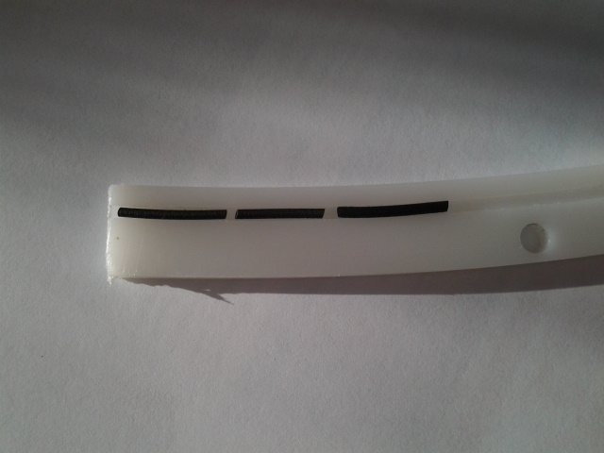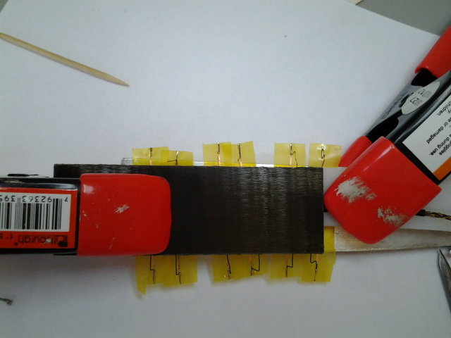
Picture 1. O-ring, traces and wires assembly.
To create an extreme condition thermostat is used. The assembly with samples placed in porcelain cup which is inside of thermostat. The thermostat filled with water at one half. Thermostat controls heat exchange between water and thermal element. And use heating element to heat water if temperature starts following down.The wires take out using steam holes. See picture 2 and 3.
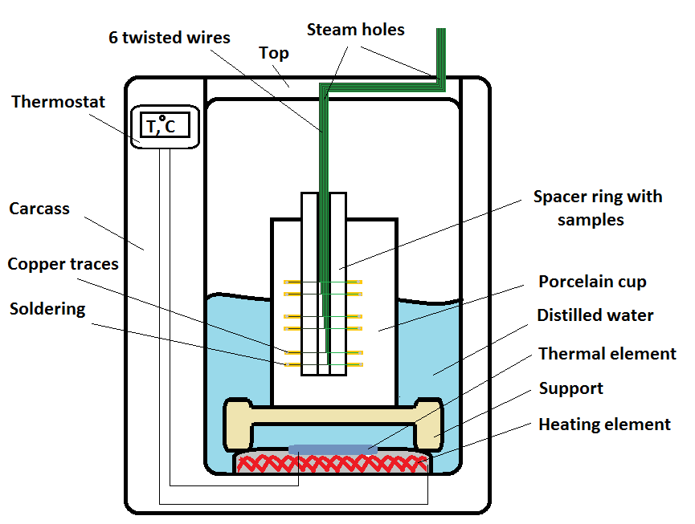Picture 2. Experemental scheme.
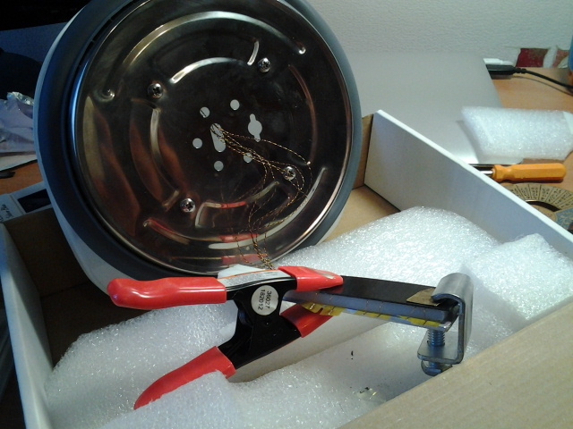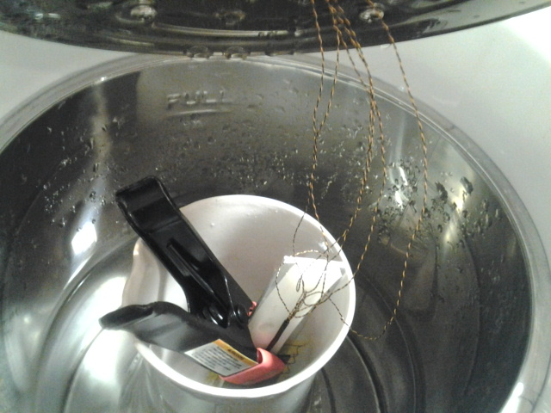
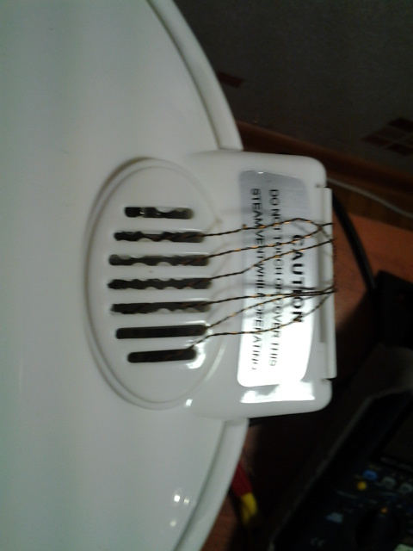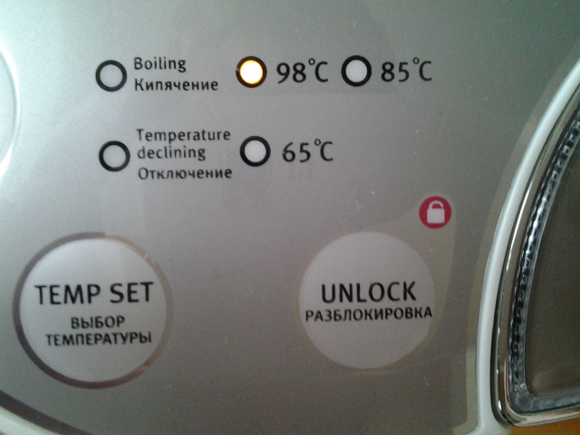
Picture 3. Photo of assembly.
The experiment will run with two temperatures 98 ̊ and 65 ̊ C. The resistence measured with multimeter used twisted wires and “crocodiles”. See picture 4.
