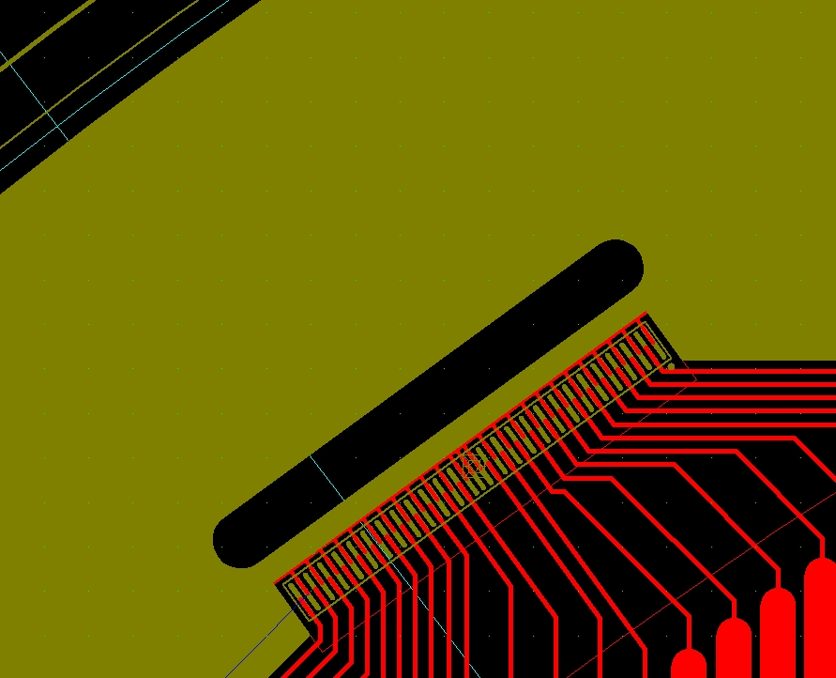

Solder pads move out 1.5mm.

The slot will move outward 2mm. This edge will be at 537R.

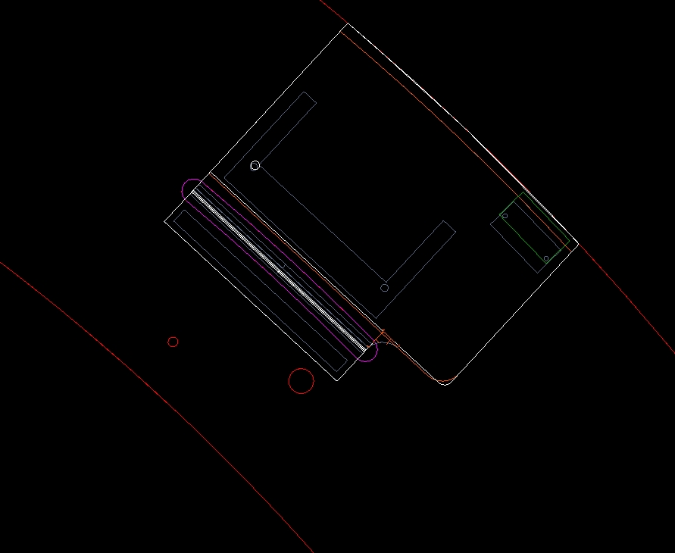

The cards you received are actually too long. They are supposed to be 60.845mm, I measure 62.5. That’s an error of 1.655mm. Secondly, the foils stretched a bit, so Casey may have soldered them on outwards a small amount. This corresponds nicely to the measured “protrusion” of 2mm.

I plan to move the slot radially outward. This edge will move from 535R to 537R (change 2mm).

This edge MUST move outward 1.5mm.

This is the new flex board over layed on the old one. The only thing that seems to have changed is the O.D. and the location of the small Erni connector (these changes are okay).