Hall D_Sample1_areas2-3
Contains 2 images with a total of 6 analyses

01. Image 1
3 analyses: 1x region, 2x spot

02. Image 2
3 analyses: 3x spot

Image 1
1. region
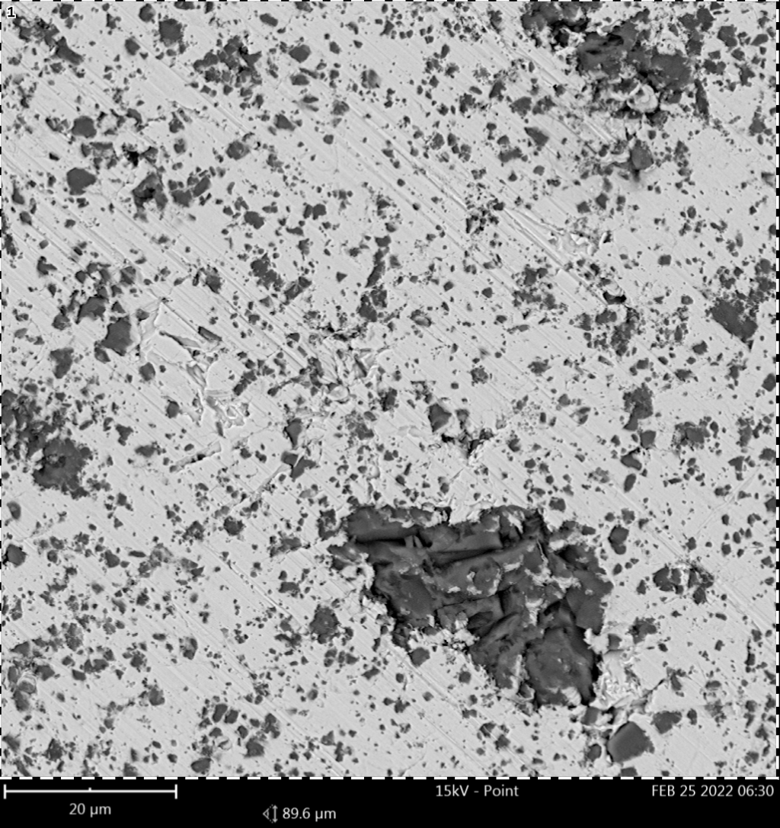 | Element Symbol Atomic Conc. Weight Conc. Oxide Symbol Stoich. wt Conc.  Cu 47.65 74.33 Cu 81.36  O 23.53 9.24  C 10.18 3.00 C 3.28  Si 9.43 6.50 Si 7.12  Al 8.03 5.32 Al 5.82  Fe 1.17 1.60 Fe₃O₄ 2.42
FOV: 89.6 µm, Mode: 15kV - Point, Detector: BSD Full, Time: FEB 25 2022 06:30

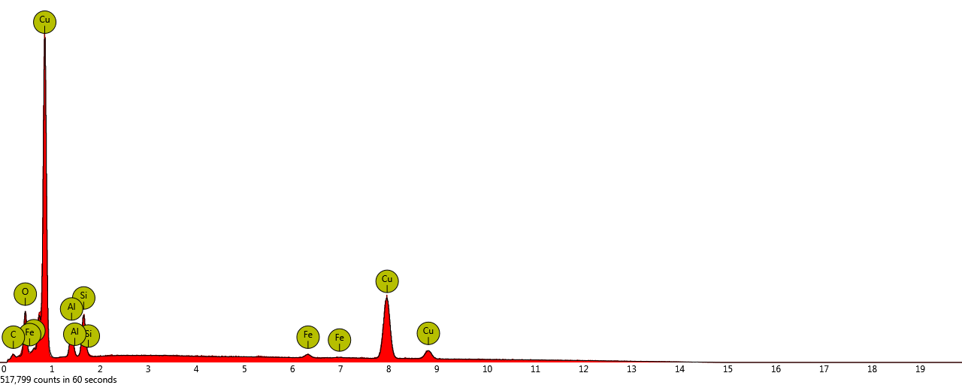
Disabled elements: Au, B, Br, Mo
2. spot
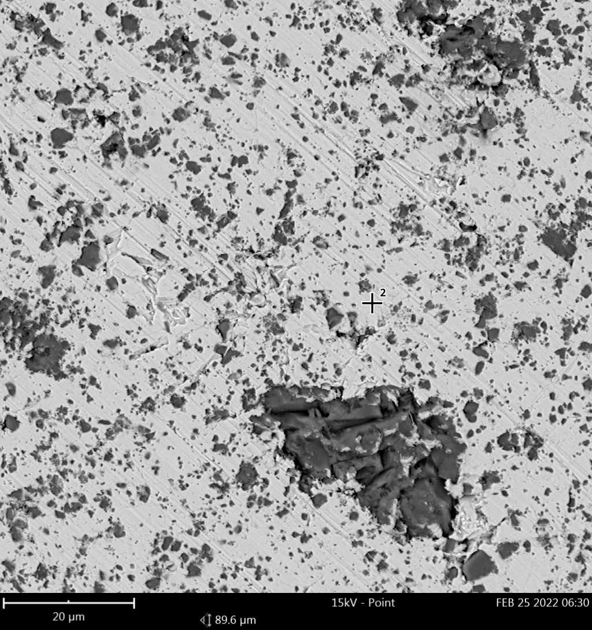 | Element Symbol Atomic Conc. Weight Conc. Oxide Symbol Stoich. wt Conc.  Cu 76.42 92.45 Cu 95.02  C 9.68 2.21 C 2.27  O 8.87 2.70  Al 2.93 1.50 Al 1.55  Si 2.11 1.13 Si 1.16
FOV: 89.6 µm, Mode: 15kV - Point, Detector: BSD Full, Time: FEB 25 2022 06:30

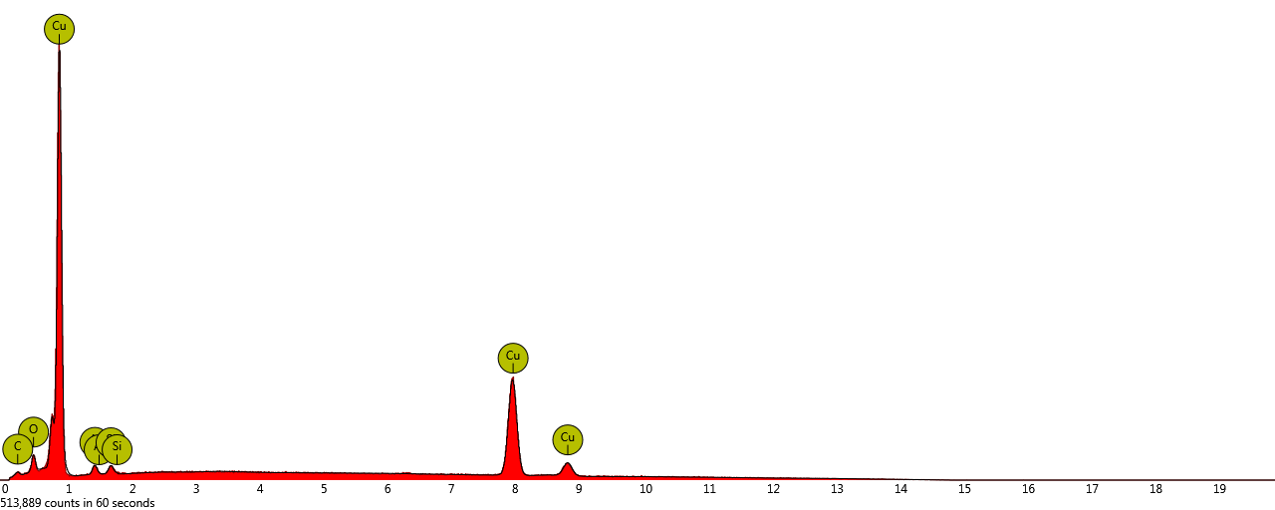
Disabled elements: Au, B, Br, Mo
3. spot
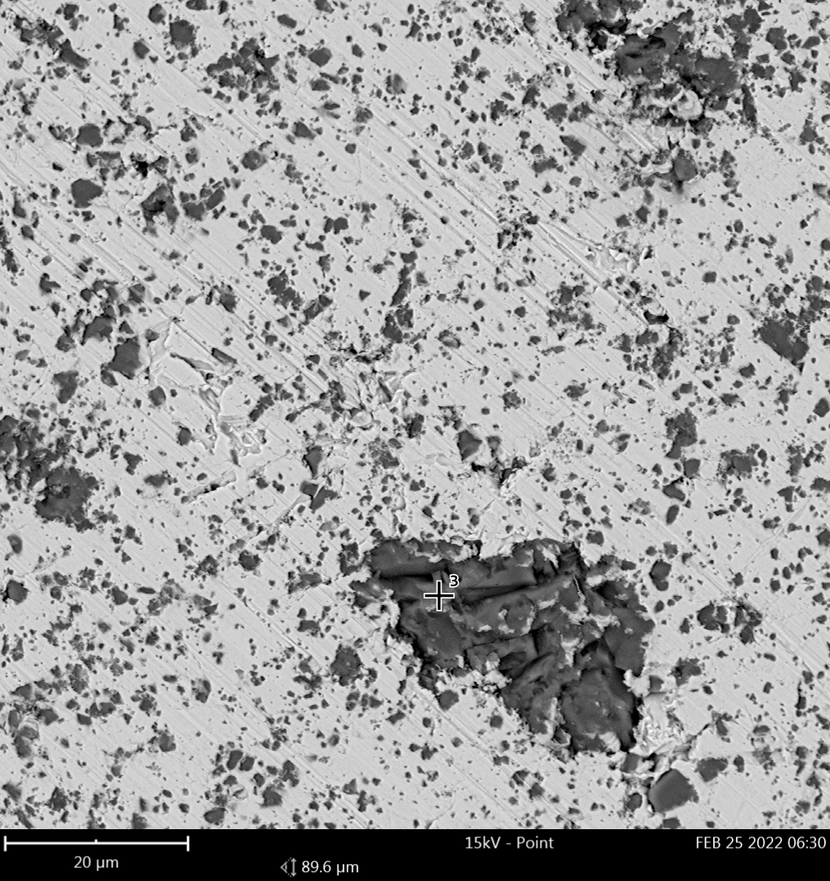 | Element Symbol Atomic Conc. Weight Conc. Oxide Symbol Stoich. wt Conc.  O 67.34 48.99  Si 26.13 33.37 Si 65.43  Cu 5.79 16.73 Cu 32.80  Al 0.74 0.90 Al 1.77
FOV: 89.6 µm, Mode: 15kV - Point, Detector: BSD Full, Time: FEB 25 2022 06:30

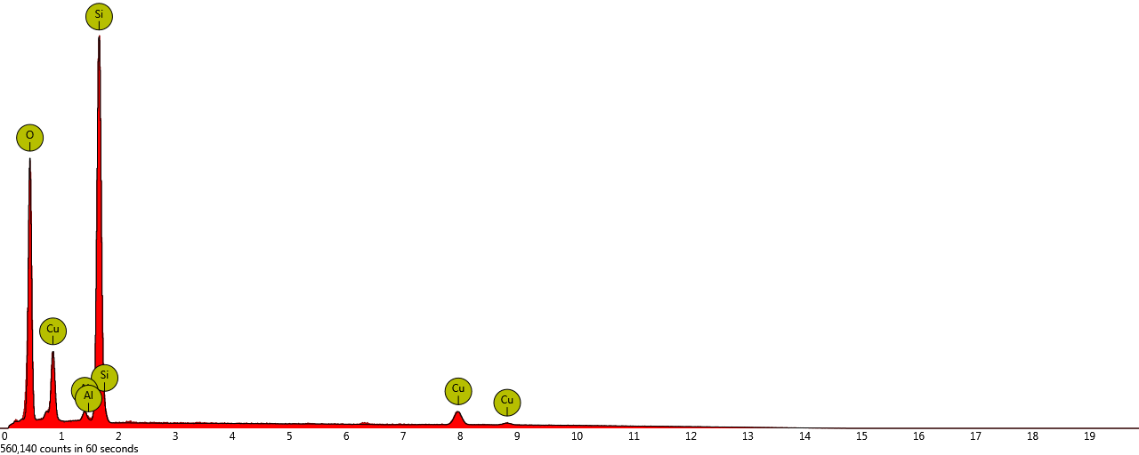
Disabled elements: Au, B, Br, Mo
Image 2
1. spot
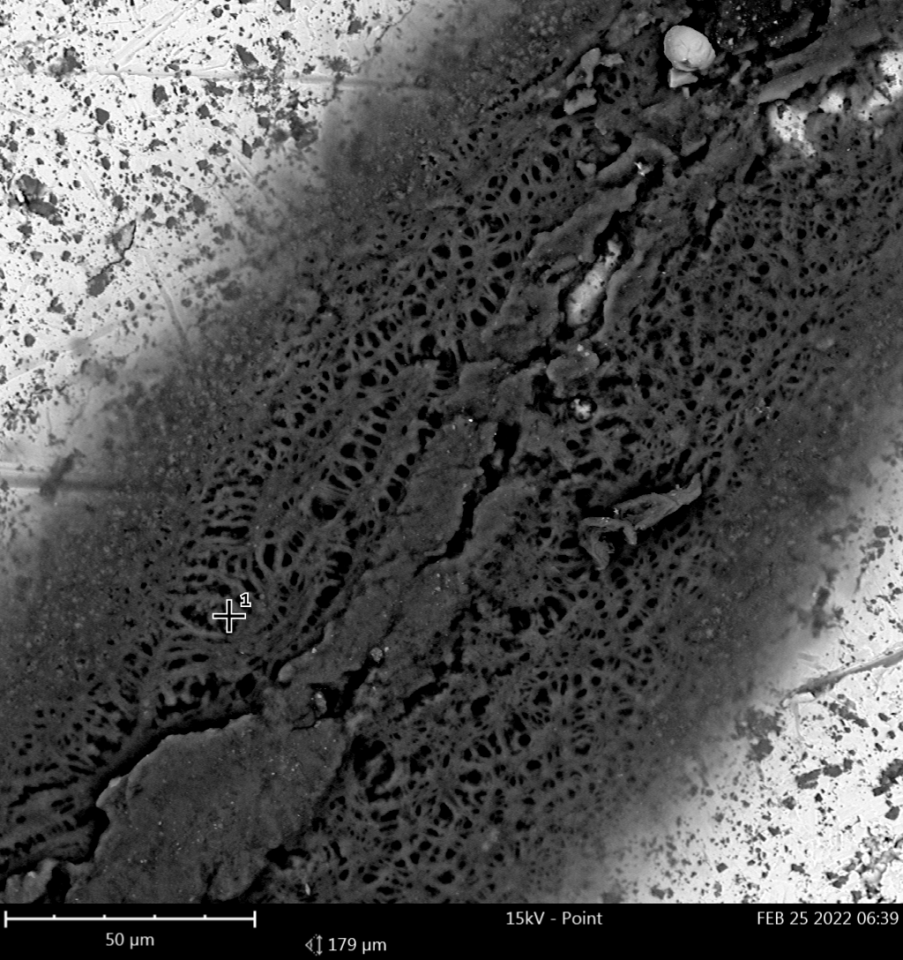 | Element Symbol Atomic Conc. Weight Conc. Oxide Symbol Stoich. wt Conc.  C 61.24 33.58 C 37.19  Cu 14.62 42.41 Cu 46.97  O 13.29 9.70  S 5.49 8.04 S 8.90  Na 3.75 3.94 Na 4.36  Cl 0.61 0.98 Cl 1.09  Al 0.59 0.72 Al 0.80  Si 0.26 0.33 Si 0.37  K 0.16 0.28 K 0.31
FOV: 179 µm, Mode: 15kV - Point, Detector: BSD Full, Time: FEB 25 2022 06:39

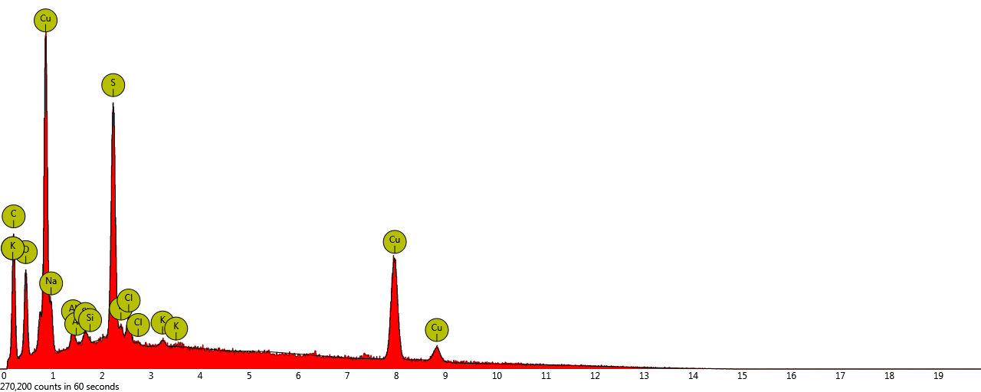
Disabled elements: Au, B, Br, Mo
2. spot
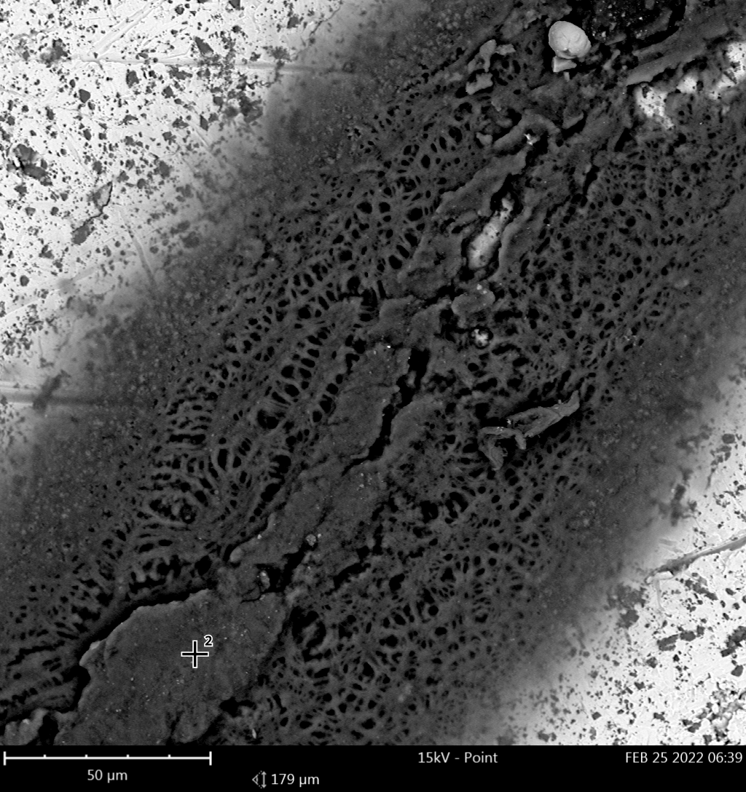 | Element Symbol Atomic Conc. Weight Conc. Oxide Symbol Stoich. wt Conc.  C 64.87 43.47 C 52.33  O 19.65 17.54  Cu 6.76 23.97 Cu 28.85  S 3.85 6.89 S 8.29  Na 2.92 3.74 Na 4.50  Cl 0.62 1.23 Cl 1.48  Ni 0.36 1.16 NiO 1.78  Al 0.31 0.46 Al 0.55  Si 0.26 0.40 Si 0.48  Fe 0.24 0.75 Fe₃O₄ 1.24  K 0.18 0.40 K 0.48
FOV: 179 µm, Mode: 15kV - Point, Detector: BSD Full, Time: FEB 25 2022 06:39

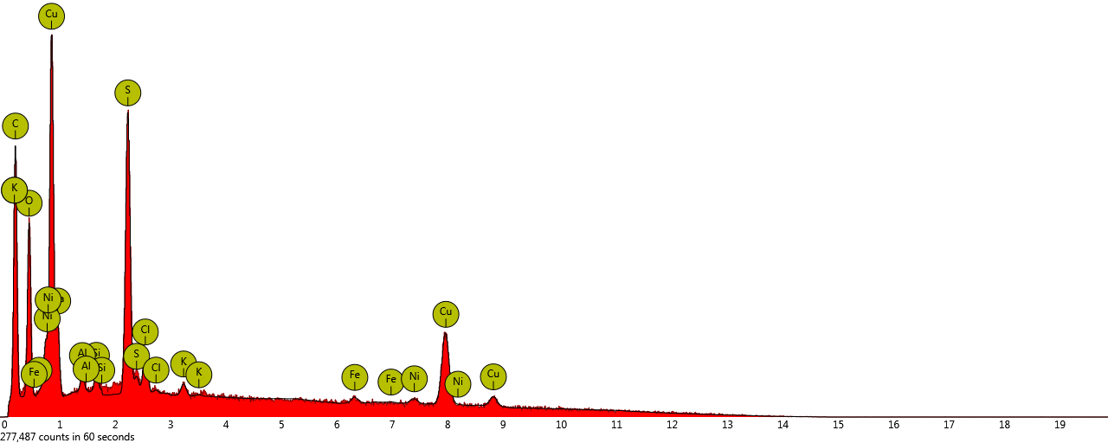
Disabled elements: Au, B, Br, Mo, Zr
3. spot
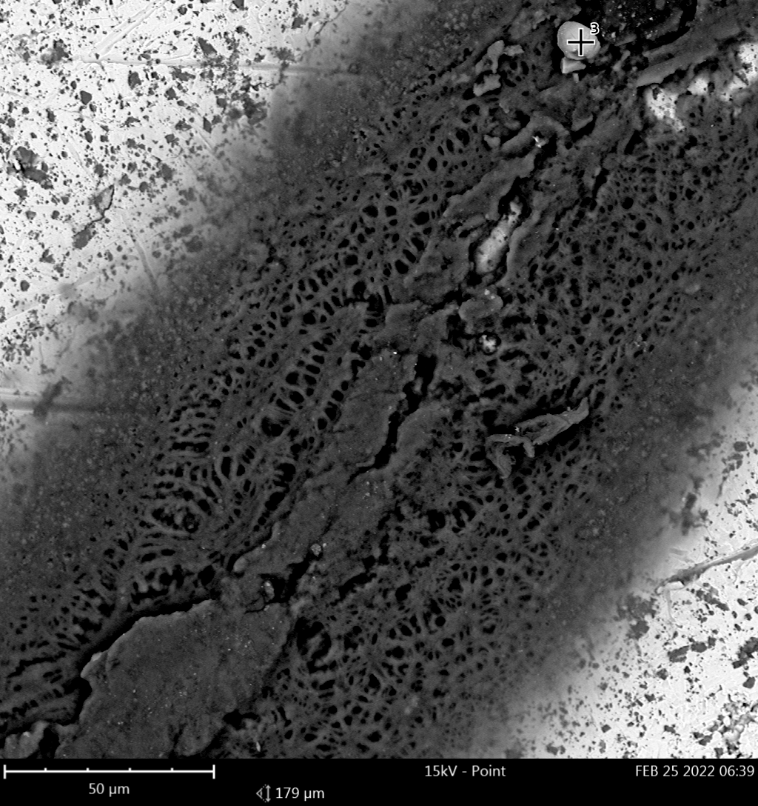 | Element Symbol Atomic Conc. Weight Conc. Oxide Symbol Stoich. wt Conc.  O 49.39 24.86  Fe 34.35 60.34 Fe₃O₄ 84.92  C 10.06 3.80 C 3.87  Cu 4.95 9.89 Cu 10.07  Al 0.56 0.47 Al 0.48  Si 0.41 0.36 Si 0.36  S 0.28 0.29 S 0.29
FOV: 179 µm, Mode: 15kV - Point, Detector: BSD Full, Time: FEB 25 2022 06:39

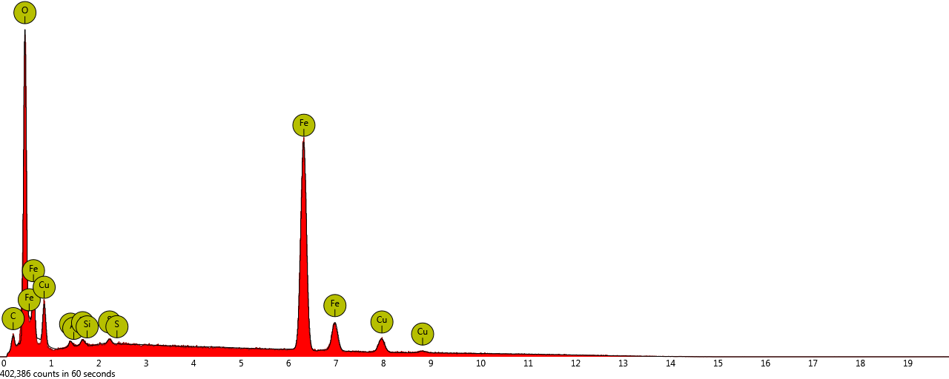
Disabled elements: Au, B, Br, Mo

