 | Oxygen Deficiency (ODH) Safety Review Form  (See ES&H Manual Chapter 6540 Appendix T1 ODH Safety Review for instructions)

PART 1 - PRELIMINARY ANALYSIS:
- INTRODUCTION
Task/Title: |  | Hall D Gas Blending Room |  |  |  |  | Task # (If applicable)
Location of Use: Bldg/Room/Area |  |  | Gas Room of Hall D Counting House (Bldg. 202 rm. 410) |  | Effective Date: |  | 24APR14 | Expiration Date:  (Not to exceed three years.) |  |  | 24APR17
Document Owner: | Tim Whitlatch |  |  | Division Owner: |  | Physics |  | Department Owner: |  | Hall D

- PRELIMINARY INFORMATION |  |  |  |  | √ if YES
Gas to be Introduced:  (List Name(s) and Source Concentration(s)) |  | Argon, Pure, and CO2, Pure, from outdoors cylinders. There are two gas blend tanks inside the room. |  | Flammable
 |  |  |  | Corrosive
Is gas self-contained?  (In a Dewar or similar?) | Yes | No | Size | Toxic
Is gas self-contained?  (In a Dewar or similar?) |  | √ |  | Other
Attach copies of any related “Oxygen Deficiency Hazard Risk Assessments” for the building and any additional supporting documents/calculations.

ATTACH A ROOM FLOOR PLAN (Show location of ODH):

- PRELIMINARY ODH Calculation:
Source is Inside Proposed ODH Area  (e.g. dewar, tank, etc.) |  |  |  | OR |  | Source is outside Proposed ODH Area  (e.g. from a compressor, pump, etc.)
Total volume of room: | V_{R} (ft³) = | 2085 |  |  |  |  | Total volume of room: | V_{R} (ft³) = | 2085
Volume of gas at room temperature and pressure | V_{G} (ft³) = | 6.8 |  |  |  |  | Volumetric flow rate of gas into room at room temperature and pressure  (Contact Engineering) | Q = (ft³/hour) = |  | 2507
21(V_{R} – V_{G})  V_{R} | = | 20.9 |  |  |  |  | 21(V_{R} – Q) *  V_{R} | = |  | 0
* Assuming minimum one fresh air change per hour (ACH). If more than one ACH is needed additional review may be required.
If Resulting % Oxygen is: | Then:
<18 | Continue to Part Two – Additional Information.  Then submit form to ODH Safety.
>18 | Submit form to ODH Safety.

The above referenced hazard has been determined to be: |  |  | 0 | If resulting % oxygen is between  18 and 19.5 a second ODH Safety Reviewer approval is required.
APPROVALS |  | Print Signature |  |  |  | Date:
ODH Safety Reviewer | Dick owen |  |  |  |  |  | 28apr2014
Second ODH Safety Reviewer (if required)

Additional Approvals per Department Procedures
 | Department or Group Head:
 | Division Safety Officer:
 | Other:
 | Other:
Review per Department Procedures
 |  |  |  |  |  | Print Signature |  |  |  |  | Date
 | Area Safety Warden:
 | Other:

PART 2 – ADDITIONAL INFORMATION:
- Engineering and Administrative Controls (be as specific as possible, provide existing and planned)
Engineering Controls:  Example: Fume hoods, valves, critical orifice, etc. | Two restrictor orifices at inlet lines, one for Argon, one for CO2, each one of 0.052” diameter. Fan provided inside gas room is intended only for temperature control, so it has not been considered here.
Administrative Controls:  including, but not limited to:  (list names, types, and document numbers)  - Training Required  - Standard Protecting Measures  - Work Control Documents | Operators will be trained to perform the procedures of the Gas System Operation Manual (D00000-10-02-P001).
Attachments - list all that apply:  (e.g.: Confirmation Communications, Risk Assessment, Task Hazard Analysis etc) | Attached calculations of ODH and orifice diameter.
Submit: Completed form to ODH Safety for review and approval

After Approval Distribution:
Original: Document Author; Copies: affected area, all approvers, all reviewers, and ESH&Q Document Control.

Form Revision Summary
Revision 0 - ##/##/## – New content.
 | ISSUING AUTHORITY | FORM TECHNICAL  POINT-OF-CONTACT | APPROVAL DATE | EXPIRATION DATE | REV.
 | ESH&Q Division | Richard Owen | 01/17/12 | 01/17/2017 | 0
This document is controlled as an on line file. It may be printed but the print copy is not a controlled document. It is the user’s responsibility to ensure that the document is the same revision as the current on line file. This copy was printed on 11/24/2026.

Calculations References:
Crane Corporation, “Flow of Fluids”, Technical Paper No. 410, 2009 Version.
“Perry's Chemical Engineers' Handbook”, McGraw-Hill, Eighth Edition, 2007.
L. K. Spink, “Principles and Practice of Flow Meter Engineering”, Foxboro Co.; 9th revised edition (1967)

Attachment to Oxygen Deficiency (ODH) Safety Review Form
The calculations for oxygen content (0%) on part 1 of the ODH safety review form reflect no engineered or administrative controls in place. The controls from part 2 (engineered orifice) brings the oxygen content to 18.75% (worst case- 2 lines rupture in gas room simultaneously) when using the calculation on part 1. There is a 0.052 inch orifice installed in both the argon and C02 lines. The 3 references listed on the previous page were used as well as an internet calculator and the most conservative numbers were used. Below are the summary of the engineered orifice calculations.
ODH and Orifice Calculations for Hall D Gas Room

Results with proposed 0.052” diameter orifices on both Argon and CO₂ lines
Note: Calculations tables follow
Input Data:
Room Volume [V_{R}] = 2085 ft³ (row 31 of calculations)
Flow after Argon line ruptures [Q_{Ar}] = 117.9 sft³ / hr (row 86 of calculations)
Flow after CO₂ line ruptures [Q_{CO2}] = 105.3 sft³ / hr (row 128 of calculations)
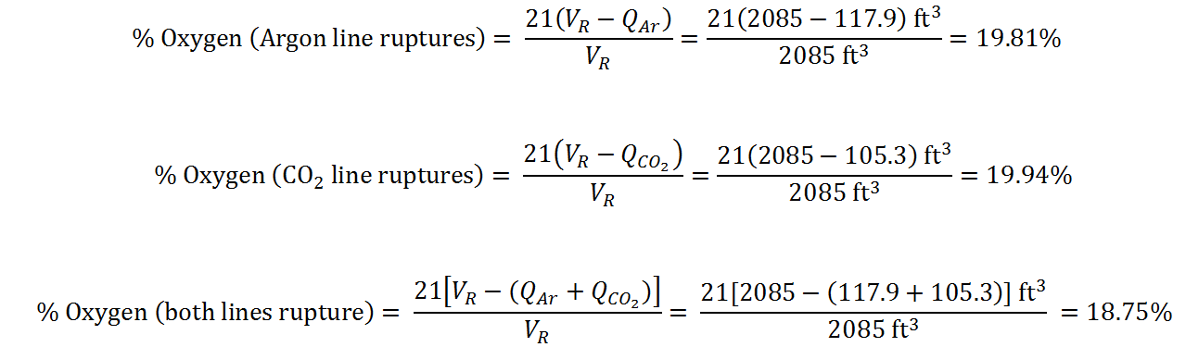
Oxygen Percentages inside room:

Calculations summary:
- Flows of ruptured lines of Argon and CO₂, without orifices, were calculated following a theoretical model (Crane).
- Flows described in point 1, were verified using an Internet calculator, and these were found to be about 9% lower.
- Conservatively, the higher flows obtained in point 1 above, were used for the preliminary ODH calculation, arriving to the conclusion that orifice restrictors are needed on both lines, even in the event of only one line being broken.
- The most critical ODH situation calculated, is the event of simultaneous rupture of both lines. It was considered that this event will occur with the regulator working properly and set to the operating pressure of 50 psig.
- Sizing of the orifices must meet simultaneously three requirements: flows of Argon and CO₂, to be minimum 0.5 lbm/hr, and 0.6 lbm/hr, respectively, as were calculated in the Gas System Analysis (Doc. D00000-10-02-A002); an acceptable pressure drop through the orifice with those flows, which was set to be 0.5 psi or less; and a calculated oxygen content inside the gas room after the rupture of both lines between 18 and 19.5%, as per ESH&Q requirements.
- Calculations were done with a theoretical model (Perry) for the minimum ratio of orifice diameter to upstream diameter that it covers, which is 0.2.
- Results of the theoretical model were verified with an internet calculator, and extremely close correlations between those values for both lines were found. It was also verified that this internet calculator does not have a minimum diameter ratio like the model, at least it does not show any error message even with an impossibly small orifice.
- The internet calculator was then used with orifices diameter of 0.052”, resulting in an acceptable room oxygen level after rupture of both lines, even when neglecting the pressure drops after the orifice, which increases the flows above the actual values. This configuration could not be calculated with the model, being its diameters ratio 0.129, smaller than the minimum indicated in point 6.
- Finally, ruptured lines flows were verified with an empirical equation (Spink), resulting in flows in average 10% lower than those obtained using the internet calculator.



