To investigate the cathode corrosion problem, a test procedure using the small-scale FDC prototype is proposed. The corrosion was observed on all the cathodes of the first and second packages, although in different extend. They both had EPDM O-rings and their wire frames were deadened using copper sulfate solution. The damages are on the copper at the places where the O-ring sits. Significant amount of sulfur was found there using SEM analyses. At this time, no damages are seen on the top cathodes of the fourth package where Viton O-rings with vacuum grease (Apiezon-L) were used.
The purpose of the tests is to reproduce the corrosion process, using the same materials as in the first two packages: same Kapton foil, same wires, Epon epoxy to hold them, EPDM O-rings, and deadened area of 7.8cm diameter. At the same time we want to see if this environment will cause corrosion in case we use Viton O-rings with and without vacuum grease. The idea is to use a small chamber where the corrosion effects might be accelerated; at the same time it’s easier for handling, dismounting and putting additional materials. Similar test was started already using production cathodes and a wire frame, however we expect results in a longer time scale. The tests will be performed initially at Blue Crab. In both cases we plan in addition to irradiate the chambers with Sr90 (100uCu) source to study the radiation effects that can be done in 126EEL. To simulate the radiation dose as it will be accumulated in the Hall the irradiation time will be ~20 days, as it was done for the CDC tests.

The small-scale prototype will be reconfigured as shown below. The gas flow will be adjusted to have the same number of exchange volumes per unit time as used in the tests of the first and second packages.
The prototype is shown in the picture below. Note the wire orientation with respect to the metal frame and the cathodes. Shown are green and yellow rectangles representing regions where samples of the new foil (yellow) and old foil cut from an original cathode (green) will be placed. Same samples will be placed as shown for both the upper and lower cathodes.
The Oring in the lower cathode is to be .139” Viton- McMaster part 7643K75 (55 durometer). This Oring is to be installed with 2” spaced Loctite 406 dots as per standard procedure. Apply Apiezon grease to the entire periphery. Add to the stack and place foil samples as shown above.
Coat one end of the wires with Epon 828, but not the other. While this is curing, check the fit of the two different sizes of EPDM foam material. As with the prototype, the groove is for the .139” material, but you may need to install the .156” size to get a good seal. Install with Loctite.
We should allow the EPON to cure for several days, as this more closely matches our process. Deaden the wires using the standard procedure for 7.8cm diameter - the interval after deadening prior to closure should be ~1/2 day. Add to the stack. Install Viton O-rings on the top cathode and apply, only on half of the length, Apiezon-L. Add Foil samples as with the lower cathode, and close the package. Flow the standard gas mixture for ~ 2 hrs. Apply HV of +2100V on the sense and -500V on the field wires. Open the chamber every week to record the corrosion effects.

7.8 cm deadened area
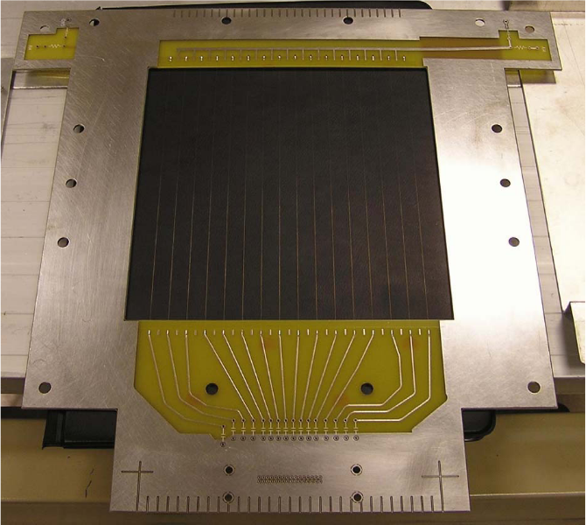
Epon this end

