Hall D Wire Characterization
Samples F6-1 & F6-2

- Sample preparation: ultrasonic cleaning in DI water for 45 minutes.
- Sample installation: for SEM inspection wires were installed on a sample holder (diameter=36 mm) on 2 stripes of conductive carbon tape, 2 fragment of each sample per stripe (nomenclature: F6-1a, F6-1b and F6-2a, F6-2b).

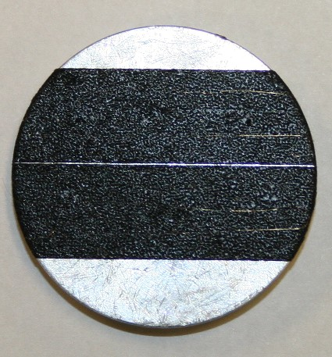

Pic1. Typical sample installation.
- Wire inspection:
- Each wire fragment was examined along its length (beginning at approximately 5mm from the sample holder edge and ending ~5mm before the opposite edge) at magnification of ~x600, at fast scan rate.
- Images at designated magnifications (x300, x500, x800, x1000) were taken randomly along the sample length;
- Images for the ovality measurements were taken at 1000x magnification in three points of each wire fragment: in the middle (approximately) and close to both ends;
- Measurements of wire diameter, as visible on the images, were done using the Quartz PCI Image Management System, 3 measurements per image;
- Additional images at various magnifications were taken at the points of interest (variations in sample topography, contaminated areas, etc.)
- EDS analysis was performed on the most typical points of interest.

Sample F6-1 A, B
I. Images at designated magnifications

F6-1A-1 | F6-1B-1
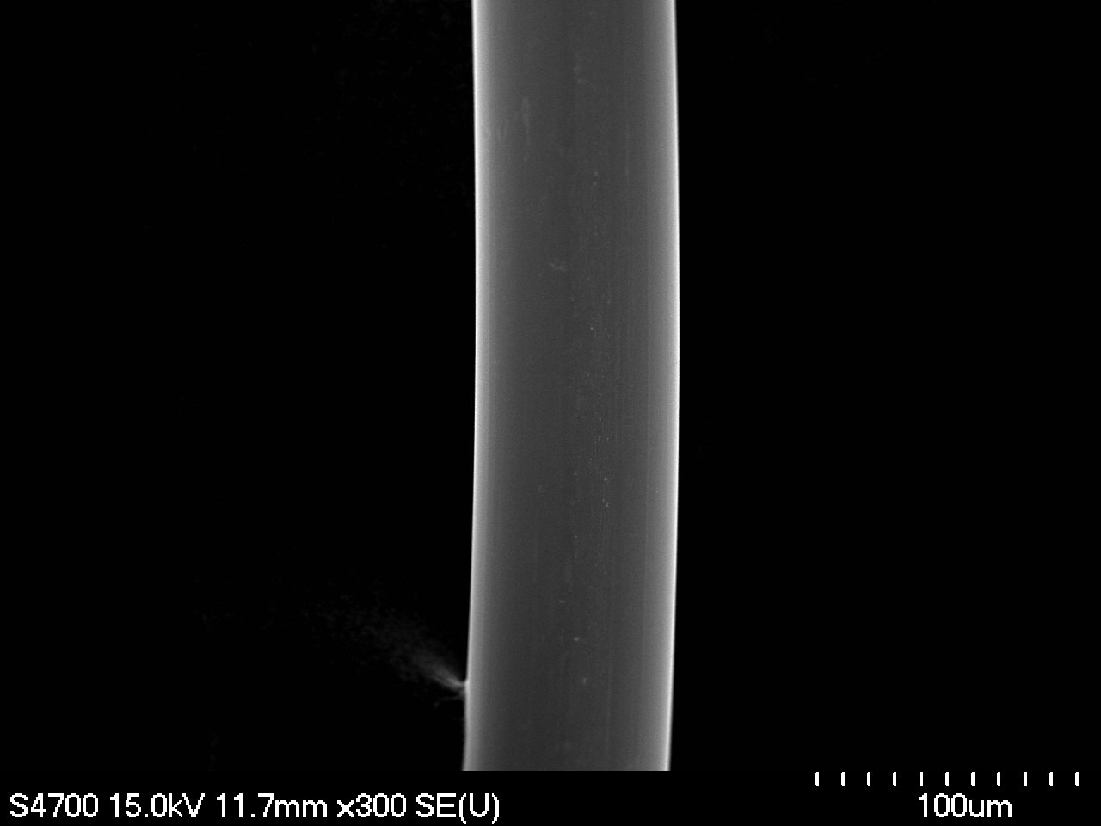 | 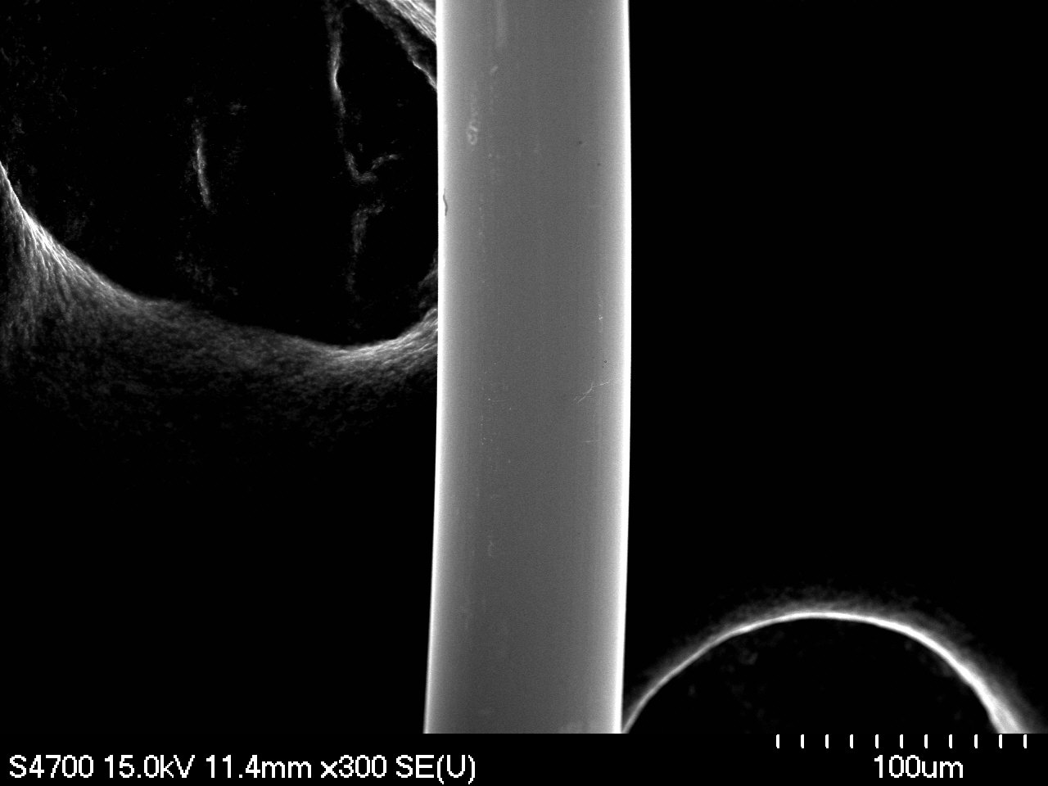
Magnification: 300x | Magnification: 300x
F6-1A-2 | F6-1B-2
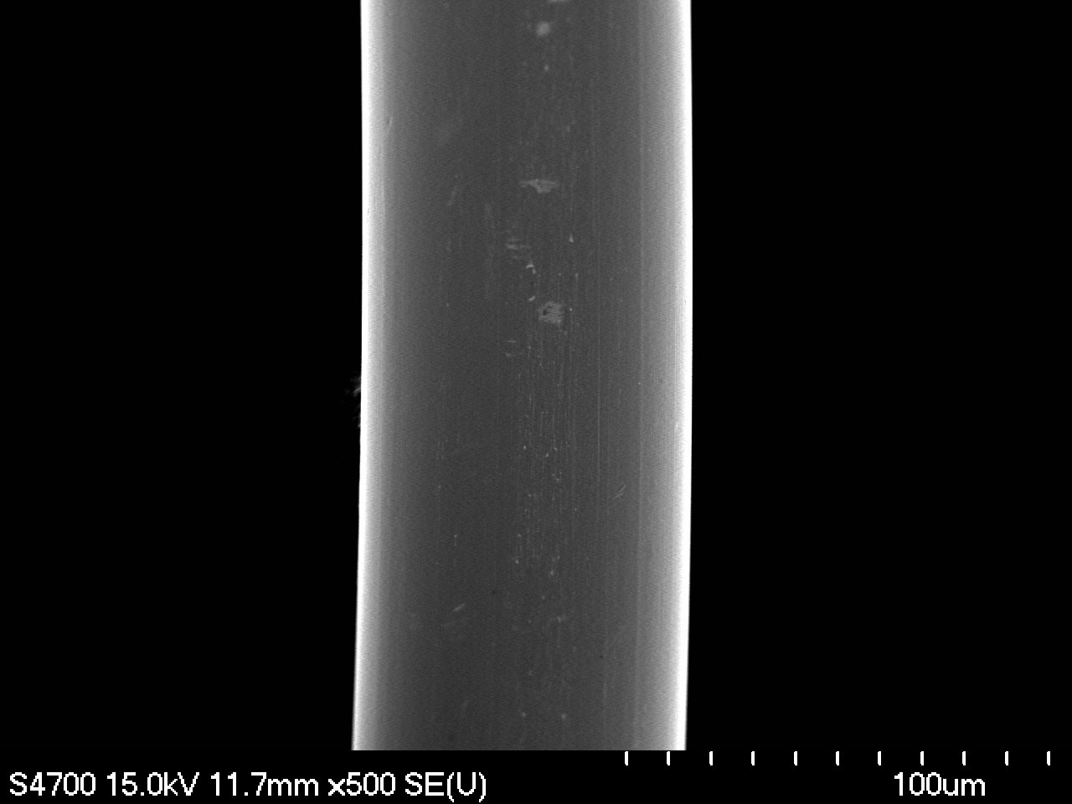 | 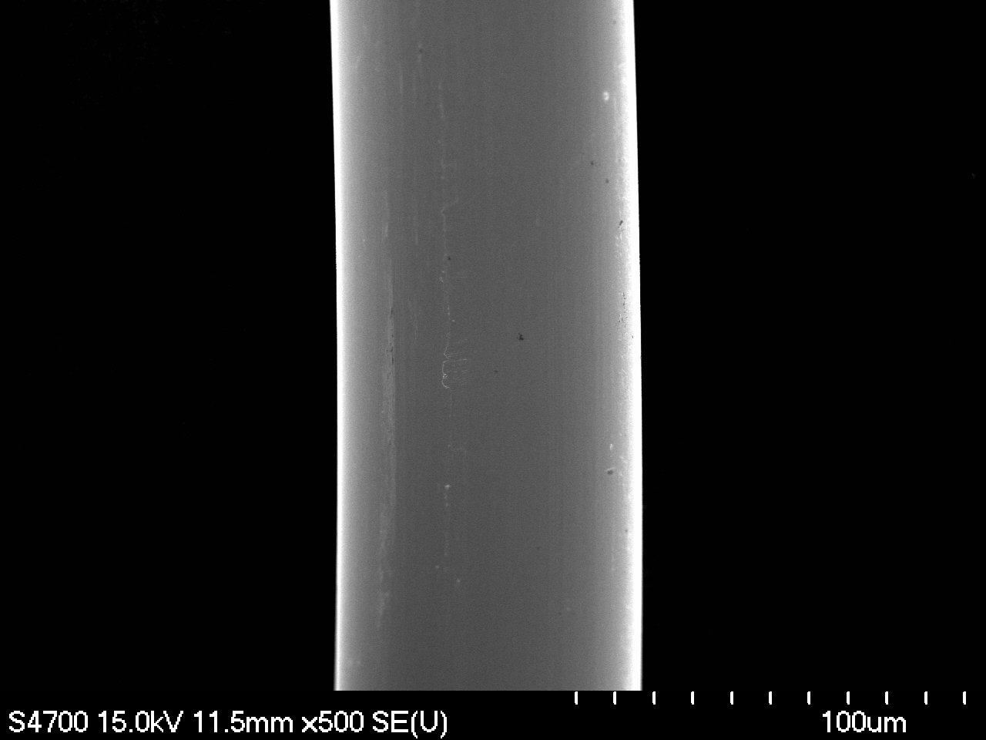
Magnification: 500x | Magnification: 500x

F6-1A-3 | F6-1B-3
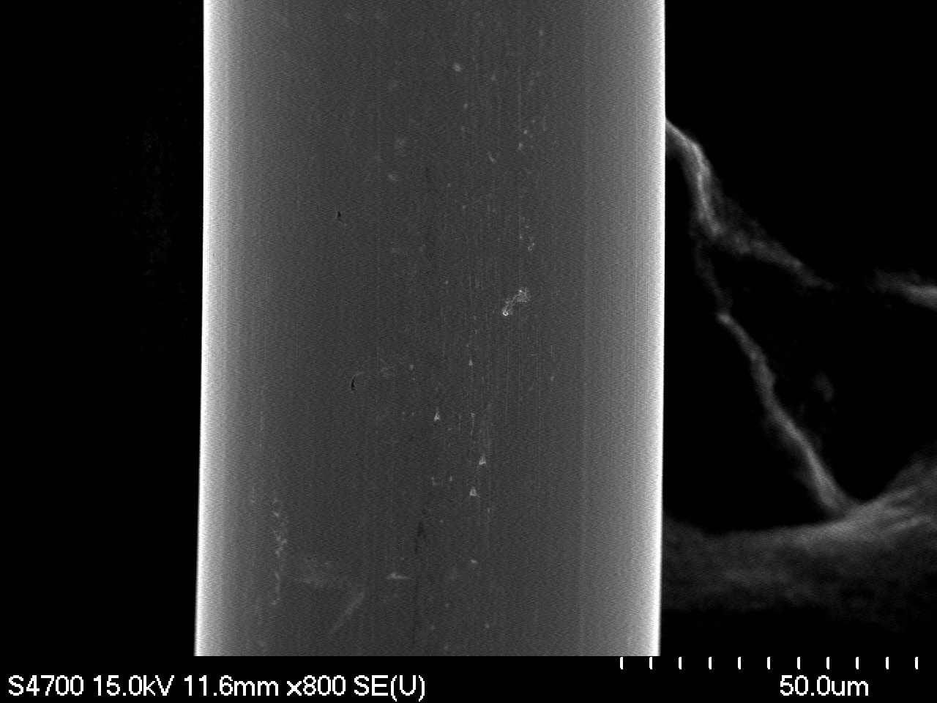 | 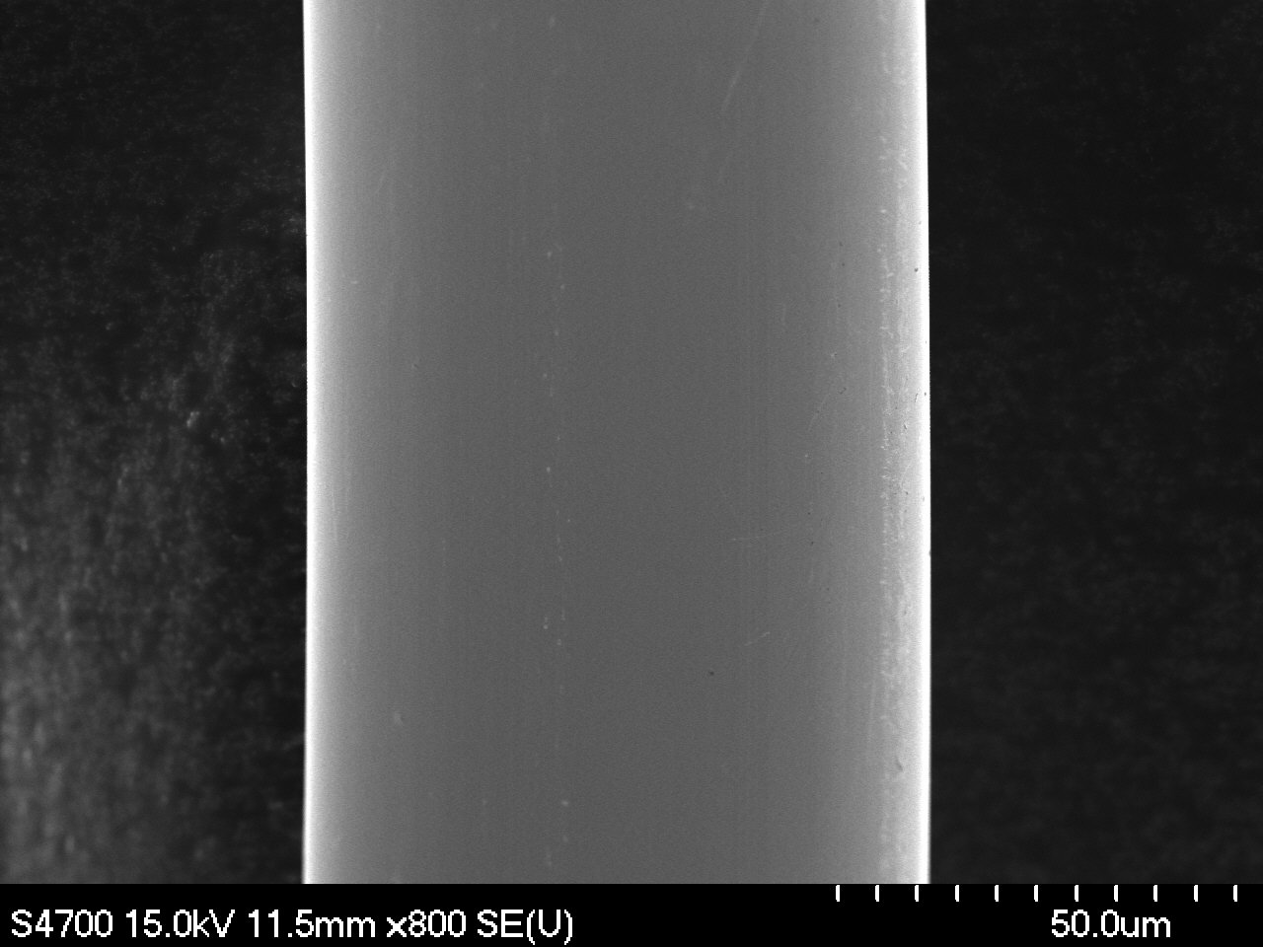
Magnification: 800x | Magnification: 800x
F6-1A-4 | F6-1B-4
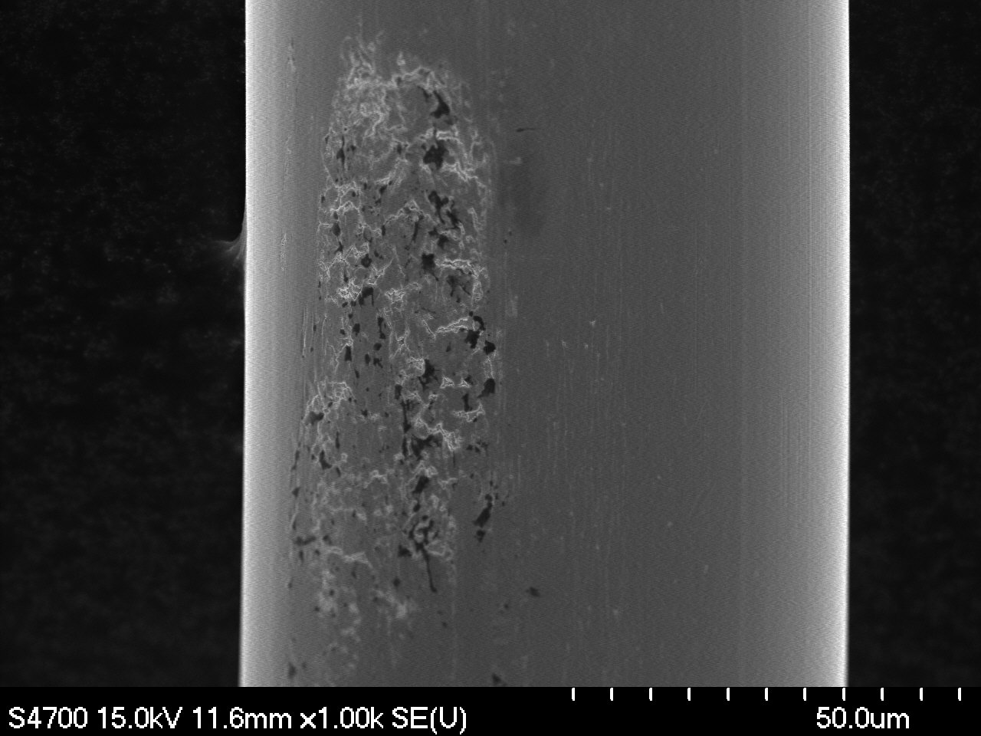 | 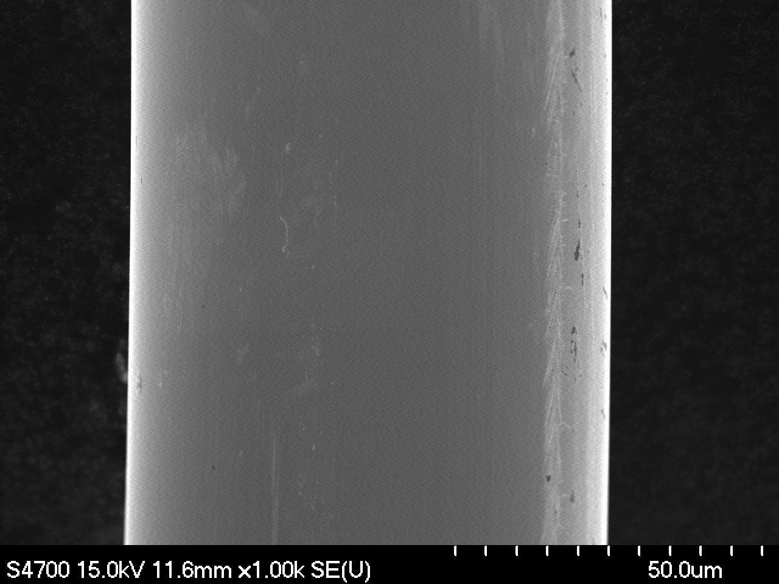
Magnification: 1000x | Magnification: 1000x

II. Ovality Measurements

F6-1A-1o | F6-1B-1o
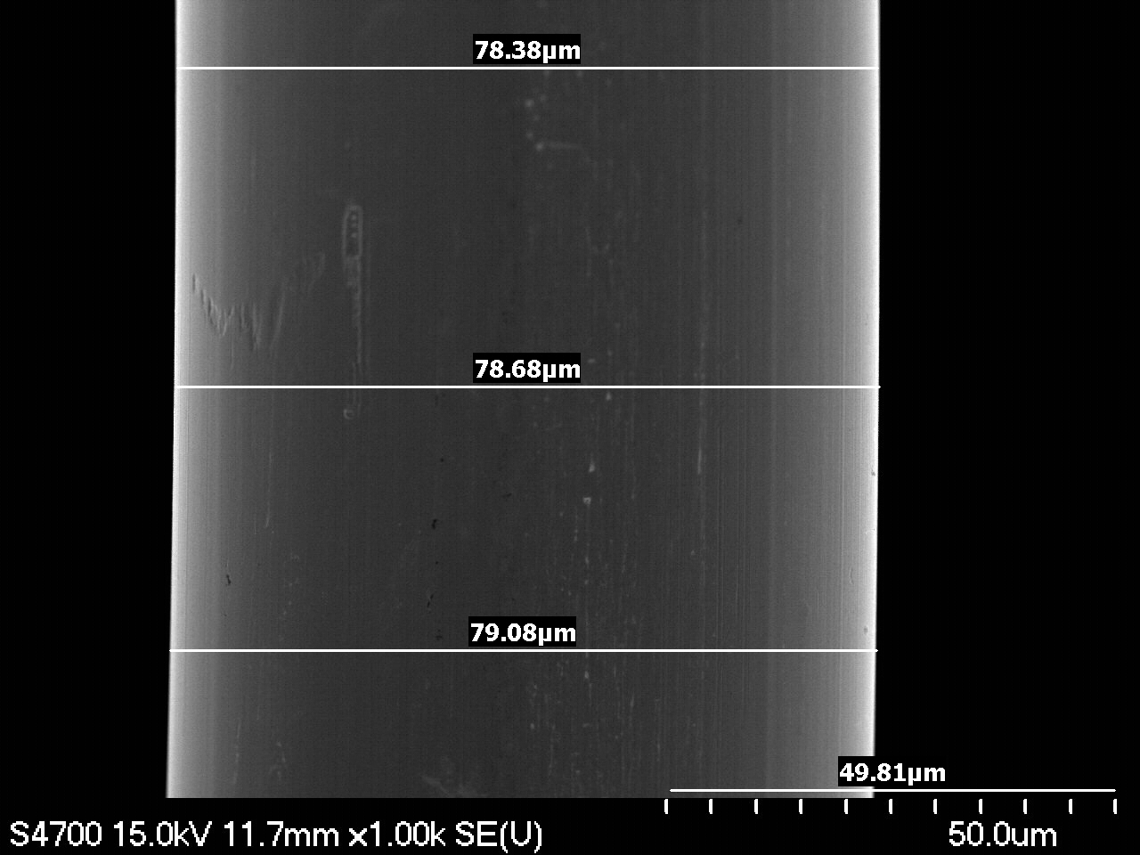 | 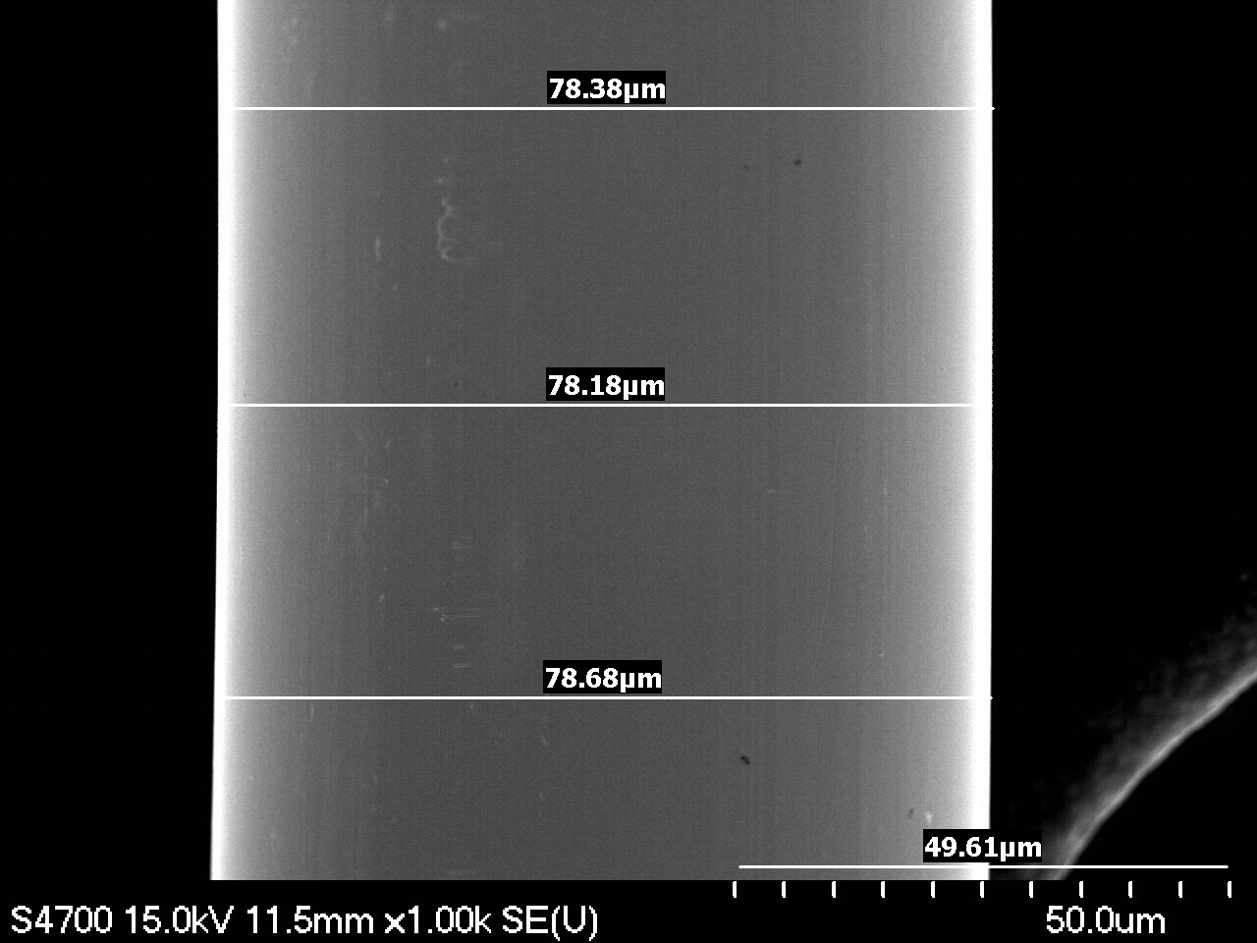
Magnification: 1000x | Magnification: 1000x
F6-1A-2o | F6-1B-2o
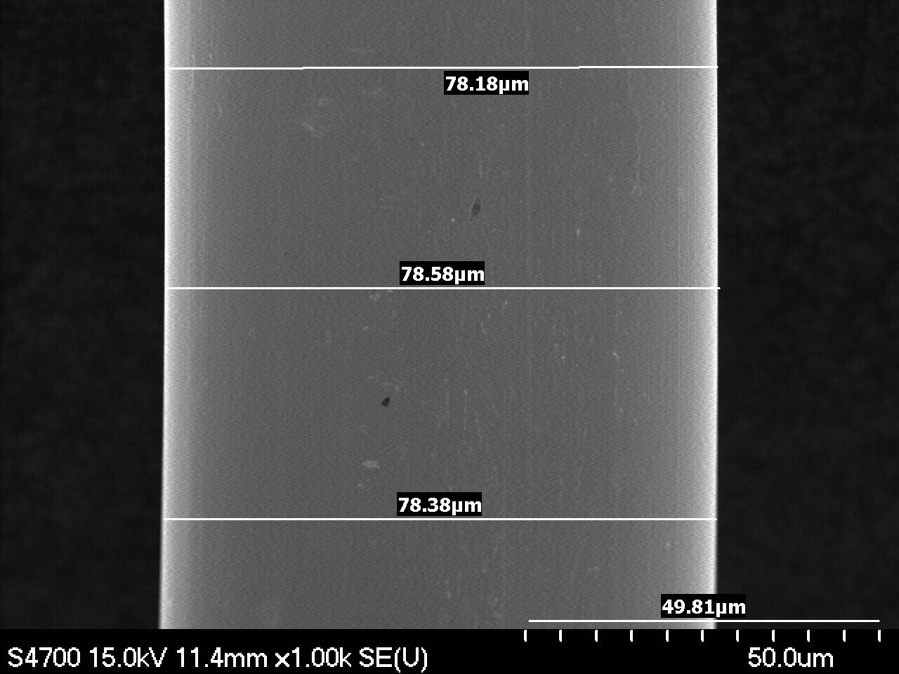 | 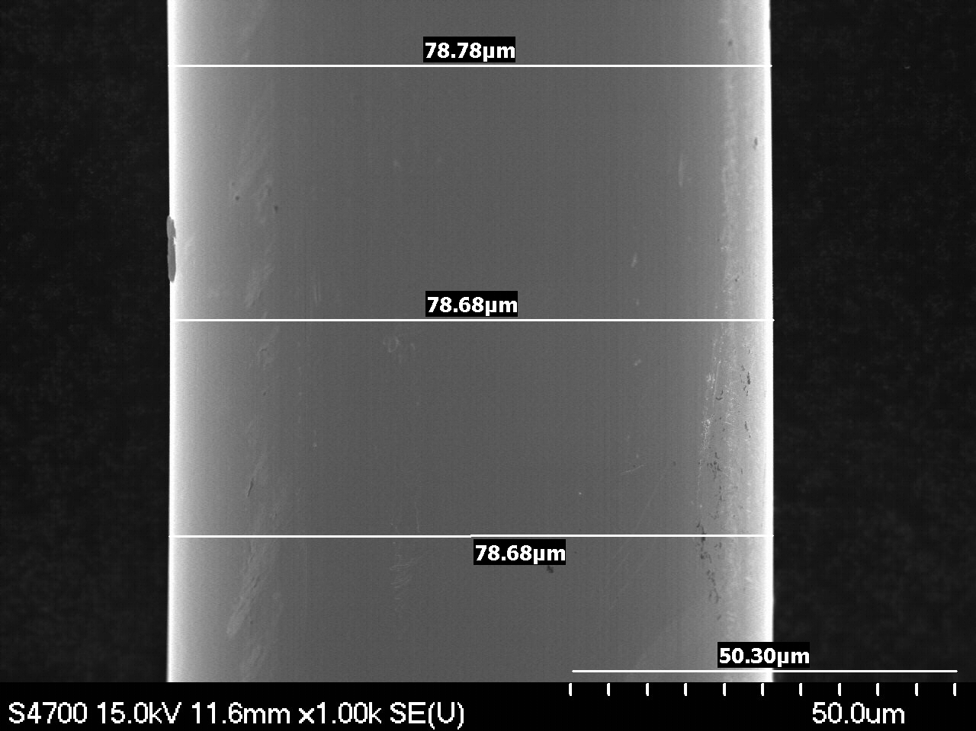
Magnification: 1000x | Magnification: 1000x
F6-1A-3o | F6-1B-3o
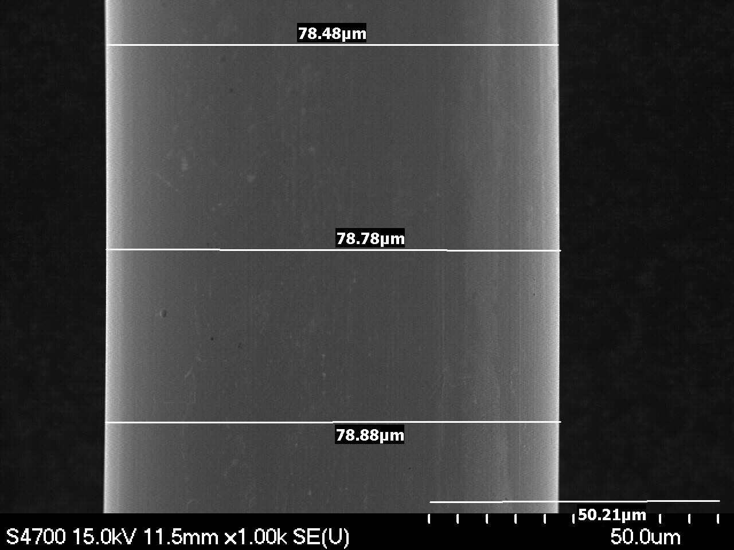 | 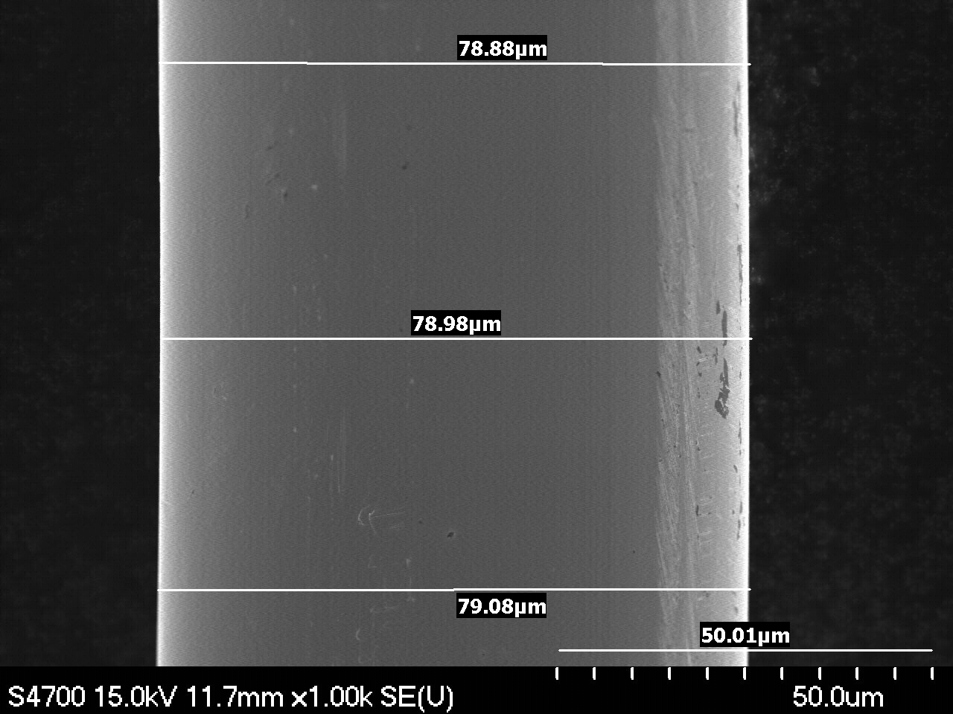
Magnification: 1000x | Magnification: 1000x

III. Points of Interest

F6-1A-14 | F6-1A-14 Environmental contamination
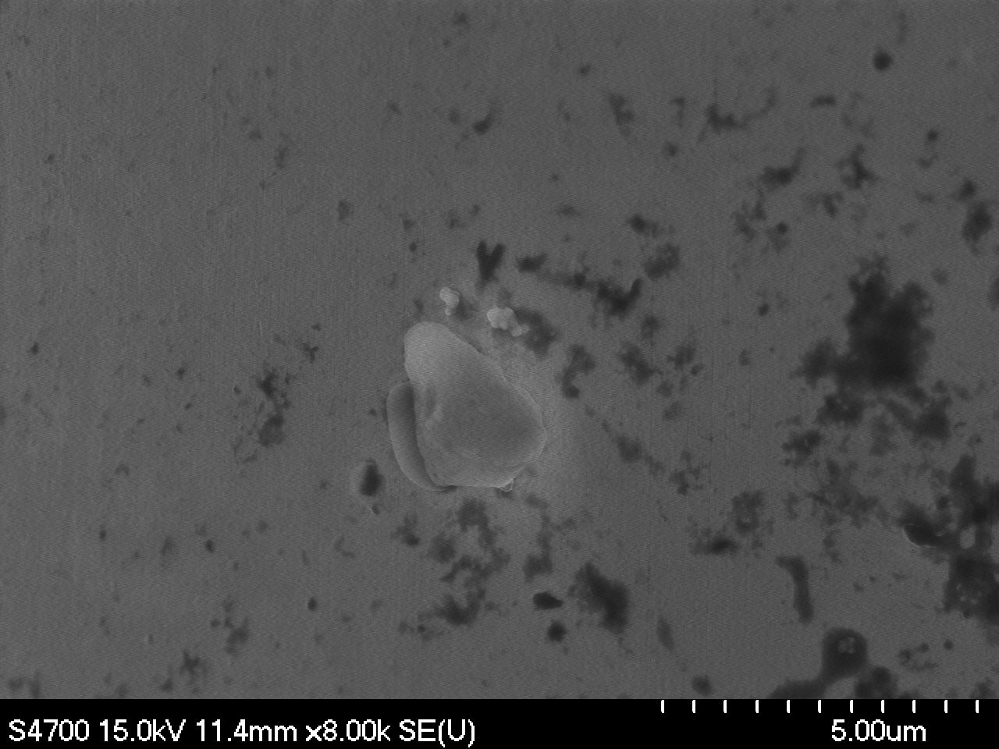 | 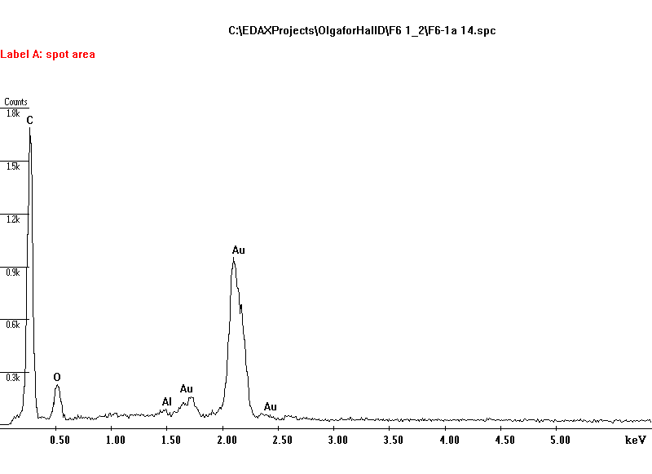
Magnification: 8000x | EDS Analysis. Surface contamination..
F6-1A-4 Minor surface damage. | F6-1A-5 Surface damage magnified..
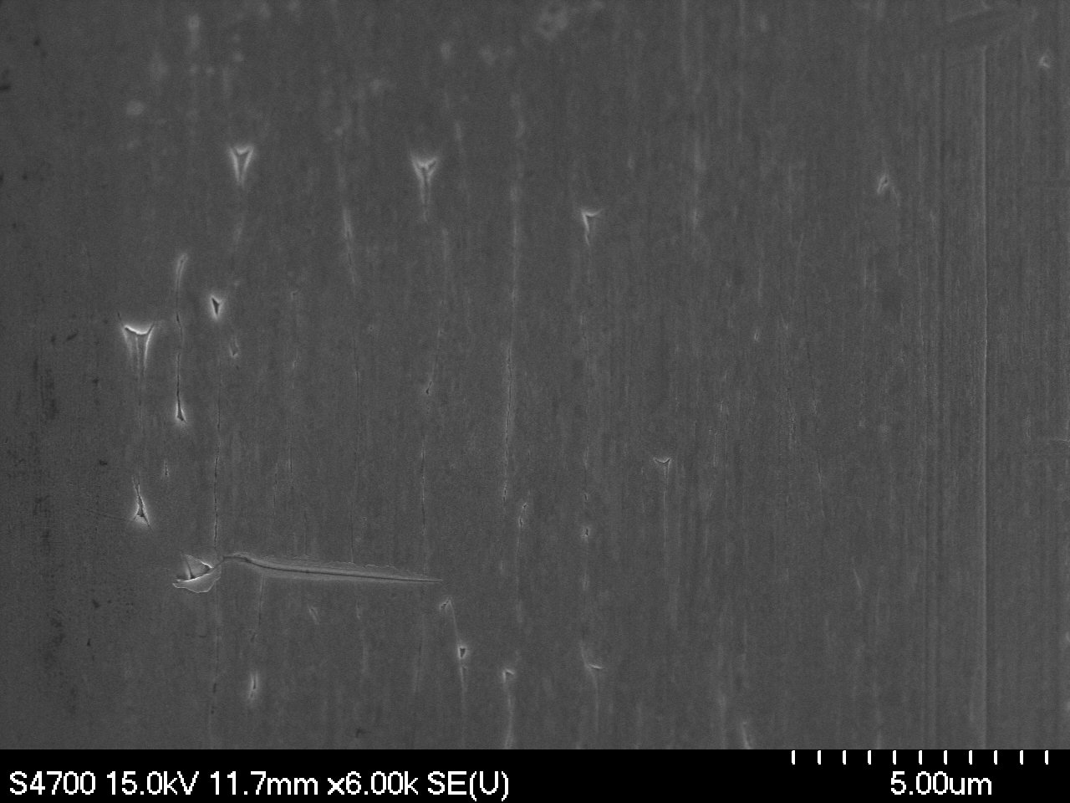 | 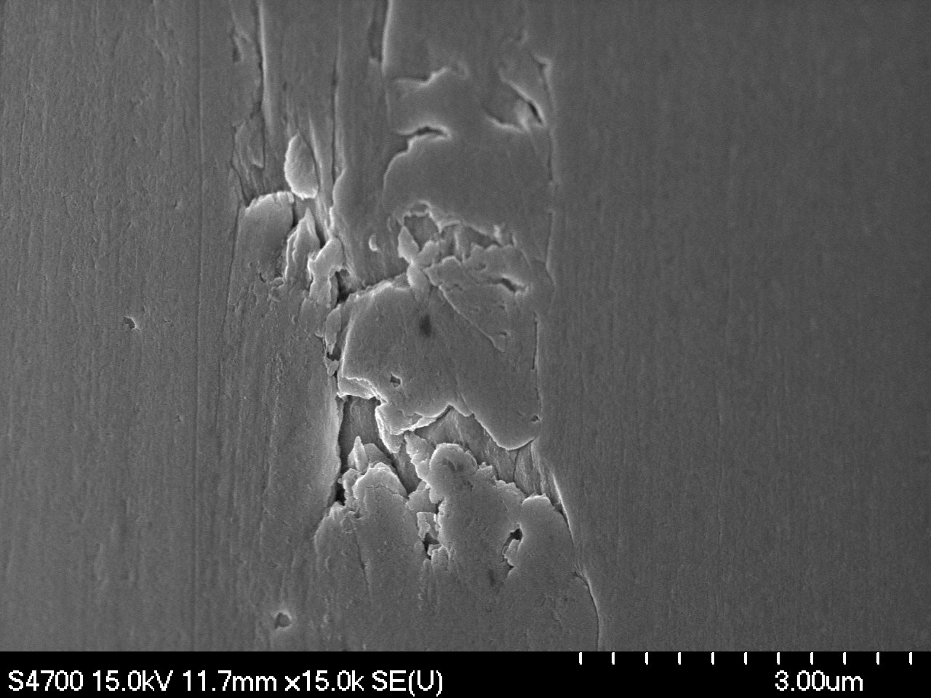
Magnification: 6000x | Magnification: 15000x
F6-1A-8 Surface damage | F6-1A-10 Surface damage and contamination
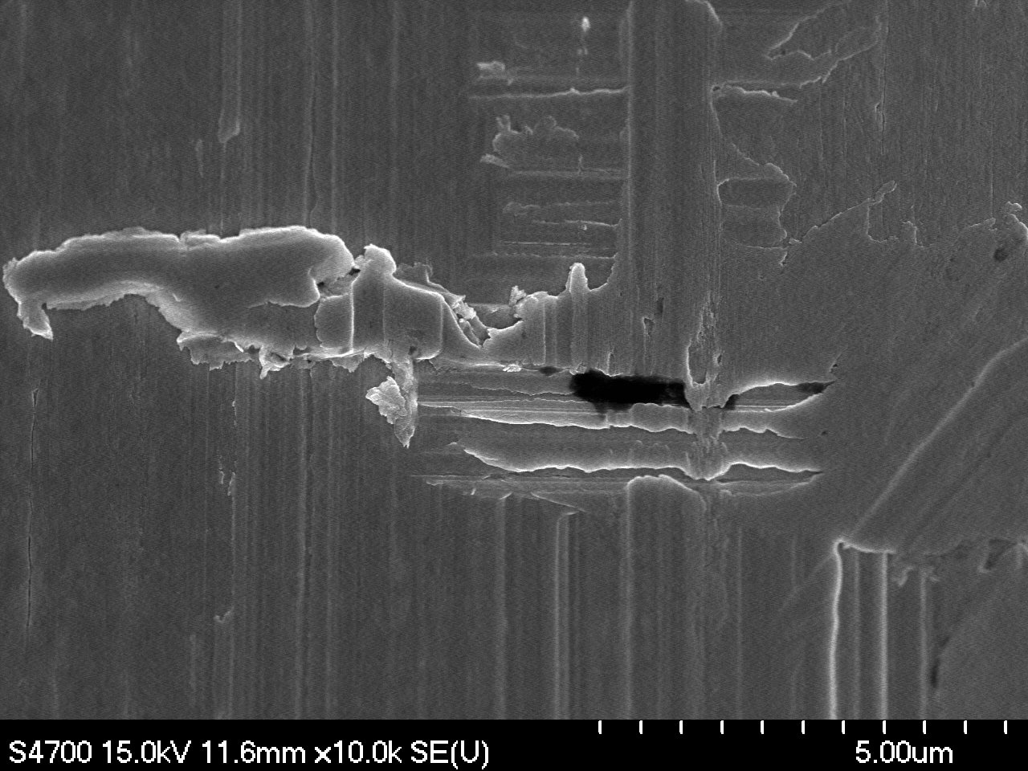 | 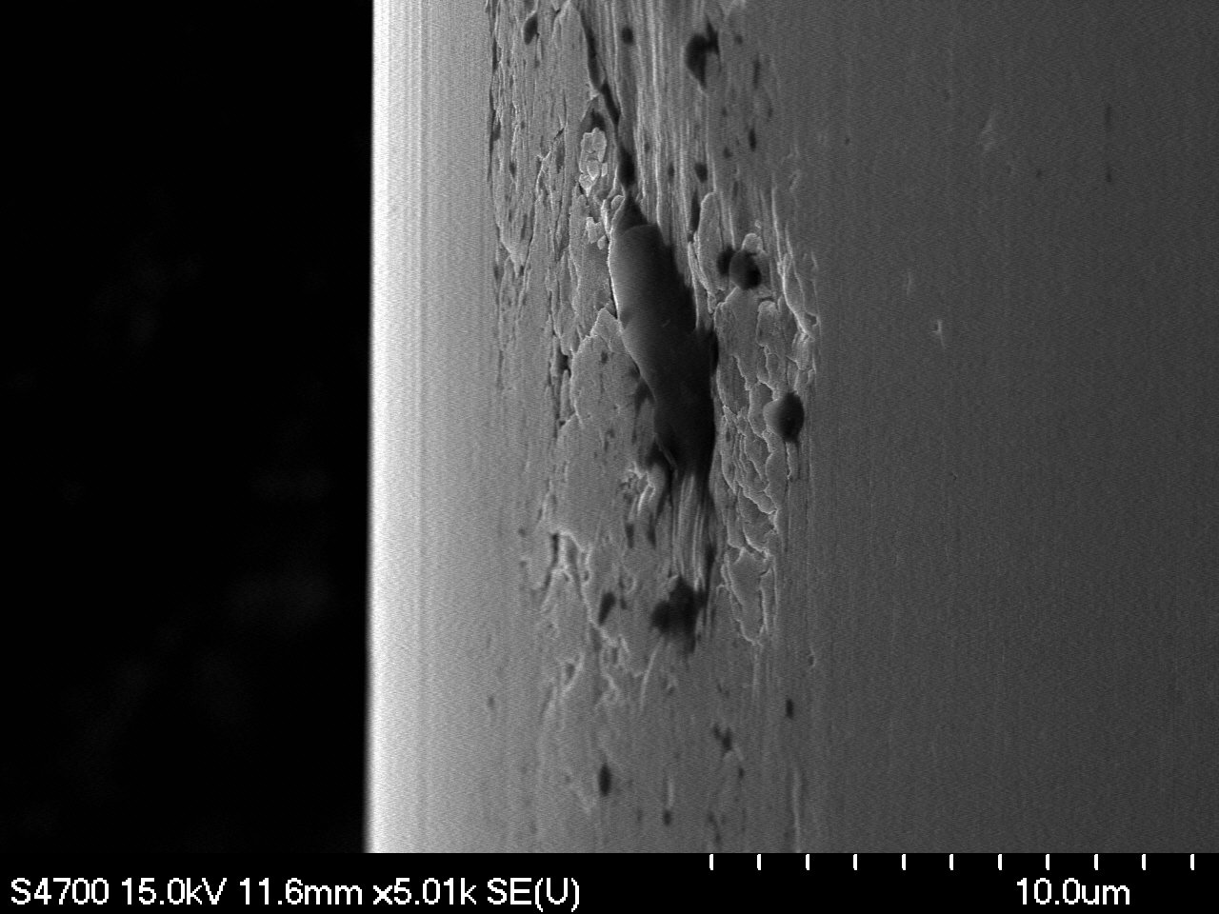
Magnification: 10000x | Magnification: 5010x

F6-1A-7 Surface damage and contamination | F6-1A-12 Surface damage and contamination
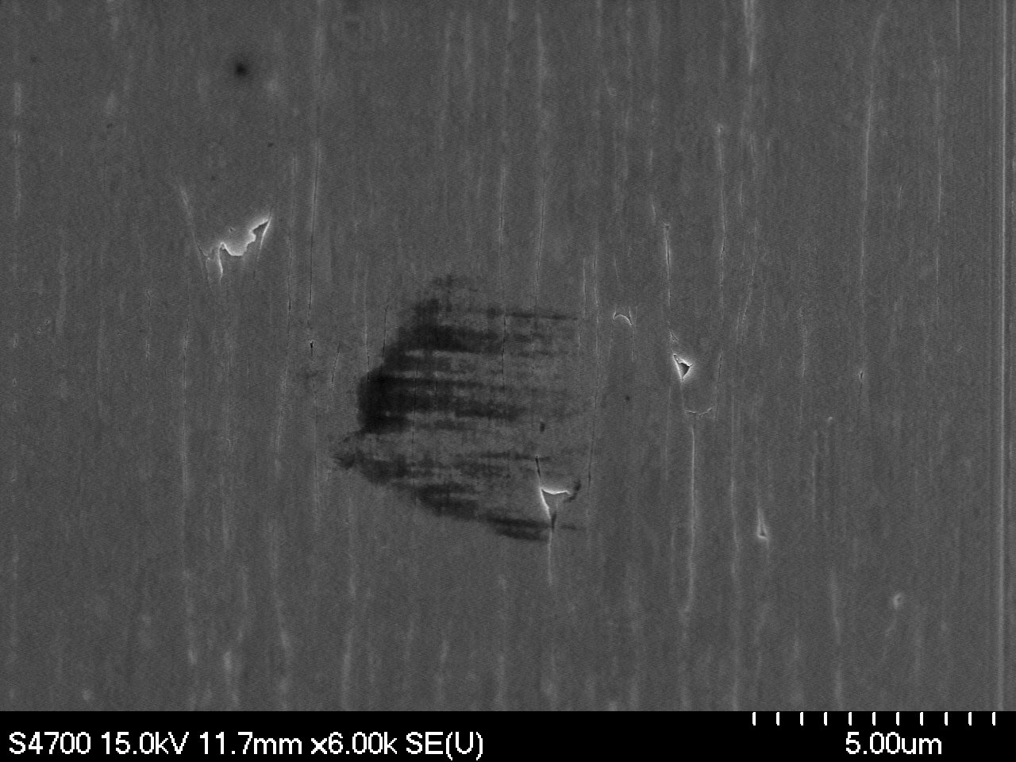 | 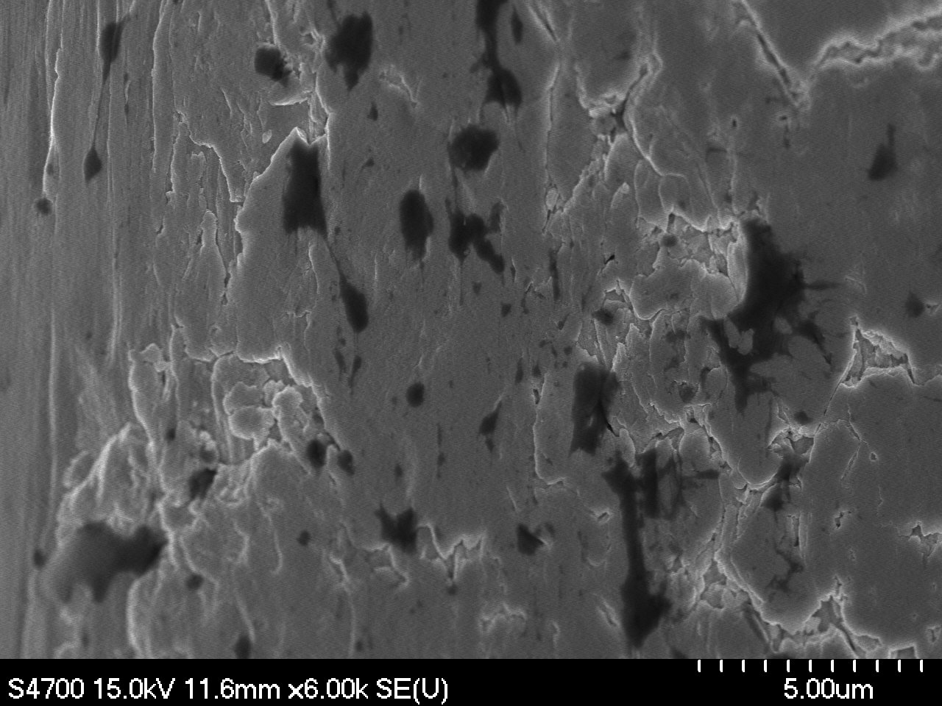
Magnification: 6000x | Magnification: 6000x
F6-1A-3 Surface damage. High mag | F6-1B-3 Surface damage and contamination
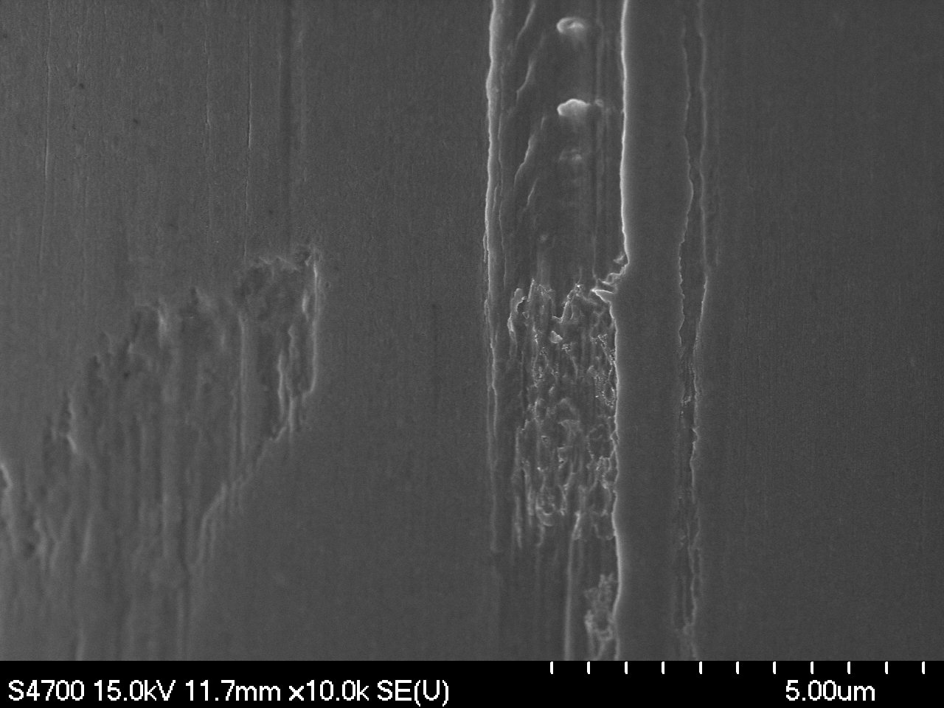 | 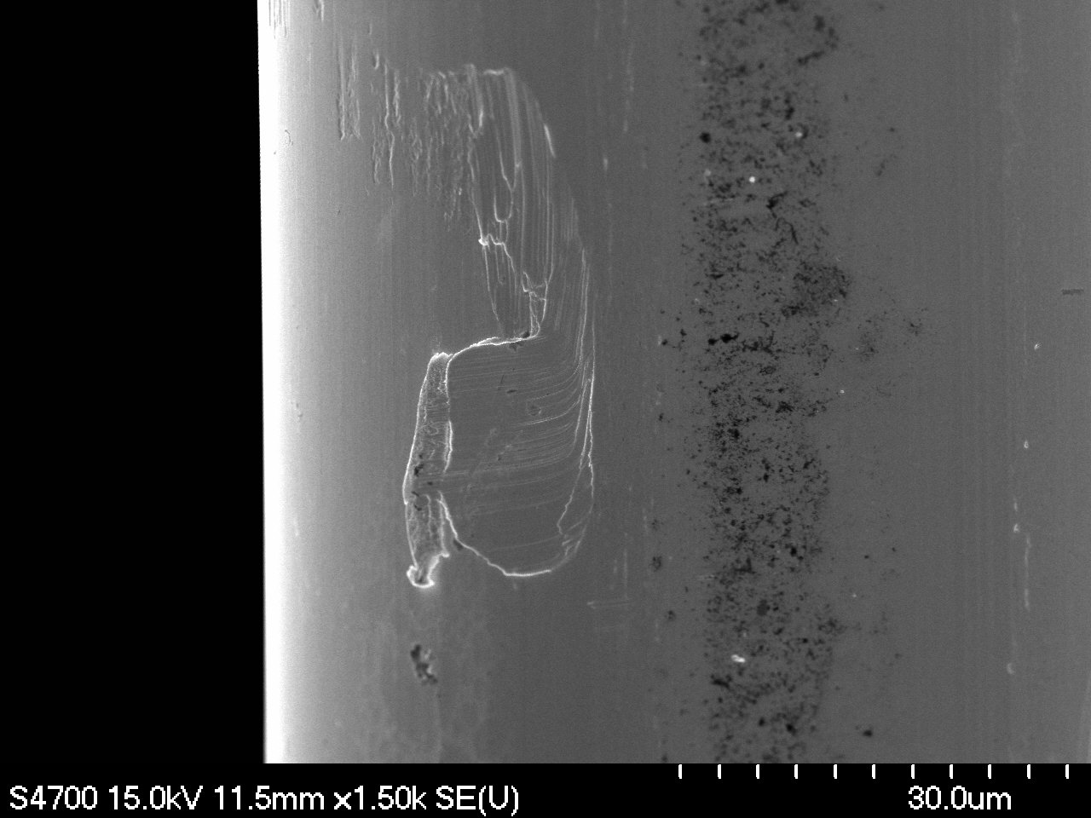
Magnification: 10000x | Magnification: 1500x
F6-1B-8 Surface contamination | F6-1B-8 Surface contamination
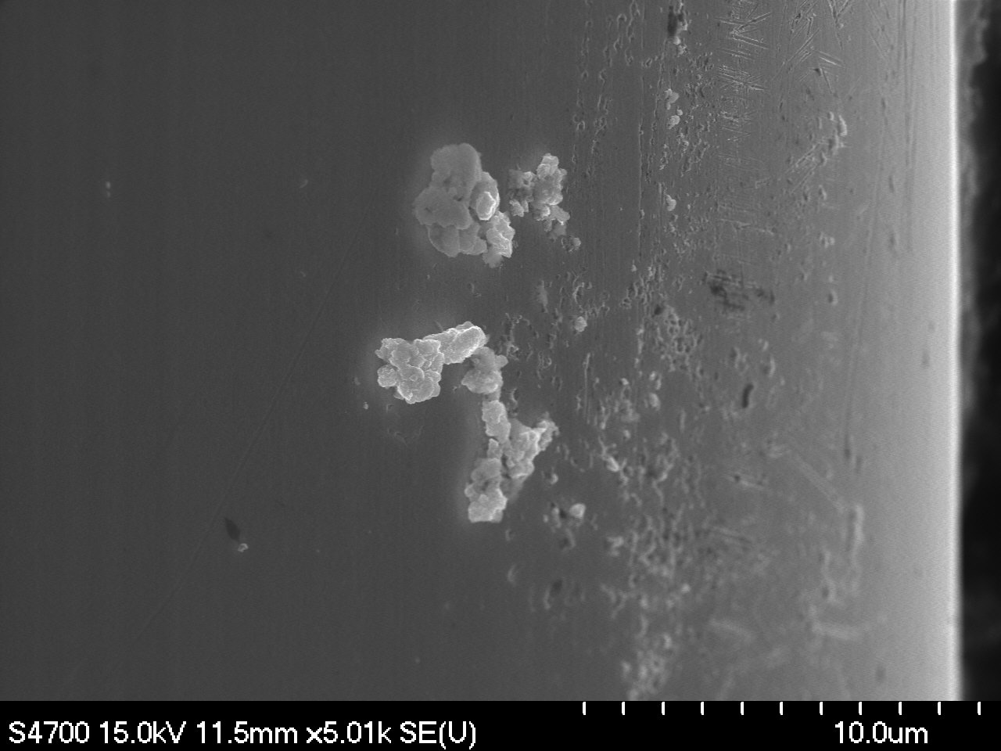 | 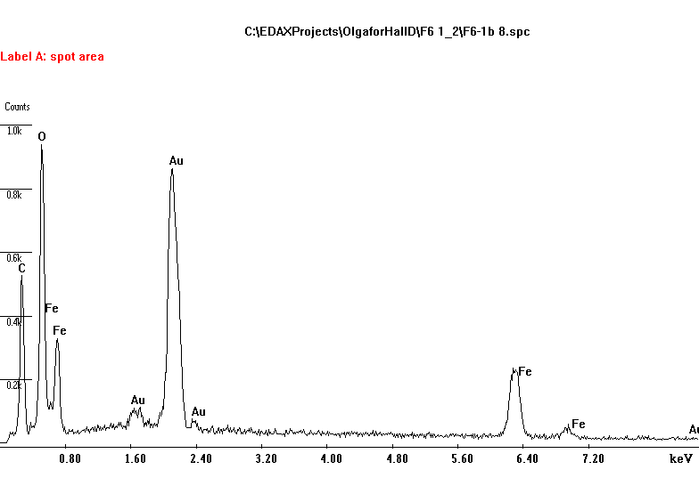
Magnification: 5010x | EDS Analysis. Surface contamination. Iron oxide particles?

Sample F6-2 A, B
Images at designated magnifications

F6-2A-1 | F6-2B-1
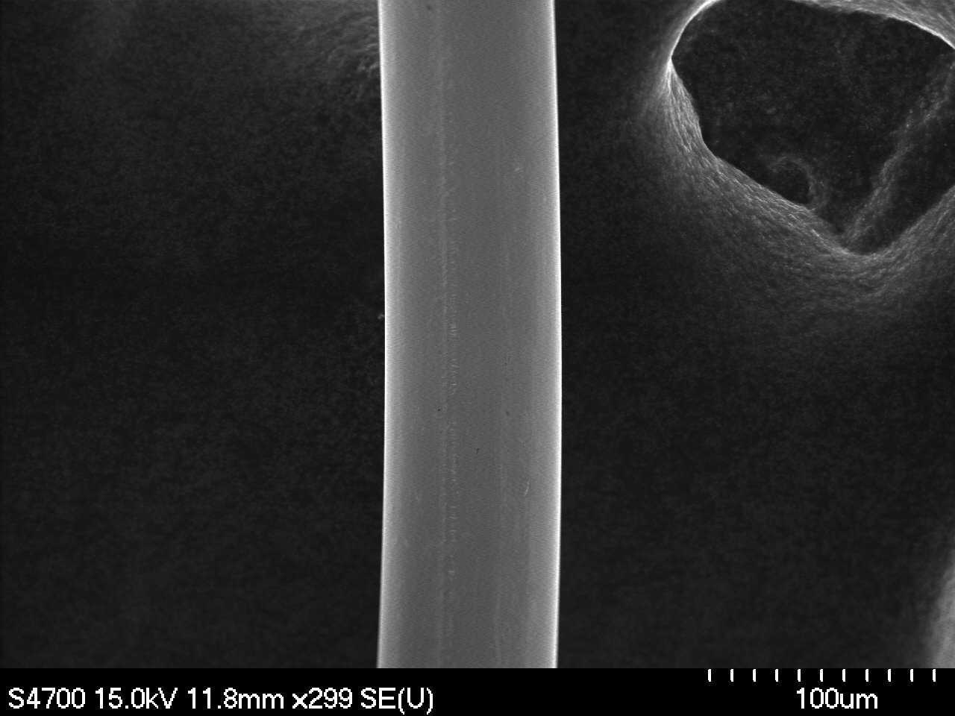 | 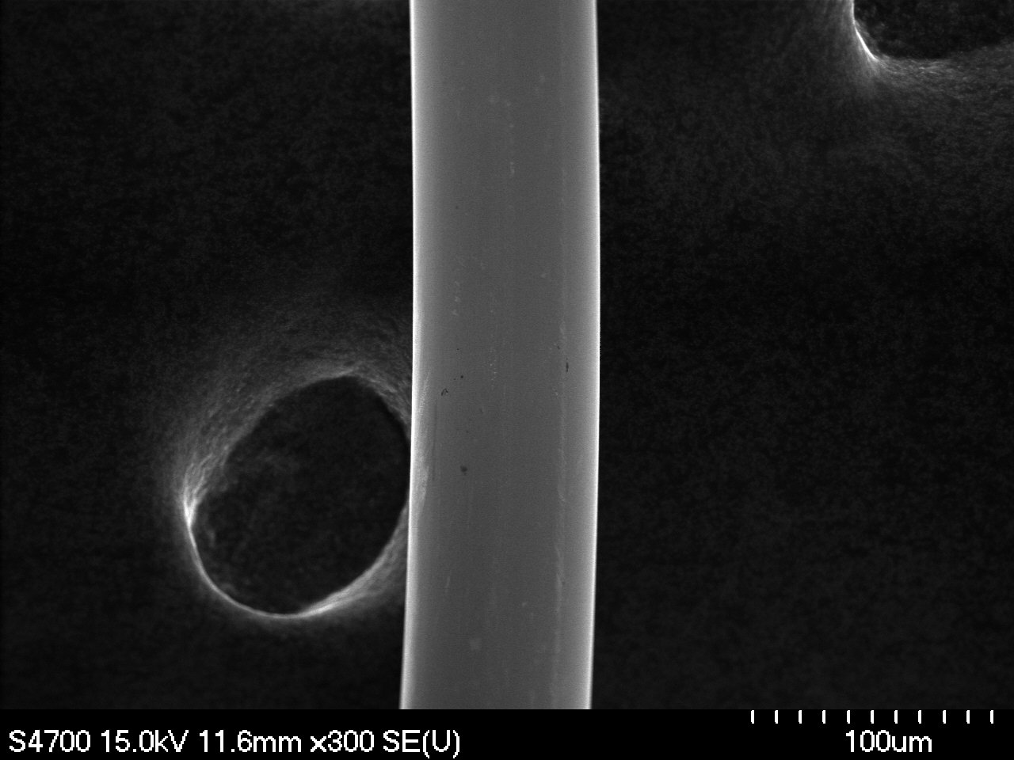
Magnification: 300x | Magnification: 300x
F6-2A-2 | F6-2B-2
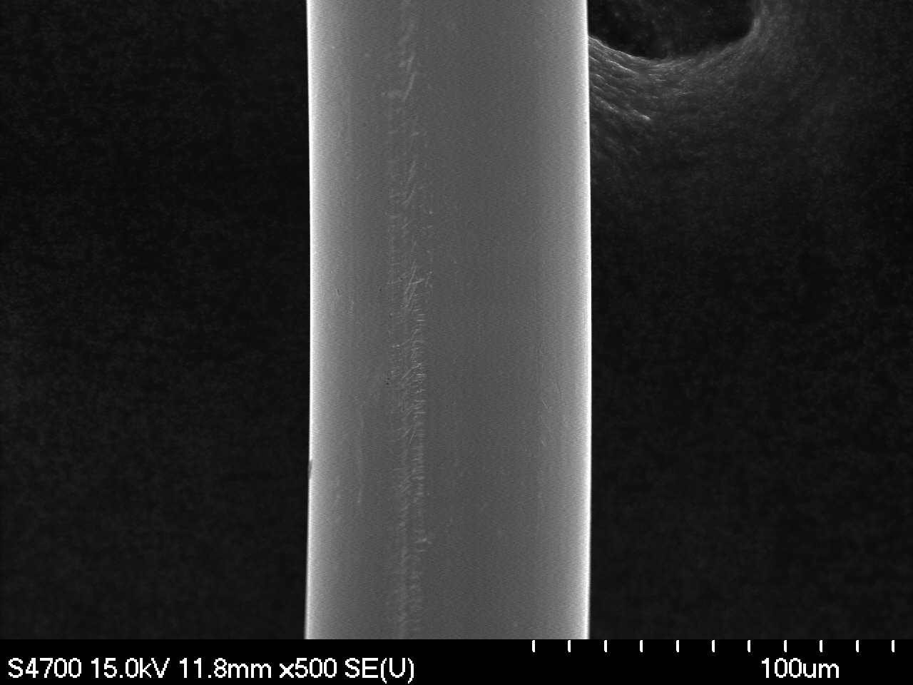 | 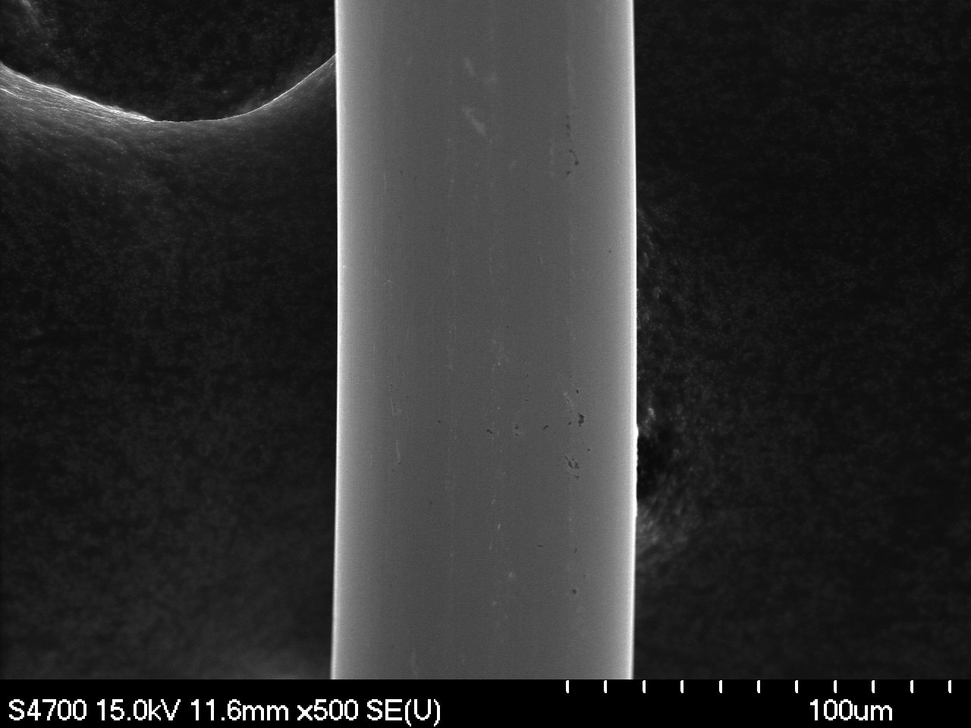
Magnification: 500x | Magnification: 500x

F6-2A-3 | F6-2B-3
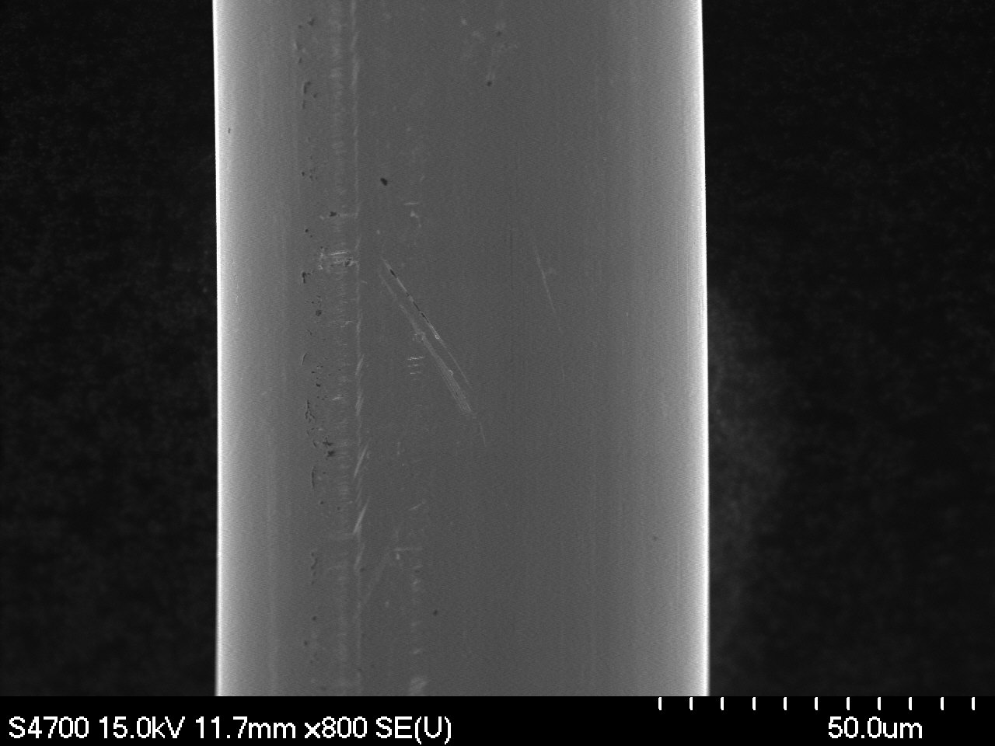 | 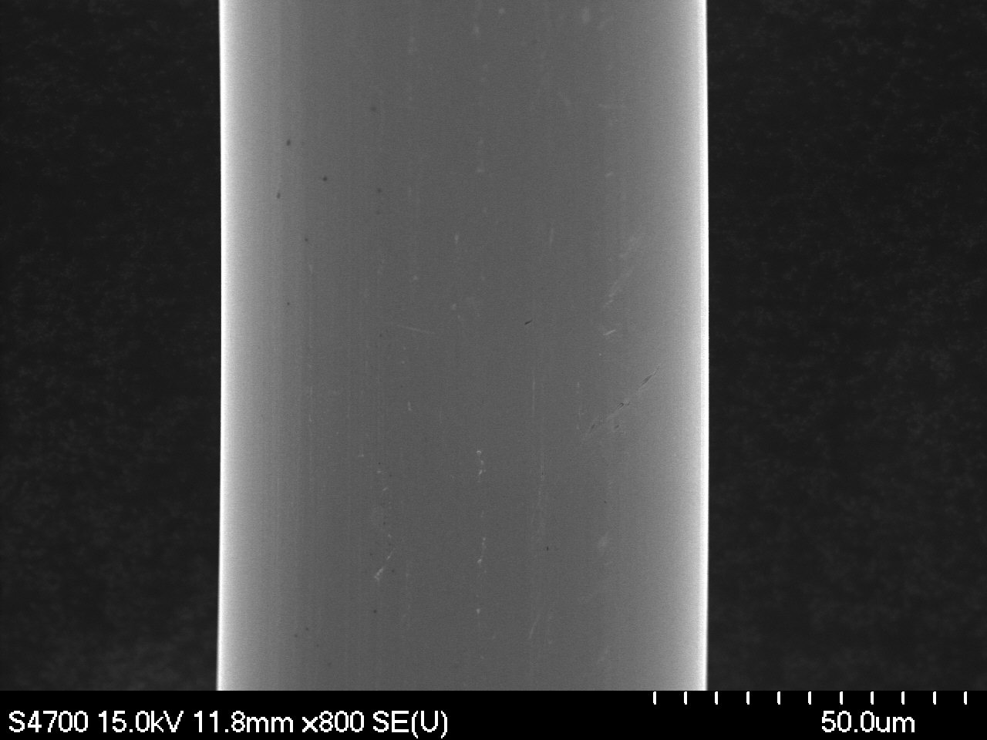
Magnification: 800x | Magnification: 800x
F6-2A-4 | F6-2B-4
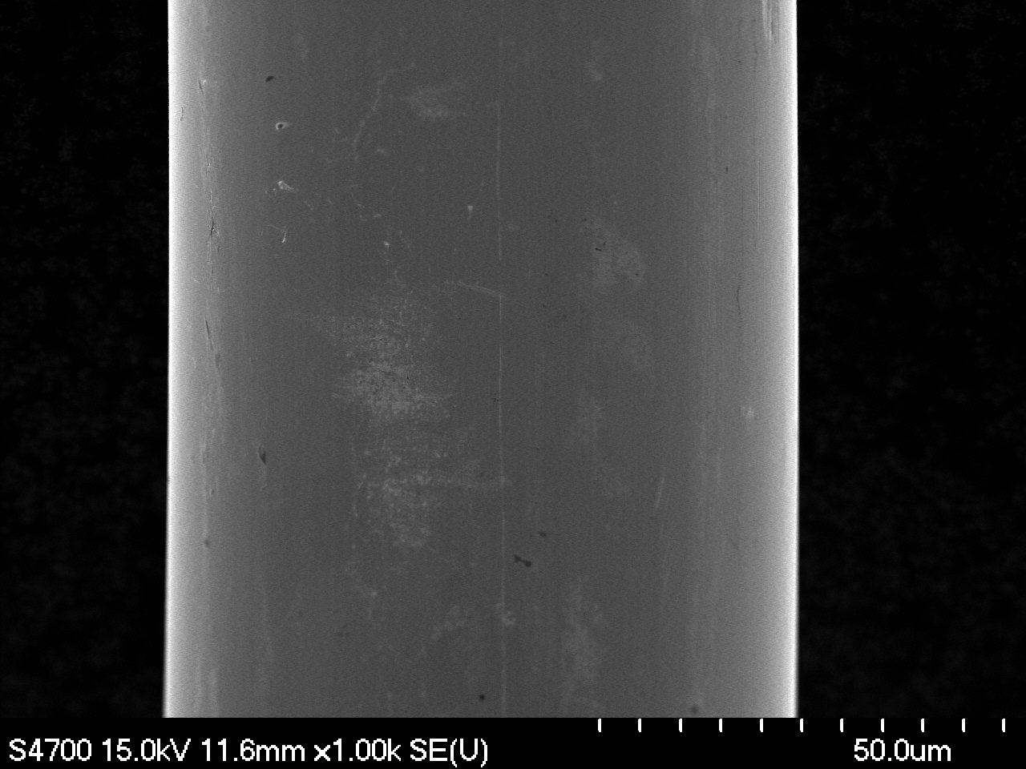 | 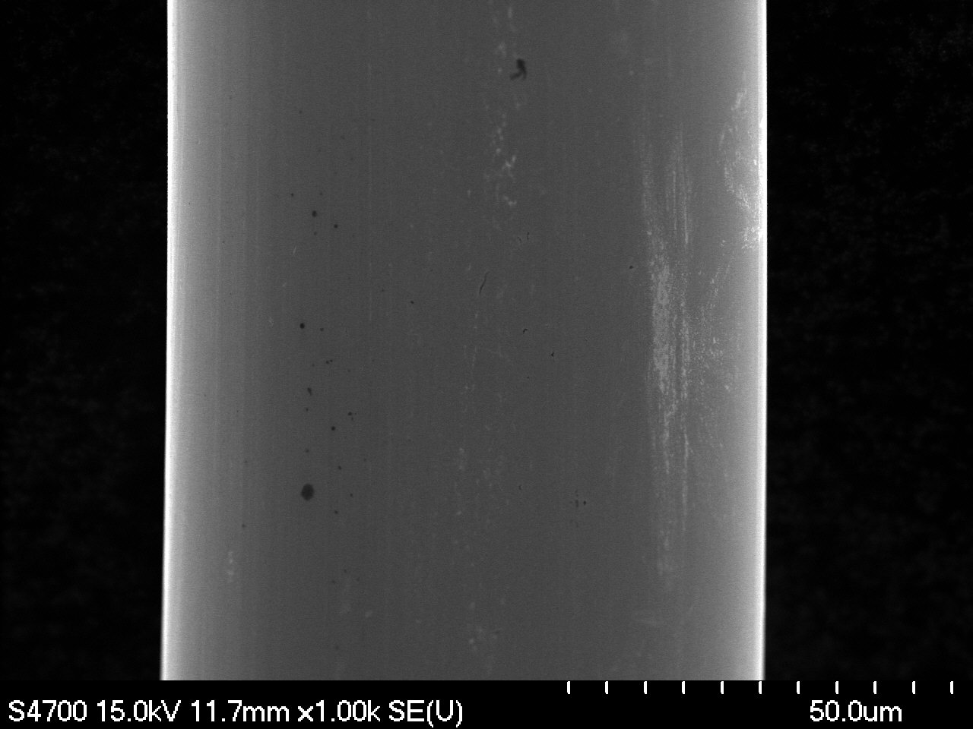
Magnification: 1000x | Magnification: 1000x

II. Ovality Measurements

F6-2A-1o | F6-2B-1o
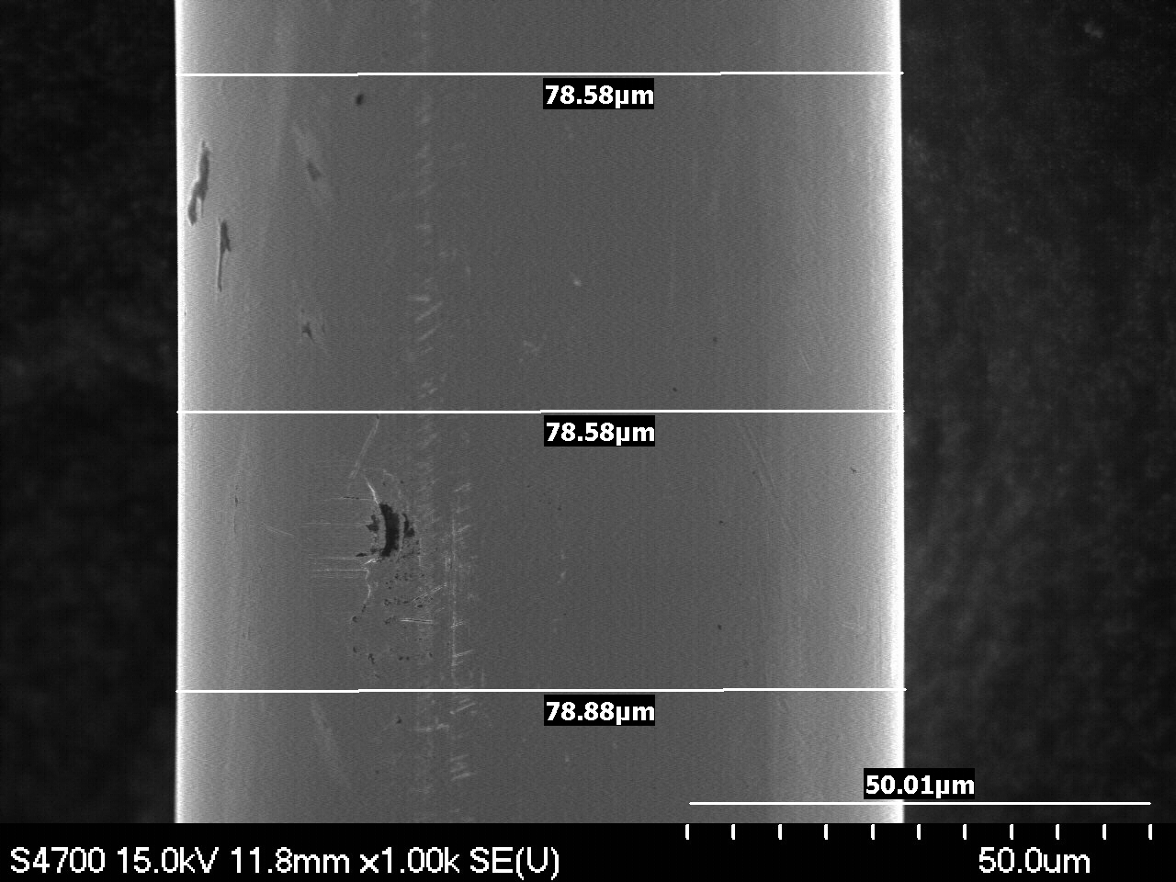 | 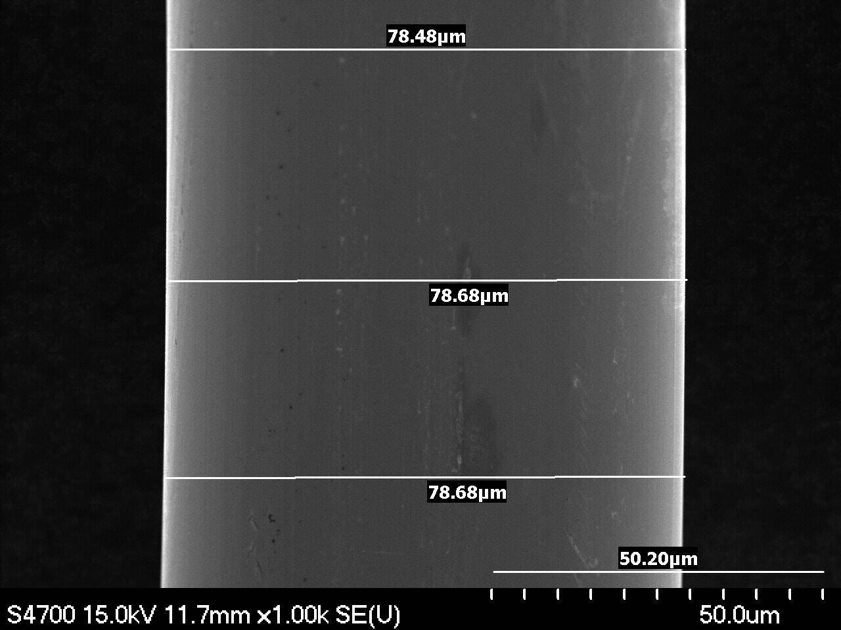
Magnification: 1000x | Magnification: 1000x
F6-2A-2o | F6-2B-2o
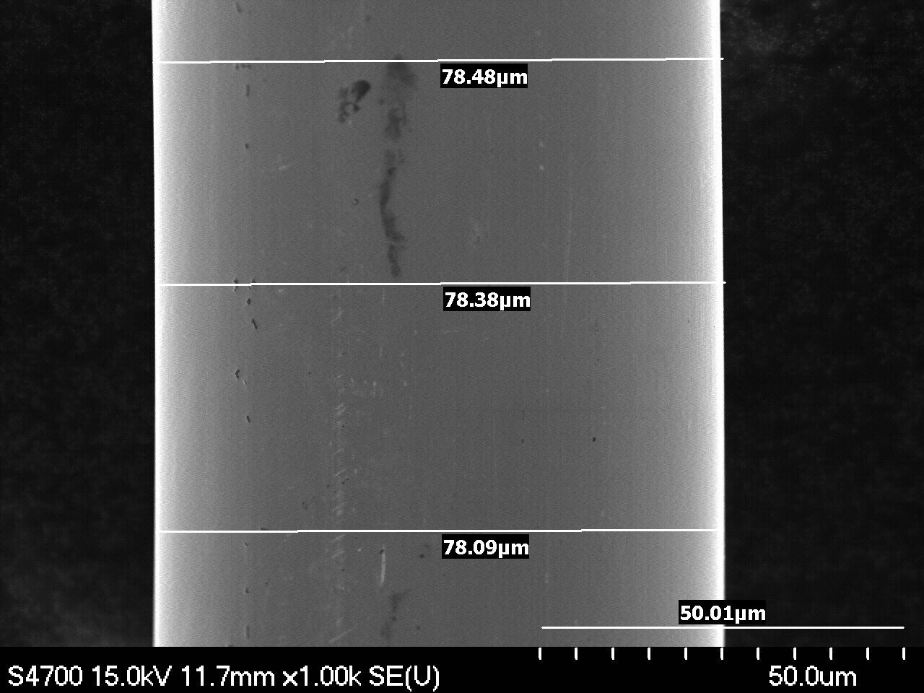 | 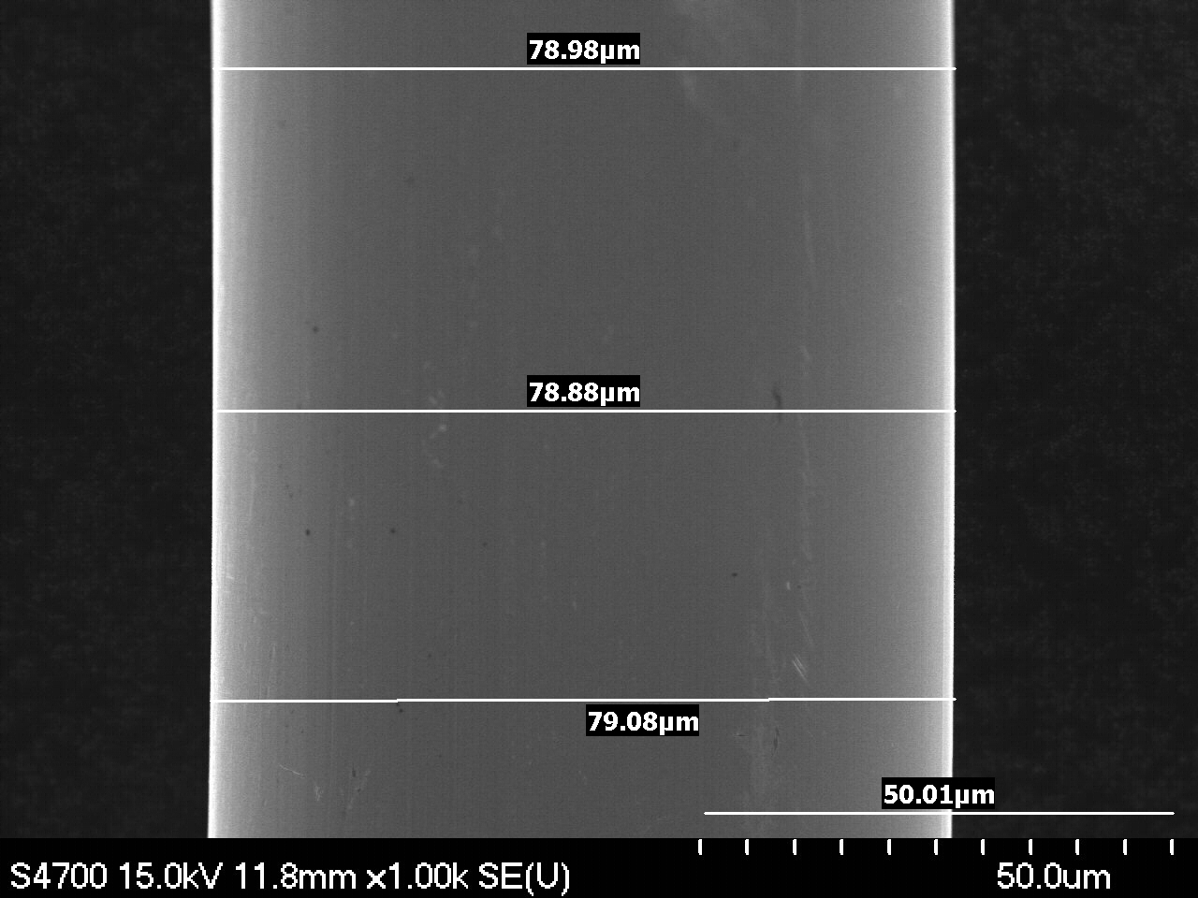
Magnification: 1000x | Magnification: 1000x
F6-2A-3o | F6-2B-3o
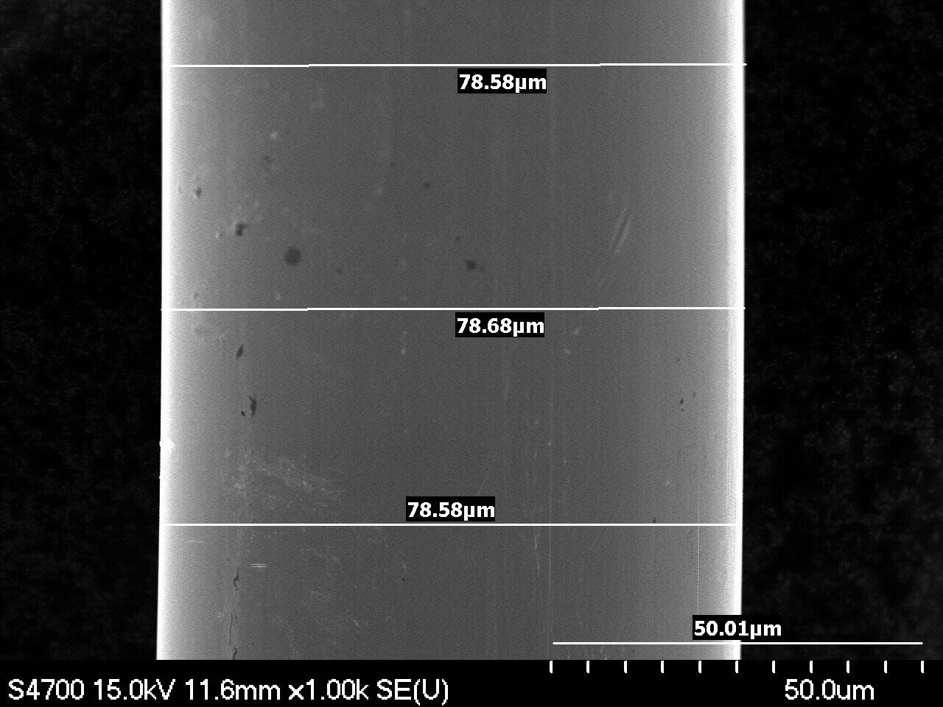 | Sorry, image was not saved properly.
Magnification: 1000x | Magnification: 1000x

III. Points of Interest

F6-2A-7 Surface contamination. | F6-2A-7 Surface contamination.
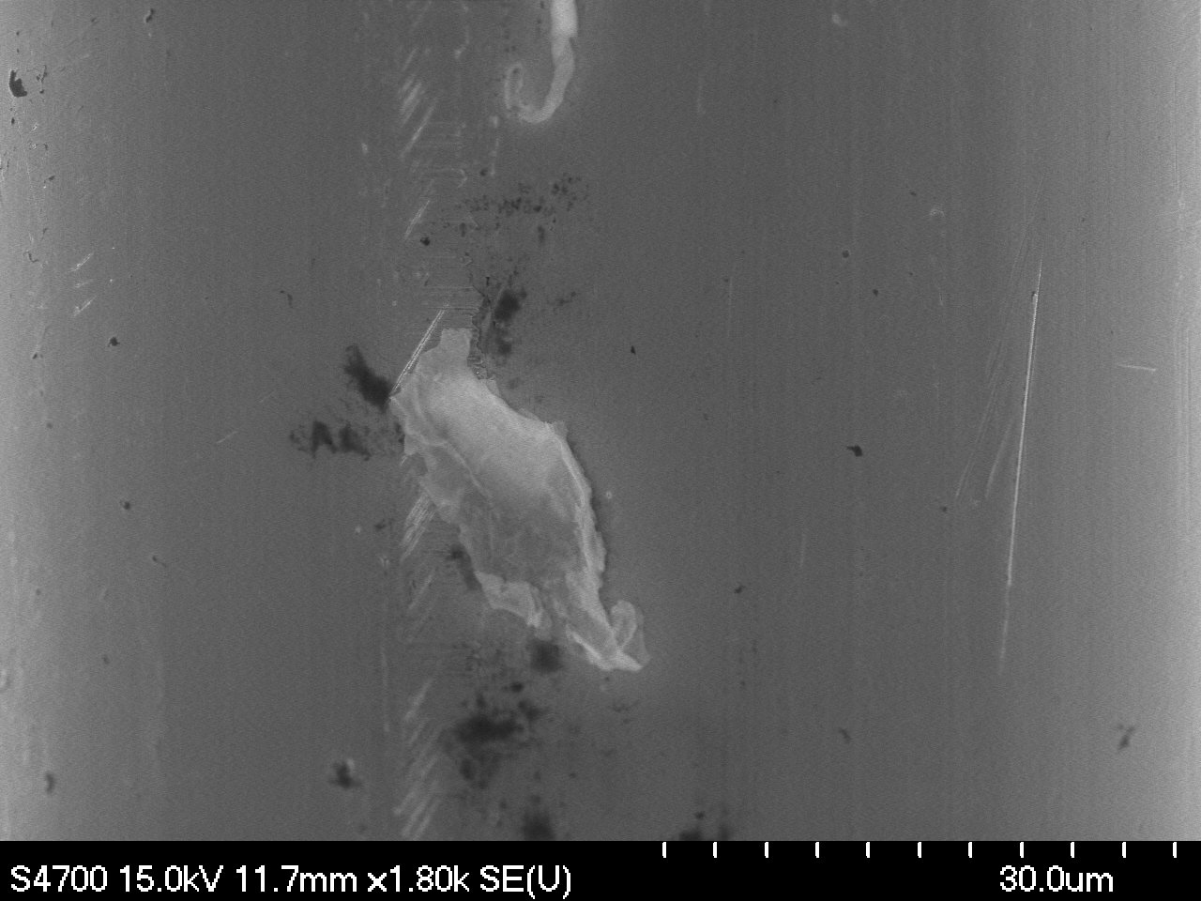 | 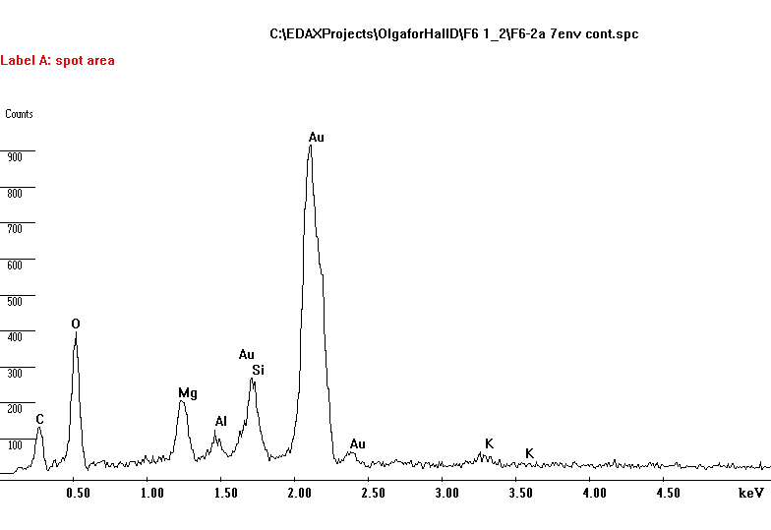
Magnification: 1800x | EDS Analysis. Surface contamination. Environmental.
F6-2A-2 Minor surface damage. | F6-2A-9 Scratch..
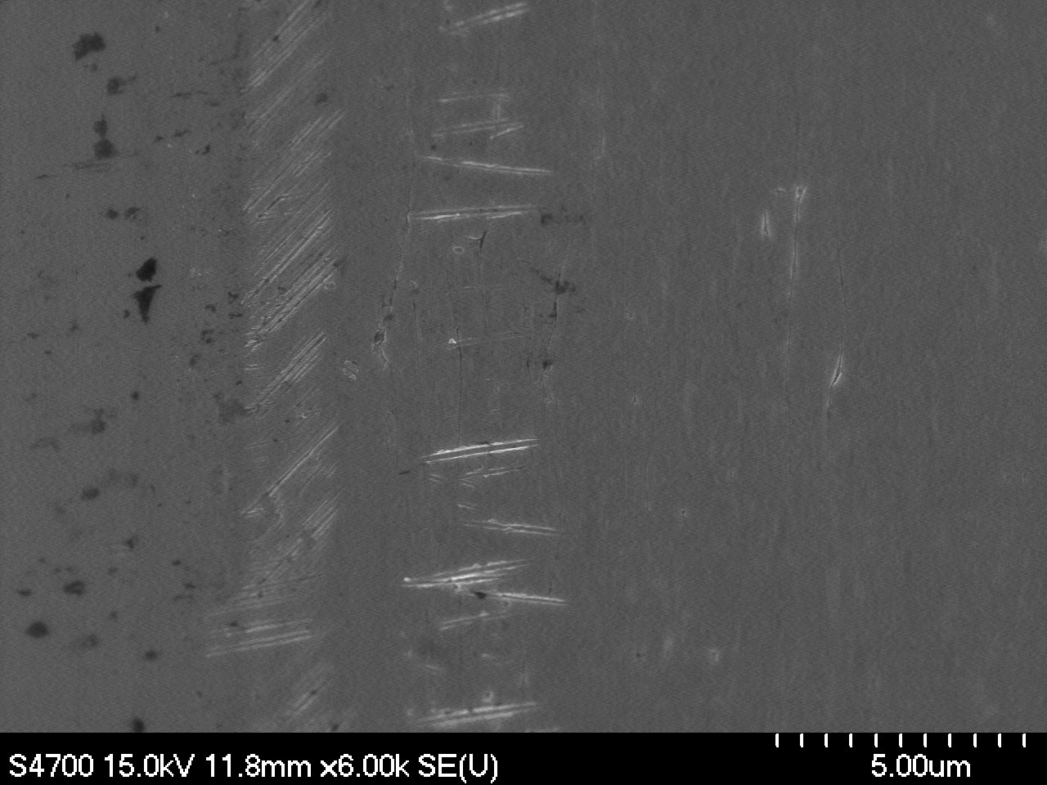 | 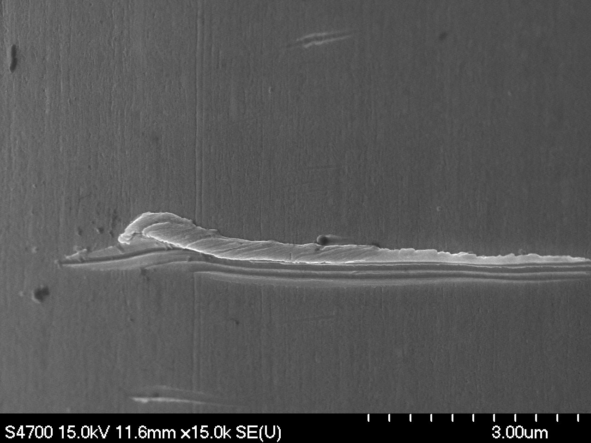
Magnification: 6000x | Magnification: 15000x
F6-2B-4 Surface contamination. | F6-2B-4 Surface damage.
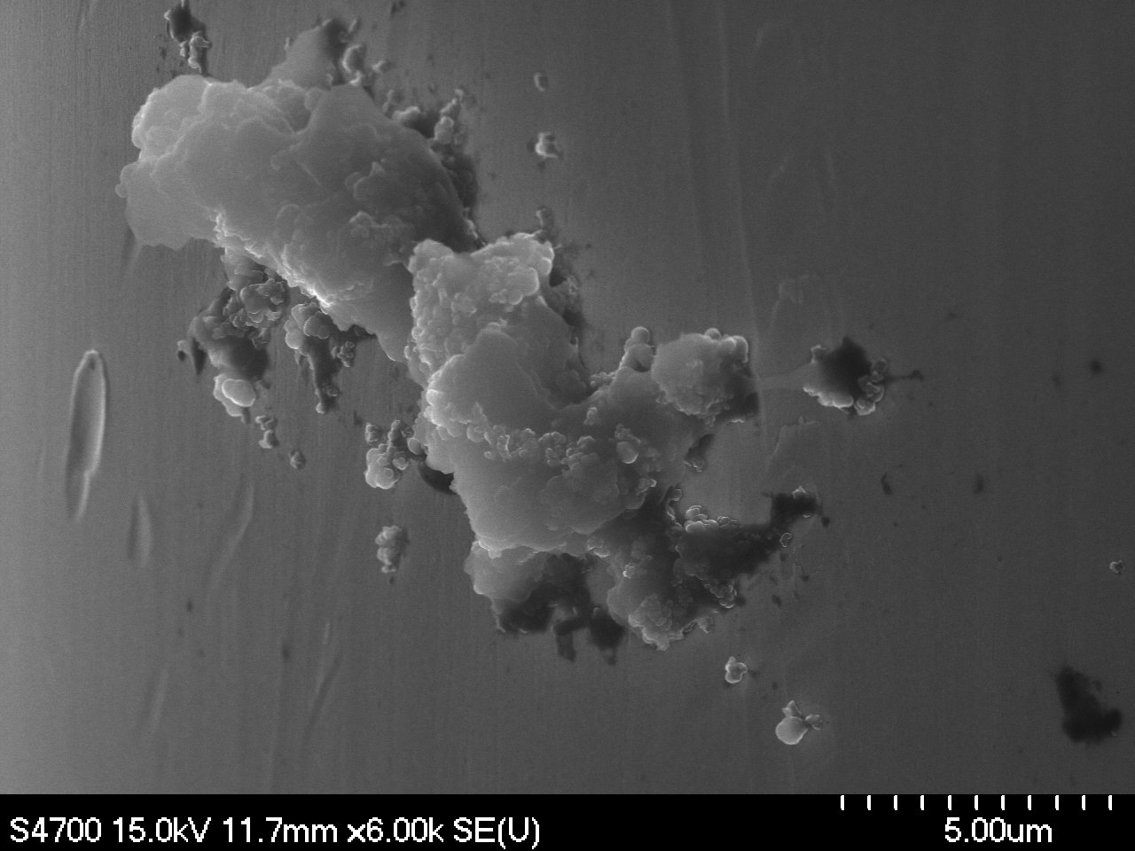 | 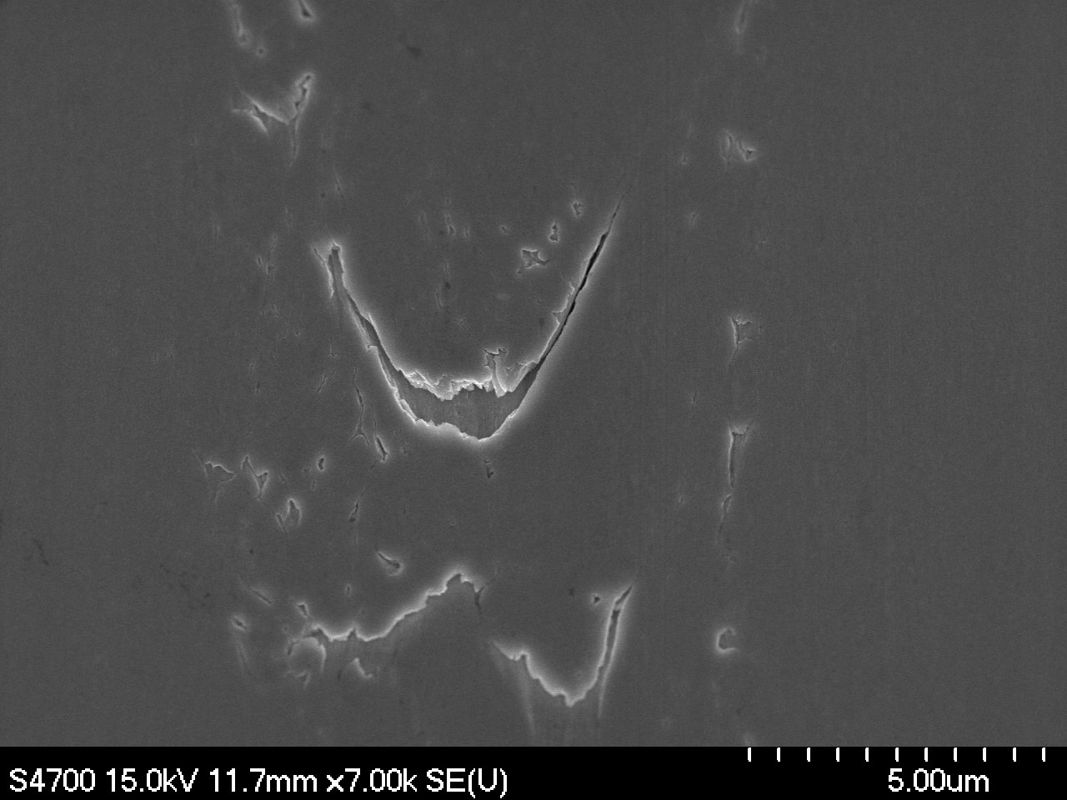
Magnification: 6000x | Magnification: 7000x

