Hall D Wire Characterization
Samples F7-2 & F7-1

- Sample preparation: ultrasonic cleaning in DI water for 45 minutes.
- Sample installation: for SEM inspection wires were installed on a sample holder (diameter=36 mm) on 2 stripes of conductive carbon tape, 2 fragment of each sample per stripe (nomenclature: F5-1a, F5-1b and F5-2a, F5-2b).

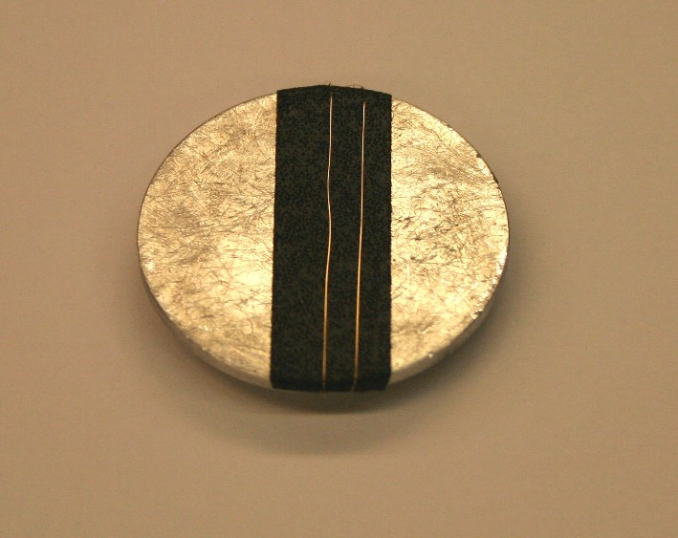

Pic1. Sample installation.

Wire inspection:
- Each wire fragment was examined along its length (beginning at approximately 5mm from the sample holder edge and ending ~5mm before the opposite edge) at magnification of ~x600, at fast scan rate.
- Images at designated magnifications (x300, x500, x800, x1000) were taken randomly along the sample length;
- Images for the ovality measurements were taken at 1000x magnification in three points of each wire fragment: in the middle (approximately) and close to both ends;
- Measurements of wire diameter, as visible on the images, were done using the Quartz PCI Image Management System, 3 measurements per image;
- Additional images at various magnifications were taken at the points of interest (variations in sample topography, contaminated areas, etc.)
- EDS analysis was performed on the most typical points of interest.

Note:
Sample F7-1 was inspected BEFORE the current protocol was established, thus the report on F7-1 differs slightly from other reports.
Sample F7-2 A, B
I. Images at designated magnifications

F7-2A-1 | F7-2B-1
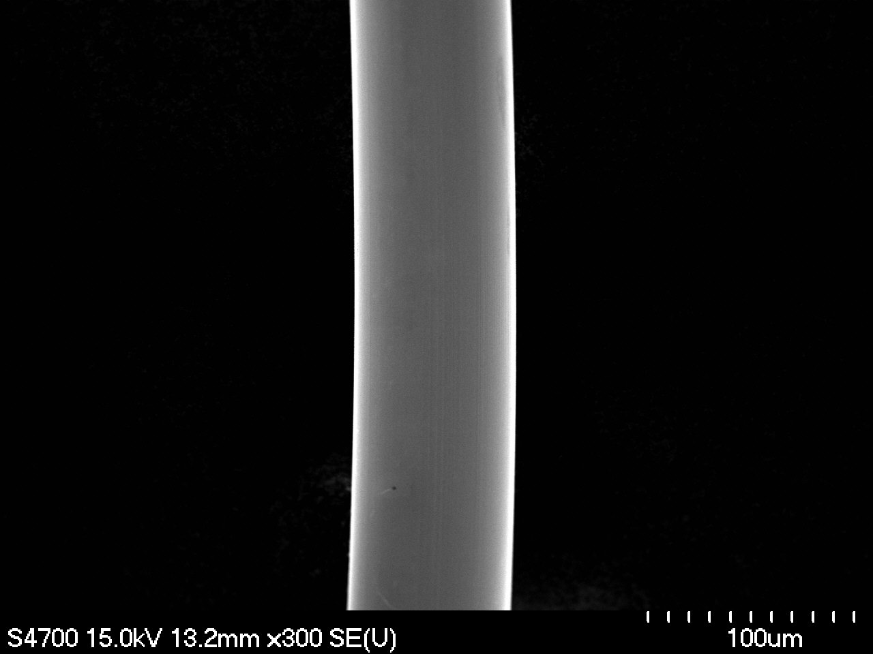 | 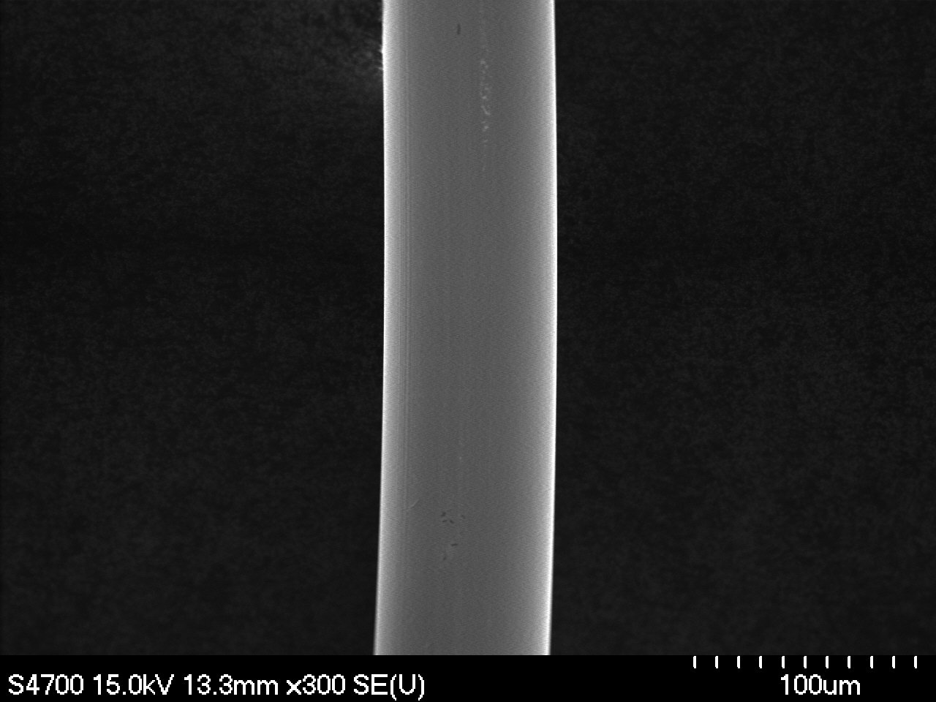
Magnification: 300x | Magnification: 300x
F7-2A-2 | F7-2B-2
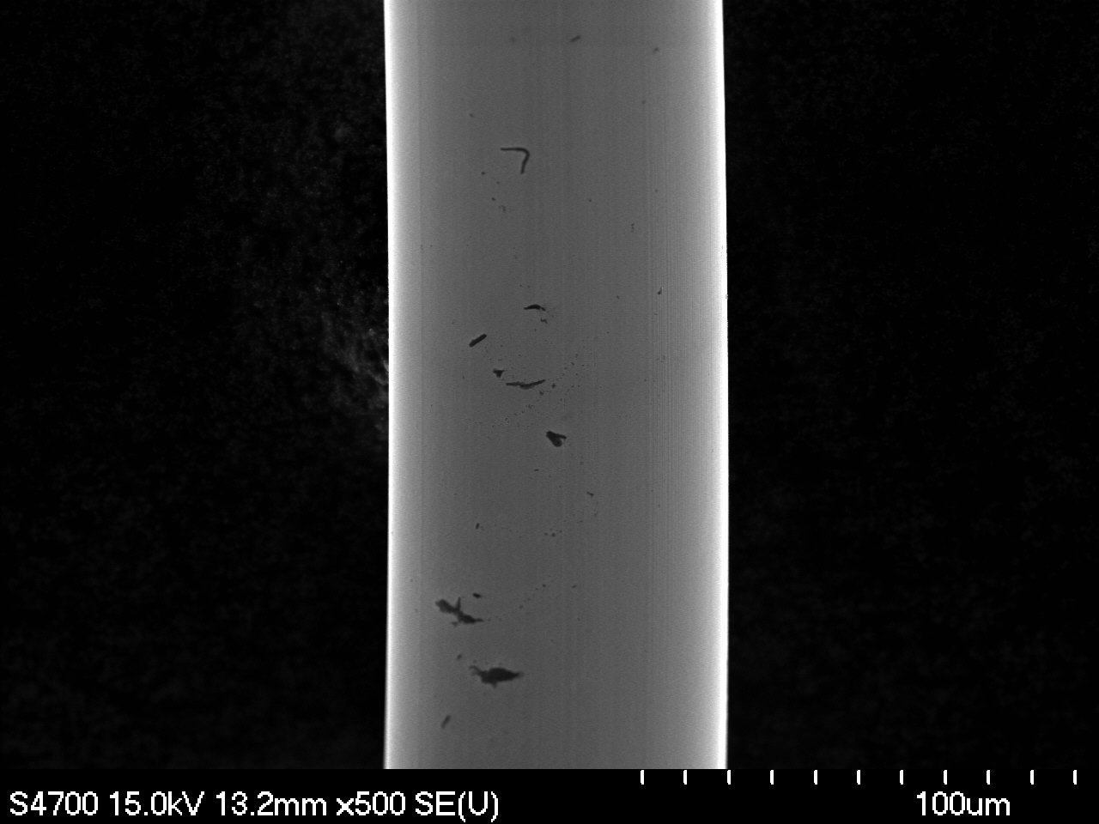 | 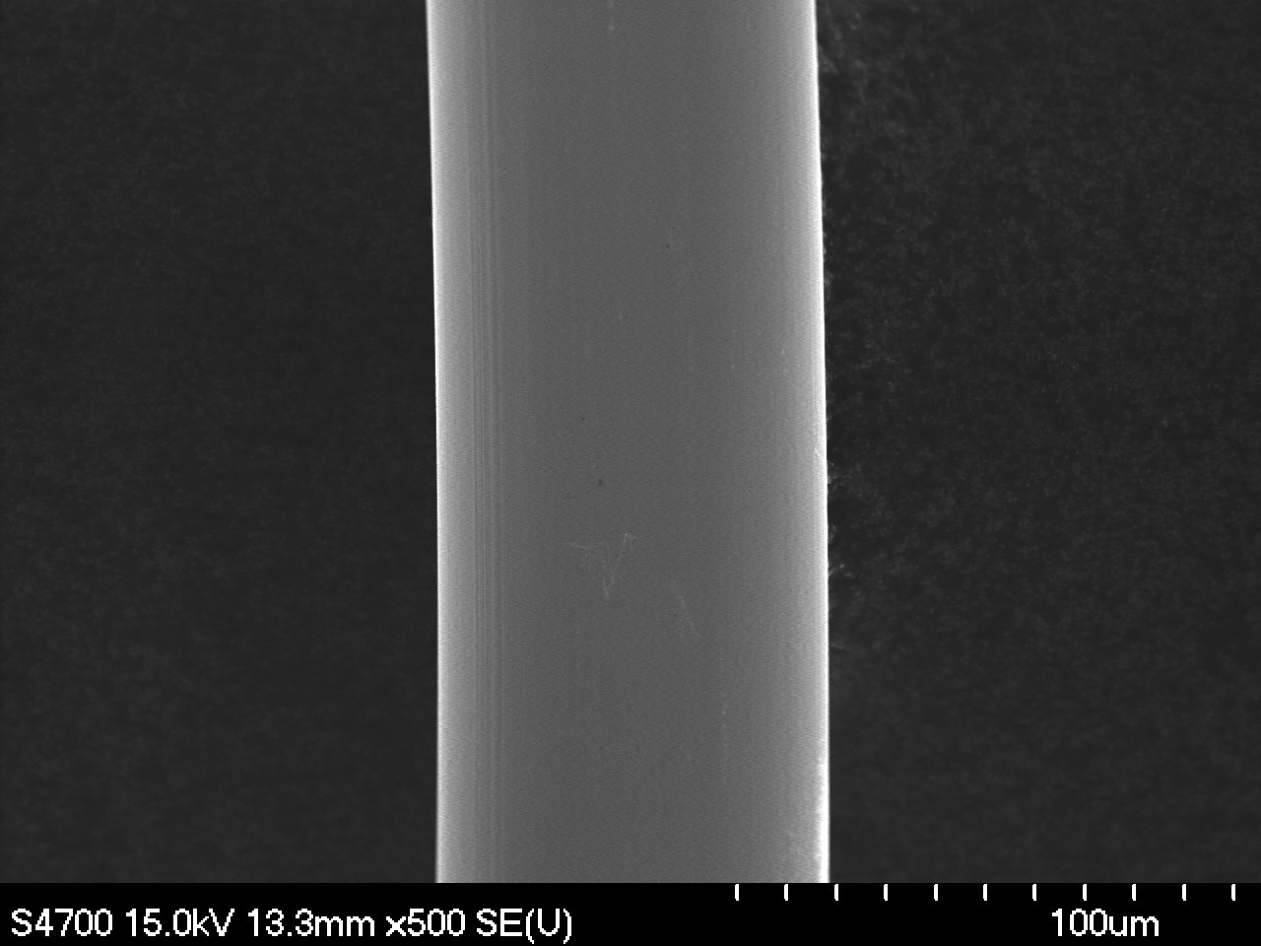
Magnification: 500x | Magnification: 500x

F7-2A-3 | F7-2B-3
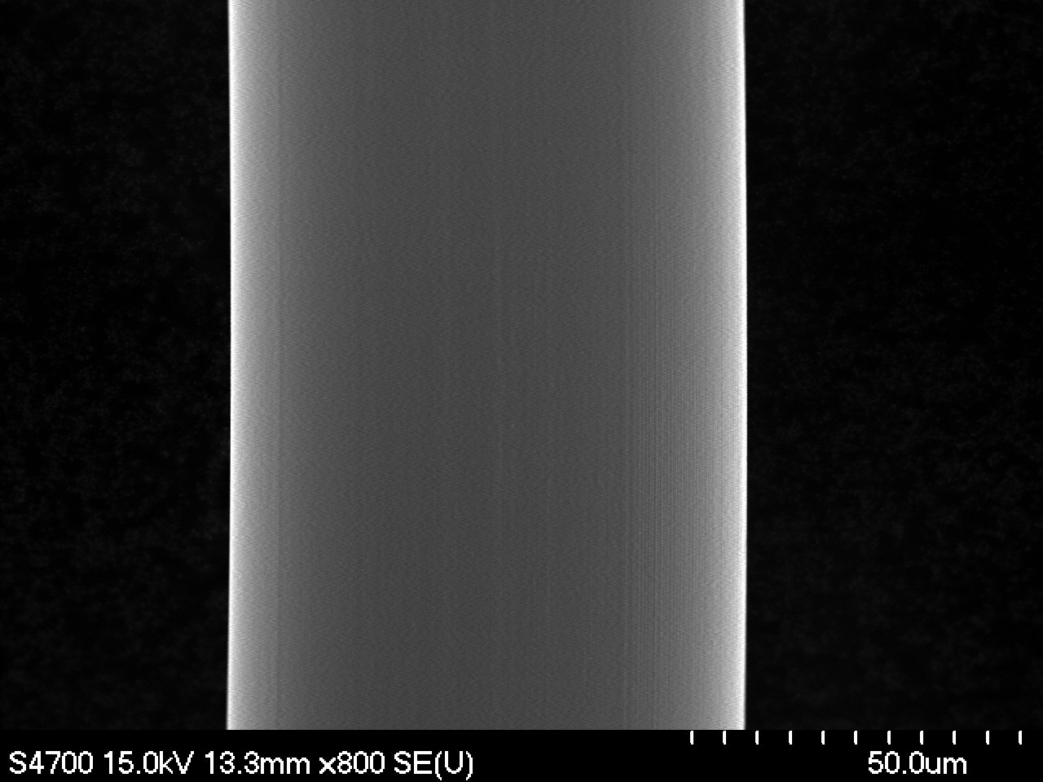 | 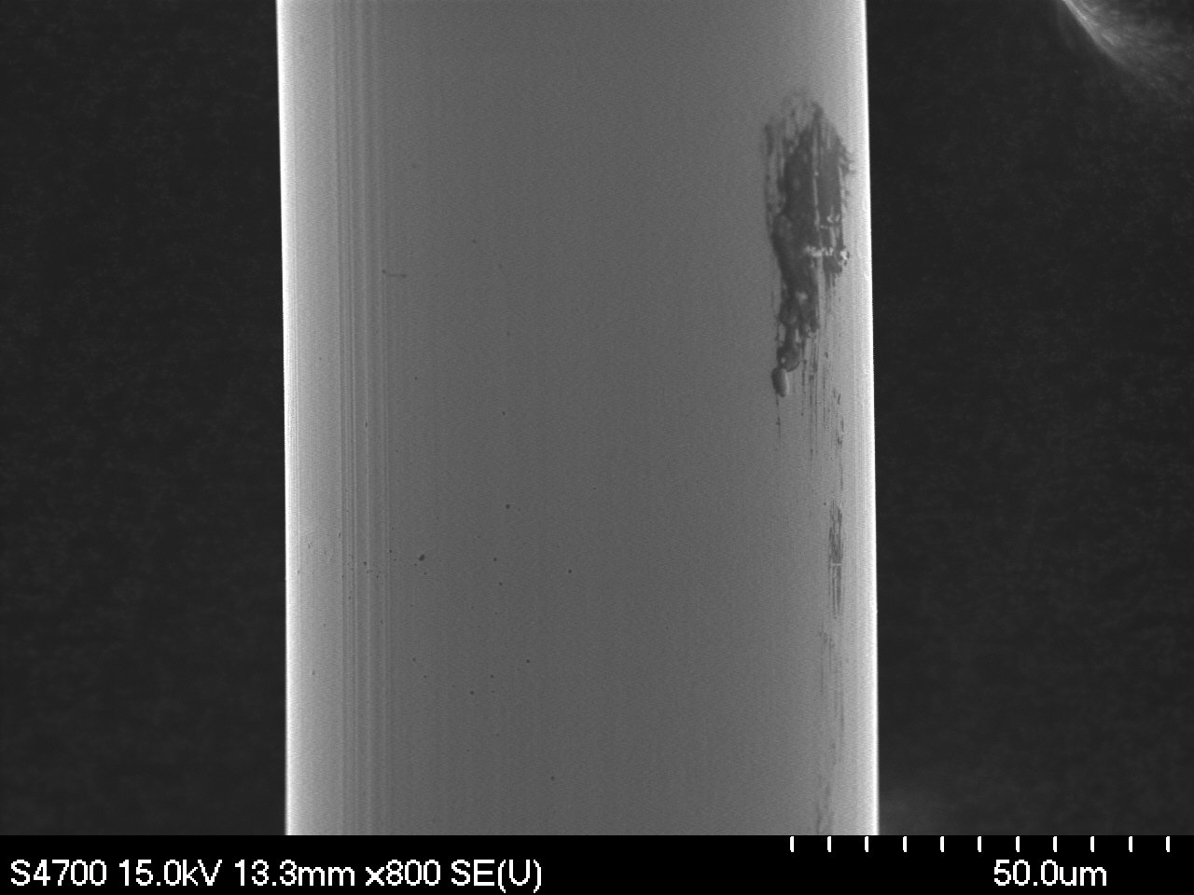
Magnification: 800x | Magnification: 800x
F7-2A-4 | F7-2B-4
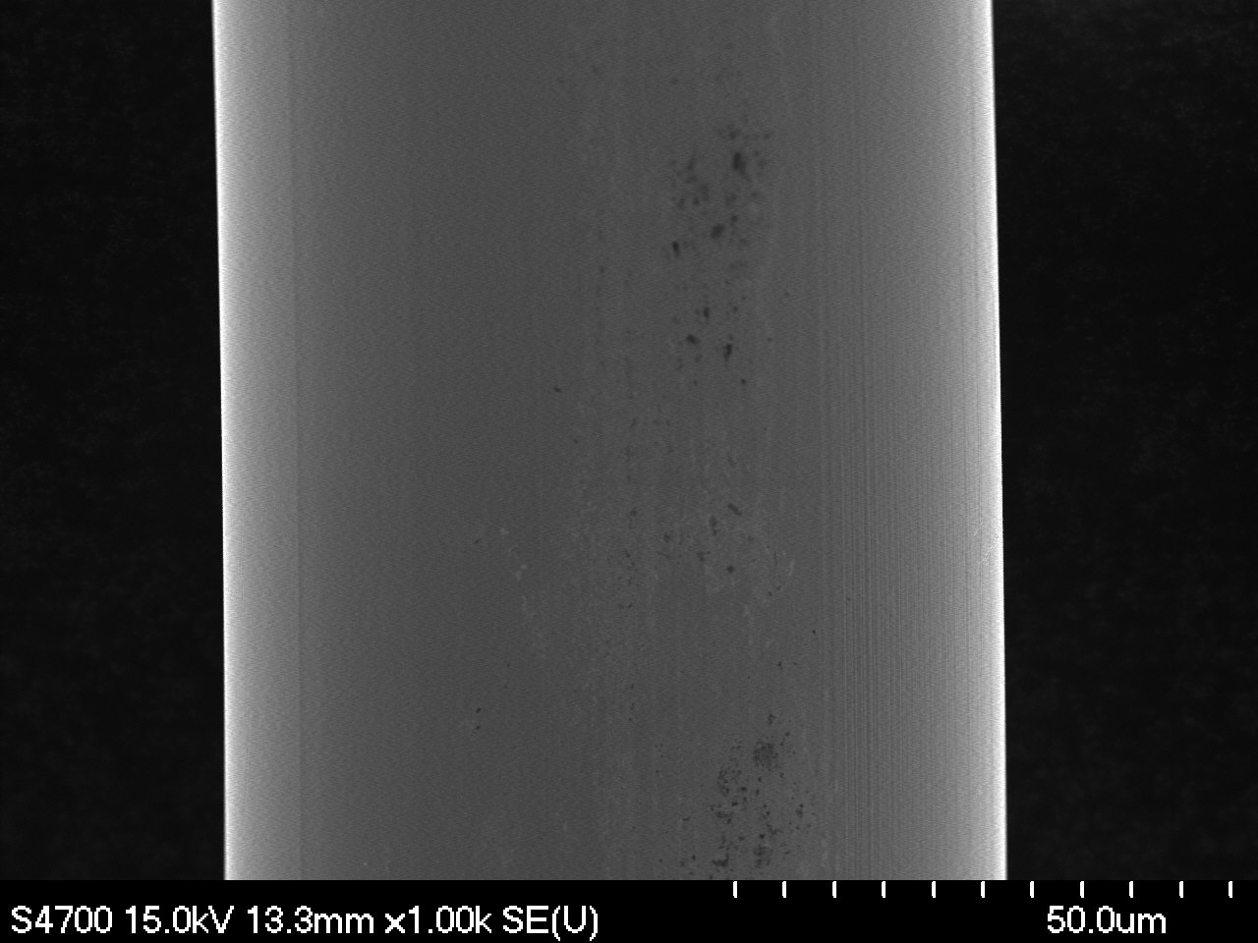 | 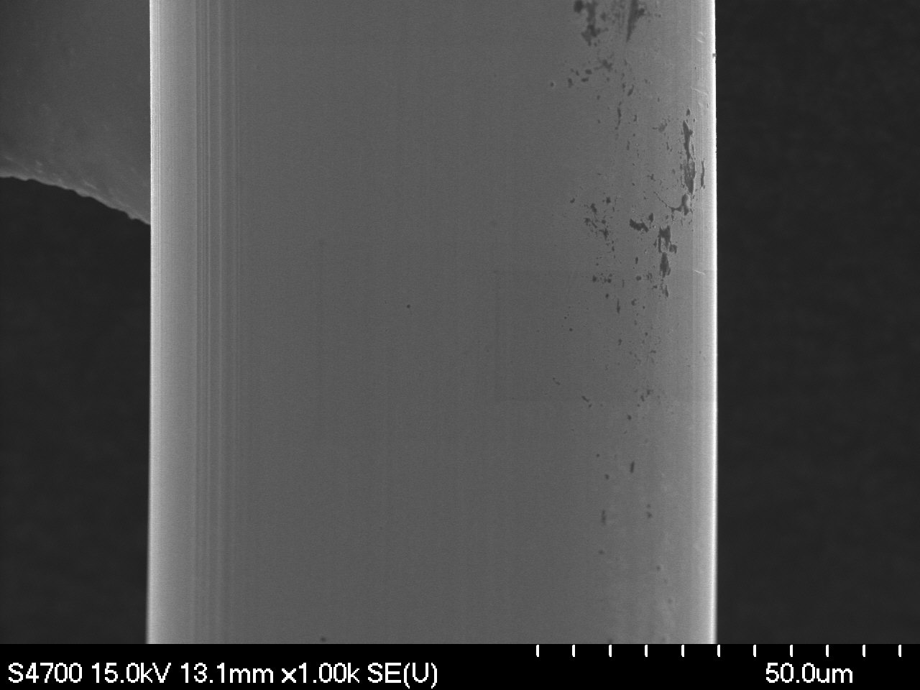
Magnification: 1000x | Magnification: 1000x

II. Ovality Measurements

F7-2A-1o | F7-2B-1o
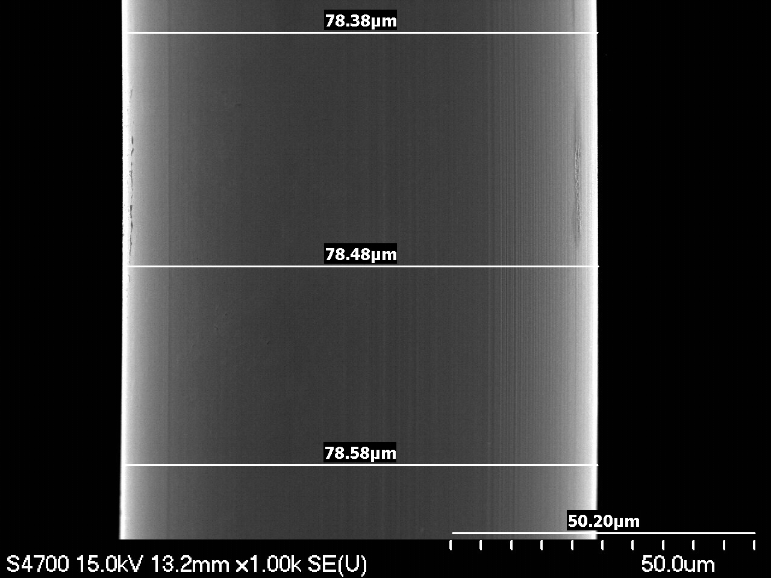 | 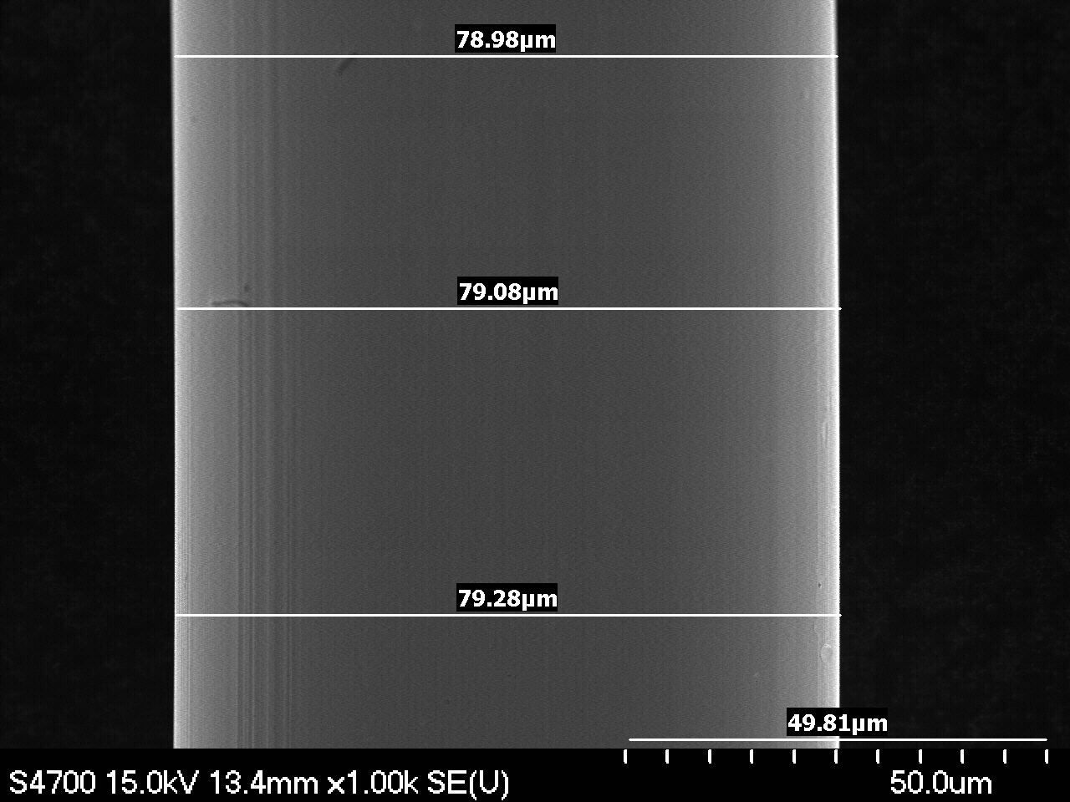
Magnification: 1000x | Magnification: 1000x
F7-2A-2o | F7-2B-2o
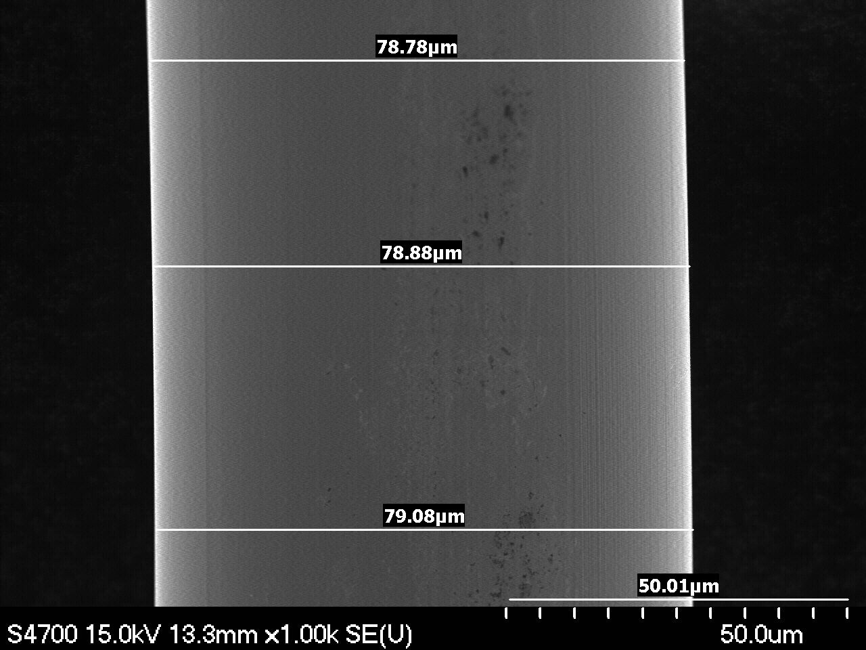 | 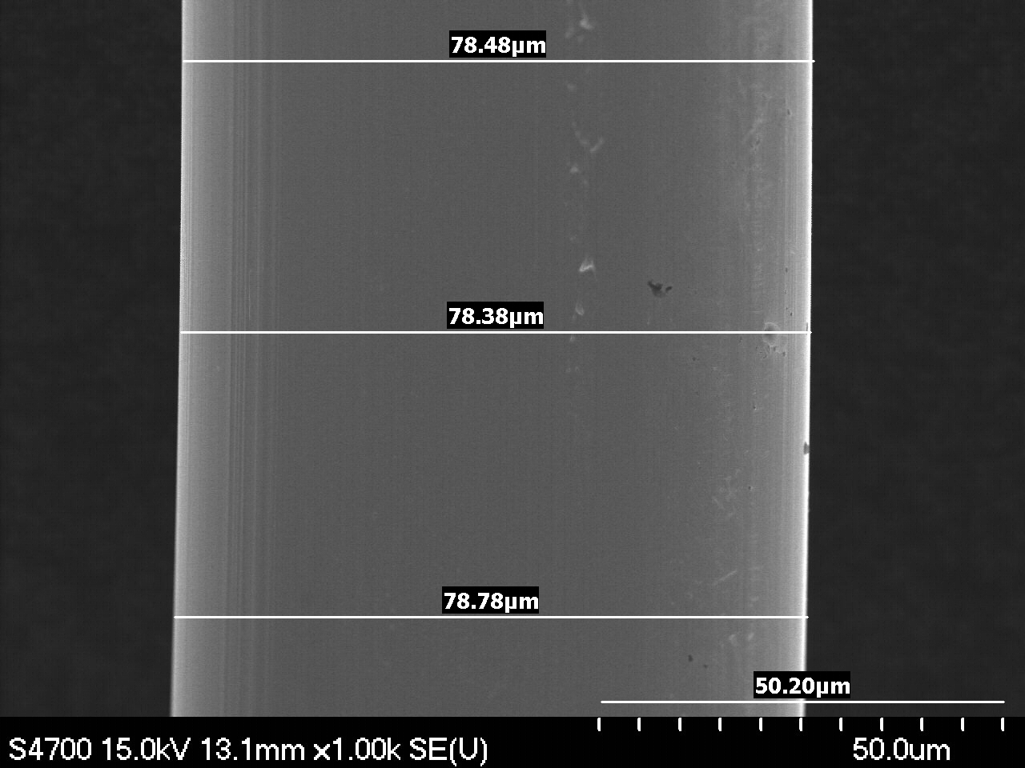
Magnification: 1000x | Magnification: 1000x
F7-2A-3o | F7-2B-3o
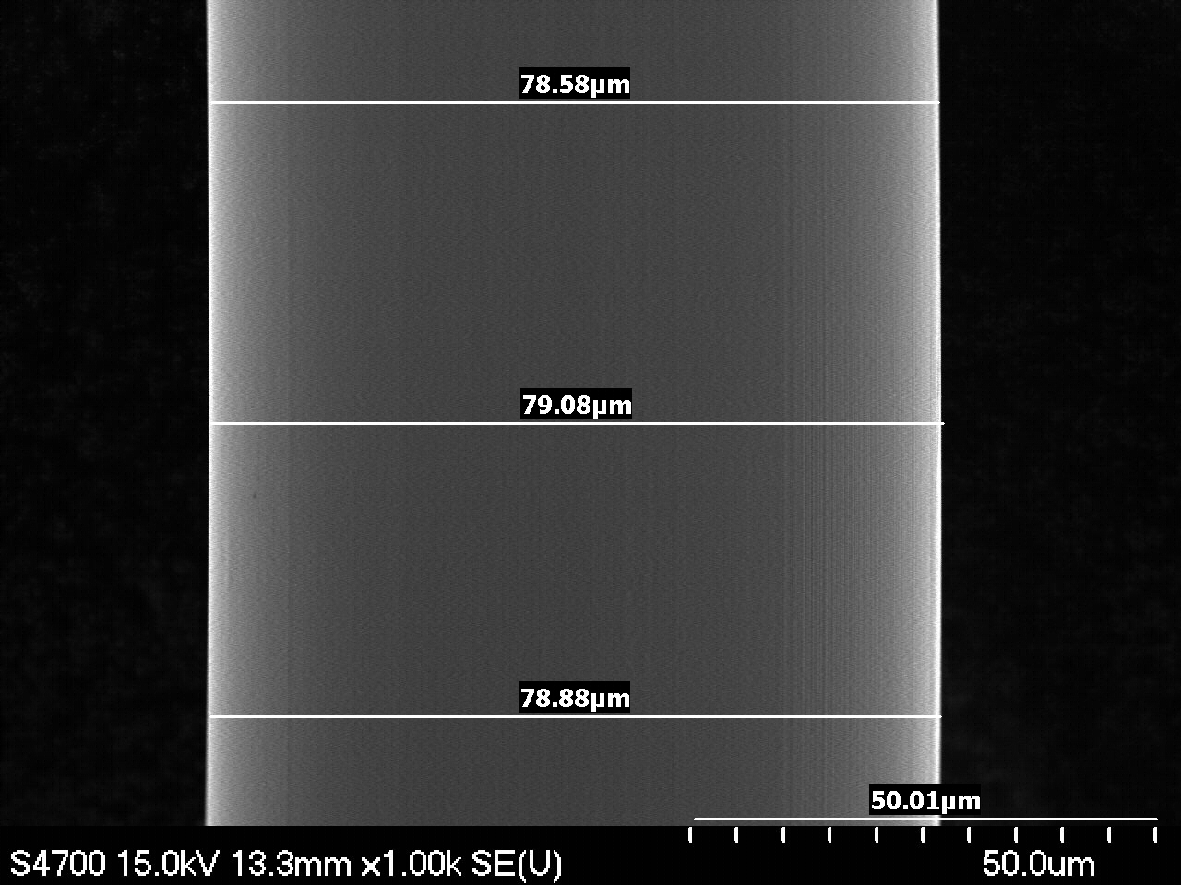 | 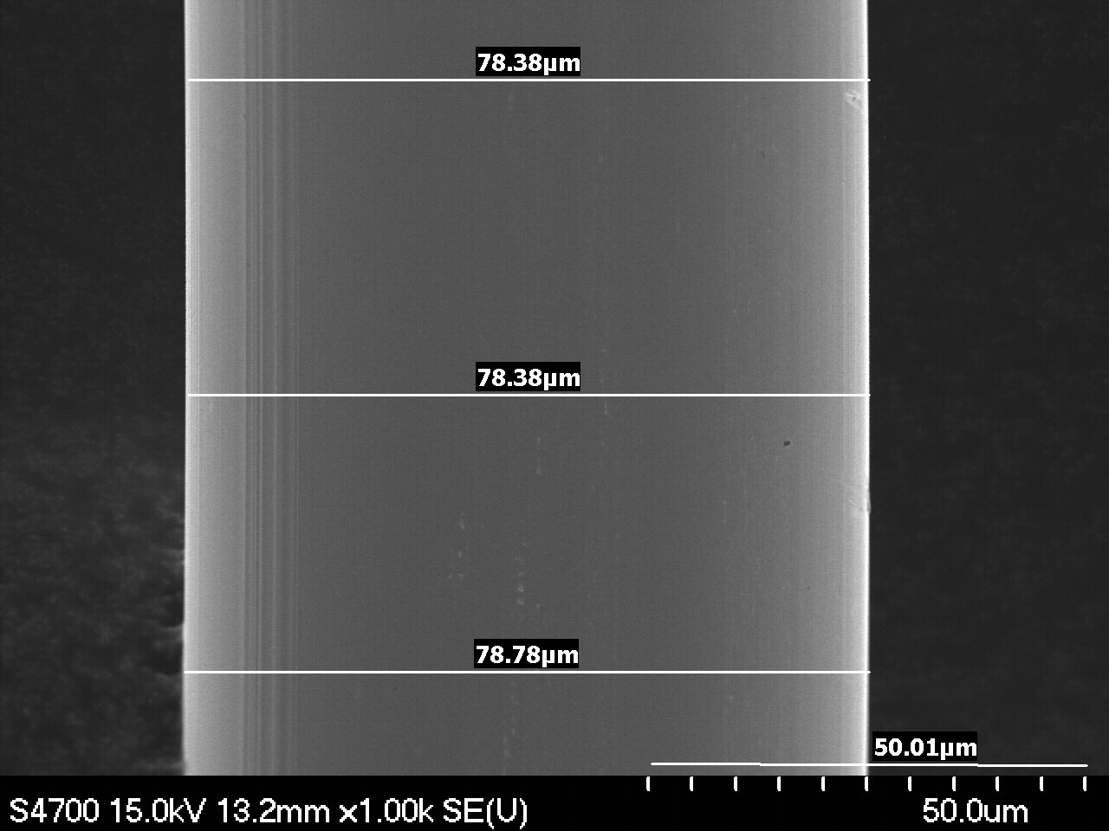
Magnification: 1000x | Magnification: 1000x

III. Points of Interest

F7-2A-3 | F7-2A-3
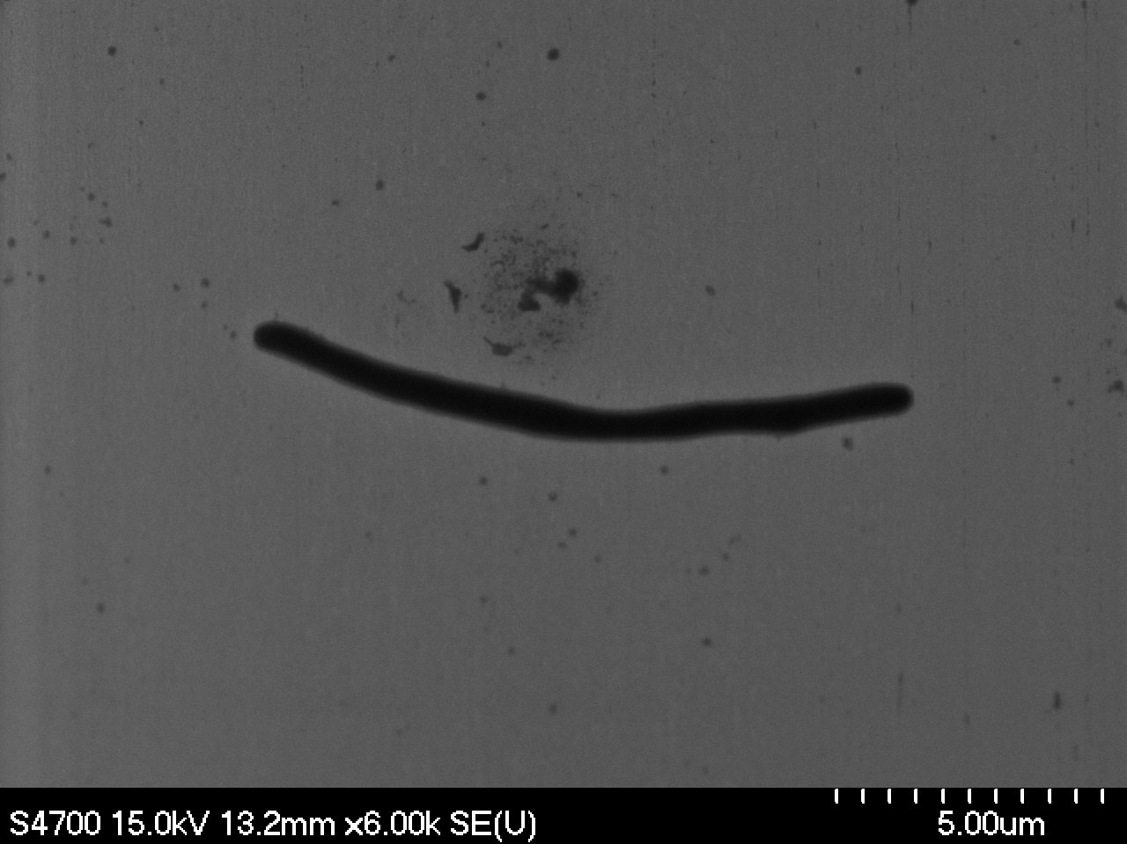 | 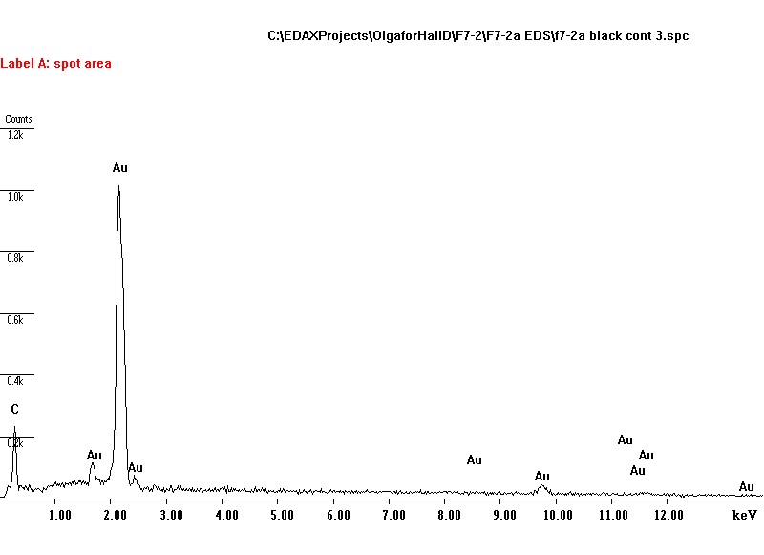
Magnification: 6000x | EDS Analysis. Environmental contamination
F7-2A-5 Minor surface damage | F7-2A-6 Minor surface damage
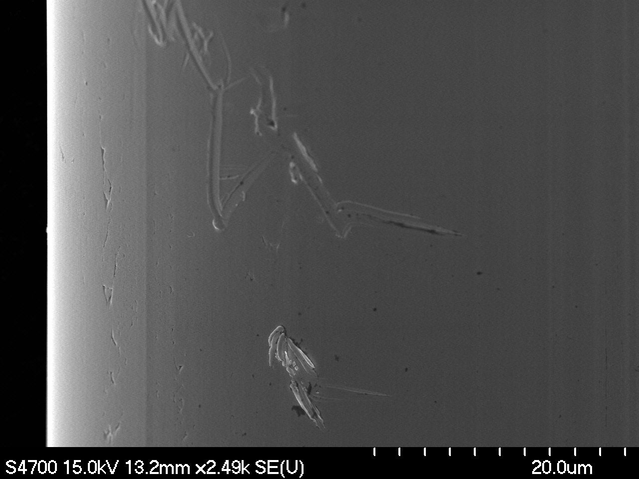 | 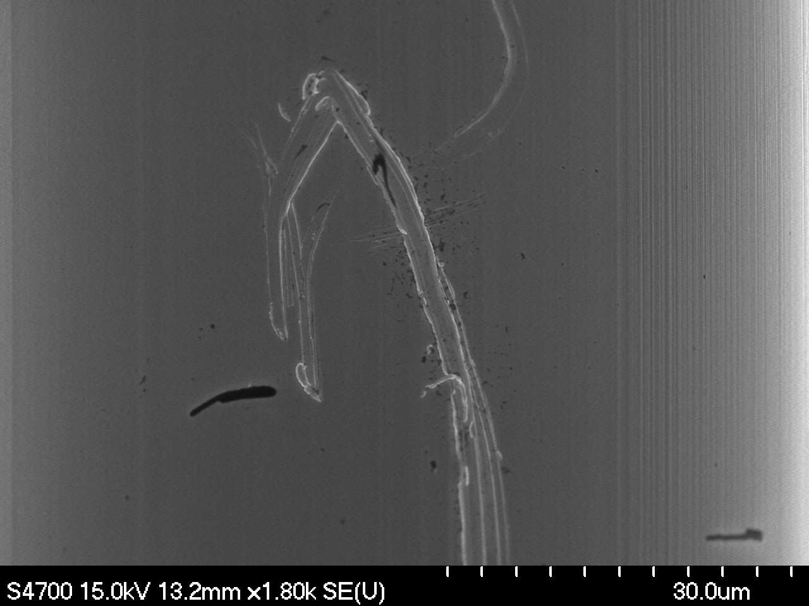
Magnification: 2490x | Magnification: 1800x
F8-2A -8 | F7-2A -8
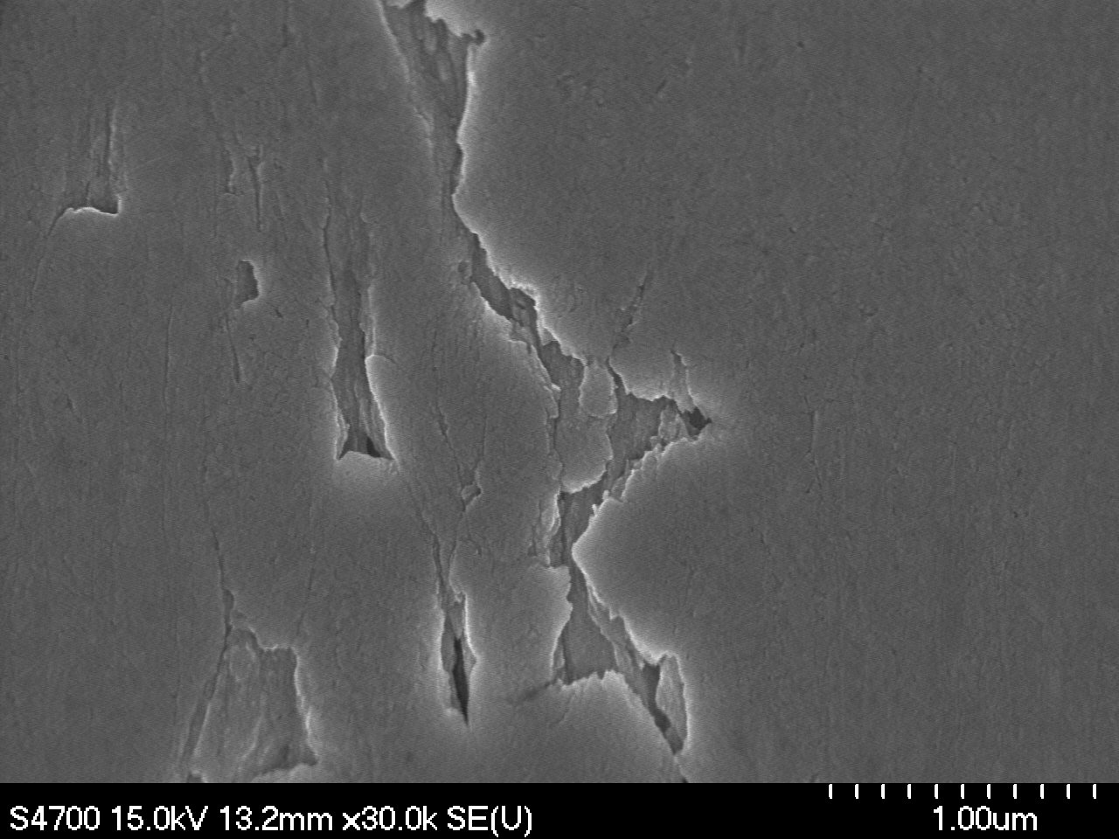 | 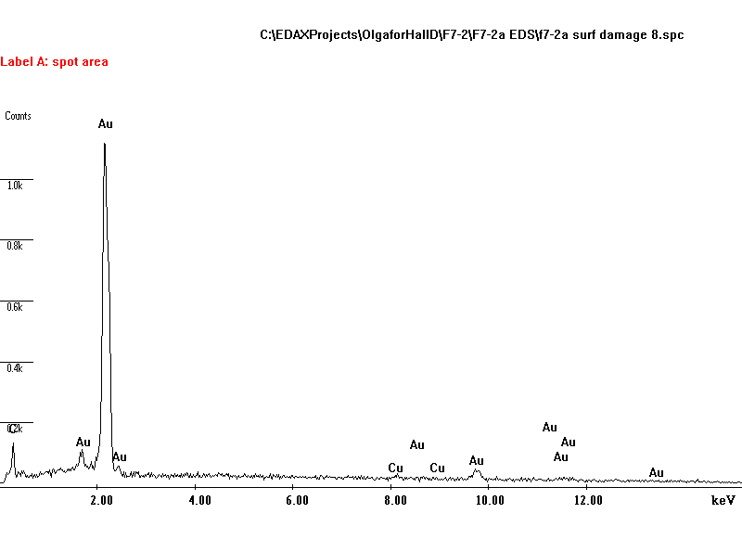
Magnification: 30000x | EDS Analysis. Surface damage. Possible traces of Cu

F7-2A-7 | F7-2A-7
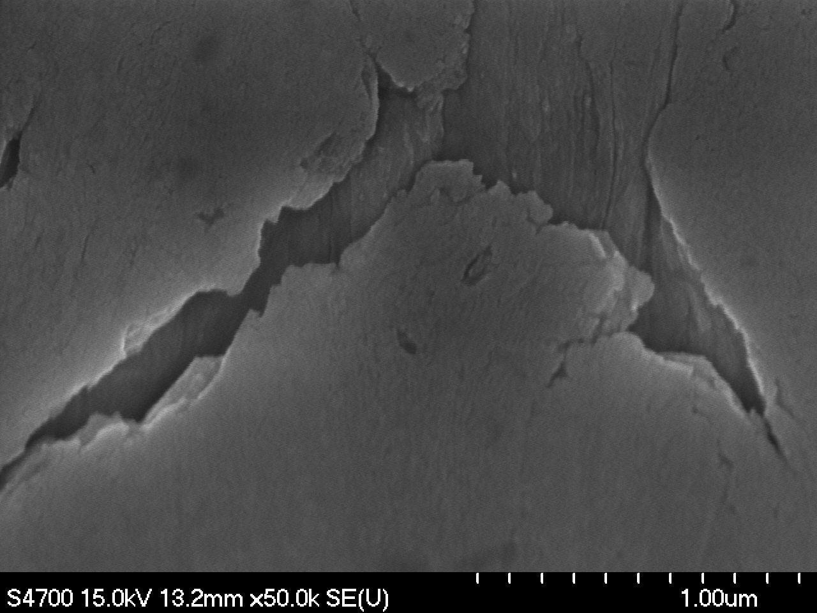 | 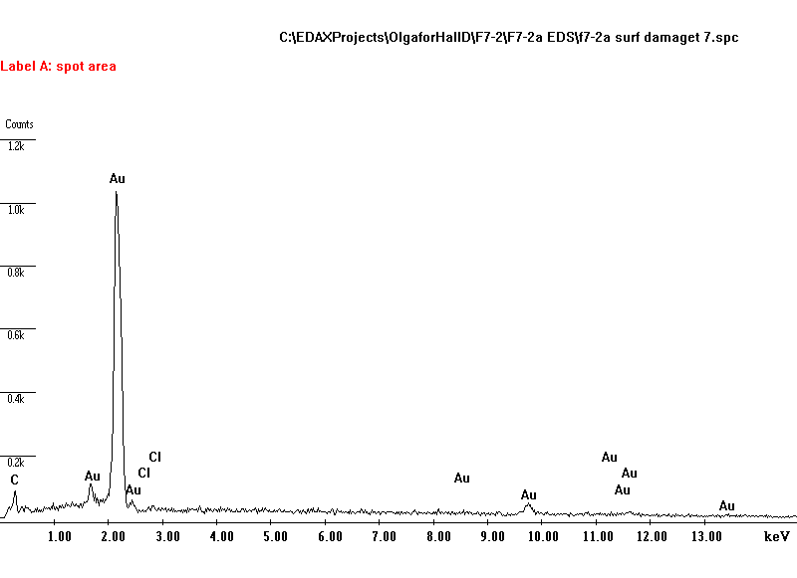
Magnification: 50000x | EDS Analysis. Surface damage. Possible Cl contamination
F7-2B-5 | F7-2B-8
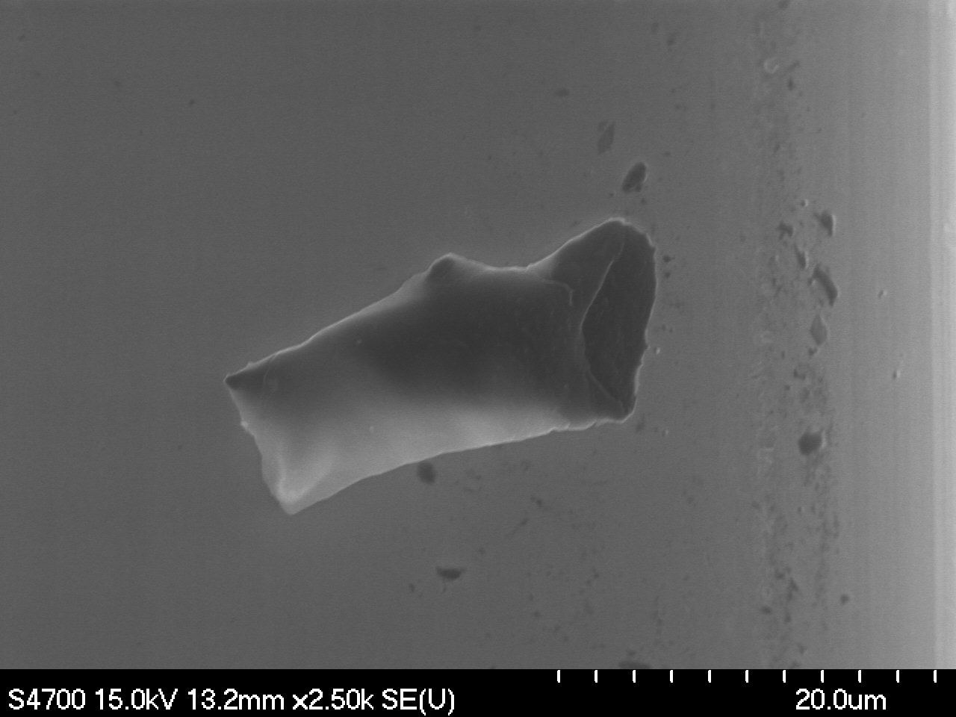 | 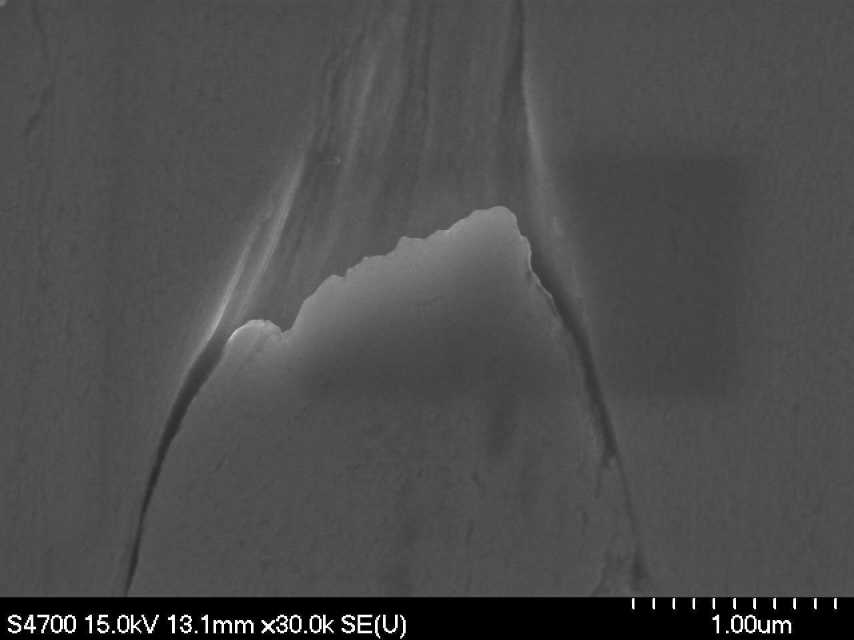
Magnification: 2500x Contamination | Magnification: 30000x

Sample F7-1 A, B
Images at designated magnifications

F7-1A-1 | F7-1B-1
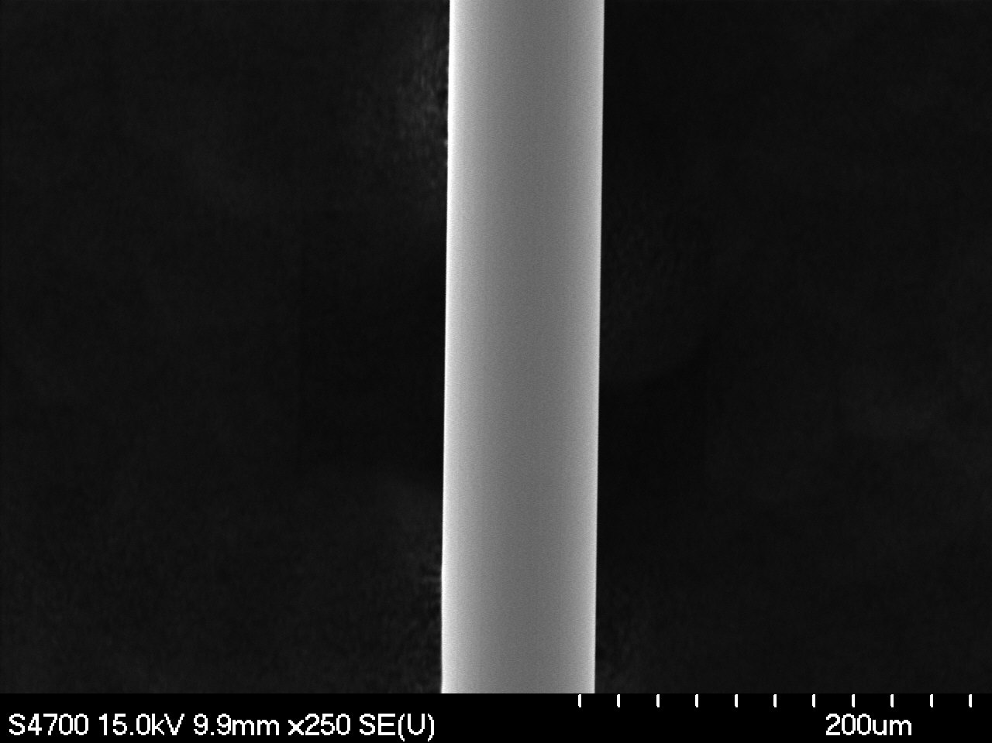 | 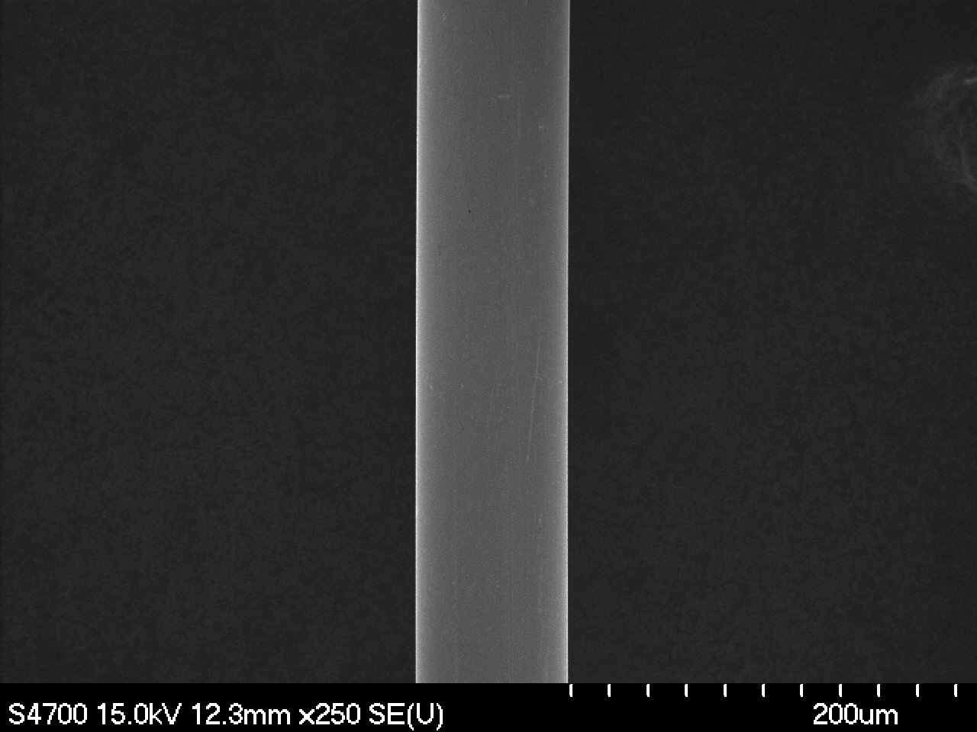
Magnification: 250x | Magnification: 250x
F7-1A-2 | F7-1B-2
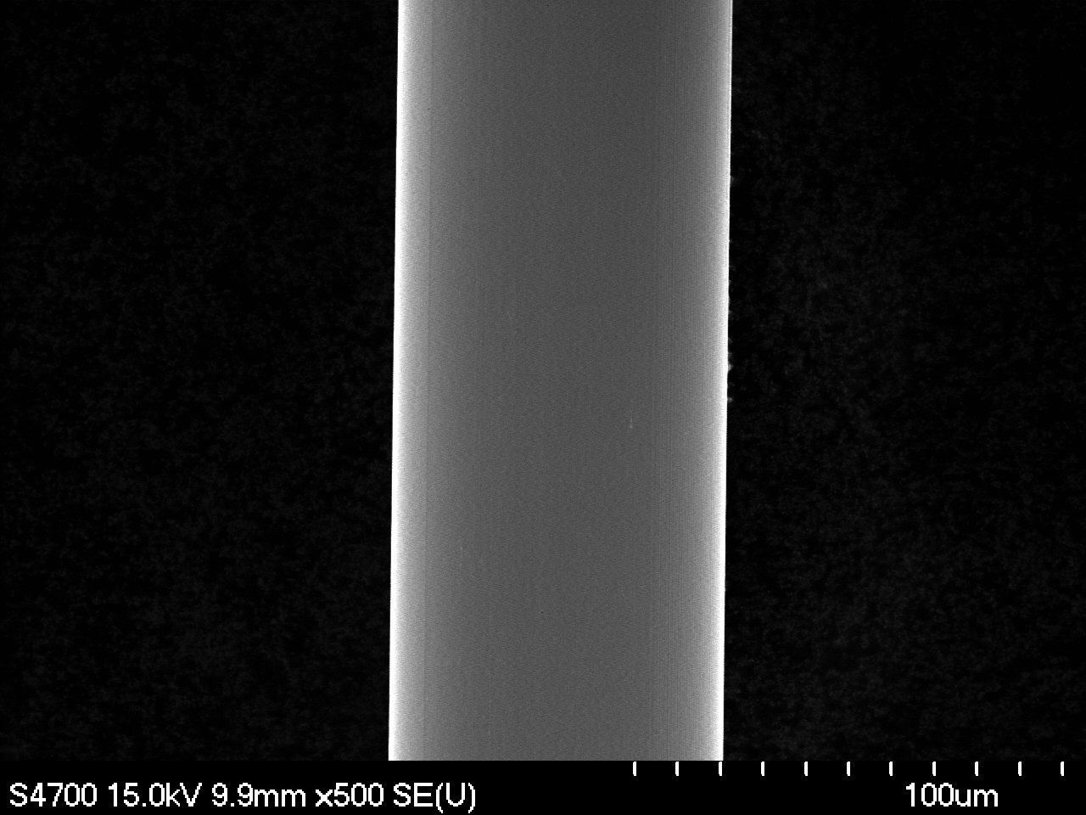 | 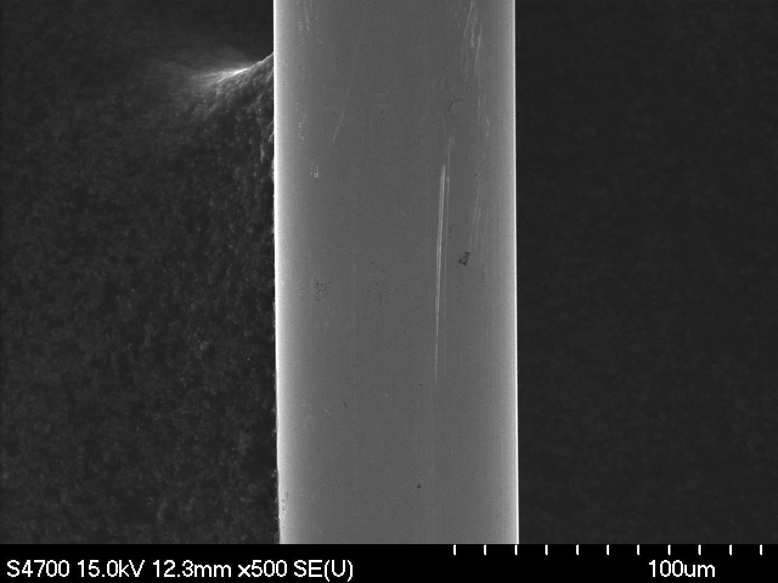
Magnification: 500x | Magnification: 500x

F7-1A-3 | F7-1B-3
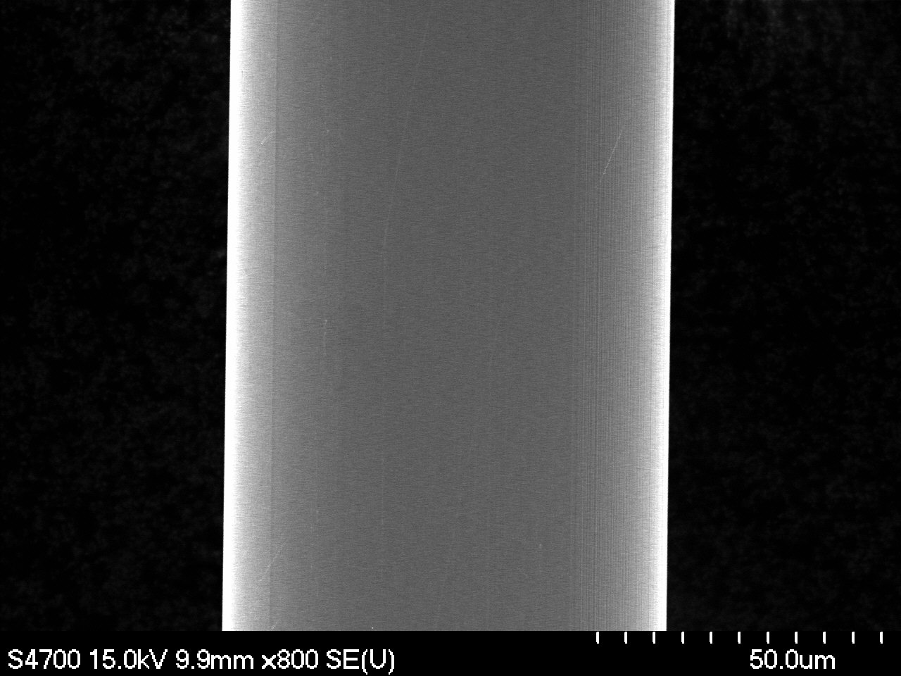 | 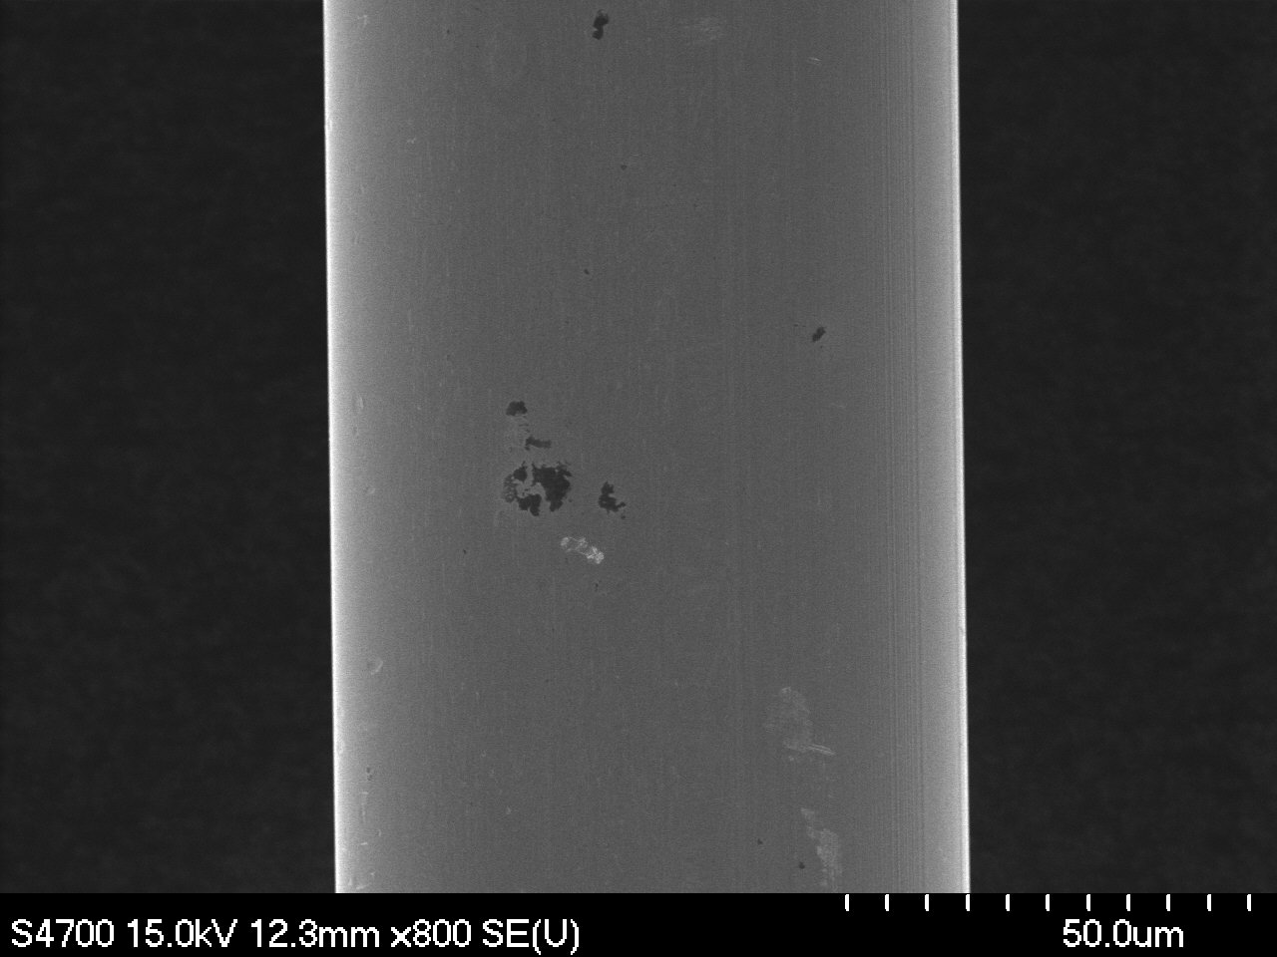
Magnification: 800x | Magnification: 800x
F7-1A-4 | F7-1B-4
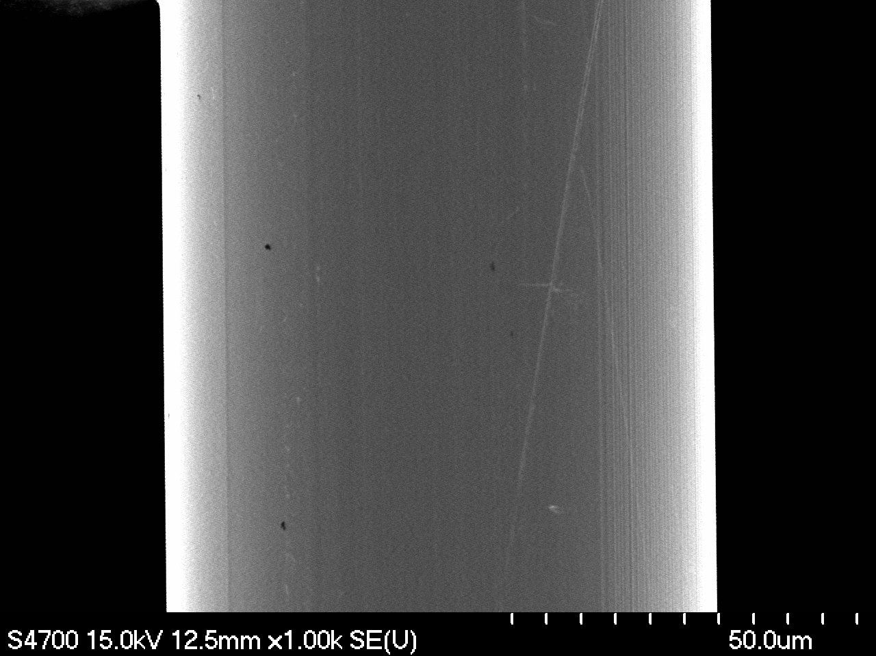 | 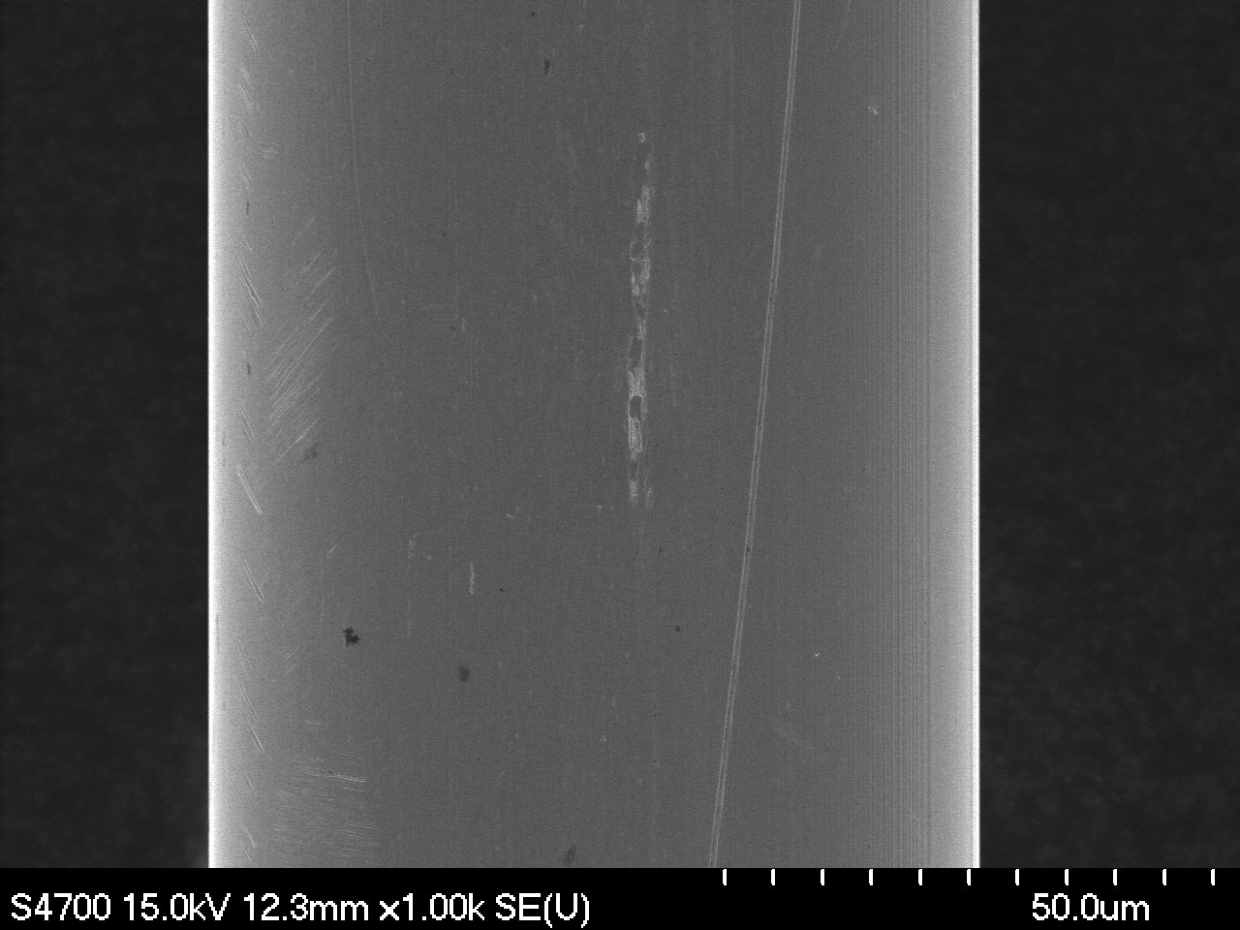
Magnification: 1000x | Magnification: 1000x

II. Ovality Measurements

F7-1A -1o | F7-1B -1o
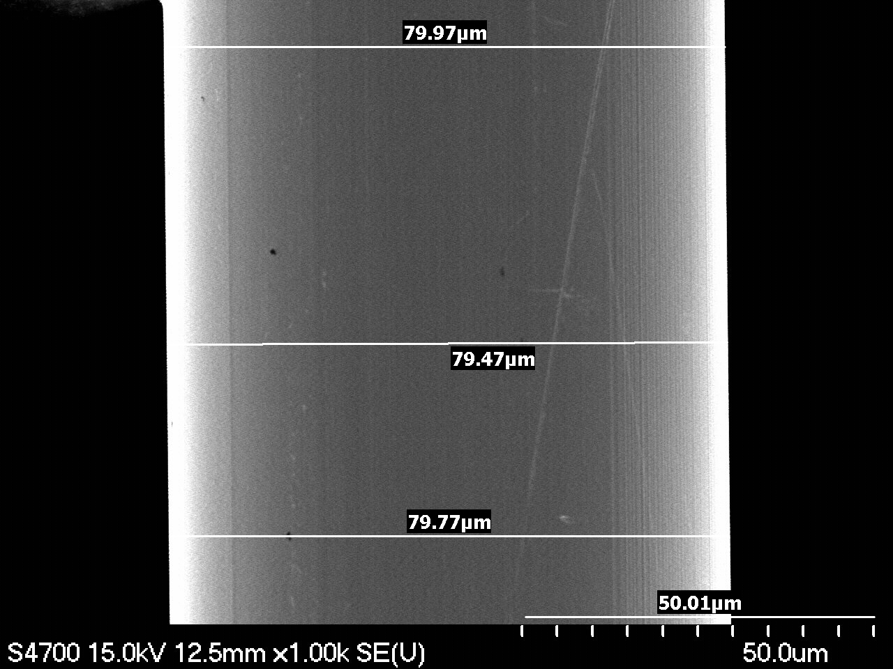 | 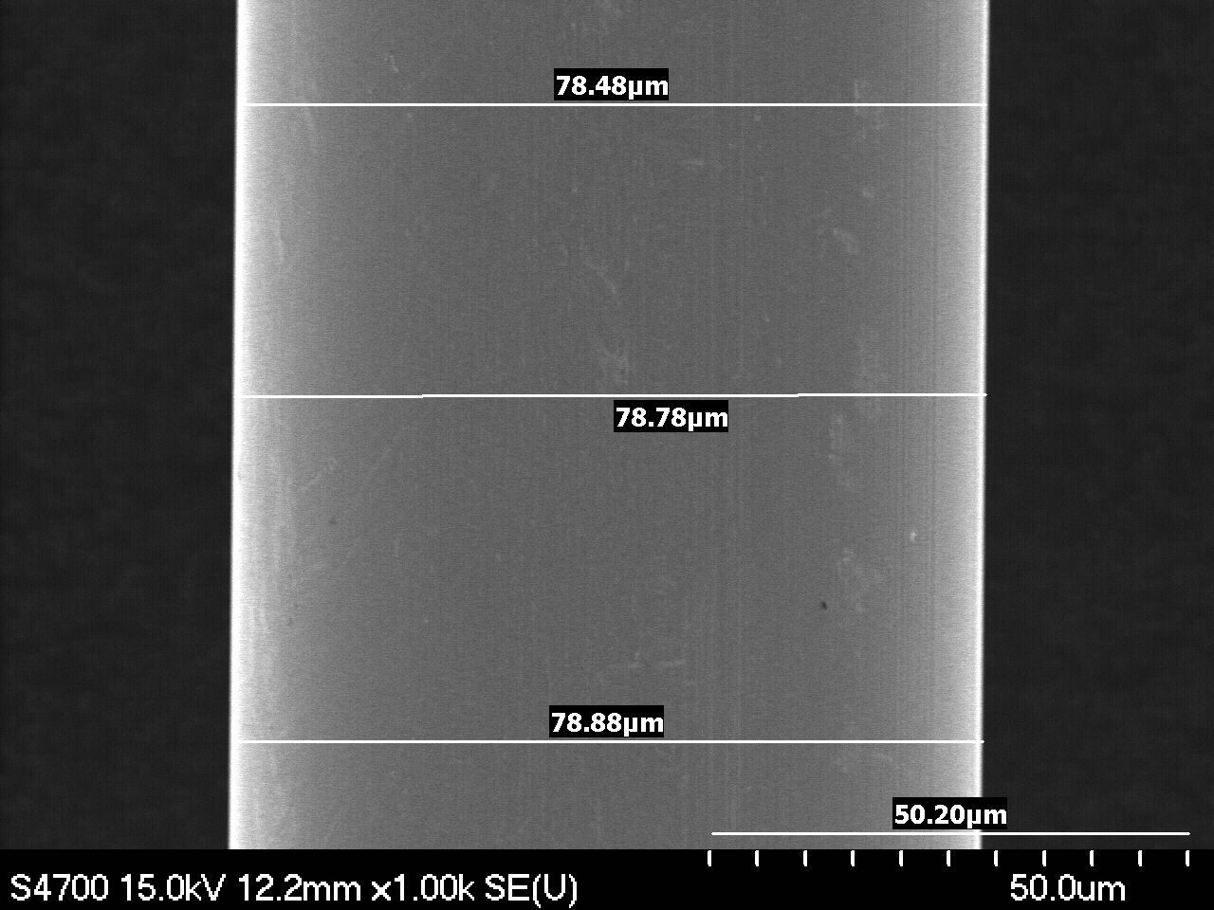
Magnification: 1000x | Magnification: 1000x
F7-1A -2o | F5-2B-2o
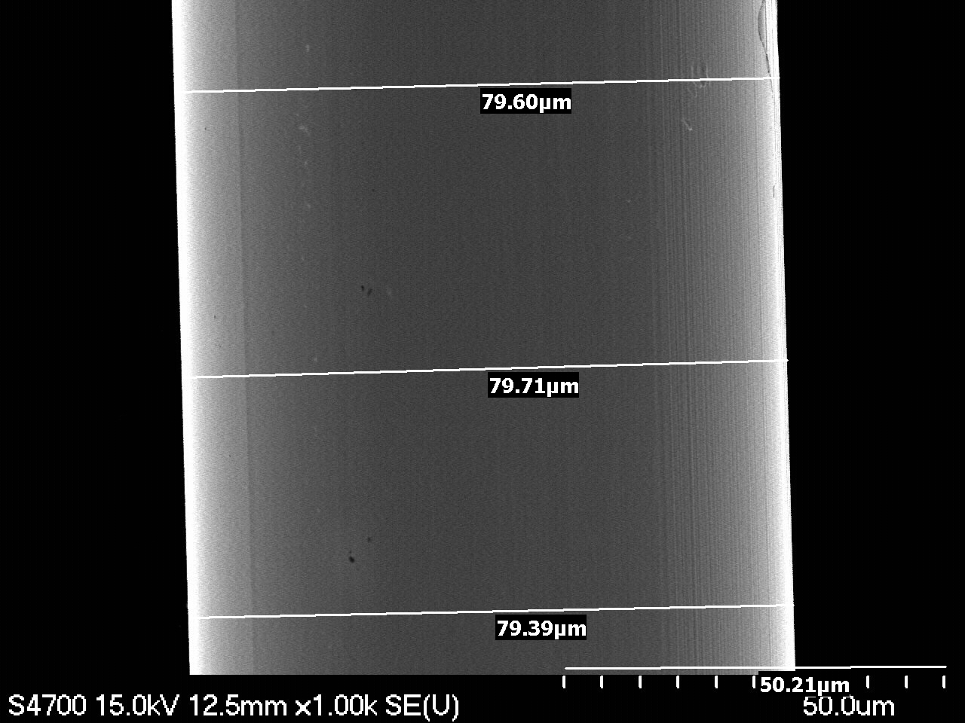 | 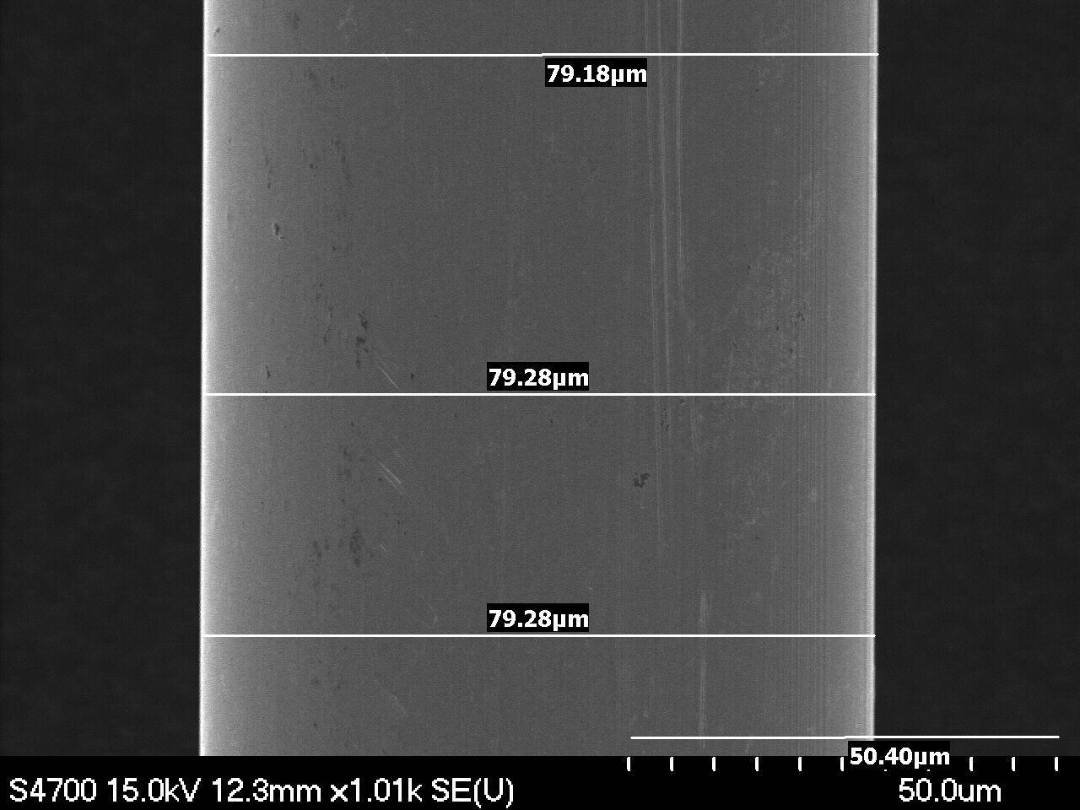
Magnification: 1000x | Magnification: 1000x
F7-1A -3o | F7-1B -3o
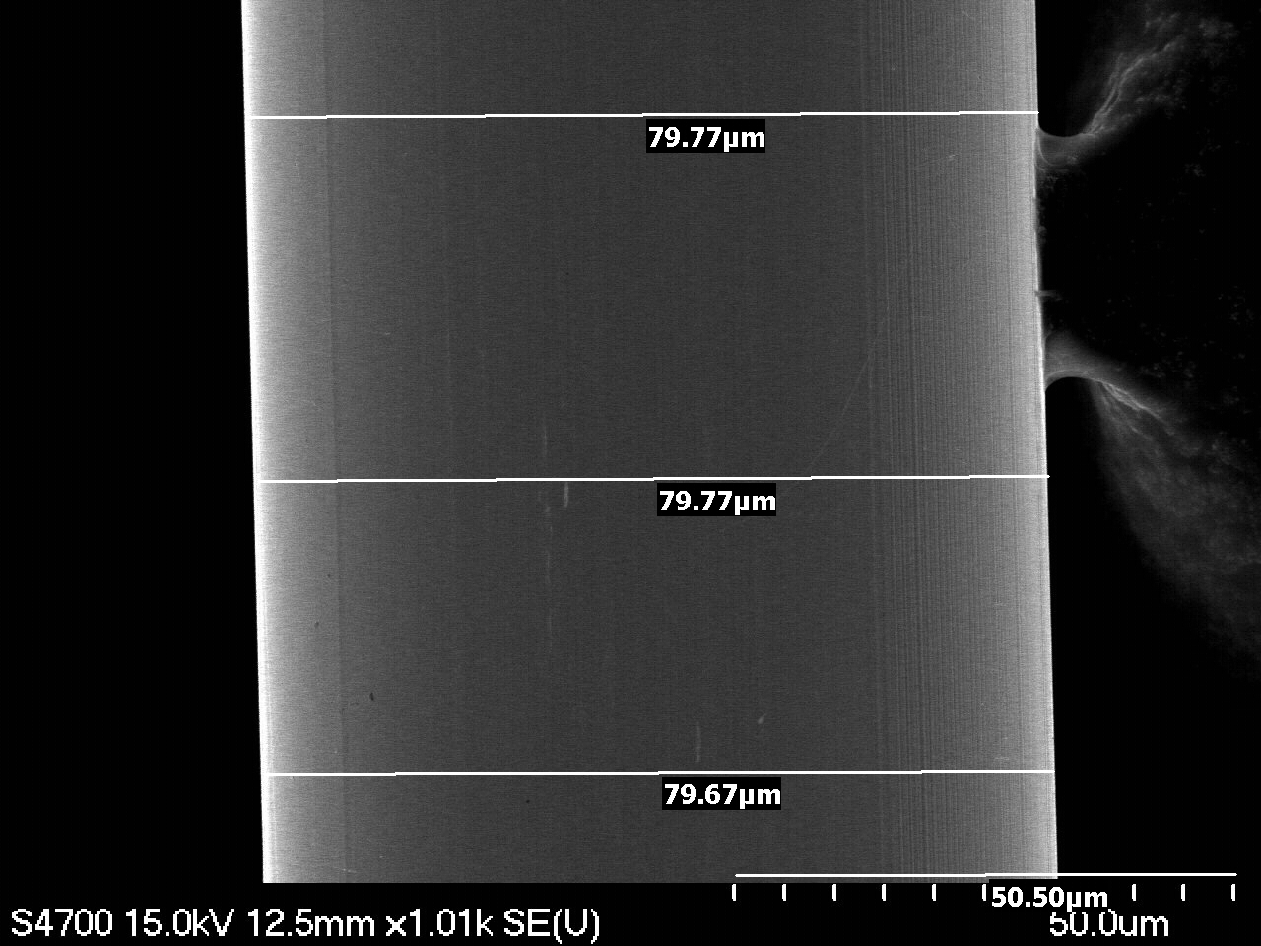 | Sorry, image was not saved.
Magnification: 1000x | Magnification: 1000x

III. Points of Interest

F7-1A-7 Surface contamination. | F7-1A-7
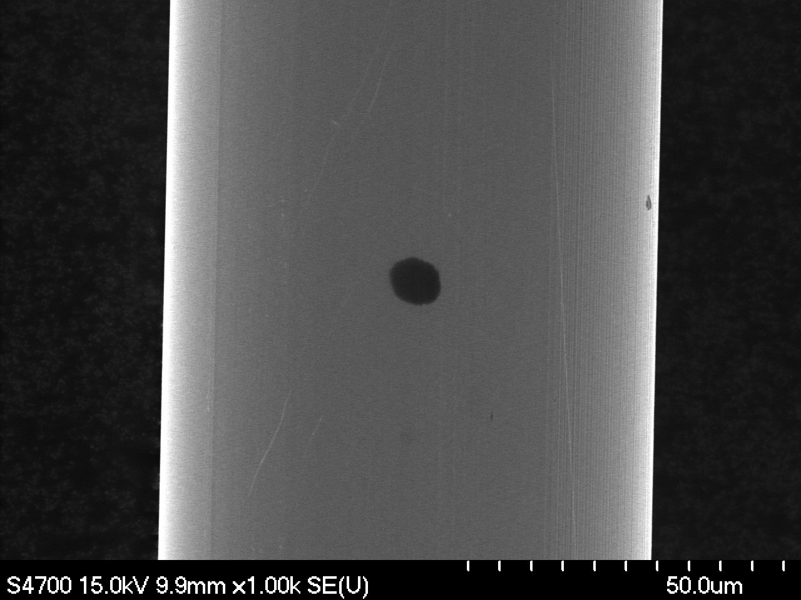 | 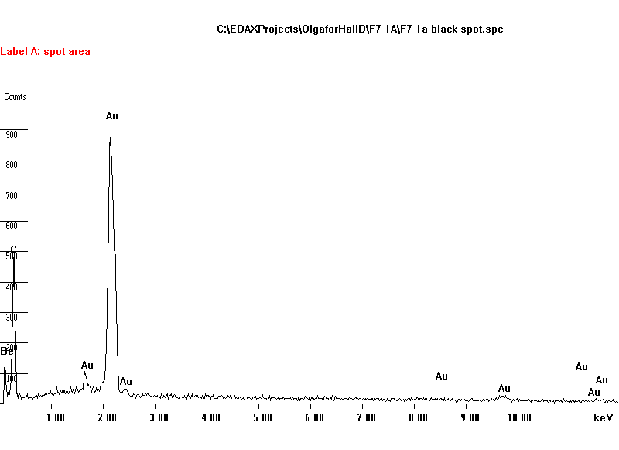
Magnification: 1000x | EDS Analysis. Surface contamination. Carbon.
F7-1A-4 Surface structure detail. | F7-1A-minor surface scratch
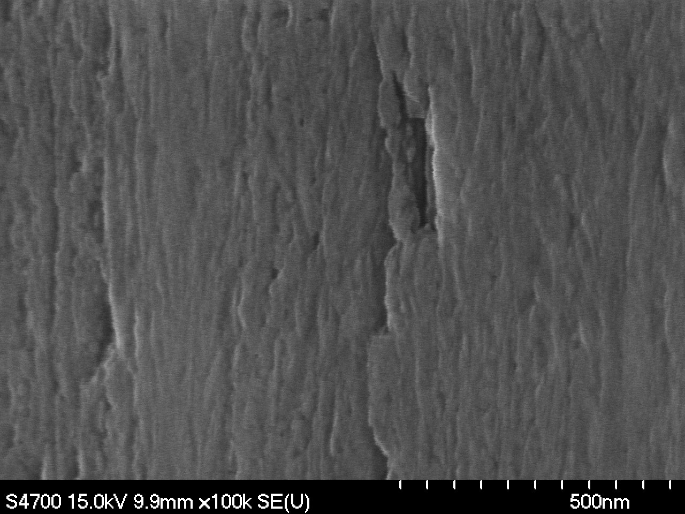 | 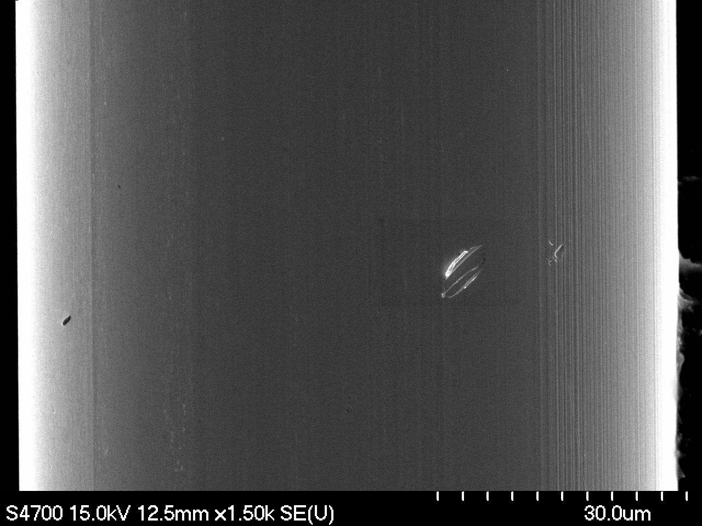
Magnification: 100000x | Magnification: 1500x
F7-1B-8 Surface feature. | F7-1B-11 Surface feature.
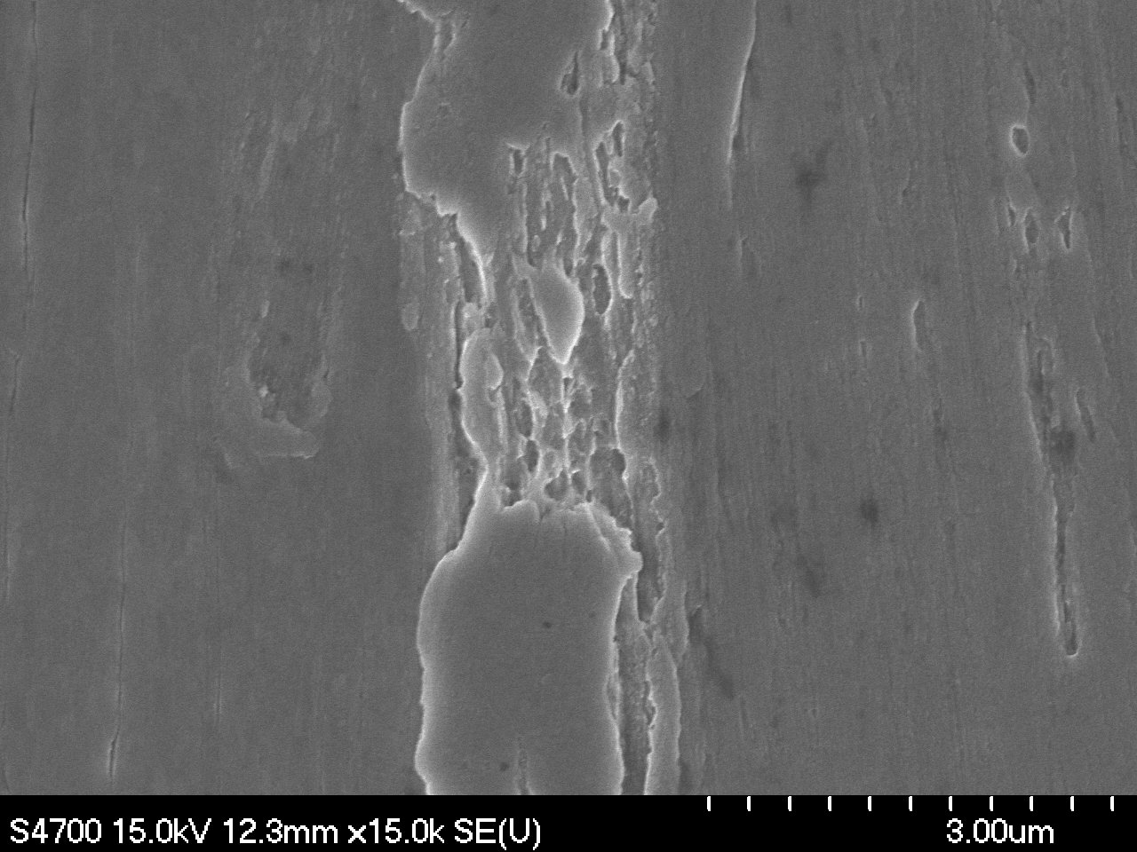 | 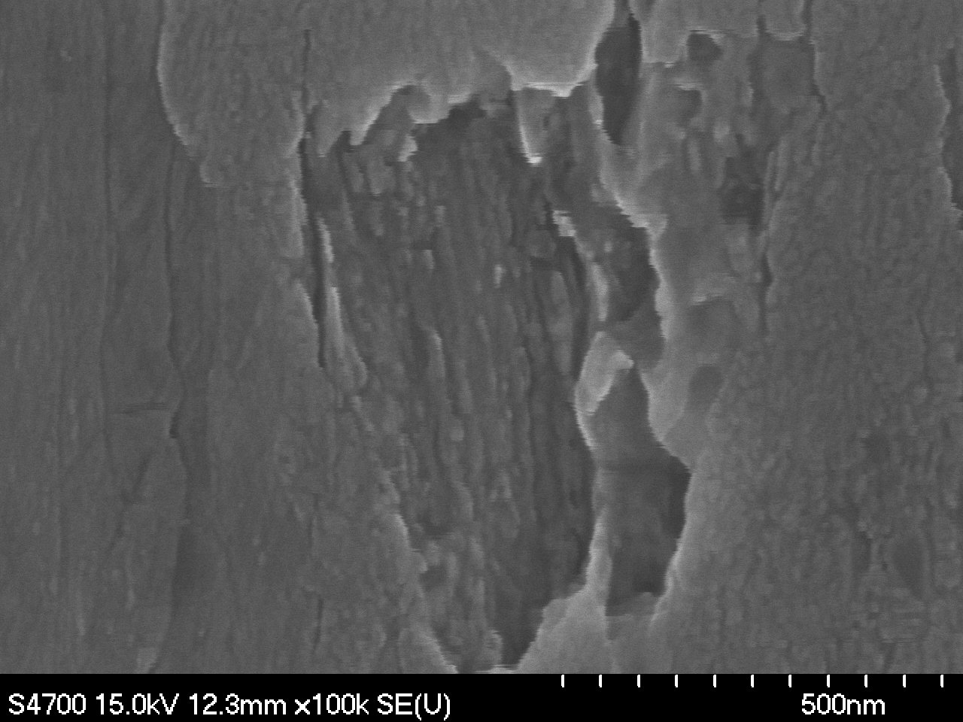
Magnification: 15000x | Magnification: 100000x
Note: No Cu was observed by EDS probe for the features F7-1B-8 and F7-1B-11.

