Hall D Wire Characterization
Samples F8-1 & F8-2

- Sample preparation: ultrasonic cleaning in DI water for 45 minutes.
- Sample installation: for SEM inspection wires were installed on a sample holder (diameter=36 mm) on 2 stripes of conductive carbon tape, 2 fragment of each sample per stripe (nomenclature: F5-1a, F5-1b and F5-2a, F5-2b).

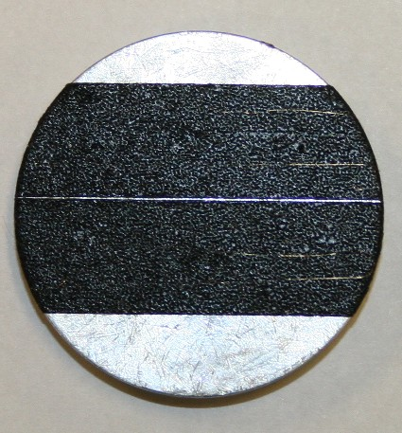

Pic1. Typical sample installation.
- Wire inspection:
- Each wire fragment was examined along its length (beginning at approximately 5mm from the sample holder edge and ending ~5mm before the opposite edge) at magnification of ~x600, at fast scan rate.
- Images at designated magnifications (x300, x500, x800, x1000) were taken randomly along the sample length;
- Images for the ovality measurements were taken at 1000x magnification in three points of each wire fragment: in the middle (approximately) and close to both ends;
- Measurements of wire diameter, as visible on the images, were done using the Quartz PCI Image Management System, 3 measurements per image;
- Additional images at various magnifications were taken at the points of interest (variations in sample topography, contaminated areas, etc.)
- EDS analysis was performed on the most typical points of interest.

Sample F5-1 A, B
I. Images at designated magnifications

F8-1A-1 | F8-1B-1
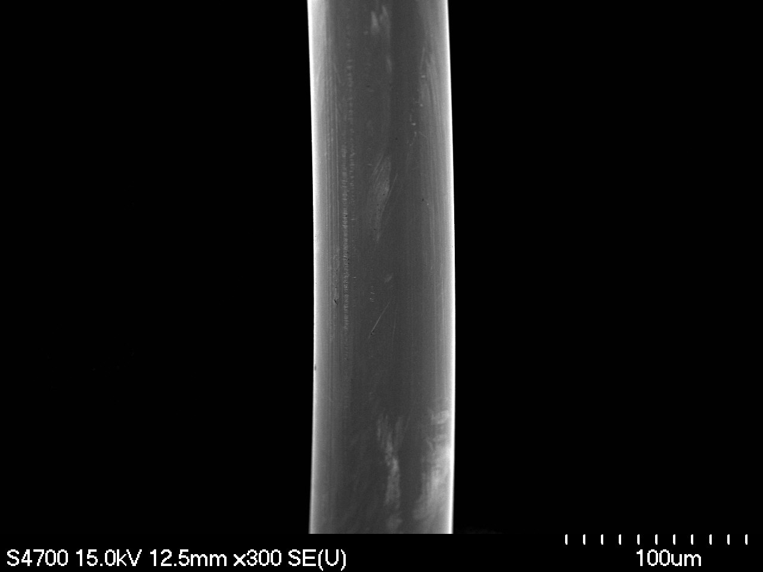 | 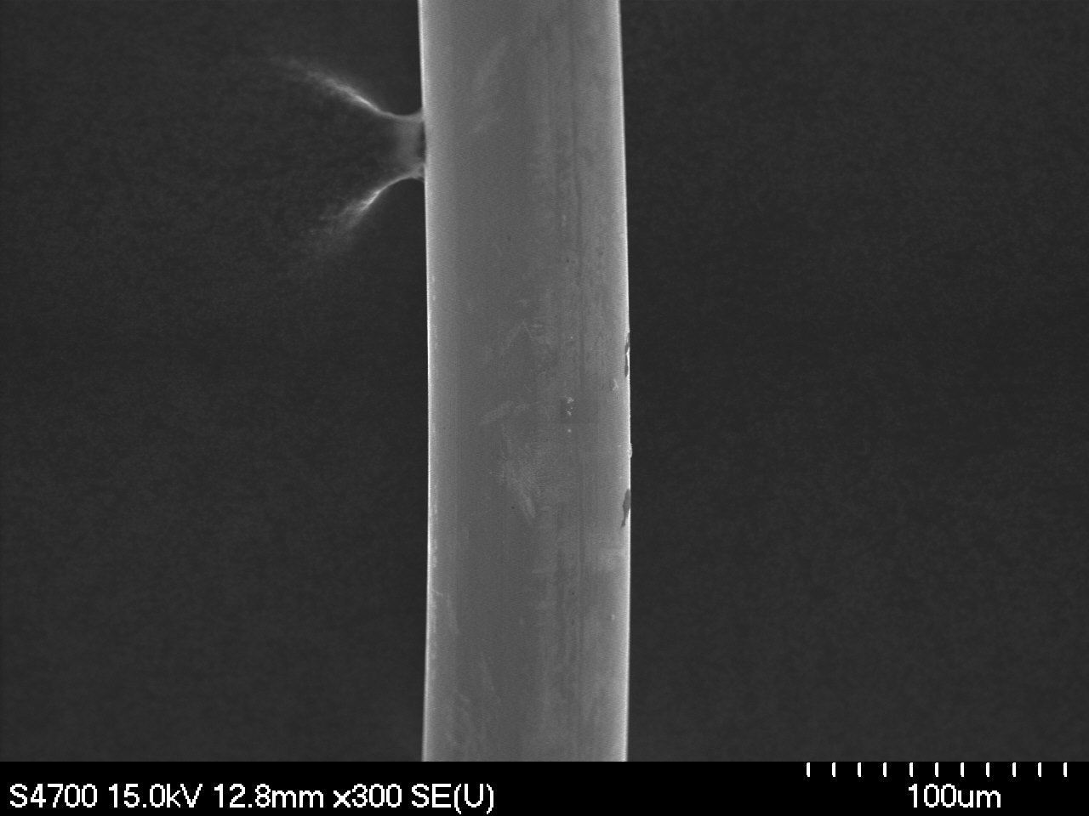
Magnification: 300x | Magnification: 300x
F8-1A-2 | F8-1B-2
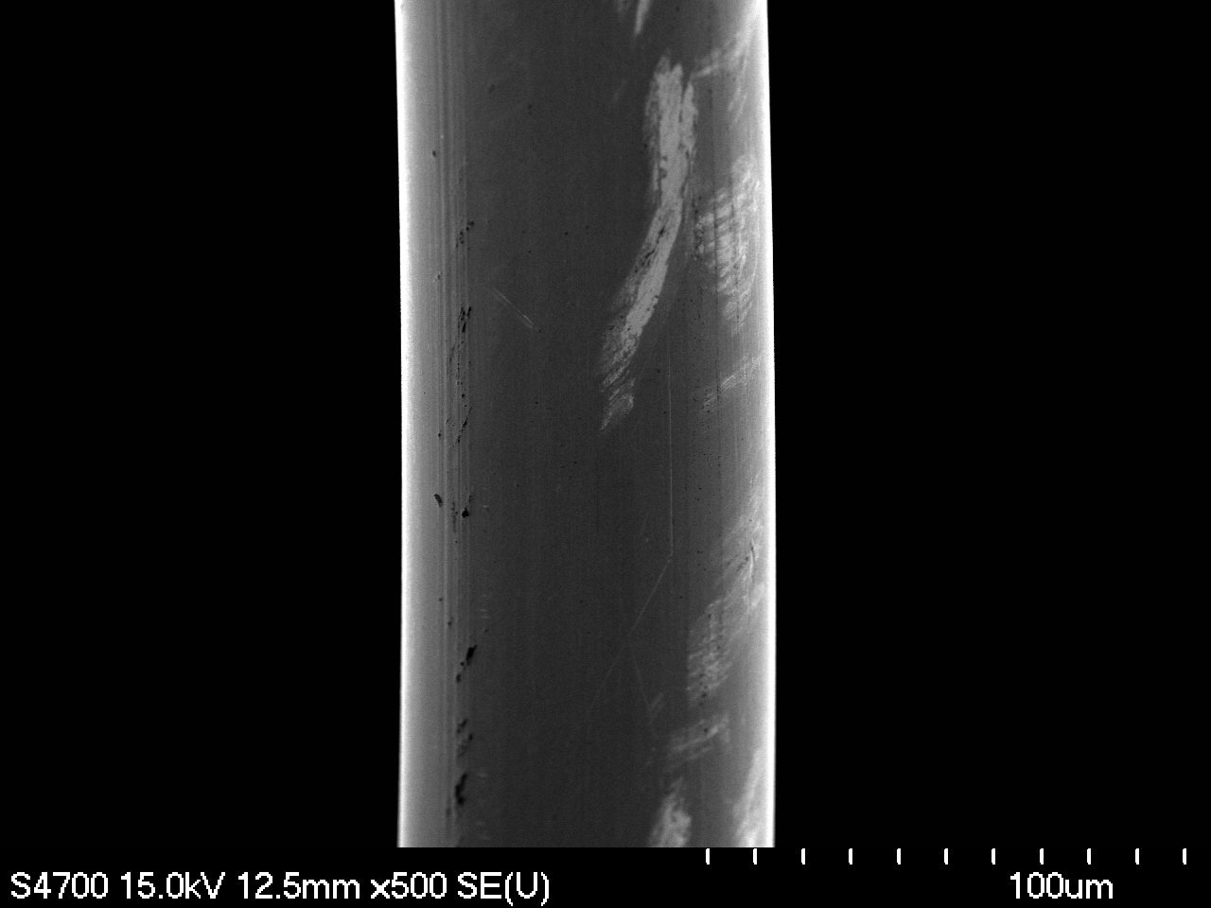 | 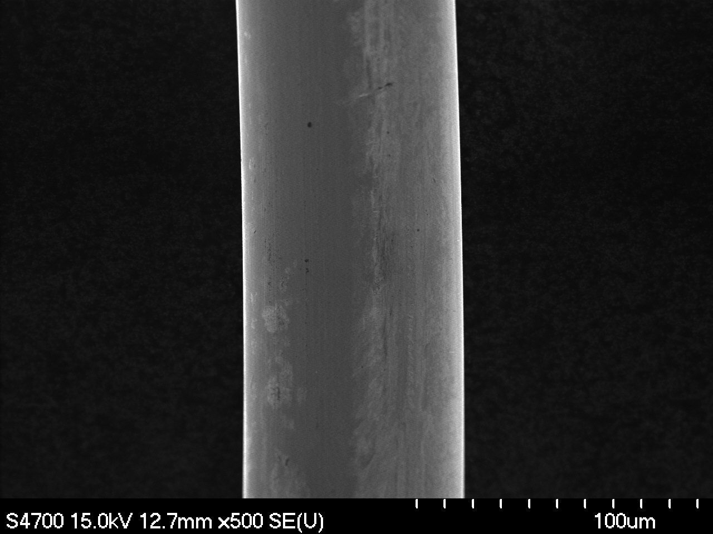
Magnification: 500x | Magnification: 500x

F8-1A-3 | F8-1B-3
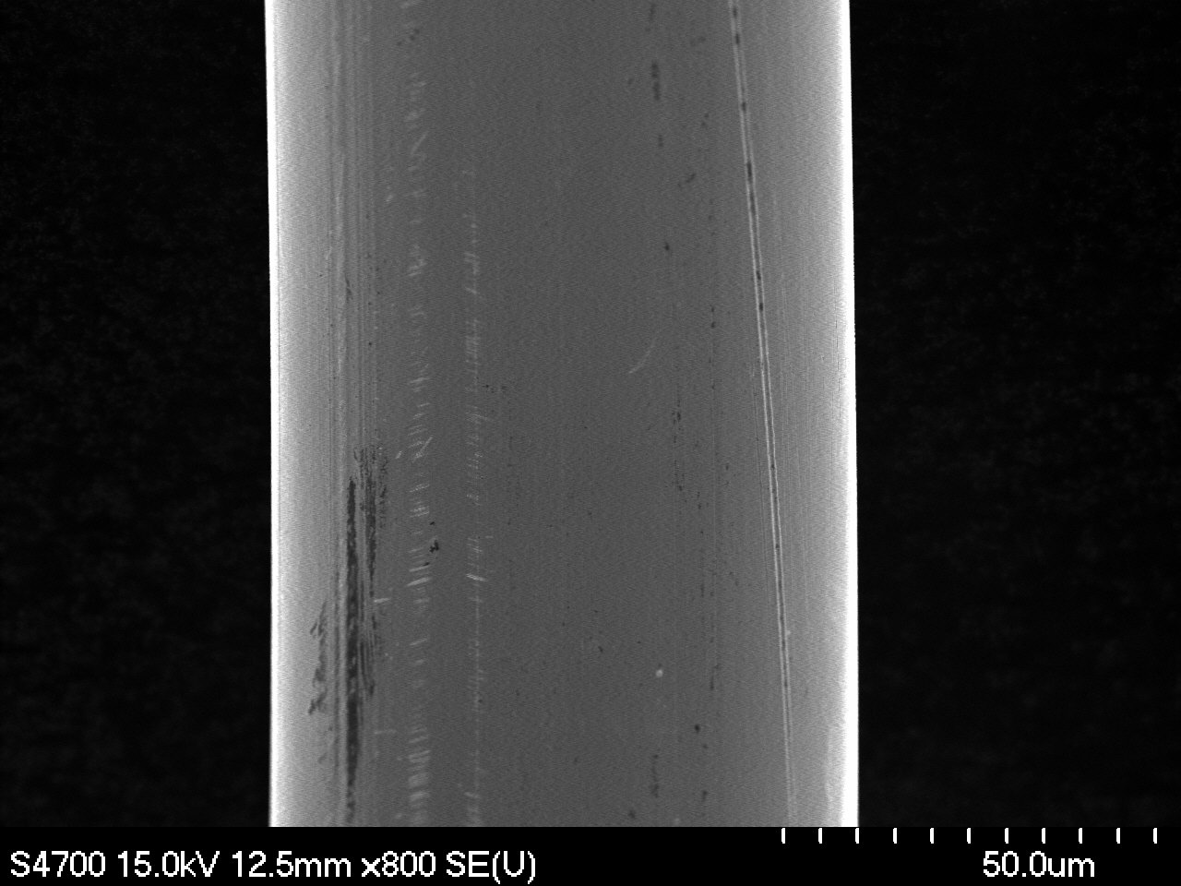 | 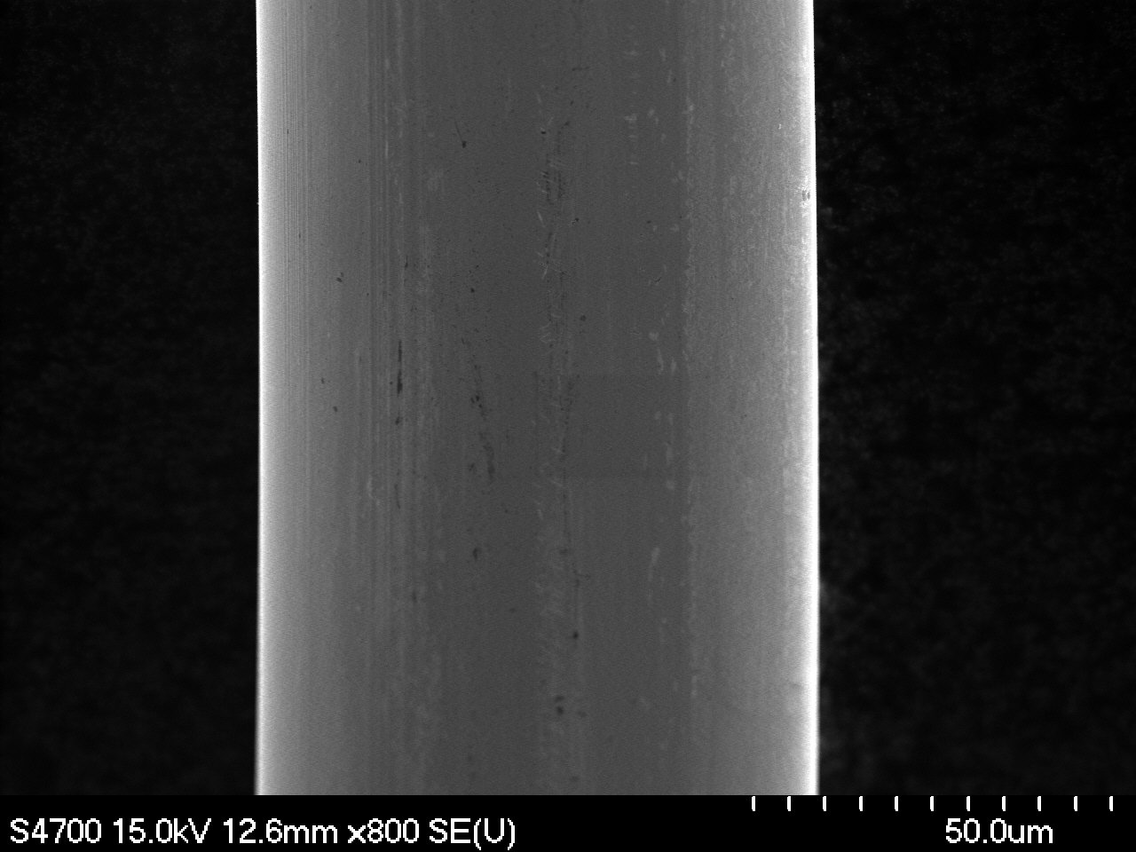
Magnification: 800x | Magnification: 800x
F8-1A-4 | F8-1B-4
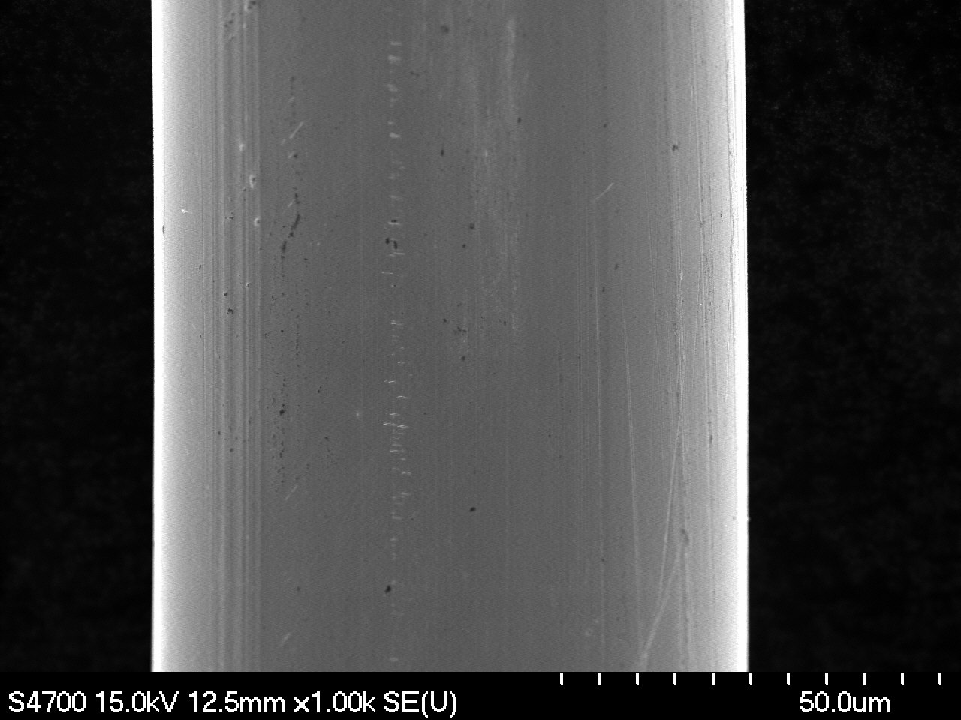 | 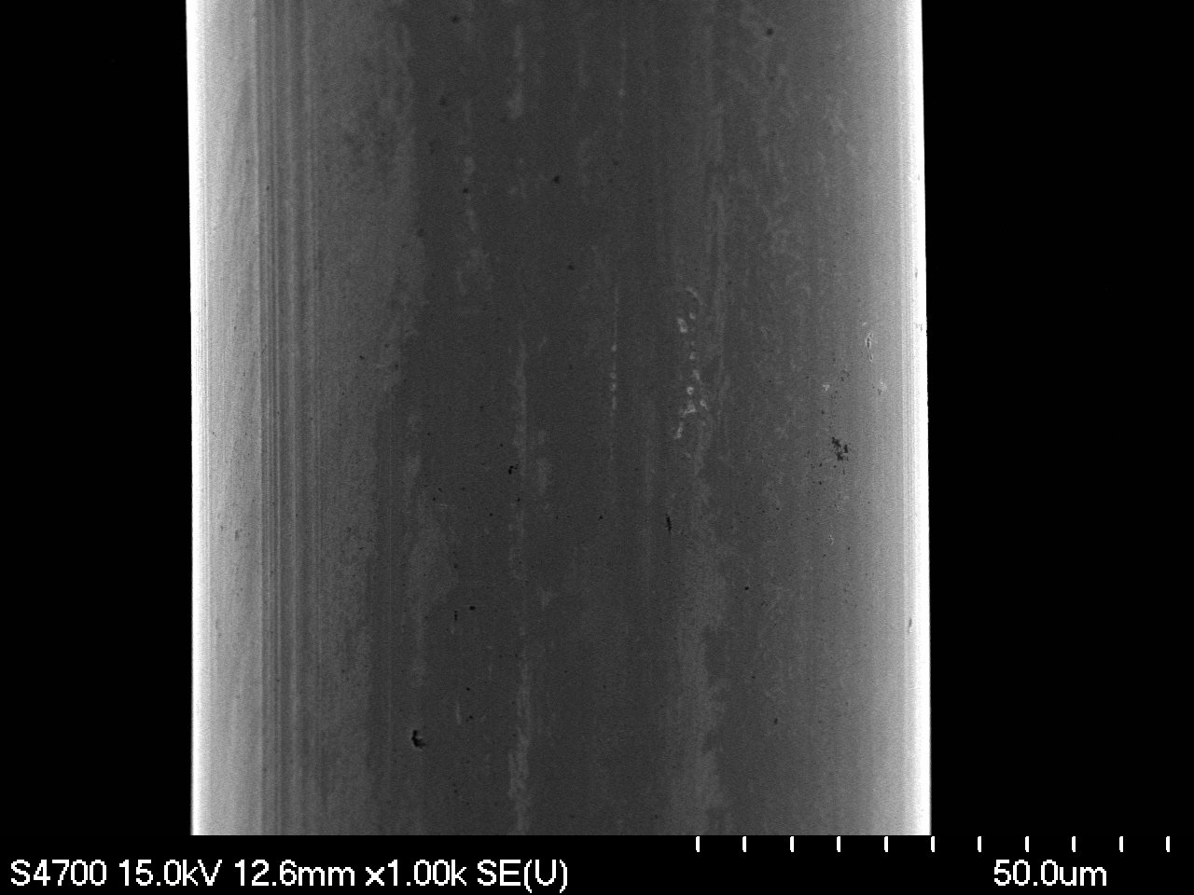
Magnification: 1000x | Magnification: 1000x

II. Ovality Measurements

F8-1A-1o | F8-1B-1o
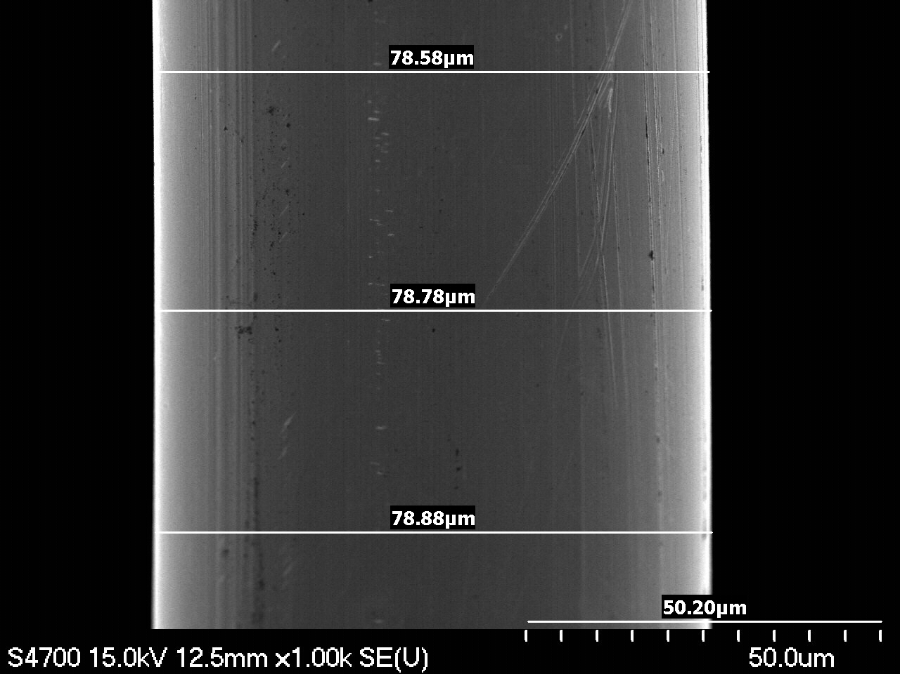 | 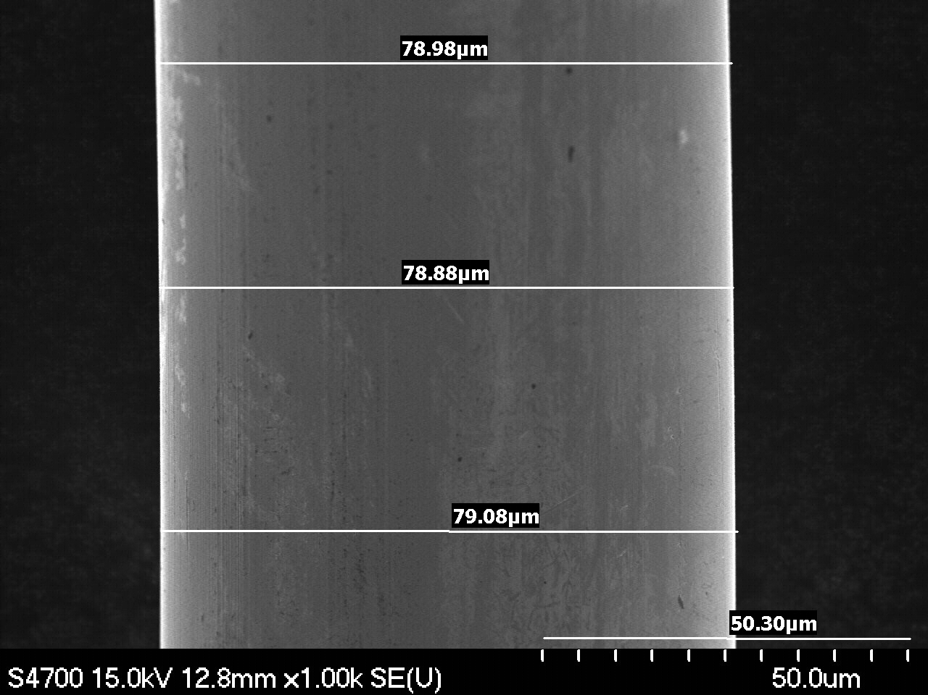
Magnification: 1000x | Magnification: 1000x
F8-1A-2o | F8-1B-2o
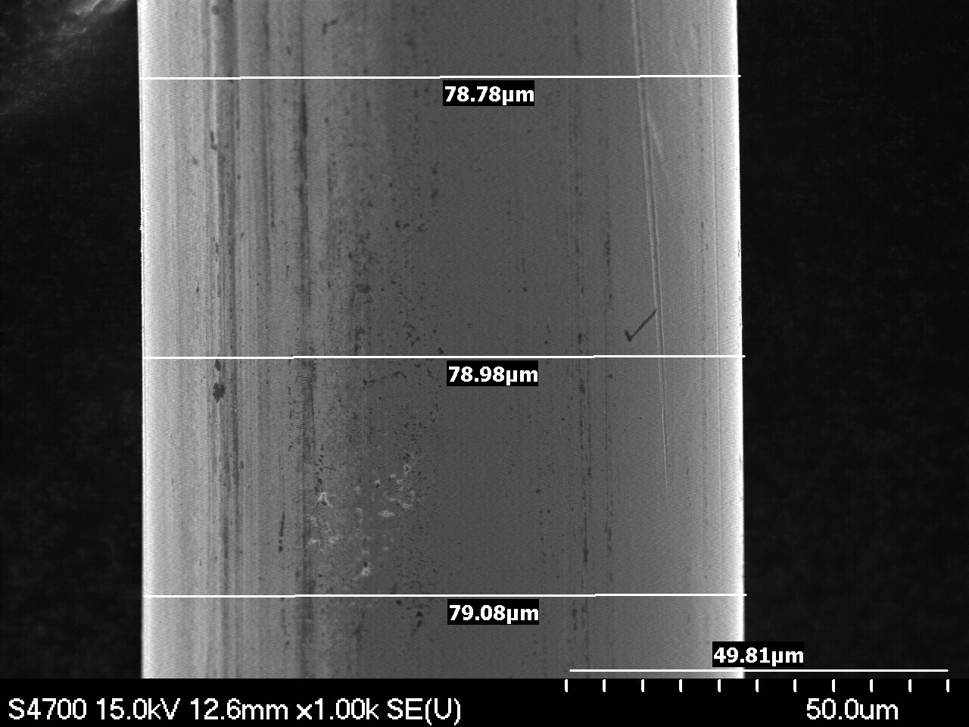 | 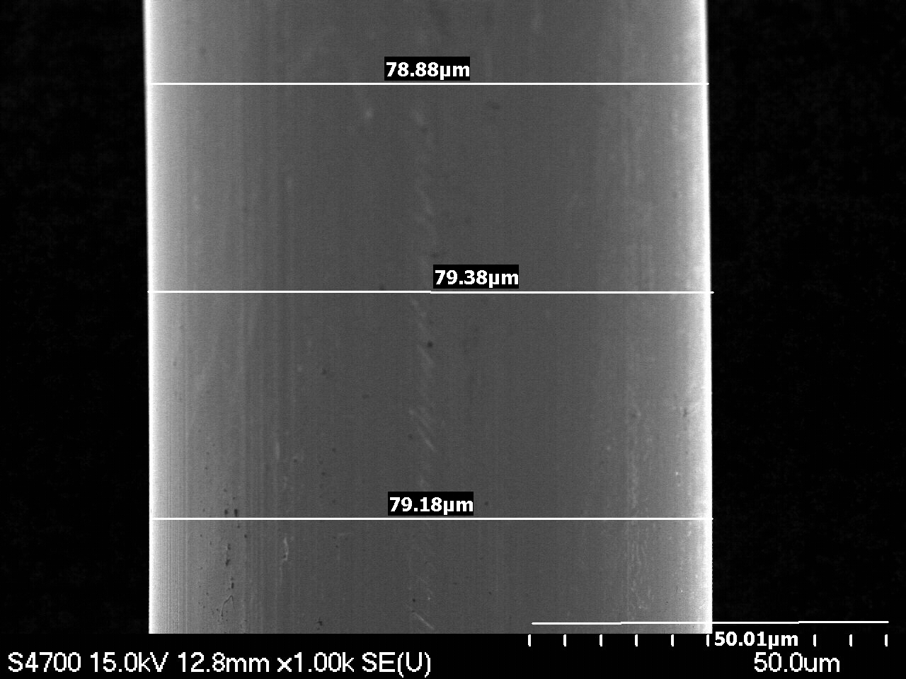
Magnification: 1000x | Magnification: 1000x
F8-1A-3o | F8-1B-3o
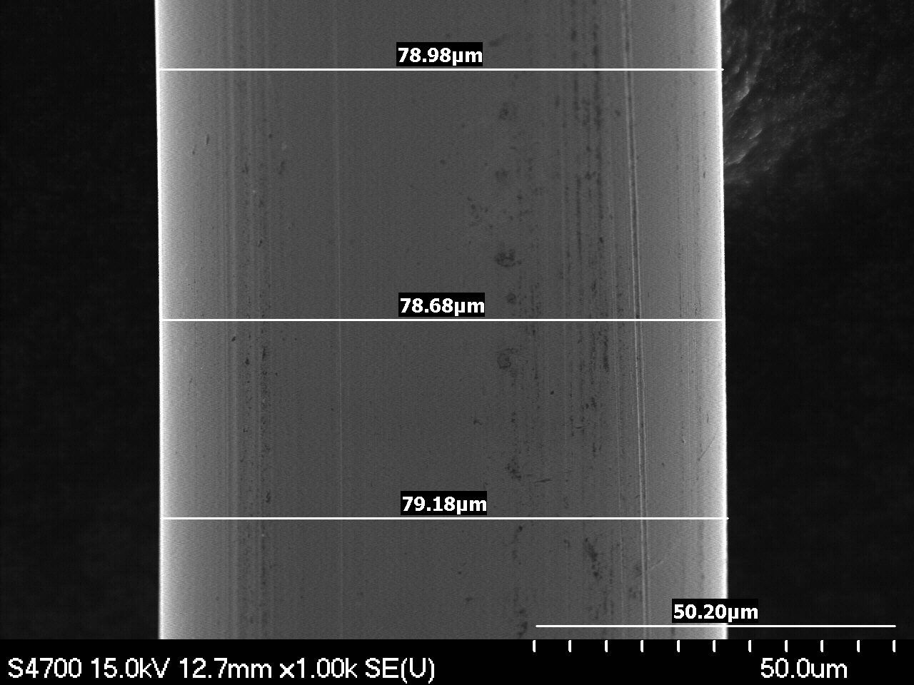 | 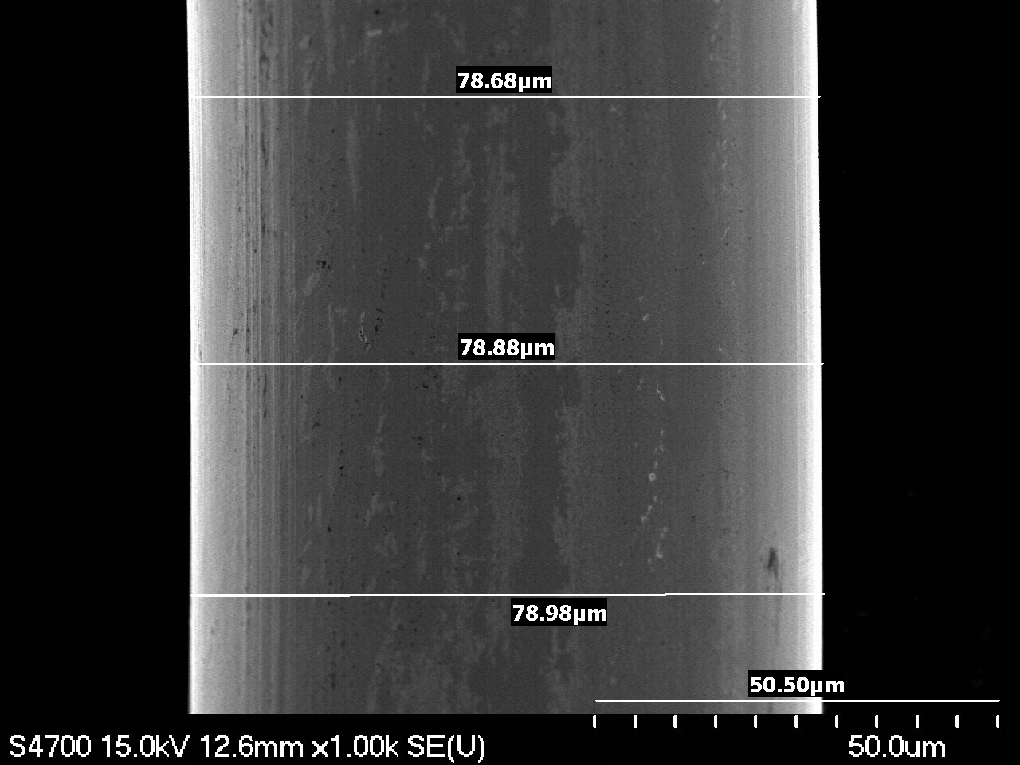
Magnification: 1000x | Magnification: 1000x

III. Points of Interest

F8-1A-6 | F8-1A-6
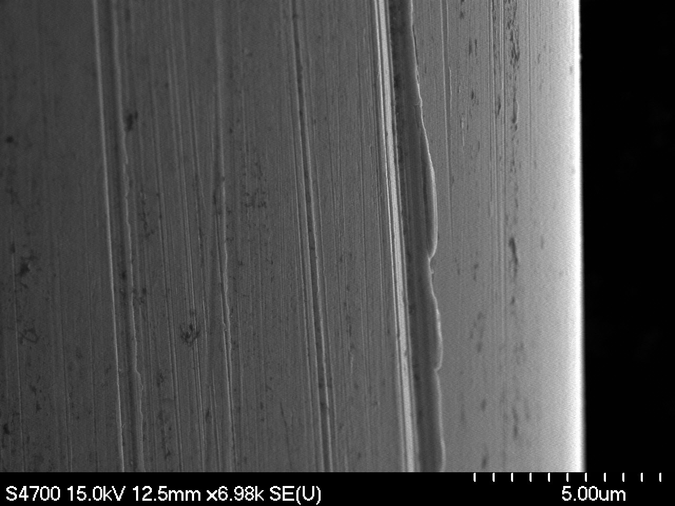 | 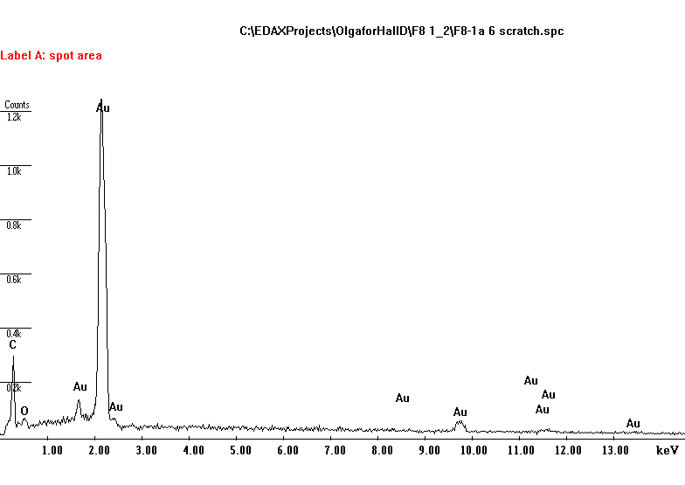
Magnification: 6980x | EDS Analysis. Scratch. No Cu found.
F8-1A-4 Minor scratches. | F8-1A-8 Scratches and contamination.
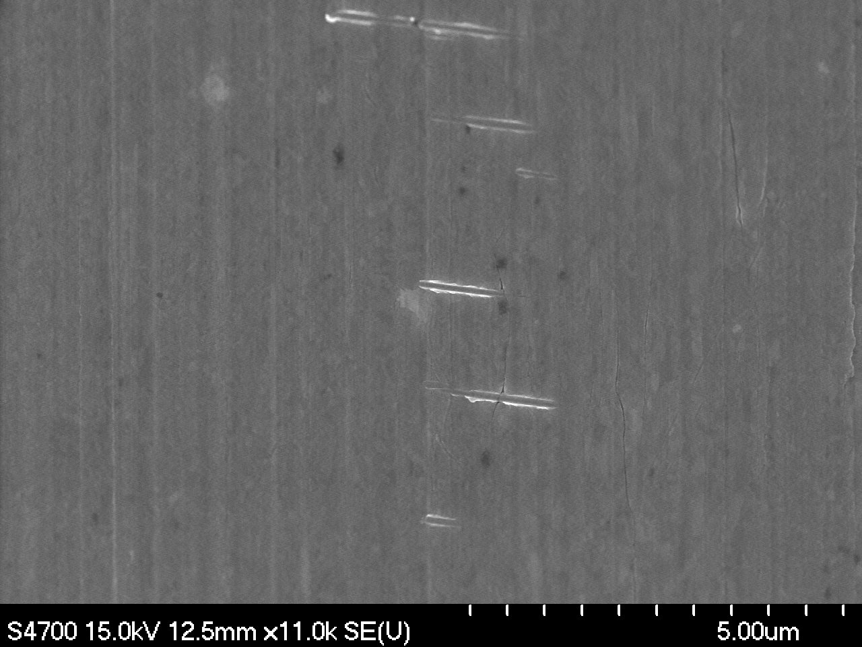 | 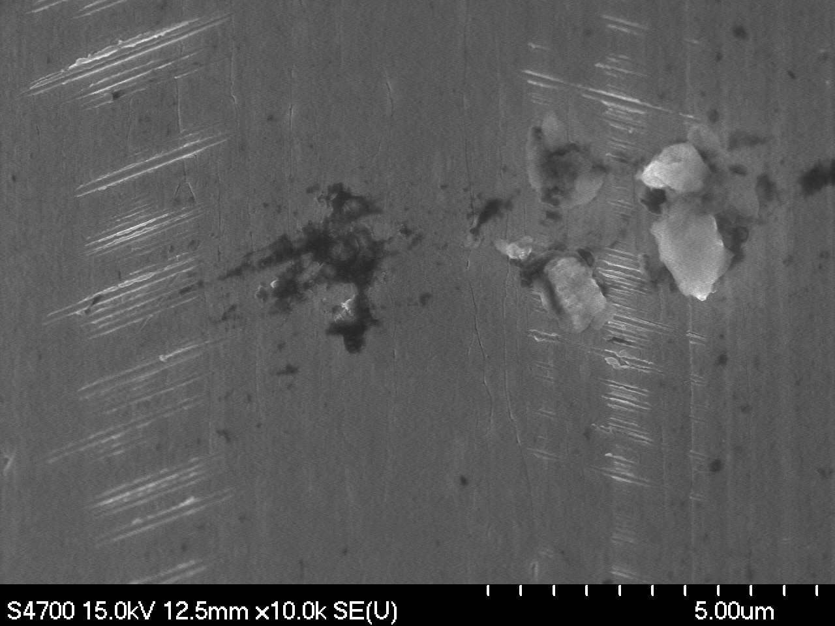
Magnification: 11000x | Magnification: 10000x
F8-1B-5 Environmental contamination | F8-1B-5 Environmental contamination
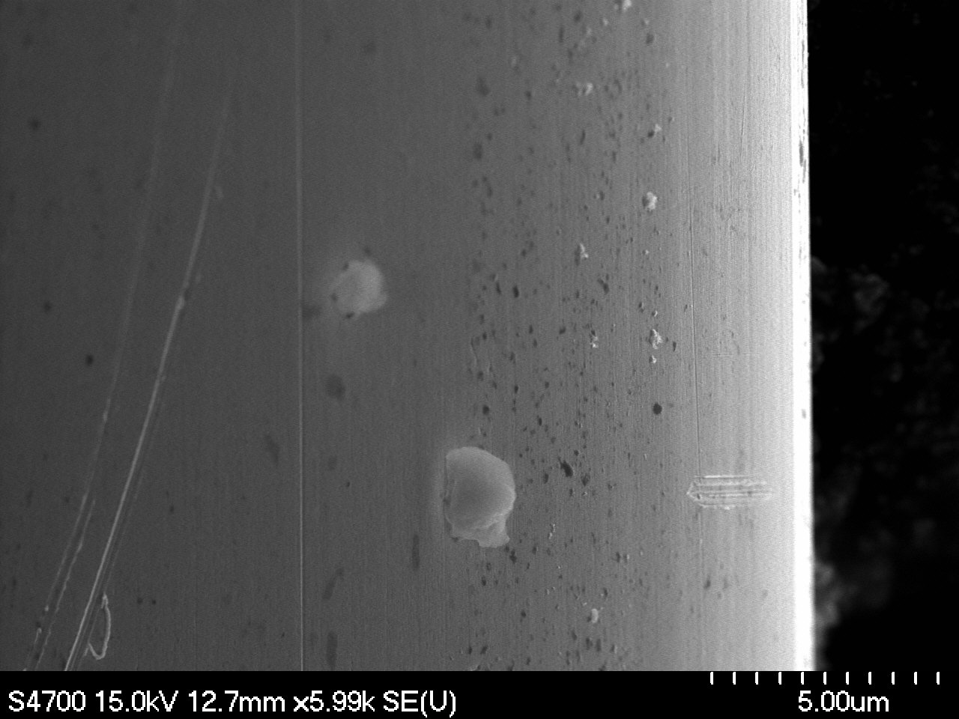 | 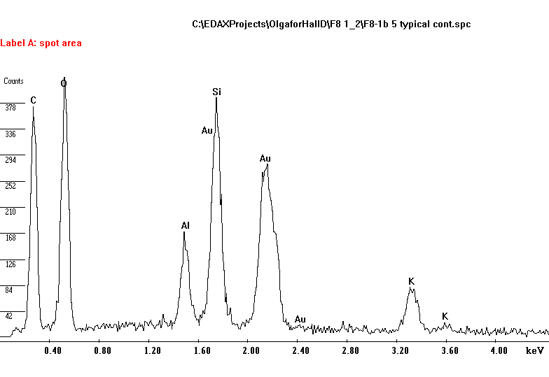
Magnification: 5990x | EDS Analysis. Typical surface contamination

F8-1B-10 Surface damage | F8-1B-7 Surface damage
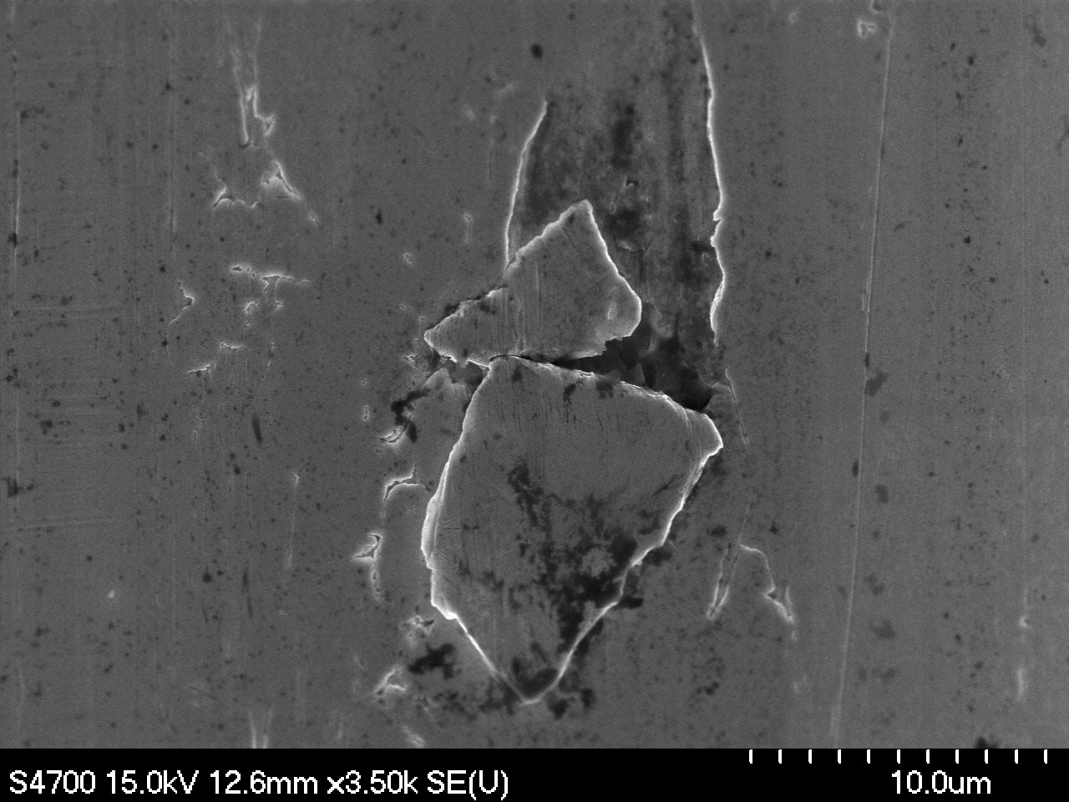 | 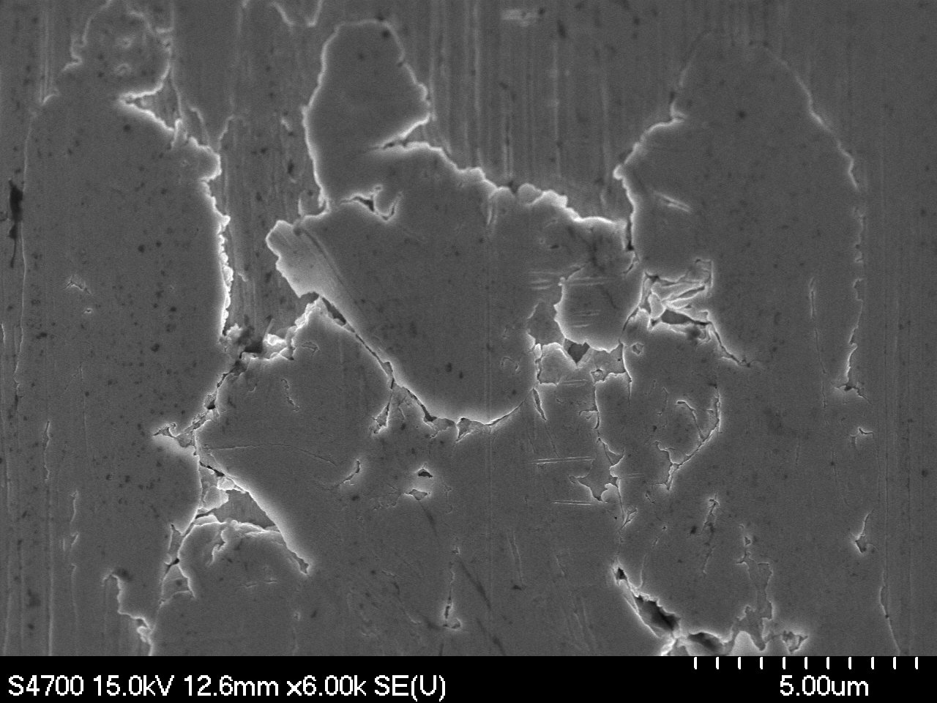
Magnification: 3500x | Magnification: 6000x
F8-1B-7 Surface damage. High mag | F8-1B-7 Surface damage. High mag
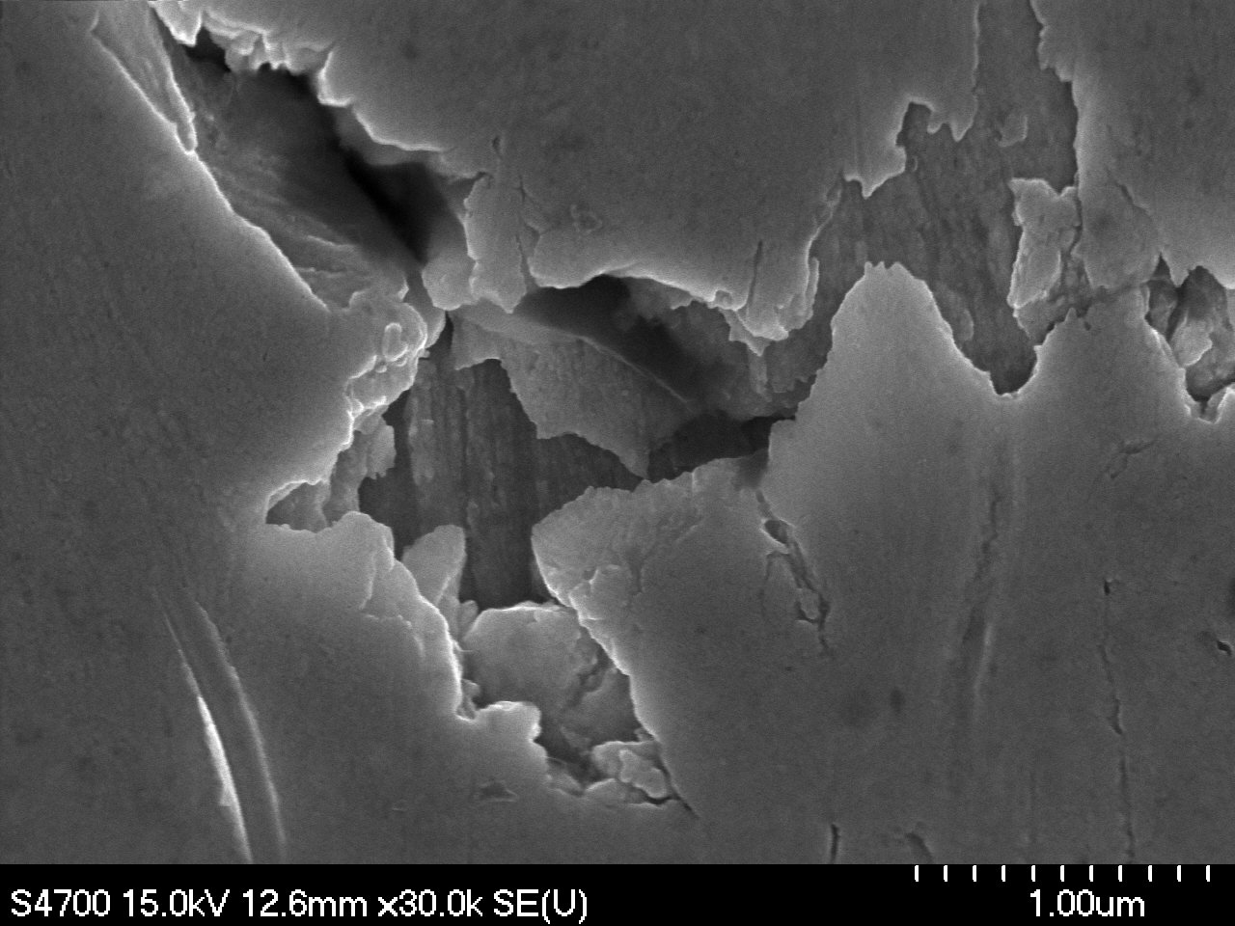 | 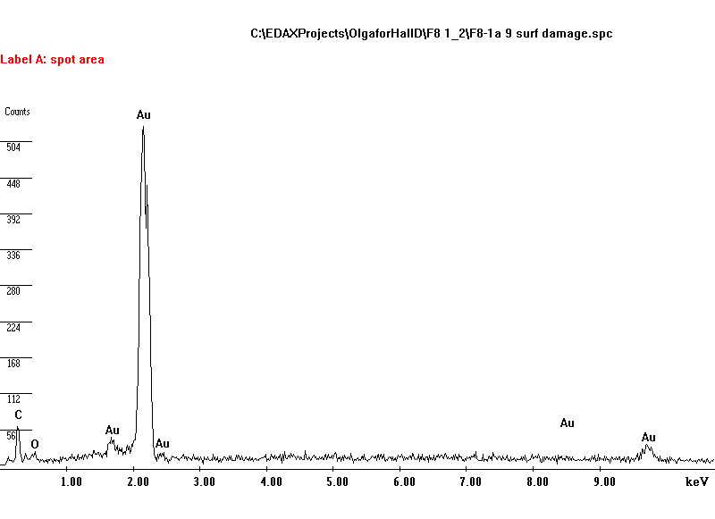
Magnification: 30000x | EDS Analysis. Surface damage. No Cu found.

Note:
- No traces of Cu within the damaged area were indicated by the EDS analysis (detection limit ~1%).

Sample F8-2 A, B
Images at designated magnifications

F8-2A-1 | F8-2B-1
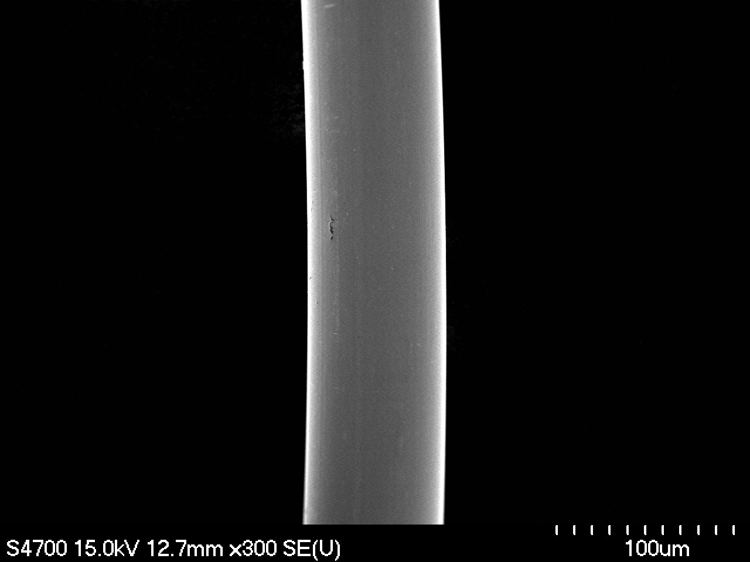 | 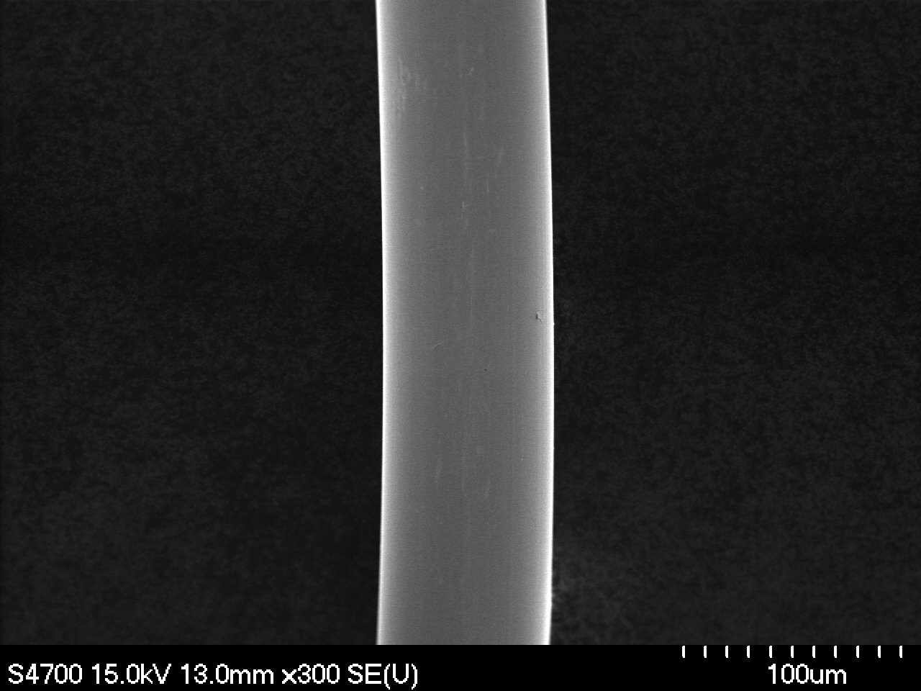
Magnification: 300x | Magnification: 300x
F8-2A-2 | F8-2B-2
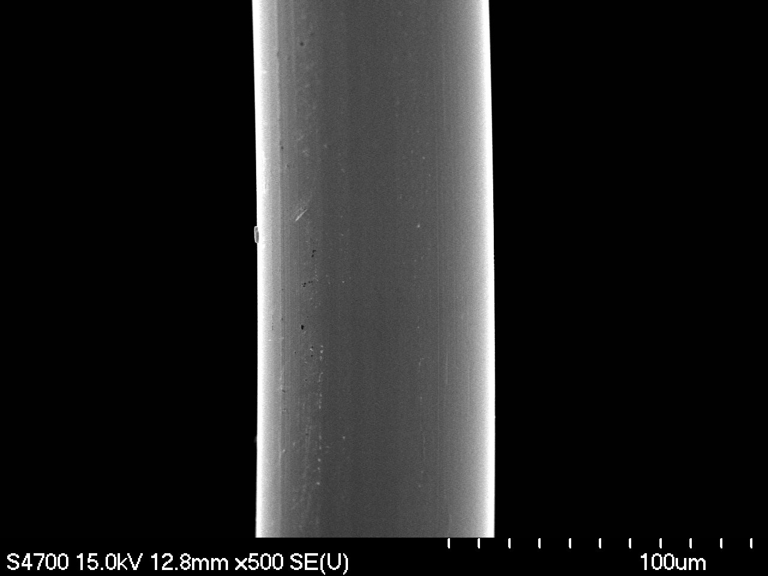 | 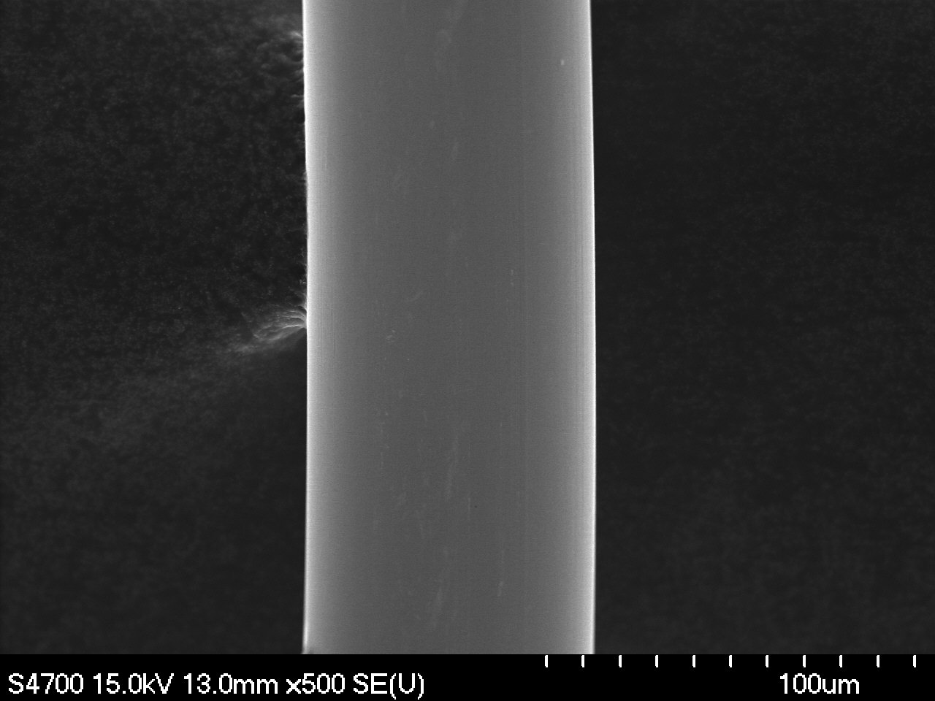
Magnification: 500x | Magnification: 500x

F8-2A-3 | F8-2B-3
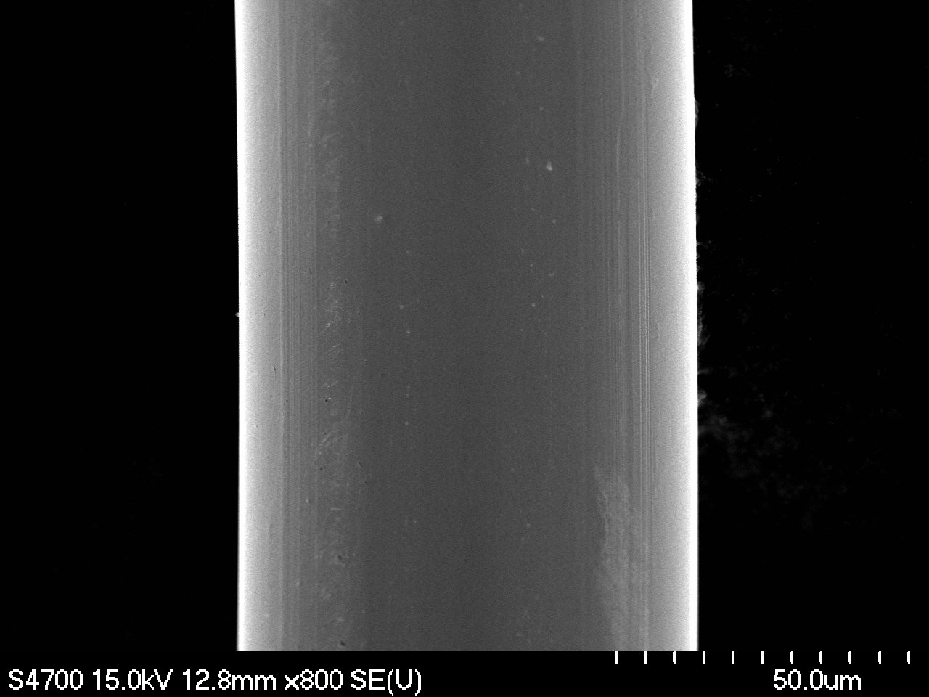 | 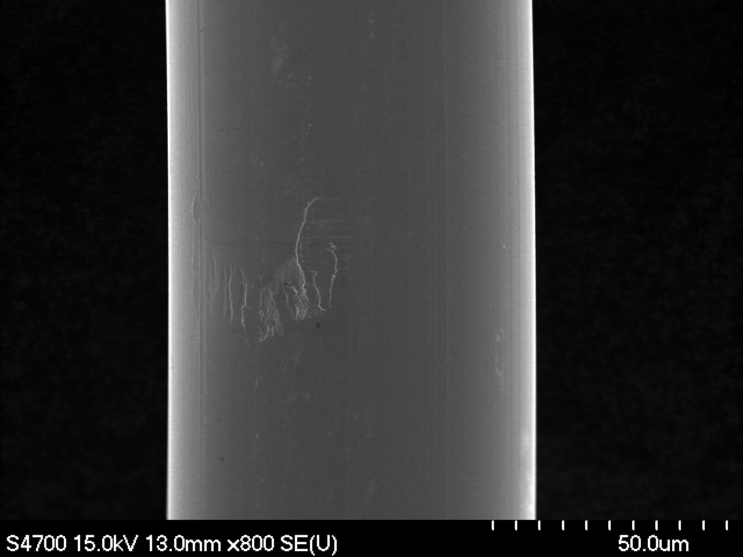
Magnification: 800x | Magnification: 800x
F8-2A-4 | F8-2B-4
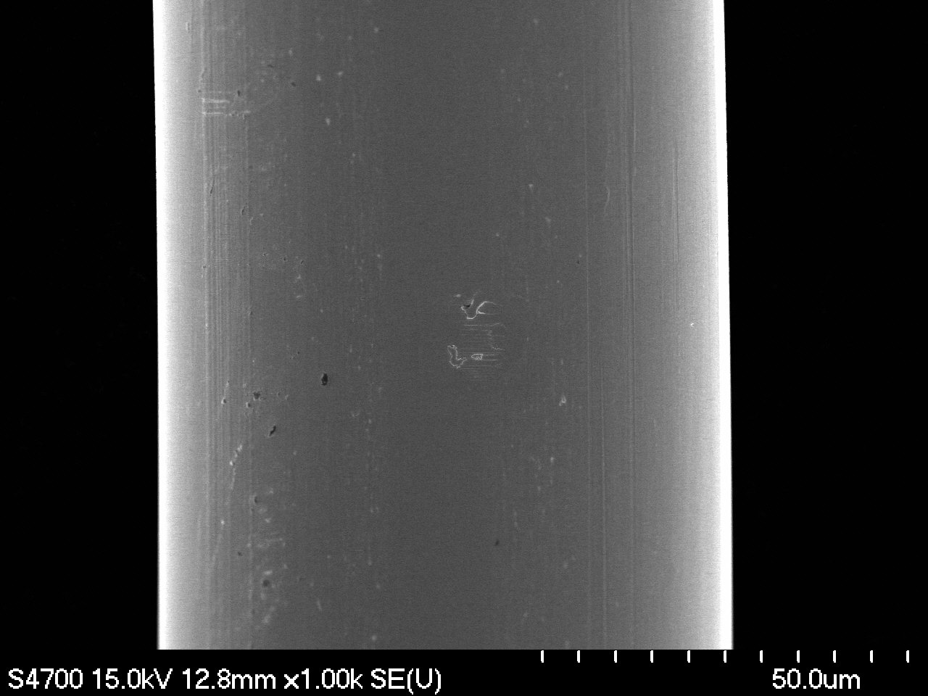 | 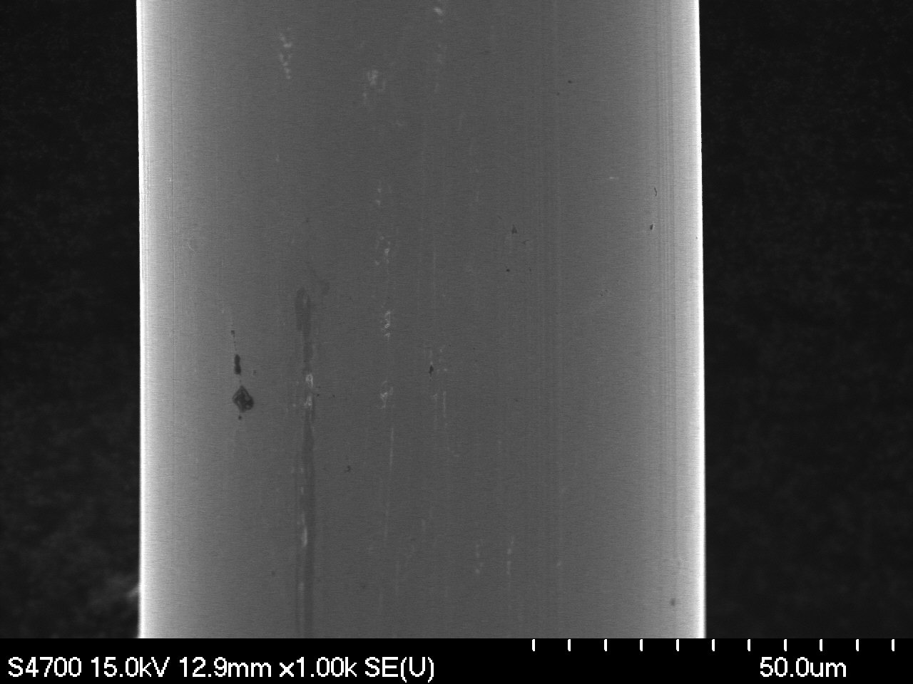
Magnification: 1000x | Magnification: 1000x

II. Ovality Measurements

F8-2A-1o | F8-2B-1o
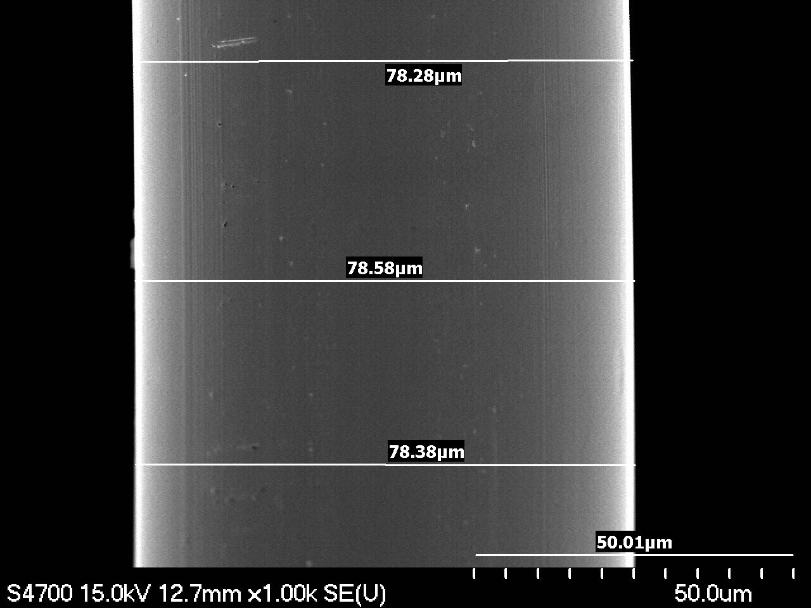 | 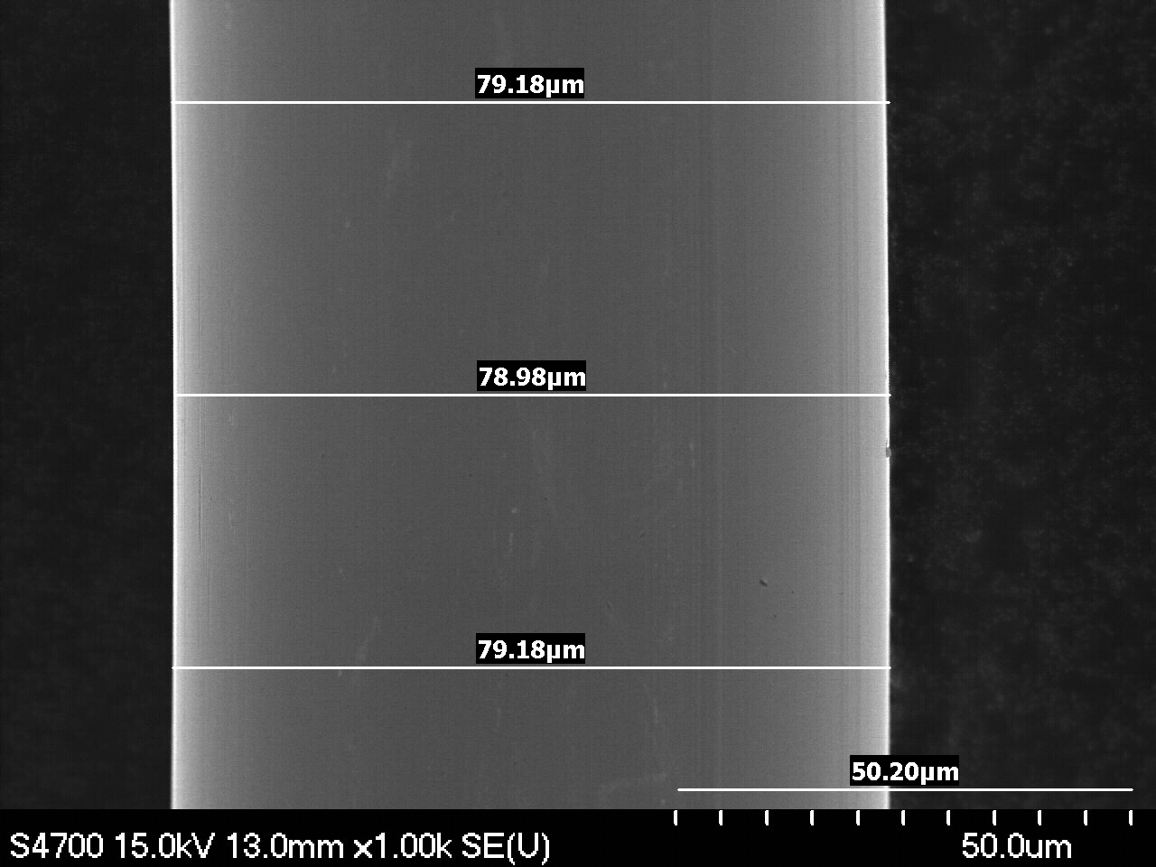
Magnification: 1000x | Magnification: 1000x
F8-2A-2o | F8-2B-2o
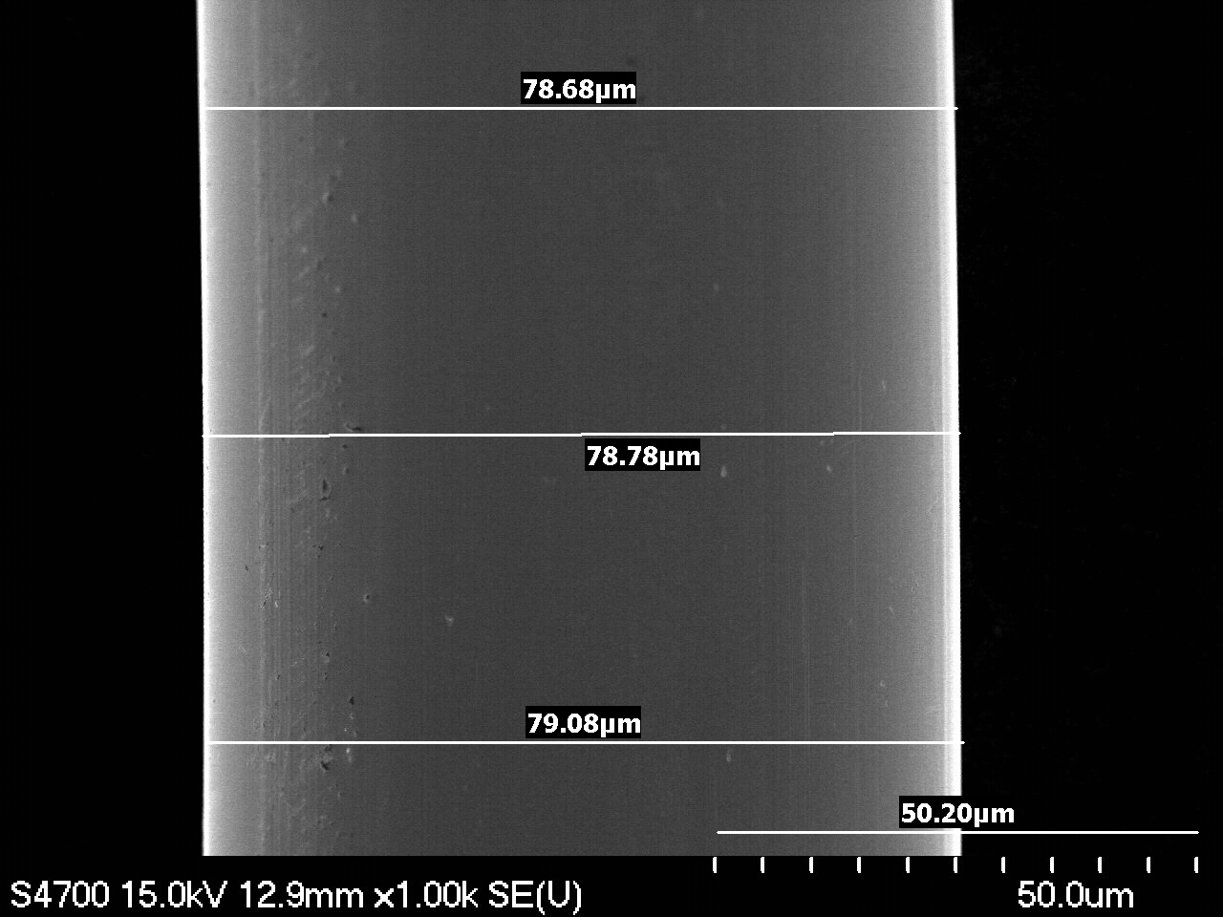 | 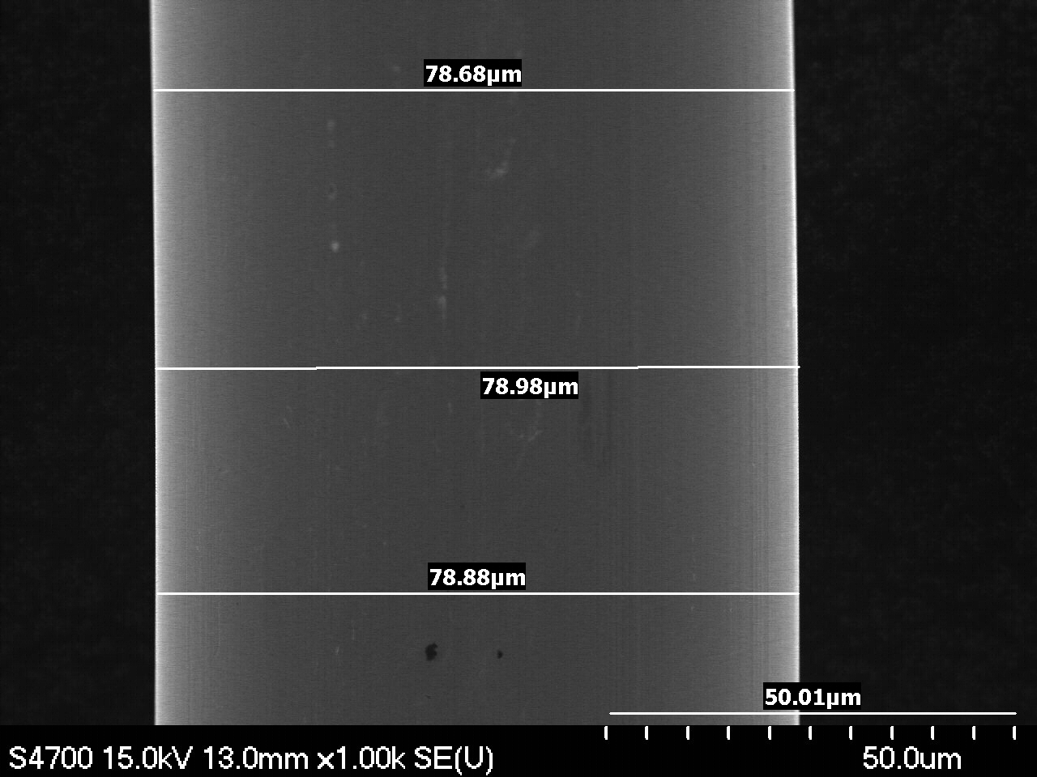
Magnification: 1000x | Magnification: 1000x
F8-2A-3o | F8-2B-3o
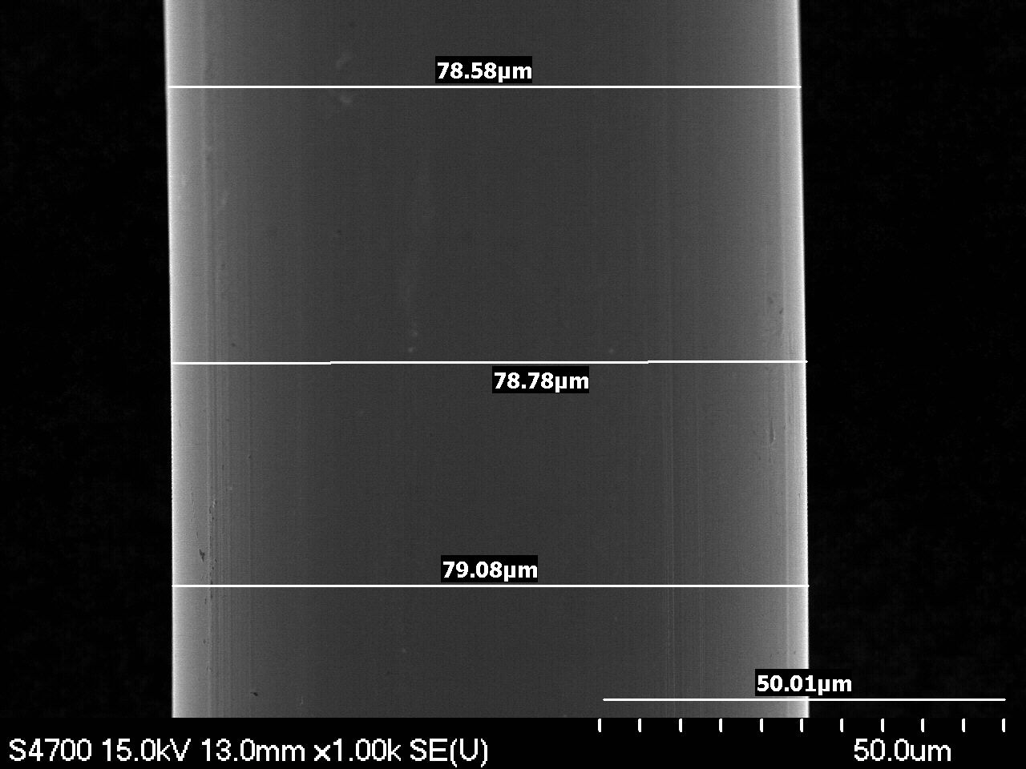 | 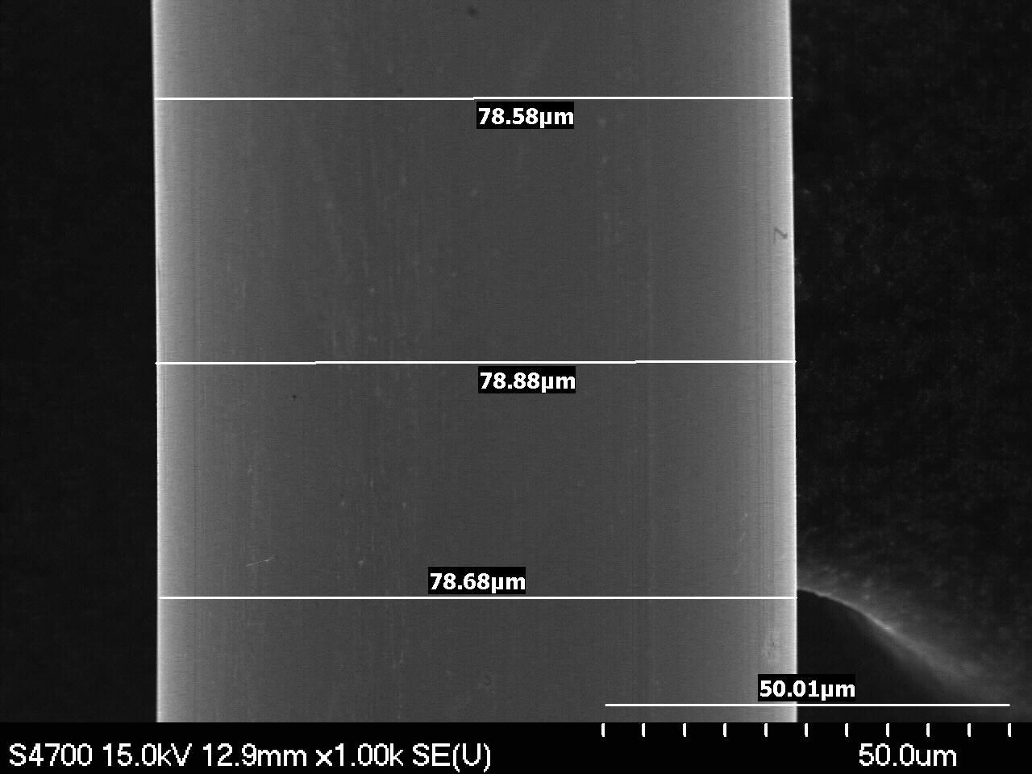
Magnification: 1000x | Magnification: 1000x

III. Points of Interest

F5-2A-5 Scratch and contamination. | F8-2A-8 Surface damage.
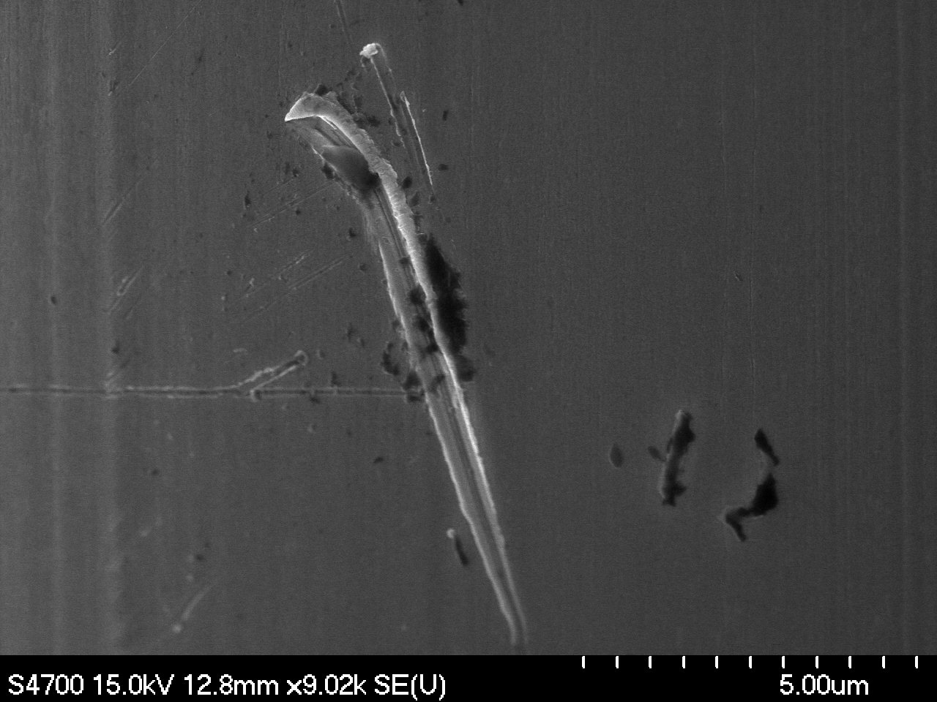 | 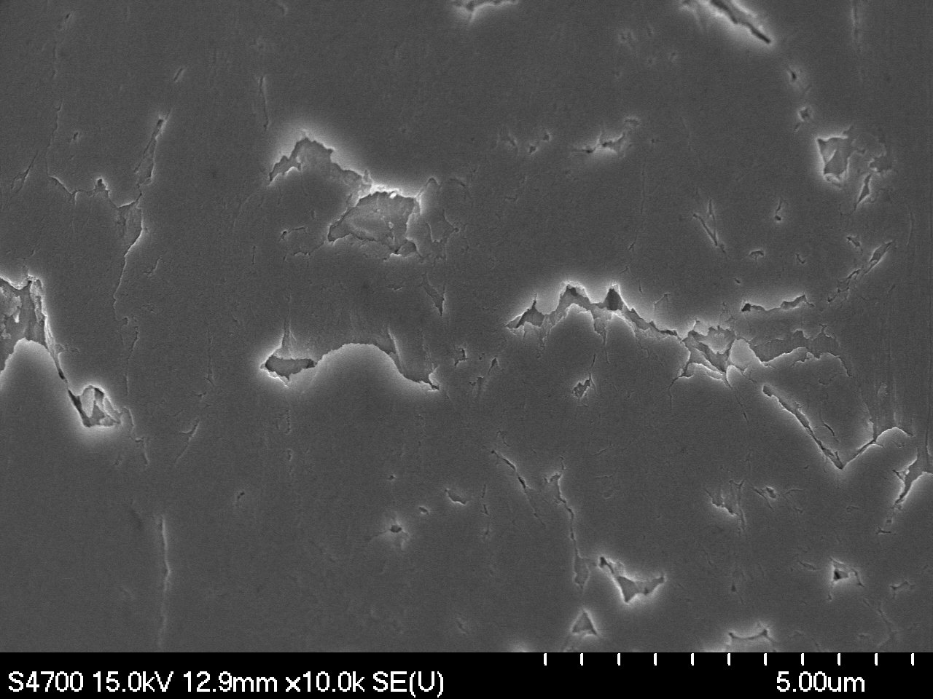
Magnification: 9020x | Magnification: 10000x
F8-2B-6 Surface damage. | F8-2B-4 Surface damage.
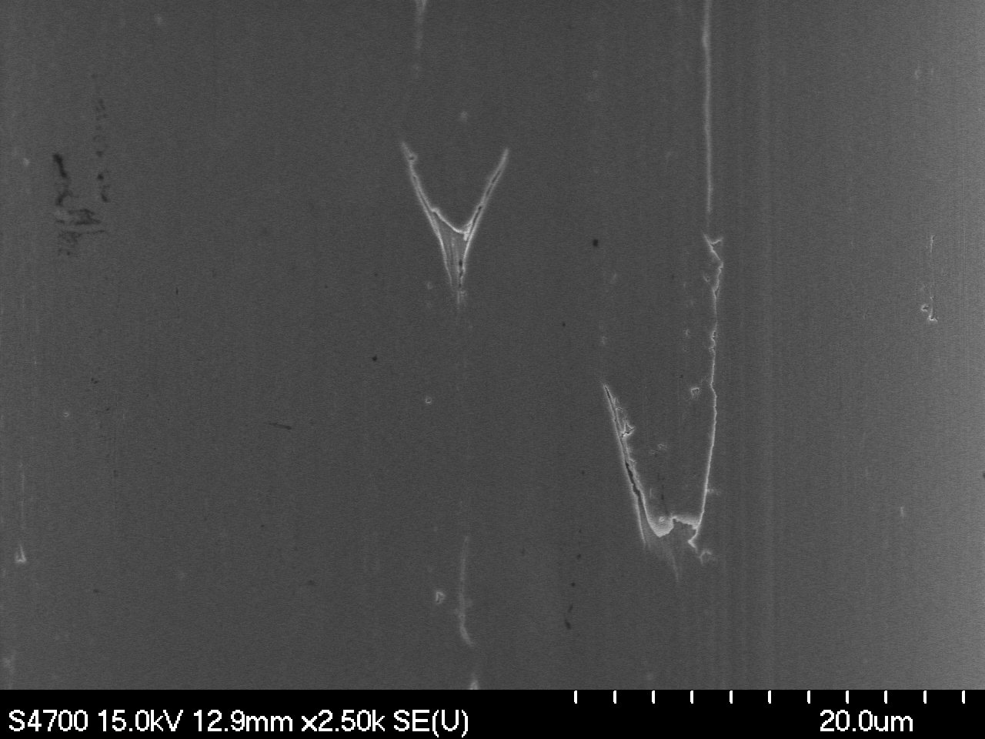 | 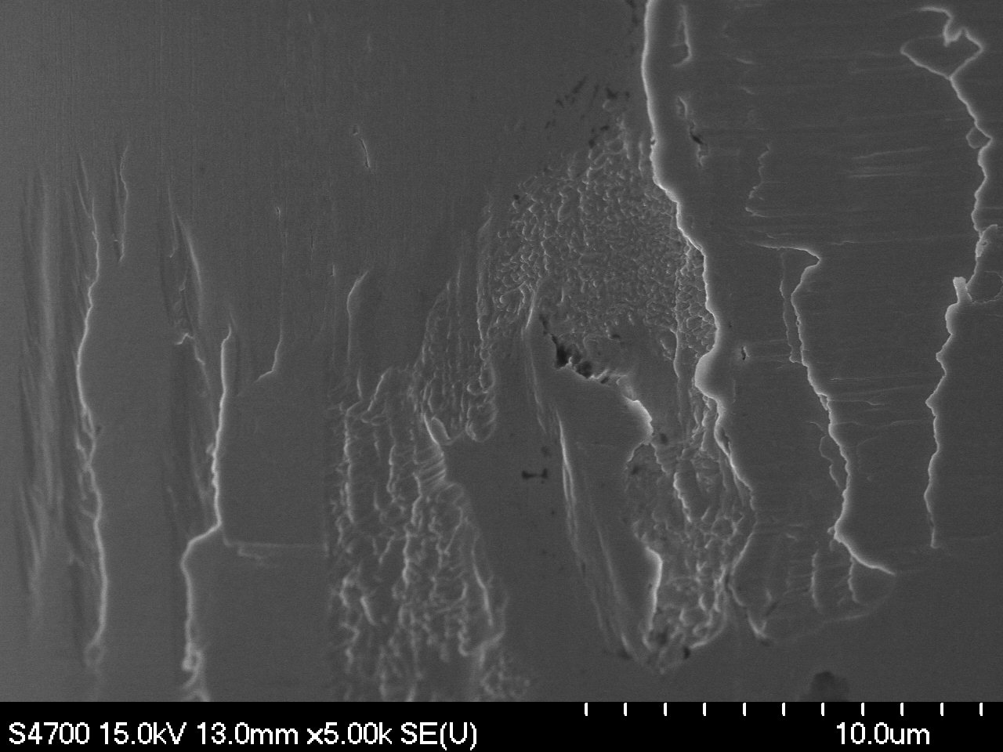
Magnification: 2500x | EDS Analysis. Surface damage. No Cu.
F8-2B-7 Details of surface structure.
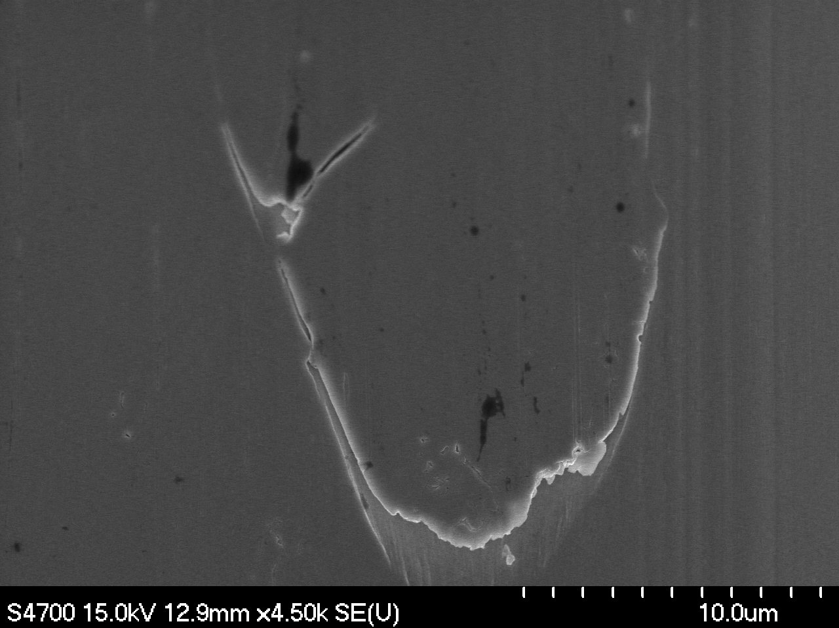
Magnification: 4500x

