TITLE: FORM COOLING TUBE ENDS AND INSTALL MANIFOLDS | DATE: 02/13/2013
BY: DAVE BUTLER | APP: ___________________________
 | PRINT: WILLIAM CRAHEN
CHK:______________________  PRINT: WILLIAM CRAHEN | APP: ___________________________  PRINT:TIM WHITLATCH

REV. | DESCRIPTION | BY | CHK. | APP. | APP. | DATE

PREPERATION
Safety Equipment Required:
# of Technicians Required:
1
Work Station:
??

Material Required:
3/8” Open end or socket wrench
Calibrated torque screw driver set to 100 oz-in with 3/8” socket head
Calibrated torque screw driver set to 13 in-lbf with 14mm socket head (will need to adapt to 6 sided drive- see Tom Cartens. Unit he has is a Utica TS-30, range 6-30 in-lbf)
Torque wrench with 1” socket calibrated to 100 in-lbf
3/32” and 5/32” Allen wrench tips for the torque screw driver
5/32” Allen wrench
Dremel tool with Flexible Shaft attachment
2” diameter fiberglass reinforced abrasive cutoff discs (McMaster 4550A54 or 4550A55)
HEPA Vacuum
Battery powered drill with #2 bit (.1094” diameter)
Ultra soft Polyurethane strip D00000-07-01-2229
Clamp strip D00000-07-01-2228
Cooling tube shaping tool D00000-07-01-2203 4-40 by 1” long socket head cap screw (6 required)
Assembly D00000-01-03-1040 (2 per package)
Assembly D00000-01-03-1037 (if this is package FDC1, use D00000-01-03-1041 instead)

Reference drawings:

D00000-01-03-1037,1038,1040,1041 and tool drawing D00000-07-01-2203

Procedure

- Assemble manifolds D00000-01-1037 (or D00000-01-1041 if this is FDC1) as per their corresponding drawings. The Noryl manifold should be held in a vise for this operation. Install the small fitting with a 14mm socket wrench on a calibrated torque screwdriver to 13 in-lbf, and the large fitting with a 1” socket to 100 in-lbf.

- Here is a reference view for the cooling tubes. The 8” dimension would be for future repairs. Packages FDC1-FDC4 currently have extra length.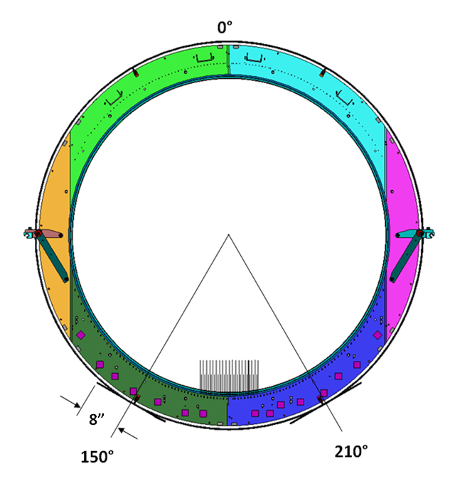

- Here is a close up for what you should see at the 150° location. The cyan tube is for cell1: 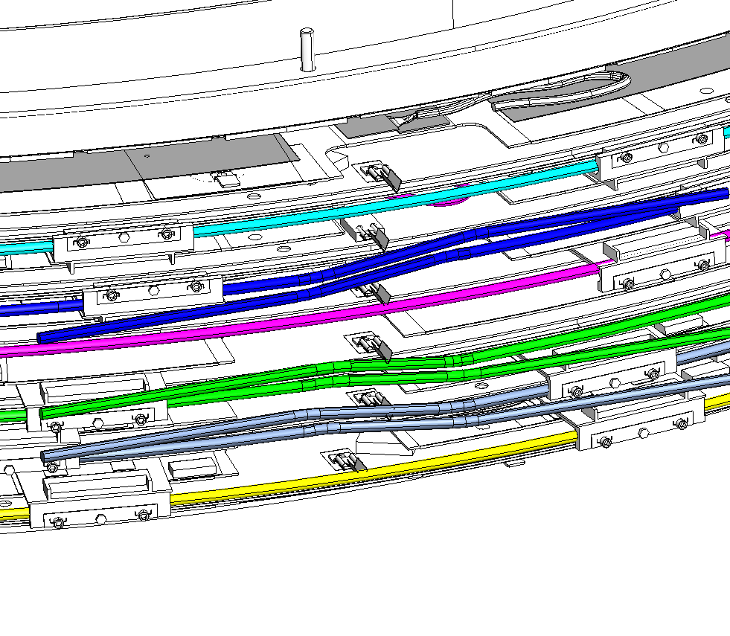

- Use the 3/8” wrench and the torque wrench to add side brackets. Torque to 100 ounce-inches:

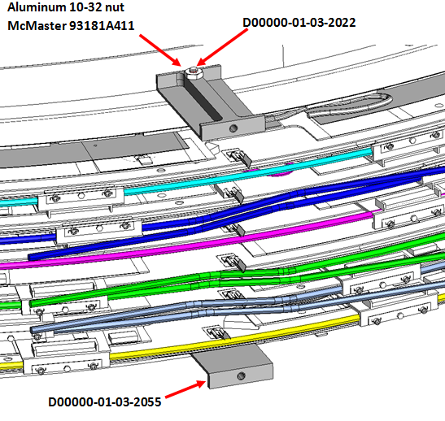

- Use the 5/32” Allen wrench to add the lower plate as shown below:

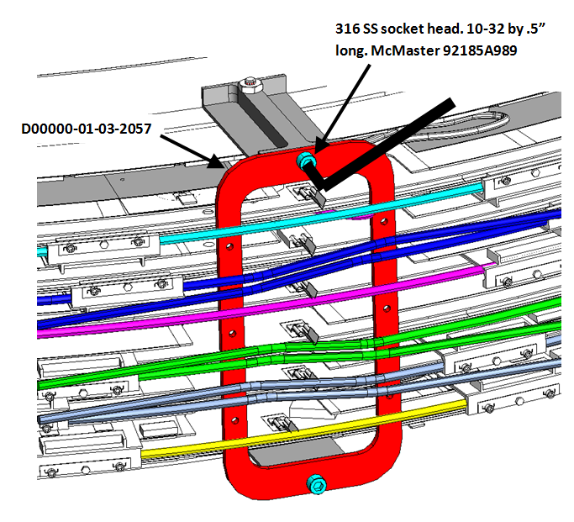

- Position Ultra soft Polyurethane strip D00000-07-01-2229 As shown below:
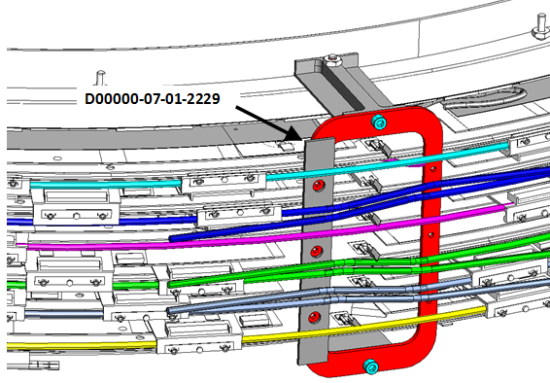

- Add the clamp strip D00000-01-2228. You will need 4-40 by 1” long socket head screws and the 3/32 Allen wrench, just tighten until tubes are secure :

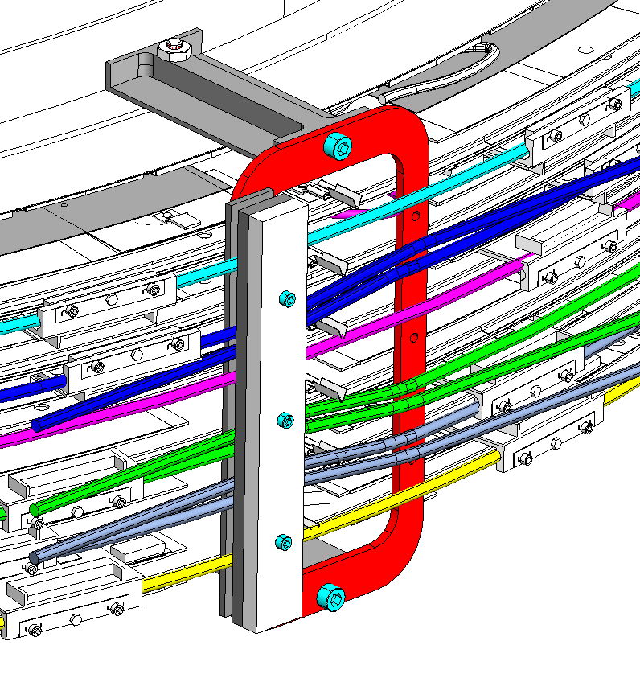

- Bend the tubes by hand as shown below. Inner radius should be about 9/16” and begin at the clamp strip. Bend slowly to control the shape (a wooden dowel split in half might work as a forming aid):

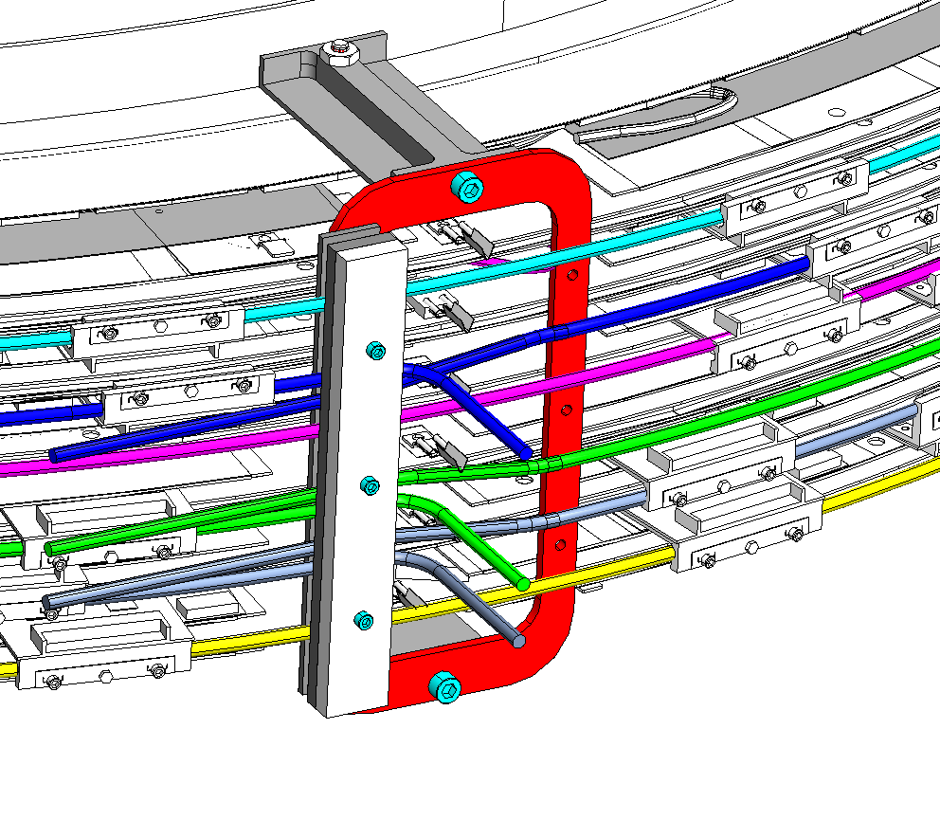

- Move the clamp pieces and repeat for the other side:

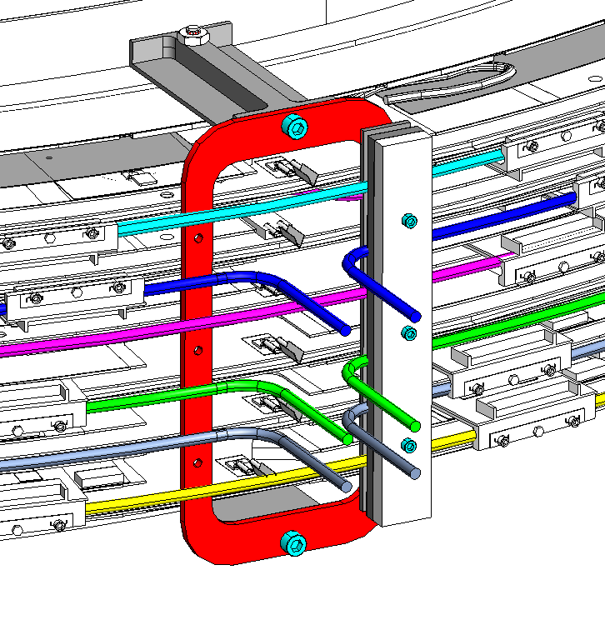

- Remove the clamp pieces and attach pieces D00000-01-03-2056 with six 316 stainless steel screws 4-40 by 3/8” long (McMaster 92185A108). Use the calibrated driver set to 25 in-oz for this operation! Note the position of the notched ends. You will need to adjust your bends to fit the notches and to match the tube positions in tool D00000-07-01-2203. You may also wish to fully immobilize the tubes by wrapping them with pieces of the Ultra soft Polyurethane used previously to fill the gaps under part 2056:
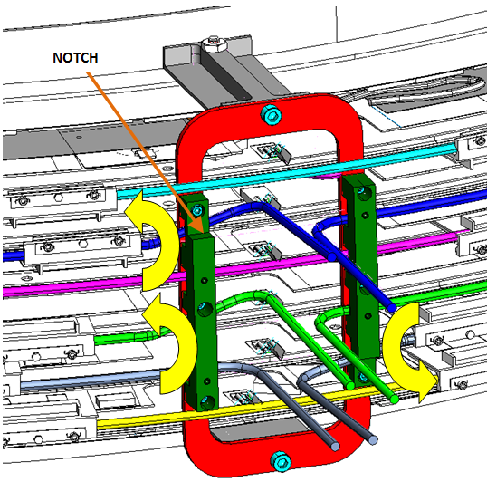

- Attach forming tools D00000-07-01-2203 with 4-40 by 1” long 316SS socket head cap screws (McMaster 92185A115) using the calibrated driver set to 36 0z-in:
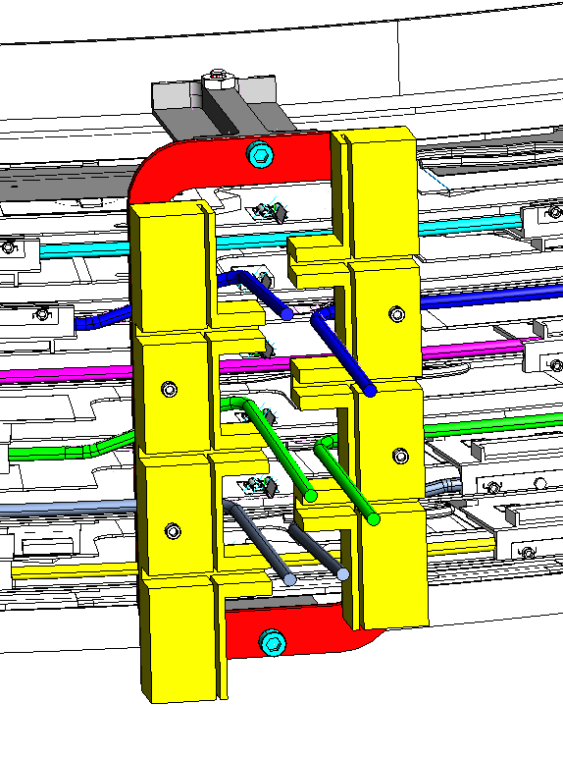

- Bend the tubes down into the slots as shown below:
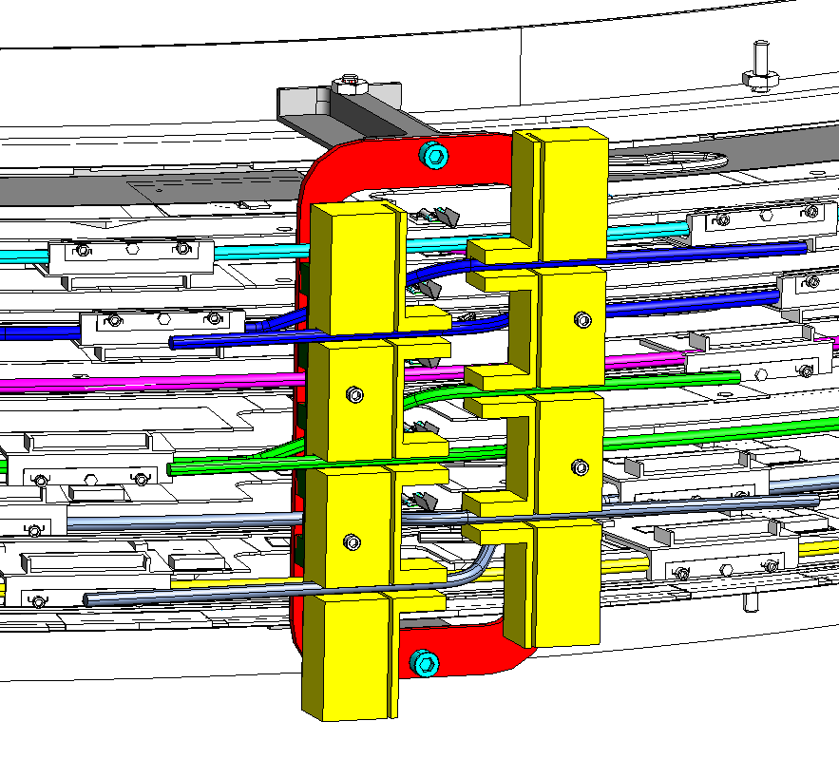

- Mask the area around the tubes with wads of Kemwipes to keep stray copper particles from winding up in the package electronics. Use the Dremel Flex shaft attachment with the abrasive cutoff discs to cut the tubes, use the HEPA vacuum held close to the cutting area to collect debris:
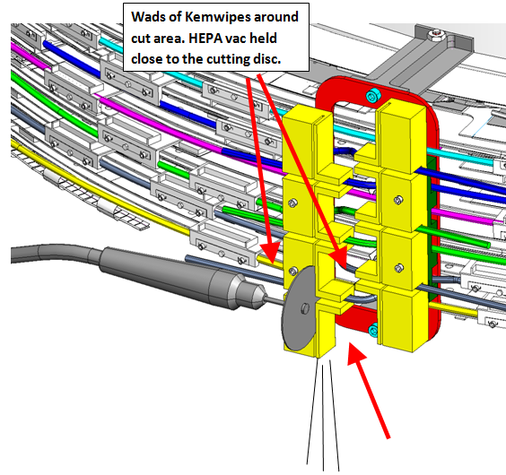

- Remove the forming tools but and de-burr the tube ends. Be careful in doing this to not scratch the outer surface of the tube, as this could cause the Swagelok fitting to leak. Use the battery powered drill (at SLOW speed) with the #2 bit (.1094” diameter) to open up and de-burr the tube I.D.

- Use canned air to remove any copper particles that may have landed on the package. Insert the Canned air nozzle in one end of each tube, while covering the other end with the HEPA vacuum to collect debris. Thoroughly flush each tube:

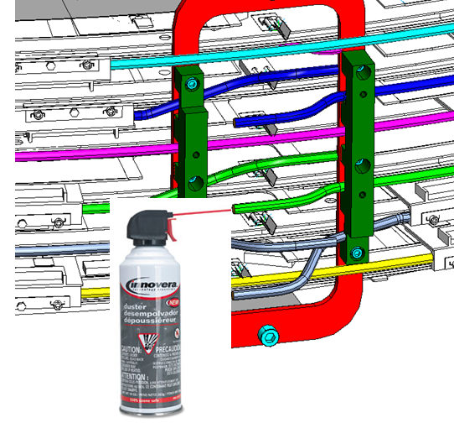

- Add A piece of tape to act as a backstop for the Swagelok nut and Ferrules:
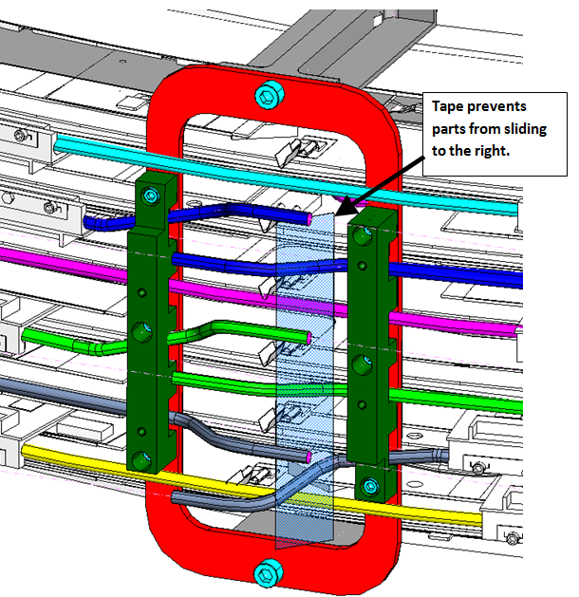

- Add the Swagelok nut, upper and lower ferrules to all three tubes. These are included with the fittings, but the part numbers are shown for future reference. Slide the manifold into place as shown below:
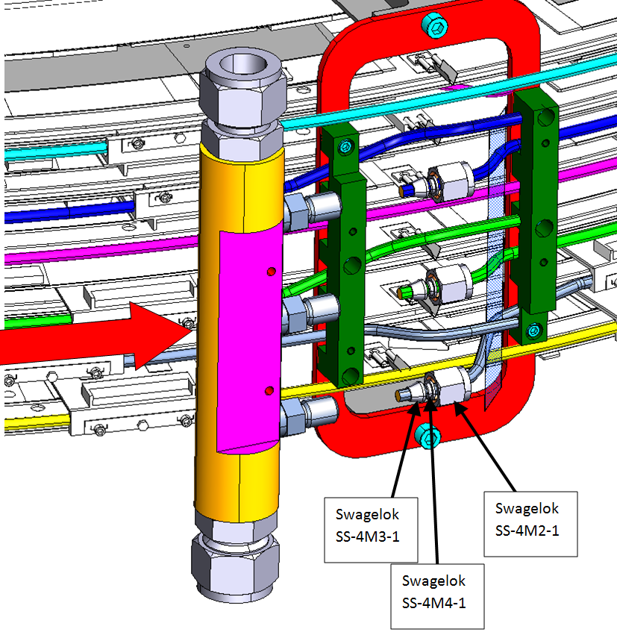

- Screw the Swagelok nuts on, but leave them loose. Attach the manifold to the bracket with 4-40 by 1” long 316SS socket head cap screws (McMaster 92185A115). Torque screws to 36 oz-in. Tighten the Swagelok nuts to finger tight. Use a 12 mm open end wrench to tighten the nuts one and a quarter turn while holding the base of the fitting with a 14 mm wrench:
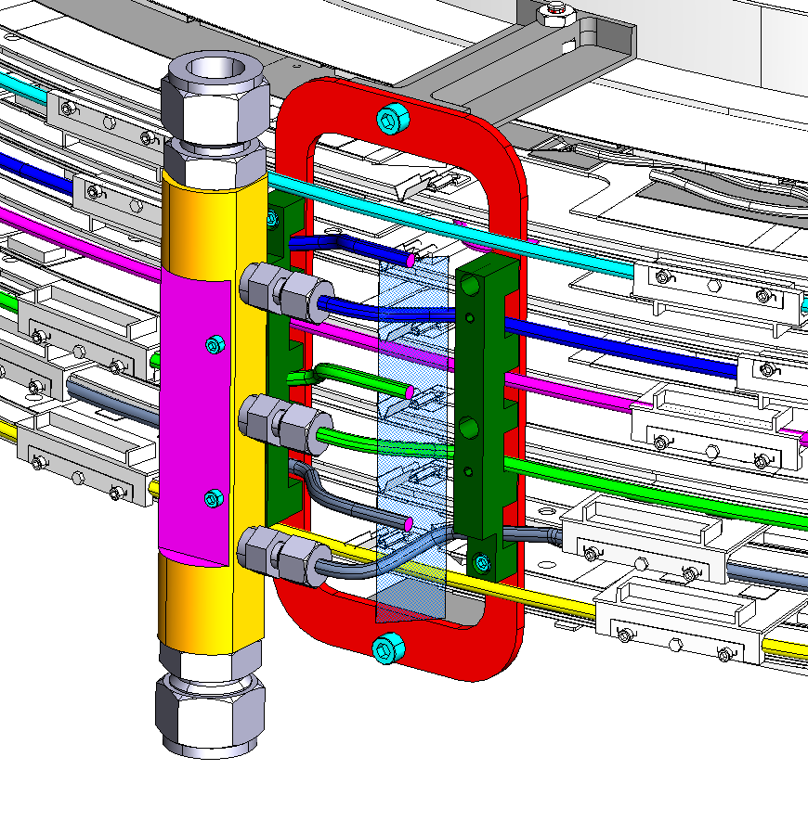

- Repeat the procedure for the right manifold.
- Repeat entire procedure for the assembly located at 210°. Here is what the final assembly should look like when complete:
