FDC prototype stack assembly Procedure
Procedure 1: Grind out pockets on the back of the wire board for the screwed up preamps and grounding card! Blueprint in 126.
Procedure 2: Glue the first wireboard to the end window lamination with the screwed up cathode:
NOTE: THIS CATHODE IS A xxxxxx MICRON BOARD
Mark the protective cover on the Rohacell edge as shown below to assist in relocating it to the wireboard.
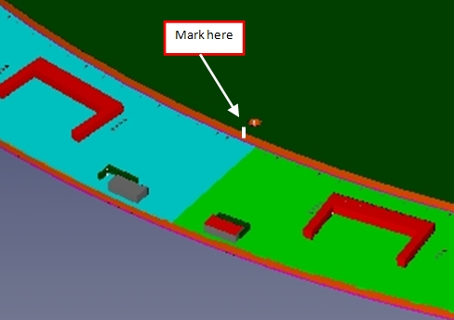
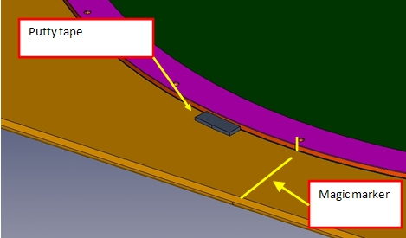
Place the protective cover (wire side up) on the Lexan sheet and locate it with two lamination pins. Apply putty tape on the Rohacell edge to secure the cover to the Lexan sheet (three or four places). Make sure that the putty tape does not extend above the top edge of the cover. Remove the lamination pins. Use a magic marker to extend the mark on the edge of the cover radially outward on the Lexan sheet.

Install two lamination pins in the wireboard from the backside (side opposite the wires). Have one pin located at the position used to mark the cover. Carefully lower the wireboard onto the cover oriented with the magic marker line. Tack the edges of the wireboard to the Lexan sheet in three or four places as was done with the cover. Remove the lamination pins.
Install two lamination pins in the screwed up cathode end window assembly and dry fit to the wire board, orienting as shown. Pay special attention to the areas where the preamps feed through- make sure that the cathode comes in contact with the wireboard with no gaps. Remove the cathode when done.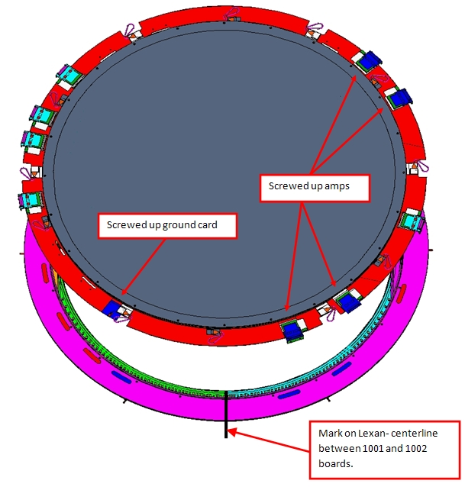
Place Kemwipes around the O.D. of the wire board to catch epoxy drips. Mix approximately 20 cc of Hysol. Using the foam roller, SLOWLY ROLL (don’t roll fast- this causes splatter) epoxy onto the G10 surface- keep drips and splatter off the wires!

Carefully lower the cathode onto the wireboard, taking care that the lamination pins engage the holes before the cathode makes contact. Install the remaining pins. Place .86” tall shims around the O.D. of the wire board and apply lead blocks in a manner similar to the photo below. Allow to cure for 12 hours. Remove the lead blocks, but leave the shims in place.
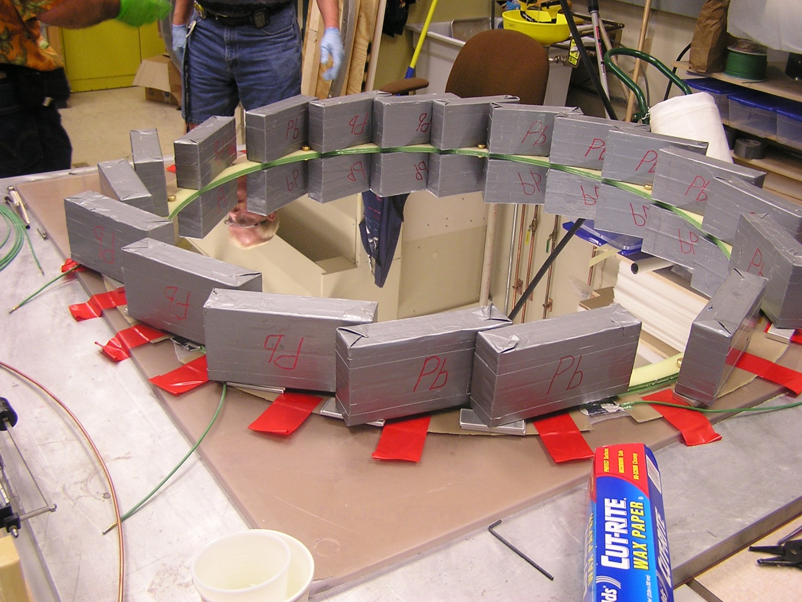

Have three lamination pins available. Clean an aluminum gusset arc with Alcohol. Apply four spots of Scotchweld to the arc as shown below:
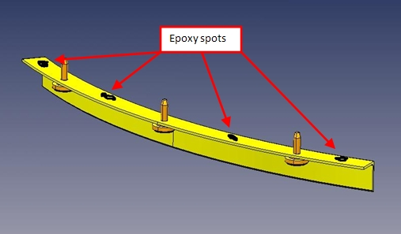

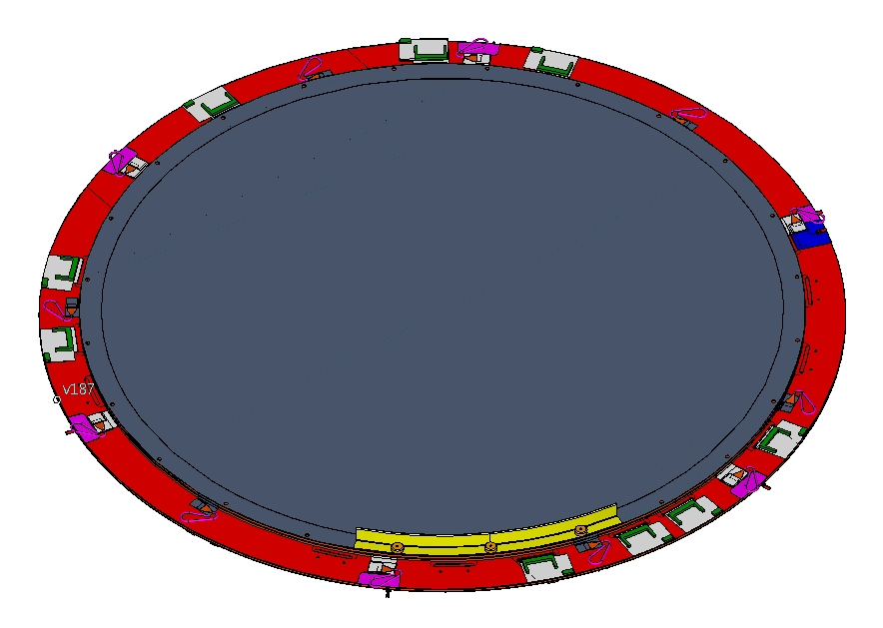
Position the first arc as shown:

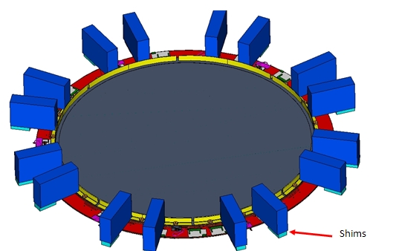
Repeat the above procedure to attach the remaining aluminum arcs. With all arcs installed, apply 16 weights as shown below. Allow to cure for 12 hours:

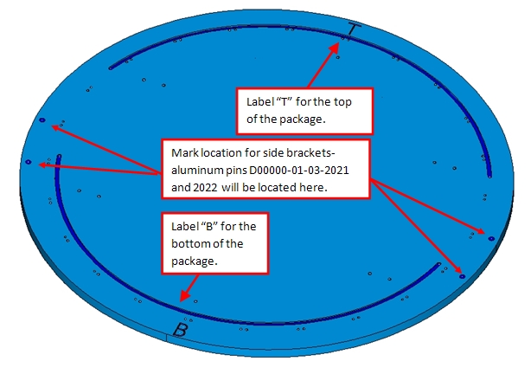
Attach high voltage pigtails to wireboard. Apply Scotchweld in the area reserved for sticky tabs to secure the wires. Install remaining Faston tabs.
Procedure 3: put the jig plate on the granite table spaced up approx 2” to allow installation of the screws from below. Use a magic marker and label as shown below:
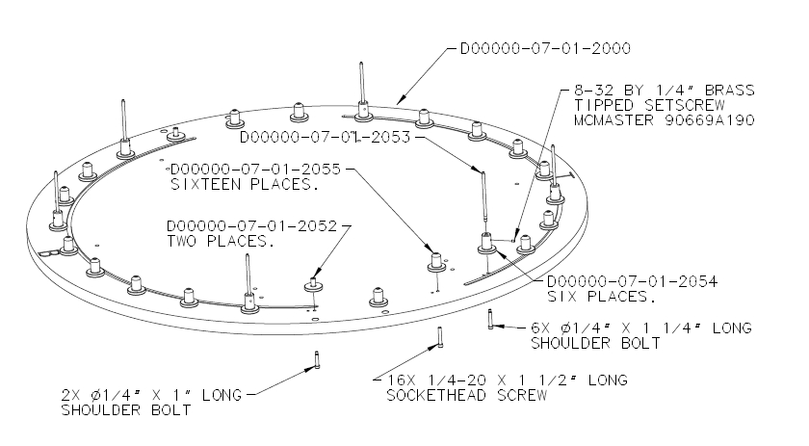
Assemble the jig as shown in the pictures below. Test fit a cathode to confirm that there are no alignment problems with the pins. Correct as required.

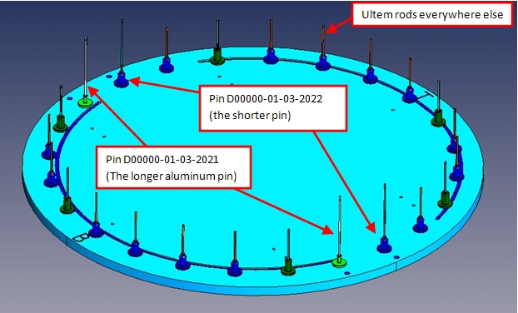
Cut the Ultem 10-32 threaded rod into 20 pieces 4” long. Aluminum threaded rods D00000-01-03-2021 and D00000-01-03-2022 will also be installed at this time. Install the threaded rods as shown in the photos below:

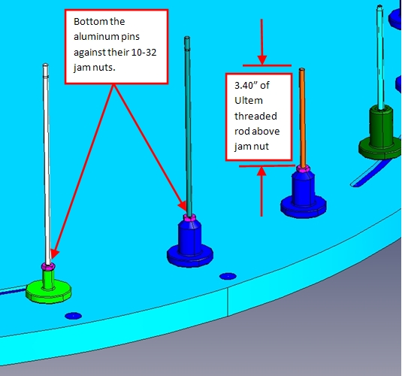
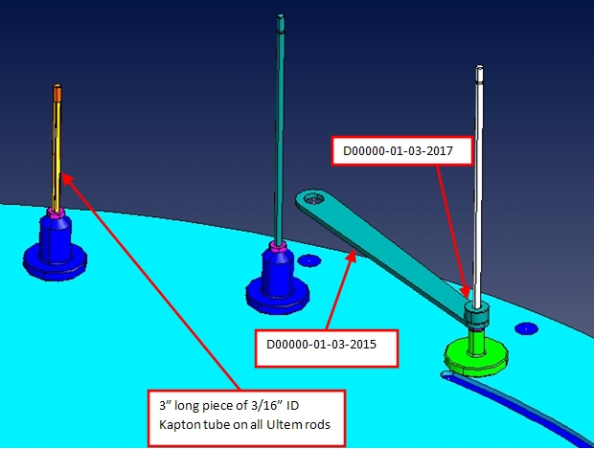
Cut fourteen pieces of the 3/16” I.D. Kapton tube to 3” length (+0/-.0625”). Slide these pieces over the Ultem threaded rods. Parts D00000-01-03-2015 and D00000-01-03-2017 are installed on the longer aluminum threaded rods as shown below:

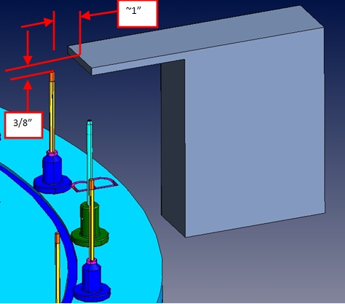
Create three temporary supports whose upper surfaces are approximately 3/8” higher than the tops of the Ultem rods as shown below. They should be arranged at approximately 120 degree intervals with one of them positioned as shown. They may need to be shifted slightly during the installation of the first cathode to clear ground tabs or the daughter boards:

Three people required for this operation (2 lowering, 1 to move supports as needed) .Position the wireboard/cathode/aluminum gusset arc assembly as shown below. Carefully lower onto the 4 aluminum pins and let rest on the temporary supports:
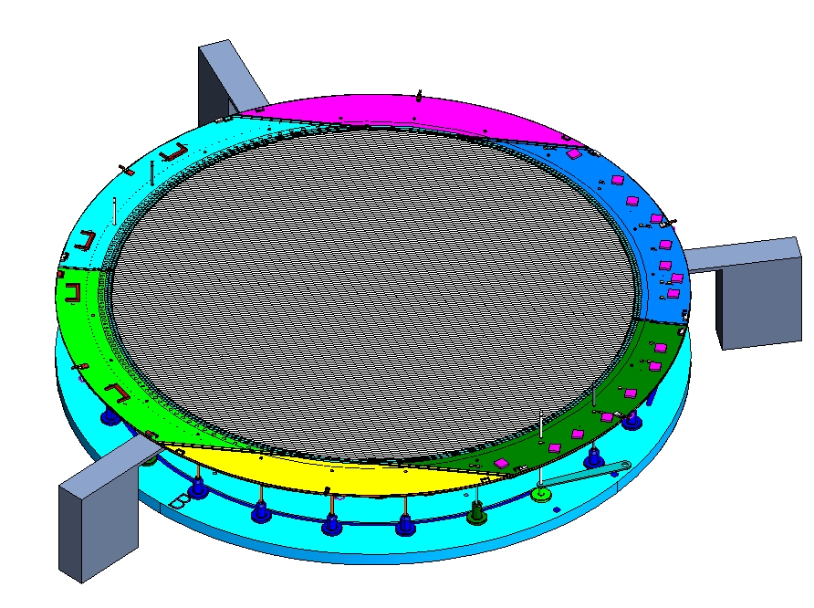
Cut fourteen pieces of the 3/16” I.D. Kapton tube to ~1” length. These will be used to assist in getting the assembly onto all of the Ultem rods simultaneously. Install them as shown below: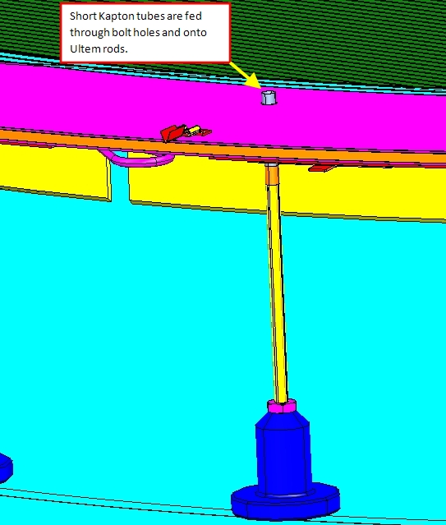

This operation requires a minimum of three people. After all short Kapton tubes are installed, two people hold the assembly while the temporary supports are removed. The assembly is then carefully lowered onto first the tapered pins, then all the way down: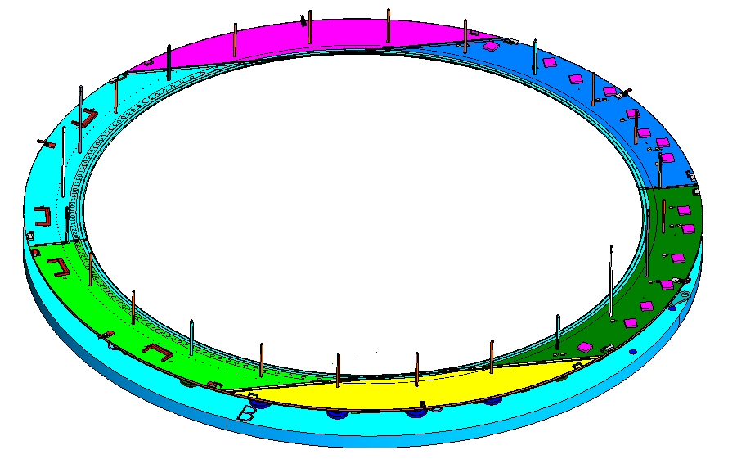

Glue on the remaining pieces of the solid gas spacer! Add tubing to the ends.
On the Lexan jig plate, use lamination pins to dry fit the gas spacer against the 2 micron cathode of the glued cathode pair to be installed next. Orient as shown below. Examine the area indicated below- notch/sand the polyethylene to clear. Use a magic marker to mark the notched end. Check and correct any other problems.
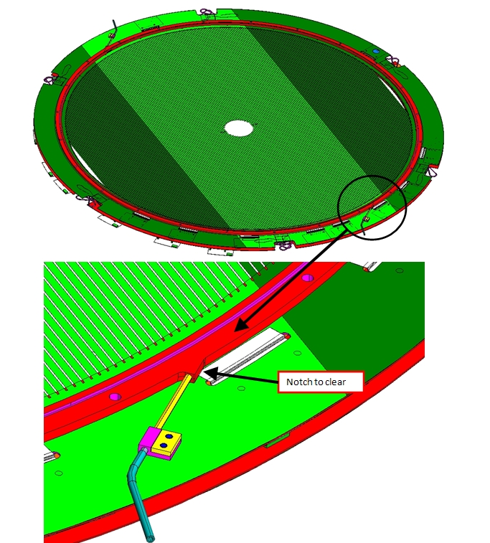

Remove the spacer from the cathode, and make two O-rings from the .07” diameter medium density Neoprene/EPDM blend sponge cord stock (Ace Hose & Rubber company- item 5781). Cut to fit the spacer groove length, and bond the ends with Loctite 406.
Tack-glue one O-ring into the spacer on the side shown below:
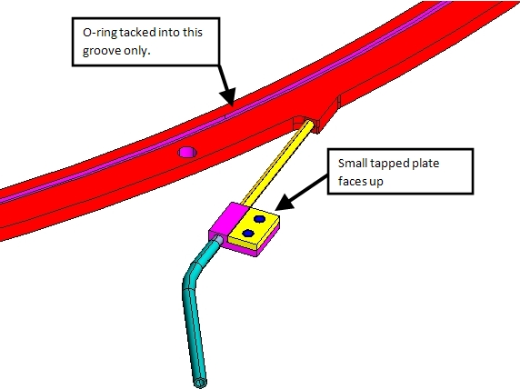

Put the spacer on a table with the tacked O-ring side down. Install the other O-ring in the upper groove. Transfer the spacer onto the assembly jig oriented as shown below. The temporary supports and short Kapton tubes shouldn’t be needed, but use if it seems appropriate. Push down until the gap to the wireboard is about 1/8”, and make any final adjustments to the lower O-ring if it has fallen out. Push into contact with the wireboard. Inspect that there are no gaps: 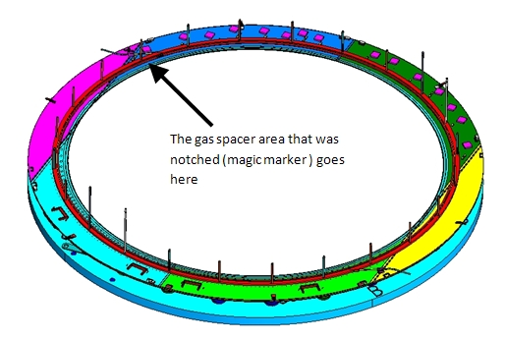
Remove the small plastic screws shown below, and slide the tapped plate out. Apply Scotch weld to its lower surface, then replace the plate and reinstall the screws. Secure the assembly to the wireboard with a piece of red Vinyl tape. Repeat this procedure at the top of the jig plate. Allow the epoxy to cure for 12 hours.
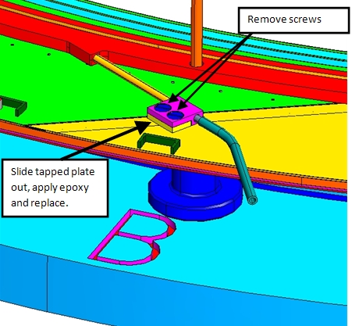

**** At this point a gas test can be done. Make up another O-ring for the Lexan test plate. Tack it in place with Loctite 406. Place the temporary supports back on the Granite table, and lower the plate onto the temporary supports using the previous technique:

