First Article Cathode Foil Inspection
We have inspected the first article foils, 12 panels, four of each: left, central and right panel. The resistance of the strips end to end (excluding traces to the connectors) was measured. A visual inspection using a magnifier was done to detect physical nonconformities.
This report will address the following topics:
- Packaging
- Chemical stains
- Individual wrinkles and repeating wrinkles
- Scratch marks and discoloration across signal traces
- Debris on panels when rolled
- Summary/Recommendations
______________________________________________________________________________
- Packaging:
  - Two sheets of paper taped together create an undesirable wrinkle in the middle of the foil. In addition, when the paper sheets were lifted from each end of the foil, the taped area “fell open”- bunching up the panel across its width. One continuous paper sheet for subsequent shipments please.
  - The weld ridge on the inside of the shipping tube in not acceptable (Will cause wrinkles and difficulty removing from tube). We recommend use of PVC pipe as an alternative. See the summary section for additional information.

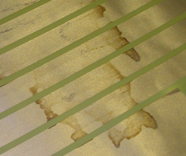
- Chemical stains:
  - Several of the foils had chemical stains on them. The resistive data that was taken was inconclusive in determining if the stains have a direct effect on resistance however a better understanding of the stain from the vendor is required. We are concerned that these stains might indicate that etchant is still present, and might cause corrosion of the strip in the future.

- Repeating Wrinkle Pattern:
  - On several of the foils there is a repeating pattern wrinkle that was observed. These wrinkles will be a problem if they don’t come out in the tensioning process, as they represent a rapid change in the local foil height. They were not prevalent on all of the foils so the presence of variation is also a concern.

These rollers seem like the likely culprit for indentations shown above. If this style roller is in rinse area with liquid jets, the impact of the rinse could be creasing the foils around the fingers on these rollers as shown above.

- Wrinkles:
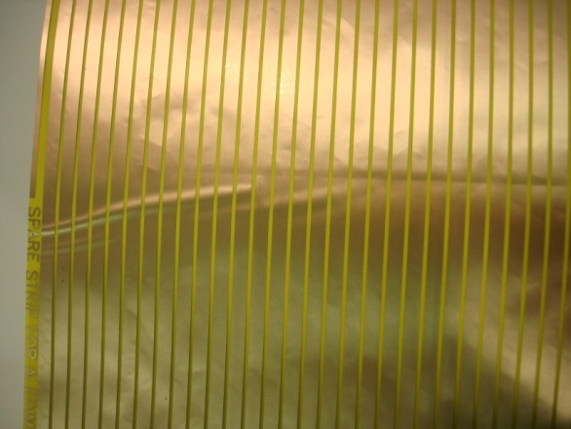
  - There was a wrinkle that was found consistently in the right side foils. This represents a permanent distortion in the cathode panel that complicates the edge cutting process and will still be present to some extent after tensioning (material will stretch flat, but the pattern will be distorted).

- Creases

Cathode 001 had a crease in the foil that crossed strips 69 thru 85. The picture below shows the crease and the graph has the effected strips highlights. The resistance did not seem to be affected by the crease however it was unclear if this crease would remain after tensioning.

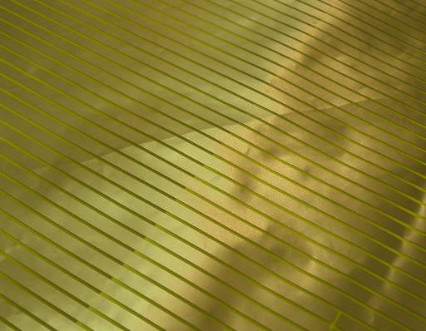

Cathode 002 had a predominant chemical stain on the right side foil. A better understanding of this chemical or process is desired. Some of the resistance measurements were elevated in this region but it was not conclusive that the stain was the problem.

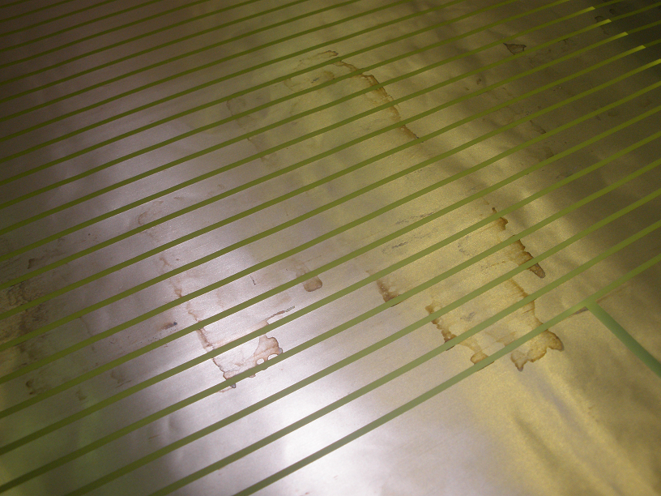

Cathode 003 had some discoloration and damaged traces when viewed under a microscope. The resistance was checked on the traces and there was no difference in resistance with respect to similar traces, but we are concerned about open/high resistance paths for subsequent panels, as the trace is very narrow in this area.
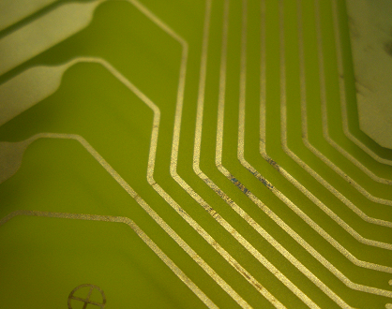
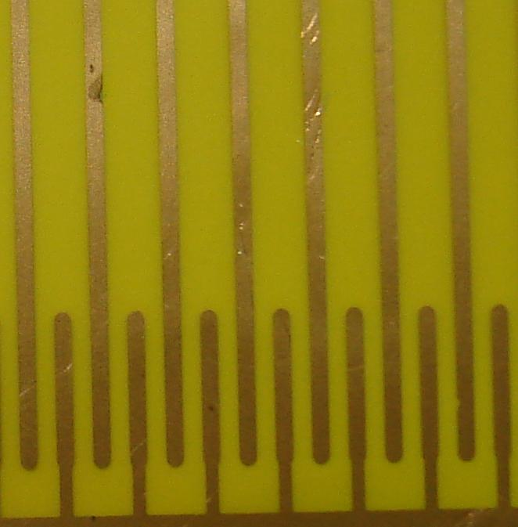

Cathode 004 had some debris between the foil and the packing paper. The foil was visibly raised by the object and left an indentation. The debris appeared to be a blue plastic of some sort and was just over 1/8” long. If not caught this could have easily punctured the foil, and in any case would create a step in the local foil height when tensioned, which prevents proper operation in this region.
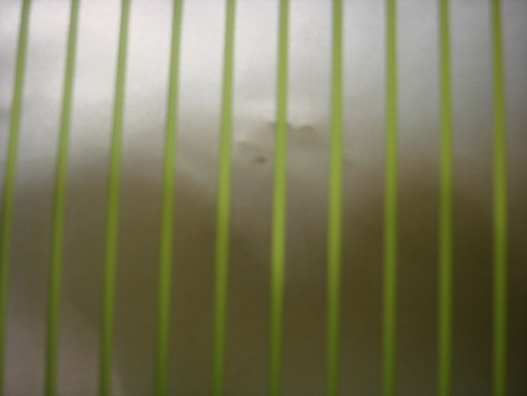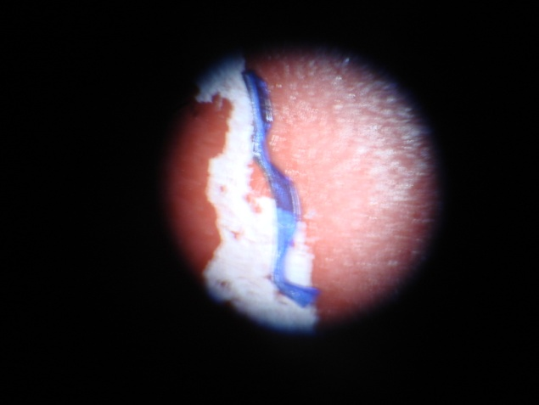

Summary:
Overall the four sets of foils that were inspected met our requirements. However, as noted in the report there were several deficiencies that will require vendor action in the form of explanation and some process/handling/packaging improvements.
- Packaging:
  - Single sheet of paper without seam in the middle and tube without weld seam.
  - Suggest rolling and taping the panel one panel at a time on an inner mandrel of PVC tube- see idea below:
_______________________________________________
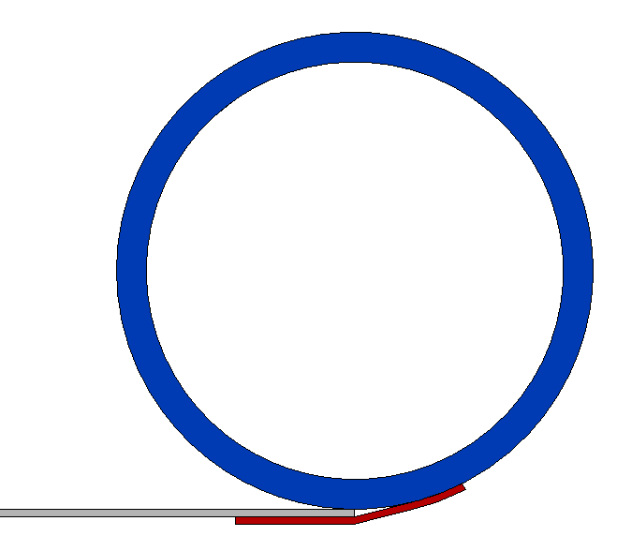
Mandrel tube at least 2” longer than the paper is wide.
Tape one sheet of paper to mandrel. Confirm that it will roll up straight, and adjust as necessary.

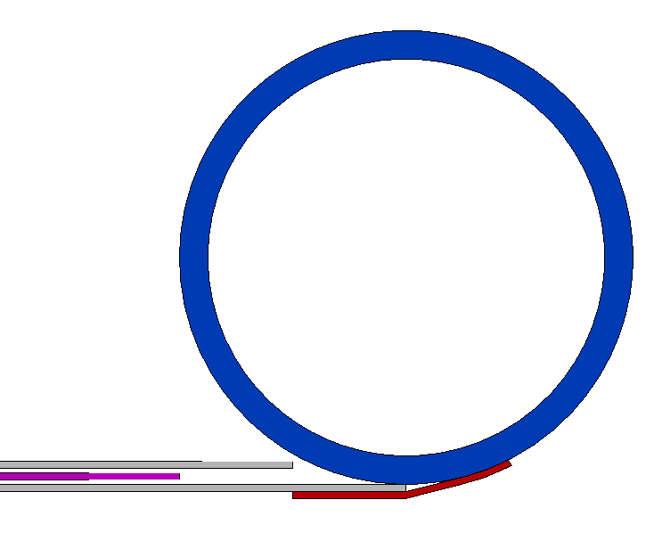
Add the foil and an upper sheet of paper as shown. Roll up.

Apply tape to secure the first foil.

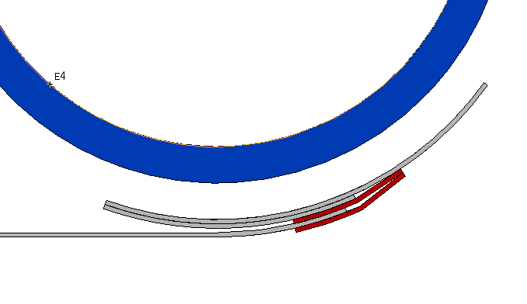

Attach lower paper sheet for the next foil in approximately the same area (assures that the tape area is over the end of the foil below it- i.e. a scrap area.)

Add a spacer on both ends of mandrel to center in shipping tube and hold away from inner wall.

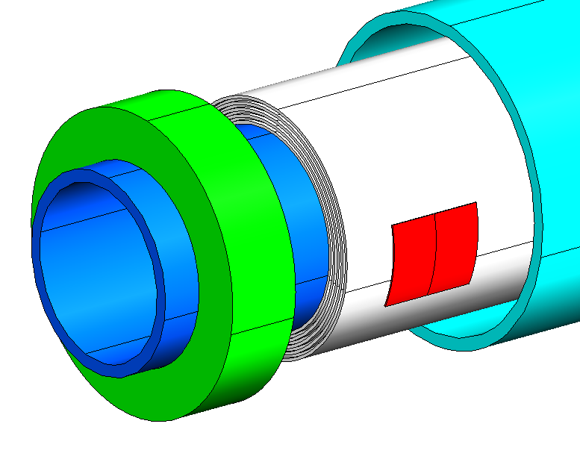

- Chemical Stains:
  - Vendor to provide the following information:
    - Is the chemical still present/reactive?
    - Why is it not present on all foils? Can we prevent this?
- Wrinkle Pattern:
  - What is causing the pattern?
  - How will wrinkles be prevented or minimized?
  - Some ideas that might help- Would attaching the protective foil being removed below to a fiberglass bar allow peeling with fewer wrinkles?
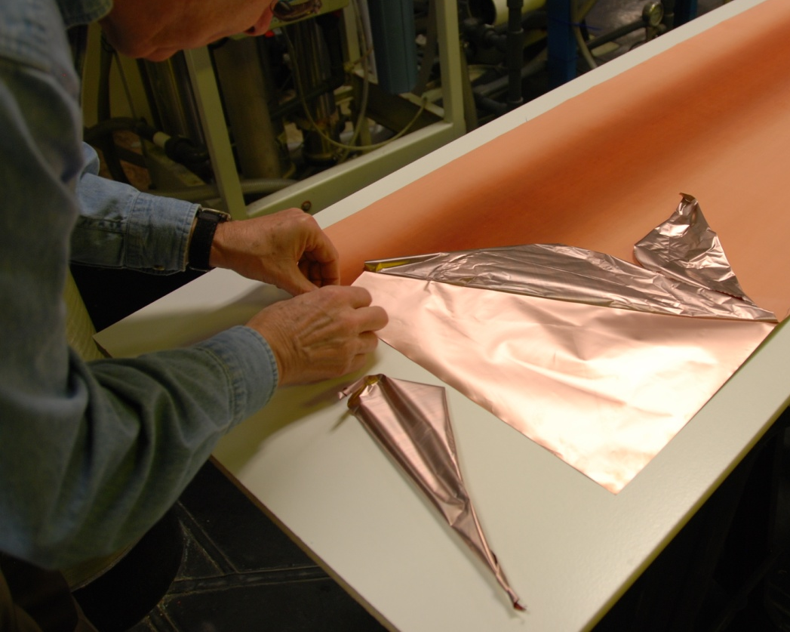

I am assuming that the two black rollers shown below are ‘nip’ rollers that help drive the fiberglass boards on the end of the panel. This picture and several others appear to show the trailing edge of the foil ‘out-running’ the leading- which would be likely to occur if the attached fiberglass boards are the same thickness- when the leading board enters the nip point, it will tend to hesitate feeding in, causing a wrinkle. If the trailing fiber glass board were thinner than the leading board (preventing it from actually being driven by the nip rollers), it might act to create drag- and maintain foil tension, preventing this problem.

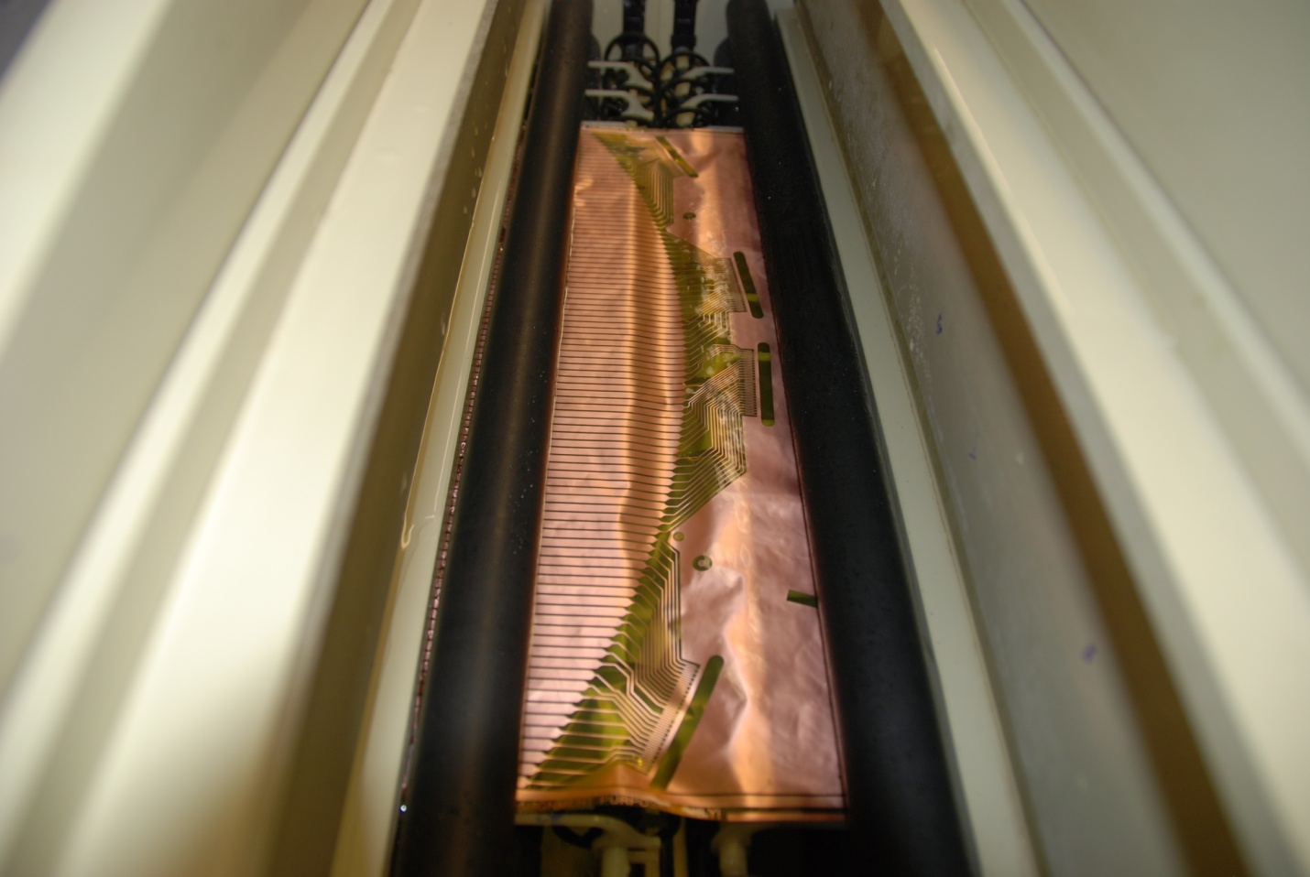

Are these nip (pinch) rollers?

- Foil Creases:
  - What is causing creasing? Is this occurring during removal of the protective copper layer?
  - Can it be prevented or minimized?
- Connector Traces (scratched/discolored):
  - What is causing scratches?
  - What is causing discoloration?
- Debris under Foil:
  - What can be done to exclude the debris ?

