First Article Cathode Foil Inspection

We have inspected the first article foils, 12 panels , four of each: left, central and right panel. The resistance of the strips end to end (excluding traces to the connectors) was measured. A visual inspection using a magnifier was done to detect physical nonconformities.
This report will address the following topics:
- General Remarks
- Resistance test method
- Resistance graph of all four tested cathodes
- Cathode 001 resistance graph and nonconformities
- Cathode 002 resistance graph and nonconformities
- Cathode 003 resistance graph and nonconformities
- Cathode 004 resistance graph and nonconformities
- Summary

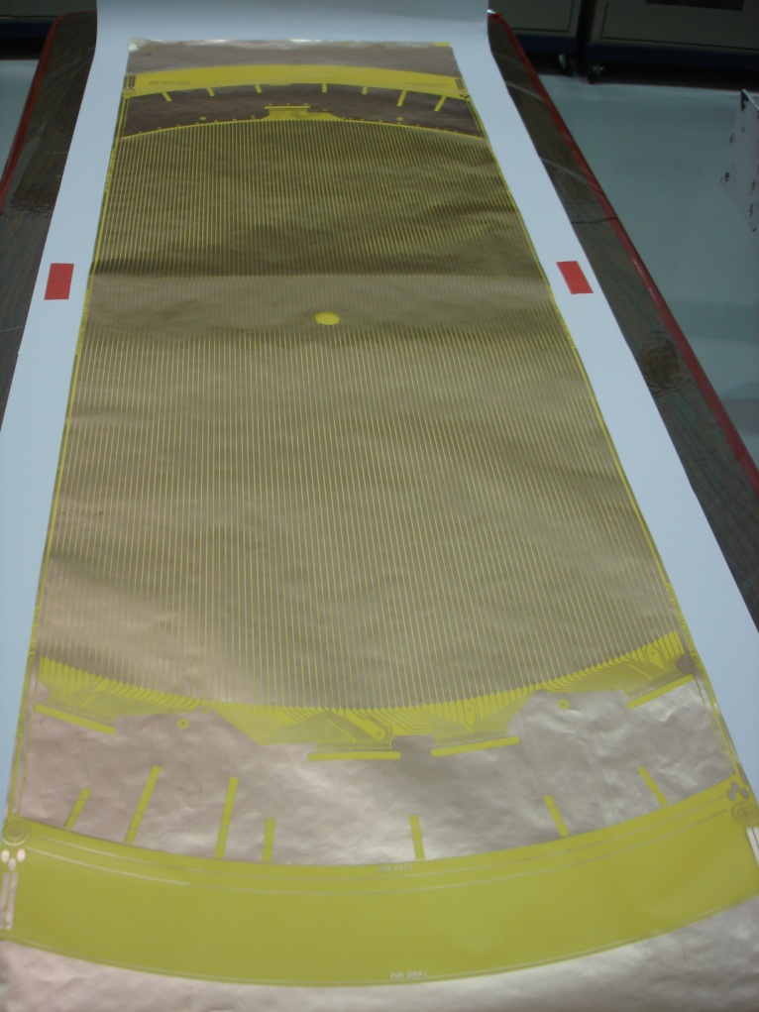
General Remarks:
- Packing:
  - Two sheets of paper taped together create an undesirable wrinkle in the middle of the foil. One continuous sheet for subsequent shipments please.
  - The weld ridge on the inside of the shipping tube in not acceptable( Will cause wrinkles and difficulty removing from tube). We recommend use of PVC pipe as an alternative.

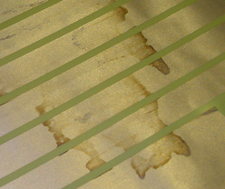
- Chemical stains:
  - Several of the foils had chemical stains on them. The resistive data that was taken was inconclusive in determining if the stains have a direct effect on resistance however a better understanding of the stain from the vendor is required. We are concerned that these stains might indicate that etchant is still present, and might cause corrosion of the strip in the future.

- Wrinkle Pattern:
  - On several of the foils there is a repeating pattern wrinkle that was observed. These wrinkles will be a major problem if they don’t come out in the tensioning process, as they represent a rapid change in the local foil height. They were not prevalent on all of the foils so the presence of variation is also a concern.

- Wrinkles:
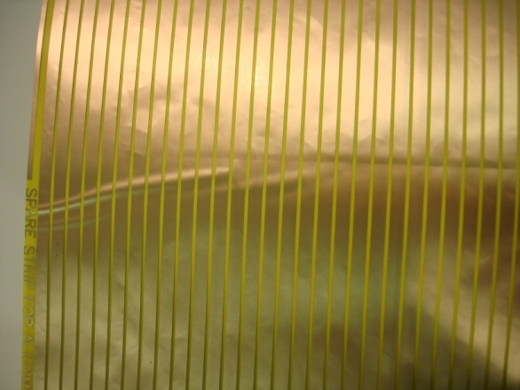
  - There was a wrinkle that was found consistently in the right side foils. This represents a permanent distortion in the cathode panel that complicates the edge cutting process and will still be present to some extent after tensioning (material will stretch flat, but the pattern will be distorted).

Resistance Test Method:
End to end resistance measurements were taken according to the two wire configuration from GlueX-doc-1082. A Fluke meter model 179 was used. Resistance measurements were taken and recorded and the probes were moved in a leap frog manner to also test for shorted strips.

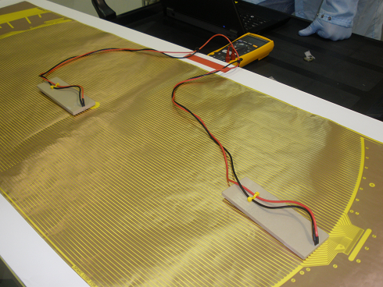
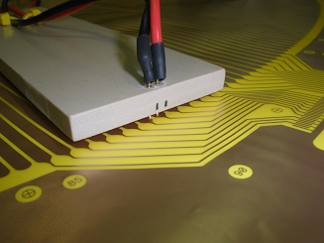

Resistance Graph of all four tested cathodes:
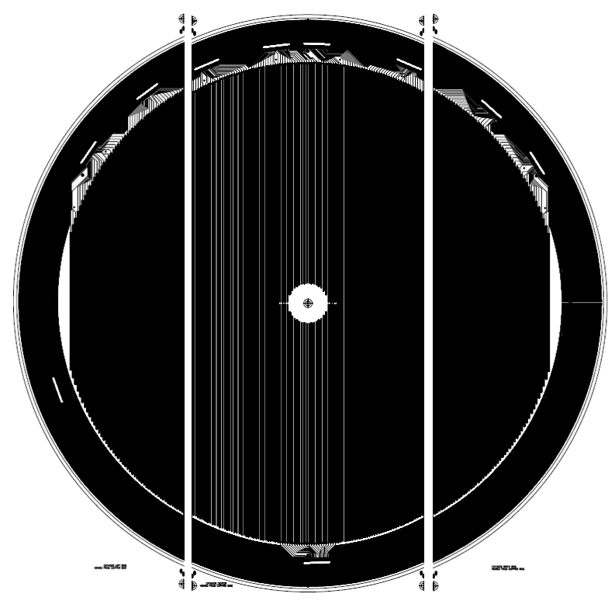
The graph shows the resistance measurements of all four of the tested cathodes. The “B” readings and the low readings in the center of the graph represent the Beam Hole Region where the cathode strip does not go all the way across the foil so the values are approximately half the value of the nearby strips. The right side foil showed the most variation in measured resistance

Beam Hole Region

Right Foil
Center Foil
Left Foil
Cathode 001 Resistance Graph and Nonconformities:

There was a crease in this area

Cathode 001 had a crease in the foil that crossed strips 69 thru 85. The picture below shows the crease and the graph has the effected strips highlights. The resistance did not seem to be affected by the crease however it was unclear if this crease would remain after tensioning.

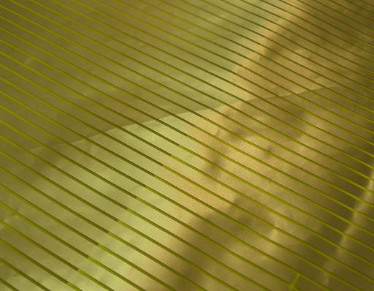

Cathode 002 Resistance Graph and Nonconformities:

There was a chemical stain in this area

Cathode 002 had a predominant chemical stain on the right side foil. A better understanding of this chemical or process is desired. Some of the resistance measurements were elevated in this region but it was not conclusive that the stain was the problem.

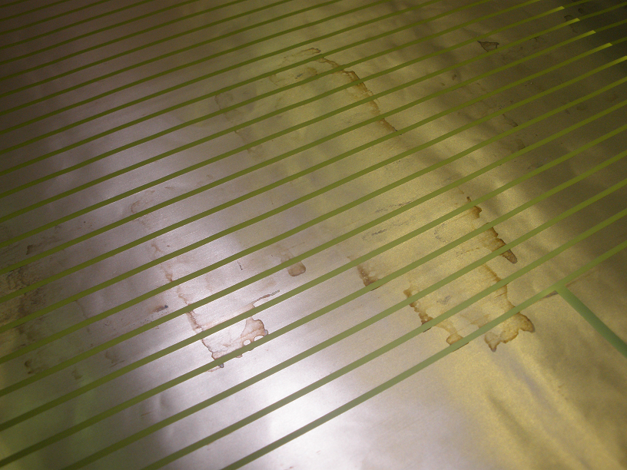

Cathode 003 Resistance Graph and Nonconformities:

Cathode 003 had some discoloration and damaged traces when viewed under a microscope. The resistance was checked on the traces and there was no difference in resistance with respect to similar traces.
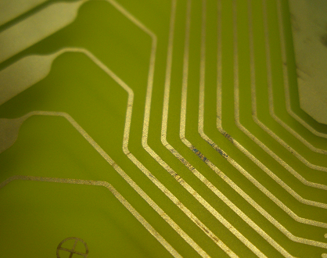
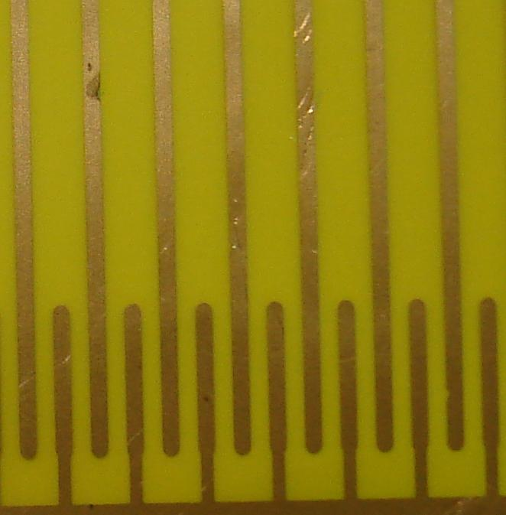

Cathode 004 Resistance Graph and Nonconformities:

Cathode 004 had some debris between the foil and the packing paper. The foil was visibly raised by the object and left an indention. The debris appeared to be a blue plastic of some sort and was just over 1/8” long. If not caught this could have easily punctured the foil.
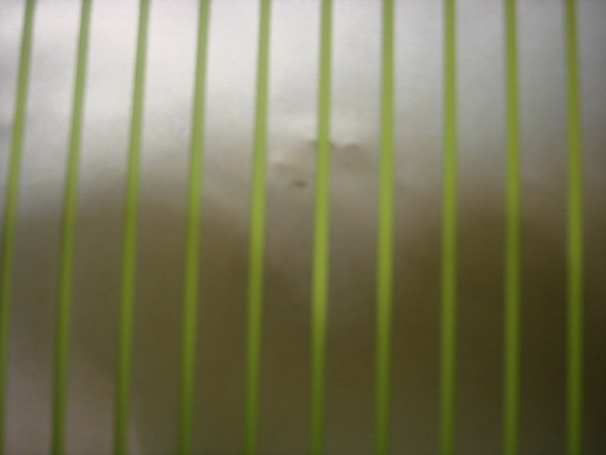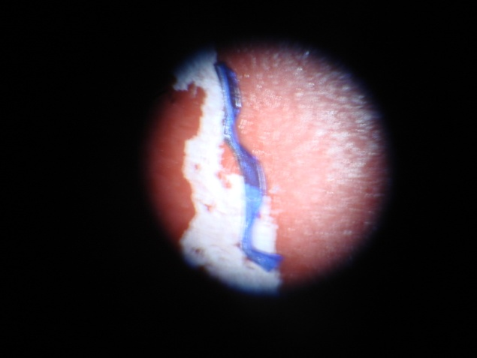

Summary:
Overall the four sets of foils that were inspected met our requirements. However, as noted in the report there were several deficiencies that will require vendor action in the form of explanation and / or irreversible corrective action.
- Packaging concerns:
  - Single sheet of paper without seam in the middle and tube without weld seam
- Chemical Stains:
  - Vendor to provide the following information:
    - What is the chemical?
    - Is the chemical still present/reactive?
    - Why is it not present on all foils?
- Wrinkle Pattern:
  - What is causing the pattern?
  - How will wrinkles be prevented or minimized?
- Foil Creases:
  - What is causing creasing?
  - Can it be prevented or minimized?
- Connector Traces (scratched/discolored):
  - What is causing scratches?
  - What is causing discoloration?
- Debris under Foil:
  - What can be done to exclude the debris ?

