Detector Foil
Characterization Report

- Optical imaging
Equipment: Digital optical microscope Hirox

Pic1a. General view. Magnification x350.
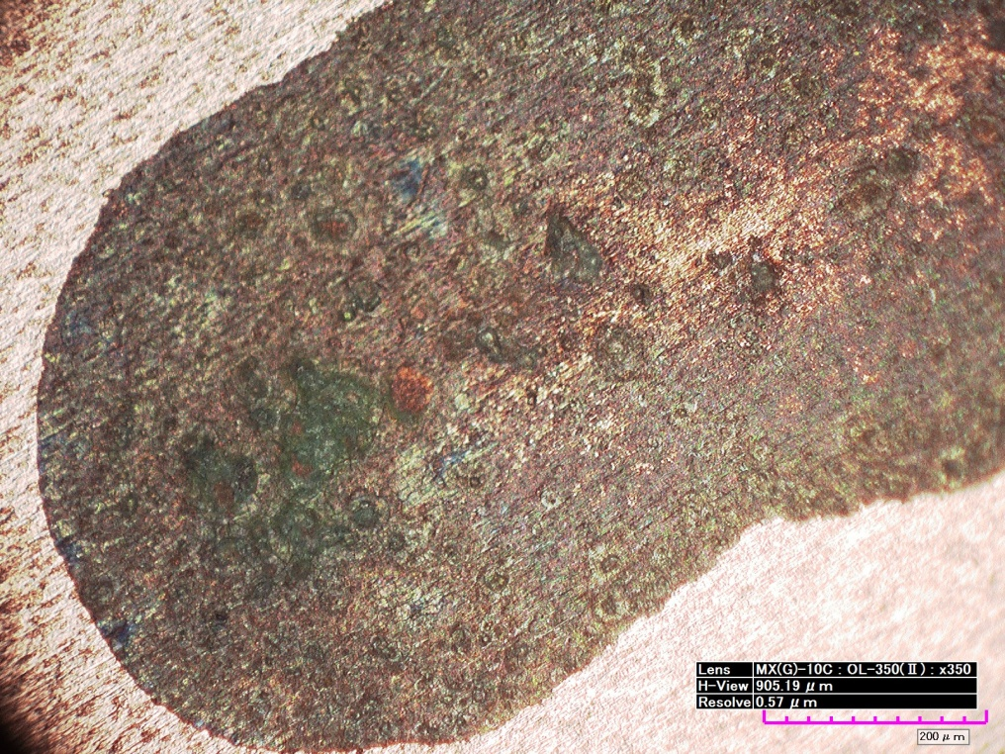

Pic1b. Same area, SEM image at low mag.

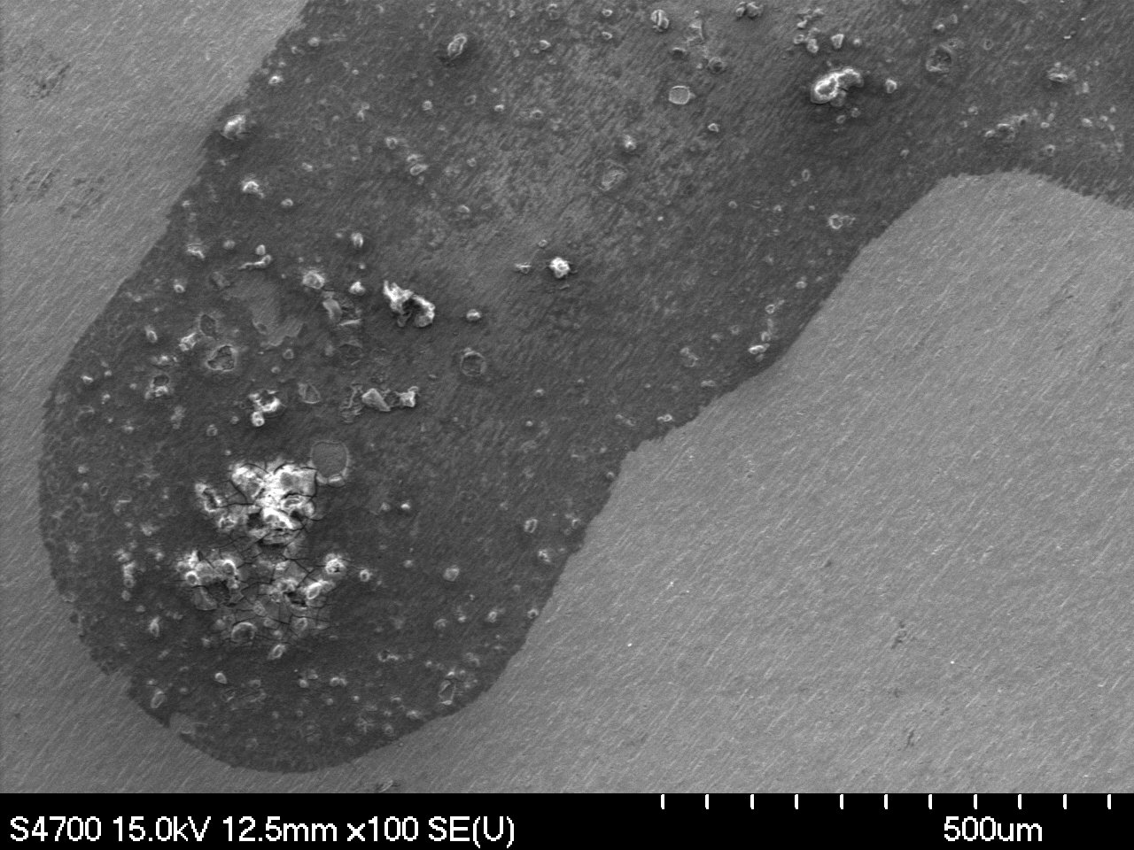
Pic2. Optical Hirox
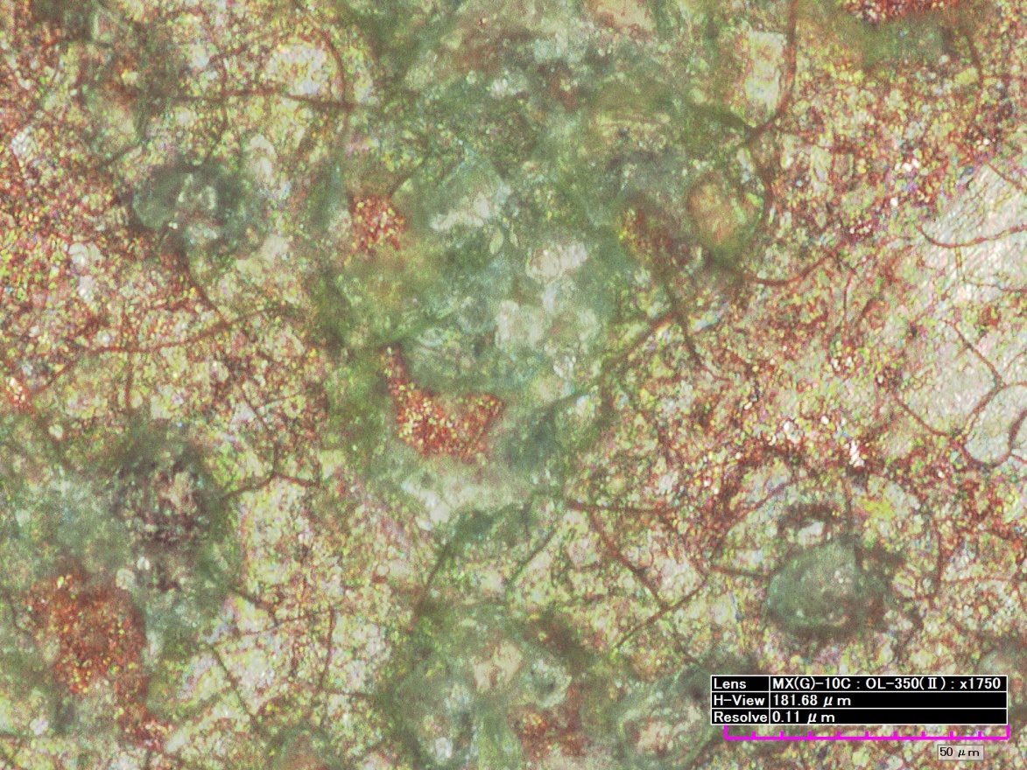

Pic3 Optical Hirox
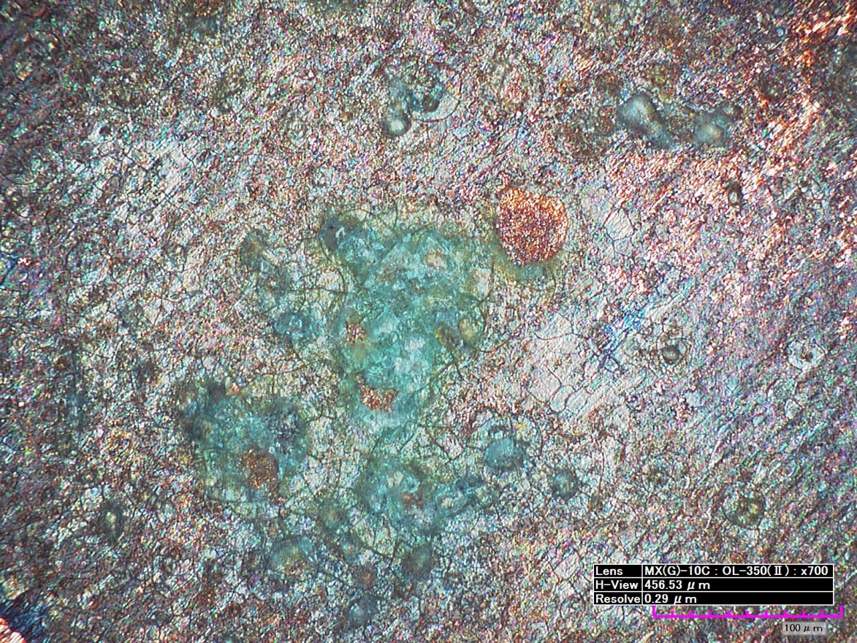

Electron Microscopy and EDS Analysis

Pic4. SEM image of blue-green “crystals”. Charging reduces image quality.

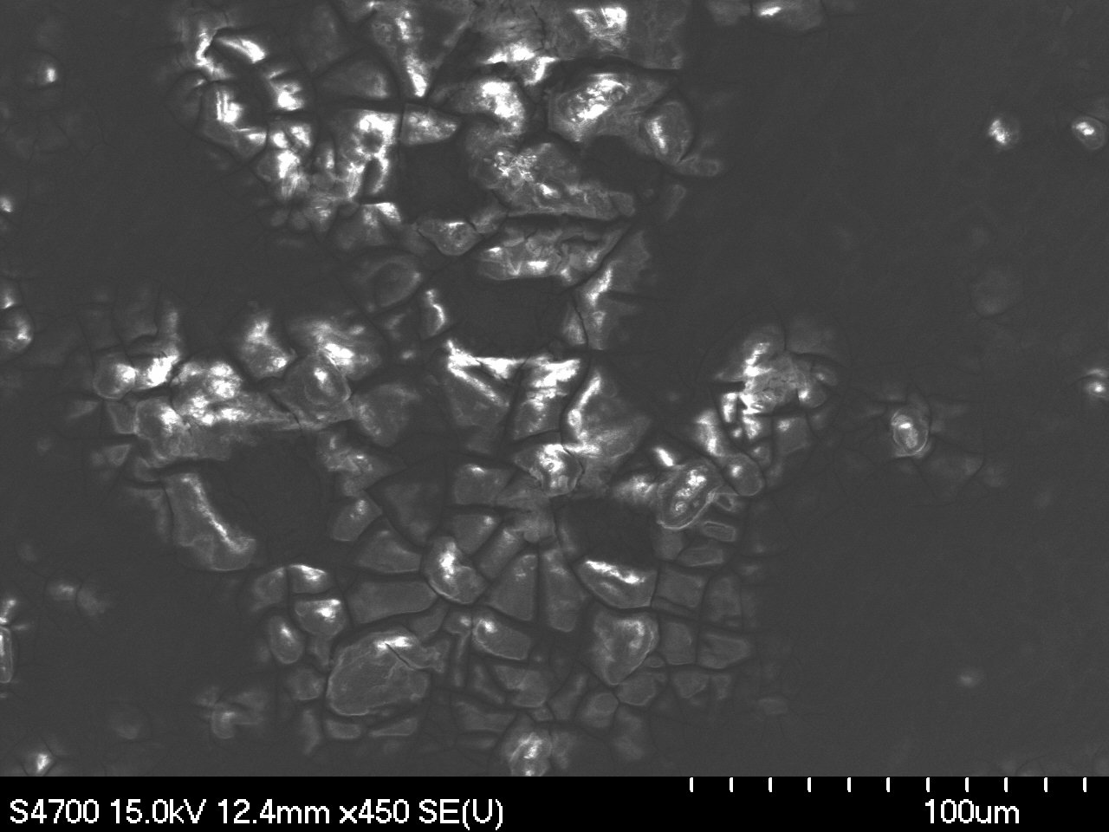

Pic5. Corresponding EDS spectrum.

Pic6. Central brown area image of the contaminated spot.
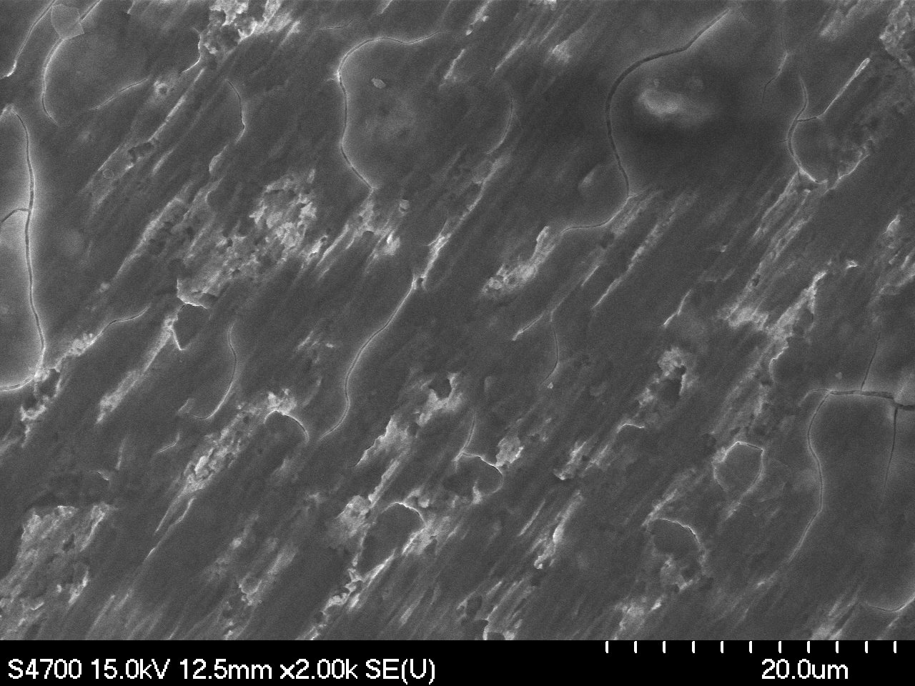

Pic7. Corresponding EDS spectrum.

Pic8. Another cluster of blue-green “crystals”.
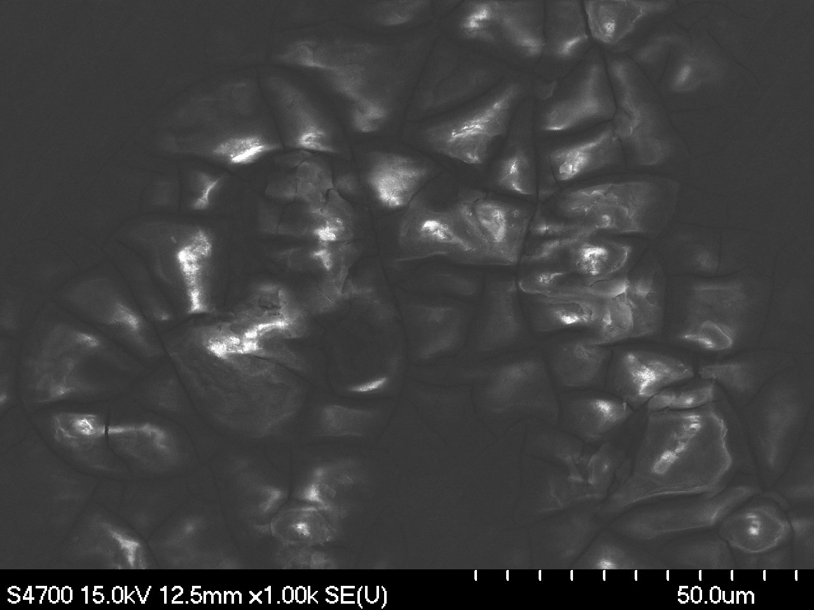

Pic9. Corresponding EDS spectrum.
Pic10&11. Highly charging cluster of separately located “crystals. Low and high mags.
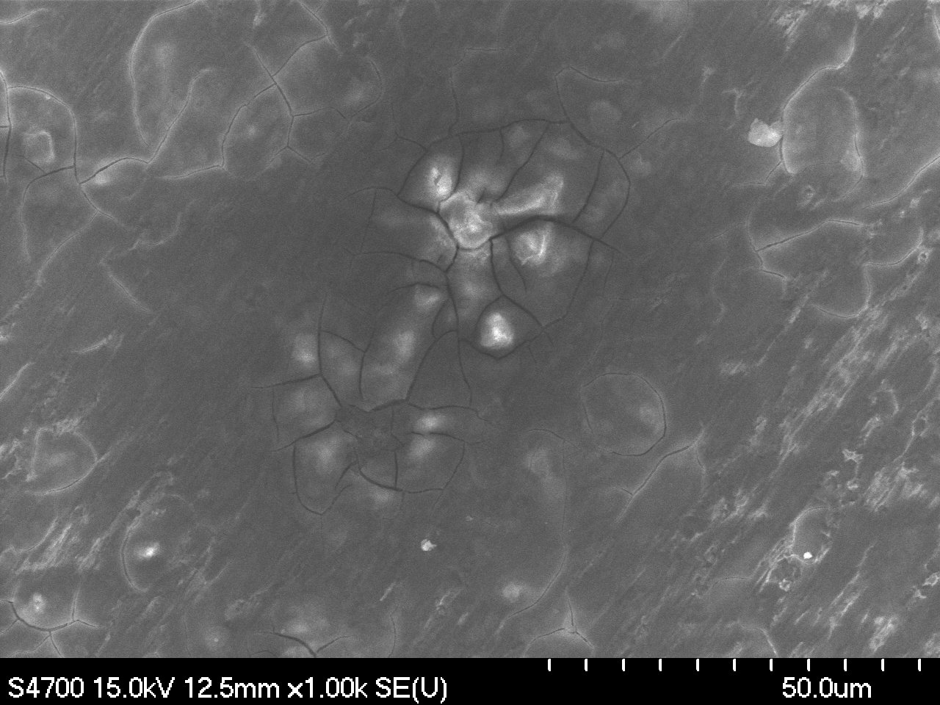

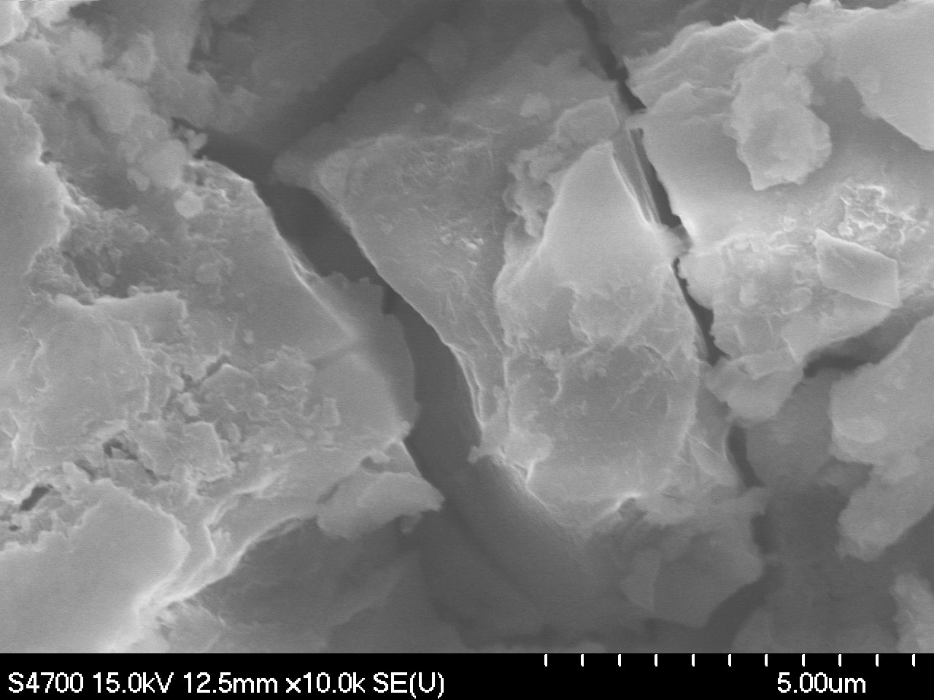

Pic11. Corresponding EDS spectrum taken at high mag (11Kx) directly from the crystal surface.

