Response to Jefferson Lab First Article Foil Inspection

- Packaging: Because the 2 µm copper is sensitive to any stress, leaving impressions it the cathode traces, we understand that the inner ridge in the tubing can impart a visible deformation. The suggested packing method looks very feasible. We have found a suitable inner tubing and anti-tarnish paper that will accomplish the suggested packaging. (see Cortec VpCl paper link.)
http://www.cortecvci.com/Products/single.php?code=10191
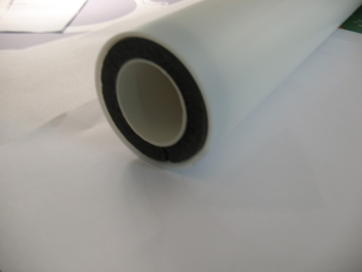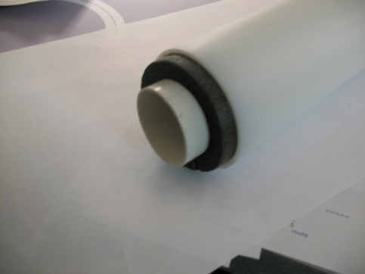
Inner Tubing is PVC thin walled vacuum tube, Spacer is two inch pipe insulation
- Chemical stains: The staining at the end of the resist stripping may be the most difficult to totally eradicate. The resist striping chemistry is caustic and will neutralize any etchant residue. We feel the staining is mostly water stains. The resist strip dryer will be cleaned more frequently; the rinse sump will be dumped and refilled daily, rinse nozzles will be checked every other day.

- Repeating Wrinkle Pattern: These wrinkles are coming from roller wheels in resist stripping process. Will try turning top spray pressure down even further, possibly increase bottom pressure to decrease the spray force pushing the material against the rollers.

1.

- Wrinkles: We are no longer attaching a FR4 “leader board” to the trailing panel edge and are looking into ways of keeping the top squeegee rollers in the resist strip machine off of the flex panels, these things will eliminate the back of the panel “out running” the front causing the long panel to bunch-up and wrinkle.

- Creases, Scratches and Debris: Many creases and scratches are caused by simply handling the thin flex, and All Flex will continue to work on improving handling. The photo resist debris and other foreign material will be cleaned from the inspection and packaging areas prior to the completed panels are moved into these final processes.

Chris Carlson, Process Engineer
Clark Webster, Applications Engineer

2.

