MEMORANDUM

To: Distribution

From: F. Dylla

Subject: FEL Upgrade Project Weekly Brief – October 27-31, 2003

Date: October 31, 2003

Highlights:
We are holding to our schedule for re-starting FEL commissioning operations next week. The key task of installing the final version of the pi-bend magnet (GY) in first arc was accomplished this week. Alignment, vacuum, water cooling, and power hook-ups are proceeding today through Monday. Significant other accomplishments this week include: (1) re-certification of Personal Safety System (PSS) which is required for machine operations was done on Thursday; and (2) we had first RF power onto the linac and injector modules. Next week after completion of the GY installation we will devote most of machine operations to RF conditioning of the linac modules.
We note that start-up of the CEBAF linac after the storm hiatus has gone well. We thank the efforts of the SRF, EES, Software and Cryo teams for bringing these systems back on line.

Management:
F. Dylla attended the FEL Technical Working Group (TAWG) meeting organized this week (Oct. 27-28) in Albuquerque to review the proposed FY04-05 FEL program activities for the Navy and the JTO. Our Jefferson Lab presentation described work in three task areas: (1) completion of commissioning and characterization of the 10 kW FEL, in its present configuration and after installation of the 3rd cryomodule and new 1 micron wiggler; (2) further development and testing of the JLab/AES 100 mA DC injector; and (3) scaling studies in SRF linac configurations for development of higher power (100kW+) FEL devices. Presentations at this meeting were also given by NPS, LANL, NRL, ANL, BNL, AES, Inc. and SAIC, Inc. The Navy program management has promised to distribute a summary of the meetings findings and recommendations as soon as possible to keep the FY04 program on track.
Preparations continued this week for next week's visit (Nov.3rd) by Dr. Ray Orbach, Director of DOE's Office of Science on the occasion of the Lab's annual "Institutional Planning" review.
The strong support of the Navy and AFRL for the Lab's FEL development program will be highlighted during a portion of the review.

Gwyn Williams presented an invited talk on THz light generation at a THz session at the meeting of the IEEE Lasers and Electro-Optics Society meeting (LEOS-2003) in Tucson. The talk was well attended and gave an opportunity for interaction with potential users of our high power source.

WBS 4 (Injector):
The cathode QE is about 0.6%. This should be sufficient to start FEL set up operations.

The HV test stand was baked to 150 C for about two days. This week, Survey & Alignment crew set the gap between the test electrode and the anode. Everything is ready to HV test the electrode with the field emission suppression coating.

PARMELA simulations are being carried out for the UV FEL at 350kV, 60 pC.

WBS 5 (SRF):
FEL3 Status:
Work is picking up on FEL3. Most of the technicians are back from CEBAF recovery and a high level of activity is resuming on both FEL and SNS modules. The cold mass MLI is now completed except for a few details at the ends of the string. The thermal shield has been installed on the string and the fit and clearances are being checked. Once this is verified the shield plumbing and instrumentation will be installed. The next step after the shield work is complete will be installation of the space frame.
The FEL module has three new diodes on the HOM can as part of the instrumentation package. This will help to verify models of the temperature performance of the HOM can assembly.

WBS 6 (RF):
Operations - All RF systems and the Gun's HVPS were operated this week. The PSS was re-certified for the entire machine. The nominal values for the Cavity Waveguide Window Temperature (CWWT) were checked and adjusted as necessary for all cold cavities.

INJ - The Injector RF was run at full operational gradients. The Bunch Length Phase Modulator was upgraded, installed, and tested this week to include any combination of the Injector cavities and Drive Laser.

Zones 2 & 4 - were run to 5 MV/m where beam line vacuum faults caused trips. Cavity FL04-6 had a tuner motor fail. It was replaced and the tuner now functions properly. These zones need more run time to cleanup the vacuum faults. In Zone 4, new ceramic warm windows and in front of the CWWT detectors, RF screens were installed.

WBS 8 (Instrumentation):
Testing of the AMS/Video Upgrade 32 X 32 crosspoint board (F0253) prototype is proceeding well. The CAN bus interface works well with a pre-programmed processor, but to re-program the device "in-system" requires a different programming cable than the one we have. Nonetheless, we have developed our CAN buss interface firmware on a development platform and then transplanted the programmed processor onto the crosspoint board prototype. With the first chassis fully finished we are ready to begin measuring the analog performance characteristics of the finished chassis from chassis input to chassis output. This will include a complete crosstalk characterization. In parallel with the testing of the prototype crosspoint chassis, a 32 channel, high density, analog distribution amplifier board is being designed. This board will be used to terminate the "WIRE-OR'ed" outputs of both the video and AMS systems. The board will be implemented in a chassis similar to the crosspoint chassis. Currently, we are in the PCB lay-out stage of the video amplifier design and its chassis is being constructed in Lab 5.
A calorimeter has been built to measure the THz power emitted from the electron beam as it makes the 5F01 bend. This is mounted on a pneumatic cylinder and 6" cross in front of the downstream optical cavity. Many thanks to the JLab machine shop for a quick turn around on the parts. It is fitted up with 2 different heaters, 2 RTD thermometers, and 2 temperature diodes. It is fully assembled, tested, and installed. Thanks to the Optics Group for assistance in leak checking and doing a good bake prior to installation.
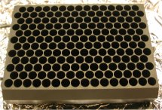

The EES fab group has finished assembling the eight VME interface modules that are used on the programmable timer boards. The interface boards need to be tested in an IOC, but after which we are ready to implement timer boards as needed now. These will provide agile timing references for the many devices we use to characterize both the electron beam as well as the drive laser and the FEL itself.
GC Magnet Control boards have all been completed. The power supplies for MGC5F01 and 5F03 have been completed, installed and are ready for operation. The third chassis is awaiting final test and the fourth should be ready for installation by Tuesday. Each chassis is a floating supply, two isolated channels per QT Panofsky Quadrupole magnet to adjust fields to give a vertical kick. These power supplies ride on the primary power supply of the quad which is a four quadrant 75 volt/ 20 amp supply. DC power for the 1st Arc GY dipole has been completed. Installation of the GY shunt, shunt resistor and thermal interlocks are in progress with checkout beginning early next week.
Rigorous testing has been performed on the Linux frame grabber's center-of-mass measurement. Some calculations produced readbacks that are inconsistent. But the problem is being narrowed down. A current problem with UDP errors associated with IOCFELT2 is being looked into. It was discussed with Joan Sage to insure that the frame grabber software was not causing such problems. Tests have been done eliminating situations from the list of potential sources.
The new Laser Personnel Safety System (LPSS) machine has been installed. This contains the database and access control for the user labs laser safety systems. The OCR and labs 1, 2, and 6 are operational. There were problems with the reader at lab 3. The source has not been determined at this point but it is not currently certified for laser operations so there is no adverse impact. A key feature of the new system is an operational keyboard. The new machine is placed in the CR racks with the old one being stored in the OCR as a backup system. All cables have been relabeled for their updated COM port assignments. The COM ports on the machine have been labeled accordingly.
Drawings for the microvideo camera boxes and the Charge Dump Current Monitor Buffer Driver are in the final stages. System drawings for the Charge/Dump Current Monitoring System are also in progress.

WBS 9 (Transport):
Arc 180 Degree Dipoles (GY)
• For the second GY, we instituted our fix to keep the Purcell Gap lamination material in place for upgrade level momenta (Max. is 210 MeV/c and we are at 90 MeV/c now). Don Bullard and Mike McCrea from the JLab Machine Shop worked Saturday and Sunday to apply the compressed o-ring stock to the Purcell Gap lamination material. With the same operation, they installed the beam chamber. The magnet was rigged into the FEL vault and into the first arc on Tuesday. The stands (which had to be removed in order to roll the magnet into place) were repositioned and grouted. We aligned today. Hook up of power leads, attaching the vacuum chamber, installing the cooling water connections, shunt system and the synchrotron light diagnostic periscope as well as final alignment are all activities planned for over the weekend and early next week. The shield blocks were replaced against the overhead door of the vault.
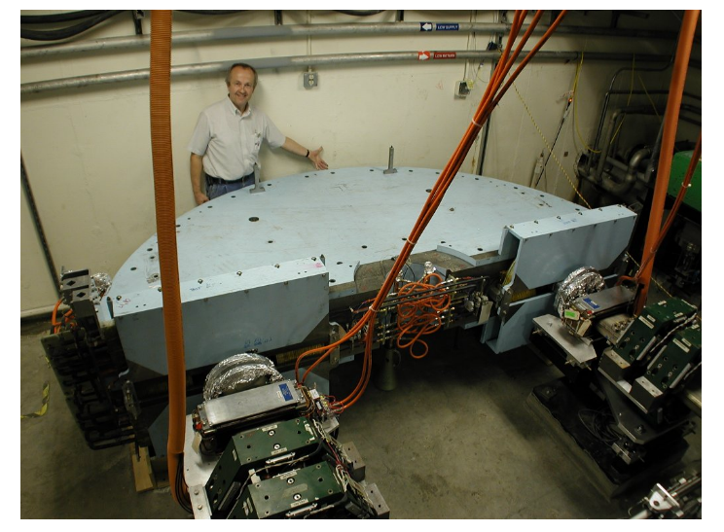

“The GY just fits.”

• There are no signs of delamination of the Purcell Gap lamination material in the GY of the second arc. It is only run up to 60 % of maximum current with operation at our low momenta and therefore we are not worried about delamination. When we go to higher momenta, we have the material on hand and a rigging plan for popping the top of this magnet to insert the compressed o-ring stock.
SF Sextupoles
• Mel Gonzales of the electrical CAD group continues making good progress in revising the drawings of the SF Sextupole design. The specification to match the drawing package is nearly complete.

WBS 11 (Optics):
This week's work on the optical cavity continued measurements of the active feedback system. More insertable optical diagnostics (e.g., a high power optical beam dump) were installed and checked out. Thanks to the I&C group for their help. We continued to work on improvements to the optical cavity that will be ready when we open the vacuum vessels to install new mirrors. One improvement is cooling line fixtures to better secure them, and they are being cleaned for UHV use. Another is the new outcoupler mirror holder, it was cleaned and brazed, and is at the Machine Shop to have the hose connections attached. The first article looks so good that the second ring is being built now. We assisted I&C with parts for the calorimeter that will be placed before the outcoupler mirror and used to measure power (especially in the IR and far-IR) radiated towards the mirror. We held several design meetings to prepare for adding new penetrations for the UV optical transport, and an EUV (from coherent harmonics) line into User Lab 1. In the process, we have a new scheme for mounting the turning mirror cassettes in the user labs.

The ultrafast laser system was moved to the vault where it will be used in a pump-probe arrangement to better determine the injected bunch length. The associated optical delay line was installed and aligned earlier this week. The periscope that routes THZ light from the port on the optical chicane to the FTIR was reinstalled and aligned. It has a simple shroud around it so the path can be purged with dry nitrogen. This should remove some of the spectral artifacts due to water absorption.

New fixturing for mounting cavity optics in the mirror test stand were used this week, and are a big improvement over the simpler (and less rigid) mounts we'd been using. Fixtures that will be used for laser calorimetry were also tested and work well.

Terahertz Project:
The drawings for M1 and the specifications are complete and ready for an initial bid solicitation. The mirror actuators for M1 and M2 and the beamline vacuum components, pumps gauges and valves have been identified. We are still awaiting bids on several beamline hardware components.

Technology Transfer:
Five different FEL/Tech Transfer activity reports for FY03 were completed and submitted this week:
- 3 to Jim Murphy (JLab Office of Technical Performance) for contract obligations,
- One to TPWG (Bob Hamilton in Oak Ridge) for DOE's master dBase for Tech Transfer,
- One to DOE's SBIR/STTR database of expertise at JLab.

