MEMORANDUM
It’s a visit from the Easter Bunny!
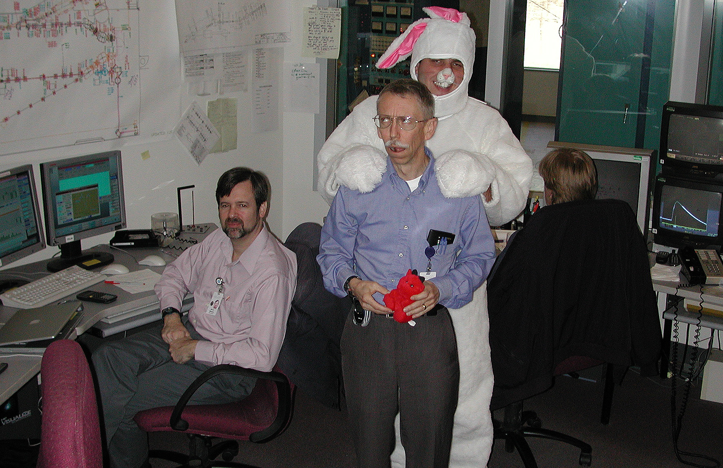

To: Distribution

From: F. Dylla

Subject: FEL Upgrade Project Weekly Brief –April 5-9, 2004

Date: April 9, 2004

Highlights:
Highlights for this week’s activities for the commissioning of the FEL upgrade are the following:
1. We successfully installed last weekend a low loss output coupling optics for operation at 6 microns and a scrapper outcoupler for operation at 10 microns.
2. On Wednesday we successfully lased with 3 different optical configurations: our original 98%, 6 micron outcoupler which we used for start-up operation, a low loss, 92% 6 micron outcoupler and a pair of high reflector, 10 micron optics with the use of the scrapper output coupler.
3. With initial set-up operations with the 92%, 6 micron outcoupler we measured the total absorption loss in the optic and found it to be <200 ppm ± 10%. This should enable outcoupling of ~ 7.5 kW. Initial operation with this optic has yielded output of 3.5 kW pulsed and 2.9 kW cw at 5 milliamp beam current.
4. We made good progress with optimizing our longitudinal beam dynamics in setting up the injector and linac. Electron beam pulse lengths as short as 600 fs and longitudinal emittances of 60 kV-psec. have been obtained at the wiggler position. This is close to our original specification (50 kV-psec.).
Management:
We prepared a summary of the status of the FEL upgrade commissioning and an update of the plans for next 3 months of operation and forwarded this document to our Navy and Air Force Program Managers and FEL steering committee on Monday, April 5. In this plan we requested authorization to install the 3rd cryomodule in the FEL linac on or about the last week of April since the 3rd cryomodule commissioning is complete and the window of opportunity exists during May to commissioning the module in the linac prior to the arrival of the new short wave length wiggler in June.
F. Dylla made a presentation to the SURA Development committee on April 6 concerning the plans being developed by University of VA, Harvard University and the Hampton Roads Research Partnership to develop bioscience applications of the FEL Users Facility.

Commissioning Summary (Steve Benson):
Due to a slow pumpdown in the optical cans we had Monday and Tuesday to try to optimize some new setups for lasing and to fix some problems with the magnets and RF. On Monday we worked on optimize the so-called 10-10 configuration. This has the electron beam 10 degrees off crest in both the injector and linac. It produces a fairly short bunch with acceptable energy spread. We continued the matching for this configuration on Tuesday and started to set up the 20-20 configuration. This configuration still needs more matching and has a rather low energy. At this point the 20-15 and 10-10 are our two good configurations. One Wednesday we could finally open the vacuum valves to the optical cavity and try to lase. It was a successful day. We lased with the 98% 6 micron output coupler, the new 92% 6 micron output coupler, and the new scraper. The efficiency for the 92% coupler was as high as the 98% but the energy spread we less. This is very good news. The scraper produced 500 W/mA with no optimization at all except for mirror steering. This means that 10 kW is not out of the question but we will have to see how the power scales with current.
On Thursday we pushed for high power. At the long end of the mirror detuning curve the mirror absorption was high enough to make lasing difficult. The mirrors not only distort but steer. The response time of the power meter is about the same as the time that the mirrors steer off, preventing us from optimizing the cavity. We could lase up to 2 kW but could not hold it. We then shifted the wavelength to 5.66 microns where the absorption of both the output coupler and the high reflector are less absorbing. At this wavelength the efficiency and gain are lower than the long wavelength side but we could operate at 5 mA and over 2500 W at 37.4 MHz. We tried operating at 74.85 MHz but found that we were getting persistent vacuum trips above 8 mA and, since the efficiency is a steep function of charge, we could not get more than 2500 W with this much current.
Today we are working on seeing if we can improve the efficiency of the laser and to find out why we are vacuum getting the trips in the cryounit and fix that problem. If we can run 10 mA we can get up to 5 kW (since the mirrors are not distorting much at 5.66 microns).

WBS 4 (Injector):
The gun continued delivering beam, total charge off of this wafer to date is around 900 Coulombs. Work is nearly complete on a new mount system for the implant system. The mount and a tube should be tested next week.

WBS 8 (Instrumentation):
Preparations are being made for when the new streak camera arrives. We have chosen 3 Synchrotron Light Monitor (SLM) ports to start with. Prior to receiving the purchased unit we will have access to a "loaner unit". The loaner has a resolution of 1 picosecond (compared to 500 fsec for unit on order). We will first set up a lens and camera at the 2F06 SLM port (start of first arc) to look at the projected image. This will determine correct location for the camera.
The new CNi3253 (OMEGA) temperature process controllers came in this week. These are the replacements for the CN491A-V1 process controllers we had been working with in the past. The critical improvement in these controllers is the analog "retransmission" of the temperature that the CN491A-V1 deceptively lacked. This feature will provide a true, steady, analog signal to the asynchronously sampling ADCs in EPICS. Having oriented ourselves with the new part, we are ready to install them during the maintenance day this coming Monday. Both the old & new units are 1/16 DIN package making the change very easy.
An optimization of the framegrabber program took place. This allowed the program to run much more smoothly and created fast returns of data calculations to the user. Saving data now allows for a users to select the information categories that they are interested in. The categories range from histogram data to reports. A script was added to allow the users to view the Gaussian fit results, plotted relative to the actual data points acquired from the image. Designs for automating the emittance calculation are in the works. The configuration control database has been updated with 2600+ new items which enumerate the existence of every FEL drawing provided to document control and every FEL electrical drawing on record from the EECAD group. FEL drawing numbers can now be easily found based on keywords searches and system, location, and status filters. This gives us a long over due tool to keep track of status and progress of drawings throughout the creation and revision process. This also provides us with a place to state any corrections that need to be made or any omissions that have been found during the check-print process between the designers and engineers.
The front and rear panels (F0282 and F0283) that we received last week for the new AMS and video system chassis (F0253) have both been found to be in error from the vendor. The vendor is very eager to correct the mistake for us, but it will take another week before they can ship us the new panels. Another manufacturing error that showed up this week was on the new Happek pre-amp module (F0295). In this case the PCBs came to us with only one side solder masked. These boards will be re-made as well compliments of the vendor.
Designed, documented, and initiated the construction of six IR Wiggler Optical holders. The pieces will be made in house. Assembled and tested the new CCD digital cameras to replace our aging Lab cameras. The new HVPS Analog I/O Boards have arrived and one is currently being assembled and tested. Progress is continuing on the FEL Pre Amp Chassis with the front and rear panel drawings undergoing edit and review. The PCB boards arrived from the vendor but were shipped with a manufacturing error. Assembly and testing will continue on one module while the vendor corrects the error and ships new ones. Effort continued on the documentation and fabrication of the Dump Charge test fixture.

WBS 9 (Beam Transport):
Sextupole Lite Re-coiling to obtain higher field
• The 48 new add-on coils are being made at New England Technicoil for delivery in 3 weeks.
Wiggler

Electromagnetic Wiggler for 2.8µ
• Conductors are scheduled to be cut out at water jet vendor today and Monday. Cooling plates will follow.
• PECo is machining the core pieces.
• Ancillary fabricated parts are on order from local shops.
• PECo’s ancillary parts are being made by their local shops
• The assembly drawing is checked. Fastener part sets are on order.
• The shop will start welding the beam chamber on Monday.
Sextupole (SF)
• Procurement on hold pending 10 kW efforts
WBS 11 (Optics):
Here is a summary of our progress on the various plans.

Plan A is to obtain low loss 6 um optics.
Interleaved with operations, we have been doing metrology on the new substrates made with the lowest loss material available. The best two will be shipped out for coating. The choice of vendor was made evident when we lasing with one of the refigured and recoated 92% outcouplers. As will be discussed in more detail below, the coating absorption is quite low, of order 100 ppm. New HRs are at the vendor. We were informed they will ship no later than the week of the 19th.

Our three Plan B's had the following progress:
Scraper outcoupler: The scraper and associated diagnostics was installed over the weekend. We took the opportunity to try to lase with it on Wednesday and were gratified to see that, on an average power basis, it was easy to run. The ~300 W is the highest output from a scraper-outcoupled FEL; and we were nowhere close to pushing the average current. We will work to improve the lasing efficiency (currently about 0.5kW/mA) and then push the power next week. Thanks to the I&C group for the flow interlock for the HR mirror that is installed in the OC position, and the work they are doing on the other readbacks. We are also indebted to Tom Elliott for his invaluable services to get the cooling tubes brazed to the scraper, and for gold coating it, and to Don Bullard from the Gun Group for polishing the scraper, getting the tubes properly bent, then sheparding it through final machining. We are all looking forward to seeing how this scheme performs.
Cryomirror:
The cryogenic mirror mount was assembled and came out of the braze furnace this morning. It was just leak checked, and has one leak along its outer periphery. It will be rebrazed this afternoon. We tried thermally cycling (to 77 K) one of our new standard mirror mount (2" dia) and had it leak. See more details below in the 2.8 um mirror report.
In concert with George Biallas we had this report:
• The cryogenic mirror mount is brazed.
• The system to do a trial of the cryo concept is being installed in Lab 2. We will be able to heat a spare cavity mirror to see assess cooling schemes as well as mirror vibration and distortion
• The work on the cryo cooling liquid flow for an enclosure installation continued to advance. The Cryo group is helping us put together some hardware for simple, low heat leak liquid nitrogen transfer. The Installation Group is installing the vent tube for the gaseous N2 next Monday.
2.8 micron mirrors:
In fabrication. Brazing the mirror holders has been problematic, as the latest billet of Mo that we acquired was not homogeneous in grain size. The large-grain material acts less ductile than the fine grain material, and in order to braze at all we have had to go to paste rather than foil, increasing the chance we'll have a void or gap. So far we are having problems at the junction where the stainless steel tubes (for coolant inlet and outlet) enter the molybdenum mount. Two plans are being pursued - one is to make a thicker braze joint in this area, the other is to better handle the thermal expansion mismatch by making the stainless steel wall thinner.
As mentioned last week, we received 2" Si HRs, the OCs will arrive in about a week. 3" mirrors are in fab, expected in mid May. We plan to install a set of mirrors capable of operating at 2.8 um by lasing on the third harmonic later this month. They will be used to do calorimetry on witness samples that coating vendors are submitting for test.
Other activities:
The weekend turned into a marathon to finish a long list of installation activities (completed Saturday evening), then find and fix a vacuum leak in the outcoupler assembly. The hunt for the leaks and their remedy took most of Sunday to fix, the main culprit being a leak that had appeared in a cooling tube on the newly-installed 92% outcoupler. The latter half of this week's been an exciting time for the group, as we see the fruition of our labors, and get ready for next week's cryomirror tests. Once we ran +400 W of output it was obvious that the outcoupler coating was low loss (order 550 ppm). Thursday's operation gave us the chance to determine the THz heating contribution; once subtracted from the total heat load, this coating has a loss at ~ 5.7 um (another advantage of a tunable laser system!) of ~ 120 ppm (15% error bar). This bodes well for finally getting very high average power out of the FEL.

