MEMORANDUM

To: Distribution

From: F. Dylla

Subject: FEL Upgrade Project Weekly Brief - November 7 - 11, 2005

Date: November 11, 2005

Highlights:

This week we continued our progression from system check-out to start-up of operations.

Highlights for the week included:

-successful final leak check on the FEL03 cryomodule rf windows, followed by cool-down to 2k on Wednesday; concurrently the rf waveguides were hooked up and the process of check-out and re-certification of the rf interlocks continued through today

-the alignment and vacuum activities in the wiggler region of the machine were completed this week; the entire machine is now under vacuum

-injector activities continued this week during late first shift activities; high quality signals were obtained on the “multi-slit” emittance diagnostic

-the Optical Transport System from User Lab 2 through 6 is now under vacuum

Next week we will shift the remaining punch-list activities to very early in the day 0500-0900 and devote the majority of the working day to re-commissioning of FEL03 and then move on to re-establishing linac operations.

Management:

We worked on a draft report of FY05 accomplishments for the Navy funded FEL program. The format for this report and the subsequent cost-performance reports for FY06 were reviewed with ONR program management.

The project financial reports for the month of October were completed and will be sent to the respective program offices next week.

All FEL program cost account managers met today to continue our planning for the optimal use of our resources in FY06 to meet the established list of high level goals (which start with 10 kW operations at 1.6 microns).

Gwyn Williams gave an invited talk at a THz Systems Workshop in San Diego.

Operations:
While we are waiting for zone 3 to be commissioned we are working on commissioning the injector. We ran tune-up beam to the injector dump this week and checked out all the magnets and diagnostics. We also tried increasing the injector energy to take advantage of the increased gradients available after helium processing. With field emission at levels comparable to what we had before at 7.3 MeV/c we now can run at 8.7 MeV/c. The spot size after the cryounit is much smaller than at the lower energy. With this beam we checked out the magnets in the injector. The new vertical corrector embedded in the first quadrupole after the cryounit now works and allows us to correct the vertical trajectory after the unit. This corrector replaces two correctors spread over a large section of beamline that had low magnetic field quality.
All the diagnostics present before the down still work fine. The new emittance measurement multi-slit is now working. We took data with it (see figure below) to measure its linearity and alignment. This should be a very useful diagnostic for beam setup. We are now commissioning the new BPMs in the injector. So far the injector is behaving quite well, with few problems to date.

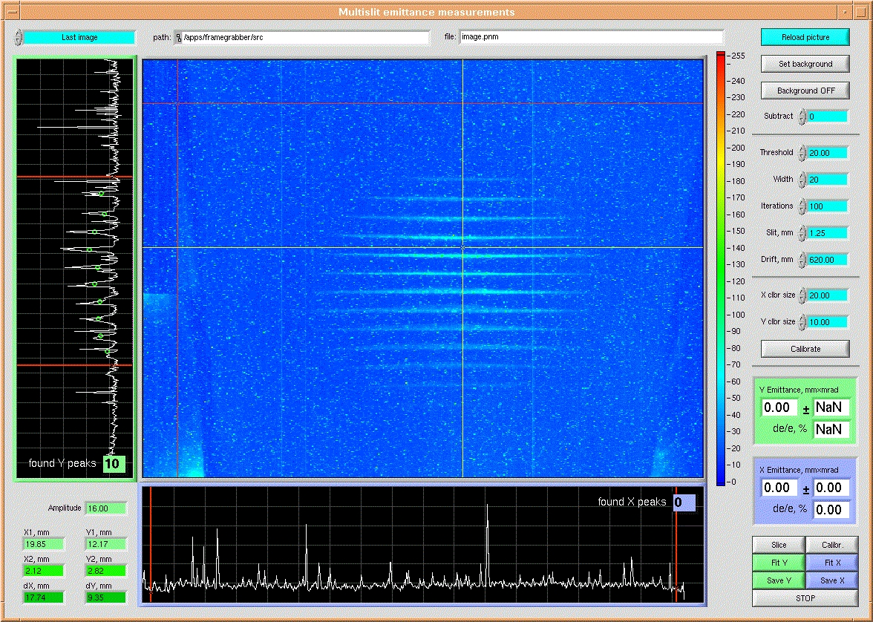

WBS 4 (Injector):
Injector setup continued this week by threading down the beam from the gun to the injector dump at 8.7 MeV/c. Preliminary PARMELA simulations at this energy show a horizontal longitudinal distribution with ~ 10keV energy spread and 2.5 ps rms bunch length. Both vertical and horizontal multislits were operated successfully as well as the data collection software developed by Pavel Evtushenko and integrated by Wes Moore.
WBS 6 (RF):
During the past week we continued to prepare cryomodule FEL 3 for commissioning. SRF staff reconnected the waveguide between the klystrons and the cavities. EESRF staff found a leak in one of the waveguide joints and repaired it. PSS staff completed the PSS certification for the zone; this included bringing the zone up to the high voltage mode. The window IR and arc detector sensors were installed, the channel mapping and functionality of each was verified. We did a complete checkout of the interlocks for the zone except the new coupler vacuum interlocks, which are in the process of being verified.
We brought cryomodules 2 and 4 on line and characterized the klystron capabilities, including body currents for zone 4. The LLRF output attenuators were set on zone 4 to insure that the klystrons are not operated beyond the desired maximums. We found that cavity FEL2-8 has a thermal quench at 7.25 MV/m and a klystron body current limit at 6.5 kW. We made adjustments to the LLRF output attenuator and the maximum allowed gradient settings in order to insure that these fault limits would not be exceeded.

WBS 8 (Instrumentation):
We have had an excellent week beginning to commission the various new and upgraded diagnostic in the injector. Most notable was the multislit emittance monitor. We have had a few versions over the year that were marginally succesfull. The improvements were three fold; 1. separated the horizontal and vertical slits to allow for accurate alignment, 2. EDM wire cut new slits (they look like a mans pocket comb)out of Nb (we had a few scrap pieces...), and 3. the DESY style phosphor coated viewer paddle. (see highlights for image)
Progress continues on commissioning of the BPM electronics. A series of characterization measurements were made is to better understand the how each channel will function. The first measurements that were made were setting the initial calibration points via the zero adjust and then the slope adjustment. Once these points were set a series of data was taken as the input power was varied from -60 dBm to 10 dBm with steps of 1 dBm. These points were plotted for each channel and then error measurements were made as a function of input power. The results of these measurements show that the current technique for calibrating the position gives as much as a 2mm error at certain input powers. So in order to handle this error a spline interpolation is being made in the on board processor based on the channel to channel variations. According to the measurements this should improve the error down to a maximum of 200 microns. This software change is being made at this time with the hope to be able to test with the FEL injector. The other measurements that were made so we can try and get the bandwidth of the system in the most operable point of FEL operations. The zero crossing point was swept across a range of 10 dBm and the slope was altered to get the maximum output of the system for 10 mA operations. These bench measurements are useful in identifying the problems with these electronics and help provide the data needed to correct them. A scanning wire calibration stand is being designed to determine the actual resolution (both short and long term) of the electronics. A spline interpolation is also being programmed for each channel of the BPM. A set of points of rf power (db), and a set of points of volts from each channel are obtained from calibration and used as inputs for spline interpolation. The subroutines for all four channels are coded. I am going to make the subrecords and new database for the x, y position calculation.
Calibration of the new 3F viewers began this week. The cameras were positioned to the standard height. The mirror positions were adjusted to fine tune the size of the foil on the screen. A WesCam calibration was done for the completed viewers. ITV0F04 was replaced this morning after some WesCam triggering issue. The fix will be tested during today's shift.
The EPICS cubic spline fit for the wiggler K to gap calculations was tested successfully. The safe guards for the wiggler gap size will be implemented and fully tested before the software goes into operation.
All of the parts except for one have arrived for the sextapole reversing switch. The boards have arrived; one has been populated and tested successfully. The brackets for the enclosure have all arrived as well and the enclosure has been fitted up with the electronics, brackets, and wiring. The rest of the boards are being assembled at this time so they will be ready for installation once the last part arrives.
System checkout / Ops support continued this week with the semi annual PSS certification. Functional testing of our major systems Personal Safety System interlocks was completed. With the exception of 2 box supplies all other interlocks passed. These 2 box supplies (2G Dump Spectrometer, 2nd Arc String) have been repaired and should be tested by end of business this week.
WBS 9 (Beam Transport):

Sextupole (SF)
• At week’s end our magnetic measurements showed horizontal field where there should be none when scanning the horizontal mid plane. We found that some of the above reading may be due to the test stand itself. We found that perturbing the field clamp positions results in changes to the horizontal field. Identical magnetic readings at the pole tips indicate that the turns in the coils are all the same. Mechanical measurements of a second magnet showed no pole positions or field clamps significantly out of position. In all, we have more questions than answers.
• Over the next two weeks we will mechanically measure as many magnets as possible to allow us to correlate field quality with physical dimensions. The magnet test stand will be off the project, devoted to a 12 GeV dipole magnet test. In the interim we will plan a series of magnet measurements to assess the sensitivity of various pole movements and field clamp movements to field quality, with the goal of finding and eliminating the quadrupole and dipole components we see in these sextupoles.
Replacement Chicane Dipoles (GW)
• The remaining two units in at Magnet Test, awaiting the testing of Sextupoles before the GWs get measured.

UV Line
• Meanwhile, quads are not tested and girder assembly remains on hold.
• The NEG Pump cartridge holder design for the second corner UV chamber is on hold.

UV Wiggler Progress
• No progress on the new wiggler vacuum chamber until new funds are identified

WBS 10 (Wiggler):
The rest of the vacuum chamber around the wiggler was installed this week. We are now hooking up the rest of the diagnostics around the wiggler. Final alignment was completed this week as well. We have a few punch list items to complete and then the IR wiggler will be ready for beam.
The UV wiggler is in the magnet test facility at STI Optronics. First measurement results should be available early next week.

WBS 11 (Optics):
FEL mirrors
The HR and OC assembly's ancillary diagnostics were checked out. We are ready for ops. We have initiated discussions on coating work with a few other vendors that use different deposition techniques than the one we currently use (ion beam sputtering). In order to move forward on our absorption measurements, we've moved the calorimeter to User Lab 6, in order to use the advanced drive laser.
Other Activities
Early this week we started leak checking the newly-built optical transport system (OTS) that exists between User Lab 1 (UL1) and UL6. There were numerous small leaks that were systematically found and fixed, this consumed about 3 days for a portion of the group. Work continues on the THz pump probe synchronization electronics. We need to add some low phase noise signal processing components to properly shape the clock signal. A requisition for a new pump laser diode for the maser oscillator was placed. The original laser diode failed prematurely, but well out of warranty. The vendor will sell us a replacement at a greatly reduced cost. This way we'll recover the ability to operate the laser system ay 748.5 MHz. We also purchased some beam condensing optics for the master oscillator that will decrease the beam size in order to use a transverse EO cell for pulse selection. The extended range NIR camera was installed so we could observe the fundamental laser mode on the HR mirror at wavelengths shorter than 1.8 microns. Several of us are completing input to the FY05 annual report.
We received the thermal isolators, for both the cooling loop and OC mirror, as well as the metal bracketry for the UV optical cavities. The utility vacuum line is complete at a local machine shop. It awaits leak check.

Terahertz:
The spectroscopy chamber has been ordered. Representatives from Thermo-Nicolet visited to advise on the conversion of the Nexus Michelson purged interferometer into a vacuum version, and components were ordered. Work continued on specifications of an ultrafast THz detector.

