Tech Note

Low Voltage Retarding Field Mott Polarimeter Operation

Overview
The compact low-voltage Retarding field Mott polarimeter is now in routine use in room 118 EEL. Longitudinally polarized electrons are excited in the polarized source with circularly polarized light incident on a GaAs photocathode biased at -258 V using a battery bias box. The electrons are bent 90degrees using an electrostatic bend then steered and focused with electrostatic tube lenses. The electrons are accelerated to scattering energy (5-30 kV) between two hemispheres, scatter off the thick gold target, and are decelerated to incident energy passing back through the hemispheres. Retarding field grids are used to for energy analysis of the scattered electrons: multiply scattered electrons have lost much of their incident energy, and when the retarding field grids are near the incident electron energy, only elastically scattered electrons pass through to the CEM detectors where they are counted.

The details of setting up and operating this polarimeter are detailed in this tech note.

Optics setup

The cathode is illuminated either with laser light or variable wavelength light from a monochromator. In either case, the light initially passes through a linear polarizer, is deflected upward into the polarized source entrance window with a mirror, an insertable halfwaveplate is used to vary the orientation of the polarization of the light and a quarter waveplate just before the vacuum window to generate circularly polarized light. With the monochromator system, a long pass filter to avoid illumination by higher order, short wavelength light is added to the system and a long focal length lens is used to minimize the monochromator spot size on the photocathode. Power is adjusted at the white light source or through manually adding ND filters to the system. The laser system has much more power, and an attenuator system consisting of another linear polarizer and a half waveplate is used to vary laser power incident on the photocathode. For position scans, the vertical bounce mirror is mounted on an x-y scanning stage and QE or transmission scans can be accomplished by moving the spot across the cathode using the computer controlled scanning stage. A shutter in the laser system allows dark backgrounds to be routinely measured and subtracted from the asymmetry measurement – no provision for this has yet been implemented in the monochromator setup.

Polarized source

The polarized source makes use of standard CEBAF components and has a load-locked system to introduce new photocathode material. The stainless steel chamber with all metal ConFlat™ seals is baked to 250C for 30 hours initially to achieve pressure in the low 10-11 Torr range. The system is pumped with a combination of sputter ion pumps and non-evaporable getter (NEG) pumps. The photocathode is mounted on a 26” long hollow tube, referred to as a stalk, which allows heating of the photocathode to a surface temperature of 550C using a heater external to the vacuum. The stalk should be at the position marked “heat” for photocathode heating and activation. The photocathode is activated using a yo-yo method and cesium from SAES getter strips (nominally 5A current is used to deposit Cs on the photocathode) and an oxidant: NF3 is currently used in the system. Photocurrent from either a white light source or laser is monitored during photocathode activation.

Load Lock cathode changes

New photocathode material can be loaded into the system using the load-lock bellows and a short bake o f only the bellows. The McAllister bellows support and manipulator is used to position the stalk. Retract the stalk fully into the bellows and close the 3” gate valve, then turn off the uppermost “bellows” ion pump before venting the load-lock using the turbo pump cart and dry nitrogen. (See figure) When the whole system will be baked, a pinch-off valve must be used to protect the right angle valve for the load-lock system, but for routine use, a CF-NW adapter can be used for venting the load lock system.
Remove the old stalk and replace it with a new one – a glove bag can be used to reduce the amount of water that enters the system. Tighten the flange, pump down and when the convectron gauge on the pump cart reads zero, try turning the ion pump on.
The load lock is baked using heat tapes: wrap the heat tapes either around the aluminum support tube or directly around the foil-wrapped bellows, then cover the heat tape assembly with the insulation blanket designed for that purpose. The photocathode should be heated to 300C during the bake to keep it warmer than the chamber and avoid contaminating the surface. The load lock should be heated to 250C using the heat tapes, maintained for 12 hours and cooled. (Get Maud’s procedure copied in here)

Internal wiring

Channel Electron Multipliers
Each CEM has three connectors. The signal is connected at the back of the CEM and designated lead 1. The front bias, connected at the front of the CEM, is designated lead 2. The back bias, in the center of the CEM is designated 3.

5
4
3
2
1
1
3
2
Figure 1 CEM and can electrode configuration 1:collector 2:front bias 3:back bias 4:can and can grid 5: retarding field grid

The detector high voltage bias and signal detection, and Mott electrostatic lenses are connected to the external electronics through two multipin vacuum feedthroughs. The cables are connected as follows.

B
A
K
C
M
L
T
J
N
U
V
S
E
F
G
D
P
Q
R
H
K
A
B
J
T
L
M
C
S
V
U
N
G
F
E
H
R
Q
P
D
PIN | connection
K | L5
A | L4
B | U5
J | L3
T | U3
L | R3
M | D3
C | U4
S | L2
V | U2
U | R2
N | D2
H | L1
R | U1
Q | R1
P | D1
D | R5
G | D4
F | D5
E | R4

Vacuum side
Air side

Figure 2 CEM bias feedthrough. L/R/U/D designate Left/Right/Up/Down. 1-5 are the connectors for the CEM collector, front, back, can and retarding field grid.
PIN | connection
K
A
B
J | 3L
T | 3U
L | 3R
M | 3D
C
S
V
U
N | 2
H | 1L
R | 1U
Q | 1R
P | 1D
D | outer hemi
G
F
E
B
A
K
C
M
L
T
J
N
U
V
S
E
F
G
D
P
Q
R
H
K
A
B
J
T
L
M
C
S
V
U
N
G
F
E
H
R
Q
P
D
Air side
Vacuum side

Figure 3 Mott lens feedthrough connection diagram. Lens 1 and 3 left/right/up/down connections, lens 2 and outer hemisphere bias connections are as listed.

Beam to target
The electron beam from the photocathode must make it to the target with at least 1% transmission from photocathode to target in order to get good polarization data. The electrostatic bend and system of electrostatic lenses as well as the position of the laser spot on the photocathode is used to accomplish this.
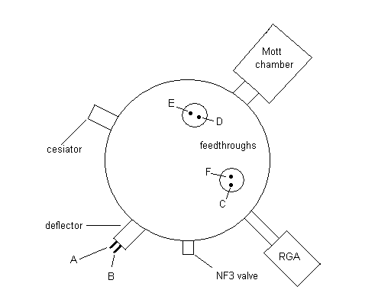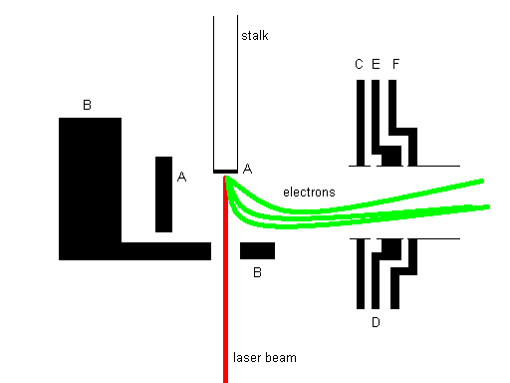
Figure 5: Vacuum feedthroughs for biasing electrostatic bend and polarized source lenses. Lettering is consistent between two diagrams.
Figure 4 Mott electrostatic lenses are designated as 1 on diagram. Uppermost MottLens1 is split in 4, L/R/U/D with respect to the electron travel direction. Center MottLens2 is a single lens. Bottommost MottLens3 is also split in 4 L/R/U/D. Support is at “down” direction.
Element | Feedthrough | Lens bias box designation | Bias
Backplane | Source A | 8 ganged with Diff 3 | -271.8 + 10.4 = -282.2
Deflector | Source B | 9 | -308.7
First source lens | Source C | ground | Ground
Upper split lens | Source D | 4 | -187.6
Lower split lens | Source E | 7 | -262.1
Third source lens | Source F | 5 | -191.2
Mott Lens 1 | Pins H/Q/R/P Left/Rt/Up/Down | Diff 1 L/R | 12.86/-12.76
Mott Lens 2 | Pin N | 3 | -191.2
Mott Lens 3 | Pins J/L/T/M  Left/Rt/Up/Down | Diff 2 L/R | 10.66/24.8???
Table 1: Electrostatic lens and deflector settings as of 3 April 2009.

Beam to target
The electron beam from the photocathode must make it to the target with at least 1% transmission from photocathode to target in order to get good polarization data. The electrostatic bend and system of electrostatic lenses as well as the position of the laser spot on the photocathode is used to accomplish this. Nominal good settings for the lens biases are shown in Table 1.

Procedure for getting beam to target is as follows.
1)If only the light has changed
First, get maximum photocurrent from cathode by adjusting the laser spot position. Ensure that retroreflected spot is coincident with incident spot on steering mirror. The more current available that is available, the easier the system is to steer up. Bias the target with +200-300V, and monitor current drawn on target with second picoammeter. Vary laser spot position with x-y stepper stage until current is seen on target. Optimize with iterative movements. Alternately, set scanning program in motion and see what you get. (James – details on using scanning program?) Fine tuning can be done with 5 kV or more on target and CEM signals to verify that counts are maximum. Polarization measurements with less that 1% transmission from cathode to target give falsely low polarization readings. When there is some current on target, slight changes to source and Mott steering lenses can be used to further optimize transmission.

2) If photocathode position has changed
Steering is very sensitive to position of the photocathode. Height adjustments can be made to try to get back to previous position using transmission as a criterion to see if things are as good as they were. The deflector bias, B, is very sensitive to the position of the photocathode, so changes to B may help if photocathode position is different. Backplane A is also helpful in starting steering after a cathode position movement.

3) Starting from scratch
With as much photocurrent as possible, put the biased “Faraday cup” in from the side of the Mott chamber. This will tell you when you are successfully getting beam around the electrostatic bend. When this is optimized, pull the cup, bias the target, and start steering down the system in an iterative manner.

Data Acquisition Setup
The CEMs are biased both at the front surface and at the back, with a collector capactively coupled to the output. The signals are amplified with a Ortec VT120a preamp, then fed to the NIM crate fan-in/fan-out where they go to both an oscilloscope and discriminators. Phillips 6930 discrete discriminators are used, with discriminator levels set to a minimum of 250 mV to filter noise. Higher discriminator levels reduce count rate but are helpful in reducing background rates. CEM bias is provided using the Bertan and/or Ortec HV supplies in the NIM crate. Proper voltage values are determined either by measuring signal vs. voltage applied (keeping count rates under 10^4 as per manufacturer’s spec) or by turning them on until they just start counting with no beam on target – both methods provide similar CEM bias values. The retarding field grids and the CEM cans are biased using a computer controlled voltage supply in user-specified voltage steps starting as low as 0 V and going as high as 350V (leads for all grids and cans are tied together in the uppermost box and voltage is varied using the HP voltage supply and monitored with the Keithley multimeter). The nominal incident energy of the electrons, provided by a battery bias box so voltage will very slowly vary with time, is 268eV, determined by careful analysis of where the retarding field fully suppresses count rates.

Computer DAQ
The computer DAQ program is a labview file. It controls the shutter, motion of the halfwaveplate, retarding field bias and reads the counts in a designated amount of time for each detector. Online asymmetry calculations are graphed in the acquisition program, but the full Asym analysis program calculates a more accurate asymmetry with dark and >280V bias background subtractions.

Troubleshooting: when visa errors occur, turn off all talking equipment, reboot computer, turn equipment back on.

