JLab-TN-10-003
27–January-2010
Marcy Stutzman

DC NEG sputtering
A DC sputtering system is used at Jefferson Lab to coat chambers with a Ti-Zr-V non-evaporable getter coating.

Motivation
Non-evaporable getters (NEGs) in a vacuum system are useful for their high pump speed for hydrogen and pumping capability for reactive gasses, primarily oxygen, nitrogen and water?? Getter material sintered to substrates can be used to add modular pumps to a system, and are activated at temperatures up to 450°C or more through resistive heating of the substrate. The low-activation-temperature alloy of Ti-Zr-V in an approximately 1:1:1 ratio has been developed and shown to activate at the moderate temperature of a 250°C bakeout, and is therefore appropriate for a coating on beampipes, where it can be activated during bakeout. A coated beampipe or chamber adds distributed pumping and can effectively eliminate net outgassing from the walls.
Ti-Zr-V coatings with pump speeds up to 10 L/s/cm² are commercially available, deposited using DC magnetron sputtering to make the process commercially viable. We have been using a non-magnetron DC sputtering system to coat the 3” diameter beampipe leading from the CEBAF polarized electron guns to the beamline for the past 10 years. The measured pump speed of our coating is a modest 0.02 L/s/cm², but has worked well as a distributed pump, reducing electron stimulated desorbtion at the gun exit and providing additional pumping to isolate the electron guns from the poorer vacuum of the beamline.
The DC non-magnetron sputtering technique used at Jefferson Lab, based on the methods described by Benvenutiand commercialized by SAES, is described here.

Equipment and Supplies Required

Consumable Supplies Required
This is where you detail all the needed stuff for the process:
- Titanium wire,1 mm diameter, Goodfellow 912-044-66 ($44/m)
- Zirconium wire, 1 mm diameter, Goodfellow 717-718-67 ($60/m)
- Vanadium wire,1 mm diameter, Goodfellow 021-796-72 ($225/m)
- Noble gas for sputtering: Ar or Kr, Ultra-high purity

Equipment Required
- Ion pump power supply with reversible polarity: Varian 921-0062, 6 kV/200 mA ion pump power supply
- “Re-entrant” High voltage vacuum feedthroughs – this avoids sputter coating the ceramic, such as Duniway part number FT-PE-218
- Bellows support assembly (Thompson rails) with springs and adjustable stops to tension getter wires
- Leak valve (manual, though automated would be helpful to maintain pressure) for gas inlet
- Gas inlet manifold (bakable) with pumpout port
- Vacuum pump with valve to throttle pump speed
- Pressure interlock for high voltage supply

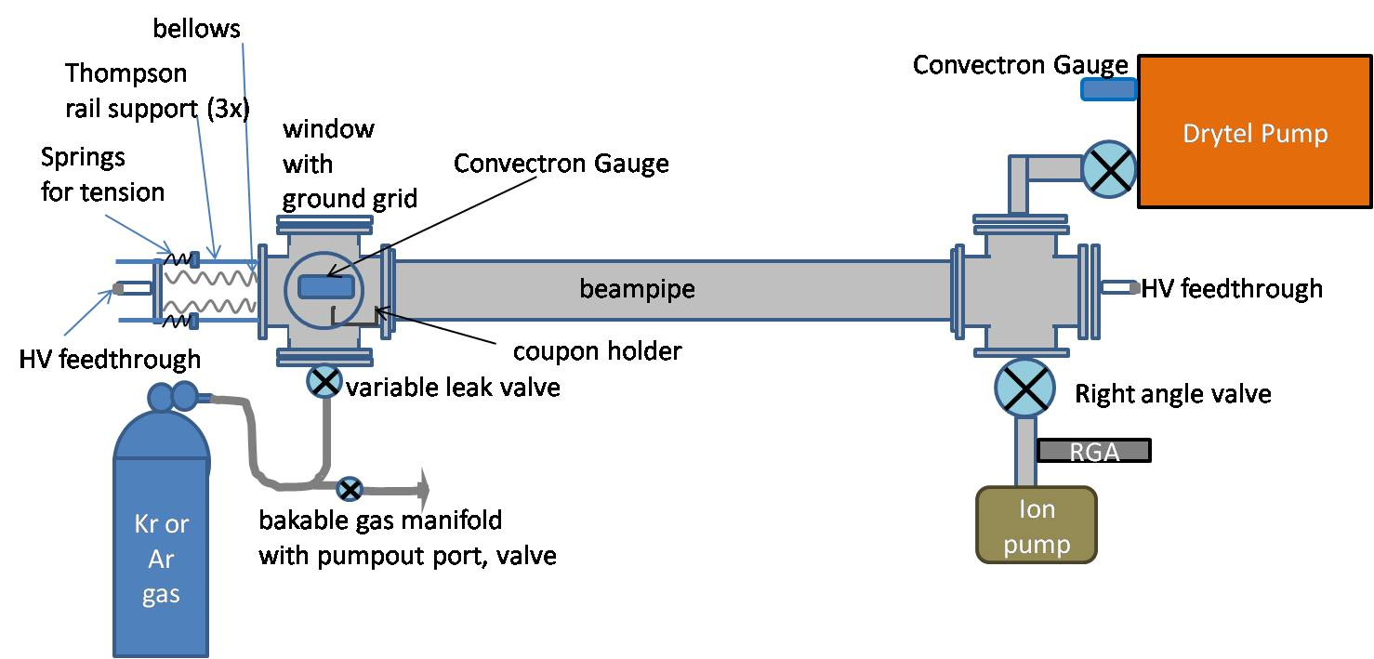
Figure 1: Sputtering setup schematic

Procedure
Twist the three wires, Ti, Zr and V, together to get a uniform coating and keep the wires together in the pipe. Hold both ends of the wires with clean vice-grip pliers. Secure one end to a bench, and manually twist the other end. Twist until the spacing is ¼ to 5/16 inch for the same material (Ti-Ti spacing).
Clean the beampipe to JLab UHV standards: degrease with Micro90 cleaner in an ultrasonic cleaner, rinse in several cycles of de-ionized (DI) water in an ultrasonic cleaner, rinse in acetone then methanol, with a final rinse in hot de-ionized water.
Assemble the sputtering apparatus with the beampipe installed between the two end ports: one with the gas inlet, and one with the pumping port. (See Figure 1)
If desired, put a glass or metal “coupon” in the system at the distance of the tube wall: this can be used for analysis of the getter composition. Measuring before and after can tell the weight/cm², surface analysis can tell the composition and porosity.
Install twisted wire in the beampipe using a barrel connector is used to hold it to the high voltage feedthroughs at both ends. One end has a bellows, with rails to support the HV feedthrough and springs to tension the wire as it heats. Adjust the set screws on the spring supports to tension the wire. Verify that the wire is not shorting to ground.
If sputter coating a chamber rather than a pipe, make a mesh cage with the Ti-Zr-V wire, using Ti wires for twist ties, with a spacing to the chamber wall ~1.5 inches.
Evacuate the gas inlet manifold with a dry rough pump and bake to 150°C with heat tapes for 24 hours to clean the line before use.
Rough down the system, turn on the ion pump then leak check the system using the RGA, which is behind a valve to protect during sputtering process.
Close valve to alcatel dry pump, then bake the beampipe with heat tapes to 250°C for at least 24 hours before beginning sputtering process: Reduce temperature to ~150°C and leave there during sputtering.
Fill the system with sputtering gas to a pressure of 50 mTorr, pump back out the refill to desired pressure. Use both inlet and pumping valves to regulate the pressure.
Connect a high voltage cable to the high voltage vacuum feedthrough, then connect the cable to the high voltage power supply. Make sure that the sputtering system is grounded to the table and that the table is connected to the room ground bus bar.
Maintain temperature ~150°C for cleaning and sputter coating NEG material (discharge will additionally warm system)
Sputter clean first for approximately 30 minutes using positive polarity on the wire and pressure/voltage settings shown in Table 1 – this will further clean the surface and ensure good adhesion of the NEG material. When the process is working, you’ll see a glow discharge with the color characteristic of the sputtering gas
 | Pressure (mTorr) | Voltage (kV) | Current (mA)
Beampipe: Ar gas | 50-80 | 2.1 | 65
Beampipe: Kr gas | 40-70 | 2.5 | 60
Chamber: Ar gas | 80-90 | 0.5-0.7 | 160

Reverse polarity to have negative bias on the wire during coating. Use current/voltage settings in Table 1. Adjust current/voltage to get a nice discharge, adjust the interlock range so that there is a nice discharge at both ends of the pressure cutoff range. Stabilize pressure using the inlet and pumping valves, and coat the beampipe.

Coat for 50-100 hours maintaining pressure within range. Coating thickness will vary depending on wire thickness, pressure, temperature. Set pressure interlock to turn off discharge when pressure varies out of good range: manually adjust the pressure inlet or pumping to stabilize in the good range, and the high voltage supply will come back on.

Conclusion
These homemade NEG coatings have pump speeds that have been measured 0.02 L/s/cm^2 for hydrogen, well below the quoted speed provided by SAES, but the system setup is relatively simple and the only expense is the cost of the wires, gas and labor. Automation of the gas inlet system would eliminate the pressure drift overnight and would be a valuable time-saving upgrade to the system.

References

[] C. Benvenuti et al., JVSTA 19 (2001) 2925. C. Benvenuti, P. Chiggiato, F. Cicoira and V. Ruzinov Vacuum 50 (1998), p. 57., C. Benvenuti, P. Chiggiato, F. Cicoira and V. Ruzinov Vacuum 50 (1998), p. 57., A. Prodomides, C. Scheuerlein and M. Taborelli Vacuum 60 (2001), p. 35.

