High voltage leads for the CEBAF -100 kV electron guns are attached to the high voltage power supply through an “Output” box in the injector service building. When operational, the HV power supply is connected to the HV leads going to the tunnel. When maintenance is required, the HV leads must be removed from the guns in the tunnel. This procedure details how the HV leads are safely manipulated.

Placing the high voltage leads that go from the output box to the guns in grounded storage on the side removes all potential for energizing system while gun maintenance is being performed. Gun HV cannot be applied unless the injector is in Beam Permit and no personnel are in the injector enclosure, so this configuration control procedure is followed to avoid damage to equipment.

The HV leads for each gun can be in one of three configurations: Operational (where HV can be applied to the gun), Offline (where the cable to the gun is in grounded storage, but still connected to the gun in the tunnel) and Maintenance (where the HV cable is disconnected both in the service building and in the tunnel for gun maintenance).

All workers planning on working inside gun HV chambers should ensure that the HV lead in the service building is in grounded storage before entering the tunnel. Visually inspecting that the appropriate gun HV cable is locked in the grounded storage is sufficient to begin work on the gun. If the appropriate cable is not in grounded storage, a trained person must move the cables to “maintenance mode” as described below.

Below is an example of the text on the Configuration Control tag:

GUN 3

SOURCE GROUP

CONFIGURATION CONTROL

LOCKOUT

Manipulation ONLY by qualified personnel
See list accompanying procedure

Condition 1: Gun operational
Key and lock shall be kept under
plexi-glass enclosure with the
H.V. Lead

Condition 2: Gun Off-line
H.V. Cable locked in grounded
storage. Key remains in lock.

Condition 3: Gun Maintenance
H.V. Cable locked in grounded
storage. Key taken downstairs
to unlock the gun shroud. Key
remains with downstairs lock until
maintenance is completed.
Removing HV cables in Service Building:
Changing from “Operational” to “Offline” mode

- Obtain permission from crew chief for a configuration change to the high voltage system.
- Make sure injector is not in Beam Permit.
- Verify zero voltage on front of Glassman power supply.
- Inform others working in the area that the gun high voltage is about to be locked out.
- De-energize power to Glassman HV supply by moving knife switch (in rack INO1B02) DOWN to “OFF” position.
- Apply a personal danger lock and tag to the knife switch in rack. If more than one person moving cables, each worker must apply his/her own lock to the knife switch using hasp if needed.
- Re-verify that the -100 kV power supply is de-energized by looking at the voltmeter on the front of the device and verify that the LOTO device is secure to prevent the knife switch from being closed.
- Remove the Plexiglas cover to the -100kV output module. Removal of the cover breaks an additional hard-wire interlock needed to energize the -100kV power supply.
- Remove the HV cable for the desired gun and touch the tip to the grounded top plate of the output box. Although the lead has been grounded internally by de-energizing the power supply, touching the tip of the lead is touched to the grounded chassis of the output module to ensure the cable capacitance is truly discharged.
- Place HV cable in any position in the grounded storage box.
- Lock cable into grounded storage box with configuration control lock.
- Place a connector cover over the empty port.
- Replace Plexiglas cover.
- Inform others in the area that the gun high voltage knife switch is going to be unlocked.
- Remove personal danger lock and tag.
- Turn the knife switch to ON (up position) unless counter-indicated.

The procedure may be stopped here to leave gun in “offline” mode, or continued with removing the HV cable from the gun in the tunnel for “maintenance” mode.

Removing HV cables in Tunnel:
Changing from “Offline” to “Maintenance” mode

- Remove the key from the configuration control lock in the service building.
- Carry this key to the tunnel.
- Unlock the cable lock on the gun safety shroud using key.
- Remove the HV shroud from the gun (use care not to put any weight on ceramic insulator – it will break.
- Lock the lock on the cable and leave the key in until the gun is to be returned to operational configuration.

Gun is now in “maintenance mode”. Trained personnel entering the tunnel and wishing to work on the polarized source can now see that the –100kV feed cable has been removed from the gun. An electron gun without a -100kV feed cable is now just an ordinary vacuum component and is perfectly safe to work on.

Inserting HV cables in Tunnel:
Changing from “Maintenance” to “Offline” Mode

- Install the HV shroud
- Insert HV cable into electrical feed and slide into corona dome
- Make up HV interlock chain
- Secure HV shroud cable lock
- Take key for cable lock upstairs
- Insert key in lock

You may either leave the cables in this “offline mode” configuration or continue as below to place cable in output module where it can be energized.

Inserting HV cables in Service Building:
Changing from “Offline” to “Operational” Mode

- Inform others that gun HV cables will be moved
- Ensure that current and voltage on Glassman supply are zero
- Close knife switch (DOWN to OFF) and apply personal Danger lock and tag to handle
- Ensure Glassman voltage still zero and lock securely attached
- Remove the Plexiglas cover to the -100kV output module.
- Unlock cable from grounded storage and insert in output box
- Put key and lock in plexiglass box
- Replace plexiglass cover.
- Inform others that knife switch is going to be turned back on.
- Remove personal danger lock and tag.
- Turn the knife switch to ON (Up position) re-enabling remote control of the Glassman power supply.

Gun is now in “operational mode” and can be energized once in Beam Permit.

CEBAF -100 kV lead system Block Diagram

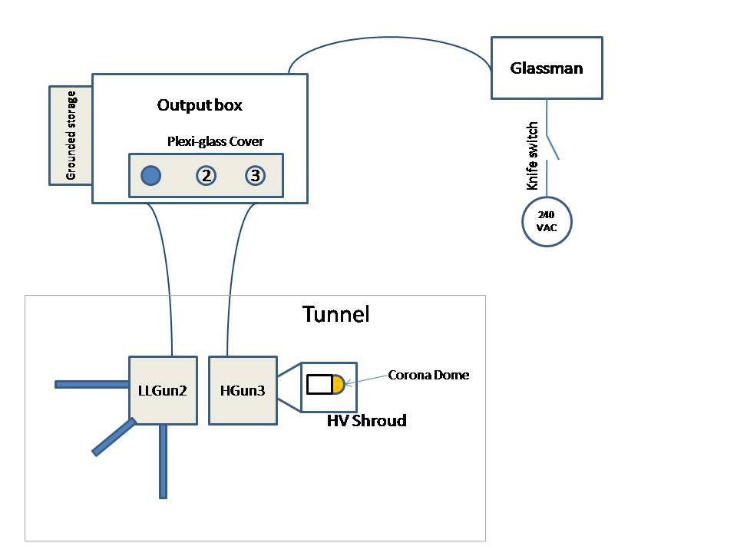

Only Authorized Personnel May Manipulate the CEBAF -100 kV electron gun HV leads

The Source group leader or his designee can authorize people on this procedure.

The following personnel have been authorized on this procedure:

Name | Signature | Date | Authorizing signature
Philip Adderley
Josh Brittian
Jim Clark
Joe Grames
John Hansknecht
Matt Poelker
Riad Suleiman
Marcy Stutzman

