**Introduction to the SOLO bake control system Hansknecht 4-2011**

The SOLO temperature controllers are designed for remote computer control with the following features:

1. The computer can start/stop/pause the bake.
2. The bake can also be started/stopped/ or paused at the controller without a computer.
3. The computer can graph the temperatures during the bake
4. Various ramp-soak patterns can be loaded or edited via the computer
5. Once a ramp-soak process is started, the process will continue even if communication with the computer is lost.
6. Patterns can be edited “on the fly” if needed to extend a bake or change setpoints.
7. Being computer controlled, one can presumably log in from home using Remote-Desktop to view or alter the bake.

Items needed for computer control:

1. A PC running windows
2. A USB to RS485 converter.
3. A SOLO controller box
4. One or more relay boxes that take the SOLO output and switch 240.208, or 115V to the heater
5. The software contained in M:\inj_group\solo temperature controller.

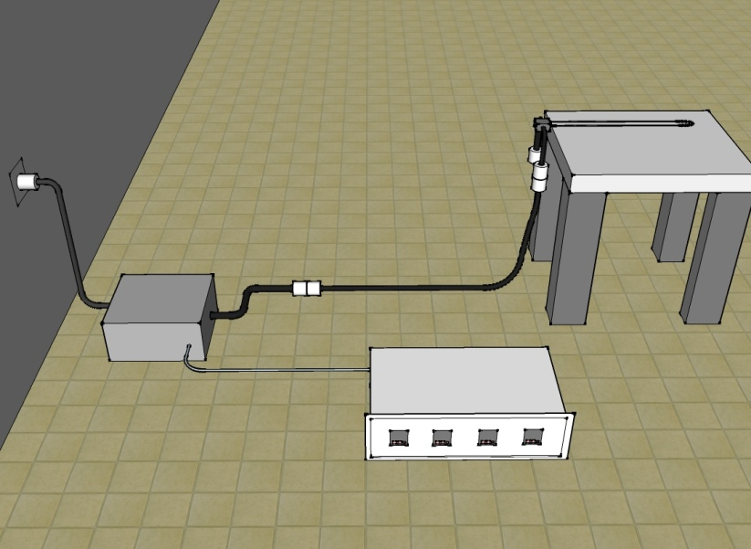

Solo Chassis receives thermocouple and controls heater via relay box bnc.

Bake heater to match power

Relay Box to match wall power

Wall Power (any type)

* The solo control software is kept at: M:\inj_group\solo temperature controller
* There are presently two files kept in this folder that contain parameters that can be downloaded into a SOLO module. The files are: *oven bake.PAR* and *30 hour 250 bake extendable.TXT*
* The oven bake.PAR file contains basic setup information for a new SOLO controller. It tells the controller that we use a K-type Thermocouple and sets the PID parameters based on an autotune of the OVEN bake setup with 4kW heater rods (2X2kW)
* The 30 hour 250 bake extendable.txt file contains the ramp-soak profile for a standard oven bake.
* Please do not overwrite these files. If you wish to make a new bake profile and save it to the group directory, please use a different name.
* The image below shows a computer connection to a controller at address 1. We can see that the operation mode is “RUN”. We that the Control mode is “PID” and it is heating to a set value (SV) of 252 degrees.

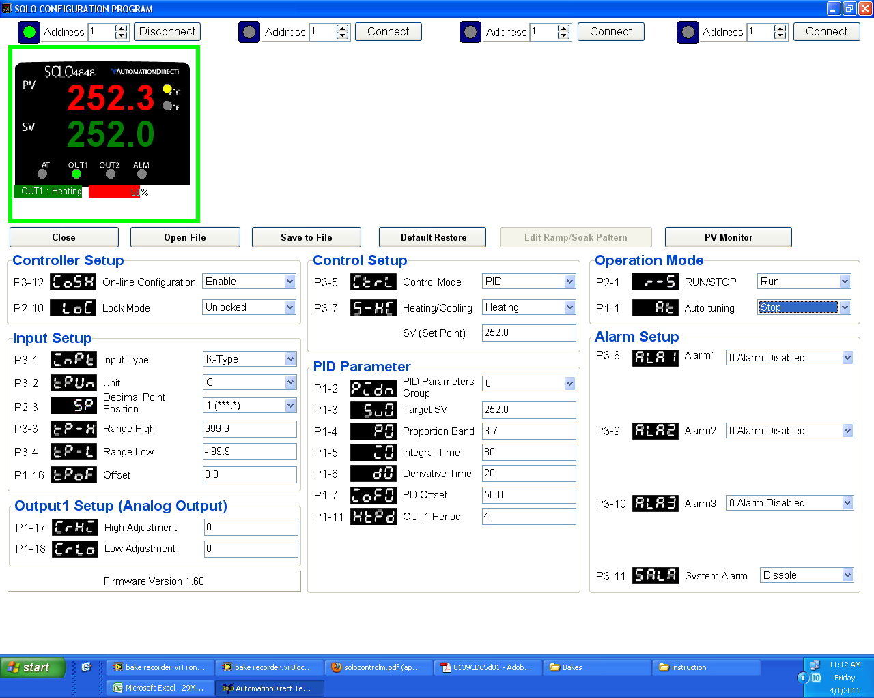

When the Control Mode is changed from PID to Ramp/Soak, the “Edit Ramp Soak Pattern” button becomes active. Once pressed, another screen will appear that shows the pattern.

1. If the entire pattern is full of zeroes, you can “read from Solo” to see the pattern that is contained in the Solo.
2. If the pattern is still blank, you can open the *30 hour 250 bake extendable.TXT pattern and download it into the Solo using the “Write to Solo” button.*

The image below shows the pattern and the resulting bake profile. This profile could have been built by entering all steps under pattern 0 and pattern 1, but we have made it easier to read by splitting the profile among many patterns.

If you look closely, you will see the following distinct pattern steps:

Patterns 4,5,6 create a ramp down following these same methods

Pattern 3 hold at 250C for 30 hours. Since max value is 15, we enter it twice and have room for more

Pattern 2 100C to 250C ramp over 8 hours then jump to pattern 3

Pattern 1 hold at 100C for 4 hours then jump to pattern 2

Pattern 0 20C to 100C ramp over 8 hours then jump to pattern 1

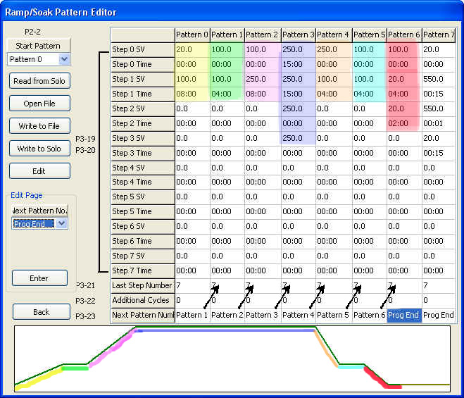

Note the Program End after pattern 6. This is the end. Pattern 7 can be selected for stalk heating.

Notice that 0 Set values are ignored if time is also 0, so this pattern 0 runs through to step 7 and then it see’s that the next pattern to run is pattern 1.

Since we have divided the profile among the different patterns, it makes it easier to make a change on the fly as the following example explains:

1. Suppose we are in the middle of a bake and we have reached our 100C hold for 4 hours shown in Pattern 1.
2. Suppose we find that we have a large water peak and we wish to extend this hold time by several more hours.
3. We can fix this in several ways:
4. We can enter a new value in Step 1 Time and hit ENTER. This changed value will immediately write to the controller. (need to verify in an actual setting)
5. We can change the Operation mode to “HOLD Program” to hold at the present setpoint and then back to “Run” when we feel we are ready to continue again. (see main screen)
6. We can make more drastic changes if we wish and then tell the unit to stop and then restart it with “Pattern 1” as the new START Pattern as selected here.

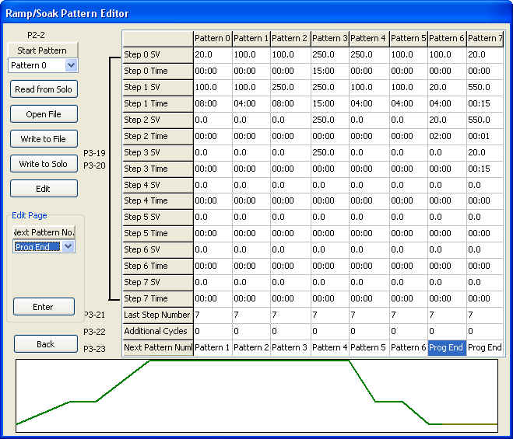

Following this same procedure, it should be obvious that “Pattern 7” can be selected as the Start Pattern when we want to do a simple stalk heating pattern. The pattern “reads” as follows: Start at 20C for 0 seconds and go to 550C in 15 minutes. Next value will be 550C for 0 seconds and go to 20C over 15 minutes.

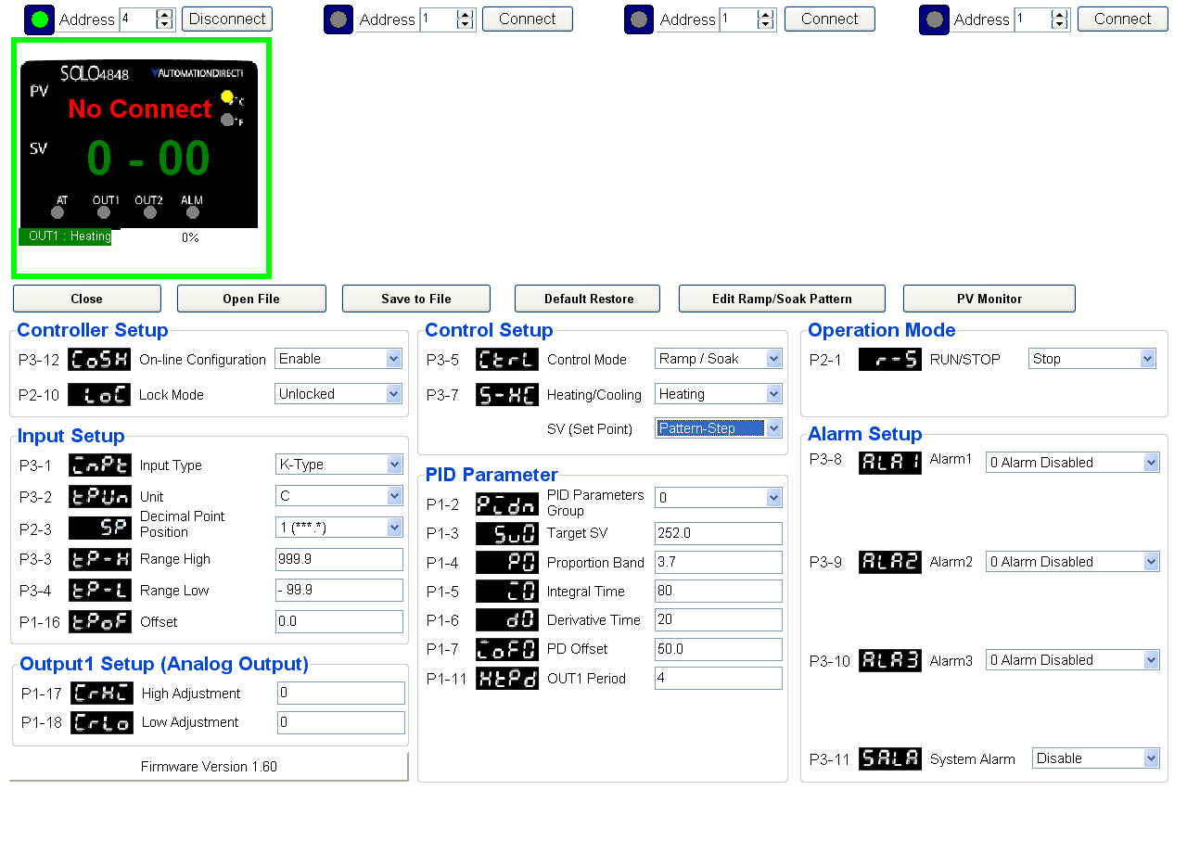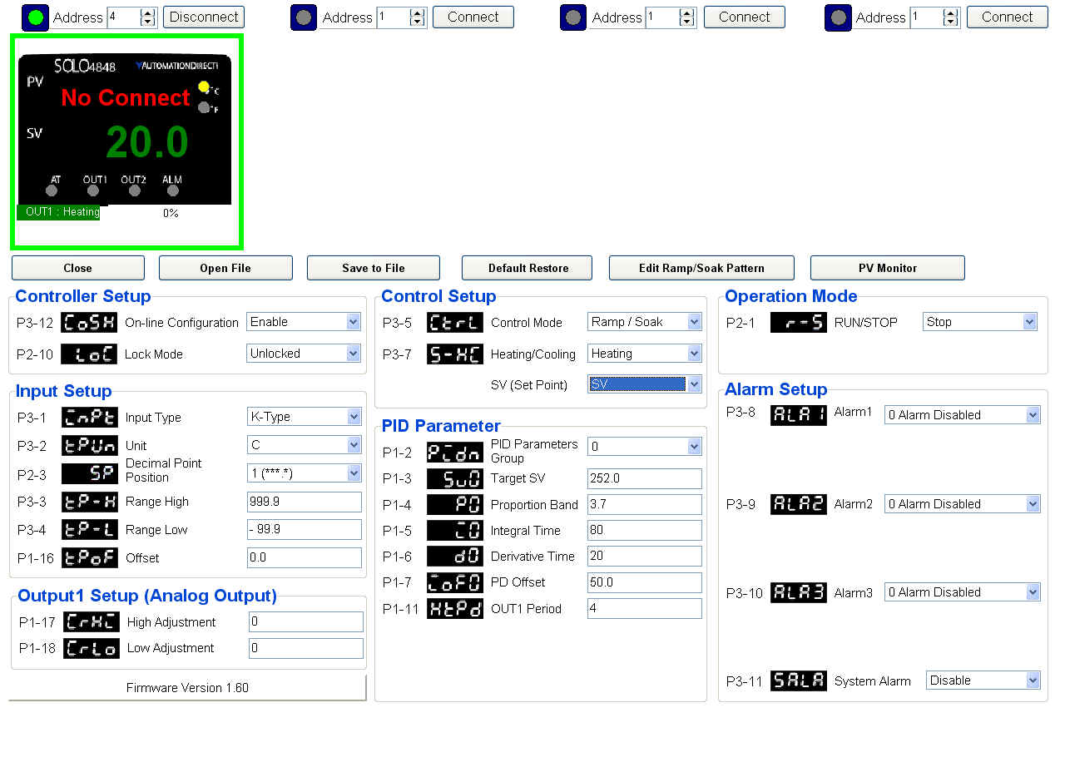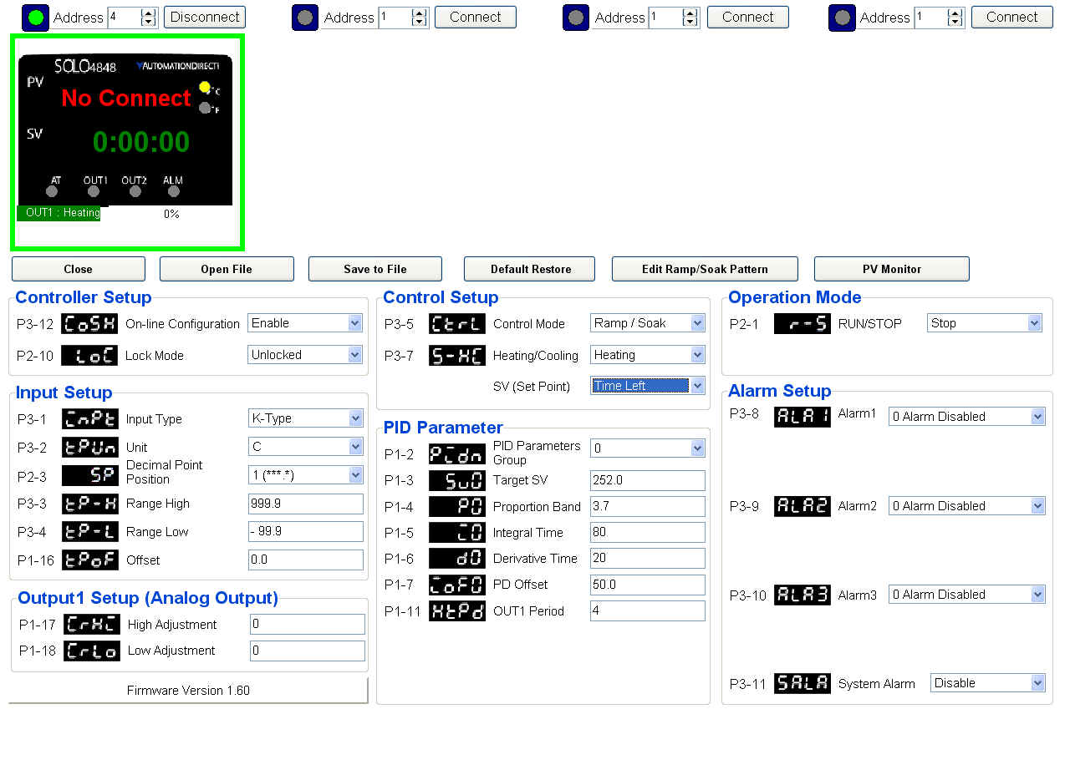

Show the SET VALUE is selected for display

Show the next Pattern Step is selected for display

Show the “TIME REMAINING in step” is selected for display

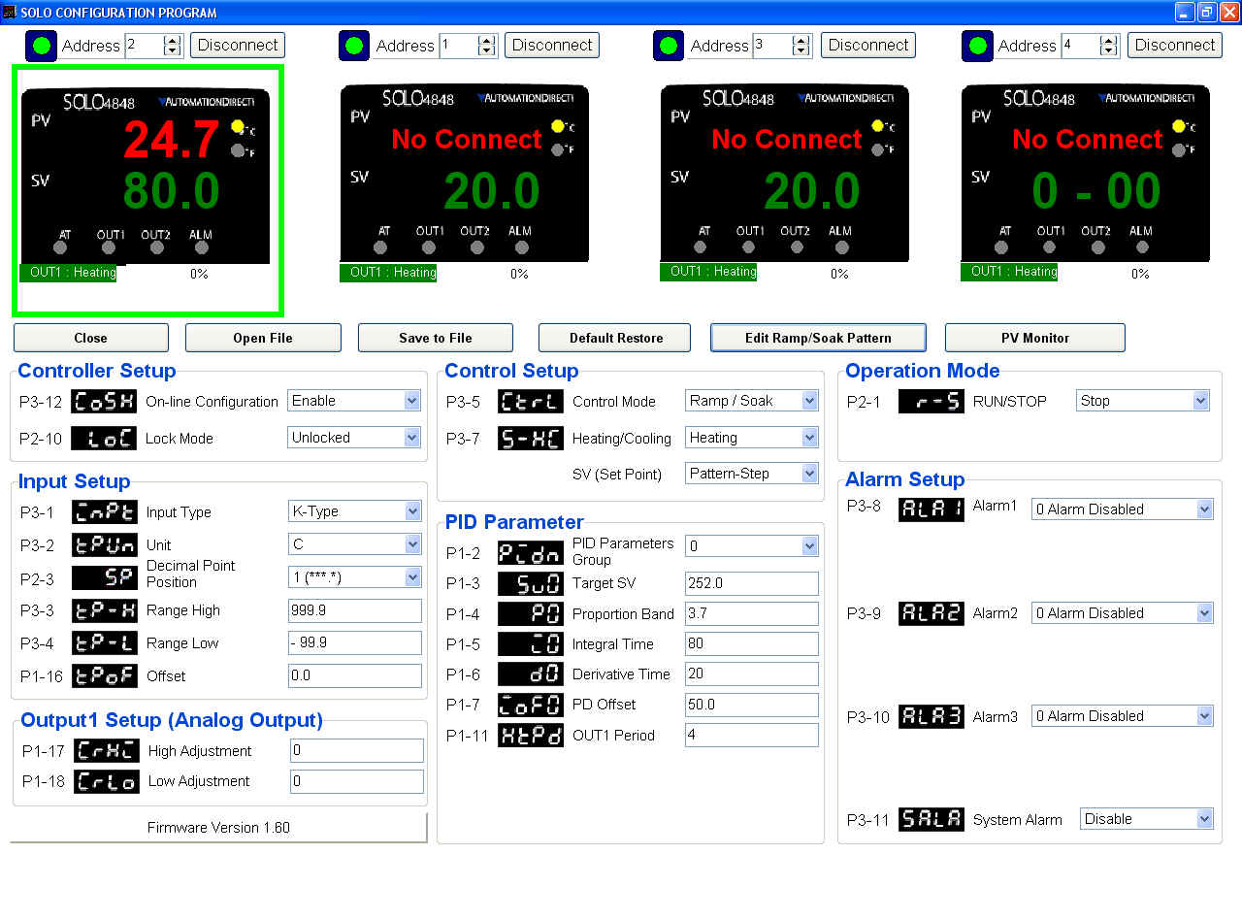

Many controllers are displayed, but the GREEN BOX surrounds the unit that is active for control using the buttons below it.

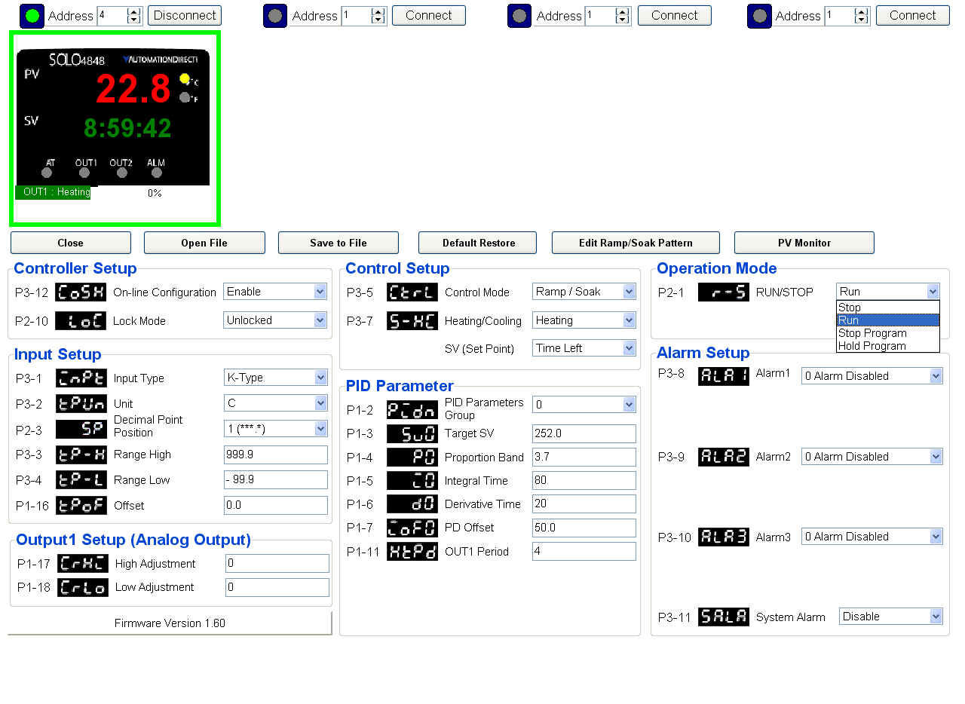

Note that when control is in RAMP/SOAK, you can select “HOLD Program” from the Operation mode pulldown menu and the clock will freeze at the present value. It will re-start from this value if the Operation mode is returned to RUN

**Local Control**







