Announcement
It is just a note to let you know that the workshop will take place from July 31 to August 1 in Lanzhou University. The registration is free and will be on July 30 and in the morning of July 31 in Lanzhou Legend hotel. Each participant will have breakfast in his own hotel and lunch, dinner and reception on the fifth floor of Tsuiying hotel. On August 2, the participants may have one day Liujiaxia free tour.
Tsuiying Hotel is in Lanzhou University. Lanzhou Legend hotel and Lanzhou Eastern hotel are on the same side of Tiannshui Road and Tsuiying Hotel is on the opposite (see map around the conference site). These three hotels can see each other. The conference room, which is about 500meters away from the hotel, is in the physics building of Lanzhou University and the room No. is 5004(See conference site map).
The railway station is about 2-3 kilometers way from Tsuiying Hotel. If you will come to Lanzhou by train, you may take buses No.1, 7, 10, 131, 127 and 110 (only two stops) or 7-RMB-taxi to go to the hotel you booked. The Lanzhou airport is about one-hour drive from the city (~42 km / 26 miles). There is an airport bus service between the airport and the city (RMB 30.00 one way per person).The shuttle bus arriving station is right in front of Lanzhou Eastern Hotel (See Travel Map).

Travel Map

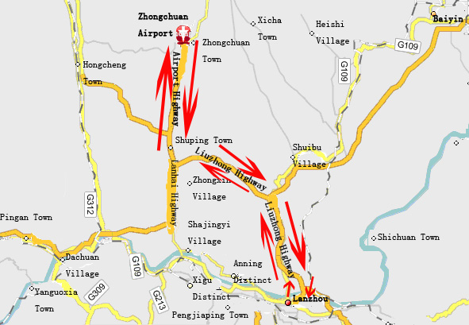

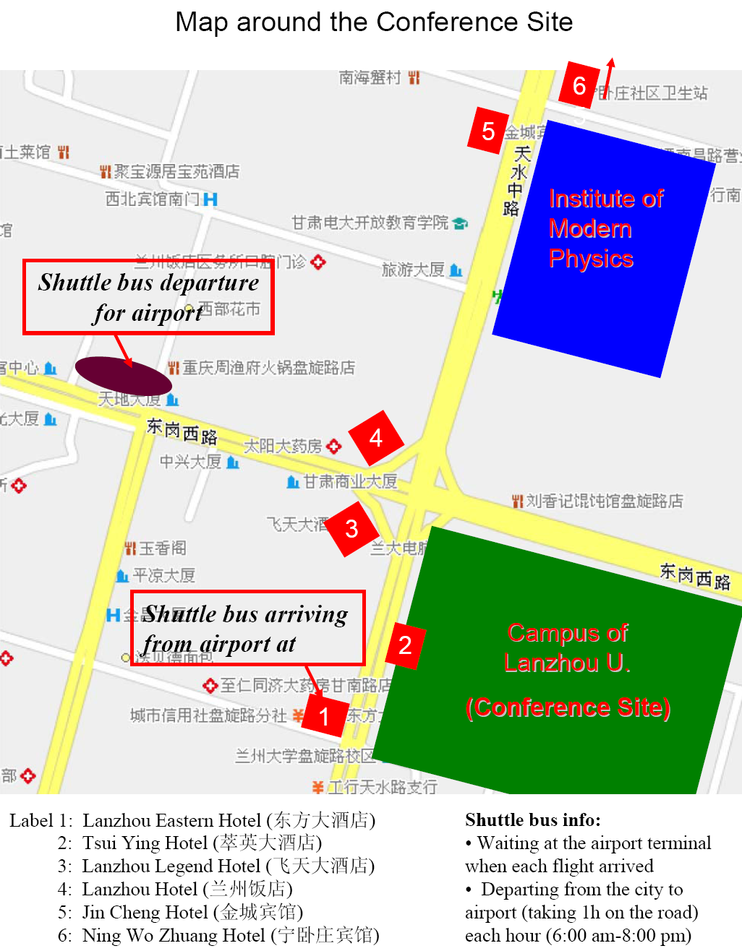

Conference Site Map


