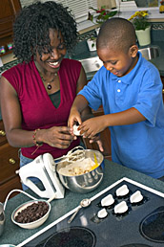

Sentara Employee Assistance Program

Presents

“Taking the Hustle

Out of the Holiday Bustle”

November 27, 2007
or
Sentara Careplex Hospital
3000 Coliseum Dr, Hampton
6:00 p.m. – 7:30 p.m.
Conference Rooms D&E (1st floor)

York River Entrance

November 28, 2007
Sentara Leigh Hospital
830 Kempsville Road, Norfolk
6:00 p.m. – 7:30 p.m.
Private Dining Room

Use Visitor’s Entrance

Come join in and explore ways to enjoy the Season. Your challenge is to create ways to make the Holidays reflect authentic and genuine feelings of sacredness and meaningful traditions. This seminar will ask important questions and help you make positive decisions facing you this Holiday Season.

Call the Sentara EAP Office at 757-363-6777 or 1-800-899-8174 to register for this free seminar.

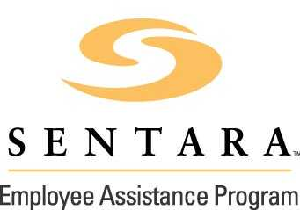
www.SentaraEAP.com

