Thomas Jefferson National Accelerator Facility
U.S. Department of Energy
12000 Jefferson Avenue
Newport News, VA 23606

JEFFERSON LAB’S
SITE ENVIRONMENTAL REPORT
for Calendar Year 2004

Prepared by:
SURA/Jefferson Lab
EH&S Reporting
EH&S Division
Date: September 2005
JEFFERSON LAB’S SITE ENVIRONMENTAL REPORT
FOR CALENDAR YEAR 2004

EXECUTIVE SUMMARY

This annual report documents Thomas Jefferson National Accelerator Facility’s active environmental protection program by presenting results of environmental activities and monitoring programs. The report provides the U.S. Department of Energy (DOE) and the public with information on radioactive and non-radioactive pollutants, if any, added to the environment as a result of Lab operations.

Major Scientific Programs
Jefferson Lab’s main purpose is to make available a research facility to support the nuclear physics community and the nation.
CEBAF The Continuous Electron Beam Accelerator Facility at Jefferson Lab provides an electron beam to three experimental halls where a variety of basic physics experiments are conducted. The electron beam begins its first orbit at the injector and proceeds through the underground racetrack-shaped accelerator tunnel at nearly the speed of light. The accelerator uses superconducting radio frequency (SRF) technology to drive electrons to higher and higher energies. The accelerator’s electron beam can be split for simultaneous use by the three experimental halls, which are circular, partially buried domed chambers. Special equipment in each hall records the interactions between incoming electrons and the target materials. A continuous electron beam is necessary to accumulate data at an efficient rate yet ensures that each interaction is separate enough to be fully observed.
FEL The Free-Electron Laser supports basic science research and serves universities, private industry, NASA, the U.S. Navy, the U.S. Air Force, and the U.S. Army. Designed and built with Jefferson Lab’s expertise in SRF accelerator technology, the FEL provides intense, powerful beams of laser light that can be tuned to a precise wavelength or color. The FEL is the most powerful tunable laser in the world, producing up to 2.1 kilowatts (kW) of infrared (IR) laser light in its initial design and setting the world’s record as a terahertz light source (20 watts). During 2002-2003, the machine underwent a major upgrade and attained 10 kWs IR in 2004. The FEL’s capabilities are currently being expanded to produce more terahertz and ultraviolet (UV) wavelengths.
SNS The Spallation Neutron Source project involves a team of six Federal laboratories - (Argonne, Brookhaven, Lawrence Berkeley, Los Alamos, Jefferson Lab, and Oak Ridge) cooperating in the design, engineering, and construction of the $1 billion-plus SNS being built in Oak Ridge, Tennessee. Jefferson Lab’s contributions include building two types of SRF cryomodules for the SNS accelerator, and providing extensive expertise, guidance, and production efforts in developing the SNS helium refrigeration plant. Once operational, the SNS will provide the most intense pulsed-neutron beams in the world for scientific research and industrial development.

The E in Environment, Health, and Safety (EH&S)

Ultimate responsibility for protection of the environment and public health rests with the Lab Director, while line management implements identified objectives within their areas of responsibility. Environment, Health, & Safety (EH&S) staff, situated within the line organizations, provide support to their management and share their expertise with the Lab as a whole. There are numerous ways in which Jefferson Lab’s EH&S program is implemented.

Integrated Safety Management (ISM) System Through ISM, Jefferson Lab incorporates EH&S requirements into all work procedures. The primary objective of ISM is to make safety, health, and environmental protection a part of routine business at Jefferson Lab.

Environmental Management System (EMS) Implementation Although Jefferson Lab has had an environmental protection program in place, in 2003 the Lab committed to begin implementing an EMS. In early 2004, key Lab staff began planning and developing an EMS for Jefferson Lab. Development and implementation continued through 2004. The EMS is expected to be fully implemented during 2005.

Jefferson Lab Work Smart Standards (WSS) Process The goal of the WSS process is to provide a means to implement EH&S in a manner that is both effective and cost-efficient. The WSS Set is comprised of the laws, regulations, and standards necessary and sufficient to ensure worker and public health and safety, and to protect the environment.

Implementation of the National Environmental Policy Act (NEPA) Most facility construction activities and all accelerator upgrades are subject to review under the NEPA. The initial Jefferson Lab construction, a later upgrade to CEBAF, and some major new buildings have been addressed in Environmental Assessments (EAs). Routine Lab activities and special projects are covered under site-specific NEPA Categorical Exclusions.

EH&S Performance Measures The DOE/SURA (Southeastern Universities Research Association, Inc.) contract-based measures, used to evaluate Jefferson Lab’s EH&S performance, include environmental items such as recycling and hazardous waste minimization. Other metrics involving worker safety are also addressed in the contract.

Inspections Jefferson Lab’s commitment to protection of the environment and public health and safety are demonstrated through its inspection programs. Both external agencies and key Lab staff conduct inspections to ensure operations and activities at Jefferson Lab are being done in the most sound manner. Compliance with all applicable laws and regulations is demonstrated throughout this report.

Compliance

Jefferson Lab complied with all applicable Federal, Commonwealth, and local environmental laws, regulations, and DOE guidance during 2004. As a result, Jefferson Lab operations had no discernable impact on public health or the environment. Our compliance status on all programs is identified in Section 2 of this report. Radiation-related issues, especially those dealing with water resources and public health, are highlighted in Section 3. Non-radiological environmental issues, such as water sampling and monitoring, are highlighted throughout. The Jefferson Lab EH&S Manual, which addresses many environmental topics, and the Lab’s WSS Set are regularly updated to ensure that new environmental compliance initiatives are integrated into site operations.
TABLE OF CONTENTS

EXECUTIVE SUMMARY i
SECTION 1 INTRODUCTION 1
1.1 PURPOSE OF THIS REPORT 1
1.2 LABORATORY MISSION 1
1.3 SITE OPERATIONS 1
1.4 SITE HISTORY AND DESCRIPTION 2
1.5 FACILITIES AND 2004 ACTIVITIES 2
1.6 ENVIRONMENTAL REVIEW 4
1.7 SITE EH&S RESOURCES 4
SECTION 2 ENVIRONMENTAL PROTECTION PROGRAM 5
2.1 ENVIRONMENTAL MANAGEMENT SYSTEM 5
2.2 MAJOR ENVIRONMENTAL PROGRAMS 7
2.3 APPRAISALS, ASSESSMENTS, AND INSPECTIONS 19
SECTION 3 ENVIRONMENTAL RADIOLOGICAL PROGRAM 20
3.1 RADIATION EXPOSURE PATHWAYS 21
3.2 ENVIRONMENTAL RADIATION MONITORING 24
3.3 OTHER SUPPORT ACTIVITIES 29
3.4 ASSESSMENTS OF POTENTIAL DOSE TO THE PUBLIC AND TO BIOTA 29
3.5 QUALITY ASSURANCE 30
SECTION 4 DISTRIBUTION LIST 1
ACRONYMS and ABBREVIATIONS A-1

SECTION 1
INTRODUCTION

1.1 PURPOSE OF THIS REPORT

The U.S. Department of Energy (DOE) requires its facilities, of which Thomas Jefferson National Accelerator Facility (TJNAF or Jefferson Lab) is one, to establish and annually report on environmental programs and performance. This document marks the 12th year that Jefferson Lab has been preparing a Site Environmental Report (SER). This report addresses the status and results of the Lab's environmental protection (EP) program, which also addresses public health items, for calendar year (CY) 2004. It serves to inform Jefferson Lab staff, DOE, regulators, and the public about site environmental performance, and provides a historical record of identified items of interest or concern.

The SER is available in a viewable downloadable pdf file. Look for this CY 2004 SER by going to Jefferson Lab’s web page at http://www.jlab.org, select ‘search’ and enter “Site Environmental Report”.

1.2 LABORATORY MISSION

Jefferson Lab, formerly known as CEBAF (Continuous Electron Beam Accelerator Facility), is a national accelerator facility managed and operated by the Southeastern Universities Research Association, Inc. (SURA) for the DOE. The accelerator complex portion of the Lab includes an underground electron accelerator, CEBAF, which is Jefferson Lab's primary research tool. CEBAF operates at energies up to about 6 GeV (billion electron volts) and provides beam to three underground halls that house physics program experiments. The CEBAF accelerator is used to conduct user driven research into how nucleons are built from quarks and gluons, and how this structure leads to the standard nucleon-based picture of the nucleus.

Mission: to provide forefront scientific facilities, opportunities, and leadership essential for discovering the fundamental nature of nuclear matter, to partner with industry to apply its advanced technology, and to serve the nation and its communities through education and public outreach, all with uncompromising excellence in environment, health, and safety.

1.3 SITE OPERATIONS

Jefferson Lab, a world-class research institution, attracts resident and visiting physicists and other scientists. Approximately 635 full-time physicists, engineers, technicians, and support staff work at Jefferson Lab. About 2,180 academic and industrial researchers from across the United States and from approximately
30 countries from around the world participate in scientific collaborations. The Lab has thus far produced more than 160 patent disclosures. Of those, 111 were submitted for the patent-application process. Forty-four patents had been issued by the end of 2004, including light-guide technologies, medical imagers, flaw-detection equipment, a fire detection/prevention system, and an electronic lockout device that can be used for both safety and security purposes.

There are six major facilities (program areas) on the DOE site: CEBAF, a superconducting radio frequency (SRF) electron accelerator; End Stations A, B, and C (large halls that house physics experiments) that make use of beams from CEBAF; an SRF Institute that serves primarily as a research and development (R&D) center for SRF accelerator cavities; the Center for Advanced Studies of Accelerators (CASA) that supports the site accelerators and considers future planning opportunities; a Free-Electron Laser (FEL) User Facility that produces laser beams to serve university, industry, and military users; and, a Lattice Quantum Chromodynamics (QCD) Computer, a 1/4 Teraflop commodity-PC-based machine.

1.4 SITE HISTORY AND DESCRIPTION

Prior to the construction of Jefferson Lab, there were several users of this general area of Newport News. The U.S. Department of Defense (DOD) acquired most of the Oyster Point area, including the land presently used by Jefferson Lab. The U.S. Air Force later acquired the land and installed a BOMARC missile site on a portion of the property. After closure of the BOMARC missile base, the DOD started disposing of the property and conveyed some land to the Commonwealth of Virginia, the National Aeronautics and Space Administration (NASA), and others. Ownership of the NASA property, including 100 acres of undeveloped land, was conveyed to the DOE in 1987. An additional 52 acres of land was also transferred to the DOE from other sources. The total DOE-owned parcel, upon which Jefferson Lab is built, is 163 acres.

In 1986, an adjacent 44 acres were conveyed to SURA by the City of Newport News. A SURA residence facility is located on a portion of this land. Adjacent to this property is the former BOMARC missile site.

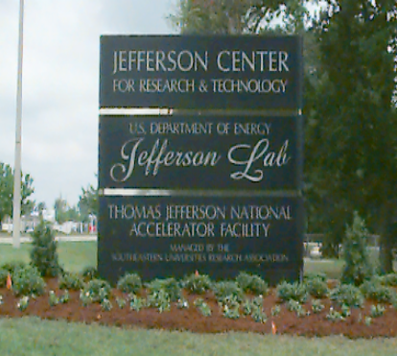
Sign at Main Entrance to Site

Also adjacent to the DOE-owned site is a 10.7-acre parcel owned by the Commonwealth of Virginia and leased to the City of Newport News. The Applied Research Center (ARC) is located on this property, and is used by Jefferson Lab, industry, and universities. Other adjacent land owned by the Commonwealth of Virginia is leased to SURA and the DOE for its use in support of Lab operations. This area, the DOE-owned site, and other nearby properties are considered part of the City's Jefferson Center for Research and Technology.

1.5 FACILITIES AND 2004 ACTIVITIES

The 163-acre DOE site is primarily divided into two main areas. One includes R&D labs, fabrication facilities, and administrative offices and is referred to as the campus. The second is a 40-acre fenced area, termed the accelerator site, where the CEBAF and FEL accelerators and related structures that accommodate experiment support functions are located. The accelerator site is located on the south end of the DOE property, and access is restricted through one entrance that is staffed 24-hours per day. The front view of the main administration building, CEBAF Center, located on the campus, is shown below.

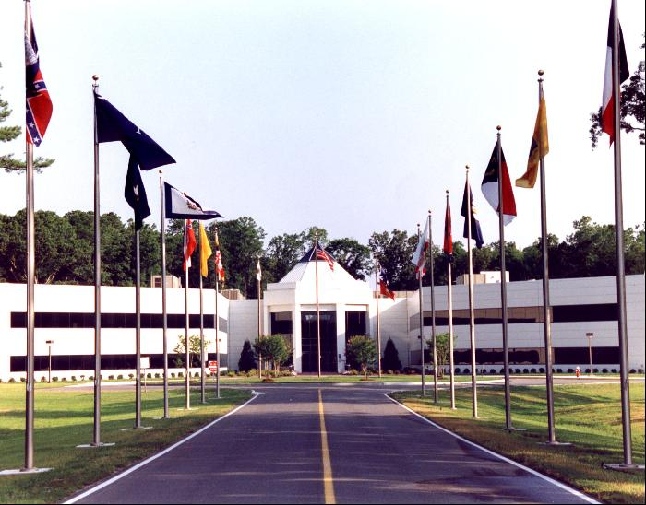
Front Entrance to CEBAF Center

The four major facilities that have environmental protection or public health-related implications are CEBAF, its experimental halls (End Stations), the SRF Facility, and the FEL User Facility. A short description of each follows. Note that these and other activities that have potential environmental implications, such as the use of chemicals and oil products, are discussed elsewhere in the text.

CEBAF This accelerator provides continuous wave electron beams with energies from 0.5 to 5.7 GeV. CEBAF is used as a tool for exploring the transition area or range where strongly interacting (nuclear) matter can be understood as bound states of protons and neutrons, and the regime where the underlying fundamental quark-and-gluon structure of matter is evident. The nature of this transition is at the frontier of our understanding of matter.

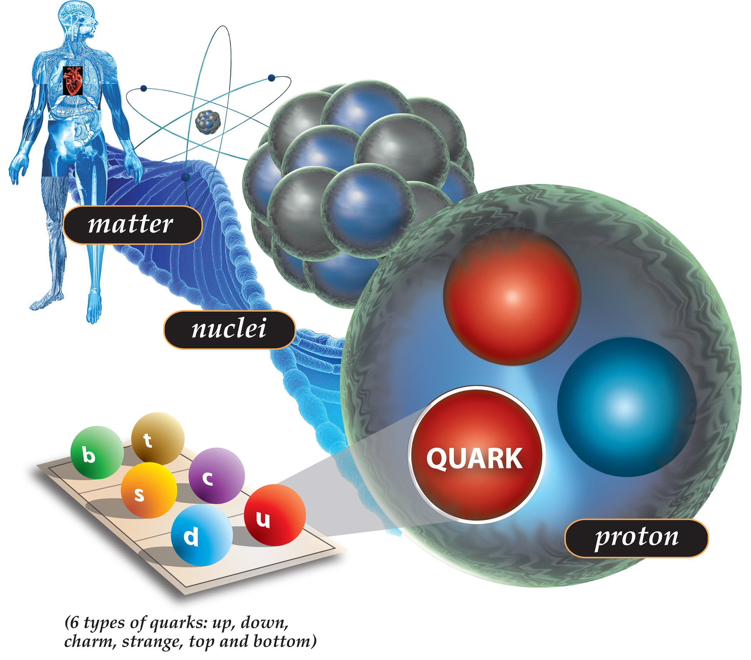
Atomic Structure
End Stations (Halls A, B, and C) Each hall (or end station) has its own set of complementary experimental equipment. Hall A has a pair of superconducting, high-resolution magnetic spectrometers optimized for precision electron scattering coincidence experiments. The CEBAF Large Acceptance Spectrometer (CLAS) that supports studies of both electron and photon-induced reactions is housed in Hall B. The third end station, Hall C, contains a pair of moderate resolution spectrometers, with one capable of high momentum particle detection, and the second optimized for the detection of short-lived reaction products.

The SRF Facility The SRF program is centered in the Lab's Institute for SRF Science and Technology. This Institute's strength is in R&D and large-scale applications of SRF, including to better upgrade or advance CEBAF and the FEL. In addition, design, development, and fabrication of the SRF niobium cavities for the DOE's Spallation Neutron Source (SNS) are a current focus. Some ongoing work in the off campus ARC also supports development of state-of-the-art surface science and SRF R&D to improve accelerator capabilities.

FEL User Facility The FEL is an accelerator that was initially designed to provide 1,000 watts (1 kilowatt (kW)) of infrared (IR) light with picosecond pulse length for use by Jefferson Lab, industrial, DOD, and university partners. The accelerator has since been upgraded, enabling operation in a range that extends from 1,000 watts of ultraviolet (UV) light to 10,000 watts (10 kW) of IR light.

Future Planning Analysis and R&D work on the proposed upgrade of CEBAF to 12 GeV continued in 2004. This upgrade in electron beam energy levels and a new experimental hall, Hall D, will support experiments that test the strong force that holds atomic particles together.

1.6 ENVIRONMENTAL REVIEW

An environmental assessment, termed EA, performed under National Environmental Policy Act (NEPA) procedures, was conducted prior to the construction of the original CEBAF project, resulting in a Finding of No Significant Impact (FONSI). In 1997 and 2002, EAs that also yielded FONSIs, addressed a CEBAF upgrade, an FEL upgrade, and five building construction projects. Existing NEPA-related documentation is periodically reviewed.

1.7 SITE EH&S RESOURCES

To ensure that staff, employees, subcontractors, and users are aware of and utilize environment, health & safety (EH&S) principles, EH&S responsibilities are incorporated into each position description. The facility makes available a variety of EH&S resources to serve the Jefferson Lab community.

Local EH&S resources are available to every employee, user, and visitor. They include: EH&S staff that support specific line organizations; EH&S program specialists that serve the entire facility in their area of expertise; groups and committees that address Lab-wide concerns, develop policy, and resolve selected issues; and, the Jefferson Lab EH&S Manual, as the primary source of EH&S implementing procedures.

Other EH&S resources available to and utilized by program managers include: DOE subject matter experts; DOE program specialists that deal with policy issues at all levels; and, colleagues at other DOE facilities that share expertise and lessons learned from their own unique experiences.

SECTION 2
ENVIRONMENTAL PROTECTION PROGRAM

There are many facets to Jefferson Lab’s EP program. As stated in Section 1, the Lab’s mission includes protection of the environment and public health. To accomplish this, various controls, including the use of an Integrated Safety Management (ISM) System strategy, were established.

The site’s EP program provides guidance and requirements for implementing site environmental programs, such as in radiological and non-radiological monitoring, for making environmentally preferable choices, and for the review of performance through assessments and inspections. Compliance with applicable EP and public health-related laws and regulations is interwoven into Lab operations.

2.1 ENVIRONMENTAL MANAGEMENT SYSTEM

During 2004, the requirement to develop an Environmental Management System (EMS) was incorporated in the DOE/SURA operating contract. Jefferson Lab began addressing the new requirement by forming an EMS Implementation Team to start the process of preparing, documenting, and putting into practice a formal EMS. An EMS focuses on establishing management level programs that serve as the basis to direct the performance of Lab activities that could affect the environment. The overall management system format includes setting up the organizational structure, planning activities, responsibilities, procedures, processes, and resources for developing, integrating, achieving, reviewing, and maintaining the commitments made in the Lab’s EH&S Policy. Elements of the EMS are being incorporated into existing site documents, such as the Lab’s EH&S Manual and work place Standard Operating Procedures.

Jefferson Lab’s EMS is under development and will serve in conjunction with the Lab’s already established ISM System. The objective of the EMS and ISM is to make safety, health, and environmental protection a routine part of doing business at Jefferson Lab.

Site EH&S Policy
Jefferson Lab’s EH&S Policy was updated in early 2005 to incorporate EMS. The updated policy reflects Jefferson Lab’s current EH&S commitments to both the Lab population of staff, users, visitors, and to our local community neighbors.

The Jefferson Lab Policy on EH&S is as follows.

Sound environmental protection, health and safety (EH&S) practices are essential elements to the successful execution of Jefferson Lab’s scientific mission and all related activities. It is Jefferson Lab policy to identify and adhere to all applicable EH&S laws, regulations, and standards, and Department of Energy contractual commitments. Jefferson Lab considers no activity to be so urgent or important that our standards for environmental protection, health, or safety may be compromised. Demonstrated performance in protecting the environment, including a commitment to the prevention of pollution, and ensuring the health and safety of our colleagues, visitors and surrounding community is paramount among our responsibilities as a national lab.
In order to effectively discharge these responsibilities, integrated safety management (ISM) principles and functions fully integrate EH&S requirements into the planning and execution of all work at Jefferson Lab.
ISM principles require that line managers be held accountable for effective EH&S performance within their programs, with each individual at Jefferson Lab responsible for establishing knowledge and control of the EH&S hazards of all work in which he or she participates. Everyone has the right and responsibility to remedy or to report – without fear of reprisal – any practice, situation, or action that endangers people or the environment.
To ensure and improve EH&S performance, EH&S objectives and targets are set and progress is measured against stated goals. It is integral to our success that we regularly assess the performance of our EH&S programs and systems in order to ensure that they are working as intended and to identify opportunities for improvement. Weaknesses are identified and abated. Involvement in this process at all levels of the Jefferson Lab organization is expected, and commitment is required. Continuous improvement is our goal.
Jefferson Lab makes this EH&S Policy available to all stakeholders including employees, visitors, regulatory entities, and members of the surrounding community for their information and use.
Christoph W. Leemann, Jefferson Lab Director
May 2005

Environmental Planning and Analysis Procedures
Environmental planning and analysis is accomplished by documenting and reviewing projects and activities for NEPA considerations. Line management is responsible for providing notification of actions and impacts of new activities to the Office of Assessment to enable sufficient time for review and authorization as applicable. Jefferson Lab flows down appropriate EH&S requirements, through subcontract documents, to its subcontractors. These documents address environmental consequences and identify mitigation measures to minimize these consequences.

Environmental Objectives and Targets
The Lab operates within the DOE/SURA contractual requirements and performance measures, which include staying within permit criteria. One of the site storm water pollution prevention permits required that the Lab identify and follow best management practices (BMPs) and targets that would better ensure protection of surface waters. In addition, environmental objectives and targets were identified as the Lab began formalizing its EMS.

Implementation and Operations Controls
The DOE/SURA contract and environmental permits define the terms and conditions for the operation and performance of Jefferson Lab. ISM (including environmental protection) roles and responsibilities and implementation procedures are included in the Lab’s EH&S Manual. Key staff, including the Lab’s EMS Implementation Team, received EMS training in early 2004. EMS awareness training for staff, users, and subcontractors was defined and will be conducted in 2005.

Identification of Environmental Aspects and Impacts
EMS-specific aspect and impact identification was performed in 2004. Reviews identified the primary environmental aspects at Jefferson Lab as water discharges and waste issues. In addition, intensive use of resources such as electricity and water that are needed to operate a particle accelerator are considered aspects.

Performance Measurement
The Lab semi-annually reviews contract performance measure results for various topical areas that include EH&S. As well, the compliance status towards meeting the new storm water measurable objectives was reviewed in 2004. EMS implementation will be monitored in 2005 as the Lab addresses the objectives and targets identified in 2004.

Corrective Action and Self-Assessment Procedures
The ISM System Plan is reviewed annually and is updated as necessary (most recently on
November 30, 2004), and shared with the DOE Site Office. This 2004 review identified a few areas where ISM program improvements should be made - the Lab Director committed to making these changes. It is projected that the EMS self-assessment process may be linked with the ISM System Plan annual review.

In early 2004, Jefferson Lab had an ISO 14001 (EMS) initial compliance review conducted by an outside consultant. This report identified the actions that needed to be accomplished for Jefferson Lab to craft an EMS under ISO 14001.

Management Review Process
The Director’s Council, comprised of senior management, reviews the ISM System Plan periodically through the self-assessment noted above. The review is documented and open items are tracked until closure, with regular status reports provided to the Lab Director. Integrating EMS review with the ISM process will be evaluated during EMS implementation.

2.2 MAJOR ENVIRONMENTAL PROGRAMS

2.2.1 Environmental Monitoring Program
Environmental monitoring is one of the primary methods used by the Lab to assess environmental conditions. Monitoring is conducted to: verify compliance with applicable regulations and other requirements; evaluate the Lab’s impact on the environment and public health; identify potential environmental problems; provide data to support management decisions; and, evaluate the need for remedial actions or mitigative measures.

The site program establishes guidelines for examining (through monitoring and measurement) chemical, oil, and radioactive effluents generated by the facility. An integral part of the program is routine sampling and tracking of air, process water, wastewater, and groundwater. These are monitored to ensure that Jefferson Lab effluents do not have a negative impact on the surrounding environment and that they remain within any applicable requirement or permit’s allowable range.

Both permit-required and routine monitoring emphasize the potential environmental exposure pathways appropriate to medium-energy particle physics laboratories. These pathways include external and internal exposure to radiation, a major focus of the site’s monitoring program. Programs responsive to on-site and offsite radiation protection requirements have been instituted. Exposure potentials are discussed in Section 3.
Standard sample collection and analysis methods are documented in program and departmental procedures. Routine environmental monitoring is performed under the direction of responsible line management and overseen by the Lab’s Office of Assessment. General program information is provided below.

      - Monitoring Water Conditions
Both groundwater and surface water quality protection are high priorities at Jefferson Lab. Groundwater quality is a focus area primarily due to operating the underground CEBAF accelerator and the potential for groundwater activation. Preventing surface water pollution is another focus area during both general site usage and civil construction actions.

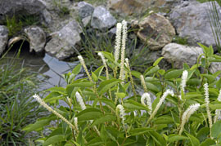
Rain Garden at Jefferson Lab

Standards used to protect water quality include Virginia regulations, the Clean Water Act (CWA), and others identified in the Lab’s Work Smart Standards (WSS) Set. Jefferson Lab complies with all requirements and performs monitoring under the three site water permits described below. Other site water quality programs, some involving permits, also apply and are described in Section 2.2.2.1.

Virginia Pollutant Discharge Elimination System (VPDES) Permits
Facilities in Virginia that directly discharge to waters of the United States must obtain a VPDES Permit, which satisfies Federal National Pollutant Discharge Elimination System requirements. The Virginia program is designed to protect surface waters by limiting primarily non-radiological releases of effluents into streams, lakes, and other waters, including wetlands. All necessary reports are provided to the Virginia Department of Environmental Quality (DEQ) as required in each permit.

Groundwater Monitoring - VPDES Permit No. VA0089320
This permit covers the quality of groundwater flowing across the site, including groundwater that is discharged in dewatering operations. Monitoring for groundwater quality, performed quarterly or as listed in the permit for both non-radiological and radiological parameters, is conducted at fifteen monitoring wells and at the groundwater dewatering collection point.

Because of the potential for activation of groundwater from accelerator operations, “baseline” water quality values for certain parameters were obtained prior to 1995, and stopped being collected when the accelerator became operational. The present well monitoring program enables the comparison of current and “baseline” values to verify that Jefferson Lab site activities are not degrading the quality of either on-site or offsite groundwater. Information on general water quality parameters follows, and radiological parameter information is presented in Section 3.2.
The wells and the collected withdrawn groundwater were sampled for the general water quality parameters of pH, conductivity, total suspended solids (TSS), and total dissolved solids (TDS). Sampling data collected in 2004 were representative of groundwater quality during accelerator operations and is consistent with previous baseline measurements. All permit conditions were met in 2004.

Cooling Water Discharges – VPDES General Permit No. VAG250018
This permit, which also contains water quality limits, covers cooling water discharges from one cooling tower system adjacent to the Central Helium Liquifier, Building 8. The materials used for cooling water treatment were approved by the DEQ and there are no environmental concerns with the use of these chemicals.

Quarterly sampling is performed under the VPDES General Permit. Flow information and sampling results for pH, temperature, ammonia, total hardness, total dissolved copper, total dissolved zinc, and total residual chlorine are reported. All permit conditions and requirements were met in 2004.

Hampton Roads Sanitation District Permit No. 0117
Facilities in Virginia that discharge to the Hampton Roads Sanitation District (HRSD) must obtain this permit. The HRSD program is designed to meet all Virginia effluent level requirements. All necessary reports are provided to the HRSD on monthly and quarterly bases, as provided in the permit terms.

Industrial wastewater is generated by Jefferson Lab and discharged to the HRSD under this permit. A small quantity of activated water is also authorized for release per permit conditions.
To meet monitoring requirements, Jefferson Lab performs sampling at two sanitary sewer outflow streams to verify that pH levels are within permit limits. Besides the activated water discharge noted above - which is also monitored for internal purposes - there are two special discharges to the sewer system. One elementary neutralization tank handles waste acid rinsewater and continuously records pH levels. The second outflow is from another elementary neutralization system, which handles acid rinsewater and waste acid from cryomodule research and development, cavity production, and some general maintenance activities. Both systems record pH information electronically and have built in safeguards to prevent release of any acid below a set pH value.

The activated water that was collected and discharged in 2004 was a combination of the output from dehumidification equipment in the experimental halls and small withdrawals from the beam dump cooling water systems. The activated water program is managed by the Radiation Control Group (RadCon) to stay within all permit requirements.

For all monitoring, subcontractors and/or RadCon staff perform all sampling at the prescribed sampling points. HRSD independently performs periodic sampling at all discharge streams for a full complement of metals and other parameters to validate Jefferson Lab’s compliance with permit and regulatory requirements. This includes an annual seven-day period of monitoring flows and taking samples at each of the discharge points to help determine if our discharges remain consistent and if any changes to the permit are necessary. Self-monitoring and HRSD results demonstrated that Jefferson Lab remained within the limits of the HRSD-issued permit in 2004. Due to no program or administrative violations in 2004, Jefferson Lab was presented with a Gold Award in early 2005 for this notable achievement. Recognition of our new acid neutralization system for the prevention of pollution was also noted by HRSD at the awards ceremony.

The total radioactivity discharged to the sanitary sewer in 2004 was 0.90 Curie (Ci) of tritium (or about 18% of the total allowed under the site industrial wastewater discharge permit), and 0.0012 Ci of other gamma-emitting radionuclides (or 0.12% of the total allowed under the same permit).

      - Monitoring Air Emissions
Jefferson Lab complies with Commonwealth and Federal regulations regarding sources of potential air pollution. The Federal Clean Air Act and its 1990 Amendments (CAAA) regulate the air emissions of DOE’s processes and facilities. Though Jefferson Lab has no processes that require air permitting, air emission reports are provided to the DEQ upon request.

Since a 1995 review of non-radiological emission sources indicated a minimal level of emissions, there have been no major changes in air emissions. Jefferson Lab, therefore, remains below any reporting thresholds. Emissions data on the site’s natural gas-fired boilers are provided to the DEQ upon request. Compliance with all applicable clean air standards was maintained in 2004.

National Emission Standards for Hazardous Air Pollutants (NESHAPs)
NESHAPs govern air emissions that contain hazardous components, such as radionuclides and asbestos.

Radionuclide Emissions
The Environmental Protection Agency (EPA) administers the radionuclide program in Virginia. Radionuclide emissions generated during CEBAF and FEL testing and operations, including emissions resulting from interactions of the accelerator beams with experimental targets and physics research equipments, fall under NESHAPs requirements. (Refer to Section 3 for discussion of direct radiation, the primary form of radiation generated on-site.)

To address NESHAPs requirements, Jefferson Lab uses sampling results and calculations to demonstrate that Lab operations remain below the EPA-defined 10 millirem per year (mrem/yr) potential effective dose equivalent to any member of the public. As effluent concentrations are below monitoring thresholds, routine monitoring of radioactive airborne effluents at the site boundary is not required; however, the Lab does make periodic confirmatory measurements to verify low emissions.

Under requirements of the Clean Air Act (CAA), Jefferson Lab submits the annual NESHAPs emission report to the EPA. The estimated dose equivalent from airborne releases in conjunction with the Lab’s accelerator operations during 2004 was 0.019 mrem. The collective effective dose equivalent for
CY 2004 was estimated to be 0.015 person-mrem.

Asbestos Removal
The NESHAP standard requires that individuals conducting asbestos-related training and individuals conducting asbestos-related activities follow approved procedures, and employ specific work practices to prevent release of asbestos to the air. There were no asbestos-related activities in 2004.

    - Other Programs with Compliance Commitments

      - General Water Programs
Small Municipal Separate Storm Sewer System (MS4) – VPDES Permit No. VAR040079
This permit, that has no monitoring requirements associated with it, authorizes operators of small municipal separate storm sewer systems to discharge storm water to surface waters within Virginia. The permit’s intent is to keep surface waters free of sediment and other pollution. Under this permit, the Lab maintains a storm water management program, as noted in Chapter 6733 of the Jefferson Lab EH&S Manual. The permit also requires that the Lab implement appropriate BMPs and related measurable goals to address the control measures identified in the permit. One of the BMPs is to track by fiscal year (FY) the number of incidences, such as spills, that could or did impact storm water. There were no incidences that affected storm water quality in 2004.

General Permit for Storm Water Discharges of Storm Water from Construction Activities –
VPDES Permit No. VAR103277
The main requirement under this permit is that the Lab must have a documented Storm Water Pollution Prevention Plan (SWP3) that must be followed for all projects disturbing one or more acres of land. The permit authorizes Jefferson Lab to discharge storm water from areas disturbed by construction activities. Though no monitoring is required under this permit, strict erosion and control measure inspection and maintenance requirements are incorporated into subcontractor specifications. Jefferson Lab’s Facilities Management Department oversees civil construction projects, ensuring that subcontractors adhere to this permit and other contract-specified standards.

Permit to Withdraw Groundwater No. GW0030800
Maintaining water table levels is necessary to prevent the partially buried experimental halls from flooding, so pumping to maintain water table control will be necessary for the life of the facility. To accomplish this, the local groundwater is collected by a network of drains into a sump pit, where it is then pumped and discharged to the surface. The only factor of concern under the groundwater withdrawal permit is the quantity of water pumped. Under this permit, which was awaiting reissue at the end of 2004, Jefferson Lab is authorized to pump a maximum of 6,000,000 gallons monthly and 23,036,790 gallons annually. Upon issuance, the new permit will authorize a number closer to that actually being pumped.

Quantities of water pumped from these tile fields are reported to the DEQ. All withdrawal quantities, both monthly and annually, were well within permit requirements. Note that the total quantity of water withdrawn in 2004 was about 16% of the annual limit. The affected groundwater is sampled for water quality parameters under VPDES Permit No. 0089320. There were no unusual issues regarding this discharge in 2004.

Spill Prevention, Control, and Countermeasure (SPCC) Plan
The Jefferson Lab SPCC Plan is reviewed annually and was last updated in 2004. This plan addresses all storage tanks and oil-containing equipment on-site. Oil inventory at Jefferson Lab mainly consists of numerous oil-filled electrical transformers ranging in volume from 2 gallons to about 4,800 gallons. A new emergency generator with a 5,000 gallon diesel reservoir was installed in 2004. (None of these units require action under aboveground storage tank regulations.) The total volume of oil on-site is estimated to be about 40,000 gallons, with about 6,000 gallons of this total under the control of Dominion Virginia Power, the regional electric service provider. The Lab maintains a used oil collection area to assist in managing the resulting used oil. To ensure proper handling and response (in the event of a spill or release), all oil workers receive SPCC Training.

Potential oil spill sources are located such that surface water discharge spillways and the sluice gates located at the site boundary can be effectively used to prevent any oil spills from leaving the site. Most DOE transformers utilize secondary containment, while the Dominion Virginia Power transformers have none. Like Jefferson Lab, Dominion Virginia Power also maintains a SPCC Plan for its oil-containing items at the Lab. There were four small and one moderate SPCC-related spills in 2004. These and two other non-SPCC spills received prompt response and attention by site response staff. The moderate size spill (about 20 gallons of oil) was controlled, promptly cleaned up, and all contaminated soils were removed and disposed of properly. There was no impact on the environment or on public health from any of the incidents.

      - General Air Programs
National Ambient Air Quality Standards (NAAQS)
The EPA has established NAAQS for sulfur oxides, particulate matter, carbon monoxide, ozone, nitrogen dioxide, and lead. The Hampton Roads area, which includes Newport News, Virginia, remained in attainment status for all NAAQS pollutants except ozone in 2004.

There is no required monitoring of air pollutant emissions performed at Jefferson Lab. There are no applicable NAAQS emissions sources present on the site although accelerator operations do result in the generation of small quantities of ozone. There are no environmental or public health effects from this generation; however, ozone is monitored as a worker health issue and is appropriately controlled.

Stratospheric Ozone-Depleting Substances (ODSs)
To support the CAAA and the objectives of Executive Order (EO) 13148, Greening the Government through Leadership in Environmental Management, Jefferson Lab strives to minimize the use of ODSs by using safe, cost-effective, environmentally preferable alternatives. ODS-containing items used at Jefferson Lab include refrigerants, degreasers, cleaners, and aerosol can propellants. The phase out of these substances will have a moderate impact on the site. To reduce ODSs and ODS-containing items on-site, Jefferson Lab utilizes trained and licensed subcontractors and staff to perform all work involving ODS-containing refrigeration and air conditioning equipment. As well, Jefferson Lab has one ODS recovery machine on-site. The one remaining chlorofluorocarbon (CFC)-based chiller on-site receives preventive and corrective maintenance by a qualified mechanical subcontractor to ensure optimal performance and minimal CFC losses.

      - Waste Programs
Waste Management
Waste streams at the Lab include both RCRA (Resource Conservation and Recovery Act of 1976) (hazardous and non-hazardous solid) and non-RCRA (low-level radioactive and medical) wastes. Site programs address applicable Federal requirements, which Virginia has adopted. The Lab endeavors to reduce its waste generation and has made progress in some areas. Lab staff encourage the reuse or recycling of previously used or discarded materials wherever possible. Waste generation and recycling quantities are tracked and reported annually to the DOE.
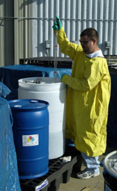
Secondary Containment in Use
There have been no waste management activities associated with spills or cleanup actions under other Federal programs such as the Comprehensive Environmental Response, Compensation, and Liability Act of 1980 (CERCLA). There were no waste-related compliance issues in 2004.

Resource Conservation and Recovery Act (RCRA)
RCRA promotes the protection of health and the environment and the conservation of valuable material and energy resources. RCRA provides the EPA authority to regulate solid waste from minimization and recovery to collection and disposal.

RCRA wastes include our hazardous and non-hazardous special waste streams and waste that is recycled or sent to a landfill. The last DEQ inspection of the hazardous waste program occurred in September 2002, with no deficiencies identified.

In FY 2004, Jefferson Lab generated 3.4 tons of hazardous waste and 287 tons of general refuse landfill waste. These wastes are managed for disposal by the appropriate staff in the Accelerator Division’s EH&S Department and the Facilities Management Department, respectively. The amount of hazardous waste generated was significantly reduced from previous years due to the new neutralization system that began processing used acid streams in August 2003.

The hazardous waste generated in the largest volumes was a waste acid mixture used for niobium cavity processing and waste solvents from cleaning operations. Jefferson Lab neither transports hazardous wastes nor operates any regulated treatment or disposal units. All wastes are disposed of through licensed waste handling transporters and facilities.

Hazardous and Special Waste Streams
Improvements in hazardous waste generation rates have been recognized and documented with the use of performance measures. Jefferson Lab has made notable progress in meeting hazardous waste minimization objectives. Accelerator Division EH&S staff, in particular, continued to emphasize substitution, reduction, and reuse of hazardous materials in the workplace.

Other Wastes
Other wastes generated at the Lab, those not covered under RCRA, include radioactive, medical, and toxic wastes. Only a minimal amount of medical waste is generated at Jefferson Lab and its disposal is in accordance with the site program. Other non-hazardous wastes are disposed of in landfills, reused on-site, recycled, or used for other purposes offsite. There were no compliance issues for any of these programs in 2004. These “other wastes” are managed for disposal by the appropriate RadCon, Facilities Management, and Medical Services staff.

Low-Level Radioactive Wastes (LLW)
The Lab generates only low-level radioactive wastes (LLW); thus, there is no source of special nuclear materials. In 2004, 5.45 m³ (cubic meters) of LLW was generated at Jefferson Lab. There has been no mixed (a mixture of hazardous and radioactive) waste generated to date.

      - Emergency Planning & Community Right to Know Act (EPCRA)
Under EPCRA, which is aligned with the Superfund Amendments and Reauthorization Act (SARA), Jefferson Lab is responsible for planning and being prepared to respond to chemical emergencies. As well, Jefferson Lab is responsible for completing applicable reporting requirements, such as toxic chemical usage and environmental releases, if there are any. Jefferson Lab files an annual SARA Tier II report (an accounting of hazardous substances and extremely hazardous substances (EHSs) used or stored on-site in quantities greater than a given threshold) with three emergency planning groups (EPGs). The EPGs are the EPA, the Commonwealth DEQ, and a local planning group. The items reported for 2004 were nitric, hydrofluoric, and sulfuric acids; bromine; argon; helium; nitrogen; lead; propylene glycol; and hydraulic oil. The Lab has not used any chemicals that are either toxic or on the persistent, bioaccumulative, or toxic (PBT) list in quantities that exceed Toxic Release Inventory reporting thresholds.

Other EPCRA-related standards that apply to Jefferson Lab include those requiring notification to the EPGs of the presence of an EHS that exceeds the regulatory threshold amount, and that the Lab must have an MSDS (Material Safety Data Sheet) available for every chemical on-site. Jefferson Lab has had no releases to date that meet the EPG reporting criteria.

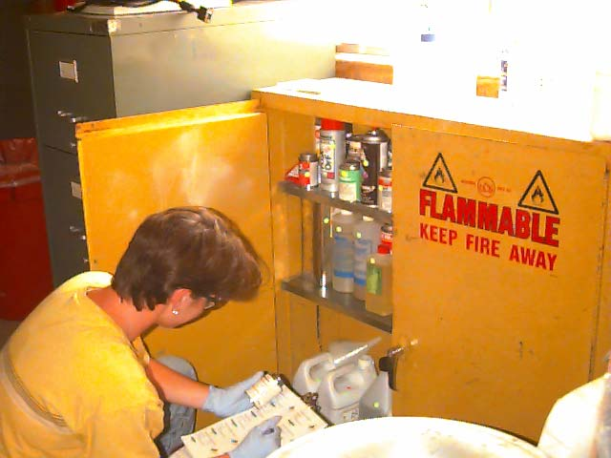
Chemical Inventory

      - National Environmental Policy Act (NEPA)
NEPA, as amended, outlines the Federal policy to restore and enhance the environment and to attain the widest range of beneficial use without degradation. NEPA-related actions are handled in conjunction with the DOE, which is committed to following both the DOE and EPA-related regulations. Jefferson Lab assists the DOE by preparing documents and performing assessments of existing documentation.

NEPA requires that projects with potentially significant environmental impacts be evaluated and alternative actions explored. These evaluations are to be performed and reported as either an EA or an Environmental Impact Statement (EIS). Jefferson Lab met these requirements by continuing to implement a program of reviewing construction activities for compliance. All activities in 2004 were addressed under the site’s 13 active DOE-approved Categorical Exclusion (CX) actions and EAs.

There were no NEPA compliance issues identified by DOE in 2004.

      - Compliance with Other Regulations and Federal Standards
Federal Insecticide, Fungicide, and Rodenticide Act (FIFRA)
FIFRA applies to the storage and use of herbicides and pesticides. Use of these substances has environmental implications, especially in terms of water quality. As such, the application of herbicides and pesticides is handled and permitted by subcontractors through a Commonwealth-administered certification program.
Herbicides were used on annual and perennial weeds and grasses, stumps of trees, and brush. Pesticides were applied on-site for control of insects. Areas treated included kitchens, laboratories, and other areas throughout Jefferson Lab.

In order to minimize the chances of herbicides and pesticides washing into local storm water channels, Jefferson Lab requires that there be no outdoor application of these compounds when rain is expected. To further minimize the chances of pollution, no industrial-strength herbicides or pesticides are prepared, mixed, stored, or disposed of on Jefferson Lab property. The subcontractor is further responsible for handling any waste disposal through an authorized disposal facility. Small containers of household pesticides are stored on-site and applied per manufacturer’s recommendations.

Applicable Executive Orders
There were numerous activities conducted throughout the Lab in 2004 that furthered efforts to be an environmental steward, especially in waste minimization and pollution prevention. Some actions were related to EO requirements, others were staff-initiated, and some a combination of the two. Information on how the Lab addresses applicable EOs is presented below. There were no concerns or compliance issues with these EOs.

EO 11990 Protection of Wetlands
EO 11990 ensures that adverse impacts to wetlands from construction activities are avoided or responsibly mitigated. Evaluation of Jefferson Lab activities involving potential wetlands is accomplished through the NEPA review process. There were no concerns involving wetlands in 2004.

EO 11998 Floodplain Management
EO 11988 relates to the occupancy and modification of floodplains. There is localized flooding during significant rain events, but no part of the site is within the 100-year floodplain. There were no compliance issues in 2004.

EO 13101 Greening the Government through Waste Prevention, Recycling and Federal Acquisition
EO 13101 encourages agencies to implement Affirmative Procurement (AP) by promoting the purchase of products made with recycled materials. The purchase of these materials helps “close-the-loop” in the recycling process.

To comply with this EO, the DOE has set goals and performance standards, including a DOE complex-wide FY 2005 procurement target of 100% for purchasing recycled content EPA-listed products. The Lab has almost reached an internal goal of 95%, as its compliance level rose to 94.6% for FY 2004. The Business Services Department’s procurement staff has made great progress in meeting the intent of the EO since tracking began in 1995.

EO 13123 Greening the Government through Efficient Energy Management
This initiative focuses on energy efficiency (E2) as a means of P2. The DOE seeks a 2005 energy use reduction of 20%, and a 2010 energy use reduction of 25% for industrial/lab category facilities from our 1999 baseline. For FY 2004, Jefferson Lab documented a 47.1% energy use reduction in all reportable industrial/lab category buildings compared to the 1999 baseline year. This improvement was primarily due to the installation of various new heating, cooling, and lighting systems in the VARC and in the Lab’s primary administration building, CEBAF Center. The site’s highly energy intensive production related buildings and the CEBAF Center’s Computer Center are considered to be exempt from reporting at this time.
Energy Management – With an increased emphasis on energy management, selected mechanical and electrical improvements have been made to building and process systems and equipment in order to improve their performance and reliability. The Lab has exceeded the prescribed energy goals. Facilities Management, which is also responsible for new building construction, is also taking E2 into account during the design process. Refer to section 2.2.3 for other ways in which the Lab has worked to become more energy efficient.

EO 13148 Greening the Government through Leadership in Environmental Management
This EO identifies a number of actions for Federal Agencies to implement. These goals include the need to develop an EMS, to reduce the use of ODS and toxic chemicals, and to report under EPCRA.

In 2004, Jefferson Lab addressed EO 13148 and general pollution prevention (P2) goals by continuing work on an EMS (see Section 2.1); minimizing chemical use; reusing and recycling various items from chemicals to cardboard boxes (to the extent practical); and, by disposing of wastes in the most environmentally safe manner. Jefferson Lab’s progress in meeting the requirements of this EO follows.

Environmental Management System
At the end of 2003, Jefferson Lab had committed to developing and implementing a site EMS by December 2005. Throughout 2004, key Lab staff continued to develop and implement an EMS.

To help track how the various DOE institutions were progressing toward the December 2005 goal, a “DOE scorecard” that shows key EMS milestones and proposed accomplishment dates was issued. By the end of 2004, Jefferson Lab had successfully accomplished four of the six FY 2003 and 2004 milestones. The Lab committed to accomplishing the remaining milestones as it continued EMS development in FY 2005.

ODS Usage Reduction
The compliance status of this EO requirement is discussed in Section 2.2.2.2.

Environmentally and Economically Beneficial Landscaping Practices
Jefferson Lab implements this requirement in conjunction with the objectives identified in the new
MS4 permit; refer to Section 2.2.2.1 regarding preventing the pollution of storm water. To accomplish these beneficial landscaping practices on the facility grounds, Jefferson Lab uses qualified subcontractors. The Lab’s intent is to maintain grass cover in open areas, to the extent practicable, to prevent runoff. Fertilizers and herbicides are applied locally on an as-needed basis and when rain is not imminent to prevent surface water contamination.

During the last contract bid for landscaping services, the bidders were required to monitor landscape irrigation to provide all areas of irrigation with one inch of water per week of natural rainfall and irrigation combined. The reduction in landscape water consumption that was noted in 2004 is a result of both above average rainfall throughout the year and the diligent monitoring on the part of the Lab subcontracting officer representative to ensure the goals are achieved. For 2004, Jefferson Lab only used about two-thirds of the water that we would normally use for landscaping. The Lab continued the use of mulch, a standard recycled content product, to reduce the amount of water needed at managed beds. Subcontractors are directed to use more environmentally preferable products, such as compost, where suitable.


Dogwood Blossoms

DOE P2 and E2 Goals and Other DOE Commitments
Jefferson Lab is committed to meeting site targets to address ten of the DOE-identified P2 and E2 goals, but additional funding continues to be needed to meet some targets. The Lab has made progress in meeting some of these goals, such as improving recycling performance, which will be refined with the institution of an EMS in 2005.

Other DOE commitments included those that address the management of radioactive waste and the new DOE Environmental Protection Program guidance that provides direction for EMS implementation. There were also four contractual performance measures in FY 2004 that addressed environmental issues.

2.2.3 Environmental Stewardship at Jefferson Lab: Other Site Programs
Waste Minimization and Pollution Prevention (WMin/P2)
Waste minimization, in combination with other P2 strategies, such as source reduction, is recognized as the most cost-effective form of EP. Jefferson Lab’s WMin/P2 Awareness Plan fosters the philosophy that waste prevention is superior to either paying for special disposal or for remediation. The goal of the program is to incorporate WMin/P2 into the decision-making process at every level throughout the organization. This is accomplished by having line managers, assisted by division EH&S staff, ensure that staff are knowledgeable about the benefits of WMin/P2; consider the waste implications of a new or modified process during the planning stage; and, are recognized when ways to enhance EP are brought to their manager’s attention. These practices benefit the environment, protect employees and public health, and reduce site waste disposal costs and foster good community relations.

EP in Product and Service Life Cycles
A variety of products and materials are purchased or otherwise obtained for on-site use. When the materials have served their purpose, and are no longer needed, they are disposed of in accordance with Jefferson Lab policy. As there are EH&S risks involved, Jefferson Lab has programs and procedures in place that include EP and sustainability considerations.

Environmentally Preferable Purchasing and Planning
Jefferson Lab is committed to integrating environmentally preferable purchasing and sustainability considerations into the acquisition of products, services, and construction projects when feasible. This responsibility is founded on the Lab’s commitment to P2 and sound environmental stewardship. Our efforts go beyond the AP requirements spelled out in EO 13101 and the list of EPA-designated products.

Jefferson Lab continues to make progress toward meeting the DOE AP goals and requirements and in implementing other environmentally preferable purchasing measures. Procurement staff continue to increase employee awareness of EPA-designated products and provide ready access to these recycled content/remanufactured products. Office supply purchases made using Purchase Cards (PCards) have been restricted and a full line of AP items is available using the Lab’s e-commerce system. The Lab is making progress at meeting an internal goal of 95% for purchasing recycled content EPA-listed products. The Lab’s compliance level rose to 94.6% for FY 2004. Jefferson Lab has made steady and consistent progress for the past five years supporting the DOE established AP goals.

EP Considerations in Building and System Design and Construction Activities
Though the CEBAF accelerator complex is the site’s primary energy user, energy management principles are applied throughout the Lab. Subcontractors and staff involved with the design of new buildings or with changing and modifying existing buildings or utility systems evaluate and implement energy and water conserving strategies where feasible. A major new construction project that was started in 2004, the Phase 1 Addition to CEBAF Center, was designed to incorporate multiple EP elements and may even meet the strict terms required for a future submission for LEED (Leadership in Energy and Environmental Design) certification. Examples of items that would meet LEED criteria are the use of energy efficient lighting and the use of an alternative source of energy, that is, to not use coal or oil.

Environmentally Preferable Use
Besides selecting the best environmentally preferred product or service for the desired activity, staff and users of Jefferson Lab are responsible for following safe and environmentally sound use, storage, and waste management practices.

Factors, such as ensuring that secondary containment is present and proper ventilation for the process is provided, help to minimize exposure to potential hazards. Lab staff and subcontractors have taken opportunities to minimize energy and water use, such as the use of motion detectors to shut off lights when no one is in the room, and providing prompt response to address reported water leaks.

Jefferson Lab uses about 56 million gallons of water annually, with 79% directly related to process or facility heat rejection. Much of this water is evaporated in cooling towers for process cooling and air conditioning. Available techniques are used to minimize water use, including a regular maintenance program. Water reductions for landscaping were again implemented in 2004.

Energy Management - With an increased emphasis on energy management, selected mechanical and electrical improvements have been made to building and process systems and equipment in order to improve their performance and reliability. The energy reduction through FY 2004 was 47.1%. The Lab has exceeded the prescribed energy goals.

A prime example of how the Lab strives to meet energy management goals is a new central chiller utility that was installed in FY 2004. Upon completion of this project, the air conditioning for the accelerator became more thermally accurate, economical, easier to maintain, and more robust. In addition to the efficiencies of a central chiller plant over multiple air-cooled package air conditioning units, this project minimizes the use of mechanical cooling by employing an outdoor air economizer cycle.

Water Conservation - With an increased emphasis on water conservation, water-using processes and site maintenance activities continue to receive extra attention. New projects that need water are reviewed to minimize water use. Existing water-using activities are, or will be, evaluated to reduce water usage as much as possible based on a life cycle cost. One example is that we are using process waste water to partly supply our cooling towers. A second example is minimizing the amount of water being used for landscaping practices.

Environmentally Preferable Disposal
Today’s rapidly changing technologies, products, and practices carry the risk of generating materials and wastes that, if improperly managed, could impair or threaten public health and the environment. In this regard, Jefferson Lab encourages, and, where appropriate, requires the purchase and use of products and services whose waste products will have minimal impact on the environment and public health. Once the waste is generated, Lab staff are responsible for ensuring proper segregation and disposal of waste items.

The range of options for disposition of materials includes recycling, neutralizing, scrapping, providing spent chemicals or equipment to co-workers on-site or to other DOE facilities for reuse, and disposing in a local landfill. The Lab intends for all items to be disposed of in the most environmentally acceptable manner that meets all applicable regulatory and contractual requirements.

Facilities Management and other staff continue to explore opportunities to find users or vendors that will take or buy items that are no longer needed for Jefferson Lab operations.

Recycling – The Lab continues to implement waste reduction strategies and to educate and encourage staff on the proper disposition of recyclable materials. Through a collaborative effort between EH&S Reporting and Facilities Management, office product recycling centers continued to be established and operated. Products collected at these local centers are: aluminum cans, small batteries, cardboard, CDs/diskettes, copier/fax/inkjet/laser cartridges, greeting cards, paper wastes, packing peanuts, telephone books, transparencies, Tyvek® envelopes, and plastic bottles. The small amount of money received from recycling the laser/inkjet cartridges and aluminum cans is returned to the recycling budget to help pay for subsequent recycling activities. The presence of local recycling centers has considerably increased staff recycling awareness. Lab-wide response and participation in recycling continued to grow. In FY 2004, with scrap metal included in the total, Jefferson Lab recycled about 166 tons of materials.

2.3 APPRAISALS, ASSESSMENTS, AND INSPECTIONS

The DOE Site Office, the DOE Oak Ridge Operations Office, and various Commonwealth and local authorities provide external oversight of the Jefferson Lab EP Program. Assurance that on-site processes do not adversely affect the environment is achieved through self-assessments, routine inspections, and oversight by the DOE, DEQ, and the HRSD. Jefferson Lab complies with all applicable laws, regulations, and permits. Actions of note are described here.

DOE Review of Jefferson Lab Self-Assessment
The DOE Site Office’s Overlay Report, produced in conjunction with SURA’s annual Lab-wide self-assessment, covers EH&S topics, contains Site Office observations and reviews, DOE appraisal results, and other information. The Report provides an overall performance assessment for the year. For FY 2004, the Overlay Performance Evaluation Report yielded a rating of “Good” in the EH&S category. The reduction from the previous “Outstanding” ratings was due to poor safety performance (injury avoidance). The environmental performance remained “Outstanding”.

External Inspections
There were two external environmental inspections during 2004. The first inspection of the year was conducted by HRSD staff on February 25th. The inspection focused on reviewing areas where chemicals were in use to review containment practices, especially in the vicinity of floor drains. Buildings involved in the inspection included Building 8 (the CHL complex) and Building 58 (the Test Lab). Jefferson Lab permit records and HRSD meter information were also reviewed. Information regarding the change in hazardous waste vendors was requested and provided. No deficiencies were identified. The second inspection was conducted by the DEQ on July 28, 2004, regarding our permit that covers discharges from one large site cooling tower. No concerns were identified.

Line Self-Assessments
Line managers perform annual line self-assessments (LSAs) of their organizational elements. The LSAs are broad in scope, covering the accomplishment of the elements’ goals, including EH&S. The Self-Assessment/Quality Assurance (SA/QA) Group performs independent assessments of four or more of the Lab’s organizational units each year, focusing on EH&S. Deficiencies identified through these independent assessments are tracked by SA/QA until the corrective actions are completed.

SECTION 3
ENVIRONMENTAL RADIOLOGICAL PROGRAM

Equipment that generates radiation, and a variety of radioactive materials, are used in research activities at Jefferson Lab. The impacts of operating this equipment and of working with and around these materials have been taken into account in Lab procedures. Any potential impacts have been significantly reduced by applying standard control measures and by implementing ALARA, or “as low as reasonably achievable”, principles. The resultant potential effective dose equivalents to members of the public from various pathways, such as inhalation, ingestion, and skin absorption, are evaluated by the Radiation Control Group (RadCon) to demonstrate compliance with EPA and DOE regulatory limits.

Jefferson Lab protects the environment and the public from exposure to radiation by implementing a number of both physical and administrative controls. The radiological monitoring program is the primary means used at Jefferson Lab to verify accomplishment of this protection objective. Exposure reduction support activities include: using permanent and temporary shielding; using active and passive controls at activated water locations; and, following proper protocols when handling radioactive materials and wastes.

The radiological monitoring program is designed to verify that radiation exposures, both for on-site radiation workers and for members of the general public, are below permissible levels and are ALARA. The program also assures that Lab support activities and accelerator testing and operations, as described within the approved operational safety envelope, will result in minimal impacts to the environment and have minimal to no effect on public health.

3.1 RADIATION EXPOSURE PATHWAYS

Accelerator operations produce three different pathways of radiation exposure that can impact the general public: direct or prompt radiation, radiation from induced airborne radioactivity, and radiation from induced waterborne radioactivity. Jefferson Lab performed extensive environmental monitoring in 2004 to measure these three forms of accelerator-produced radiation. Pathways to the general public are modeled and monitored when appropriate or as required by law. The decision to monitor a particular pathway is based on the:
- type of operations
- radionuclides released
- potential hazard
- experience from previous monitoring results at Jefferson Lab
- experience at other nuclear and high-energy physics laboratories

radioactivity – a natural and spontaneous process by which the unstable atoms of an element emit or radiate excess energy from their nuclei and, thus, change (or decay) to atoms of a different element or to a lower energy state of the same element.

3.1.1 DIRECT RADIATION AND ITS EFFECTS
Direct or prompt radiation results from the interaction of the accelerator beam with matter. This radiation is produced within the beam enclosure and stops when the accelerator is turned off.

Direct radiation penetrates shielding with nearly all of this direct radiation stopped by the shielding - any possible exposure to this radiation is at a maximum on-site and decreases with distance. During 2004, Jefferson Lab continued regular accelerator operations in support of physics experiments in the three experimental halls. Accelerator operations and related activities produced significant amounts of direct radiation; however, these amounts were restricted within constraints as managed by RadCon and were performed within an approved safety envelope.

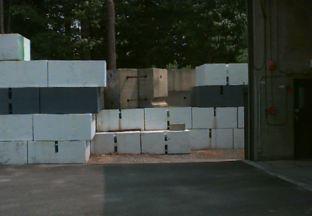
Shielding Blocks at the Hall C
Truck Ramp Entrance

The Jefferson Lab areas, where direct radiation can be produced, are not accessible during accelerator operations. There are approximately 50 electronic radiation detectors and a series of associated passive integrating detectors deployed around the accelerator site with the primary purpose of measuring on-site radiation. The majority of the electronic detectors are connected to a central computer system that automatically records the radiation levels for subsequent examination. When appropriate, Jefferson Lab employees, subcontractors, and visitors wear detection devices to monitor their on-site radiation exposure.

Six dual-channel microprocessor-based instruments for monitoring gamma and neutron radiation levels collected direct radiation data (see Section 3.1.2 below) at the site boundary in 2004. (Refer to
Exhibit 3-1 for their locations.) Radiation data collected prior to January 1995 serve as the statistical baseline for comparison to that collected since the accelerator became fully operational.

Exhibit 3-1
Boundary Monitor Locations
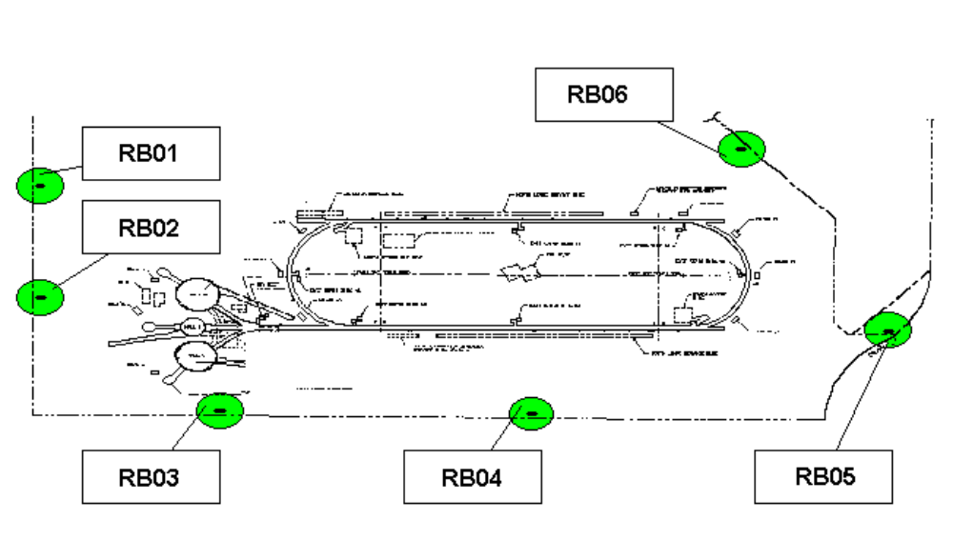
Note: RB03 is the same as RBM-3 (also referred to in Section 4.4)

3.1.1.1 Direct Radiation and Resultant Airborne and Waterborne Radioactivity
In addition to the accelerator’s production of direct radiation, the interaction of the accelerator beam with matter can cause the formation of radioactive materials through activation of the matter. The beamlines, magnets, beamline-components, targets, detectors, other experimental area equipment, and the energy dissipating devices (beam dumps) used to contain the beam’s energy may become activated. Cooling and ground waters, lubricants, and air in the beam enclosure may also become activated. These activated air, water, and particulates are possible sources of airborne and waterborne radioactivity. Though the direct radiation stops when the accelerator is turned off, the activated equipment, water, and air continue to emit radiation. All material exposed to the beam is monitored for radioactivity prior to being removed from the beam enclosure.
Controls are in place to minimize the effects of both direct radiation and radiation from activated materials on Lab personnel, the environment, and the public. The monitoring of airborne radioactivity is carried out locally to validate calculations and estimates of radiation dose.

3.1.1.2 Waterborne Radiation
Jefferson Lab is situated in the central section of Newport News, Virginia, at an average elevation of about 35 feet above mean sea level. The site is in a Zone C area on the local flood maps, so is not considered to be within the 100-year floodplain. The site is located in the watershed of Brick Kiln Creek, which discharges to the Big Bethel Recreation Area. As water is a vital natural resource, contamination could present potential problems to the general population. Because of this, both the Federal government and the Commonwealth of Virginia regulate both groundwater and surface water.

Groundwater
The Jefferson Lab Groundwater Protection Management Program provides a strategy to minimize impact to groundwater resources and is used as a management tool to guide program implementation. The Program ensures compliance with Federal, Commonwealth, and local regulations, other identified standards, and effective resource management practices. The included groundwater monitoring plan serves to assess the effect of Jefferson Lab activities on groundwater quantity and quality. (Refer to
Section 3.2).

Soil activation is a potential source of groundwater contamination at Jefferson Lab. Groundwater quality in the soil surrounding the accelerator complex is the Commonwealth’s largest concern about site operations. The monitoring of VPDES-permitted wells for particular groundwater quality parameters continued in 2004. From controls designed into the CEBAF and FEL facilities, including in-place shielding measures, and through calculations, a minimal amount of soil or groundwater activation is expected on-site and no offsite effect is anticipated. There were no soil or groundwater activation concerns in 2004.

Surface Water
The surface water sampling program commenced at the time construction of the experimental halls was completed. Quarterly sampling of the groundwater dewatering surface discharge under the VPDES groundwater quality permit continued. In addition, automated sampling equipment is used to analyze the discharged water for tritium and gross beta activity. (Refer to Section 3.2 for information on Jefferson Lab’s radiological monitoring program.) There were no concerns involving surface water in 2004.

RadCon addresses any activated water spills, thus minimizing potential surface and the less likely potential groundwater impacts. Collected water that did not meet immediate disposal criteria was transferred to a temporary storage area and released only after measurements indicated it was safe to do so: when it met regulatory permit release requirements. There were no worker safety, environmental, or public health concerns as there were no water spills or leak events in 2004 involving these activated water systems.

Surface water quality is maintained by discharging only permitted effluent from a cooling tower and unpolluted waters, such as rainwater, to the environment. Control measures identified for the site include:
- Using proper procedures, such as secondary containment, around containers where activated water may be temporarily stored.
- Water within the tunnels and experimental halls may become activated from exposure to radiation. RadCon procedures that address activated water management provide for sampling and monitoring of water (before release) from any potential sources within these areas.
For information about other non-radiological surface water quality issues at Jefferson Lab, refer to Section 2.2.

3.2 ENVIRONMENTAL RADIATION MONITORING

Jefferson Lab uses environmental monitoring to assess local and offsite environmental conditions. The site environmental monitoring program verifies that any radiation exposures, and radioactive and non-radioactive effluent releases, comply with applicable regulations and other requirements.

While radiation dose rates offsite, from direct and airborne radioactivity, are expected to be well below limits set for the general public, monitoring ensures that the established controls are effective. Jefferson Lab operations have minimal radiological dose impact to the public and the environment. Lab programs and outside advisory committees ensure that the Lab continues to function within regulatory and established administrative limits for direct radiation and airborne emissions. There has been no offsite release of radioactivity in any water effluents beyond the small quantities allowed to be discharged under the Lab’s HRSD permit.

The overall effects on the environment and the public from Jefferson Lab’s operations are summarized in Exhibit 3-2. There were no non-routine releases so all values shown result from routine operations. The ambient external dose measured was on the order of 3.7% of natural background levels or 3.7 mrem (37 µSv (microSieverts)). In summary, the maximum dose impact to the individual from both the air and direct pathways combined was 3.7 mrem (37 µSv). This is 3.7% of the DOE regulatory dose limit for members of the public from all pathways (air, water, and others), which is 100 mrem (1 mSv). Information about the air program is provided in Section 3.2.1 and the water program is described in Section 3.2.2.

3.2.1 Monitoring: Air
Airborne radionuclide concentrations at the site boundary have been too low to accurately measure. Annual calculations, using EPA-approved computer modeling codes, have indicated that Jefferson Lab operational emissions remain several orders of magnitude lower than the EPA 10 mrem/yr reporting limit. Jefferson Lab continued making continuous measurements to verify that the calculations confirmed a very low release rate. (Refer to Exhibit 3-3) A report, documenting that the 2004 dose to the maximally exposed individual of the public was 0.019 mrem/yr (0.19 µSv/yr) due to airborne releases, was sent to the EPA in 2005. This dose is insignificant when compared to the EPA regulatory public air-dose limit of 10 mrem/yr (100 µSv/yr).

3.2.2 Monitoring: Water
Groundwater
Activation of groundwater, as a result of direct or secondary radiation, is possible in certain locations around the accelerator complex. Massive concrete and steel shields within the accelerator beam enclosures and in the beam deceleration areas minimize groundwater activation. The monitoring conditions in VPDES Permit No. VA0089320 serve as the basis for evaluating accelerator-produced radioactivity in groundwater. The data collected, through the completion of facility construction in 1995, provide a groundwater quality baseline for comparisons during long-term facility operation. The background samples were analyzed for naturally occurring radionuclides, as well as accelerator-produced radionuclides, and selected chemical parameters. The radionuclides analyzed in 2004 are those known to relate to operations associated with electron accelerators. They include H-3 (Tritium), Be-7, Na-22, Mn-54, and gross beta. Total manmade radioactivity was also analyzed. The general water quality parameters measured were pH, conductivity, TSS and TDS.

Exhibit 3-2
Jefferson Lab Radiological Dose Reporting Table for 2004
Pathway | Dose to Maximally Exposed  Individual  mrem/ (mSv) | % of DOE Limit  100 mrem/yr | Estimated Population Dose  (person-rem) / (person-Sv) | Population within  80 km
Air | 0.019 (1.9E-04) | 0.019 | 0.015 (1.5 E-04) | -
Water | 0 | 0 | N/A | -
Other Pathways | 3.7 (3.7 E-02) | 3.7 | Unknown/ Unknowable | -
All Pathways | 3.7 (3.7 E-02) | 3.7 |  | 214,000 est.
Notes: 0.007 = 7 x 10⁻³ = 7 E-03
Values presented in Exhibits 3-2, 3-3, & 3-6 are presented in Scientific Notation (example, 2 E-05 is 0.00002)
mSv = MilliSievert

Exhibit 3-3
Jefferson Lab Radiological Atmospheric Releases for 2004
Radionuclide [half-life (timeframes)] | Tritium [12.26 yr] | Be-7  [53 .6 days] | C-11  [20.3 m] | N-13  [9.96 m] | O-15  [123 sec] | Cl-38  [37.29 m] | Cl-39  [ 55.5 m] | Ar-41  [1.83 hr]
Ci (Bq) in  CY 2004 | 6.03 E-03  (2.2 E+08) | 2.12 E-03  (7.8 E +07) | 6.54E-01  (2.4 E+10) | 4.95  (1.8E+11) | 2.63  (9.7 E+10) | 2.78 E-02  (1.0 E+09) | 3.37 E-01  (1.23 E+10) | 1.33 E-03  (4.9 E +07)
Notes: 1 pCi = 1 x 10E-12 Ci = 0.037 Bq
1 Ci = 3.7 x 10 Bq
m: minutes

This VPDES groundwater quality permit specifies EPA-approved sampling and analysis protocols, which were the basis of groundwater monitoring in 2004. Fifteen wells were sampled at quarterly, semi-annual, or annual intervals. The permitted wells included the “A”, “B”, and “C” Ring wells (labeled as to proximity to the accelerator) and the upgradient well. (Refer to Exhibit 3-4) Along with the A ring wells, the groundwater dewatering effluent at the experimental halls was also monitored quarterly in 2004 and reported under this permit. Note that the water quality beyond the Lab boundary must remain well below the regulated drinking water limit of 1 mrem/year. The annual effective dose equivalent to an individual consuming water activated at this level is so negligible it cannot be measured.

The VPDES groundwater quality action and permit levels for radiological parameters are representative of normal background radionuclides, which are also generated through Jefferson Lab activities. Note that if an action level should be reached at an A-Ring well, it would not result in a permit violation, but would trigger an internal investigation of potential causes. The permit is available for review at http://www.jlab.org/ehs/links.html

The maximum radiological results obtained from monitoring the wells in the accelerator vicinity during 2004 are presented in the first part of Exhibit 3-5. The results from the other locations described in the permit are shown in the second half of the exhibit. All measurements were within permit levels. No accelerator-produced activity has been detected. All values represent natural background, and variations are normal.

Other Water Monitoring
The Cooling Water Tank (Building 92) and the floor drain sump (FDS) pit (Building 97) are considered one HRSD sampling point. Sampling at the FDS pit, which collects various discharges, including low-level activated dehumidification condensate from air conditioning systems located in the experimental halls, and at the Cooling Water Tank, that contains activated water from various accelerator apparatus, continued in 2004. Sampling and analysis for tritium are performed prior to any discharges to the sanitary system. The results are recorded and monthly and quarterly concentration values are provided to HRSD. The total quantity of radioactivity released to HRSD in 2004 is presented in Exhibit 3-6. Some regulatory values (that are not required to be regularly reported) are tracked and documented by RadCon staff, such as the total amount of activity discharged to the sanitary sewer system. Monthly and composite quarterly results for 2004 are provided in Exhibit 3-7. The concentrations varied based on the quantity of beam dump cooling water discharged during the reporting period.

On a periodic basis in 2004, other water sampling and analysis for tritium and gross beta activity were performed on various discharges from potential radiological areas, such as from sump pumps. Any water identified as a potential concern was collected and discharged according to the terms of the HRSD permit.

3.3 OTHER SUPPORT ACTIVITIES

Permanent shielding in the form of thick concrete walls and earth berms protects the environment from exposure. Additionally, labyrinth entrances further minimize exposure and monitoring equipment at ventilation ports tracks exposure values.

RadCon installs shielding blocks and detection devices that are used to identify potential problem areas as needed to either minimize impacts or identify opportunities to minimize impacts both inside and outside the facility.

Various accelerator-related water systems have the potential for becoming activated. All areas where activated water could be present have controls in place. Locations with a high potential for activation have secondary containment or other physical measures installed and administrative lockout/tagout controls. Other areas with less or even minimal potential for activation are monitored periodically to ensure levels are within expected values.

RadCon establishes access-controlled areas to temporarily store radioactive materials, including those being stored for decay, and wastes. There is no impact to the environment or public health from the small quantity of materials stored on-site.

Exhibit 3-4
Monitoring Well Locations
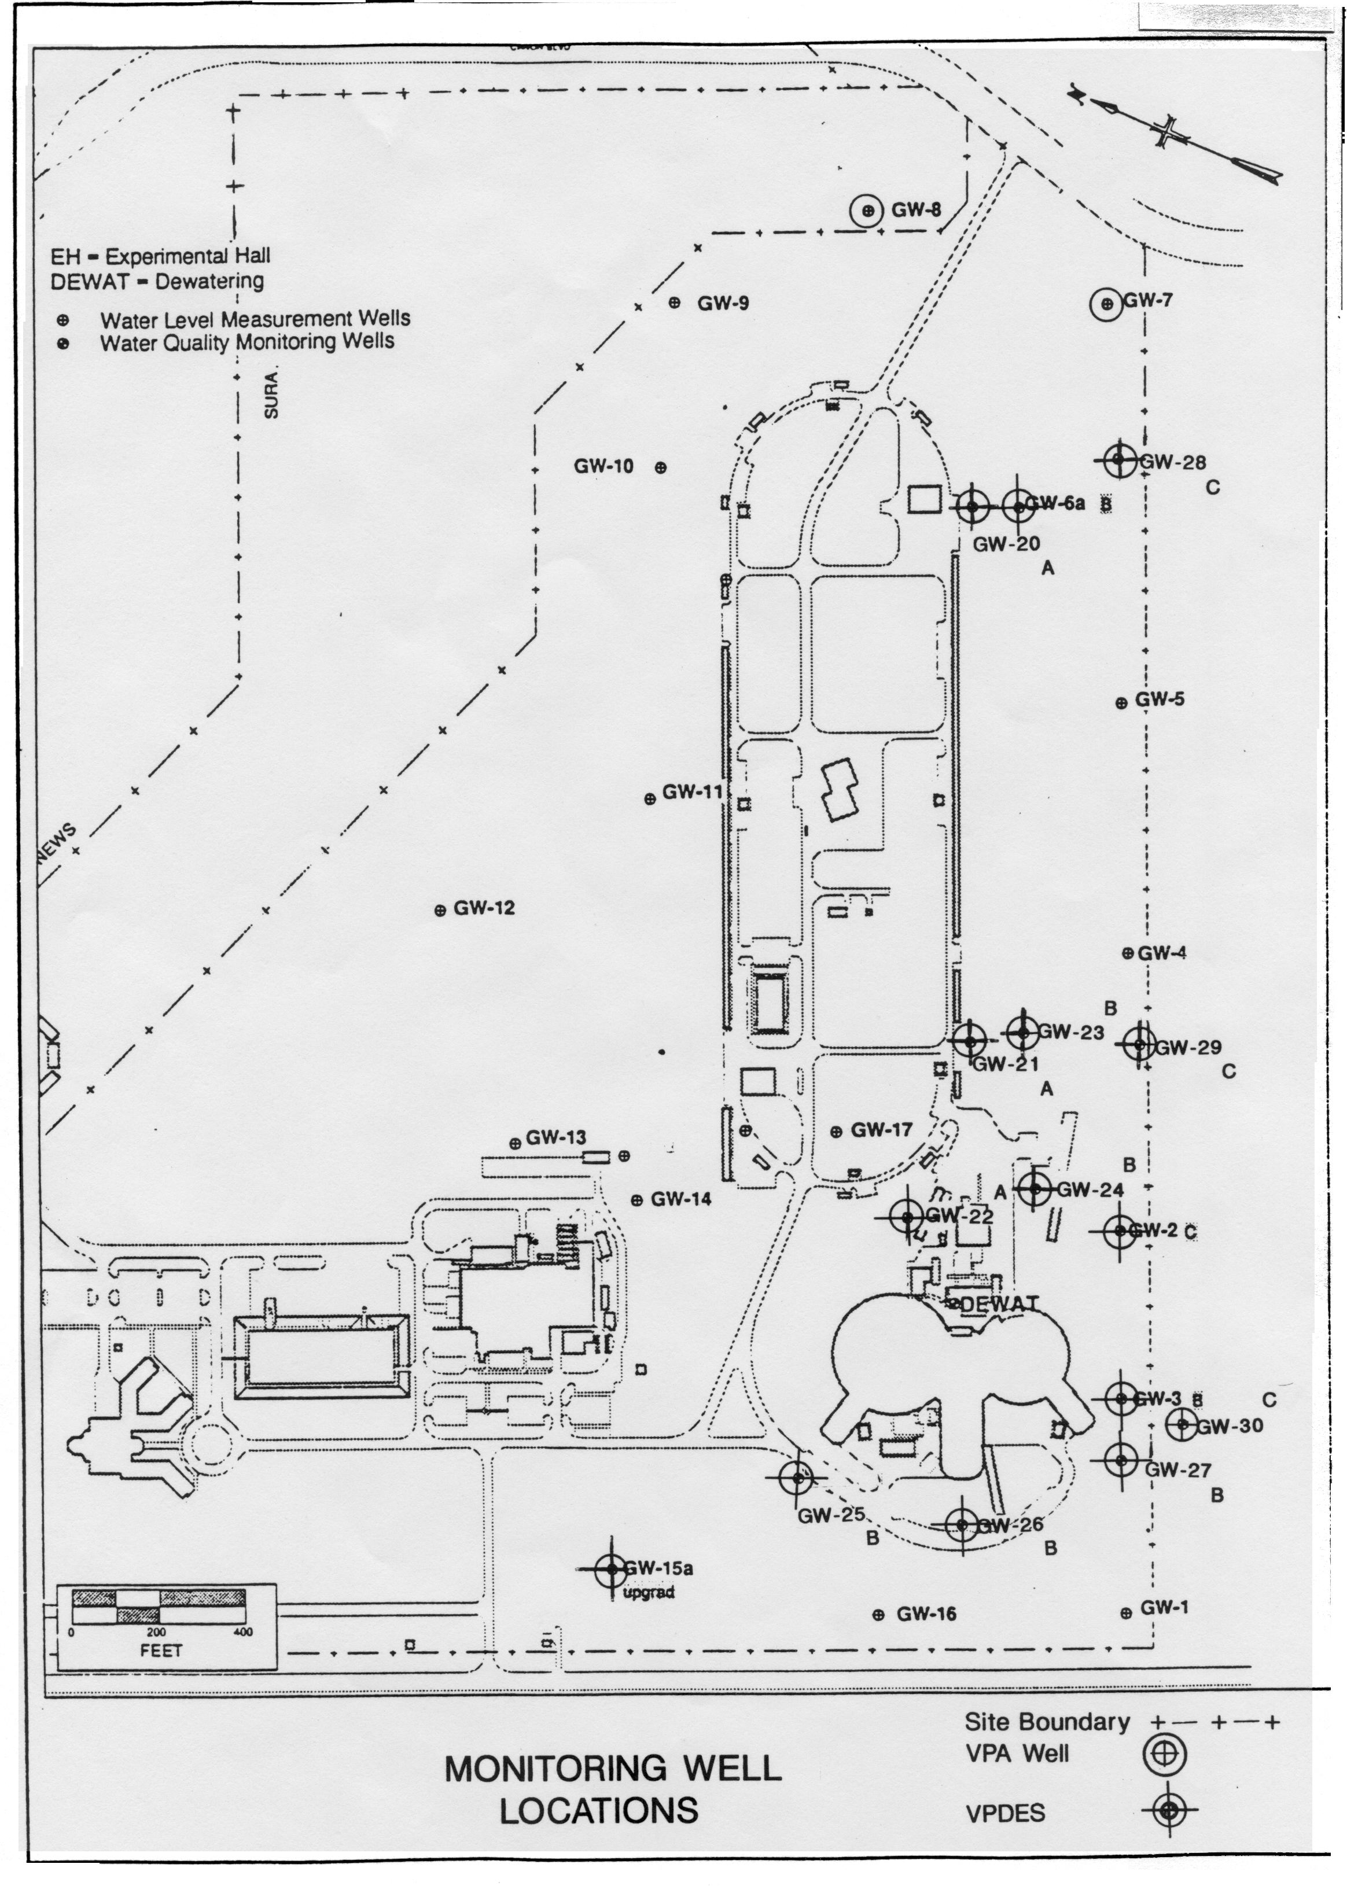

EXHIBIT 3-5
MAXIMUM GROUNDWATER MEASUREMENTS FOR RADIONUCLIDES*
JANUARY 2004 THROUGH DECEMBER 2004

Radionuclides at Associated Wells Relevant to Accelerator Operations (in pCi/l unless noted otherwise)
Analyte | A-Ring |  | B-Ring | A, B –  (Permit Level) |  | C-Ring | C-Ring  (Permit Level)
Gross Beta | 28.84 |  | 9.89 | 50 |  | 7.28 | 153
Manmade Radioactivity | < 0.177 |  | < 0.169 | 1 mrem/yr |  | not applicable | −
Tritium | ND at< 609 |  | ND at < 609 | 5000 |  | ND at < 570 | 1000
Sodium-22 | ND at < 13.6 |  | ND at < 12.8 | − |  | ND at < 11.9 | 61
Beryllium-7 | ND at < 89.2 |  | ND at < 91.5 | − |  | ND at < 93.4 | 835
Manganese-54 | ND at < 11.7 |  | ND at < 10.9 | − |  | ND at < 11.4 | 51
Radionuclides At Other Permit Locations (in pCi/l)
Analyte |  | Upgradient Well |  |  | Discharge 001
Gross Beta |  | < 2.46 |  |  | 13.8
Tritium |  | ND at < 570 |  |  | ND at < 609
Sodium-22 |  | ND at < 6.18 |  |  | ND at < 9.4
Beryllium-7 |  | ND at < 51.7 |  |  | ND at < 81.6
Manganese-54 |  | ND at < 5.63 |  |  | ND at < 9.3
Notes: *Those radionuclides determined to be relevant to Jefferson Lab operations.
No accelerator-produced activity has been detected.
ND: Not detectable above permit-required sensitivity limits
Conversion: 1 pCi = 1 x 10⁻¹² Ci = 0.037 Bq

EXHIBIT 3-6
JEFFERSON LAB LIQUID EFFLUENT RELEASES OF RADIOACTIVE MATERIAL
FOR 2004
Radionuclide | Tritium  (Permit Level 5 Ci) (Bq)  H-3 | Other Gamma-Emitting Radionuclides  (Permit Level 1 Ci) (Bq)
Radionuclide | Tritium  (Permit Level 5 Ci) (Bq)  H-3 | Be-7 | Na-22 | Mn-54
Ci (Bq) in CY 2004 | 0.97 (3.6 E+10) | 1.10 x 10⁻³  (4.1 E+07) | 6.34 x 10⁻5  (2.3 E+06) | 1.1 x 10⁻⁵  (4.1 E+05)

Exhibit 3-7
Analytical Results for Discharges to HRSD in 2004
Monthly Values
Reporting Period |  | Tritium  Concentration (pCi/l) |  | Reporting Period |  | Tritium  Concentration (pCi/l)
Monthly Values
January |  | 32,000 |  | July |  | 40,000
February |  | 45,000 |  | August |  | 41,000
March |  | 34,000 |  | September |  | 19,000
April |  | 21,000 |  | October |  | 25,000
May |  | 27,000 |  | November |  | 22,000
June |  | 33,000 |  | December |  | 27,000
Quarterly Values
Reporting Period | Tritium Concentration (pCi/l) |  | Other Gamma-Emitting Radionuclides  Concentration (pCi/l)
 |  |  | Be-7 |  | Na-22 |  | Mn-54
First Quarter | 39,000 |  | 0.87 |  | None detected |  | None detected
Second Quarter | 30,000 |  | 13 |  | 0.65 |  | None detected
Third Quarter | 34,000 |  | 150 |  | 7.7 |  | 1.6
Fourth Quarter | 27,000 |  | 0.1 |  | 0.67 |  | 0.03
Notes: These effluent concentrations are well below the 0.1 µCi/ml (1,000,000 pCi/l) permit limit.
Radionuclides are analyzed at EPA sensitivity levels or better.
Conversion: 1pCi = 1 x 10⁻¹² Ci = 0.037 Bq

3.4 ASSESSMENTS OF POTENTIAL DOSE TO THE PUBLIC AND TO BIOTA

The six electronic radiation measurement devices noted in Section 3.1.1, installed along the accelerator site boundary, continued to be used to determine offsite dose to the public due to Jefferson Lab operations. These electronic detectors - radiation boundary monitors (RBMs) - measure and log radiological information. In addition, passive integrating detectors are used for a number of measurements. All measured dose values were within statutory and administrative limits. For 2004, the highest site boundary direct (prompt) radiation level was about 3.7% of the DOE annual dose limit of 100 mrem (3.7 mSv), or 37% of the site administrative dose limit of 10 mrem (0.1 mSv).

Exhibit 3.8 displays the radiation doses in mrem for 2004 at RBM-3. RBM-3 is the detector that sees the largest dose from a combination of accelerator and experimental hall operations. A comparison with natural background radiation is made, which indicates the relatively low levels of Jefferson Lab’s contribution to the public dose. These background levels do not include contributions to dose from naturally occurring radon, which typically doubles natural radiation dose to the public.

Jefferson Lab does not release any residual radioactive material, such as concrete or soil, so there are no resulting dose impacts to the public. The absorbed dose to any local aquatic animals, or terrestrial plants or animals, from Jefferson Lab operations will not exceed the internationally recommended dose limits for terrestrial biota. As there are no potential releases of a magnitude that could result in doses exceeding 0.1 rad/day to terrestrial animals, the lowest limit for any biota, no dose limits will be exceeded.
Jefferson Lab did not contribute significantly to the radiation dose received by the public through either airborne or waterborne pathways. The direct radiation exposure was again measurable in 2004, but was found to be about 37% of the Jefferson Lab design goal of one-tenth of the DOE limit.

Exhibit 3-8
Radiation Boundary Monitor RBM-3 Results for 2004
Period | Neutron  (mrem) | Gamma  (mrem) | Total  (mrem)
Jan-Mar | 0.40 ±0.25 | 010 ± 0.25 | 0.50 ± 030
Apr-June | 0.35 ±0.25 | 0.09 ± 0.25 | 0.44 ± 0.30
July-Sept | 0.17 ± 0.25 | 0.04 + 0.25 | 0.21 + 0.30
Oct-Dec | 2.08 ± 0.40 | 0.52 ± 0.25 | 2.60 ± 0.50
TOTAL | 3.00 ± 0.60 | 0.75 ± 0.60 | 3.75 ± 0.75
Natural Background | ~1.8 | ~110 | ~112
Notes:
Statistical errors are quoted at 1 sigma.
Systematic errors including calibration (not included) are approximately 20% for neutrons.
Gamma dose equivalent rates are estimated based on best known statistical correlation techniques.
RBM-3 received the highest dose.
Conversion: 1 mrem = 0.01 mSv

3.5 QUALITY ASSURANCE

Regular quality assurance (QA) efforts are being made to ensure that Jefferson Lab’s environmental monitoring program is performed in accordance with the principles of the Jefferson Lab QA Program Manual.

QA in Sampling Procedures
The Jefferson Lab QA Program includes qualification of the laboratories that provide analytical services, verification of certification to perform analytical work, and review of performance test results. Also included in this review is the adequacy of their internal quality control (QC) practices, recordkeeping, chain of custody, and the relevant portions of the QA program itself.

RadCon and other program management are involved in the qualification process for environmentally sensitive services, including offsite analytical laboratories, and are responsible for auditing their own QA practices and implementing relevant QA procedures. The Jefferson Lab SA/QA function performs independent assessments of all functional areas, including those for EP activities. The DOE oversight organizations, in their independent overview capacity, also perform periodic audits and surveillance of Jefferson Lab. No QA concerns were noted for CY 2004 regarding sampling protocols or results.

Universal Laboratories, Inc. (Universal Labs) collected most VPDES and HRSD permit-related water samples. BWX Technologies, Inc. (BWX), their subcontractor, performed all radiological analyses on identified samples. Several field audits were performed and showed Universal Labs’ collection procedures were satisfactory.

Other sample collection that involves radiochemicals, including some required by the HRSD permit, is performed by RadCon and analyzed in the RadCon radiological analysis lab (Building 52).

QA in Analysis
Samples are analyzed for radiological (and non-radiological) attributes using standard EPA-approved analytical procedures. A continuing program of analytical laboratory QC, participation in interlaboratory crosschecks, analysis of various blanks, and replicate sampling and analysis verifies data quality. RadCon, Accelerator Division EH&S staff, and other responsible staff review all analytical data for samples analyzed under their subcontracts. The analytical results are reviewed relative to the accompanying QA/QC results and compared with regulatory limits for acceptability. These reviews include inspection of chain-of-custodies, sample stewardship, sample handling and transport, and sampling protocols. When applicable to the analysis requested, analytical labs must be appropriately certified. Inspection visits are made to both Universal Labs and BWX on a biennial basis. These visits confirm that analytical practices being performed are satisfactory.

Ongoing precision and accuracy are monitored by analysis of the following with each batch of samples: laboratory standards, duplicate determinations, matrix spikes, and matrix spike duplicates. These data are used to calculate the relative standard deviation on all applicable parameters. The quality of the data is then evaluated and compared to regulatory limits to determine acceptability. In addition, a range of radiochemical spikes is used to test the vendor’s ability to achieve the required sensitivity for each parameter, and their reliability in detecting accelerator-produced radionuclides at or below the concentration guide standards. This enables compliance with permit requirements that QA is performed.

Independent QA under the DOE
The Environmental Measurements Laboratory (EML) Quality Assessment Program (QAP) is an external, independent performance evaluation program designed to test the quality of environmental radiological measurements and provides DOE with complex-wide comparability of environmental radiological analysis. Under this program, four matrices of various radionuclides are distributed semi-annually to DOE-subcontracted laboratories for analysis, with the labs required to analyze only the parameters for which they analyze under contract.

In 2004, BWX and Jefferson Lab’s RadCon lab participated in the EML’s QAP, performed semi-annually, for radionuclides. BWX participated in a QA program for analysis of samples under the Environmental Resource Associates (ERA).

Performance results for all Universal Labs, BWX and Jefferson Lab programs were satisfactory in 2004.

SECTION 4
DISTRIBUTION LIST

INTERNAL

Dr. Christoph W. Leemann, Director
Dr. Allison F. Lung, Assistant Director
Ms. Sally J. Fisk, Chief of Staff, Director’s Office
Dr. Lawrence Cardman, Associate Director, Physics Division
Dr. Swapan Chattopadhyay, Associate Director, Accelerator Division
Mr. Craig R. Ferguson, Associate Director, Environment, Health and Safety Division
Ms. Kelly S. Mannsfeld, Associate Director, Administration Division
Dr. Dennis M. Skopik, Deputy Associate Director, Division EH&S and QA Officer, Physics Division
Dr. H. Frederick Dylla, Chief Technology Officer, FEL Program Manager
Dr. Anthony W. Thomas, Chief Scientist and Theory Group Leader
Ms. Mary C. Erwin, Chief Financial Officer
Dr. R. Roy Whitney, Chief Information Officer
Dr. Andrew M. Hutton, Accelerator Division Deputy, Director of Operations, Accelerator Division
Mr. Mark J. Waite, Deputy Associate Director, Administration Division
Dr. James J. Murphy, Director, Performance Assurance
Mr. Claus H. Rode, Director, Office of Project Management
Rhonda M. Scales, Esq., Legal Counsel
Ms. Linda L. Even, Environmental Engineer, EH&S Reporting Officer
Mr. Carter B. Ficklen, EH&S Reporting Manager, Director’s Office and EH&S Division EH&S Officer
Mr. John J. Kelly, Administration Division EH&S Officer
Mr. Robert T. May, Accelerator Division EH&S Officer

EXTERNAL

The Honorable Mark R. Warner, Governor
The Honorable George F. Allen
The Honorable James S. Burgett, Chairperson, York County Board of Supervisors
The Honorable Jo Ann S. Davis
The Honorable Thelma D. Drake
The Honorable J. Randy Forbes
The Honorable Phillip A. Hamilton
The Honorable Terry G. Kilgore
The Honorable Mamie E. Locke
The Honorable G. Glenn Oder
The Honorable Robert C. Scott
The Honorable John W. Warner
The Honorable Martin E. Williams
The Honorable Joe S. Frank, Mayor, City of Newport News
The Honorable Ross A. Kearney, II, Mayor, City of Hampton
Mr. John W. Anderson, Department Head for ES&H Infrastructure Support,
Princeton Plasma Physics Laboratory
Dr. Sayed Rokni, Acting Associate Director, ES&H, Stanford Linear Accelerator Center
Mr. Delma R. Carpenter, President/Publisher, The Virginian-Pilot
Dr. Jerry P. Draayer, President, Southeastern Universities Research Association, Inc.
Mr. Leslie P. Foldesi, Director, Radiological Health Program, Virginia Department of Health
Mr. Leonard Huesties, Pacific Northwest National Laboratory
Mr. Ronald E. Johnson, Chief, Industrial Waste Division, Hampton Roads Sanitation District
Ms. Rhondra J. Matthews, President and CEO, Daily Press, Inc.
Mr. William Griffing, Section Head, ES&H Section, Fermi National Accelerator Laboratory
Mr. Robert T. Moore, Industrial Waste Manager, Hampton Roads Sanitation District
Mr. James A. Turi, DOE Site Manager, Jefferson Lab
Ms. Patricia Sumner, DOE ES&H Manager, Jefferson Lab
Mr. Scott J. Mallette, DOE Deputy Manager, Jefferson Lab
Mr. W. Tayloe Murphy, Jr., Office of the Secretary of Natural Resources (for Virginia)
Mr. Steven J. Neilson, DOE Industrial/Occupational Safety Specialist
Ms. Deanna D. Austin, Virginia Department of Environmental Quality
Mr. Mark H. Sauer, Virginia Department of Environmental Quality

ACRONYMS and ABBREVIATIONS

These acronyms and abbreviations reflect the typical manner in which terms are used for this specific document and may not apply to all situations.

ALARA | As Low As Reasonably Achievable
AP | Affirmative Procurement
ARC | Applied Research Center
BMP | Best Management Practice
Bq | Becquerel
BWX | BWX Technologies
CAA | Clean Air Act
CAAA | Clean Air Act Amendments
CASA | Center for Advanced Studies of Accelerators
CEBAF | Continuous Electron Beam Accelerator Facility
CERCLA | Comprehensive Environmental Response, Compensation, and Liability Act
CFC | Chlorofluorocarbon
Ci | Curie
CLAS | CEBAF Large Acceptance Spectrometer
CWA | Clean Water Act
CX | Categorical Exclusion
CY | Calendar Year
DEQ | (Virginia) Department of Environmental Quality
DOD | U.S. Department of Defense
DOE | U.S. Department of Energy
E2 | Energy Efficiency
EA | Environmental Assessment
EHS | Extremely Hazardous Substance
EH&S | Environment, Health, and Safety
EIS | Environmental Impact Statement
EML | Environmental Measurements Laboratory
E M S | Environmental Management System
EO | Executive Order of the President of the United States
EP | Environmental Protection
EPA | Environmental Protection Agency
EPCRA | Emergency Planning and Community Right-to-Know Act
EPGs | Emergency Planning and Response Groups
ERA | Environmental Resource Associates
FDS | Floor Drain Sump
FEL | Free-Electron Laser
FIFRA | Federal Insecticide, Fungicide, and Rodenticide Act
FONSI | Finding of No Significant Impact
FY | Fiscal Year
GeV | Billion (Giga-) electron Volts
HRSD | Hampton Roads Sanitation District
IR | Infrared
ISM | Integrated Safety Management
kW | Kilowatt
LEED | Leadership in Energy and Environmental Design
LLW | Low Level Radioactive Waste
LSA | Line Self-Assessment
μSv | MicroSievert
M³ | Cubic Meters
mrem | Millirem
MS4 | Municipal Separate Storm Sewer Systems
MSDS | Material Safety Data Sheet
mSv | MilliSievert
NAAQS | National Ambient Air Quality Standards
NASA | National Aeronautics and Space Administration
N D | Not detectable
NEPA | National Environmental Policy Act
NESHAPs | National Emission Standards for Hazardous Air Pollutants
ODS | Ozone-Depleting Substance
P2 | Pollution Prevention
PBT | Persistent, Bioaccumulative, or Toxic
PCards | Purchase Cards
pCi/ l | Picocuries per liter
QA | Quality Assurance
QAP | Quality Assessment Program
QC | Quality Control
QCD | Quantum Chromodynamics
RadCon | Radiation Control Group
RBM | Radiation Boundary Monitor
RCRA | Resource Conservation and Recovery Act
R&D | Research and Development
SA/QA | Self-Assessment / Quality Assurance
SARA | Superfund Amendments and Reauthorization Act
SER | Site Environmental Report
SNS | Spallation Neutron Source
SPCC | Spill Prevention, Control, and Countermeasure
SRF | Superconducting Radiofrequency
SURA | Southeastern Universities Research Association, Inc.
Sv | Sievert
SWP3 | Storm Water Pollution Prevention Plan
TDS | Total Dissolved Solids
TJNAF or Jefferson Lab | Thomas Jefferson National Accelerator Facility
TSS | Total Suspended Solids
Universal Labs | Universal Laboratories, Inc.
UV | Ultraviolet
VPDES | Virginia Pollutant Discharge Elimination System
WMin/P2 | Waste Minimization/Pollution Prevention
WSS | Work Smart Standards

