Office of Project Assessment – Project Review Report
DOE/SC Annual Peer Review for the
Technology and Engineering Development Facility (TEDF)

REVIEW DATE: October 23, 2012
LOCATION OF PROJECT: TJNAF
PROGRAM MANAGER: Chris Ackerman
FEDERAL PROJECT DIRECTOR: Rick Korynta
ACQUISITION EXECUTIVE: Marc Jones
CURRENT CRITICAL DECISION: CD-4a
COMMITTEE: 5 committee members / 3 observers

PROJECT STATUS as of 9/30/2012
Project Type | Line Item
CD-1 | Planned: 4Q08 | Actual: 09/08
CD-2 | Planned: 1Q10 | Actual: 11/09
CD-3A (Sitework/Early Procurement) | Baseline: 2Q10 | Actual: 03/10
CD-3B (General Construction) | Baseline: 4Q10 | Actual: 08/10
CD-4A (New Construction) | Baseline: 2Q12 | Actual: 03/12
CD-4B (TL Renovation) | Baseline: 2Q14 | Forecast: 10/13
TPC Percent Complete | Planned: 87.8% | Actual: 88.8%
TPC Cost to Date | $63,435M
TPC Committed to Date | $70.943M
TPC | $73.1M
TEC | $72.1M
Contingency Cost (w/Mgmt Reserve) | $1.996M | 25.9% to go
Contingency Schedule on CD-4b | 7 months | 58% to go
CPI Cumulative | 1.00
SPI Cumulative | 1.01
Cumulative CPI/SPI Chart as of 09/30/2012
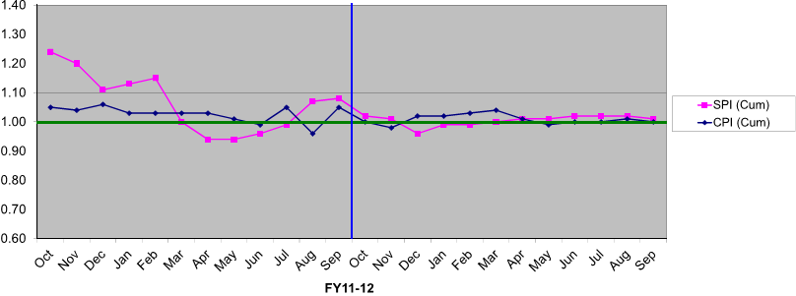
Cumulative Cumulative Cumulative
BCWS: $62,453 BCWP: $63,153 ACWP: $63,435
 | FY08 | FY09 | FY10 | FY11 | FY12 | Total
DOE | 300 | 4,400 | 27,687 | 28,419 | 12,337 | 73,143

