Report on Pair–Symmetric Background for the SANE Long Paper
L. Ndukum

Pair symmetric processes create a background to inclusive electron scattering. In SANE, Positron–electron pair constitutes the main source of background which comes from π0 decay. A π0 is created as the electron beam traverses the target and quickly decays into two photons which convert to positron–electron pair in the target. In creating electron–positron pairs, these processes provide additional electrons that can enter our detector setup (BETA) and are indistinguishable from an outgoing DIS electron.
To extract the physics asymmetries and meet the experimental goals, the background contributions to the measured asymmetry must be well understood.
Lepton pair production from bremsstrahlung photons are negligible for SANE. Also, π− and Kaon do not affect because they are removed by the BigCal as they deposit less energy than electron and are less ionizing.
The dominant decay of the π0 is to two photons π0 → γγ with a branching ratio of 98.8%. The remaining 1.2% follows the Dalitz decay mode, π0 → γ e+e−

Asymmetry Calculation
The π0 asymmetry is calculated by the reconstruction of π0 mass from energy deposited in BigCal from events with two clusters produced by neutral particles. The identification of π0 is done by placing a cut on π0 mass and using E > 0.6 GeV energy cut; at high energy π0 have low contribution, whereas below 0.5 GeV the neural network does not work

Where N + ( − ) is the number of counts with i_helicity positive (negative), C + ( − ) is the incoming charge accumulated during that event with positive (negative) helicity.
The Physics Asymmetry is gotten by considering the target and beam polarizations, Pt and Pb respectively

Results
The plot below shows the total average asymmetries of the neutral pions – the red indicates the average raw asymmetry while the blue indicates the average physics asymmetry. The green indicates the product of the beam and target polarization (PbPt), which were averagely 73% and 70% for the beam and target polarization respectively. In the above plot the product, PbPt has been multiplied by some factor so as to fit in the same plot.
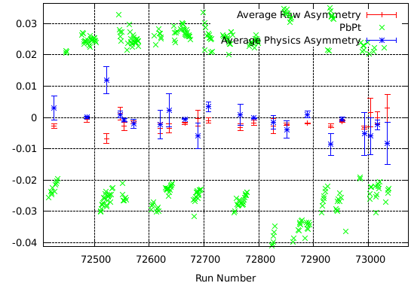
Para 5.9 GeV, 800
Para 4.7 GeV, 800
Para 4.7 GeV, 1800
Para 5.9 GeV, 800
Fig. 1: Average Raw and Physics Asymmetries with beam and target polarization, PbPt

Total Asymmetry

-0.0019 +/- 0.0001

-0.0005 +/- 0.0001

Energy & orientation | Raw Asymmetry | Physics Asymmetry
5.9 GeV, 800 | -0.0019 +/- 0.0002 | -0.0004 +/- 0.0001
4.7 GeV, 800 | -0.0019 +/- 0.0001 | 0.0001 +/- 0.0009
5.9 GeV, 1800 | -0.0022 +/- 0.0005 | -0.0009 +/- 0.0007
4.7 GeV, 1800 | -0.0014 +/- 0.0004 | -0.0024 +/- 0.0013

From this we can conclude that the total asymmetry of the neutral pion is consistent with zero and the π0 contribution is more of a background dilution rather than an asymmetry

Systematic Error in Background Correction
Even though the neutral pion data show that the asymmetry is zero with errors, the errors of this result will propagate to the systematic uncertainties of the background corrected asymmetries of about 10%.
References
- SLAC E80, M. J. Alguard et al., Phys. Rev. Lett. 37, 1261 (1976); 41 70 (1978)
- Update to TJNAF E-03-109, Spin Asymmetries of the Nucleon Experiment (2006)
- Vipuli Dharmawardane, SANE Report on Pair Symmetric Background (2005)
- SLAC E154, David E. Reyna, Measurement of the Spin Structure Function for the Neutron (2003)

