Hall D Wire Characterization
Samples F5-1 & F5-2

- Sample preparation: ultrasonic cleaning in DI water for 45 minutes.
- Sample installation: for SEM inspection wires were installed on a sample holder (diameter=36 mm) on 2 stripes of conductive carbon tape, 2 fragment of each sample per stripe (nomenclature: F5-1a, F5-1b and F5-2a, F5-2b).

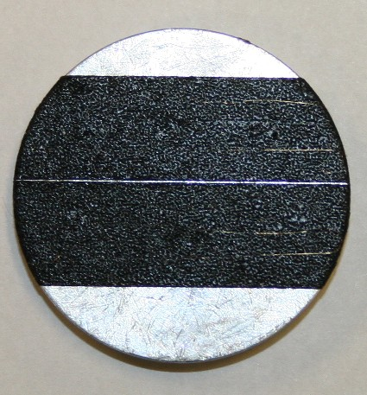

Pic1. Typical sample installation.
- Wire inspection:
- Each wire fragment was examined along its length (beginning at approximately 5mm from the sample holder edge and ending ~5mm before the opposite edge) at magnification of ~x600, at fast scan rate.
- Images at designated magnifications (x300, x500, x800, x1000) were taken randomly along the sample length;
- Images for the ovality measurements were taken at 1000x magnification in three points of each wire fragment: in the middle (approximately) and close to both ends;
- Measurements of wire diameter, as visible on the images, were done using the Quartz PCI Image Management System, 3 measurements per image;
- Additional images at various magnifications were taken at the points of interest (variations in sample topography, contaminated areas, etc.)
- EDS analysis was performed on the most typical points of interest.

Sample F5-1 A, B
I. Images at designated magnifications

F5-1A-1 | F5-1B-1
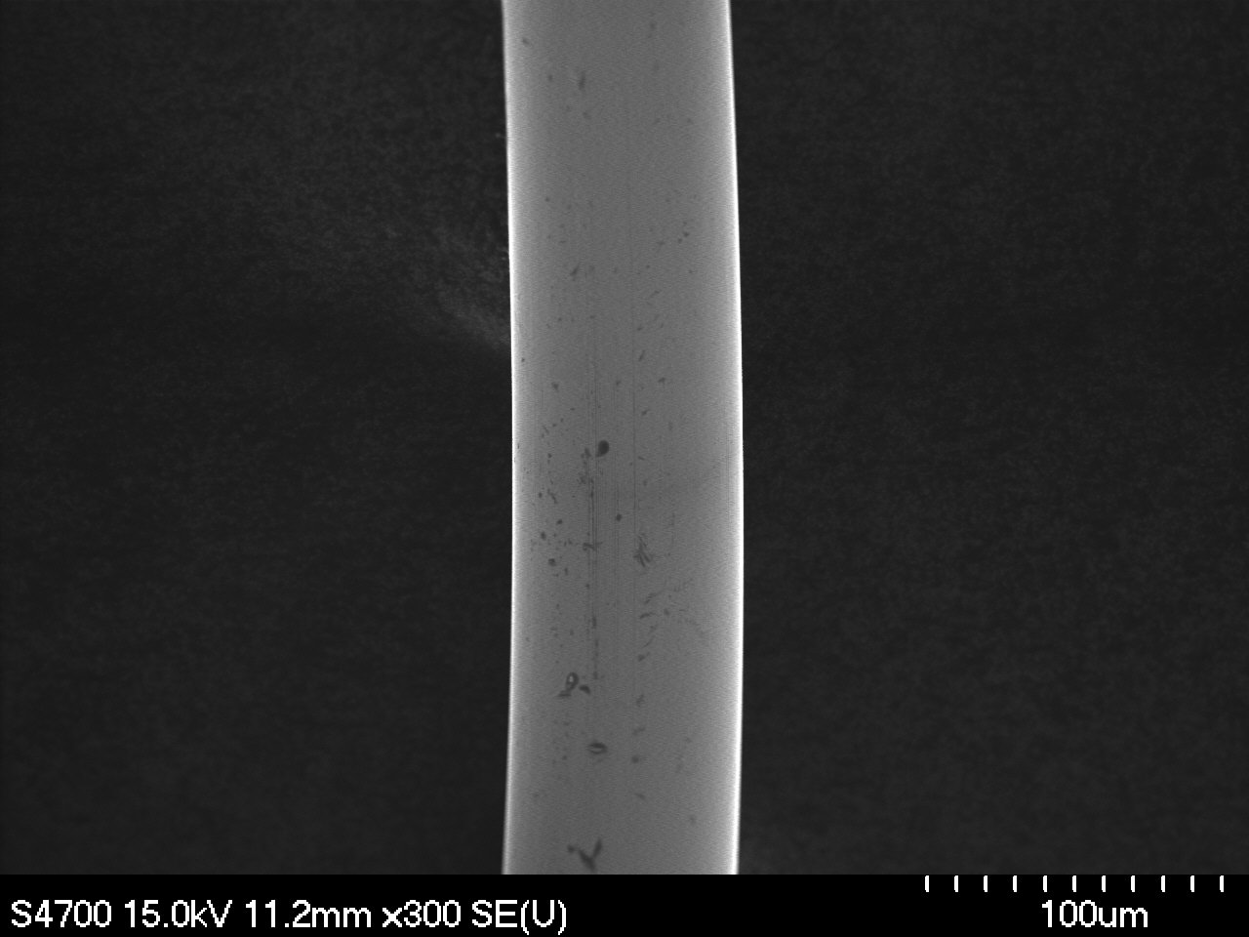 | 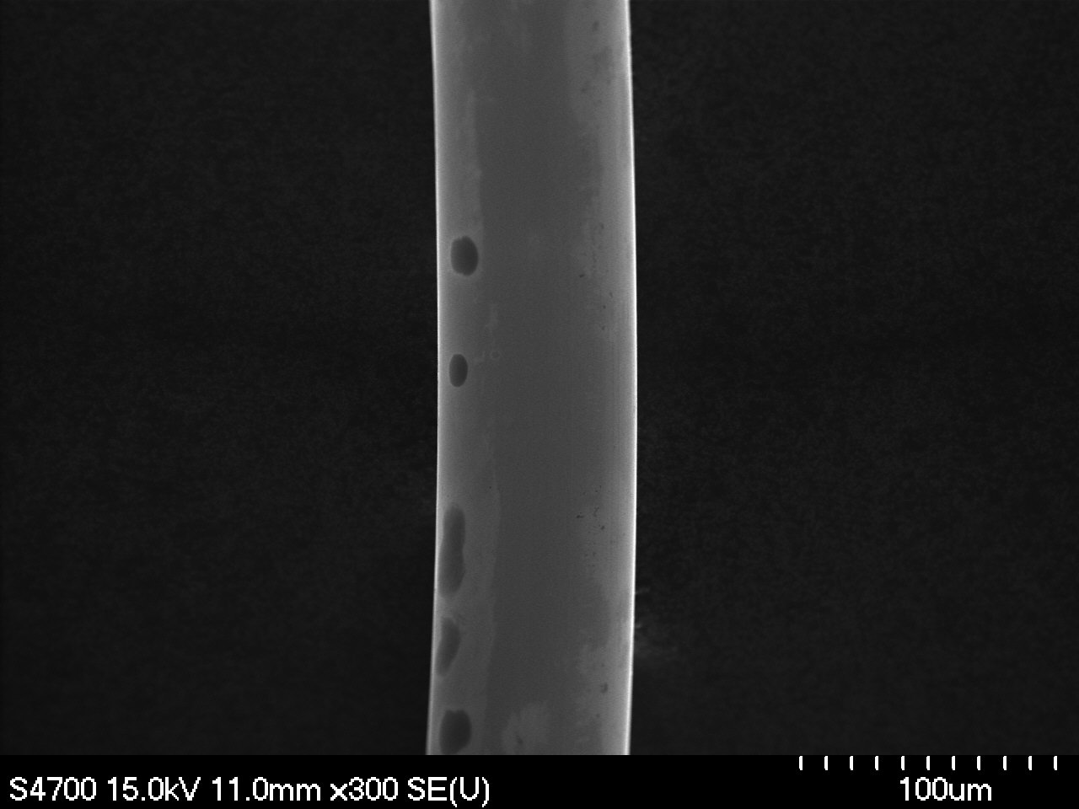
Magnification: 300x | Magnification: 300x
F5-1A-2 | F5-1B-2
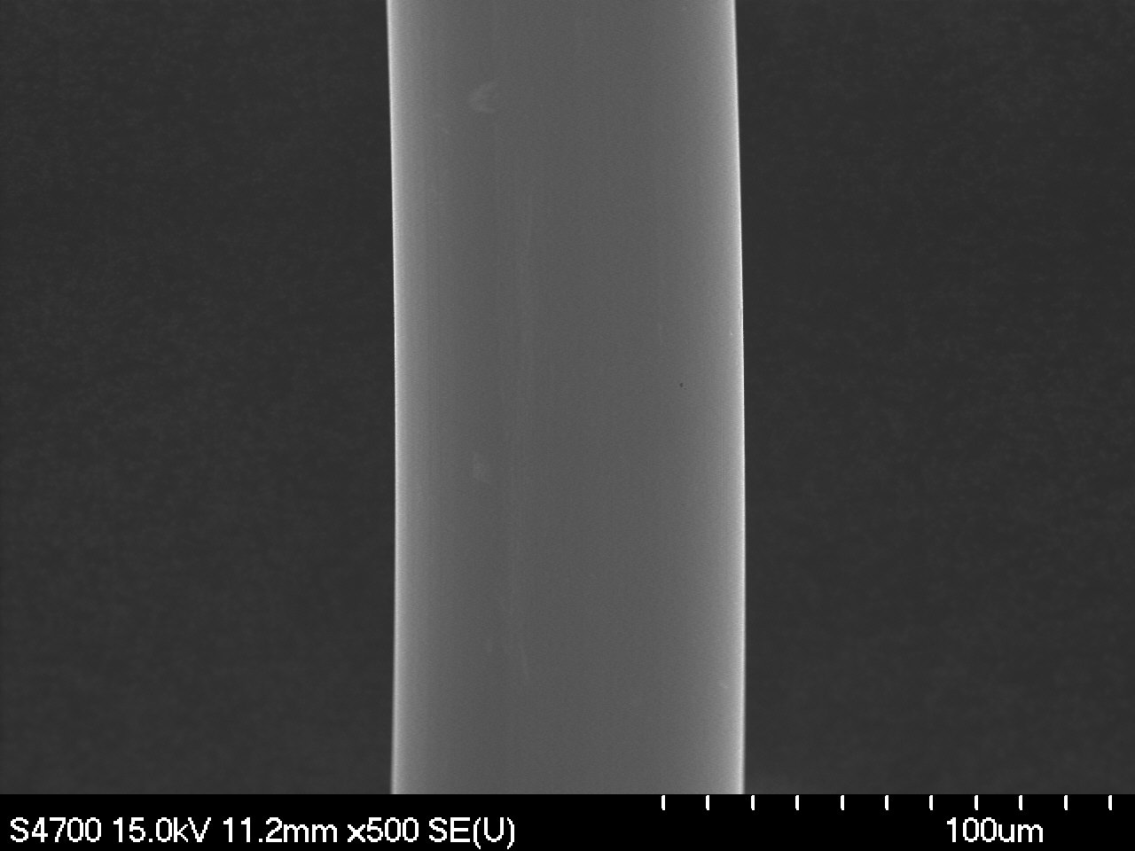 | 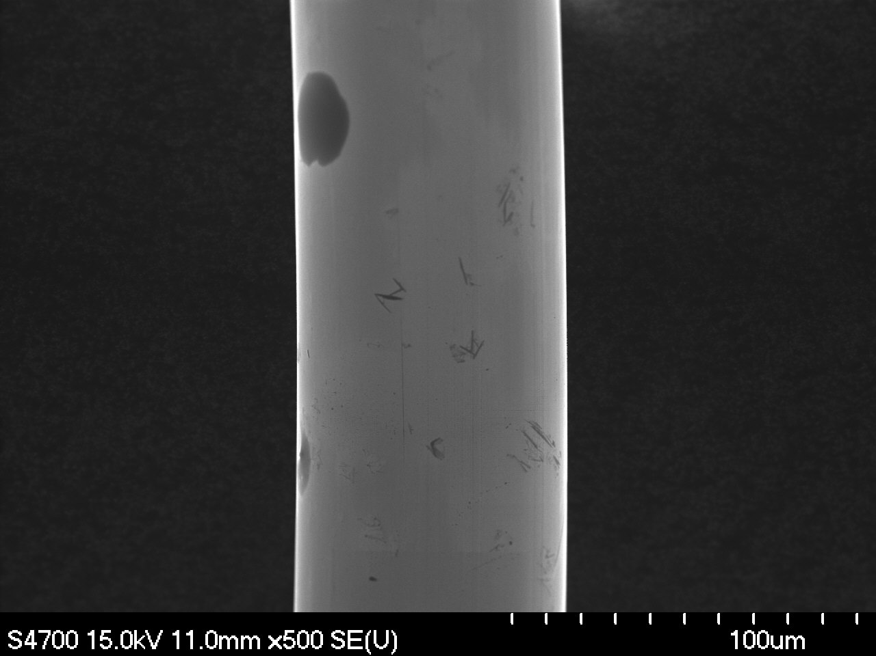
Magnification: 500x | Magnification: 500x

F5-1A-3 | F5-1B-3
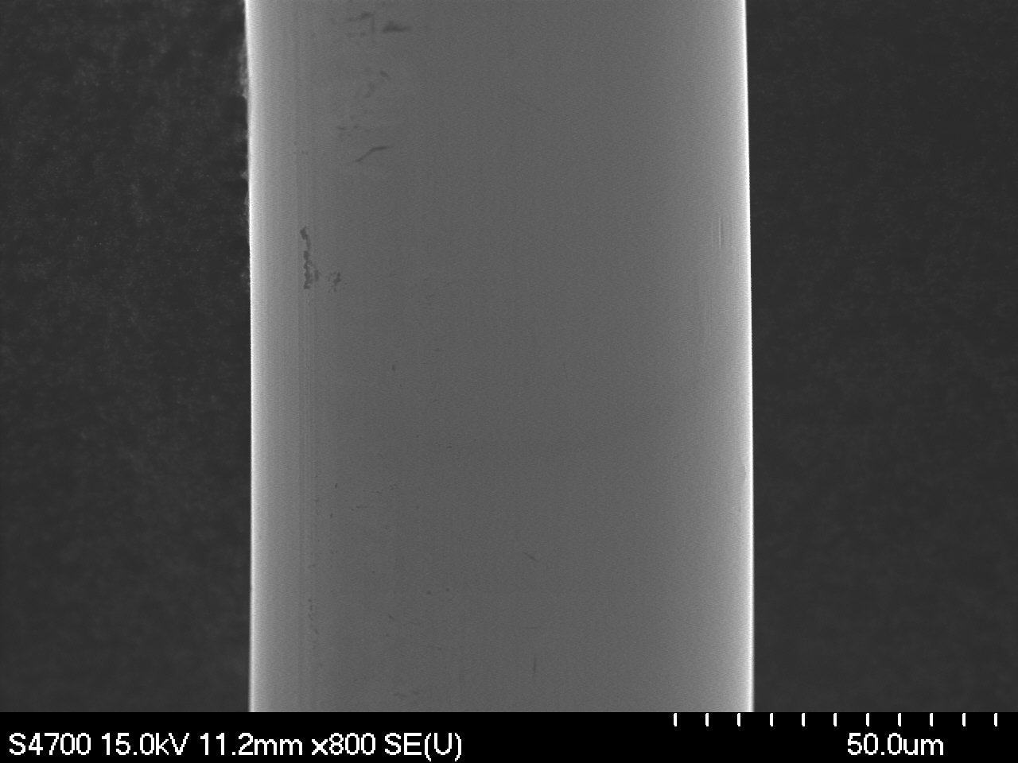 | 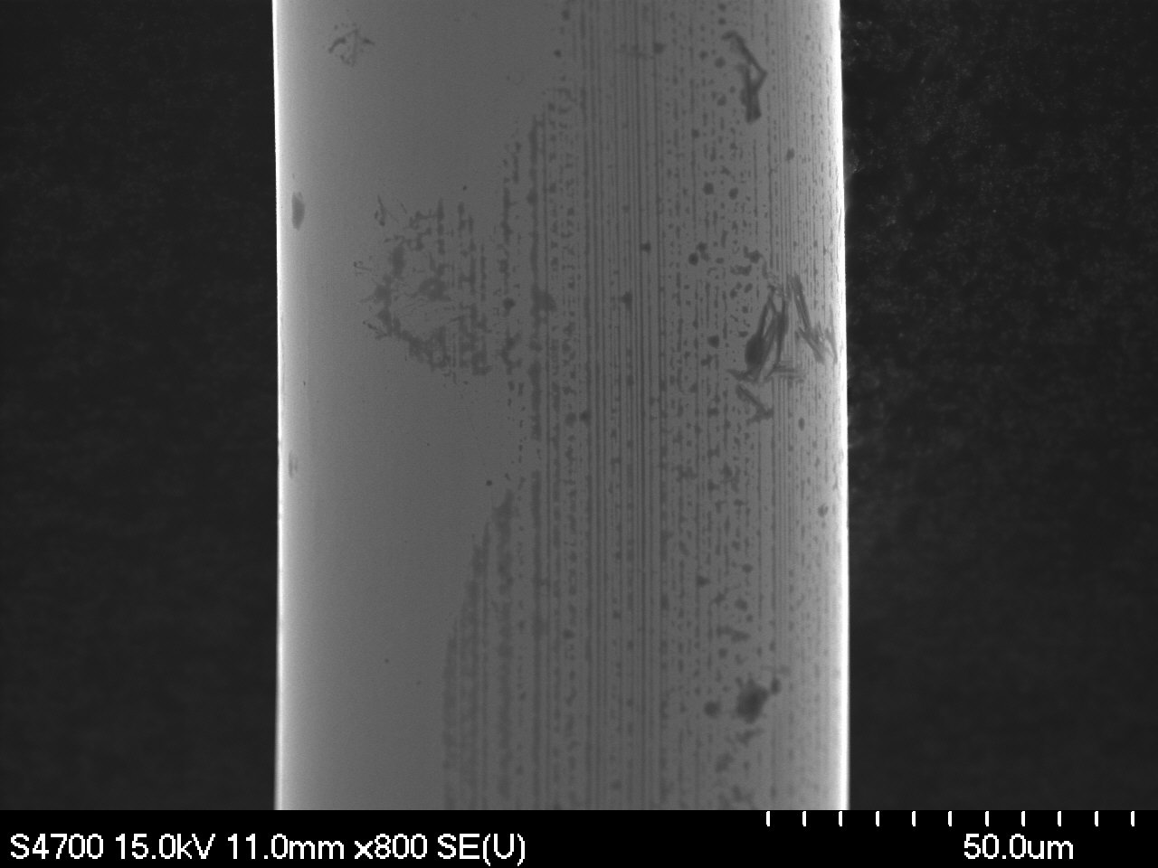
Magnification: 800x | Magnification: 800x
F5-1A-4 | F5-1B-4
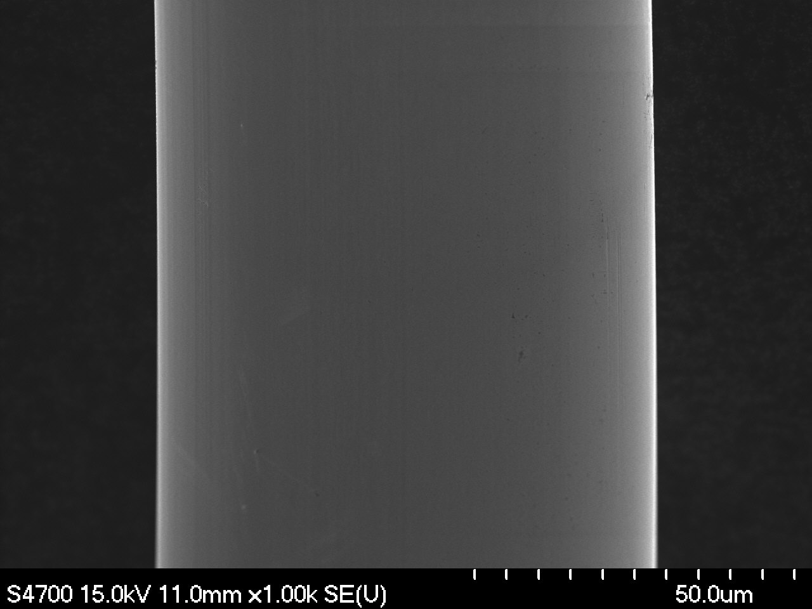 | 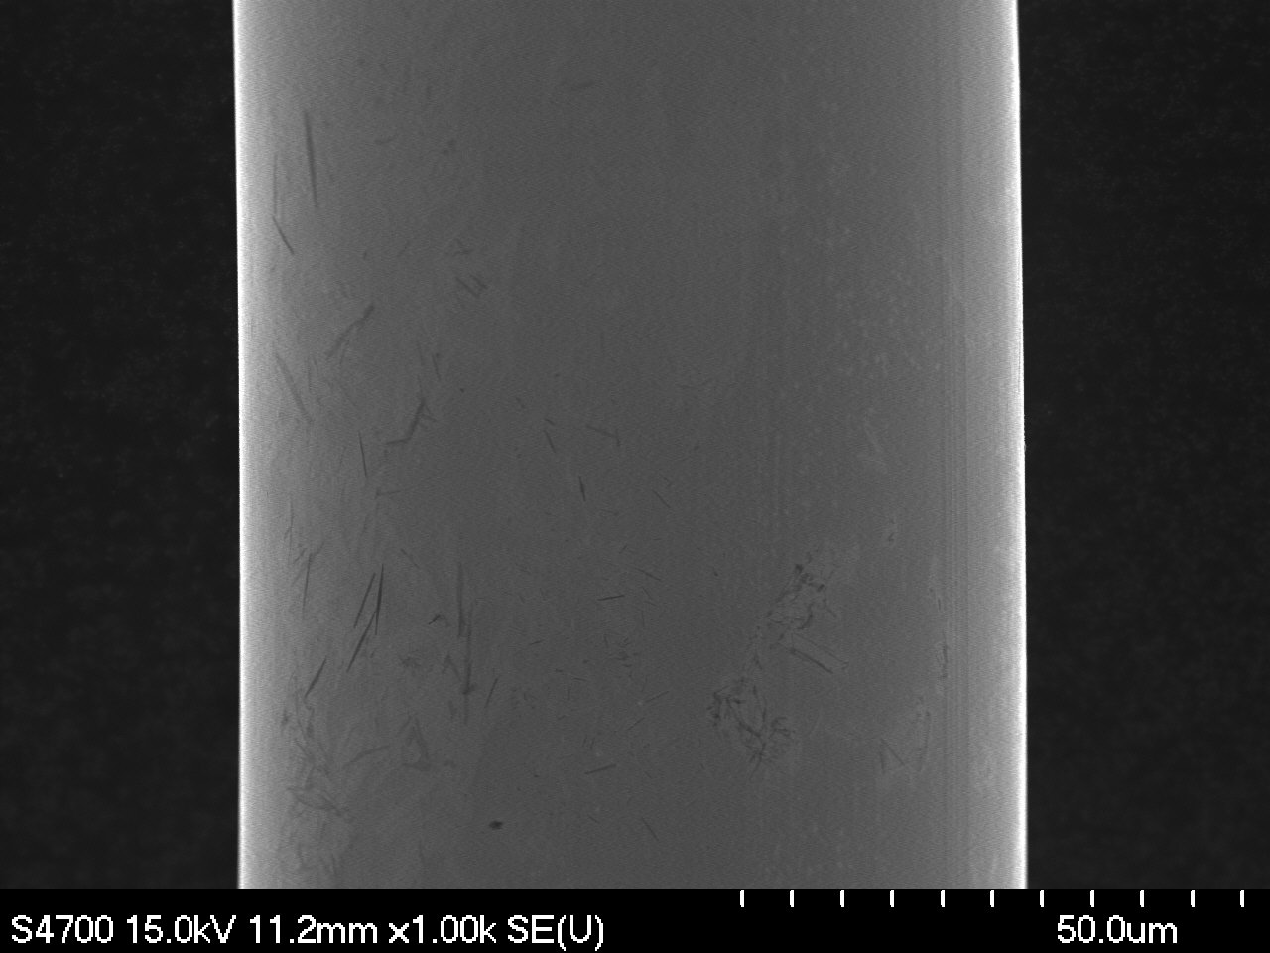
Magnification: 1000x | Magnification: 1000x

II. Ovality Measurements

F5-1A-1o | F5-1B-1o
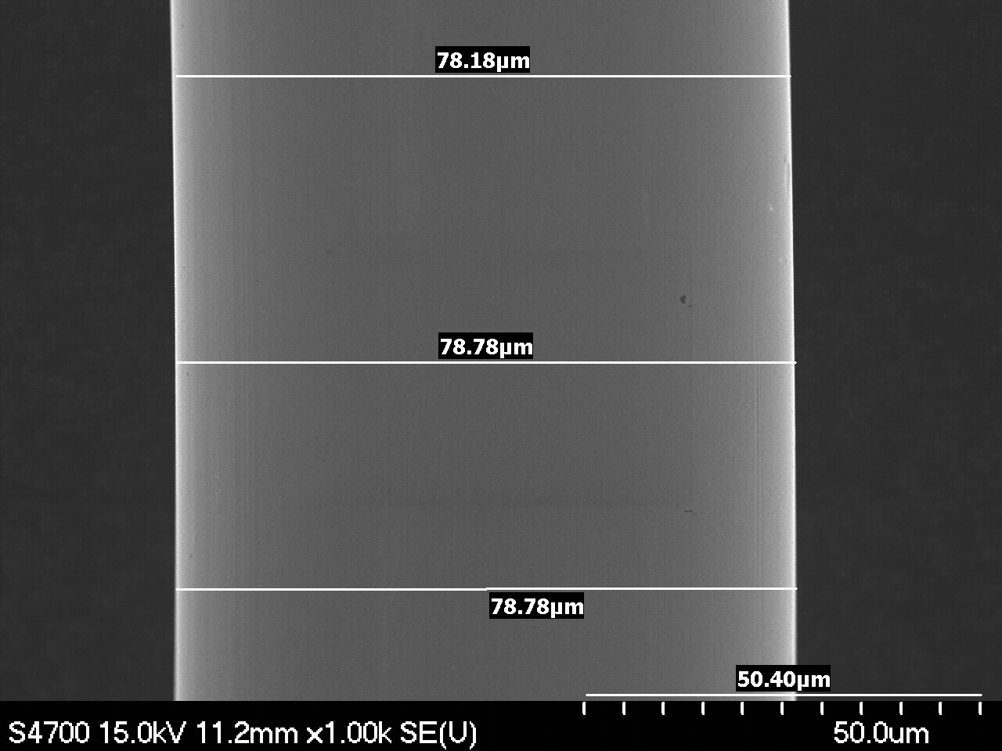 | 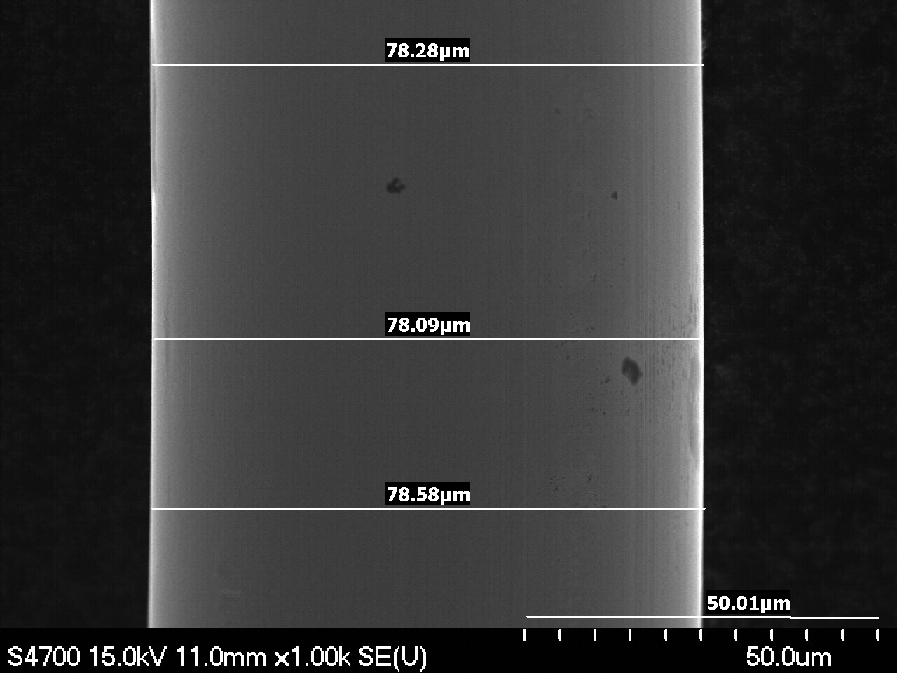
Magnification: 1000x | Magnification: 1000x
F5-1A-2o | F5-1B-2o
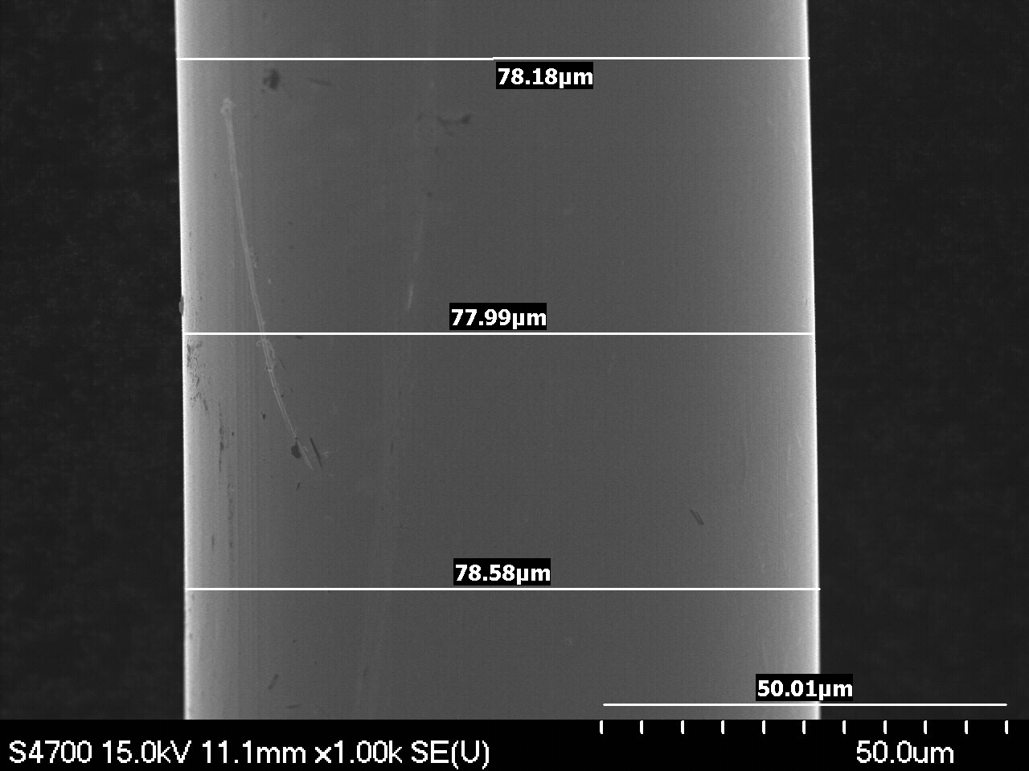 | 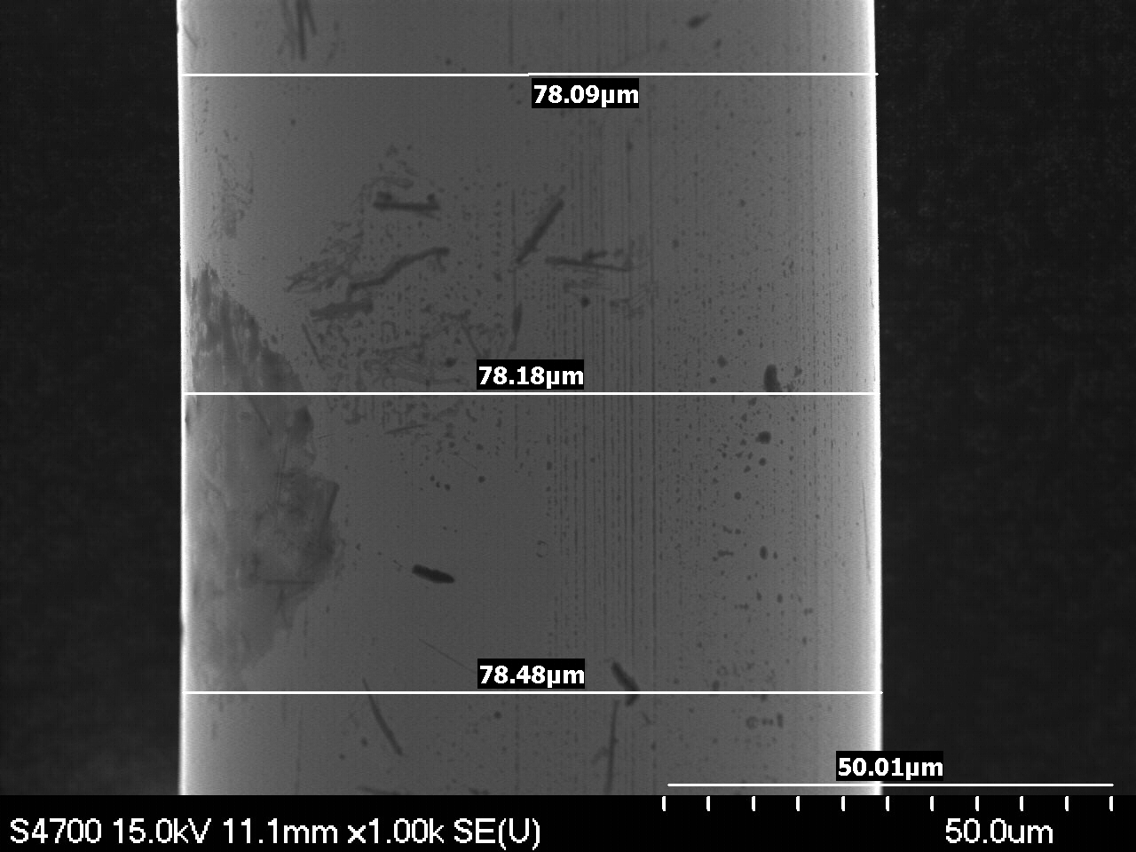
Magnification: 1000x | Magnification: 1000x
F5-1A-3o | F5-1B-3o
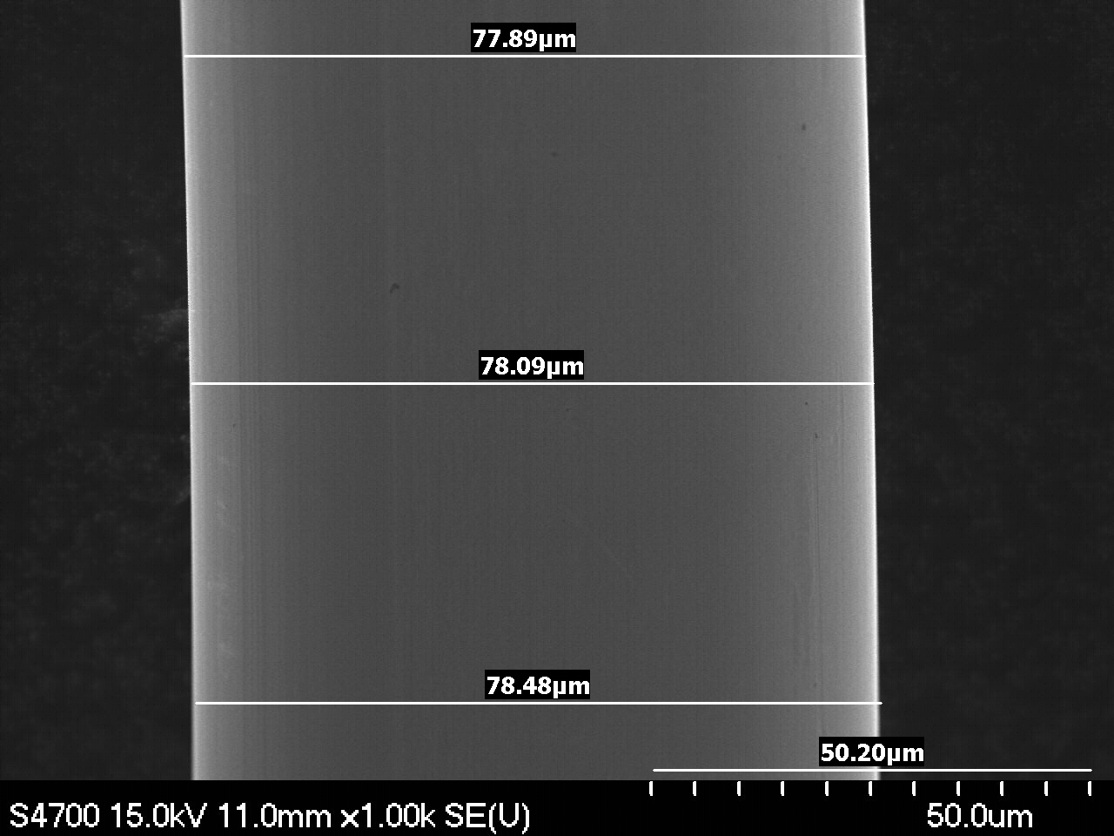 | 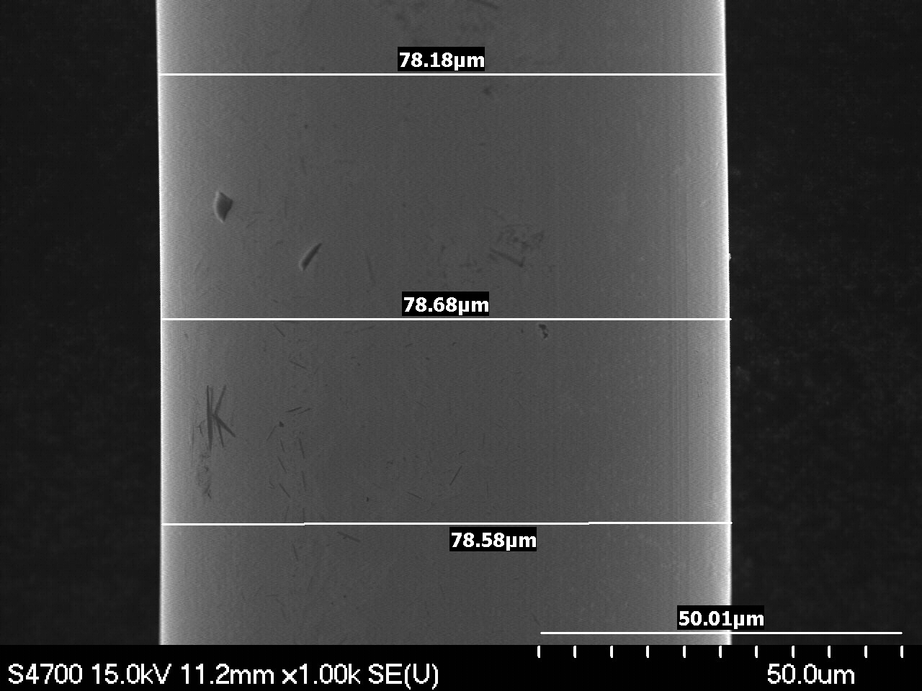
Magnification: 1000x | Magnification: 1000x

III. Points of Interest

F5-1A-2 | F5-1A-2
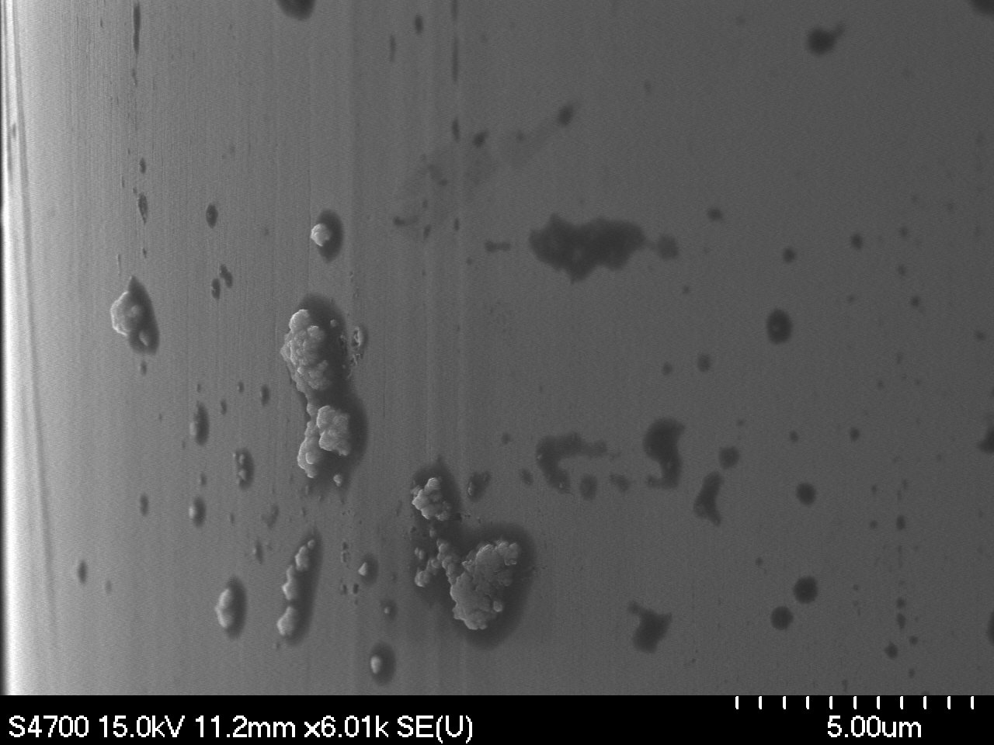 | 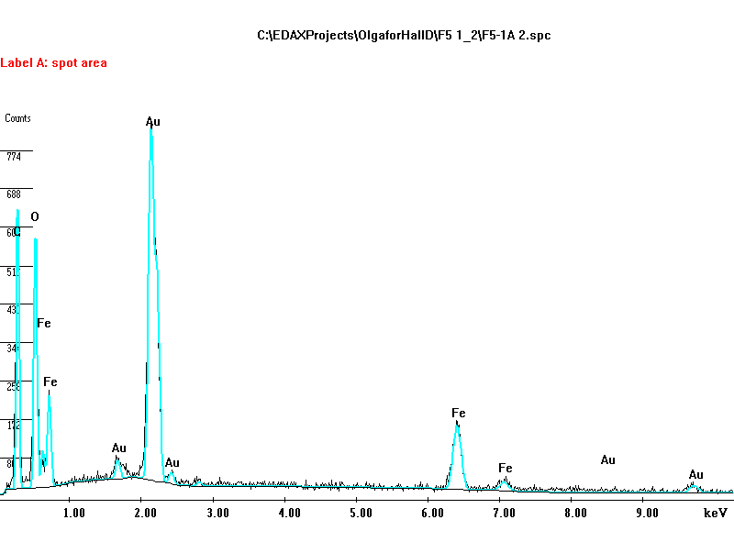
Magnification: 6000x | EDS Analysis. Surface contamination (Iron oxide?)
F5-1A-4 | F5-1A-4
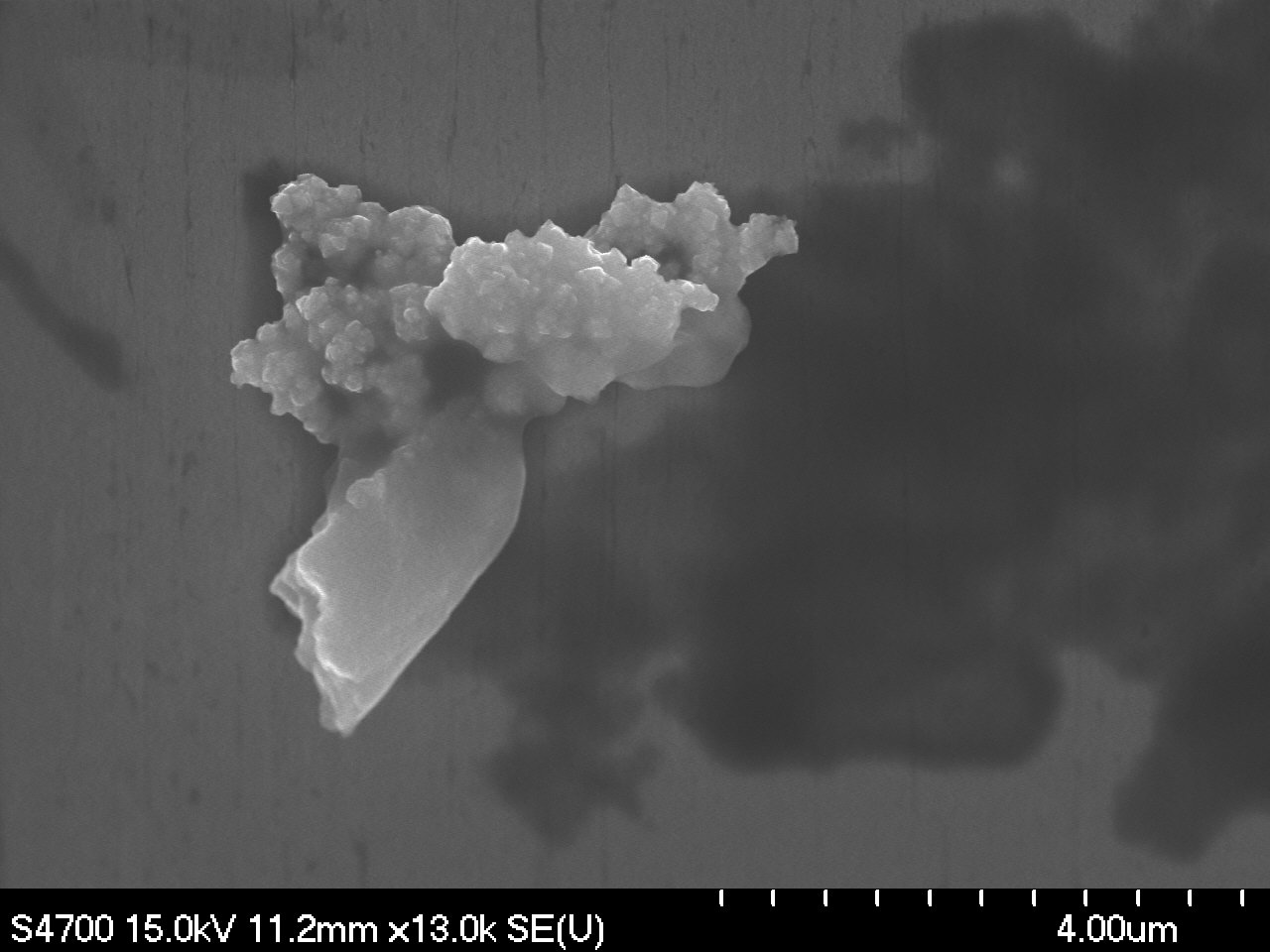 | 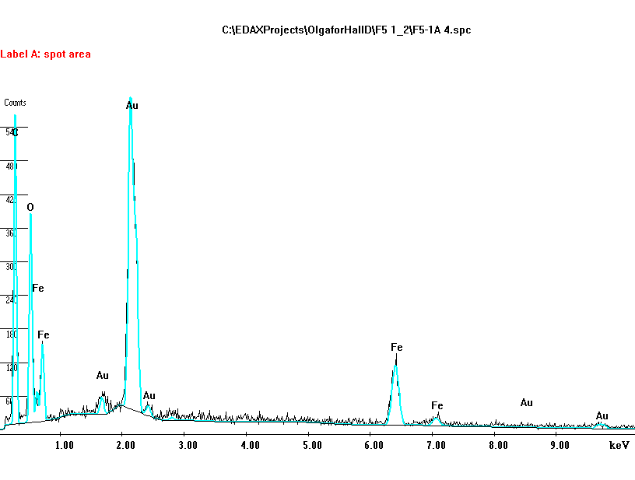
Magnification: 13000x | EDS Analysis. Surface contamination (Iron oxide?)
F5-1A-7 | F5-1A-7
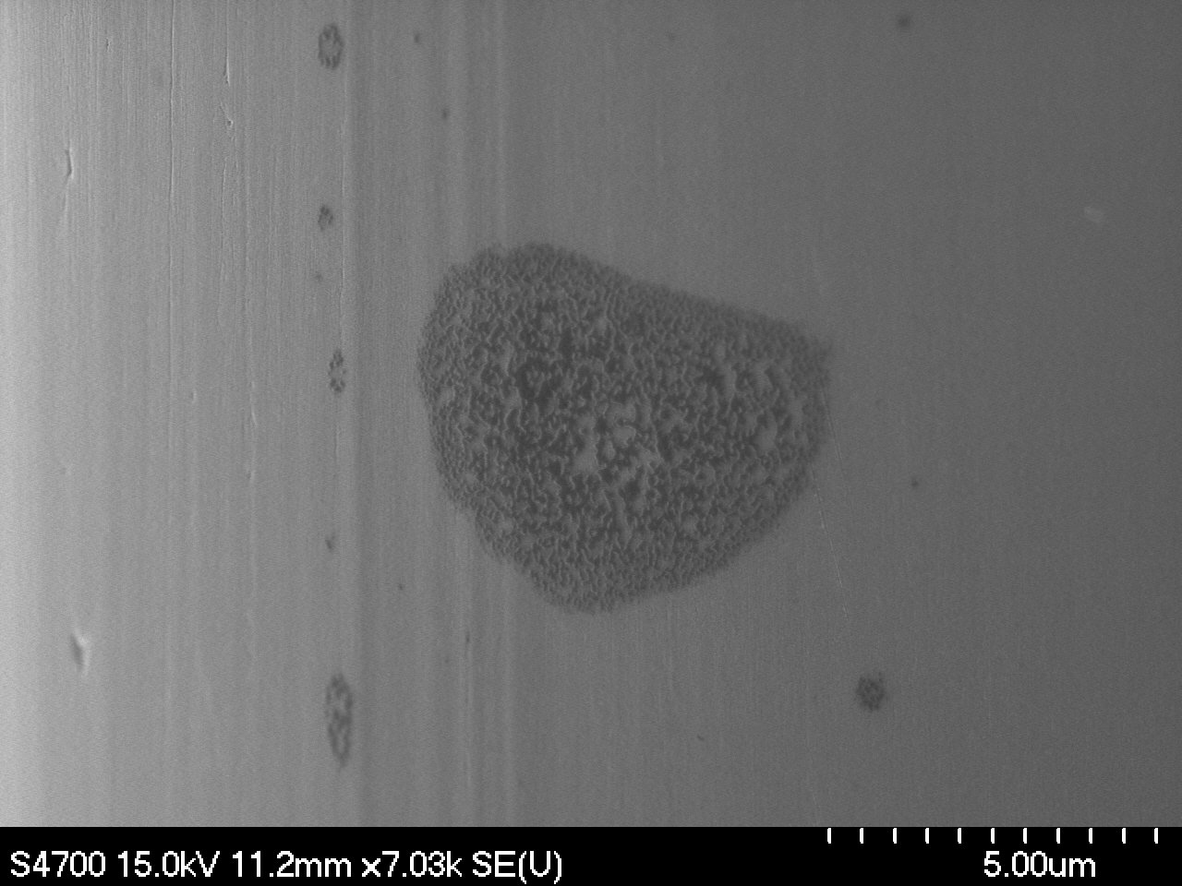 | 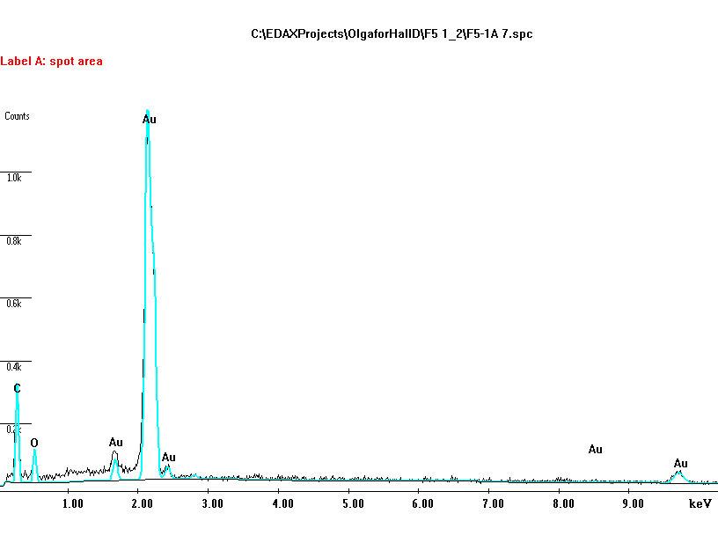
Magnification: 7000x | EDS Analysis. Environmental surface contamination

F5-1B-3 Environmental contamination | F5-1B-7 Environmental contamination
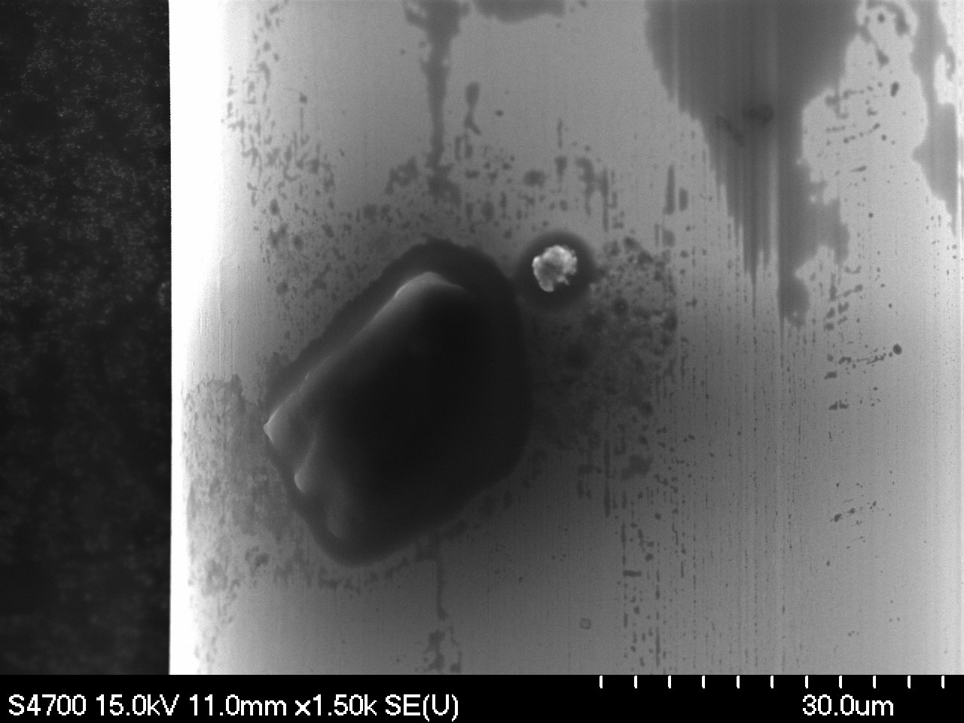 | 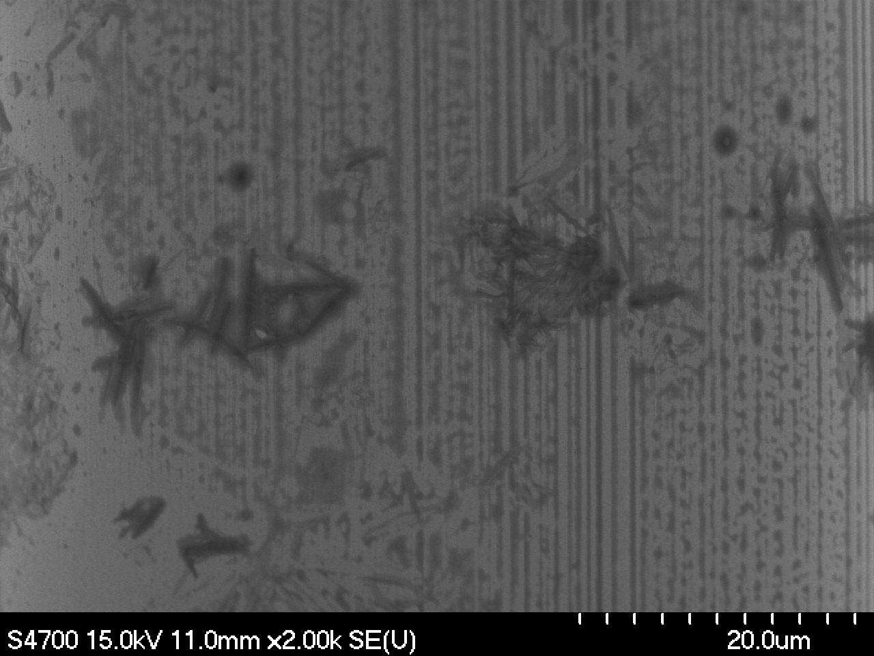
Magnification: 1500x | Magnification: 2000x
F5-1B-5 | F5-1B-5
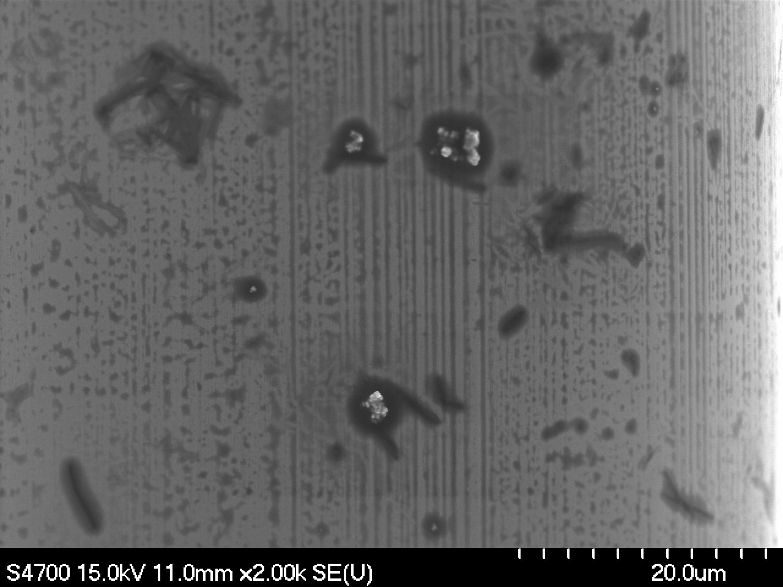 | 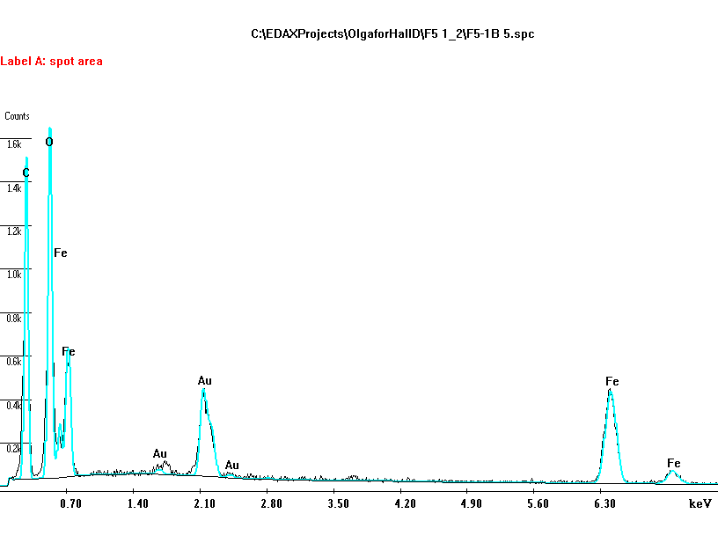
Magnification: 2000x | EDS Analysis. Surface contamination (Iron oxide?)
F5-1B-9 Surface damage. | F5-1B-10 Surface damage (magnified).
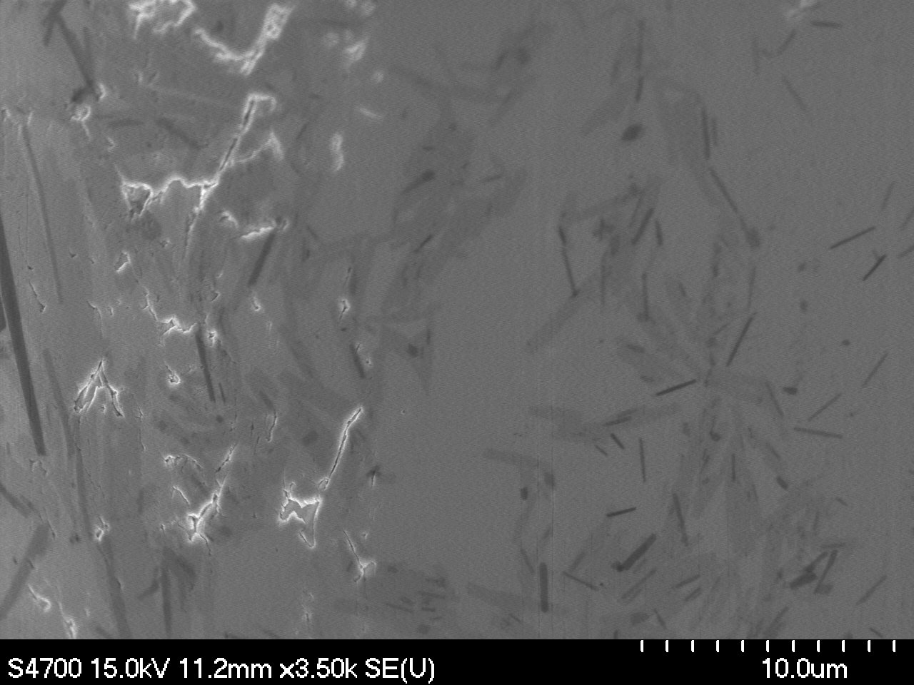 | 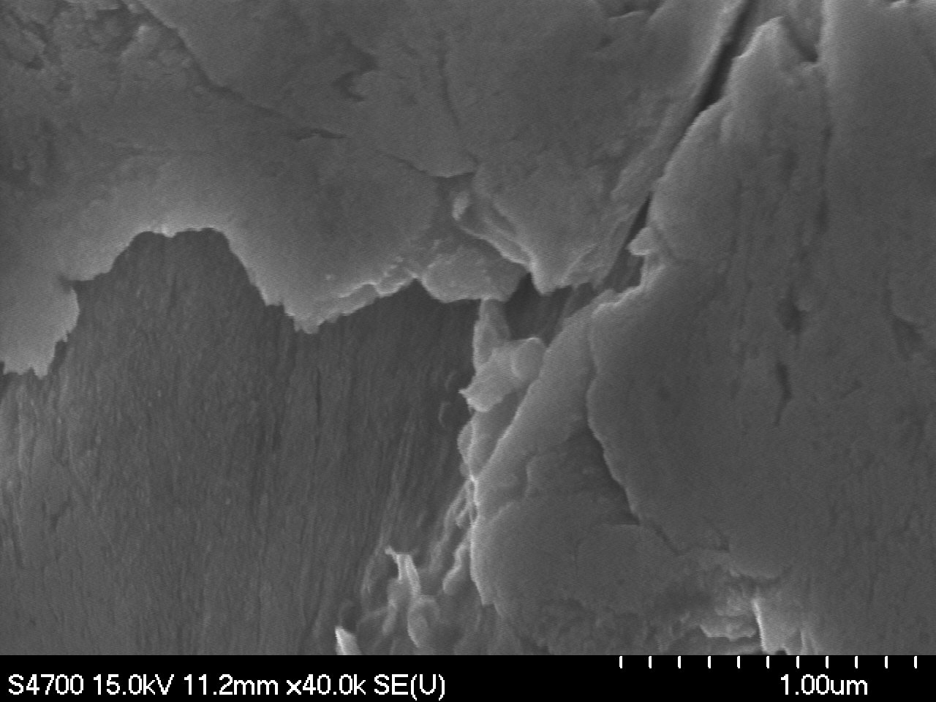
Magnification: 3500x | Magnification: 4000x

EDS analysis of damaged area.
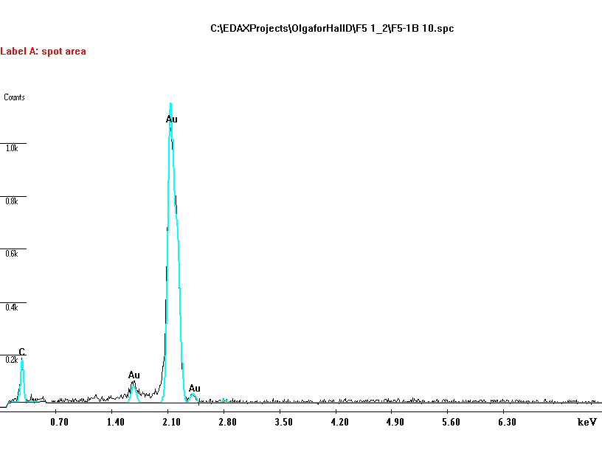

Note:
- No traces of Cu within the damaged area were indicated by the EDS analysis (detection limit ~1%).
- Environmental contamination as shown at pic F5-1B-7, could possibly be of bacterial origin.

Sample F5-2 A, B
Images at designated magnifications

F5-2A-1 | F5-2B-1
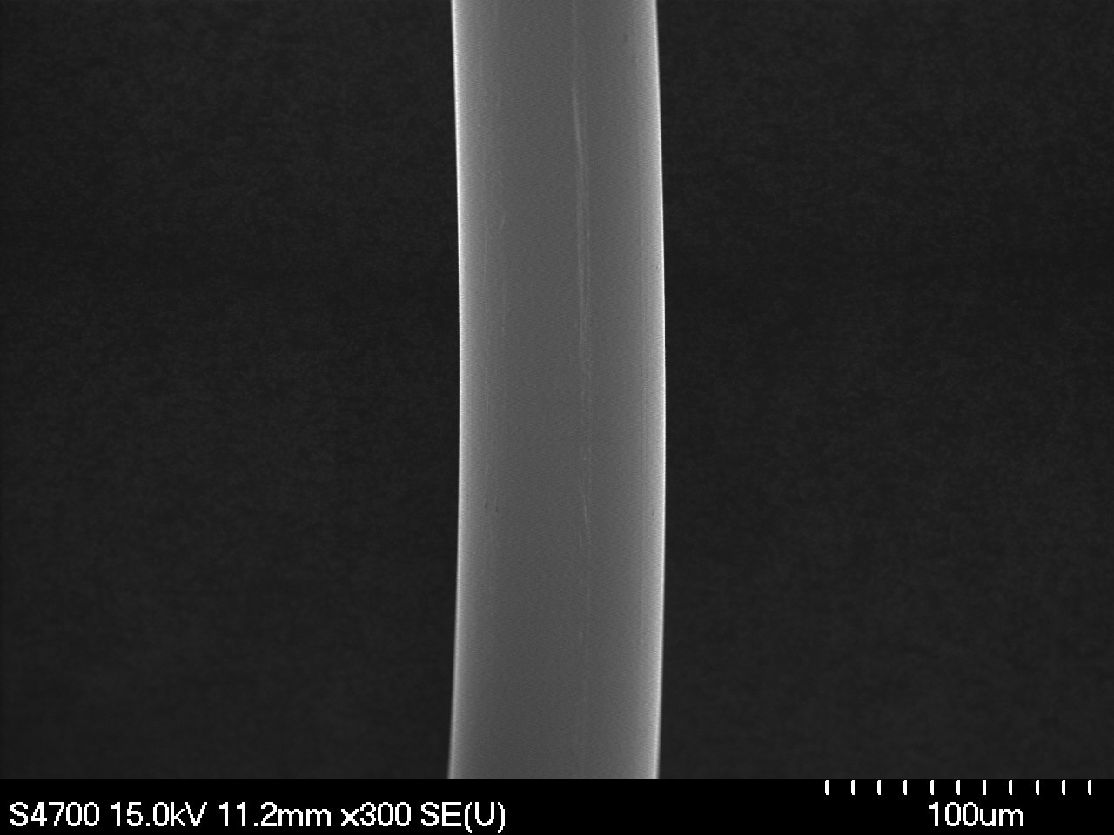 | 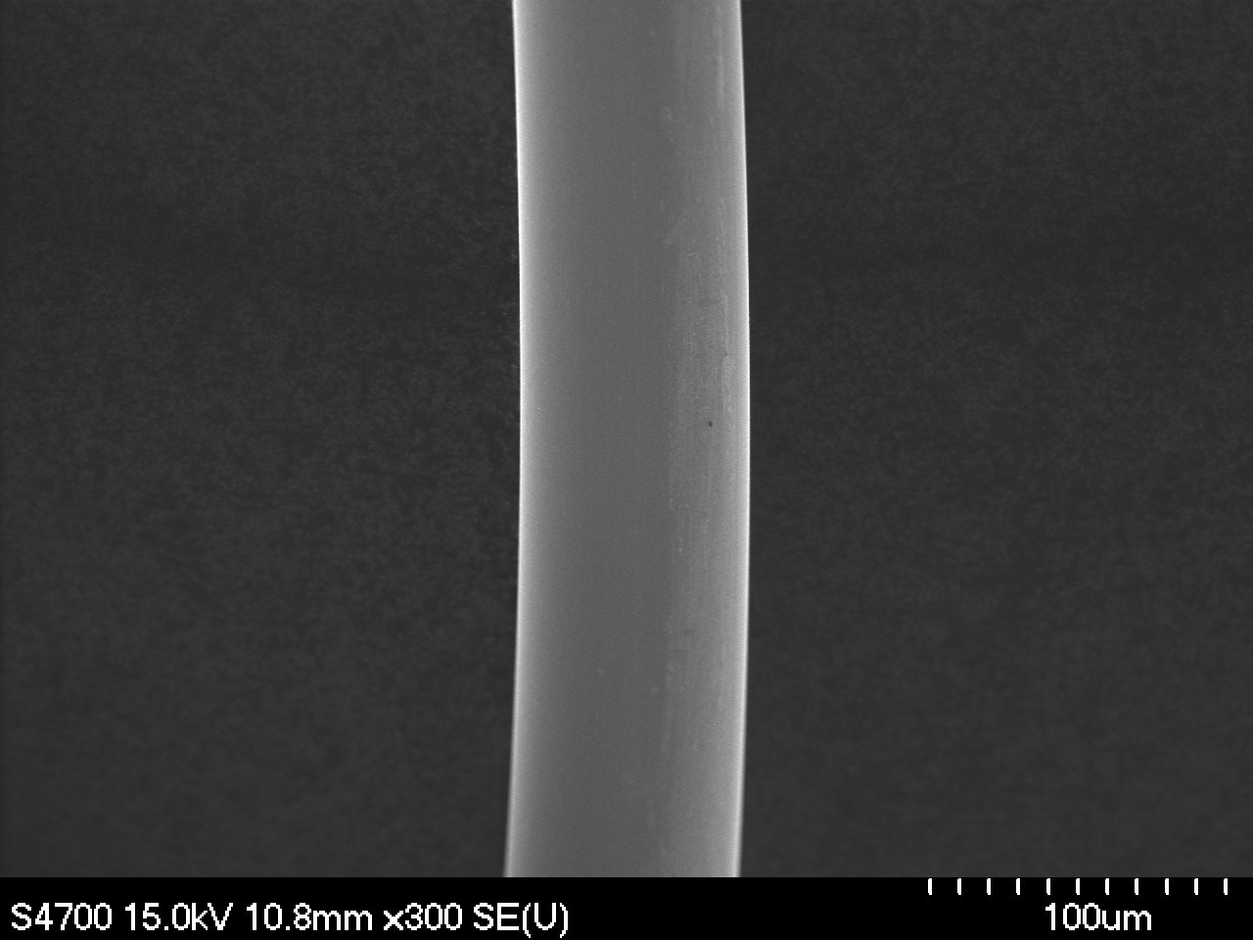
Magnification: 300x | Magnification: 300x
F5-2A-2 | F5-2B-2
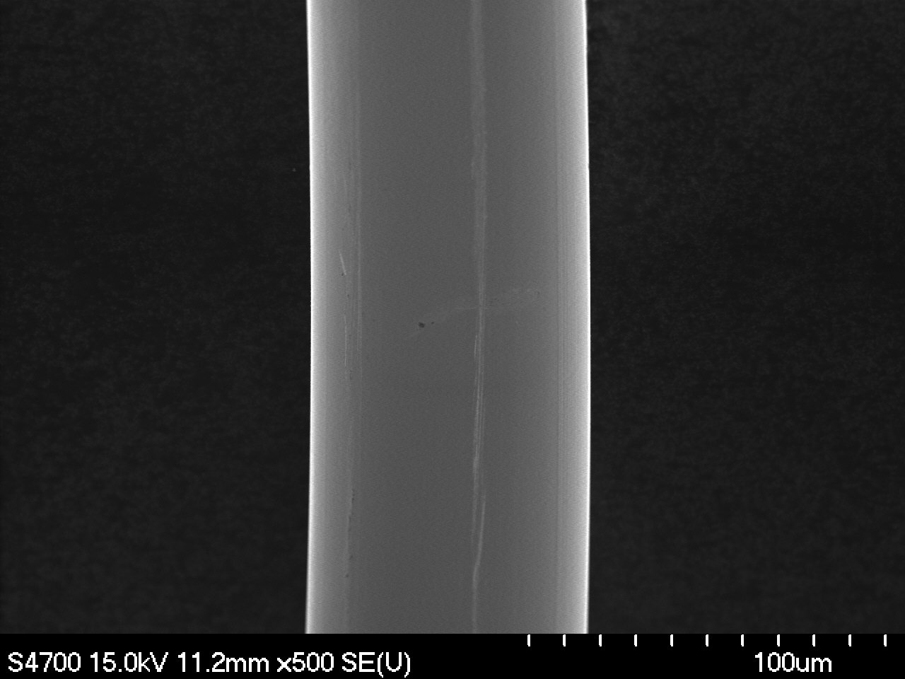 | 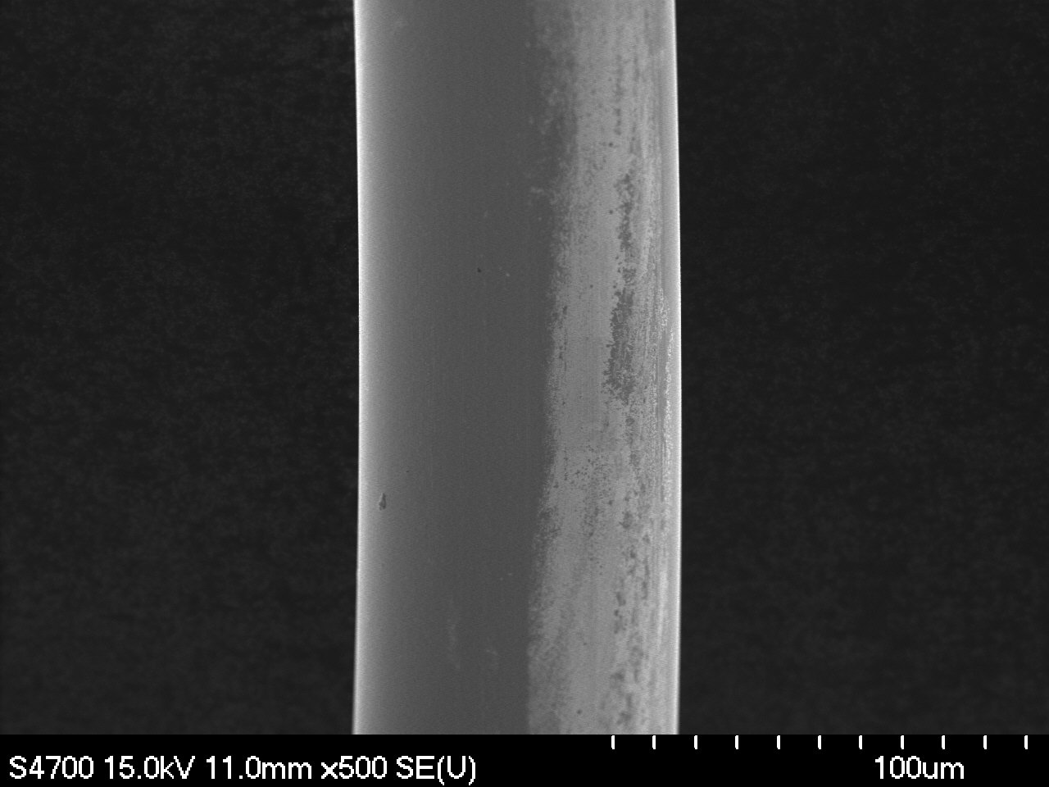
Magnification: 500x | Magnification: 500x

F5-2A-3 | F5-2B-3
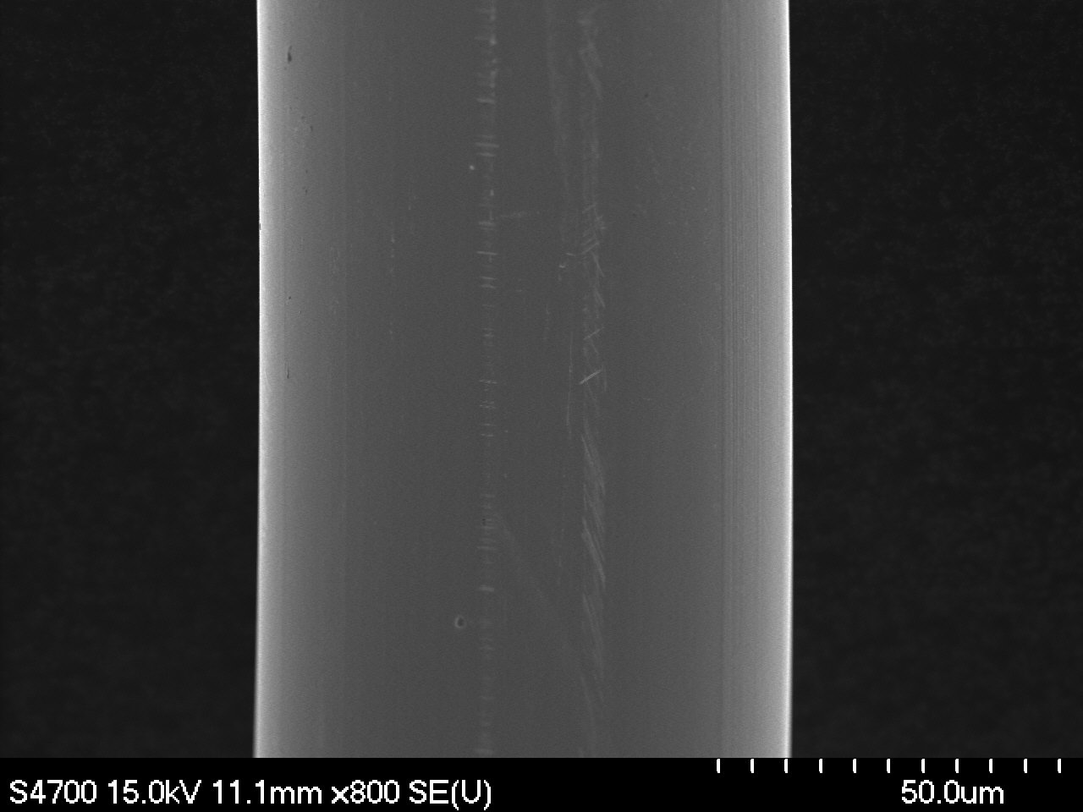 | 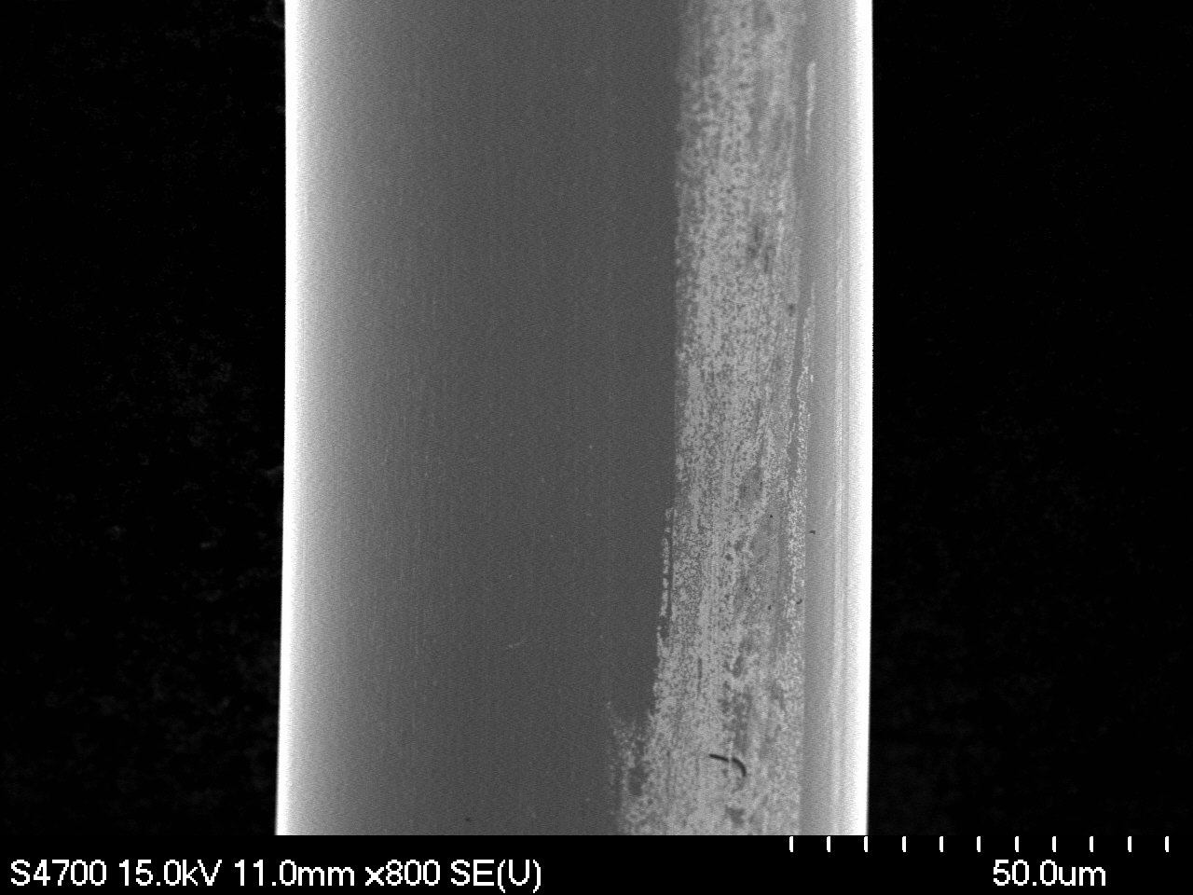
Magnification: 800x | Magnification: 800x
F5-2A-4 | F5-2B-4
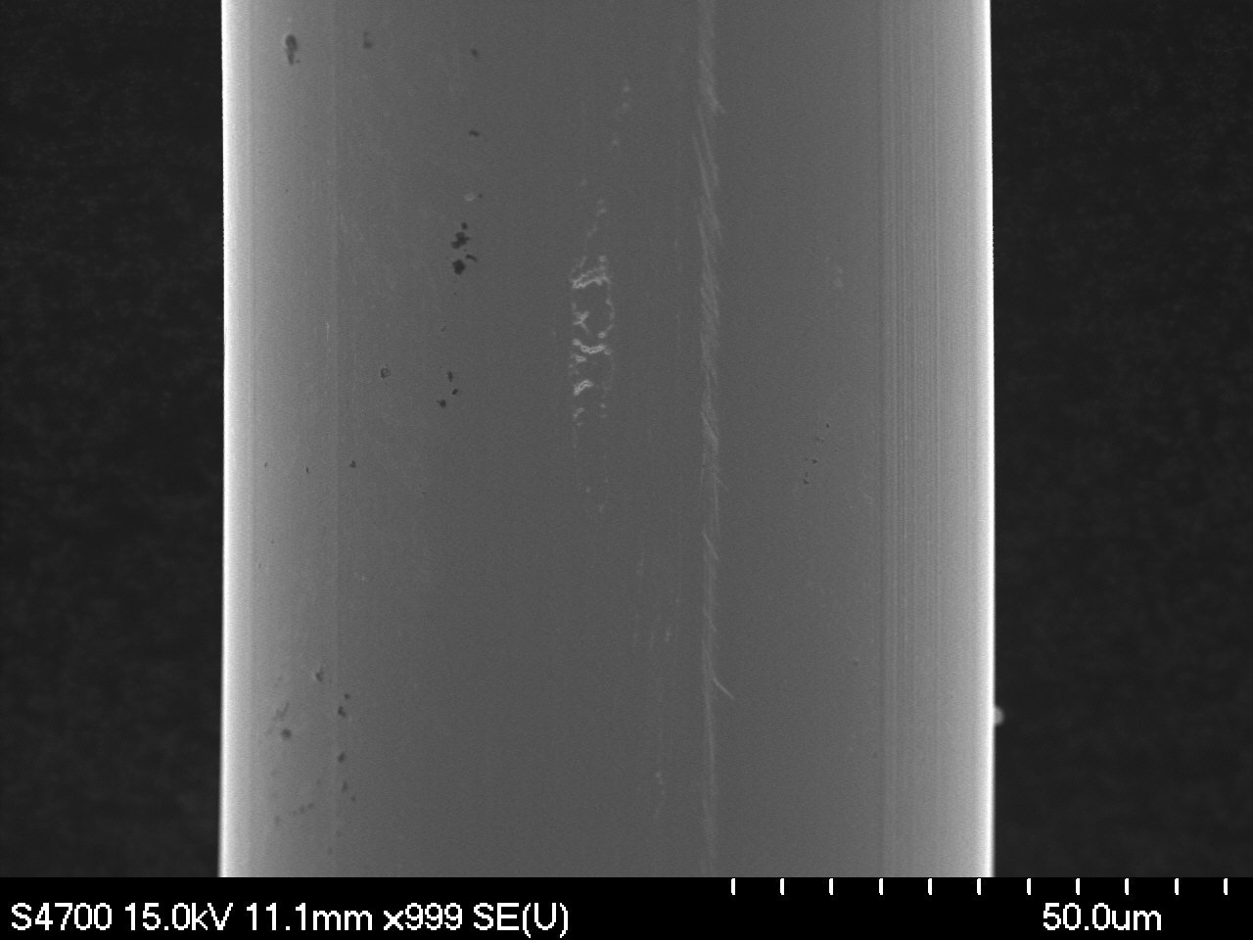 | 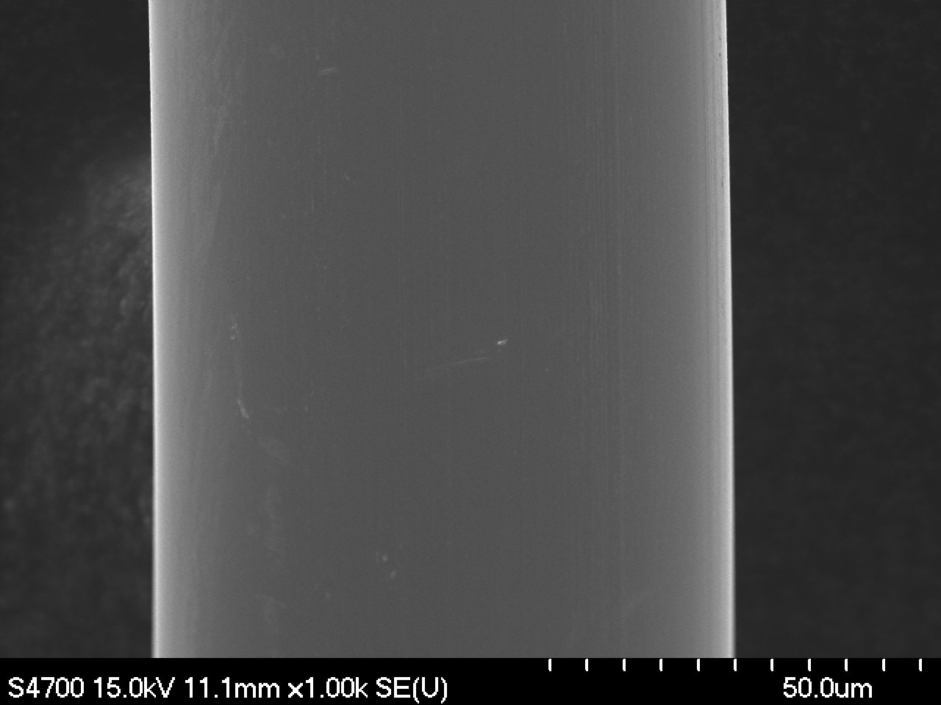
Magnification: 1000x | Magnification: 1000x

II. Ovality Measurements

F5-2A-1o | F5-2B-1o
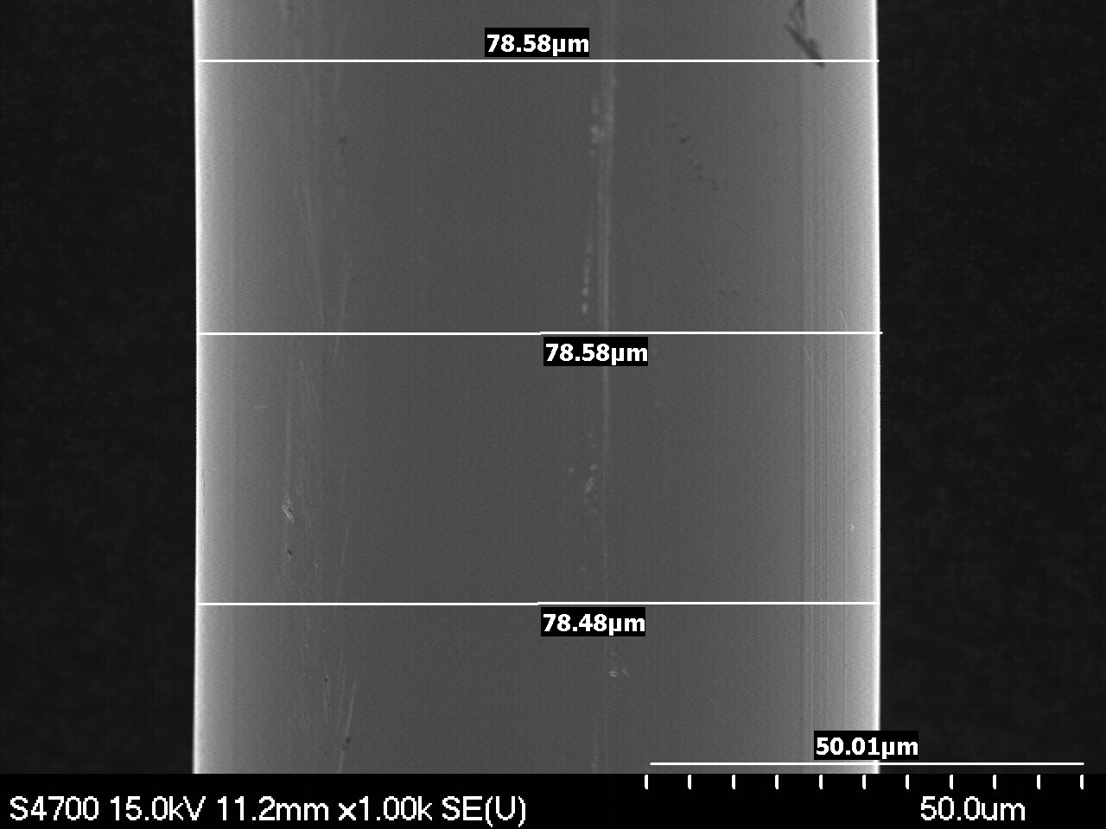 | 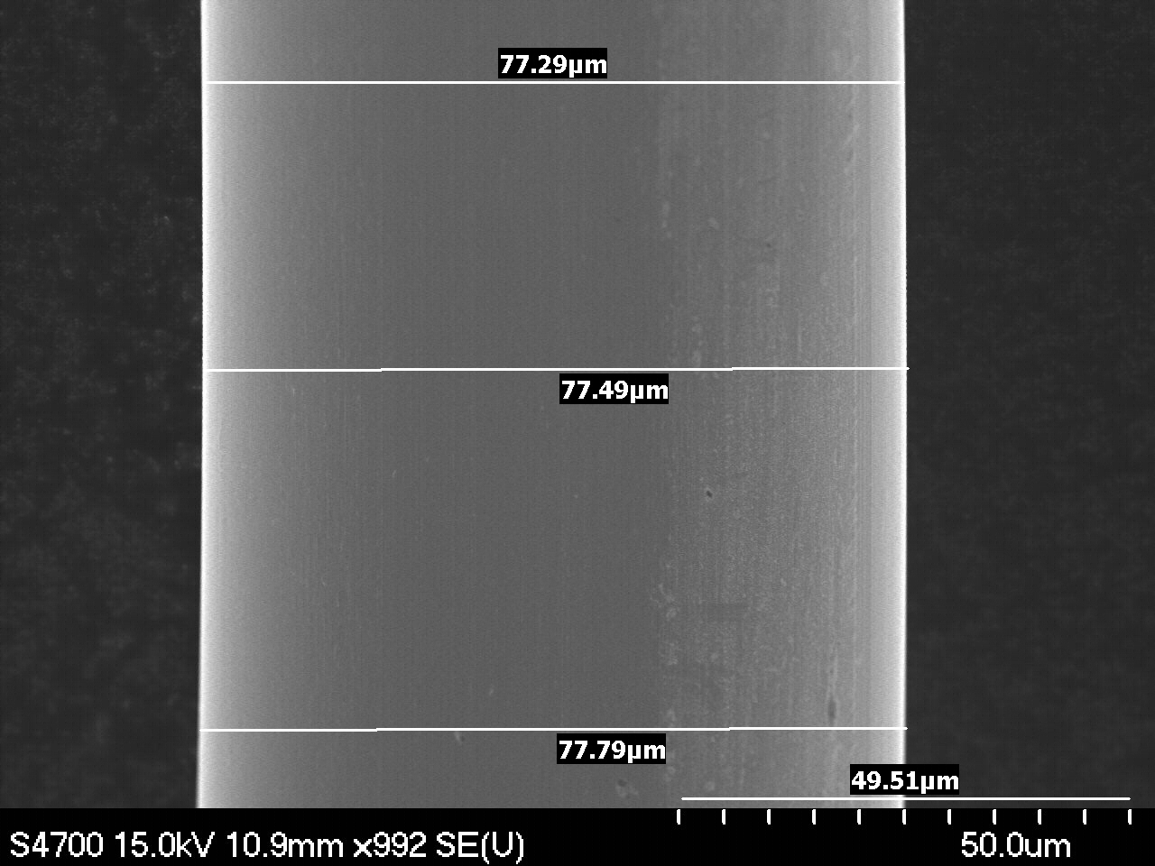
Magnification: 1000x | Magnification: 1000x
F5-2A-2o | F5-2B-2o
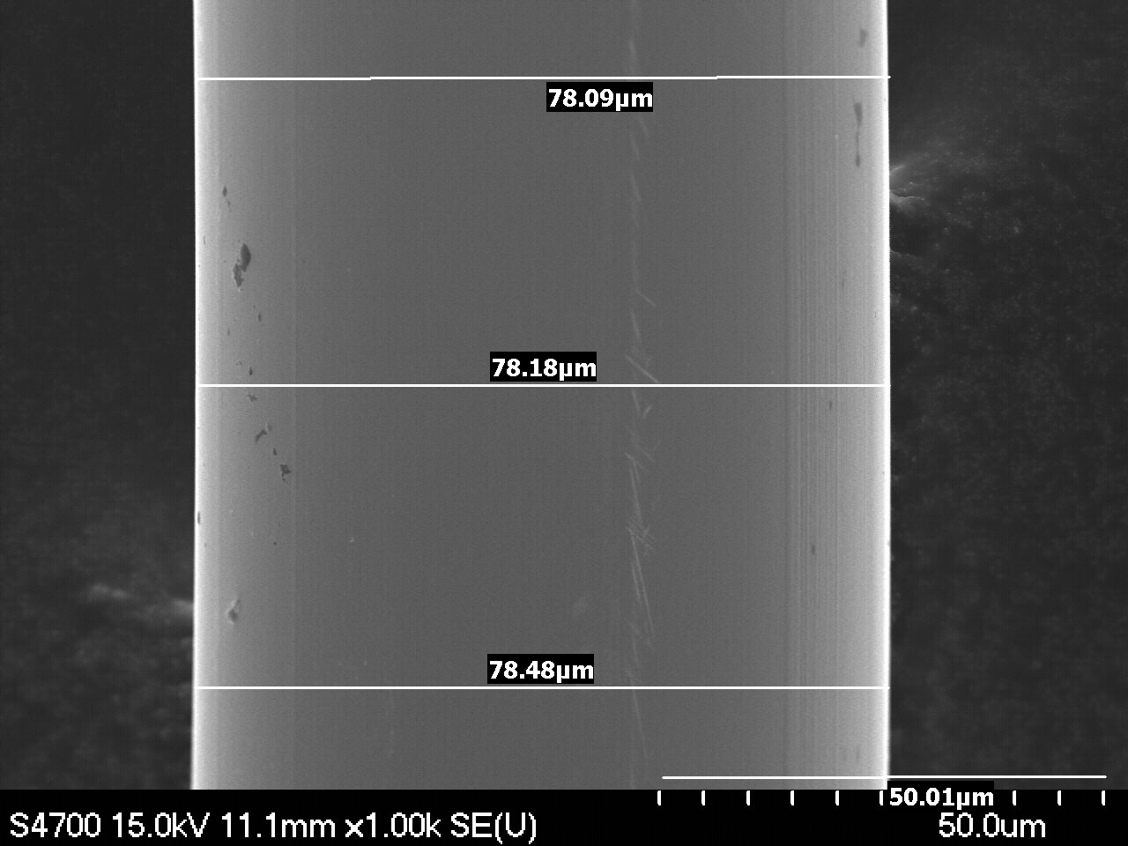 | 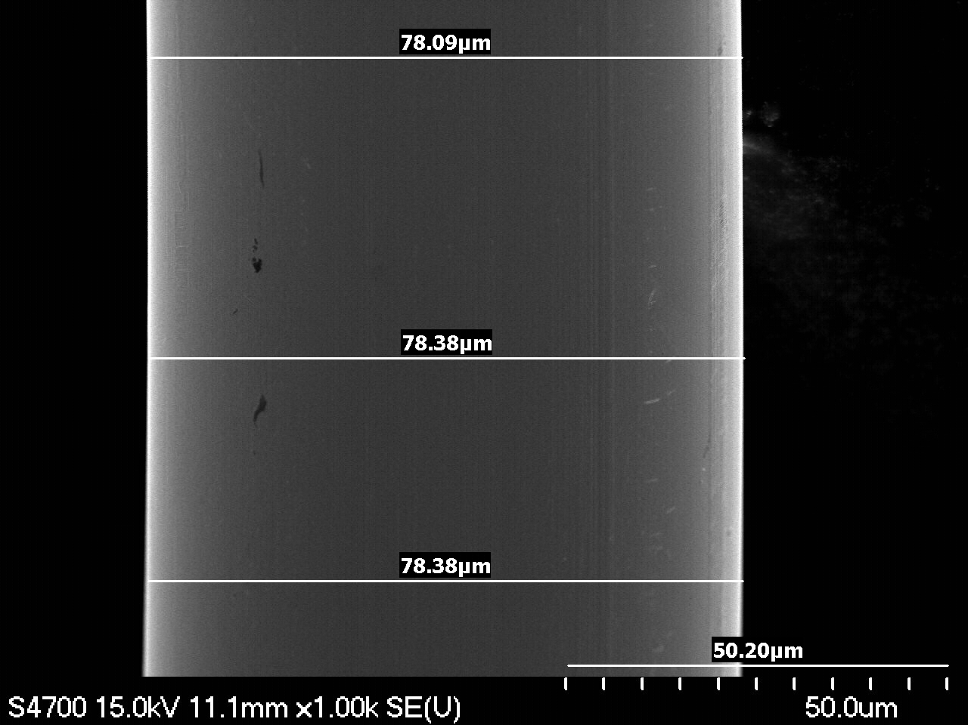
Magnification: 1000x | Magnification: 1000x
F5-2A-3o | F5-2B-3o
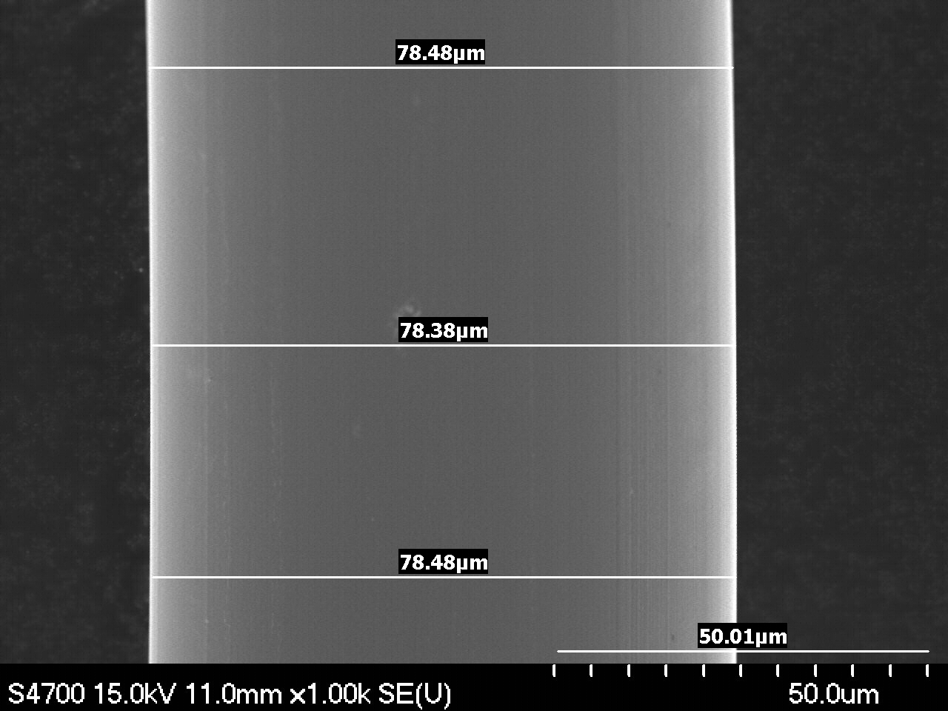 | 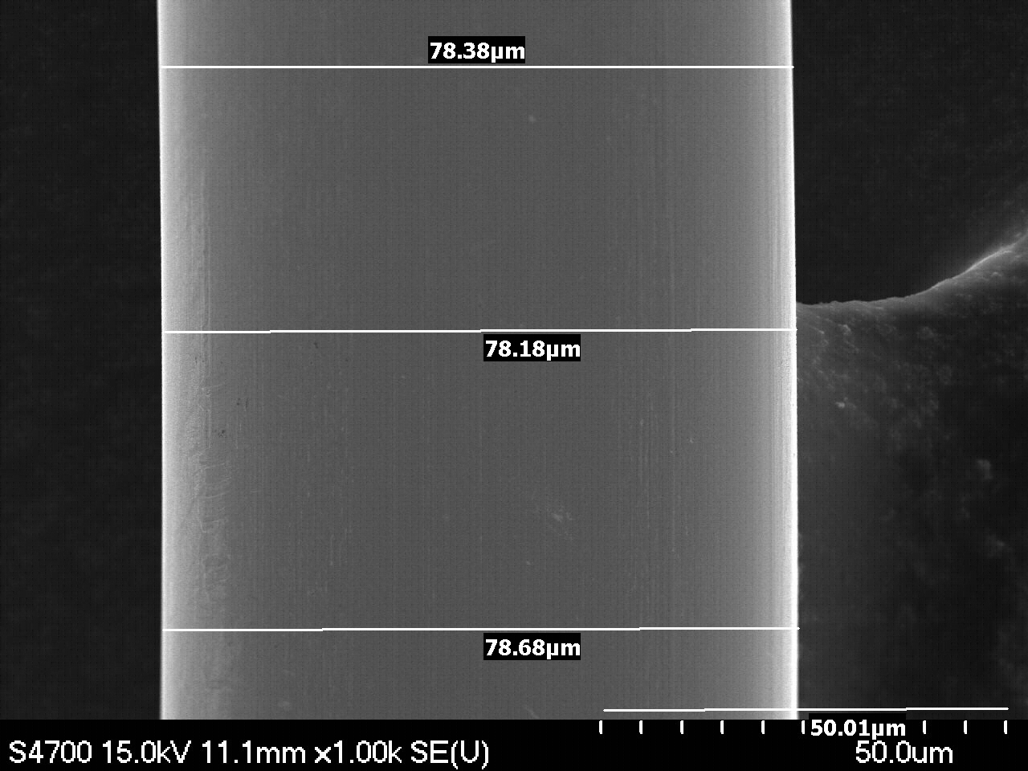
Magnification: 1000x | Magnification: 1000x

III. Points of Interest

F5-2A-7 Surface damage. | F5-2A-7
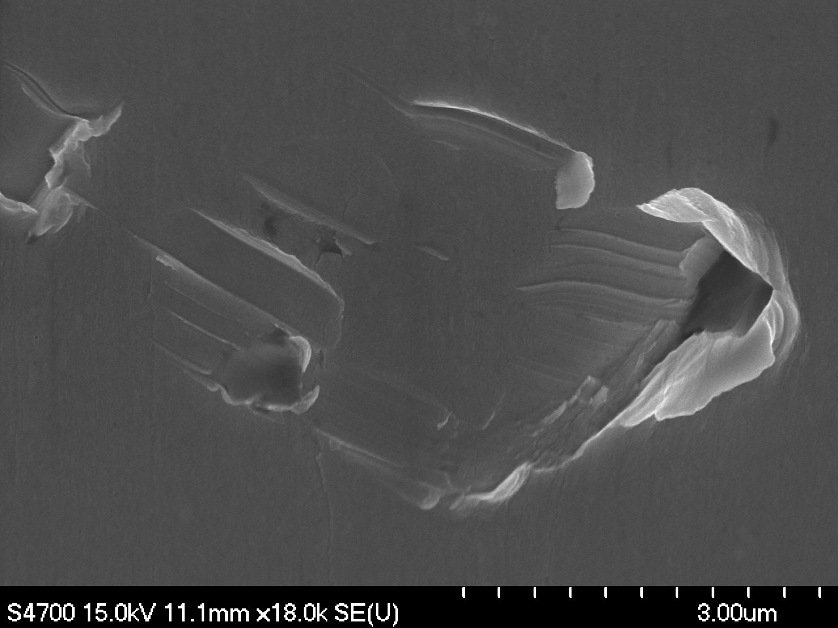 | 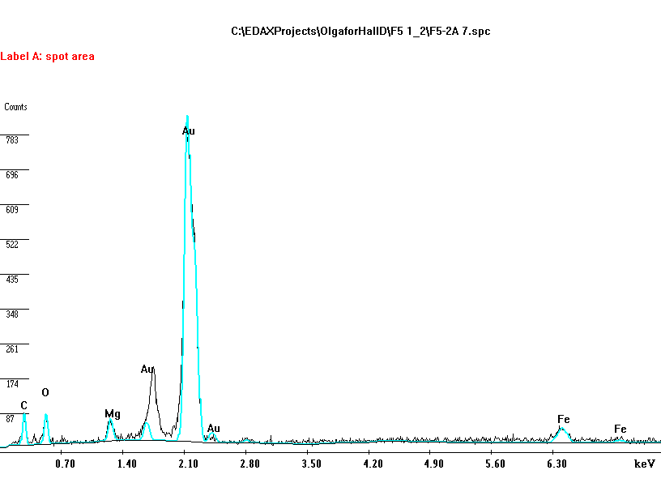
Magnification: 18000x | EDS Analysis. Surface damage and contamination.
F5-2A-9 Surface damage. | F5-2A-9
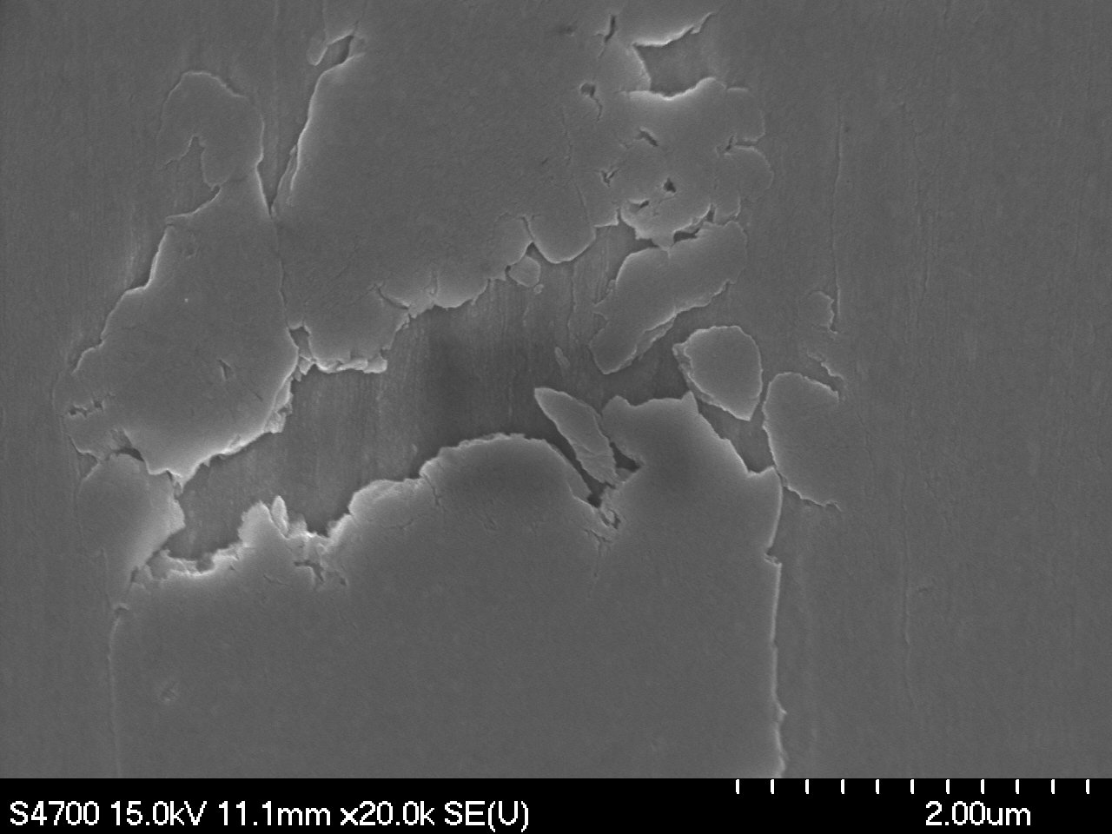 | 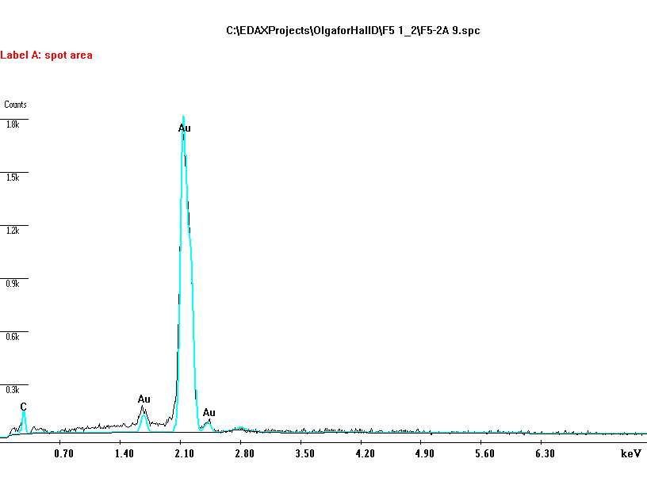
Magnification: 20000x | EDS Analysis. Surface damage. No Cu.
F5-2A-5 Environmental contamination. | F5-2B-6 Minor surface damage..
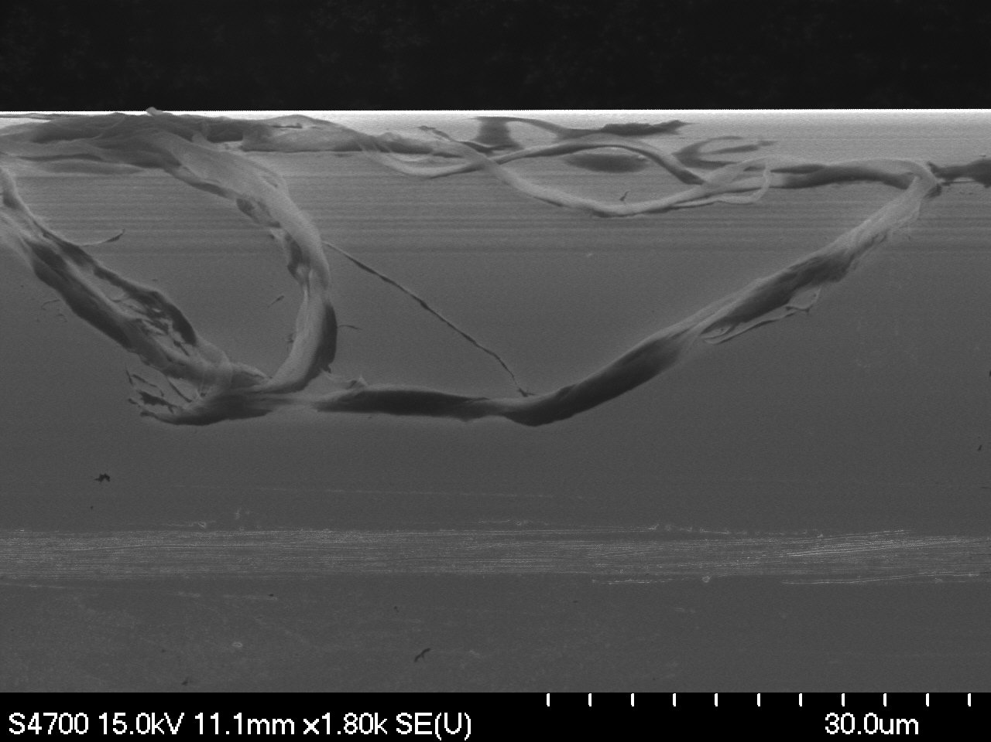 | 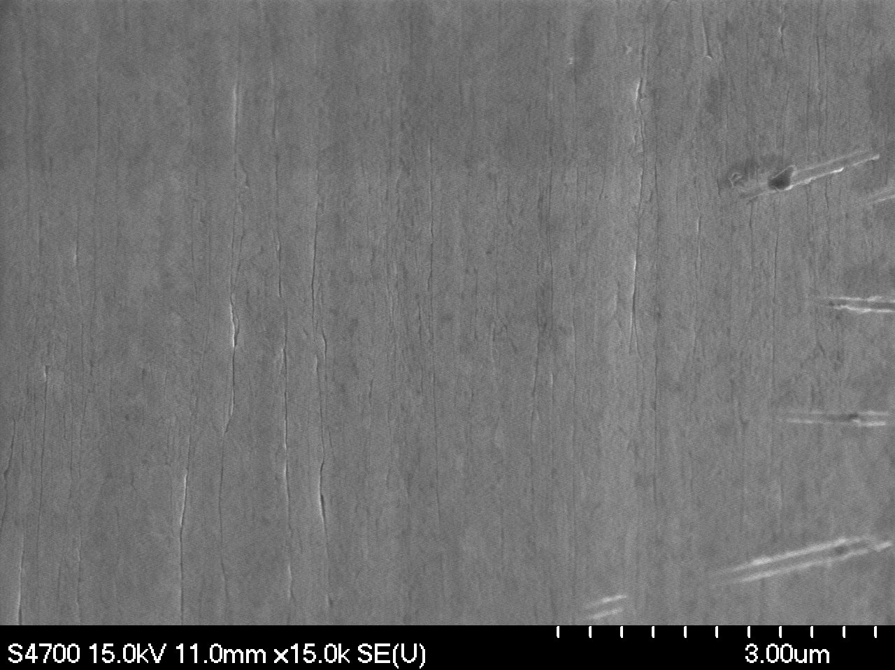
Magnification: 25000x | Magnification: 15000x

F5-2B-5 Surface structure. | F5-2B-10 Details of surface structure.
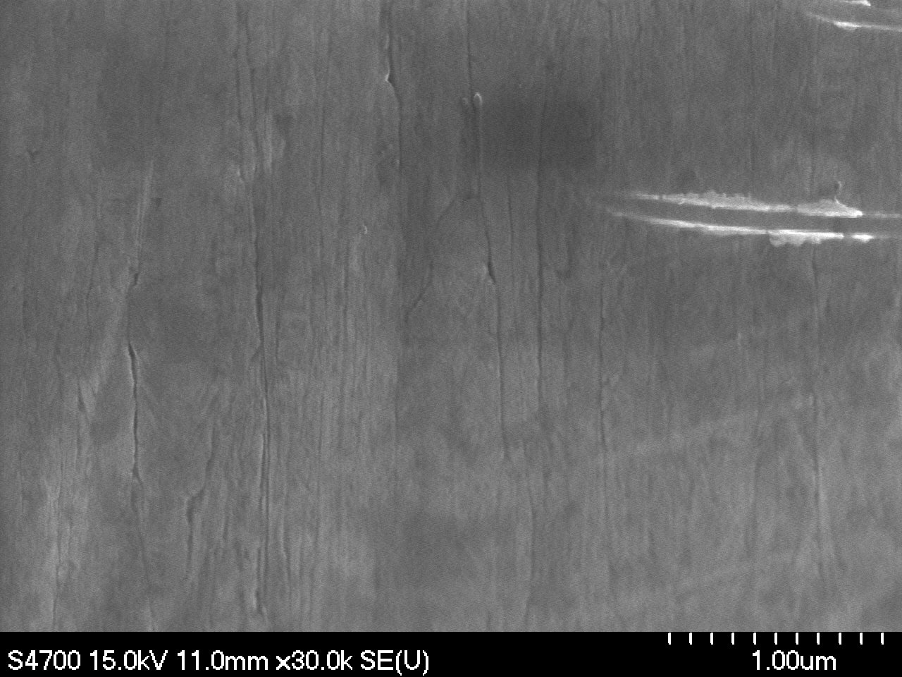 | 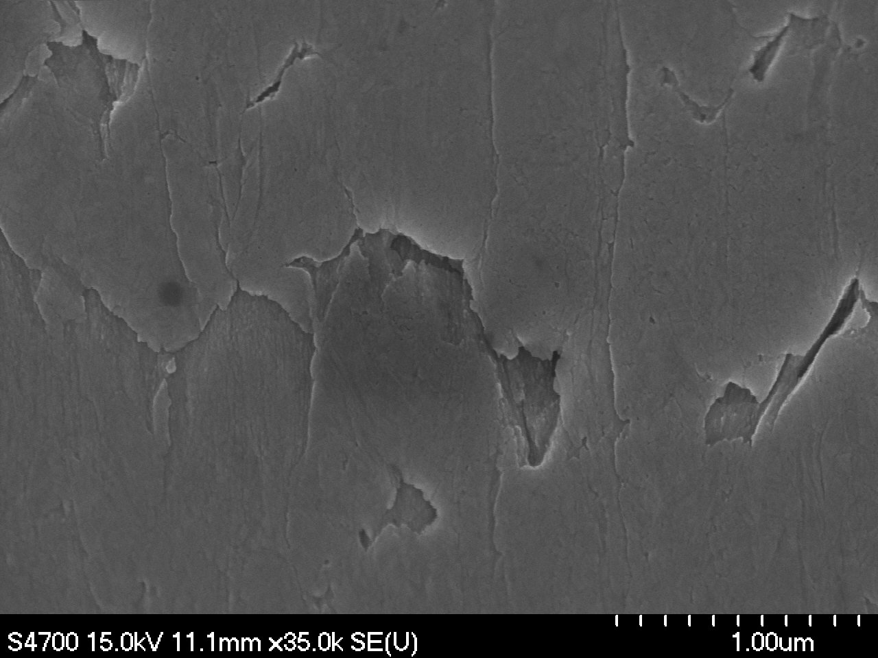
Magnification: 30000x | Magnification: 35000x
F5-2B-2 Surface contamination. | F5-2B-2
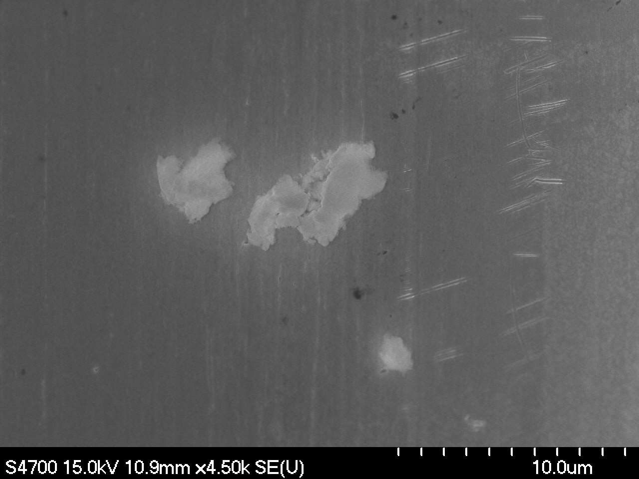 | 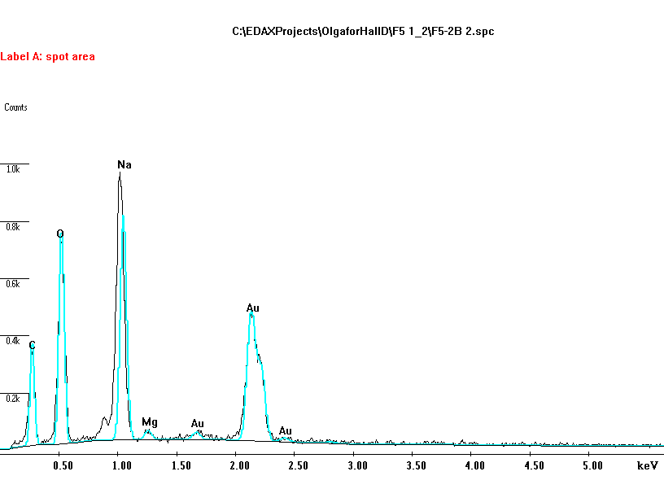
Magnification: 4500x | EDS Analysis. Surface contamination. (NaCl?)
F5-2B-7 Surface contamination. | F5-2B-7
 | 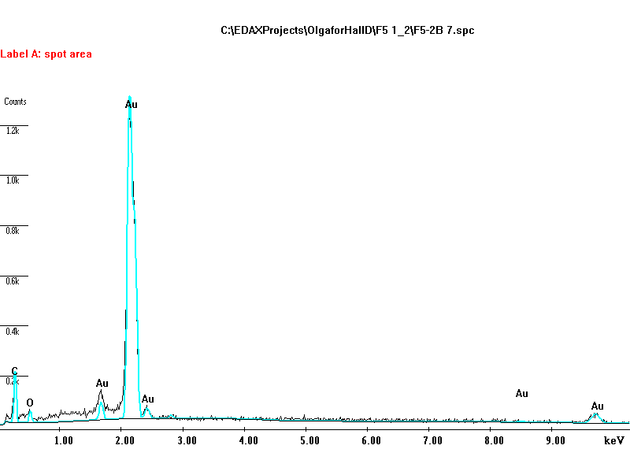
Magnification: 800x | EDS Analysis. Surface contamination. Environmental.

F5-2B-8 After EDS analysis.
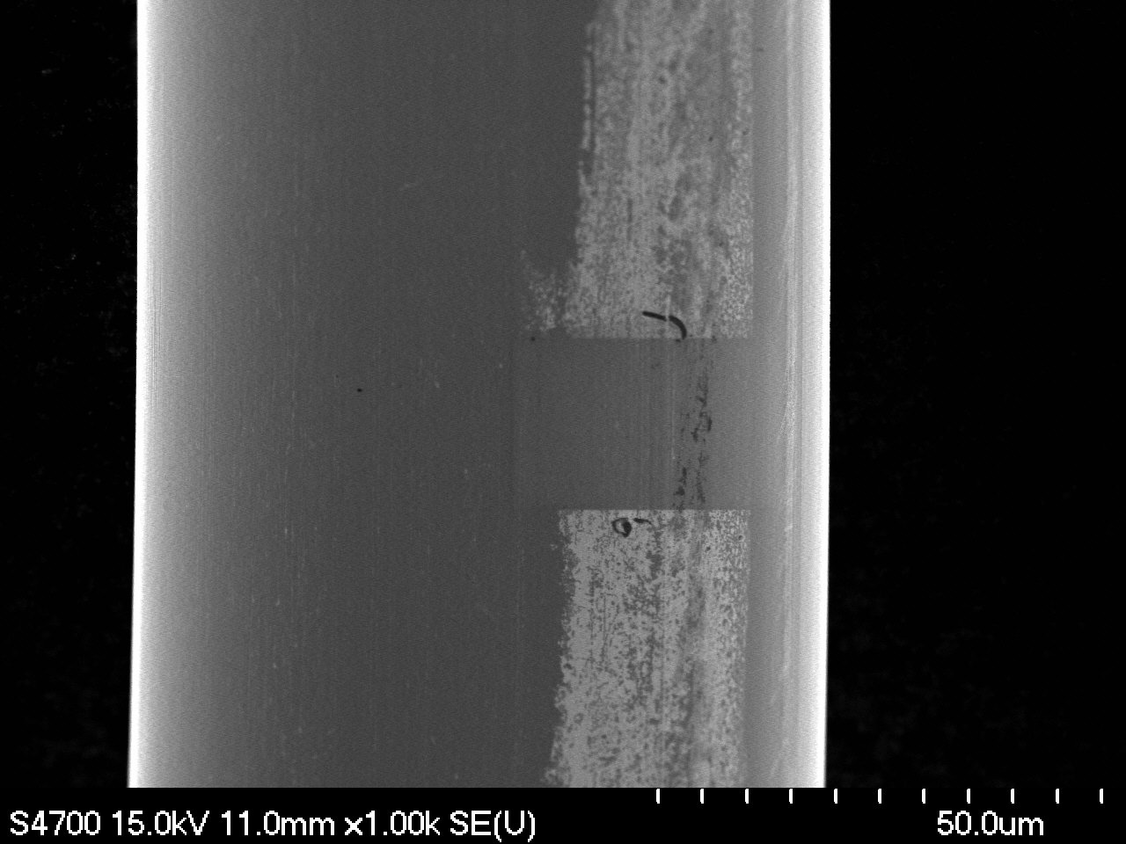 | Comment on F5-2B-8:  Electron beam eliminated contamination layer o the spot of exposure during the EDS analysis.
Magnification: 1000x

