Operations note: Humidity for all gluing operations should be less than 50%. Epoxy resin and hardener must be stored in air tight container with a desiccant pack. If Epoxy has not been used for a period exceeding one month, a test sample should be made by rolling out a thin film with the foam roller and allowing to cure.
Procedure 1- Make the Rohacell ring
Confirm that the Rohacell to be used is .155”+/-.008”( 3.93mm+/-.2). If thicker material is used, vacuum machining will be required after gluing the Rohacell to the G10 ring. Use the aluminum cathode template to cut 8 arcs of Rohacell per cathode.
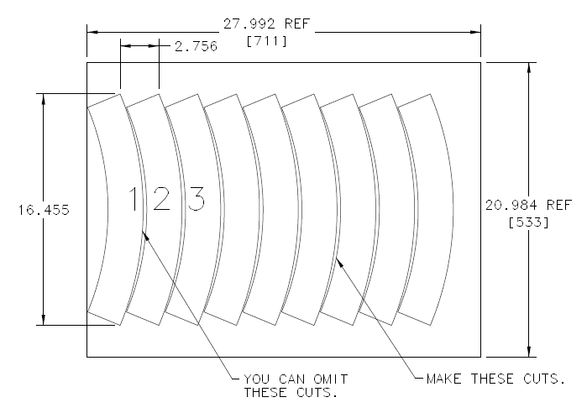
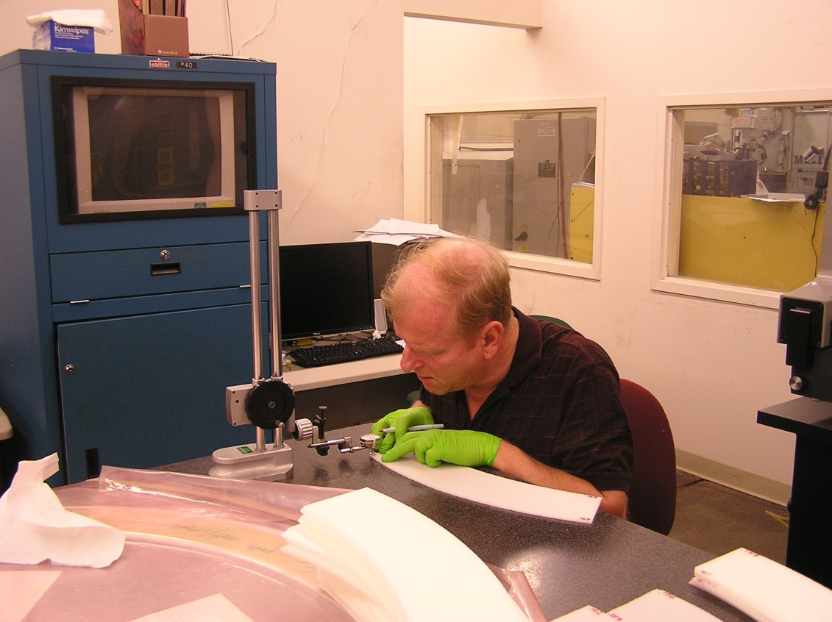
Measure the ends of the arcs, and sort by thickness (eight arcs in a group to produce one cathode). Record the value on the arc end with a felt marker.

If the lamination will be vacuum machined to thickness, the arc heights needn’t be matched for thickness. If vacuum machining will not be used, then position the arcs as described below:
The objective is to have the variation within a cathode be .005” or less. After the grouping is done, match the ends of the arcs for minimal change in height across the joint. LIGHTLY sand the joint if there was a measured step. Care must also be taken to prevent construction of a wedge shaped ring (shown in exaggeration below). Randomize positions to prevent this.
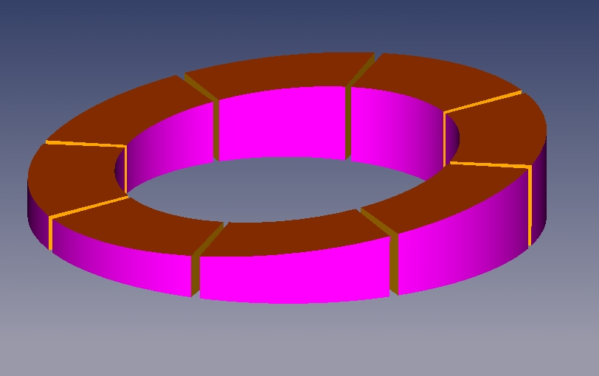

- A granite table will be used for glue application and vacuum bagging. Clean the table thoroughly, removing all dust, etc. Place either polyethylene sheeting or wax paper on the table, to protect the surface from epoxy. Dry fit the arcs on the granite table, paying particular attention to the joints. If necessary, sand ends to get a good fit.

- PPE required for next steps: Rubber gloves and safety glasses. Mix a small cup of Scotch-Weld 1838 epoxy with a 1:1 ratio, by weight. Using a popsicle stick, fill a 10cc adhesive applicator with the mixed Scotch-Weld. Install a 1/16” diameter tip on the applicator. Have isopropyl alcohol on hand for cleanup.

- Apply Scotch-Weld to one end of each arc, applying just enough to fill any gaps in the joint. Spread the bead across the Rohacell surface as shown.
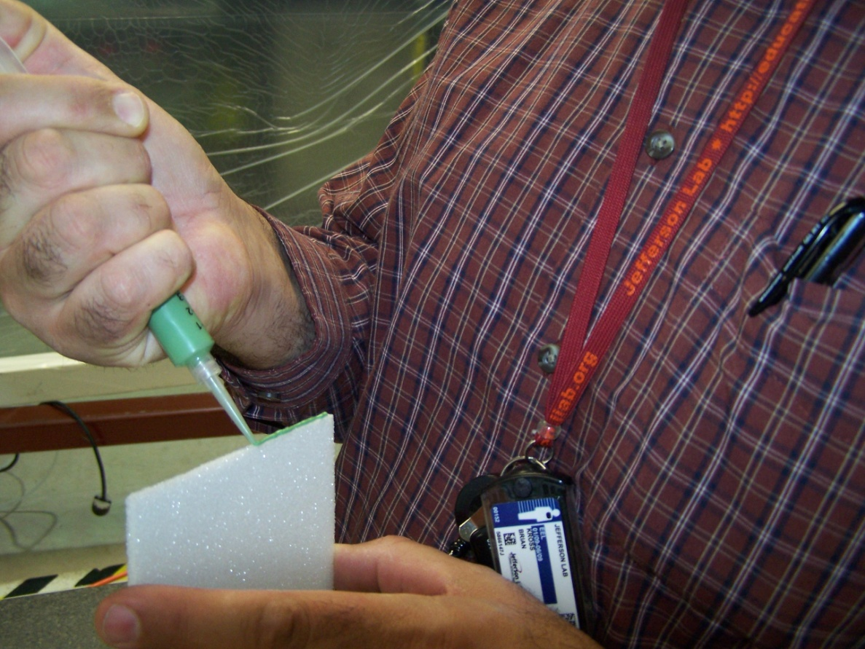

Brian wearing invisible gloves.

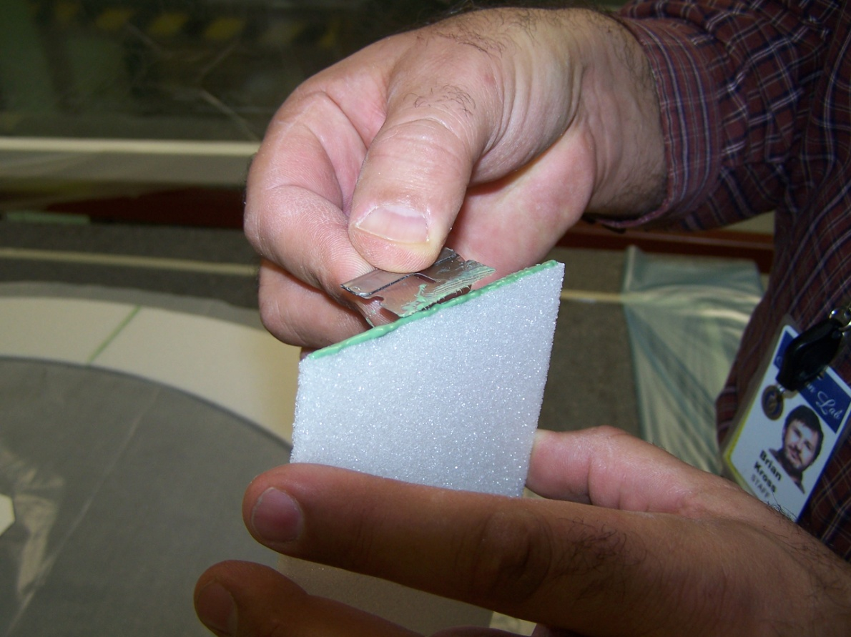

- Reassemble the ring on the table. The Scotch-Weld’s purpose here is to establish a gas seal at the joints. Scrape off any excess from the top surface of the joint.
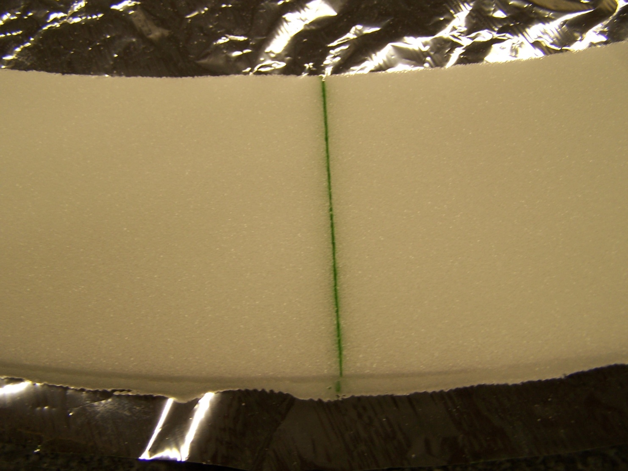

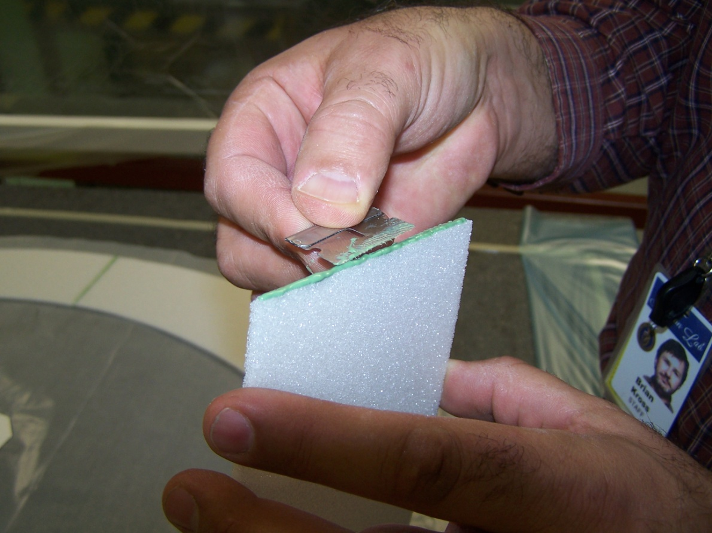
Place weights on both sides of each joint. Perform a final inspection to insure that none of the joints opened due to the applications of the clamp weights. Allow to cure for 24 hours. If the Rohacell arc ends were not matched in preceding steps (planning on vacuum machining), the exposed side should be labeled with magic marker to indicate that it shouldn’t be glued to the large G10 ring (if there are height steps, you want them on the side that will be machined!)
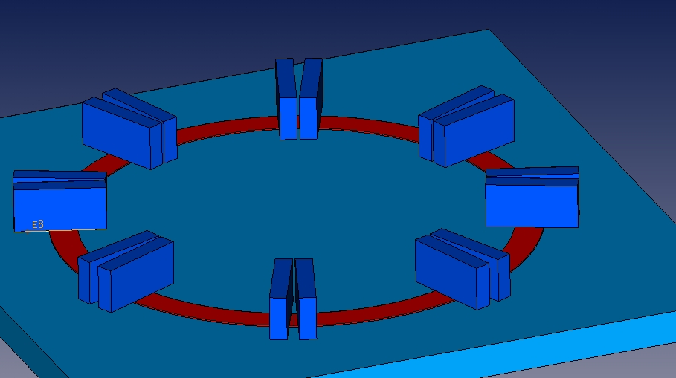
Label “don’t glue this side to large G10 ring”

When dry, use the narrow G10 ring as a template to cut the ring to its final I.D. and O.D. using the rotary cutter shown below.
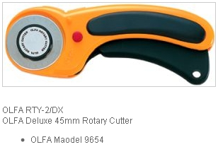
Picture of cutting to final size

If no vacuum machining step is planned, perform a final inspection of the joint area to insure that there is no height step across the joint (use the height gauge). LIGHTLY sand if necessary. Reason: a height step will cause a void in the lamination leading to failure! Use compressed air to blow off any dust.
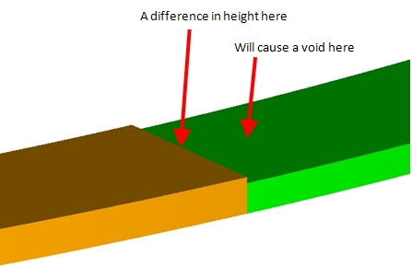

Procedure 2: Make a partial lamination with the Rohacell ring and the large cathode ring ring
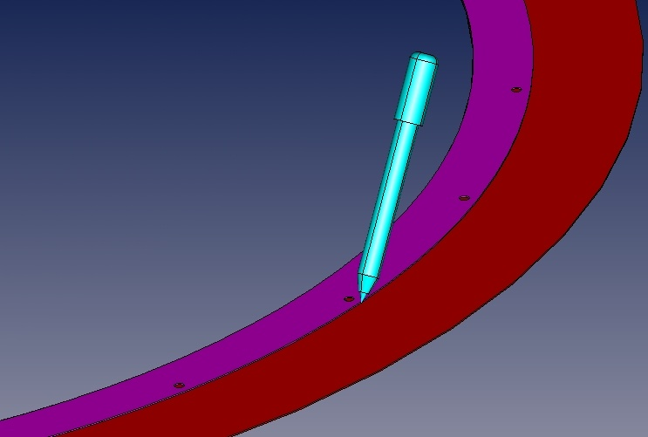
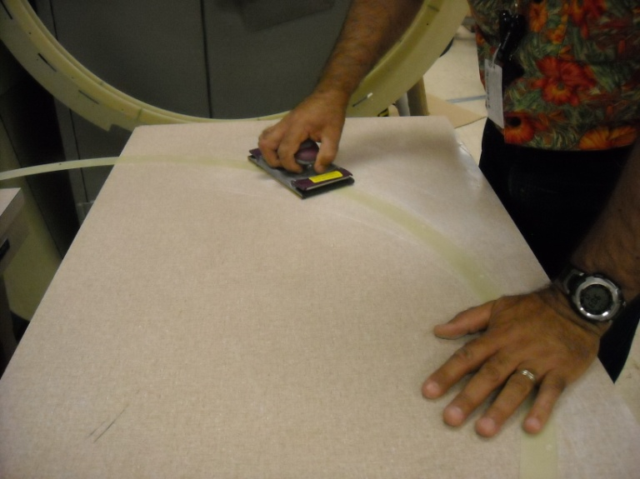
Sand both sides of large G10 skin (996 I.D./1178 O.D.) lightly with 400 grit paper. Use the sanding block at a 45 degree angle to lightly chamfer the edges at the O.D. and I.D. Clean the ring with alcohol. Use the narrow G10 ring (996 I.D./1060 O.D.) as a template, draw the O.D. on the large ring with a felt tip marker to show where epoxy will be applied. Repeat the sanding/cleaning procedure on the narrow G10 ring.

PPE for next step: gloves and safety glasses.
The following procedures should occur before noon- this will allow a spot check on the integrity of the vacuum bag after a few hours.
Clean the table surface with alcohol, and put the large G10 ring on it with wax paper underneath (marked side up).
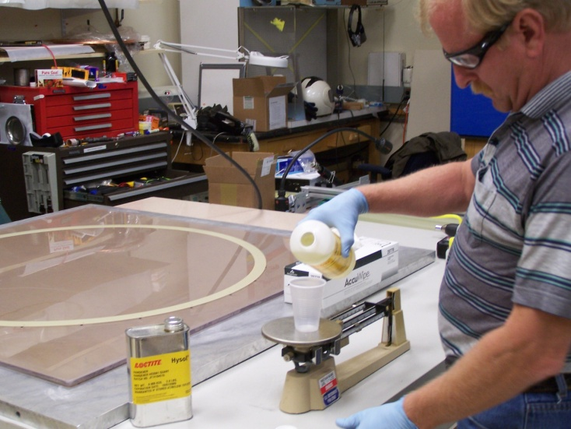
Mix a small cup (~20 cc) of Hysol RE2039 Resin and HD3561 hardener with a 3:1 ratio by weight.

Pour a 1/8” wide bead of epoxy on one side of a clean piece of acrylic plastic (the palette). Roll over the bead with a 3” wide foam roller to pick up the epoxy. Check the roller for proper loading by actually applying some epoxy to the palette. Roll a single pass of the roller, without back-tracking over the applied epoxy. Your goal is to apply a very thin coat (heavily sprayed appearance). After determining that your roller is properly loaded, move to the work piece (the G10 ring). Roll the epoxy to as uniform a layer as possible. Make sure that the ring is completely covered. Re-load the roller as necessary.
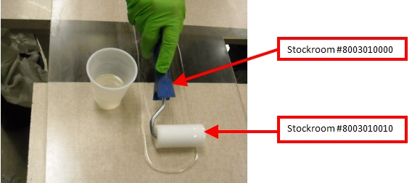

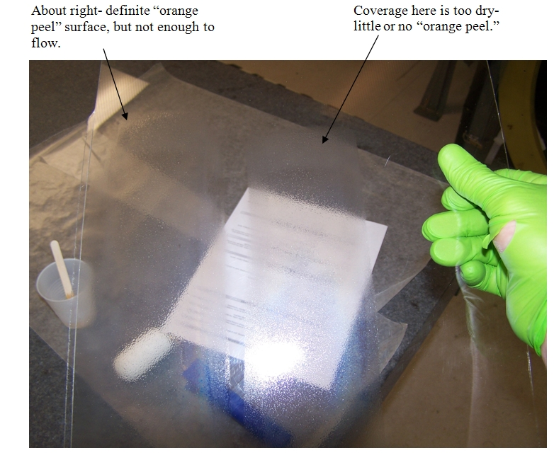
Apply epoxy to the large G10 ring. Coat the magic marker line and everything inwards (a little epoxy outside the drawn circle is okay).
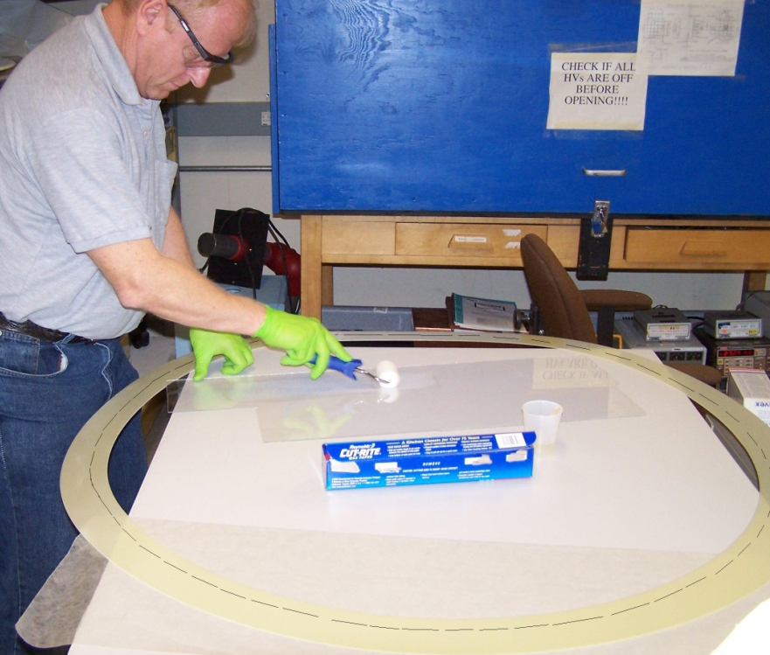
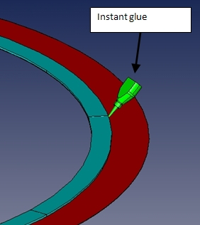
Lower the Rohacell onto the G10, trying not to slide it. Tack the Rohacell with instant glue (Loctite 406) on its O.D. in 5 or 6 places to prevent moving as the vacuum bag contracts.

Vacuum bag using the procedures developed for wireframes. Note the picture below- if your vacuum bag doesn’t pull this tight, you have leaks. Correct and reseal. Spot check the bag again in a few hours before leaving work-Cure 24 hours.
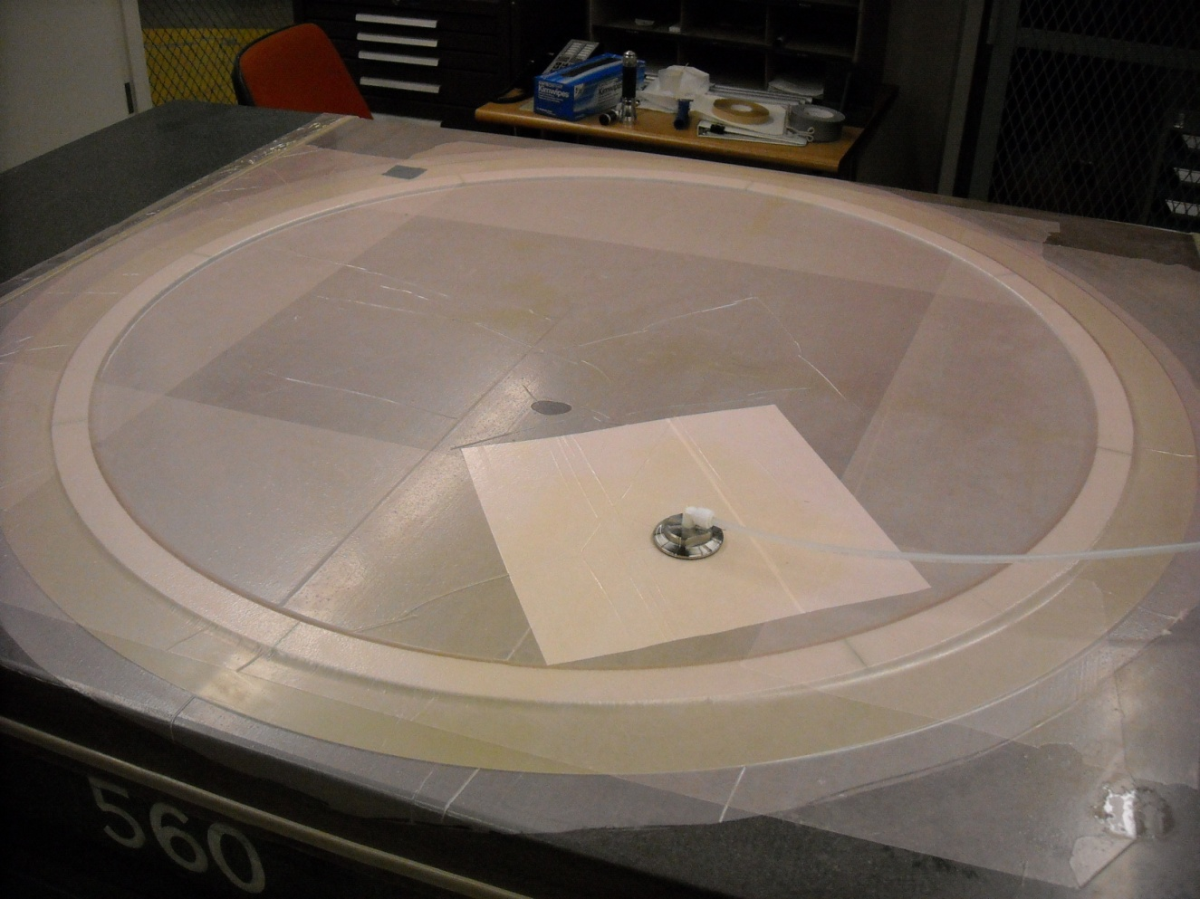

Procedure 3: Machining the Rohacell to thickness (only if thicker Rohacell was used)

The Horizontal mill rotary table should be cleaned with alcohol prior to this procedure. Gloves should be worn whenever the components are handled to prevent contamination of the Rohacell. A Hepa vacuum is needed to collect Rohacell dust.

Grooved vacuum fixture D00000-07-01-2036 is used in this procedure. O-rings are manufactured to fit in the outer and innermost grooves. Cord stock diameter is .103”. With the G10 side facing down prior to machining, a minimum of 27 in Hg should be measured at the pump, and pushing the ring down at the edges should show no visible deflection. The print for this operation is D00000-01-03-1013P.
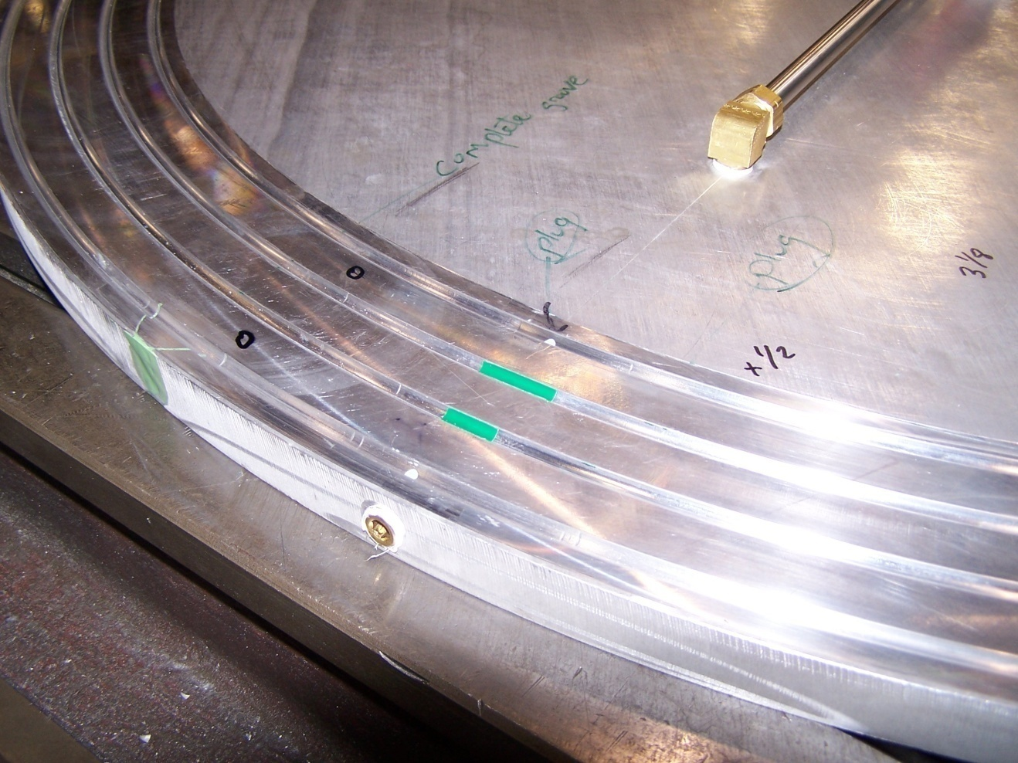

Inspect for +/-.005” on the granite table using a height gauge with a large contact face. Recommendation is to use a ground plate of known thickness between the Rohacell and the gauge to spread out the contact pressure. DO NOT USE CALIPERS! THEY WILL NOT GIVE AN ACCURATE VALUE BECAUSE THEIR CONTACT AREA IS TOO SMALL!
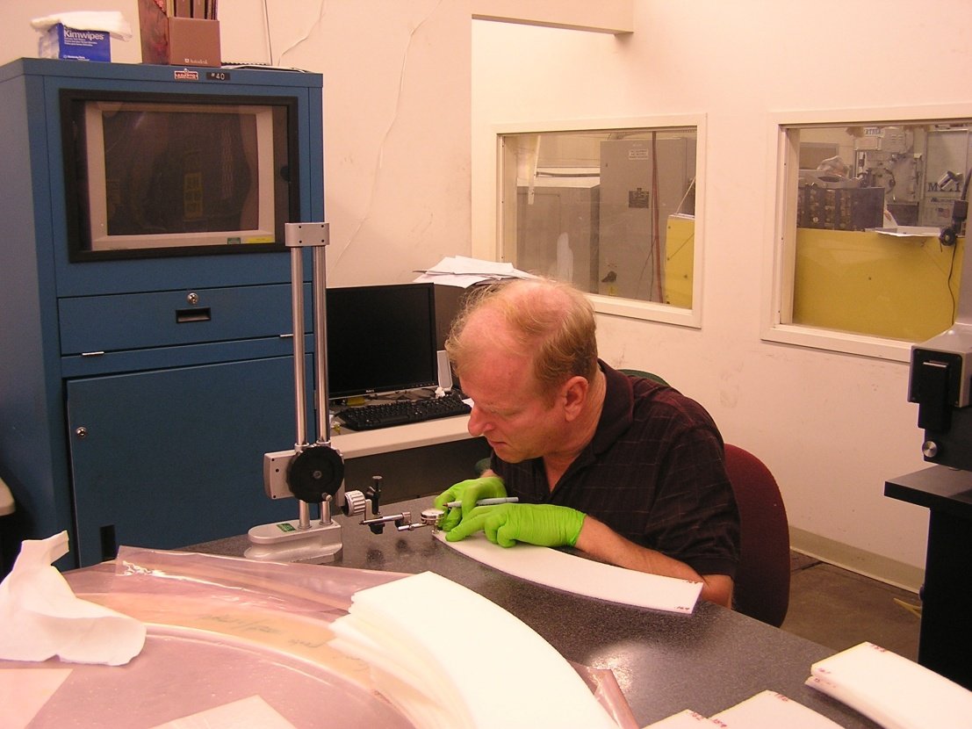

Procedure 4: Machine Holes and slots in the lamination
PPE for machine shop personnel: Safety glasses and Hepa vacuum-drawing D00000-01-03-1013
Picture showing machining, reference drawing D00000-01-03-1013, fixture part numbers. Point out toggle clamps, and note to limit pressure on Rohacell.

Procedure5: Machine the holes in the small G10 ring
PPE for machine shop personnel: Safety glasses and Hepa vacuum- drawing D00000-01-03-2003
Picture of machining with fixture numbers, drawing number.

Procedure6: Final lamination: gluing the small G10 ring
PPE: Gloves and safety glasses
Wet sand both sides of the small G10 ring and clean with alcohol. Set this aside.
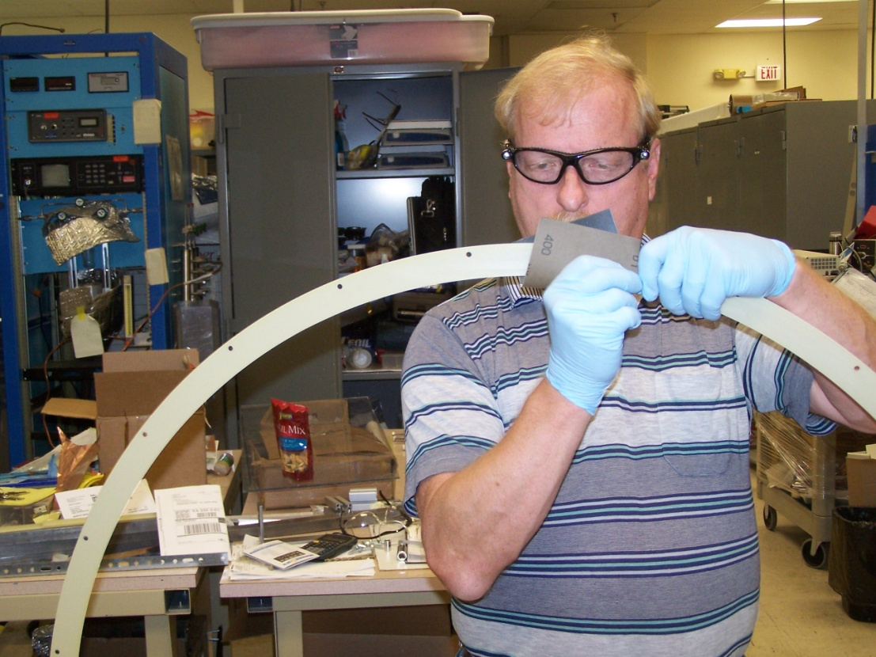
Clean the surface of the Lexan jig with Alcohol. Place the lamination on the Lexan jig foam side up, and put pieces of wax paper underneath. Push two lamination pins 180 degrees apart through the ring and wax paper. Adjacent to the two pins, shift the wax paper so that it does not extend beyond the O.D. of the large G10 ring. Use masking tape to secure the G10 to the Lexan (prevents shifting of the ring when the pins are removed). Remove the two lamination pins.
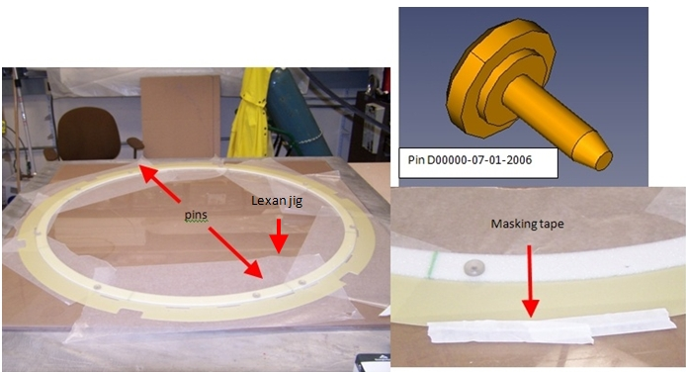

Apply silicone-free release agent (McMaster Carr 1409K61 or equivalent) to the twelve lamination pins. Make sure that this is not done near the lamination, as overspray could contaminate the foam and prevent bonding.
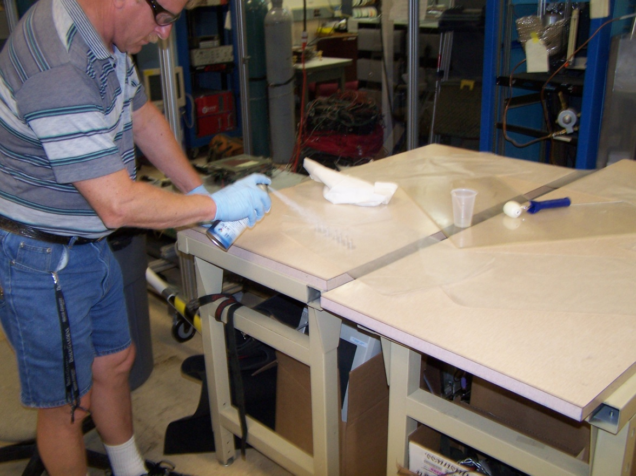
Mix a small cup (~20 cc) of Hysol RE2039 Resin and HD3561 hardener with a 3:1 ratio by weight.
Clean a work table with alcohol, and use the previously described procedure to coat the small G10 ring with epoxy.
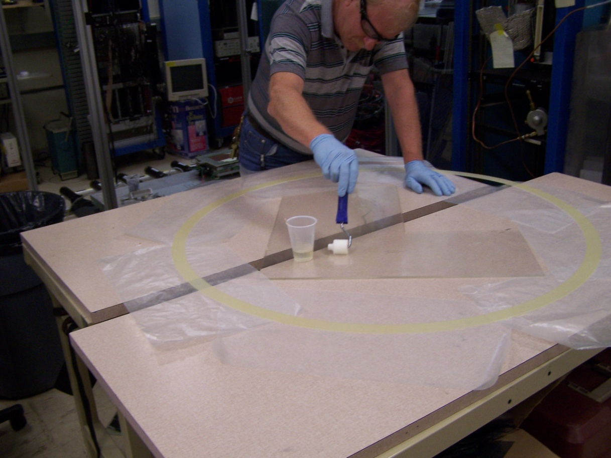

The next operation requires 2 people to handle the small (flimsy ) G10 ring. Turn the ring glue side down, and put two Polypropylene pins in holes 180 degrees apart. Position the ring over the lamination, and use the pins to pre-position the ring prior to making contact. Place the clay tape at this time as shown in the photo below:
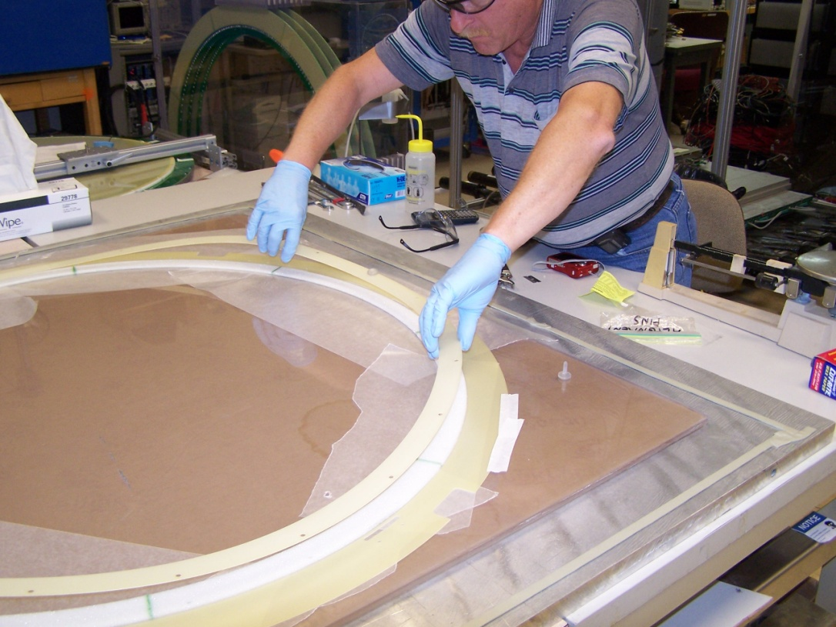
Note position of the clay tape. It is placed as far as possible from the edges of the Lexan sheet, to allow the bag to stretch into the corner formed by the Lexan and Aluminum.
After lowering the ring, add the rest of the pins as shown below:

Apply a piece of breather cloth as shown below. Note that it is cut smaller than the I.D. of the G10 rings.
Seal the bag material to the gutter tape, and cut an ‘x’ shaped opening for the vacuum pump out attachment. Use a magic marker to circle this opening, to assist in finding it the next time (you can re-use the bag several times).
Apply vacuum and pump down- your bag should look like this:
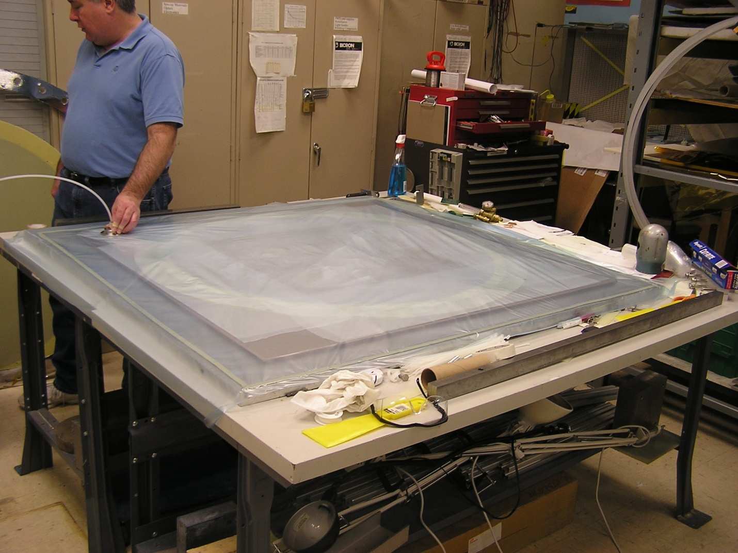
Replace this picture with one that shows the correct breather cloth and the circle marked on the vacuum bag for reuse.
Check on the seal a few hours later to be sure no leaks have developed. Allow the epoxy to cure for 24 hours.
Open the bag on three sides- leave one edge attached (will be reclosed for the next lamination). Remove the lamination.

Procedure 7: seal the Rohacell, create gas passages
Hang the ring as shown below, preferably with the center of the ring at close to eye level. Final prep for sealing is to groove the Rohacell slightly (I.D. and O.D.) with the exacto blade shown below. The objective is to make the Rohacell flush with the G10 at the edges and slightly recessed in the center. This shallow groove will be filled with epoxy:

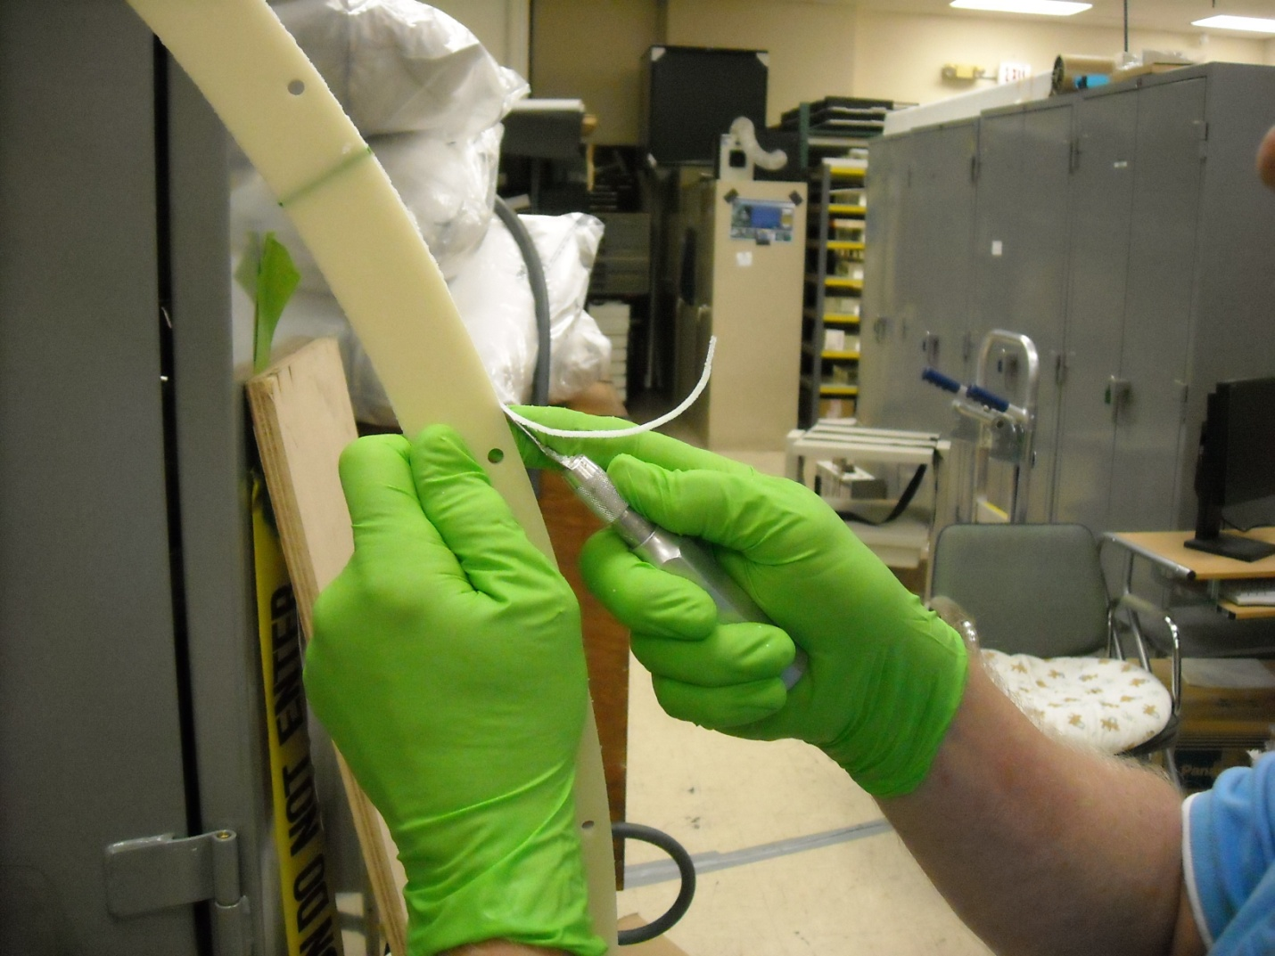
Excel blade #20350

PPE required for next steps: Rubber gloves and safety glasses.
Mix a small cup of Scotch-Weld 1838 epoxy with a 1:1 ratio, by weight. Add 2-3% Isopropyl alcohol by weight. Using a popsicle stick, fill one of the special syringes for the air applicator system with the mixed Scotch-Weld.
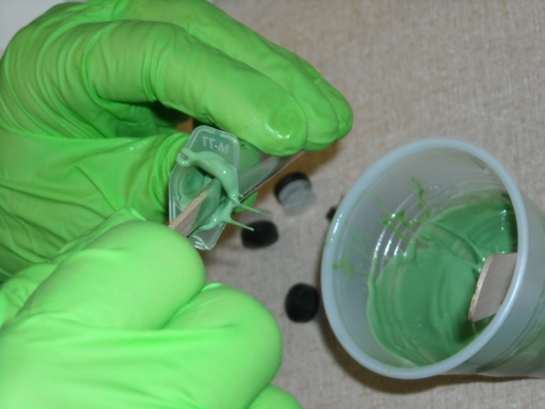
Syringe manufacturer and part number?

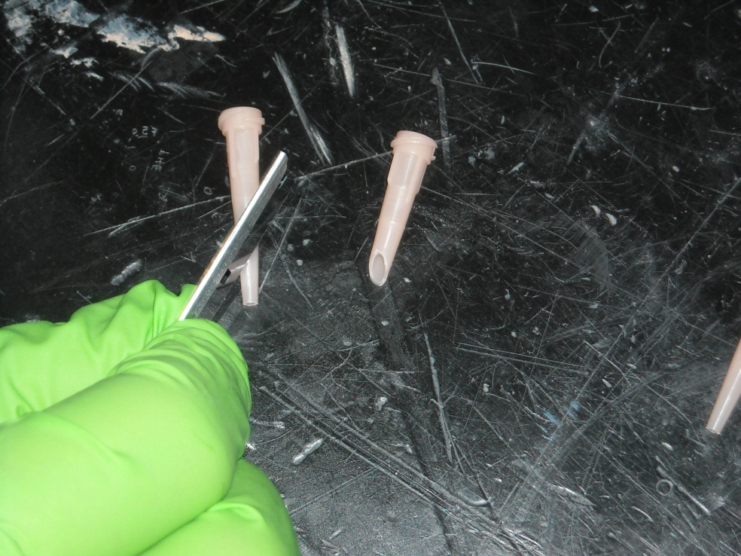
Take one of the applicator tips (manufacturer, part number) and cut as shown below with a razor blade. Put the tip on the syringe.

Remove the plunger from a manual syringe (manufacturer BD, part numberXXXX) and cut as shown. This will be used to replace the stock rubber plunger from the air applicator syringe (they tip over when pumping the viscous epoxy)
Use this cut plunger in the air applicator syringe

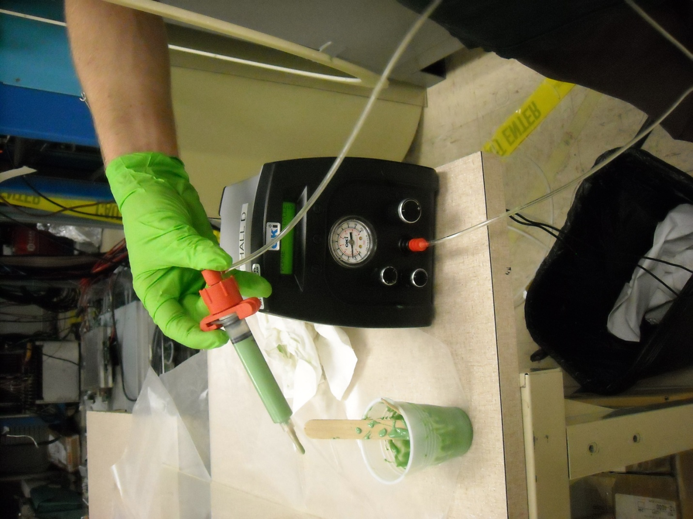
The applicator ready to use. Air pressure should be set to the lowest value that achieves an acceptable flow. This value may need to be increased during application to maintain this flow rate.

Apply as shown below- overfill the groove and come back and wipe flush:
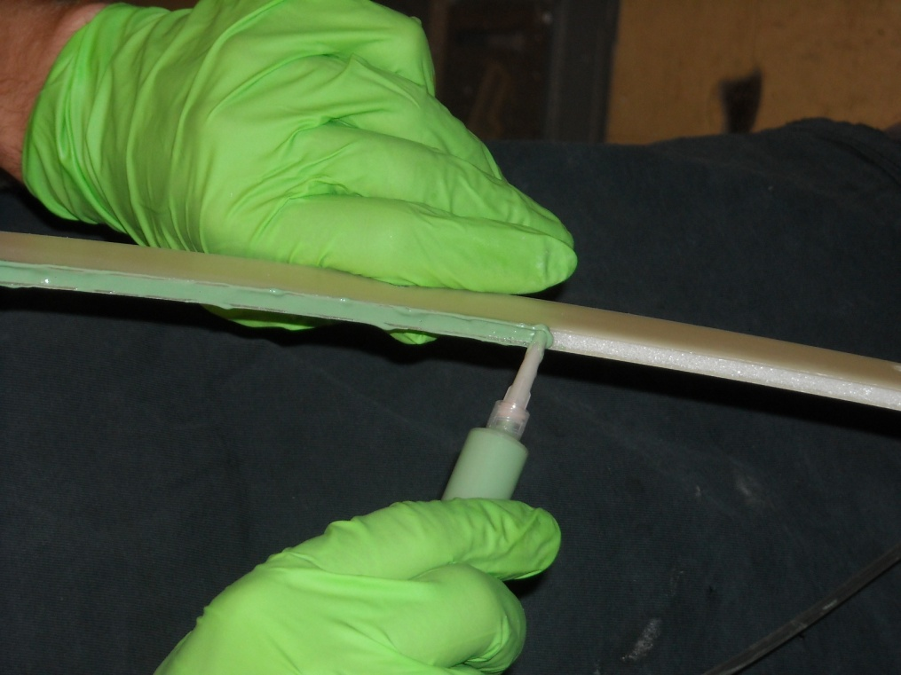
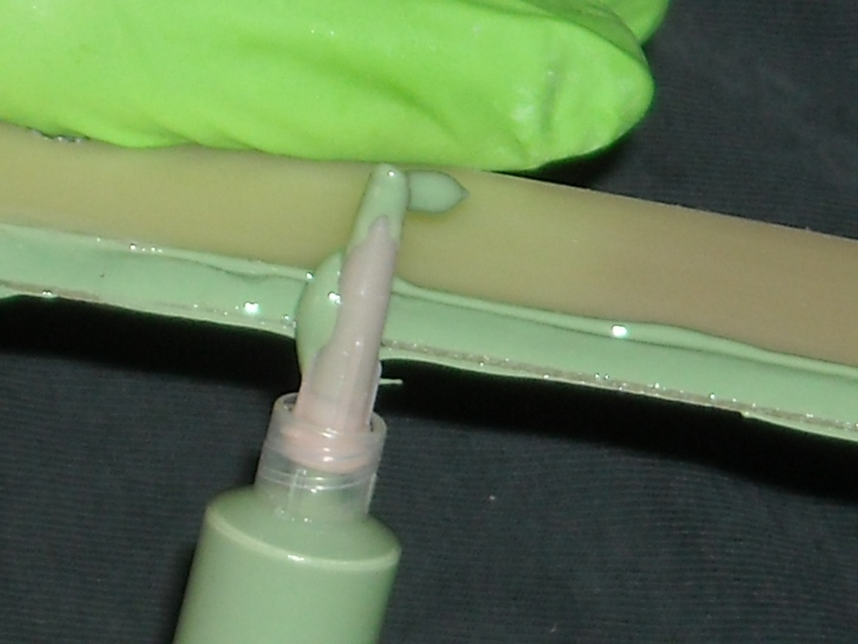

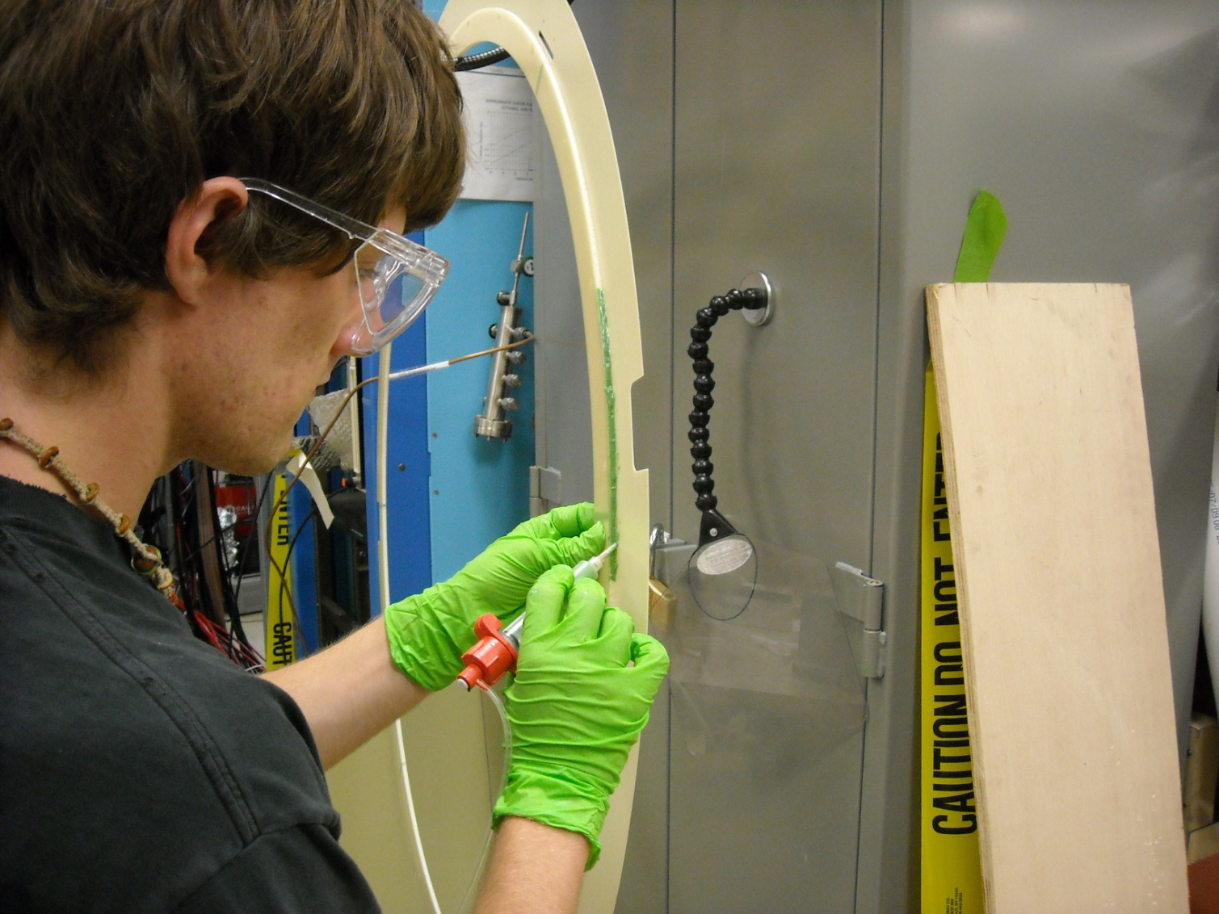

Final step in the initial coating process is to use an alcohol soaked Kemwipe to remove the excess epoxy from the front and back G10 surfaces: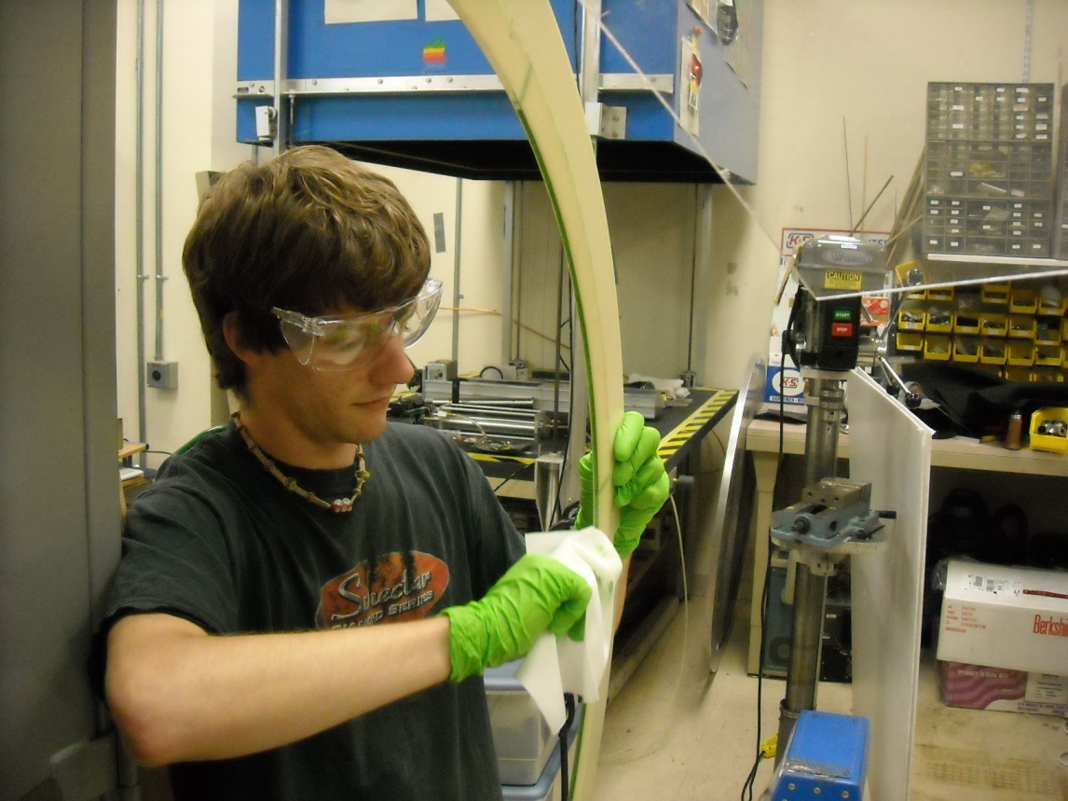
After allowing the Scotchweld to cure for 12 hours, carefully inspect the I.D. and O.D. for holes. Reseal any problem areas found.
Procedure 8: Form the gas passages and seal them with Hysol (also the bolt holes)
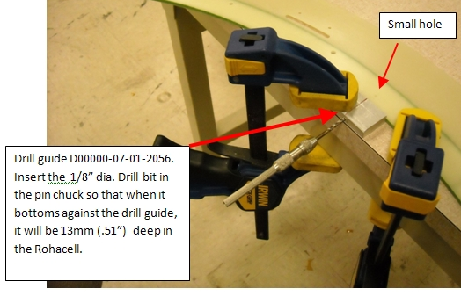
Use the drill fixture to drill the gas passages. Align the centerline mark on the Drill guide with the small hole on the large G10 ring. See pictures below for details- do not exceed specified depth! Use an air applicator syringe filled with Hysol to pressure fill these holes. Vacuum out/blow out/Wipe out excess with a q-tip or something similar.

Shown below is a cross sectional view of what the hole should look like:
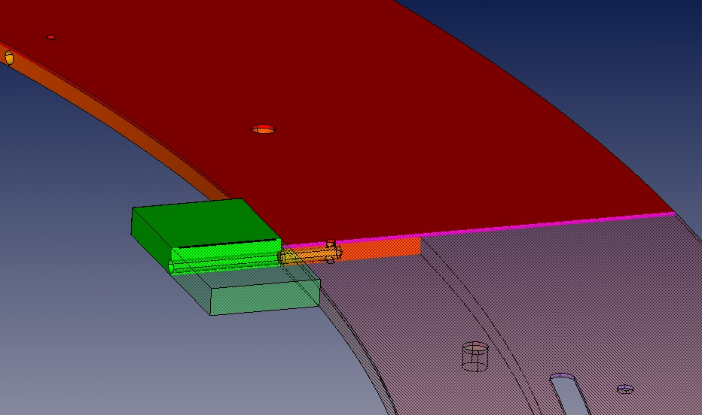

Block the bolt holes on one side, and use a syringe to pressure fill. Use a q-tip to wipe out the excess epoxy afterwards. Clean the G10 with alcohol, and allow to cure for 12 hours.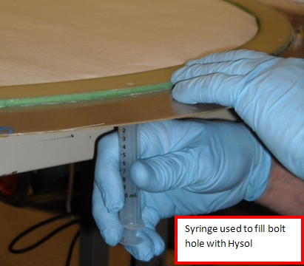
Clean any epoxy from front and back surface of the G10 rings with a razor scraper. Lightly sand both sides.

Procedure 8: Electrical/visual inspection of the cathode foils (somebody take a stab at writing this-)
**Note: the cathode Foils must be stored in a nitrogen purged container when not in use
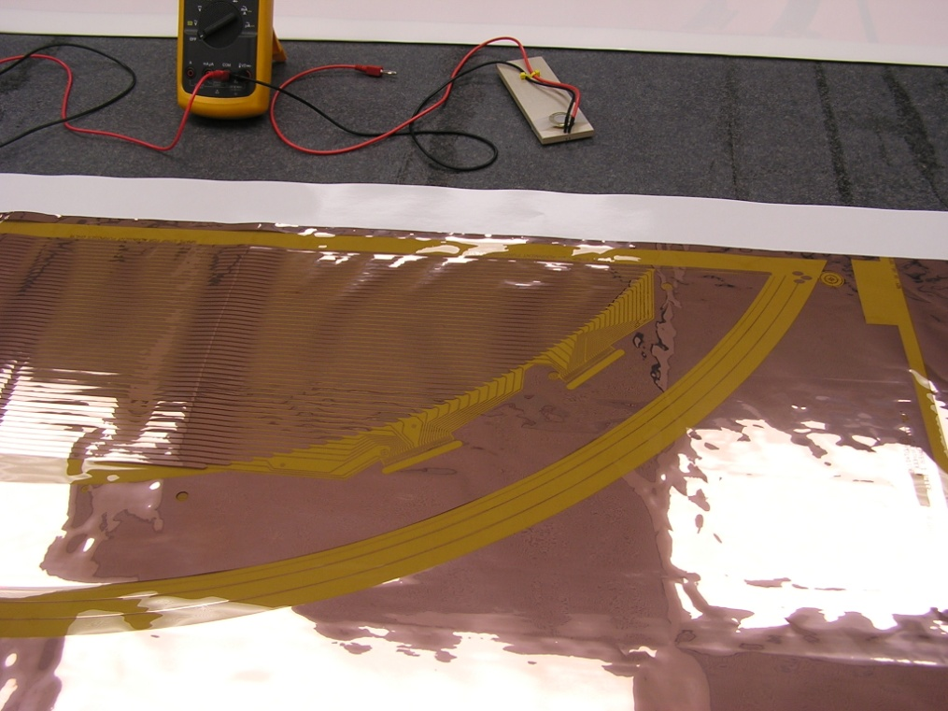

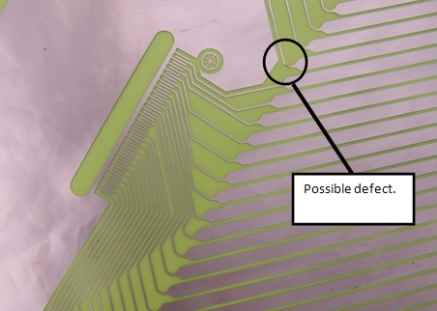

Procedure 8-Cutting the foils
clean the granite table with alcohol. Full clean room procedures apply. Remove a cathode panel from the storage container and transfer to the table, copper side up. Trim the top and bottom of the panel so that the total length is ~56” with equal lengths from both ends of the copper strips.
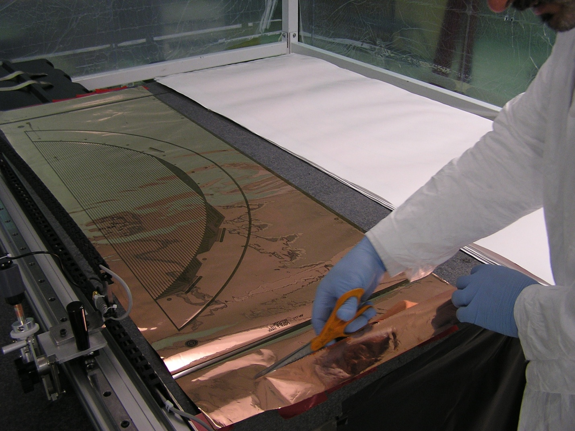
Operator should become familiar with the cutter and make several test cuts on plain Kapton film (or dummy cathode membranes) before cutting the actual films.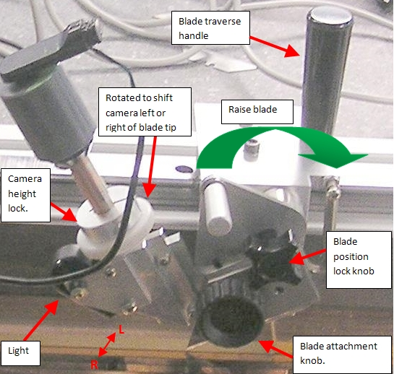
Install a new razor blade in the holder after 6 cuts. Blades should be of the regular tool steel variety- do not use nitride coated blades as they do not have well defined points, making it difficult to determine position or depth of field of the cutting tip using the camera. Lock the blade in the raised position prior to next step.

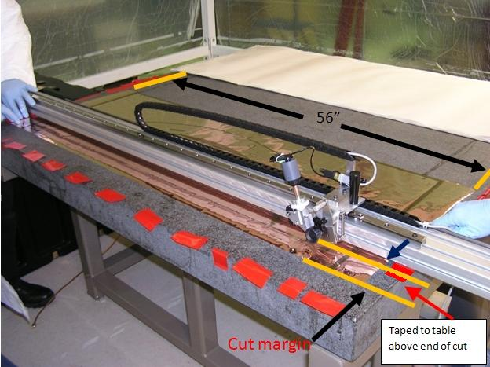
Use 2” wide packing tape to secure the top of the panel to the granite table (centered on the table). This piece of tape should be centered over the copper strip adjacent the area to be cut. Gently tension the bottom end to straighten out the copper strip near the cut area. Secure with tape.
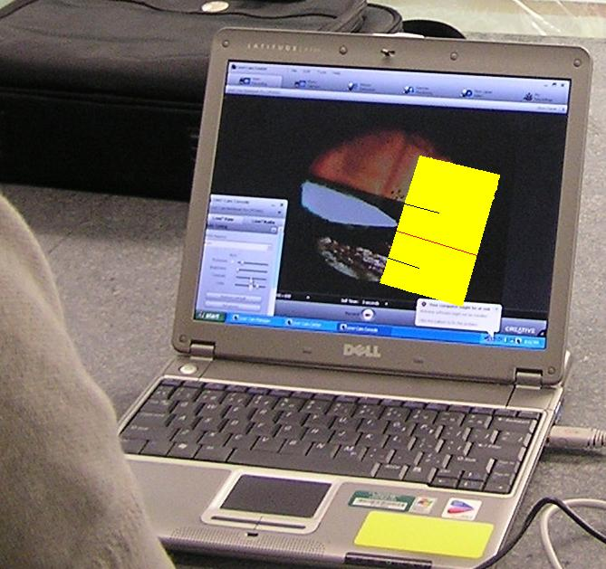
Move the cutter so that the microscope is centered over one of the gaps between cathode strips. Create a width “gauge” by attaching a post-it note to the display, and marking the edges of the copper. Remove the post it, and fold in half so that the marks align. The fold defines the cut centerline.

Fold line

Replace this picture with one where camera is rotated 180 degrees (blade to the right- this image is upside down!)
Marks at edges of copper strips

Move the blade carriage all the way to the left end of the slide travel. This should be over an area of the film that will be trimmed off when the transfer ring is mounted. Unlock the blade, and lower it onto the film. Make a ½” long cut. Reattach the post-it to the screen with the centerline lined up with the cut. The upper and lower marks on the post-it now define the correct position for the film with respect to the cutter.
Picture showing cut and post-it

Move the cutter to the correct cut position, using the post-it gauge at both ends of the copper strip. Clamp the cutter to the table with bar clamps? Recheck to see if it moved, and using a hard plastic hammer, tap it into position (later to add micrometer movement). When the image at both ends of the travel is correct, proceed to the next step.
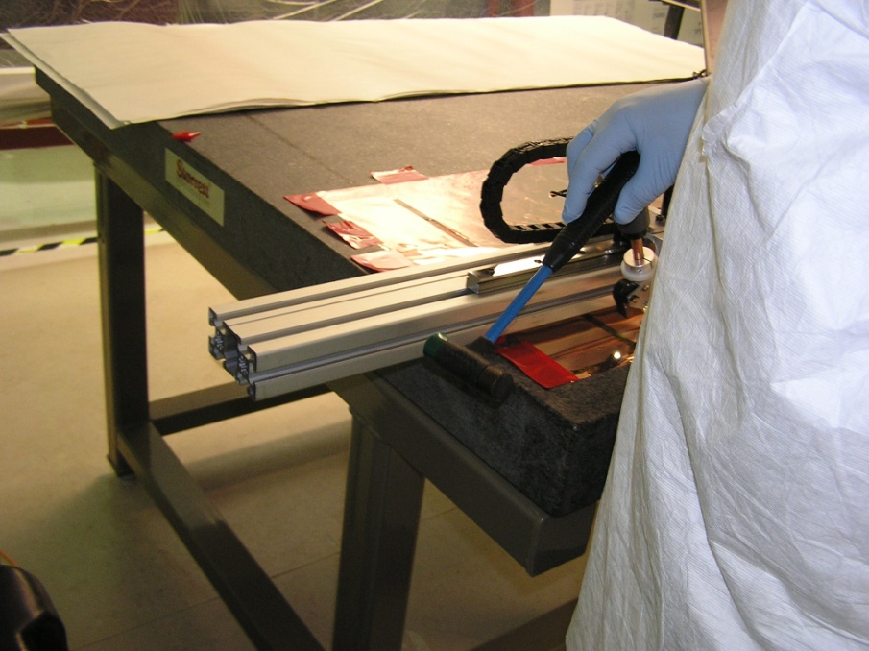

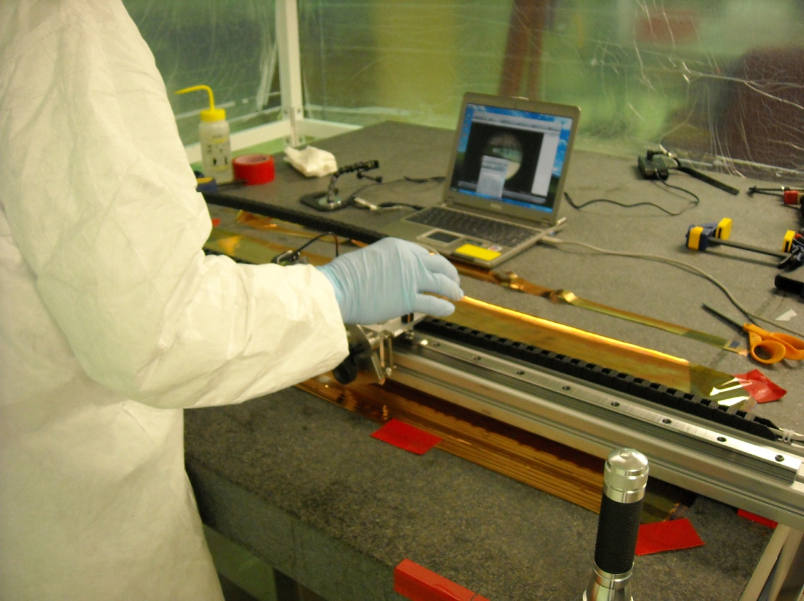
Move the microscope to the middle of the panel. Note which direction the strip needs to move, and place a piece of tape on the side you need to pull. Use the tape to pull the strip into position. Secure both edges to the table with tape.

Piece of tape used to pull, then secure foil. The first of many.

Move left and right of center, and repeat this procedure. Continue until strip is straight.
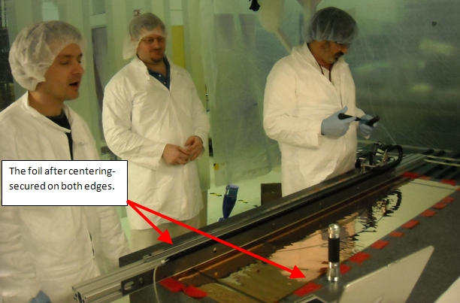
Eight or more pieces of vinyl tape necessary to properly secure.
As a final check, cut the fiducials at both ends of the foil. The cut should look like the picture below.
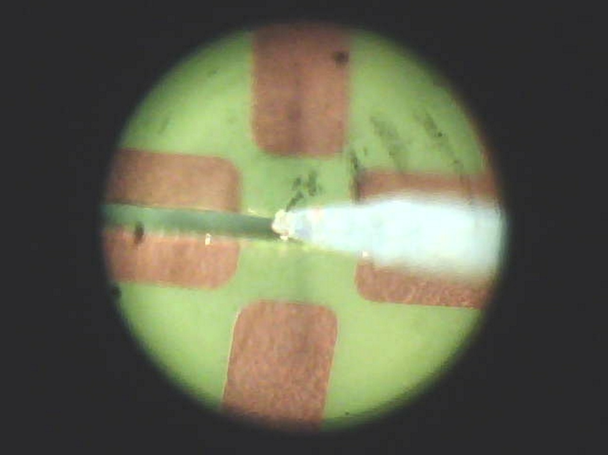

move the carriage back to the left, lower the blade and make the cut in one continuous motion. Repeat this sequence for the remaining panels- change blades after every 6 cuts.

Procedure 9- Assemble the panels. This procedure requires two people. A roll of Red Vinyl tape( stock room #???????) is also required.
PPE- full clean room procedures apply. Safety glasses to be worn when working with alcohol or epoxy.
Clean the surface of the granite table with Alcohol, and inspect for any dust or adhered epoxy and remove. The table must be completely clean for these operations- contaminants would damage the foils! Allow to dry.

Remove a set of cathode panels from the storage container, and transfer to the granite table in the correct positions, copper side up. This is what you should see:
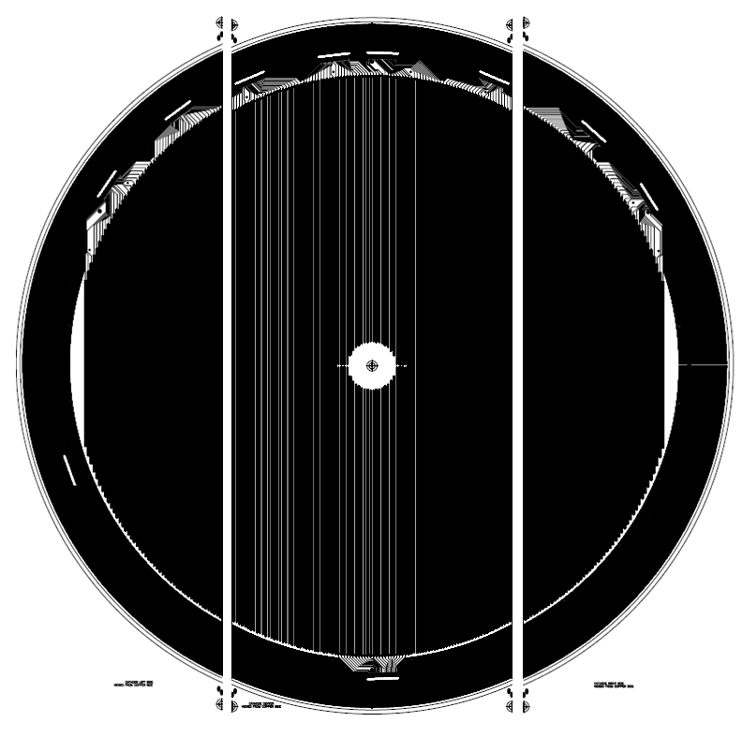

Lift up one edge of a cathode panel, and use a squeeze bottle to cover the granite surface with distilled (de-ionized?) water. Lower the panel, and repeat with the other edge. Repeat until the entire area is wetted.
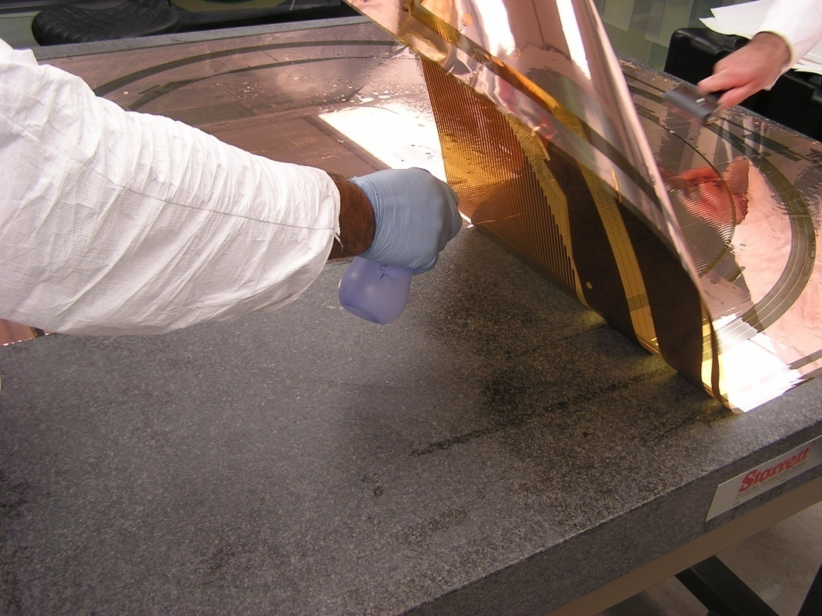
Clean the rubber roller with alcohol and inspect its surface for contaminants. Use the roller to roll out the excess water for the center panel. The roller should be started at the center of the panel, and worked outward to the edges of the panel.
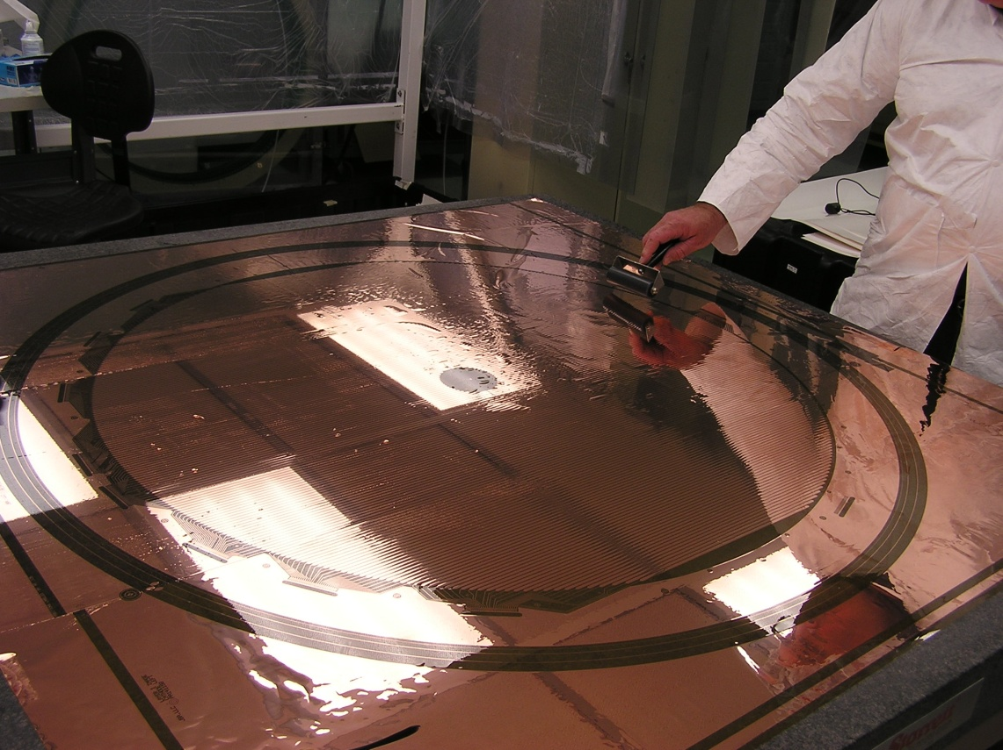

Roll out center panel first.

Start at center and roll out to edges.

Float the left panel on the water film into alignment with the center panel. Use the USB microscope to align the fiducial marks on one end of the panels.
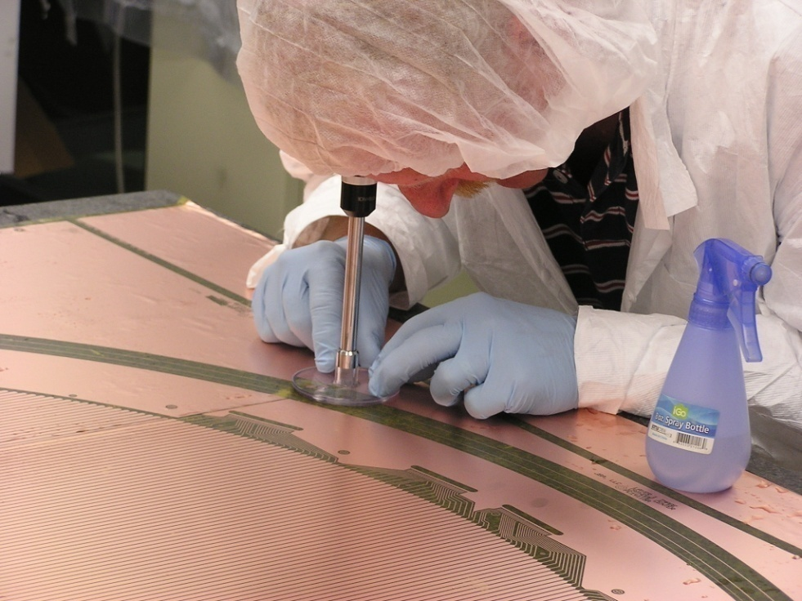

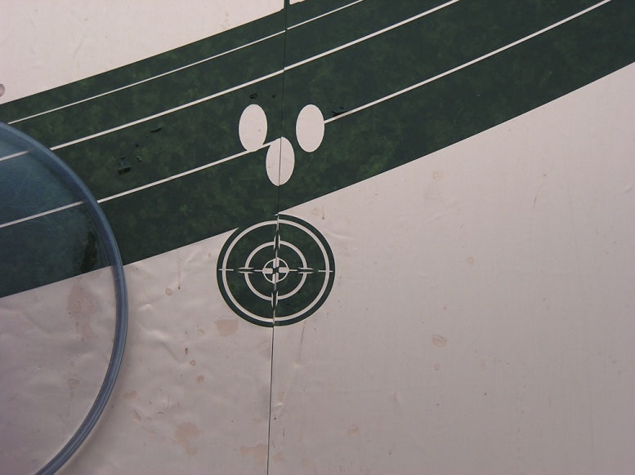

Use the roller working along the joint starting at the aligned fiducial. Roll out the panel, inspecting the gap every few inches with the USB microscope. Use the roller to “nudge” the panel into position. The gap must be very precise- 1mm +/- 0.1. If the panel cannot be rolled or pulled into position, you may have to lift the far edge of the panel off the granite table to break part of the water bond.
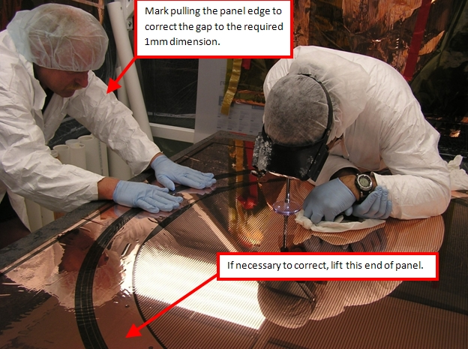

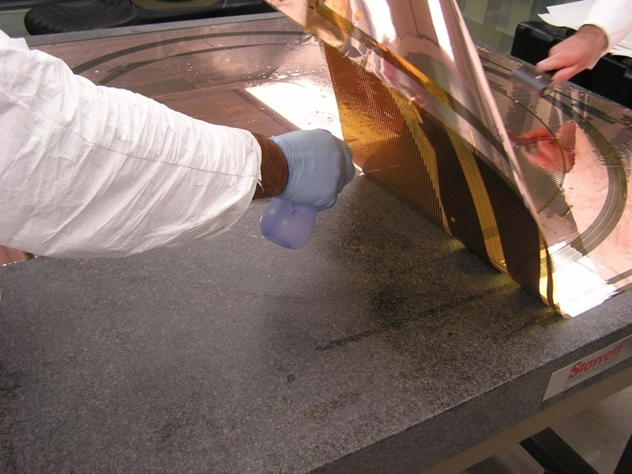
Lift and rewet if necessary.
Bring the entire edge joint into contact using the rubber roller to push/slide the side panel into position. Repeat this procedure with the other end panel.
When aligned, wipe any water from the joint area using a lint free wipe. Blot the water off, try not to wipe, as abrasion could damage the foil. Remove water from the exposed granite surface. The exposed foil surface and surrounding granite should be completely dry.
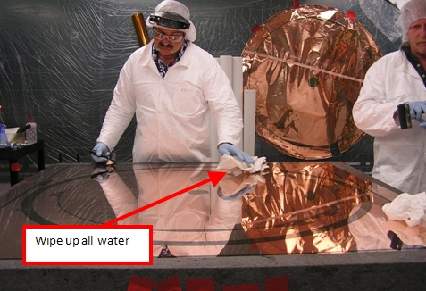

Standing at both ends of a panel joint, secure the end of the red vinyl tape roll to the granite table edge, and hand the roll across the table to the person on the far side. The tape should be under only enough tension required to keep it straight (excess tension will wrinkle the foil when the tape is released). Carefully roll the tape onto the joint. Take your time doing this- one wrinkle in the tape means that you will have to remove the whole thing with acetone and start over!
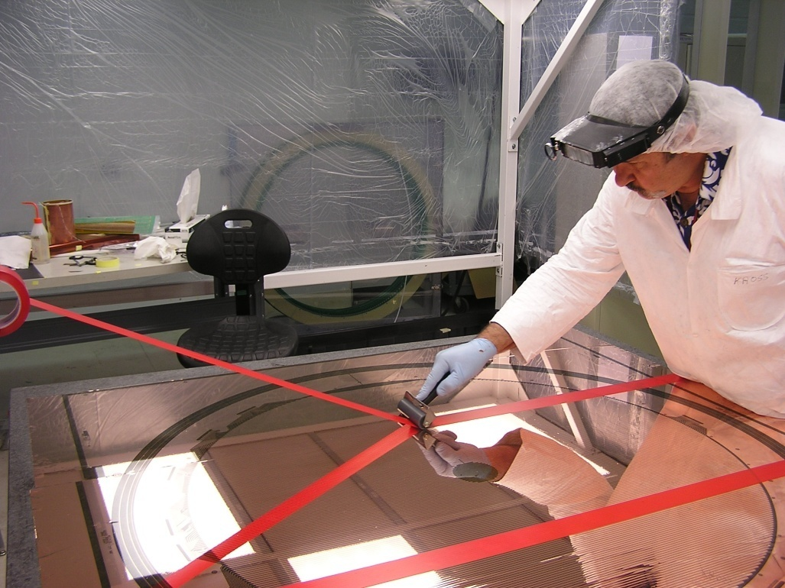
Roll about 1’ above the table.

Tape folds over granite table edge.

Take a tape end loose from the granite table, and fold it back on itself to the edge of the Kapton. Repeat with the other end. These folded ends will provide a “handle” to remove the tape in a later step.
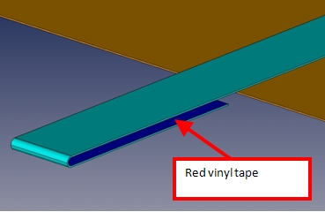
Repeat the preceding steps with the other joint.
Flipping the panels: WARNING! THIS STEP MUST BE DONE CAREFULLY OR PERMANENT CREASES IN THE FOIL WILL RESULT!
The foil will be folded in a direction perpendicular to the joints.A six foot long piece of 3” PVC pipe that has been sanded to remove all burrs and cleaned with alcohol is required for this step. The tube is placed at the center of the foil as shown in the photo below:
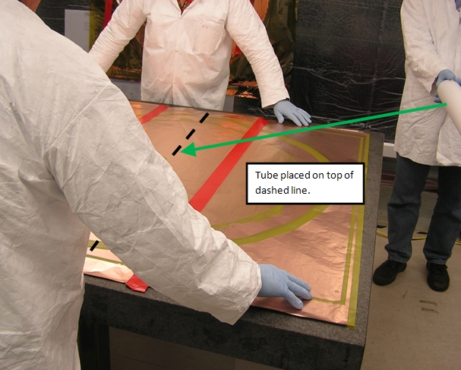
The foil is held at the corners, lifted, and folded toward the far end:
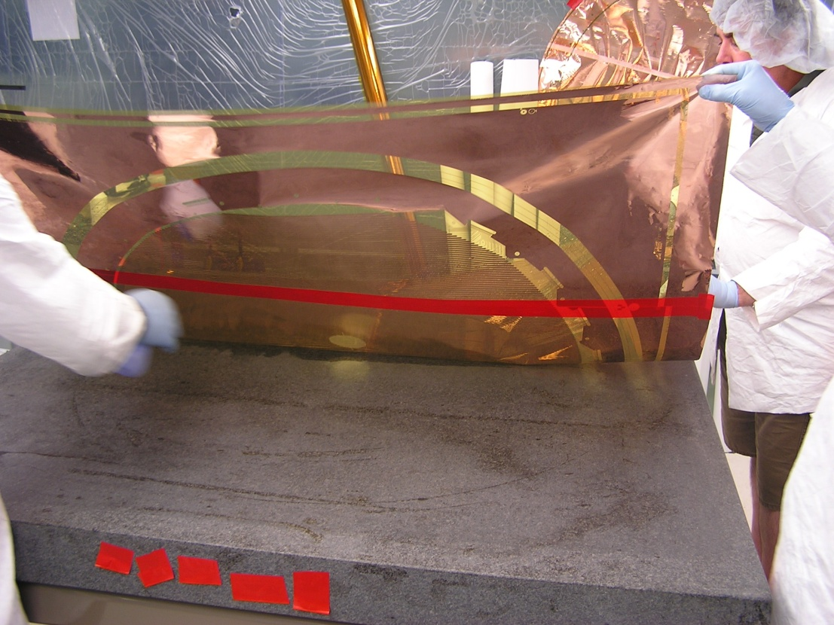
This is actually the second flip to allow removal of the red tape- get new photo

Tape the corners indicated to the table. Lift the tube ~6” off the table and move as indicated to complete the flip:
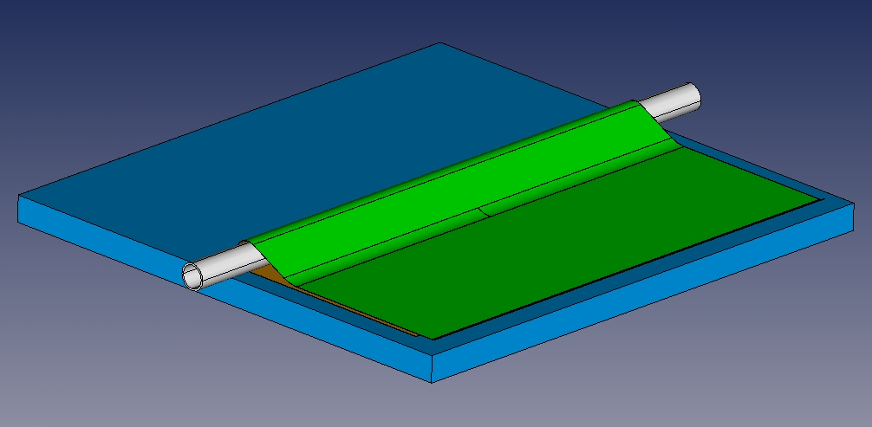
Tape these corners to granite table.

Lift the edges of the panel and wet the table with water from the spray bottles as previously described. Roll the panel out flat. Wipe up any water from the exposed surface. 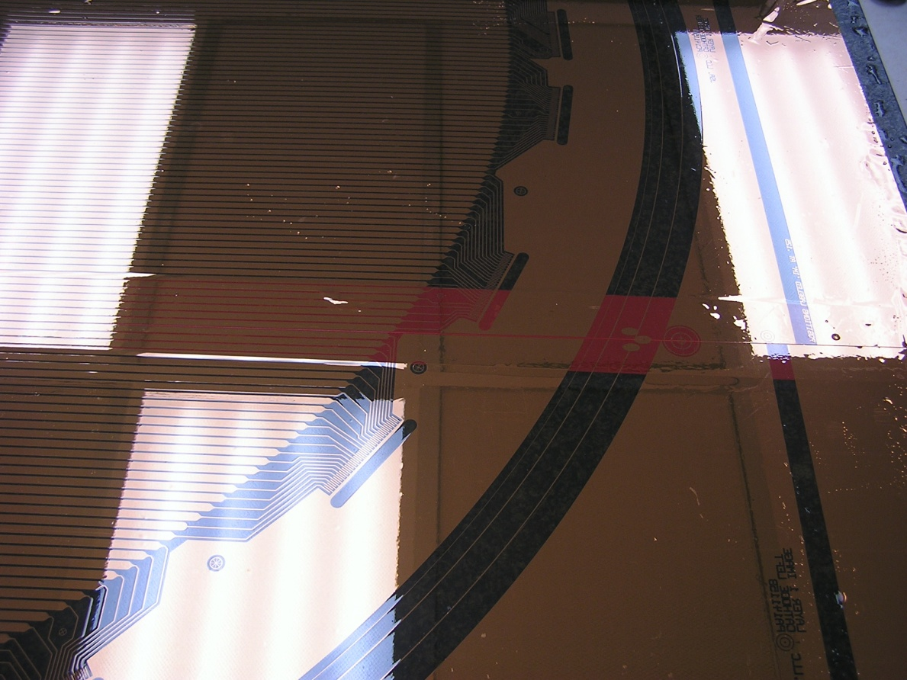

Cut two pieces of the Kapton tape to the length of the panels plus 6”. Lay these out side by side on the granite table on top of wax paper.
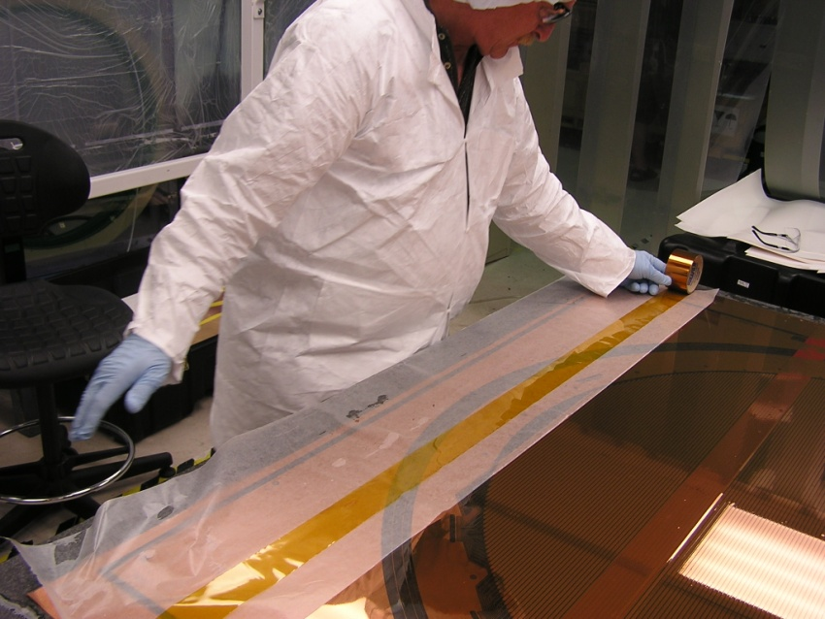
Mix a small cup (~20 cc) of Hysol RE2039 Resin and HD3561 hardener with a 3:1 ratio by weight.
Use the foam roller on the plastic pallet as previously described. Apply epoxy to the tape strips once the proper coat is achieved.

This step is similar to the procedure used to apply the red vinyl tape. Place pieces of wax paper on top of the exposed areas of the granite table at each end of a seam. Standing at both ends of the table, stretch the Kapton tape over the panel joint. Carefully lower one end into contact with the seam, with ~3” overlapping onto the wax paper. Roll out the tape with the hard rubber roller until all air bubbles are gone:
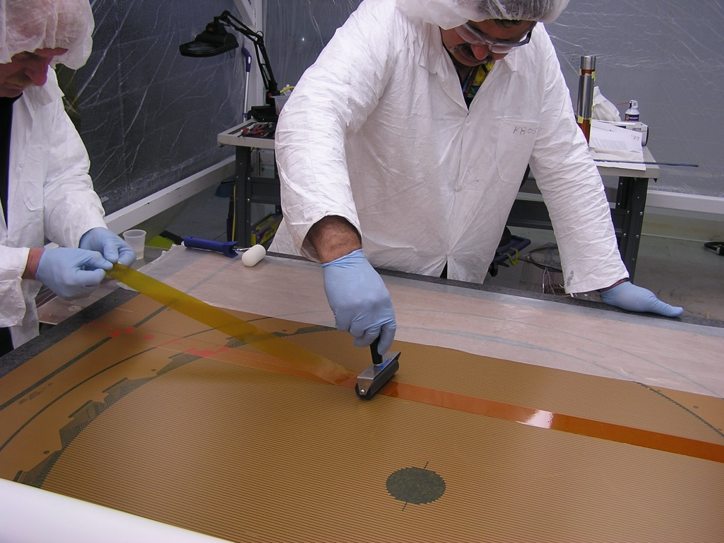
Use an Alcohol soaked wipe to remove excess epoxy from the edges of the Kapton tape and the granite table. Allow to cure for 24 hours.
Use the previously described procedure to flip the panel.

Fold back the end of the red vinyl tape, exposing the adhesive. Apply acetone directly to the bond line. The acetone will completely soften the adhesive, allowing you to slowly pull the tape away with essentially zero tension. Keep the pulled end close to the table- pulling upwards can damage the foil. Maintain the acetone film and remove the tape. DO NOT STOP DURING THIS PROCEDURE- IF THE TAPE IS LEFT TO SOAKED IN ACETONE WHILE STILL IN CONTACT WITH THE KAPTON, THE ADHESIVE WILL DEBOND FROM THE VINYL, LEAVING A MESS ON THE KAPTON!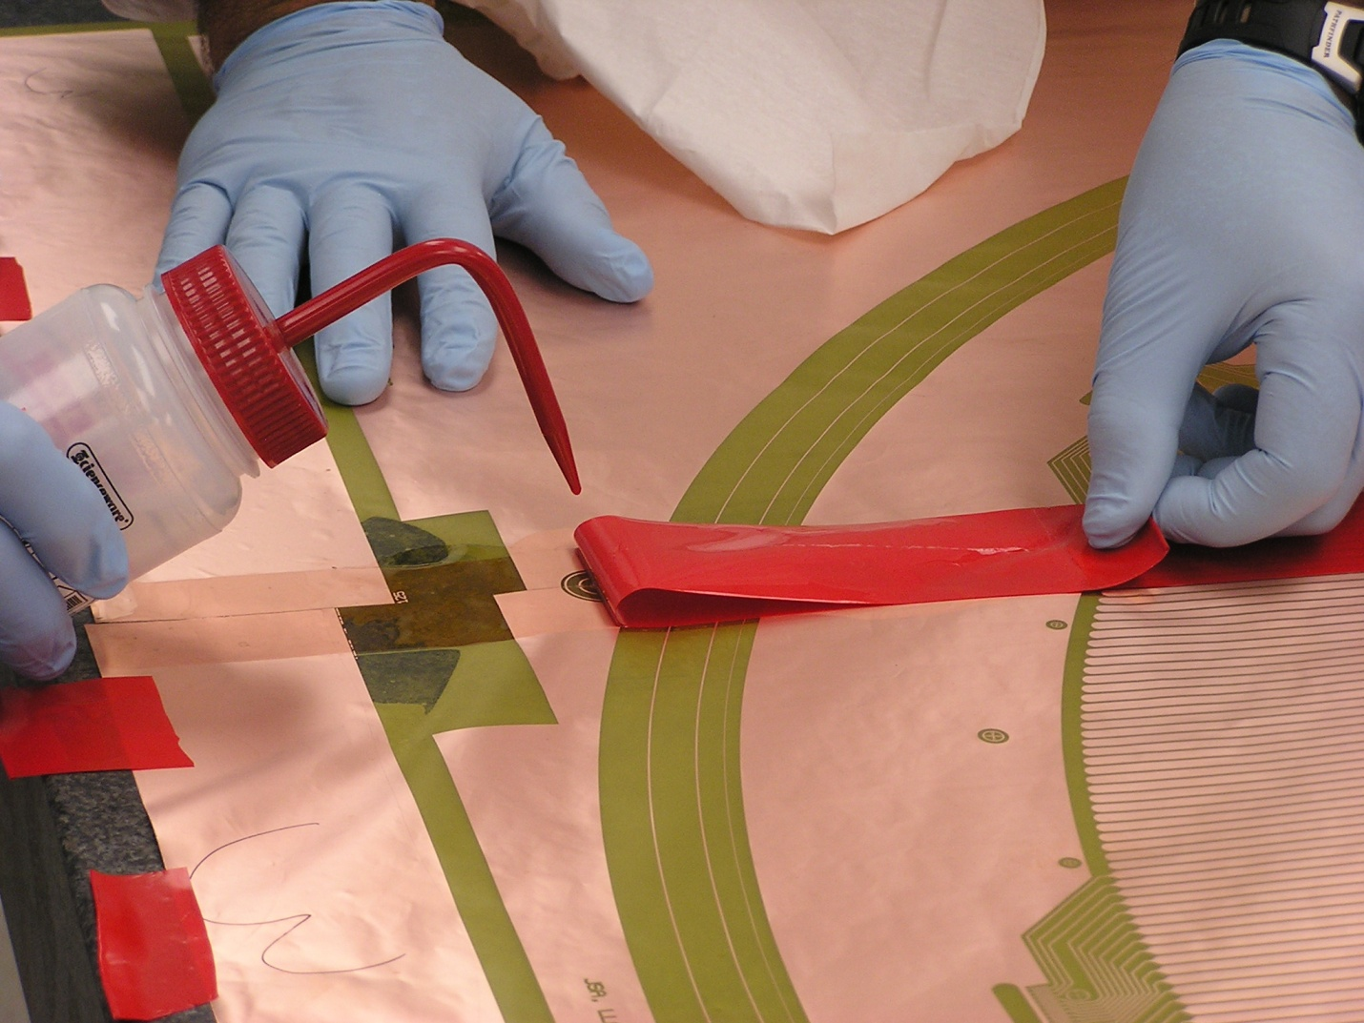
Use an acetone soaked wipe to remove any tape residue from the assembled cathode panel. Follow this with an alcohol soaked wipe.
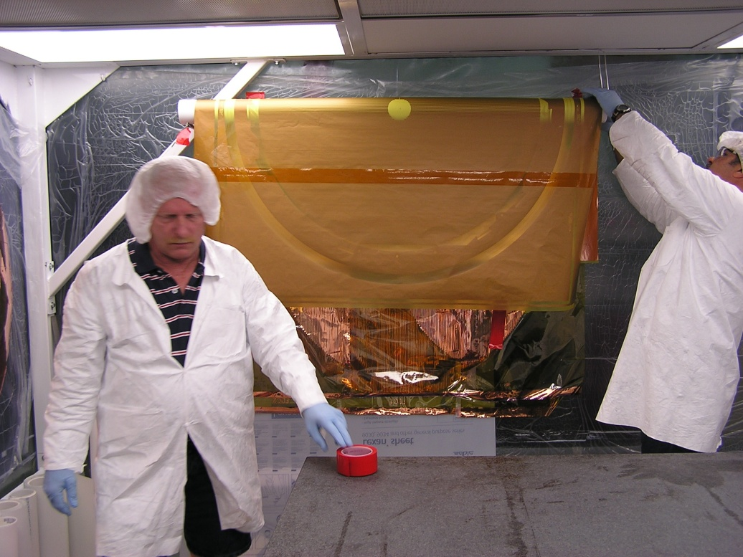
Slide the assembled panel off the table onto a second piece of PVC pipe for temporary storage:

Procedure 10: glue the cathode panel to the fiberglass transfer ring.
The transfer rings “accumulate” layers of Kapton every time they are used. At some point, the flatness of the transfer ring becomes an issue, and the layers must be removed. If this is necessary, use an orbital sander to remove Kapton film from the fiberglass transfer ring D00000-07-01-2039. Do this outside. PPE for this step- painting NIOSH approved respirator and safety glasses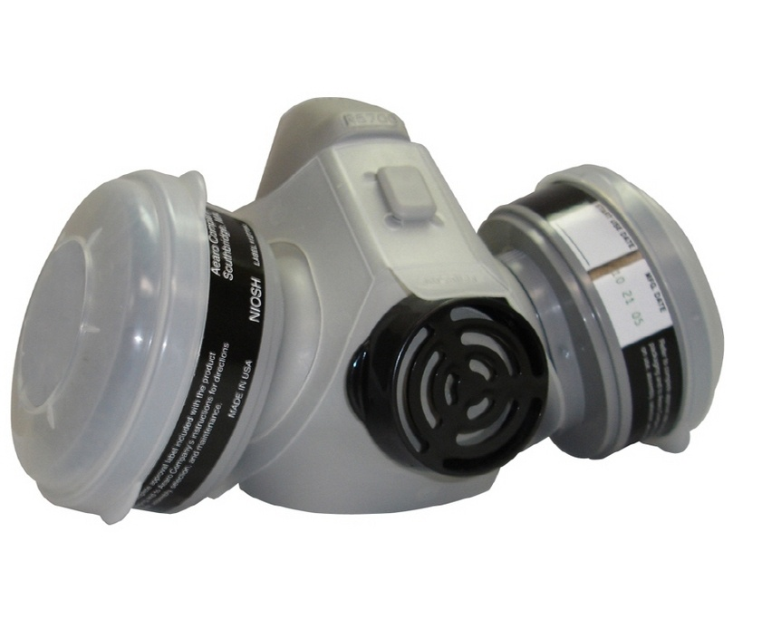
Clean the ring with Alcohol and return it to the granite table with wax paper underneath.
Mix a small cup (~20 cc) of Hysol RE2039 Resin and HD3561 hardener with a 3:1 ratio by weight.
Use the previously described procedure to load the foam roller with epoxy. A heavier coat than previously used is recommended. Coat the ring.
Move the coated ring and wax paper off the granite table (hang it up or place on another table). Clean the granite table with alcohol and remove any solid debris.
Return the assembled foil to the table top, copper side down. Use pieces of red vinyl tape to secure the edges, taking care to stretch the foil out as flat as possible.
Supporting the transfer ring from both sides of the granite table, it should be carefully lowered onto the Kapton film without sliding. The I.D. of the transfer ring should be aligned with the inner diameter mark on the cathode film shown in the previous picture.
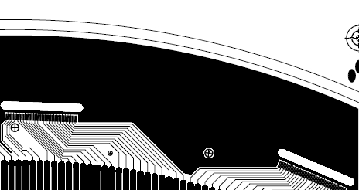
Weigh the transfer ring down and allow to cure for 24 hours. Trim the excess Kapton from the O.D. of the ring. Turn the ring over, and use an exacto knife to cut the film from the small holes.
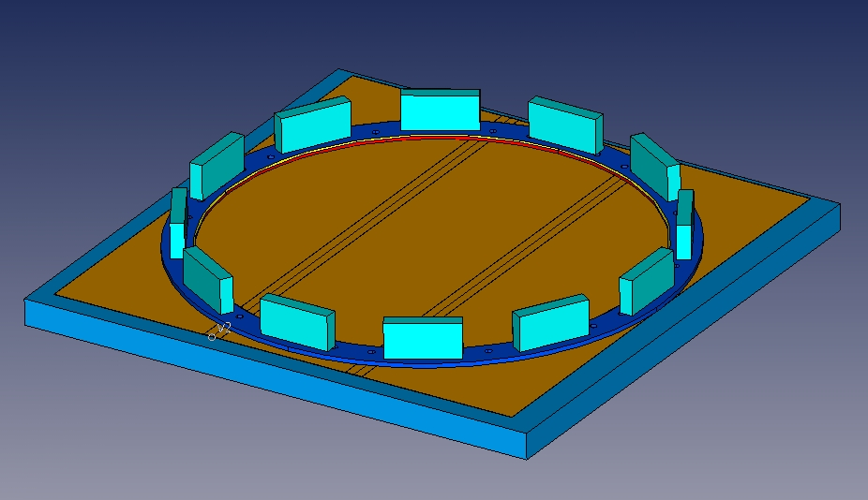
Procedure 11: Tensioning the Cathode membrane and gluing to the lamination
Place the transfer ring on the tensioning fixture copper side down, and then gently lower the aluminum clamp ring on top of it. Add the 12 springs (McMaster XXXXXXX), 24 flat washers and 12 nuts (½-13). Install the blue support posts, and place the tension measurement bar on a set of posts as shown below. The nuts are tightened in small increments to an initial uniform height of XXXXXXX .Two readings are taken- one with only the shim washer (necessary as the laser does not read well off the clear Kapton in the center), and one with the weight ring (white ring in the picture) in addition to the shim. This is the link describing how to access laser data: http://www.jlab.org/Hall-D/software/wiki/index.php/HOWTO_Read_the_laser_in_real_time
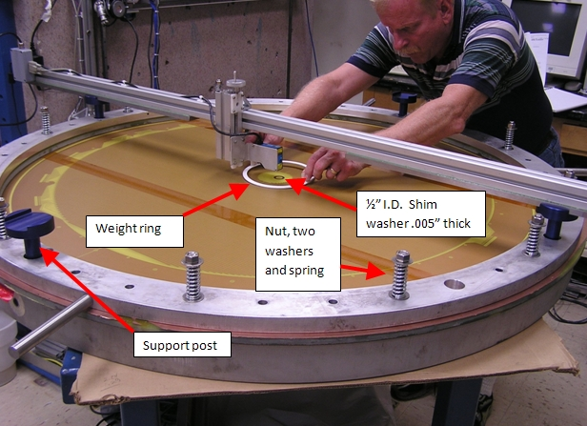
Need specifics (weight, dimensions) for the weight ring and any procedure info from Mark/Eugene on taking reading. Hyperlink to Eugene’s spreadsheet and a readme file.

Record the tension values, and then allow the membrane to relax for 12 hours. Take the readings again. Final tension should be greater than 500 N/m in both directions- increase tension if required. Remove the measurement bar and support posts from the tensioning frame.
Procedure 12: gluing the lamination to the membrane
- Form four equally spaced masking tape “handles” on the back side of the large G10 ring as shown below. These will be used to lower the ring onto the membrane after coating with epoxy.
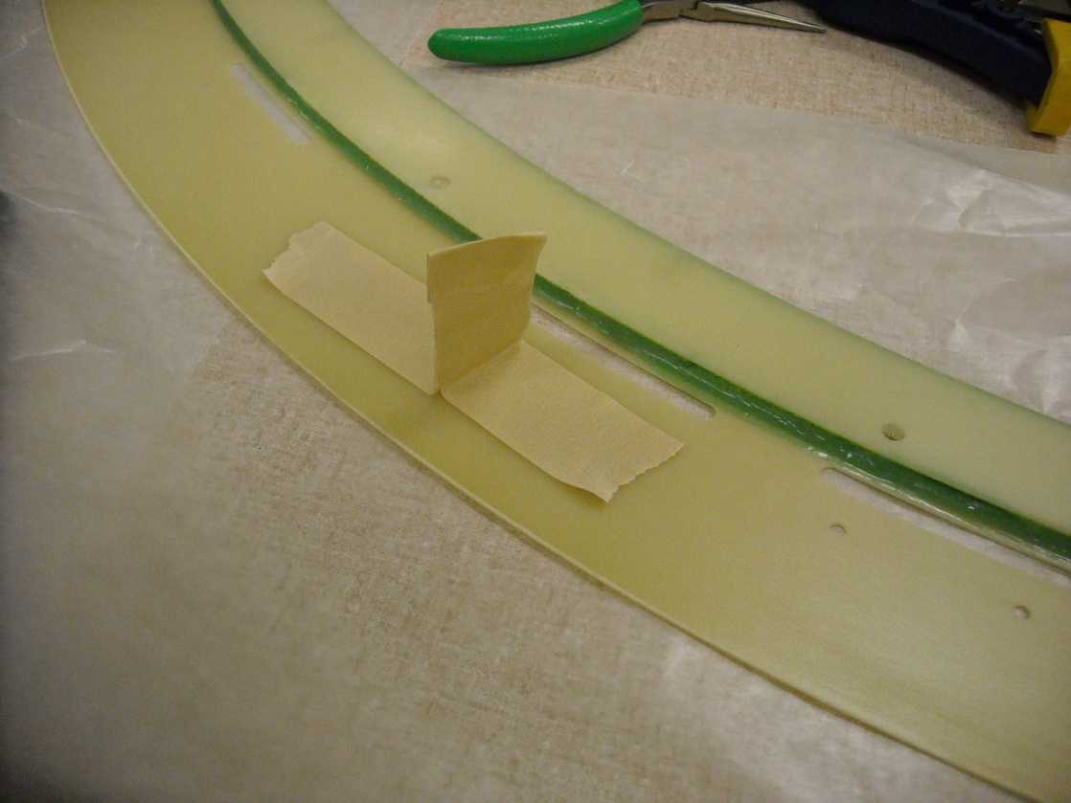

- Use the previously describe procedure to mix approximately 30 cc of the Hysol epoxy. Place sheets of wax paper on a work table, and the lamination on top with the wide G10 ring face up. Cover the areas shown below with small pieces of either masking tape or the red vinyl tape (these are kept epoxy free to allow local bonding with instant adhesive). Coat the ring with epoxy, and remove the tape pieces.
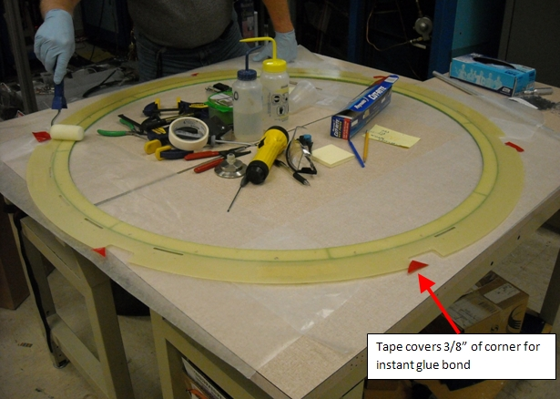

- Note the orientation of the preamp locations on both the membrane and the lamination, and then using the masking tape “handles”, carefully lower the lamination onto the membrane, taking care not to slide the lamination. Tack the corners of G10 that were left “dry” to the membrane with instant adhesive (Loctite 406)
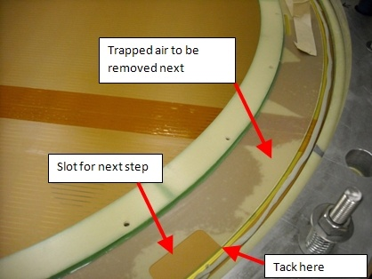
- Use the hard roller to work the air bubbles to the O.D. and slots. Remove as much as possible.
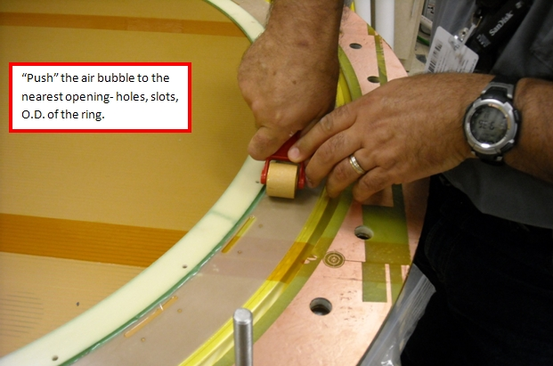

- Weigh the lamination down using 20 lead blocks. Note that 3/16” thick aluminum shims are used to account for the step in the lamination (shims are 3/16” x 1” x 2”). Allow to cure for 12 hours.
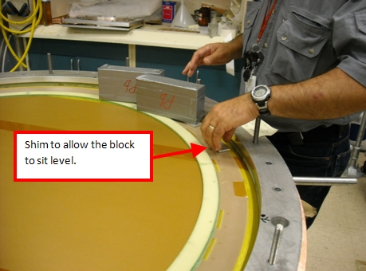

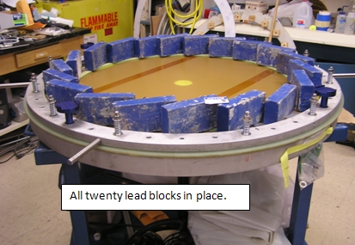

- Remove the lead blocks and shims. Remove the springs and washers. Remove the aluminum clamp ring.

- Clean a work (granite?) table with alcohol. Inspect the surface to make sure there are no burrs or debris that could damage the cathode membrane. Move the transfer ring to the table, copper side down. Use a new exacto blade to cut the membrane free from the transfer ring on its I.D. Take care not to slide the cathode on the table during this operation as this could scratch the membrane (lift it if necessary to reorient).Set the transfer ring aside, and turn the cathode copper side up for the next operation.
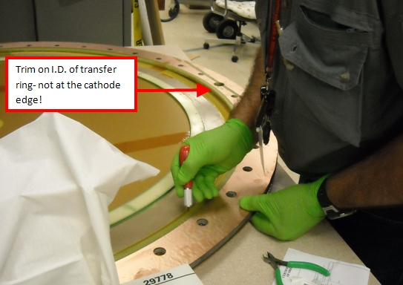

- Locate the large slots in the O.D. of the G10 ring, and press the membrane down along the slot edges to create creases in the copper, effectively making the slot visible from the top. Use a razor blade to trim the membrane to the O.D. of the G10. DO NOT CUT THE SLOTS OUT, AS THESE WILL BE USED TO FORM THE GROUND CONNECTIONS!
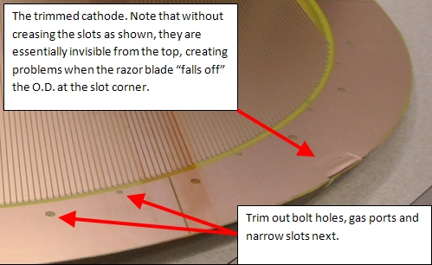

- Use an exacto knife with a new blade to cut out the gas ports, bolt holes and narrow slots for the daughter boards. Note that many of these openings are in close proximity to circuit traces- take great care in these areas and work slowly- if the blade snags at tears the Kapton, the board could be ruined!

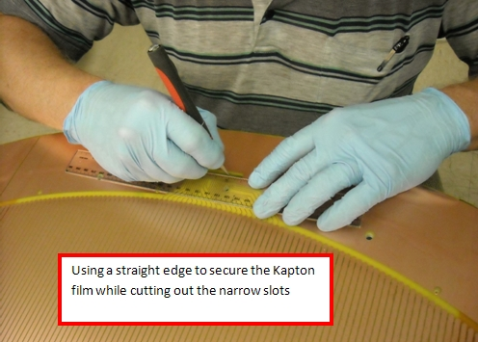

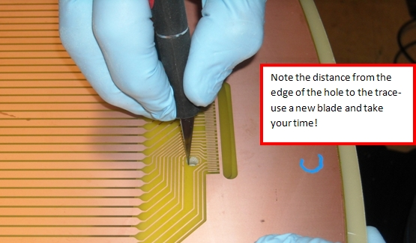

- Use the .221” diameter reamer to clean excess epoxy out of the bolt holes.

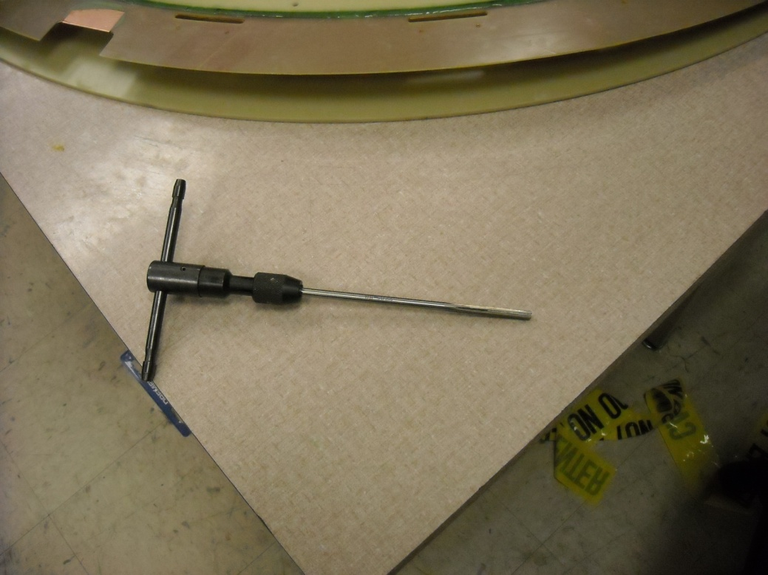
***** AT THIS POINT, THE CATHODES ARE ASSEMBLED INTO THREE DIFFERENT CONFIGURATIONS. CONSULT THE PROJECT MANAGER TO DETERMINE THE QUANTITY REQUIRED OF EACH!
Procedure 13: Final assembly of Cathode types 1-3- attachment of ground pigtails and ground planes.
- Cathodes that will be glued in pairs come in two flavors- one without a ground plane, and one with (.0005” thick Mylar aluminized on both sides) a ground. These are configurations 1 and 2. Construction is described below:
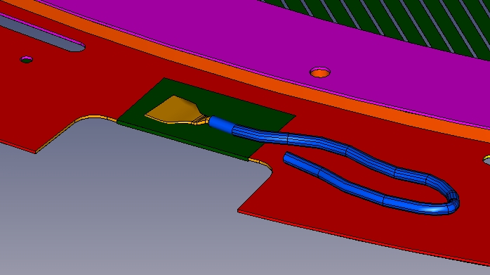
CONFIGURATION 1
Cathode to be glued as a back to back pair. This cathode does not have a ground plane.

1”

To complete fabrication of a type 1 cathode:

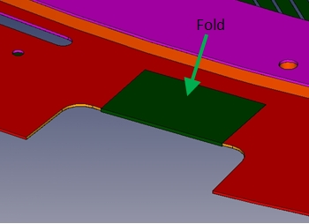
- Place the cathode on the clean table copper side down. Mix up ~ 15 cc of Scotchweld epoxy. Cut the membrane in the slots along the slot sides, and fold as shown to create ground attachment tabs on the back side of the G10 ring. Work out all of the air bubbles, and then clean the exposed copper and surrounding G10 with alcohol. Cover the bond area with either wax paper or polyethylene sheet, and clamp the flap. Allow to cure for 12 hours.

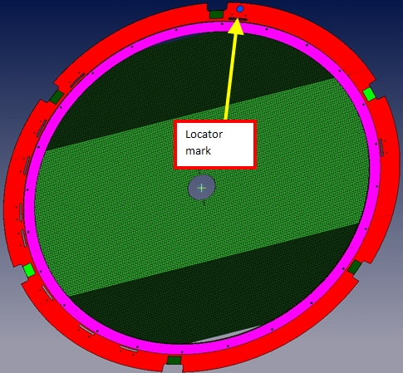
- Use a magic marker as shown in the photo below to mark the location for the grounding card. This mark will be used for location purposes in later steps.

The type 1 cathode will require 6 wire pigtails for bonding to the flaps. Fabricate them as described below:
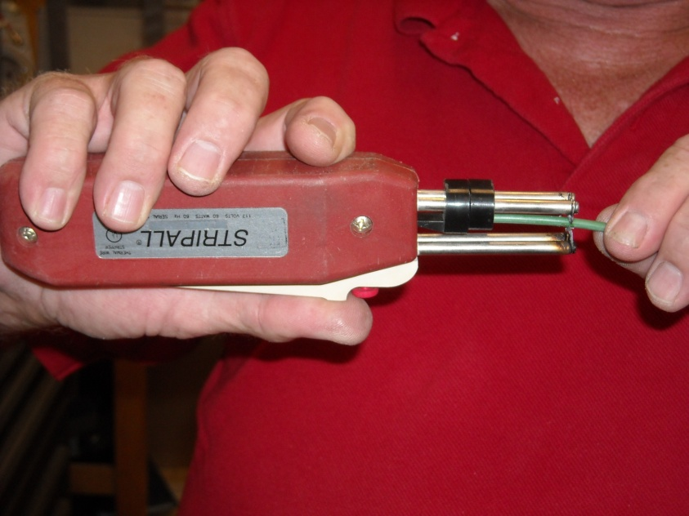
- Use a thermal wire stripper (Teledyne Stripall TC-1 shown below) to remove insulation from a 12” long piece of 16 gauge XXXXXXX wire. Remove 1” on one end, and 5/16” on the other.

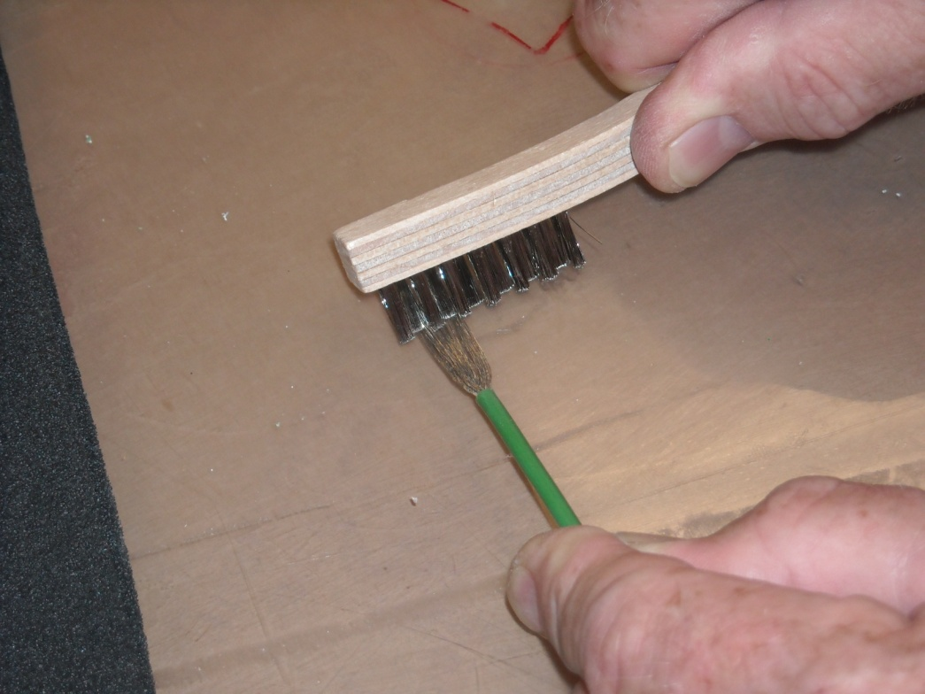
- Untwist the wires on the 1” long end, and comb them out flat with stockroom brush #5170-10015 as shown below. The fan width should be about 5/8” when complete. Clean the wires with an alcohol soaked wipe.

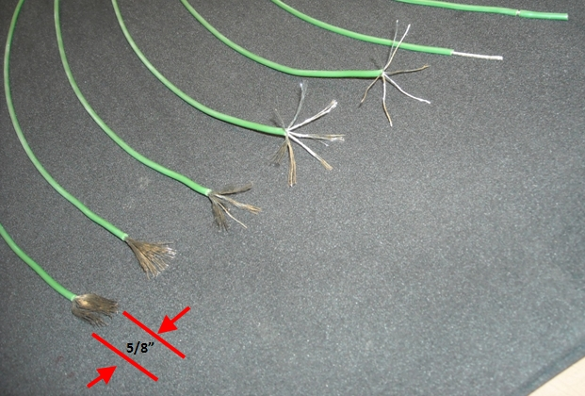
- Use the crimper shown or equivalent to crimp the male connector piece (Digikey #10-314980-16P-ND) to the other wire end. Put the female end (Digikey #10-257982-16F-ND) on the male (to keep track of it, and to protect the male end from damage).
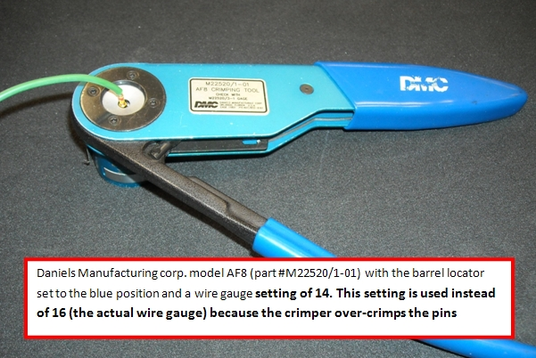

- Take one of the premeasured 2.5 gram conductive epoxy pack (Loctite 3888), and place it on a table. Use the hard roller to break the seal between the two package compartments. Roll back and forth to thoroughly mix the epoxy.

- Cut the entire end of the package open as shown. Put the fanned out wire end inside the open pack, working the package to force epoxy into the wires. Also apply a layer of epoxy to the ground fold?
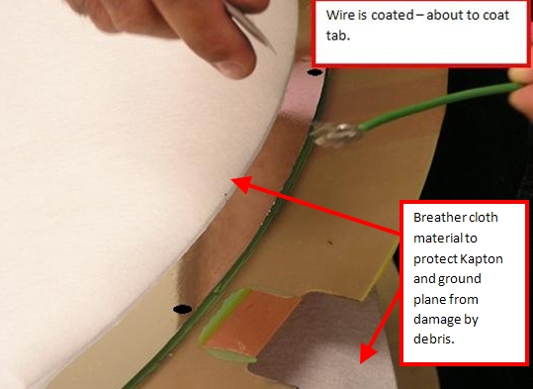

- Place the wire as shown in the previous photo and cover with a piece of polyethylene or wax paper, then clamp as shown and allow to cure for 12 hours.
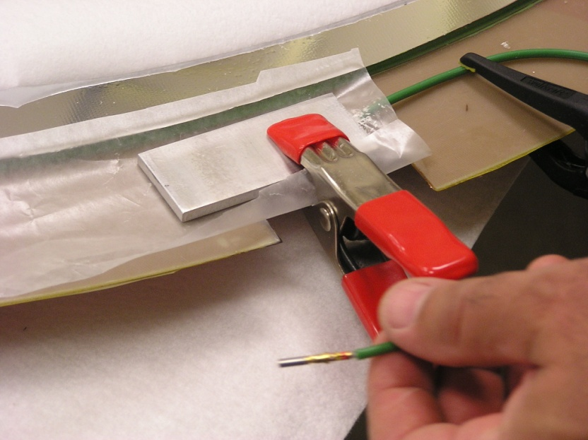

- Remove the clamps and thoroughly coat the epoxy bond with Humiseal 1B31 Acrylic coating (brush only- do not use spray!). Apply Scotchweld to approximately 3/8” of the insulation to act as a strain relief as shown below. Next operation for the type 1 cathode will be gluing to the type 2.
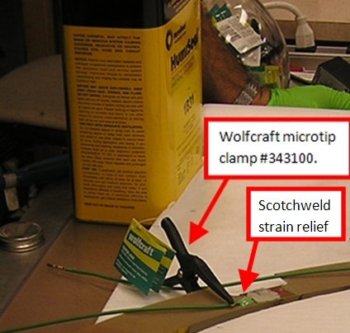

This completes assembly of the type 1 cathode. Temporarily store the cathode in dry nitrogen gas. The cathode should be held flat during storage.

Completing the fabrication of the type 2 cathode. WARNING! DO NOT FORM ANY GROUND FLAPS UNTIL THE GROUND PLANE IS ATTACHED!

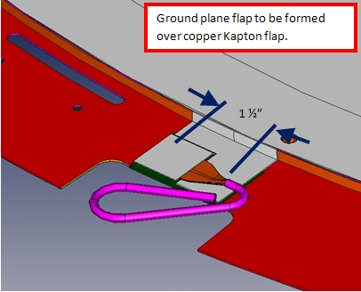
CONFIGURATION 2
Cathode to be glued as a back to back pair. This cathode has a ground plane.

Fabrication of the type 2 cathode is as follows:
- Make up 6 pigtails as described in the type 1 procedure, but make the fanned wire length
1 ½”.

- Use the steps described in procedure 10 to glue the aluminized Mylar film to the transfer ring. Allow to cure for 12 hours, and trim the excess material from the O.D.

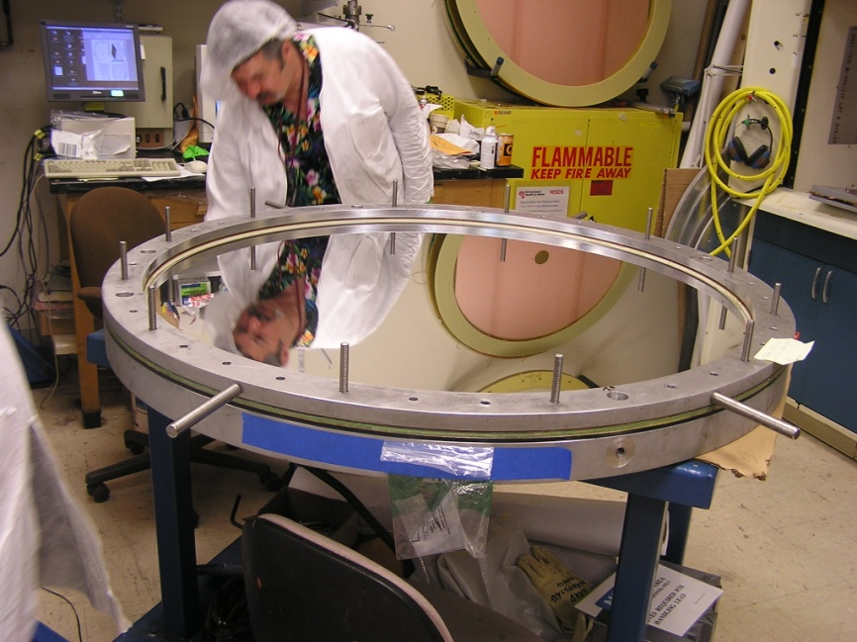
- Tension the ground plane as described in step 11. Tension should be a minimum of 270 N/m.

What parameters are changed in Eugene’s spreadsheet? Hyperlink to this document and a readme file

- Trim the O.D. of the Kapton and cut out holes and small slots as described previously. DO NOT FORM GROUND ATTACHMENT TABS AT THIS TIME.

- Place the 3/16” aluminum shims (used previously in procedure 12) on the supported area of the membrane as shown below:
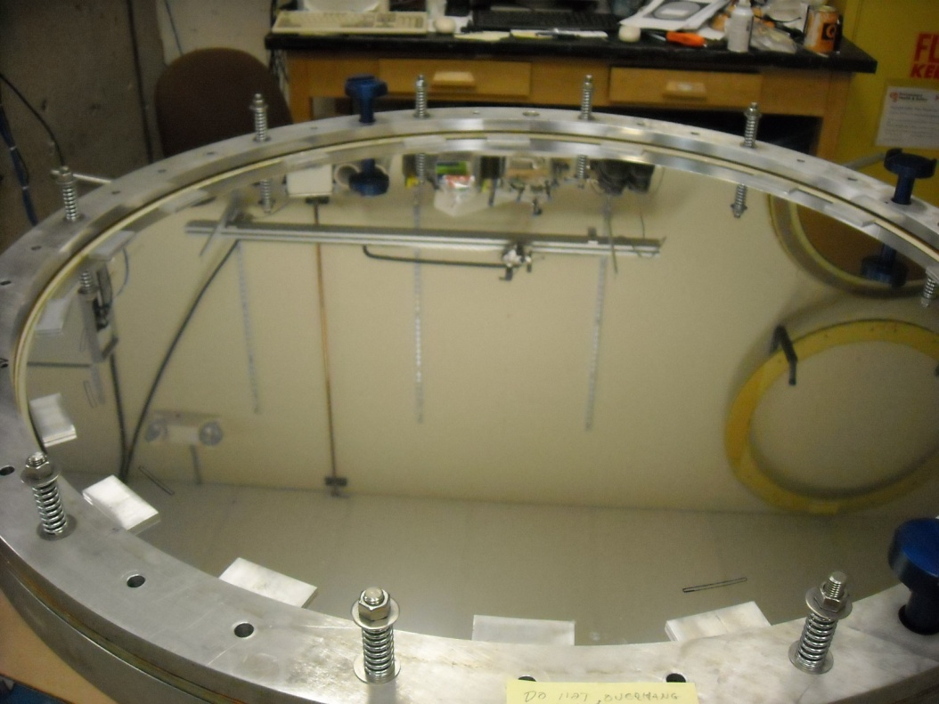

- Form four masking tape handles by feeding masking tape through four of the daughter board slots from the backside. See second photo below for locations.

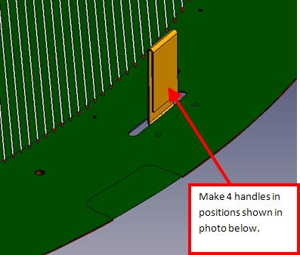

- Two people required for this step. Dry fit the cathode to check that the shim placement is okay- you may have to relocate the shims slightly to make sure that they do not align with the large slots in the G10. Use a magic marker to mark the aluminum clamp ring and the cathode so you can relocate after coating with epoxy.

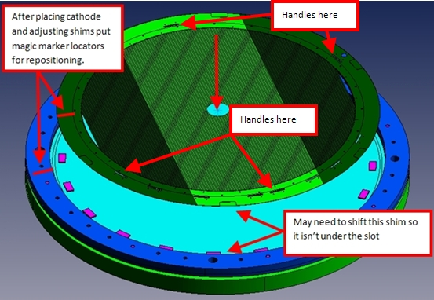

- Clean a table with alcohol and lay the cathode copper side down. Use a round glue shield cut from breather material to protect the back side of the membrane while applying glue to the small G10 ring. Use the foam roller as shown to apply epoxy. After application, use an alcohol soaked wipe to clean any epoxy splatter from the back side of the large G10 ring and the exposed Kapton in large slots.

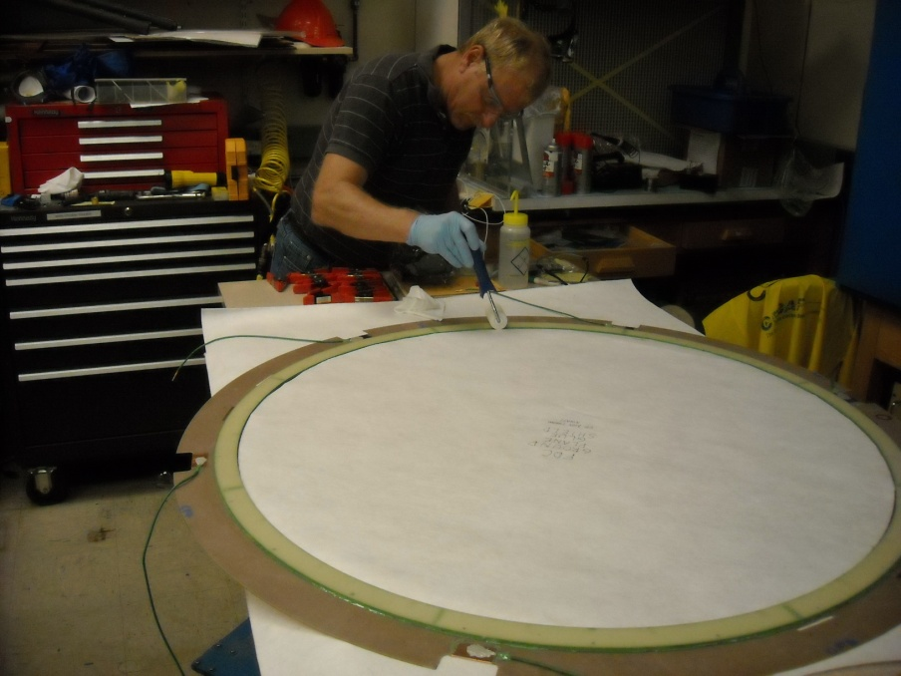
Need a picture to replace this one- NO WIRES ON TYPE 2 CATHODE AT THIS TIME

- Use either dry nitrogen or a well filtered compressed air source to blow any dust particles off of the tensioned Mylar film and the back side of the cathode. Do this carefully and inspect with good light- anything left behind will be permanently trapped inside the cathode!

- Flip the cathode and use the masking tape handles to carefully lower it onto the stretched ground plane WITHOUT SLIDING (sliding would coat the aluminum and prevent it from bleeding off electrical charge).

- Weigh down the cathode ring in a manner similar to procedure 12, with one difference- THE LEAD BLOCKS MUST NOT OVERLAP THE UNSUPPORTED MEMBRANE! Arrange as shown below and allow to cure for 12 hours(19 blocks used):

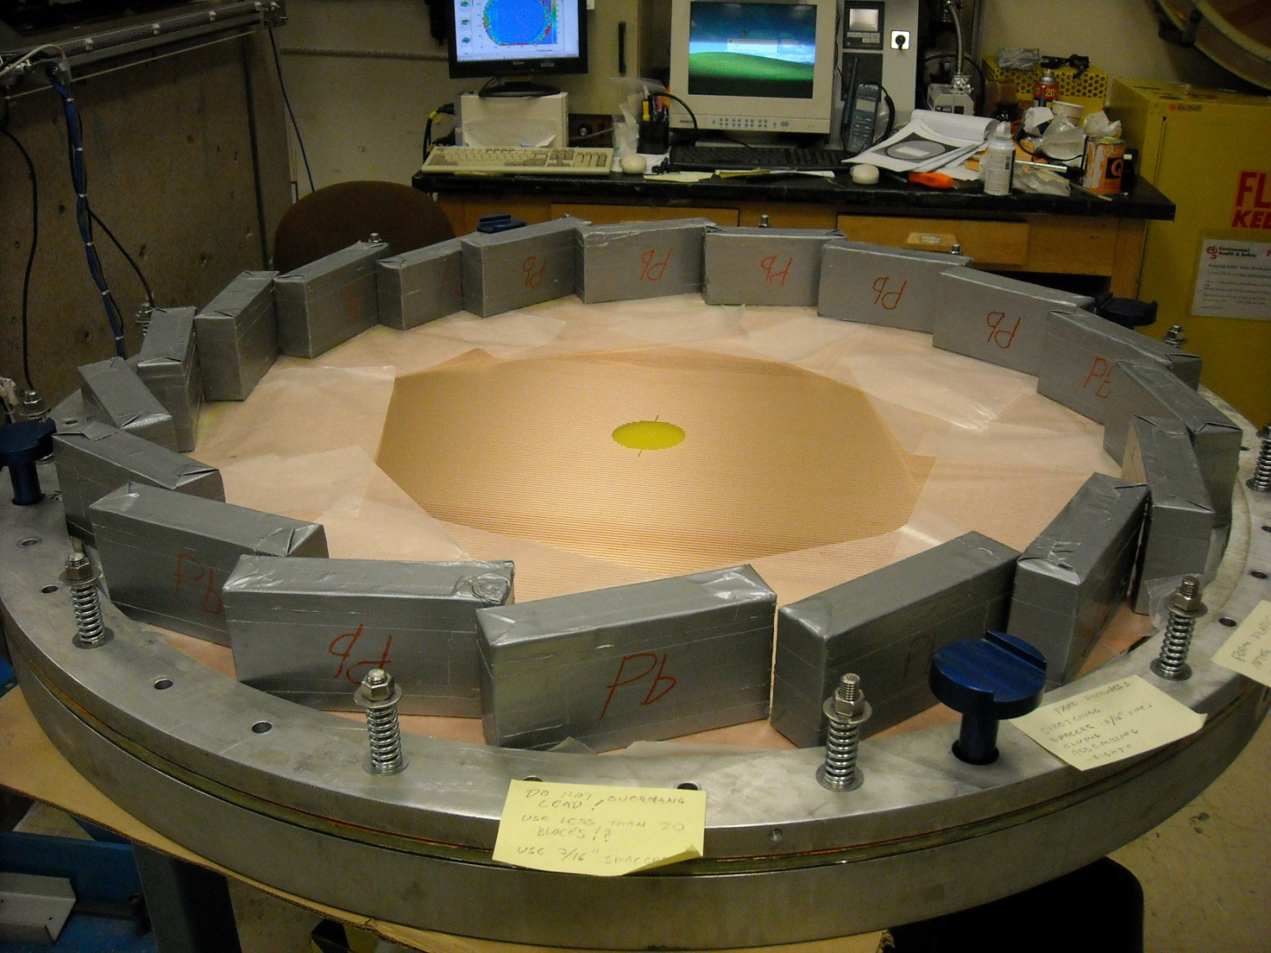

- Remove the lead blocks, shims, and the aluminum clamp ring.

- Clean a work (granite?) table with alcohol. Inspect the surface to make sure there are no burrs or debris that could damage the ground plane. Move the transfer ring to the table, copper side up. Use a new exacto blade to cut the ground plane free from the transfer ring on its I.D. Set the transfer ring aside, and turn the cathode copper side down for the next operation.
Picture similar to this one cutting the ground plane free of the transfer ring
- Cut the copper/Kapton flaps as previously described in the type 1 procedure.

- Use sharp scissors and/or a razor blade to cut the ground plane flaps. These will be 1 ½” wide, and will need to completely cover the copper flap once formed.

- Glue the copper flap to the G10 ring as per the type 1 procedure (Scotchweld used here).

- Use the previously described procedure to mix a pack of conductive epoxy (Loctite 3888). More epoxy will be required for the ground plane tab assemblies because you will also use it to bond the Mylar to the G10 and Rohacell surfaces.

- Coat the G10, copper flap and the Rohacell edge that will be in contact with the Mylar foil with a thin layer of conductive epoxy. Coat the Mylar flap in the area that will contact the wire. Glue the lower flap down, leaving the upper flap loose. Push the Mylar film into good contact with the Rohacell edge, working all air out of the bond line (unbounded Mylar film could be easily torn!).
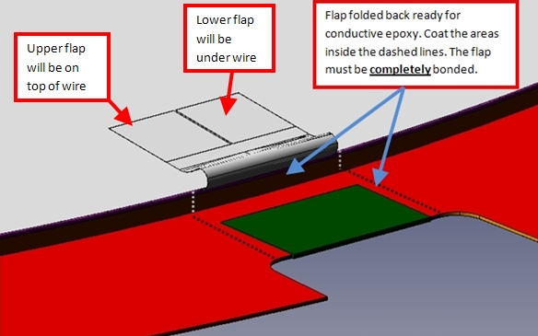

- Use the previously described procedure to coat the fanned wires with conductive epoxy.

- Place the wire as shown in the photo below, and cover with either polyethylene sheet or wax paper.
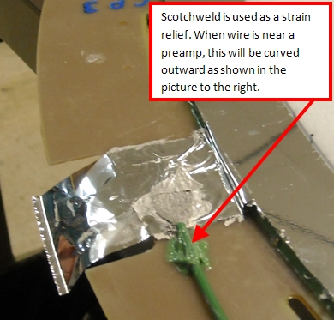

- Form a strain relief using Scotchweld as shown above.

- Cover this with a foam rubber pad and an aluminum clamp block. Push the clamp block against the Rohacell, and apply a spring clamp. Allow to cure for 12 hours.
The clamp block is pushed against the Rohacell to remove all voids from the Mylar, and because this wire is very close to a preamp card, it is curved outward and clamped as well.

- Coat all conductive epoxy with Humiseal 1B31 (brushed, not sprayed).

- Use an exacto knife to open the bolt holes on the ground plane.

This completes assembly of the type 2 cathode. Temporarily store the cathode in dry nitrogen gas. The cathode should be held flat during storage.

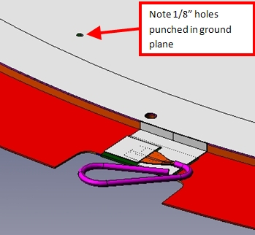
CONFIGURATION 3
Cathode to be glued to end window

Note: the type 3 cathode is identical to the type 2, with the only difference being that its ground plane has holes punched in it prior to tensioning.
Fabrication of the type 3 cathode is as follows:
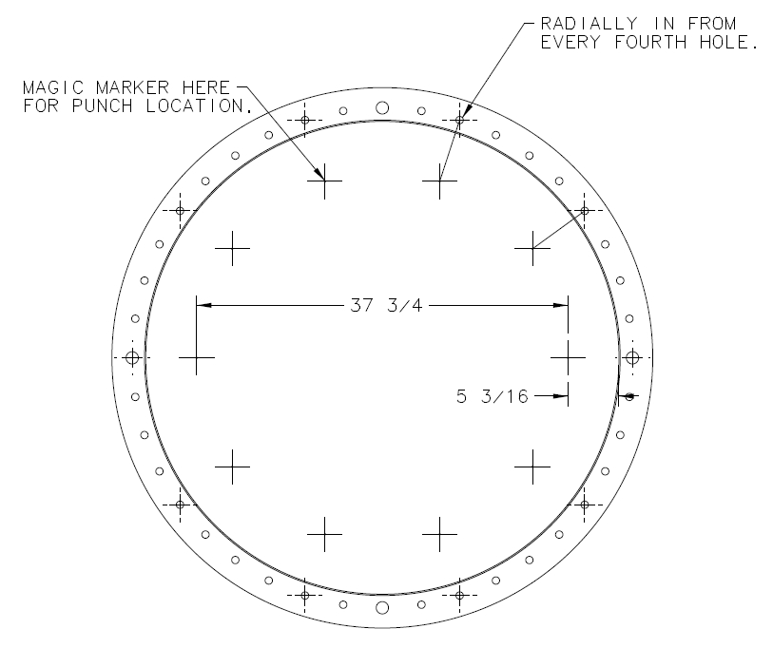
- Make up 6 pigtails that have 1 ½” long fanned wires.

- Use the steps described in procedure 10 to glue the Mylar film to the transfer ring. Allow to cure for 12 hours, and trim the excess material from the O.D.

- Space the transfer ring off the granite table by one inch as shown below :
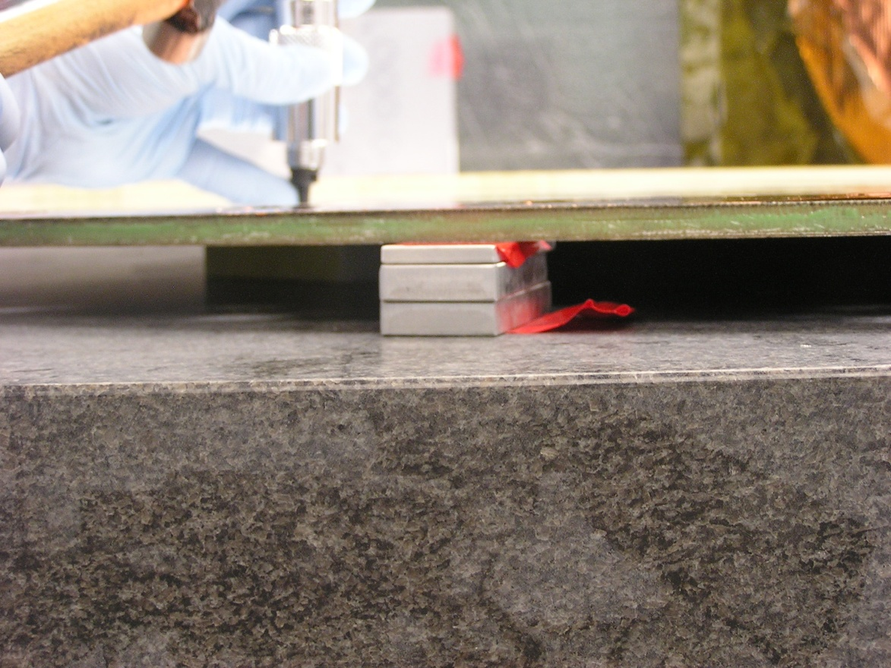

- The tool shown below is made from a cast nylon cutting block (90 shore A hardness) attached to a handle. This will be used to back up the gasket punch.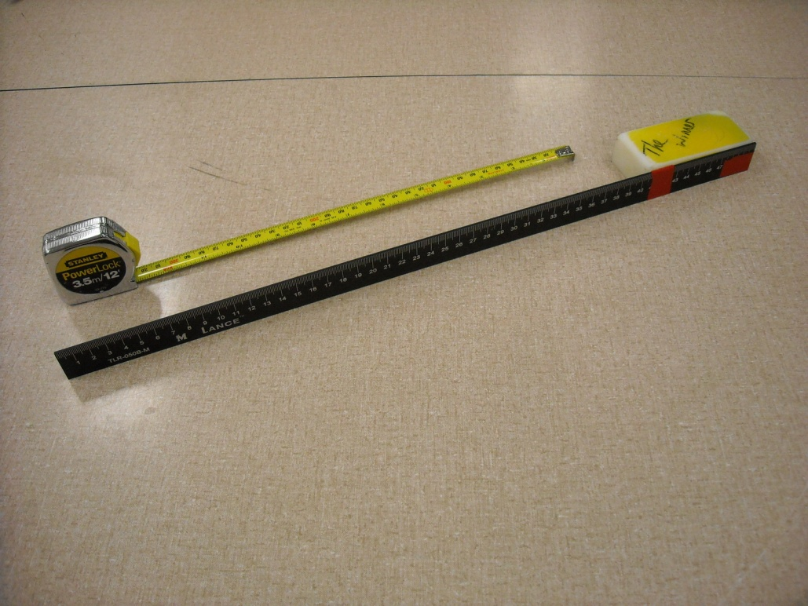

- A punching template is made out of Mylar sheeting with 10 holes arranged on a 37 5/8” bolt circle and cut to fit the I.D. of the transfer ring (48” O.D.). Lay this template on top of the membrane.
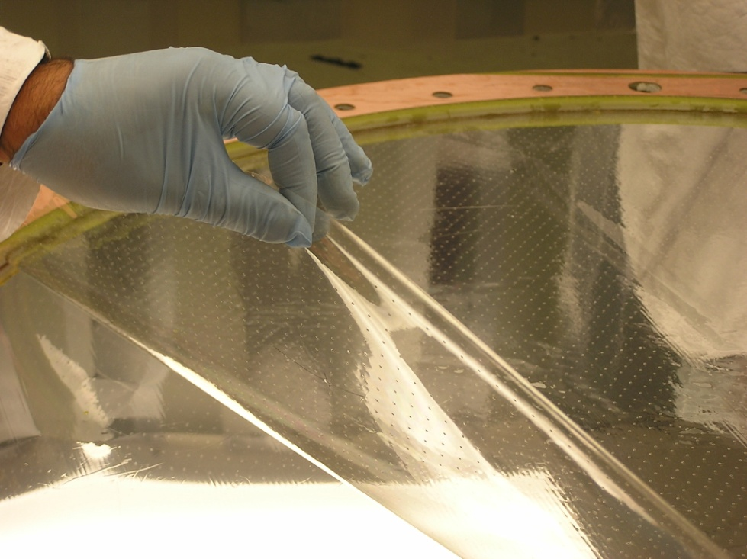

- Use the tool to position the plastic block beneath each hole location. Use the 1/8” gasket punch to cut the holes.
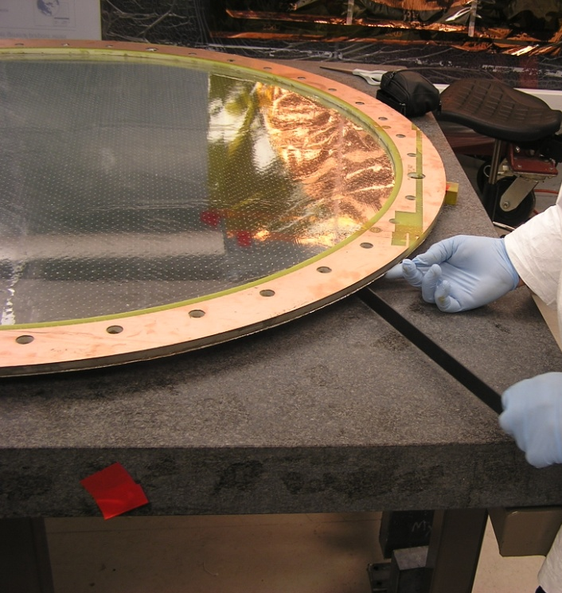
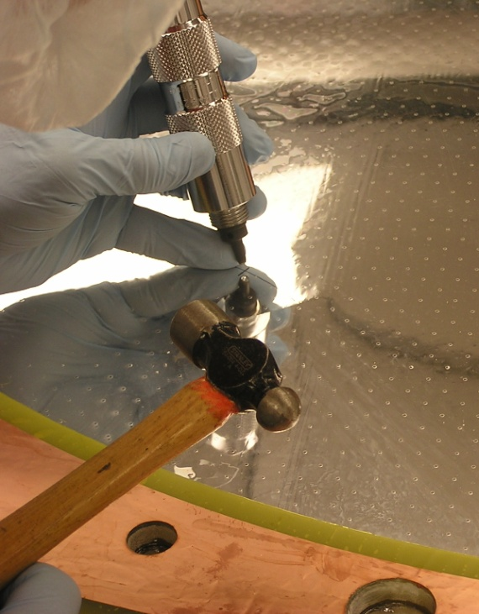

- This is what it should look like when done:

- Use the procedures used to complete the type 2 cathode, attaching the six pigtails to the copper/Kapton grounds, and 6 to the aluminized Mylar grounds. Create Scotchweld strain reliefs and coat with Humiseal as previously described.

This completes assembly of the type 3 cathode. Temporarily store the cathode in dry nitrogen gas. Cathode should be held flat during storage.

Procedure 13: Fabricate the end window laminations
- Repeat procedure 1 to make a narrow Rohacell ring; do not trim to final size (this can be done after gluing to one of the G10 rings).

- Place the Rohacell ring on the Lexan jig plate.

- Take two of the narrow G10 rings (part #D00000-01-03-2003) and repeat the sanding procedure described previously. Clean with Alcohol

- Use the previously described procedures to mix approx. 20cc of Hysol and coat a narrow G10 ring.

- Place the narrow G10 ring on top of the Rohacell ring, and clean any excess epoxy from the exposed G10 surface. Cover the rings with wax paper and vacuum bag the assembly. Cure for 12 hours.

- Use the rotary cutter to cut the Rohacell O.D. and I.D. to the edge of the G10 ring.

- Use the sharpened tube punch to cut out the Rohacell from the bolt holes as shown below. After punching a hole, use a 1/8” diameter steel rod to knock the Rohacell plug out of the punch. Use the .221” reamer afterwards to clean out the holes.

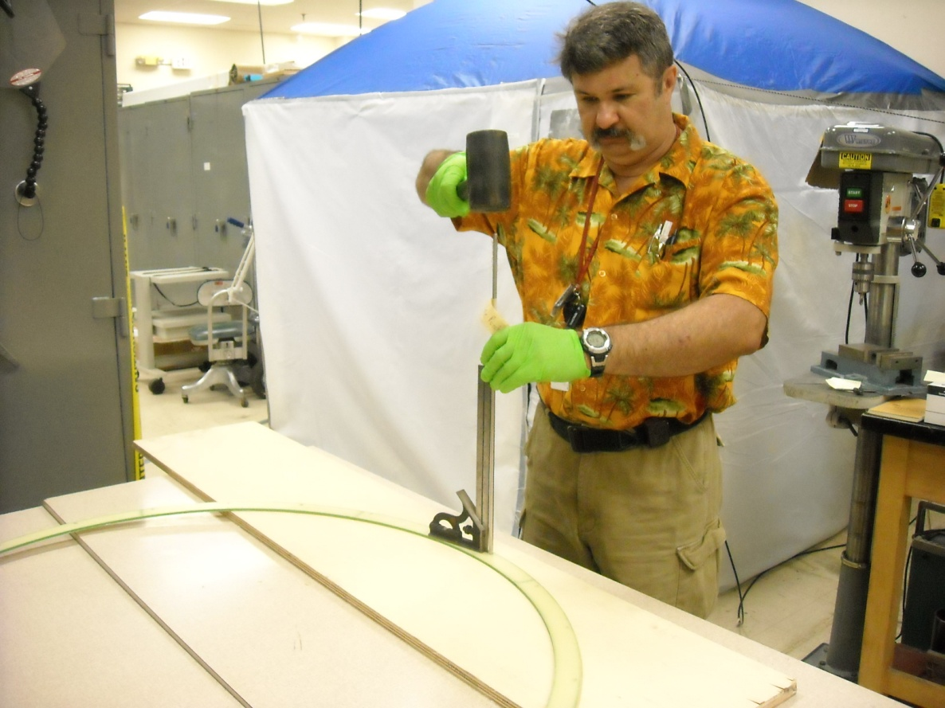

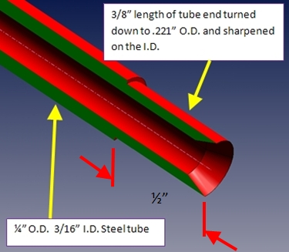

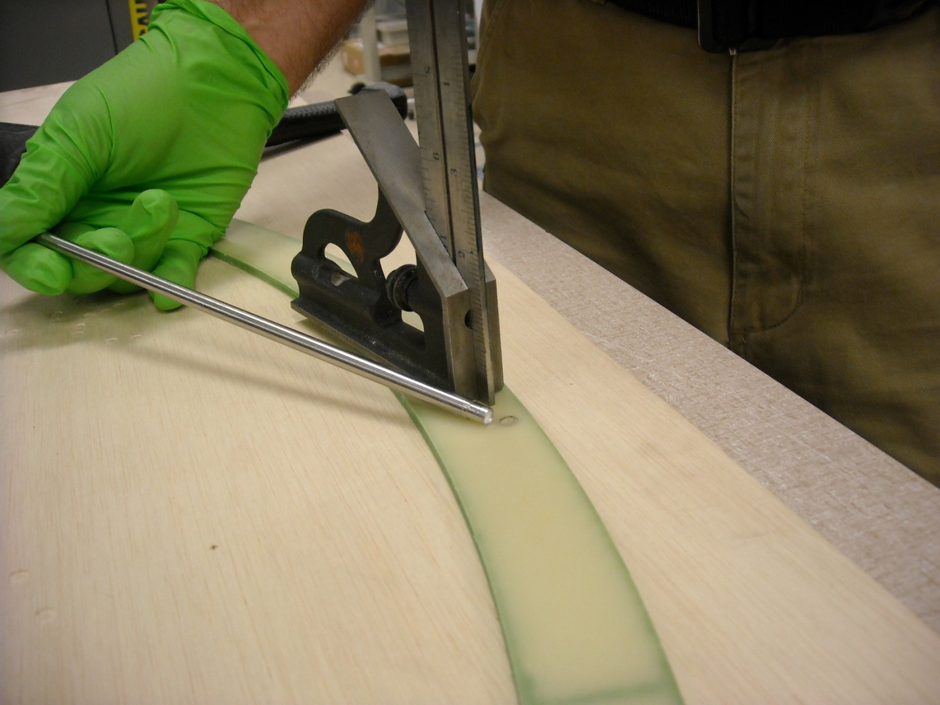

- Put down wax paper on the Lexan jig plate. Put the Rohacell/G10 lamination on the Lexan jig plate with the G10 side down.

- Coat the second narrow G10 ring with epoxy and place it on top of the lamination.

- Coat the 12 lamination pins used in procedure 6 with the release agent.

- Install the pins in the lamination to position the G10 ring for vacuum bagging. Use an alcohol soaked Kemwipe to clean any excess epoxy from the exposed G10 surface. Cover the assembly with wax paper, and vacuum bag as per procedure 6. Allow the assembly to cure for 12 hours.
- Remove the vacuum bag and transfer the assembly to a worktable. Use the sanding block and/or razor scraper to remove any epoxy drips on the surface of the G10.

- Use the steps in procedure 7 to seal the O.D. and I.D. of the lamination with Scotchweld. Seal the bolt holes with Hysol as described in procedure 8.

Some pictures for these steps?

The end window is now ready for gluing to the type 3 cathode.

Procedure 14: bond the end window to the type 3 cathode and form ground flaps
- Place the type 3 cathode copper side down on the Lexan jig plate. Install two lamination pins (part#D00000-07-01-2006) 180 degrees apart.

- Use 8-10 pieces of the red Vinyl tape to secure the cathode in position and flat against the Lexan jig plate as shown below. Remove the lamination pins.
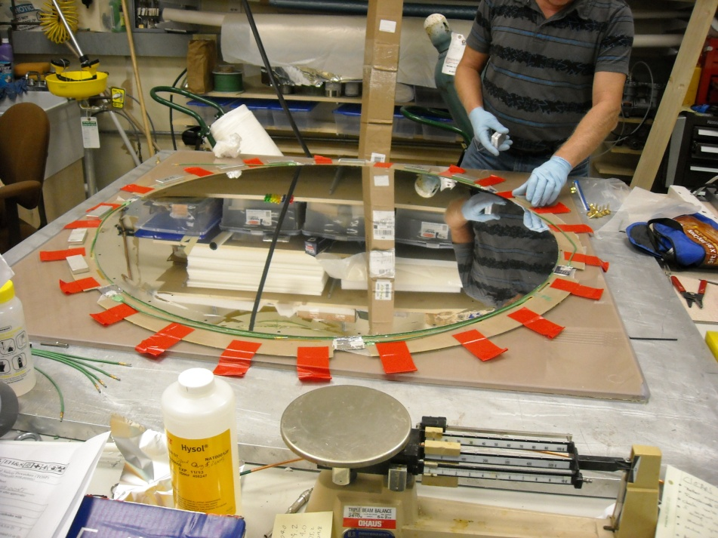

- Place the 3/8” thick shims as shown. Add pieces of .032” thick G10 on top (the 3/8” shim is .032” too thin by itself).
- 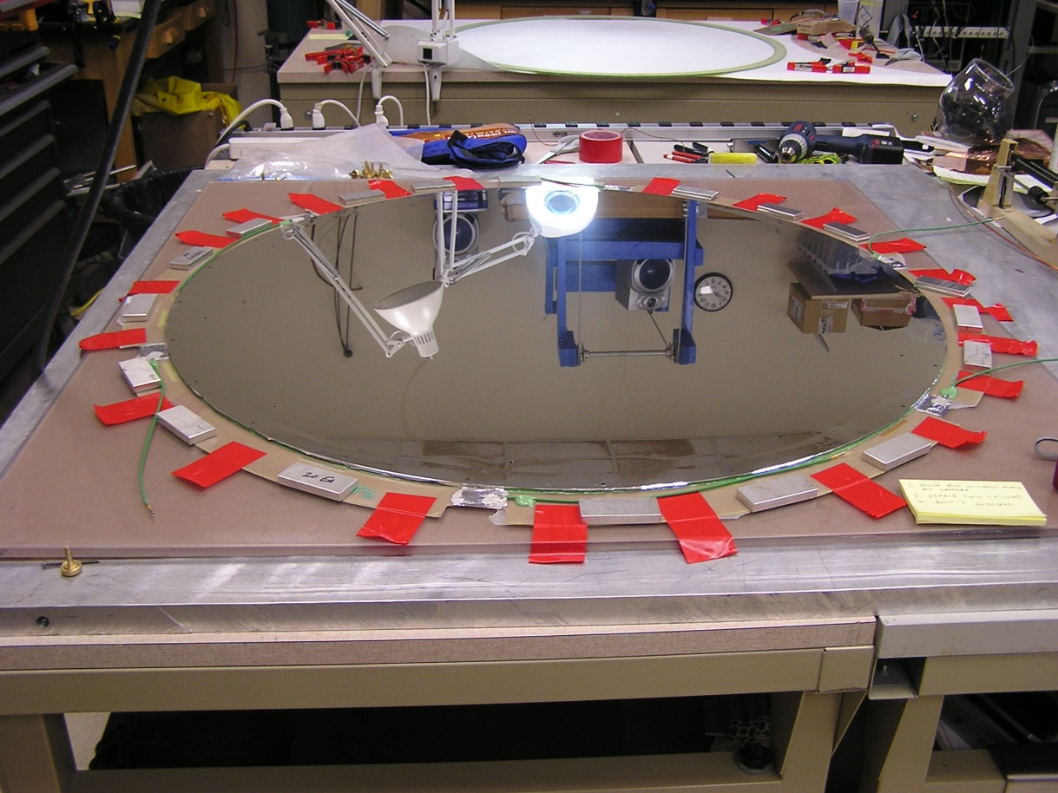
- Coat all of the lamination pins with mold release as previously described.

- Place the end window lamination on a clean work table. Lightly sand both sides.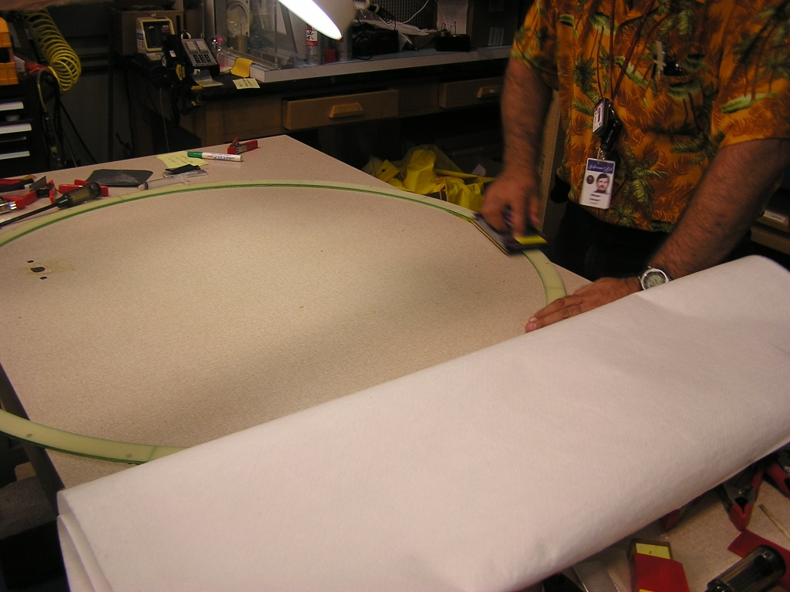

- Coat the narrow G10 ring with Hysol.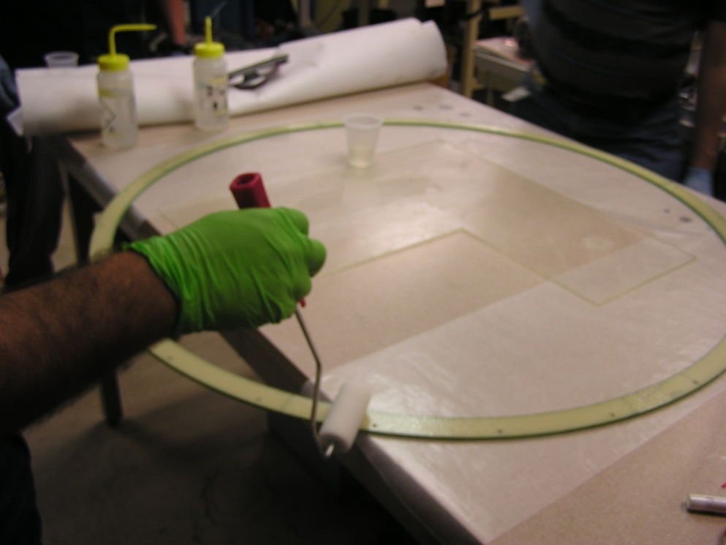

- The following operation requires two people. Lift the end window lamination off the table and flip it. Install two lamination pins 180 degrees apart.

- Carefully lower the end window lamination onto the type 3 cathode, taking care that the pins engage the holes before the cathodes come into contact (to prevent sliding). 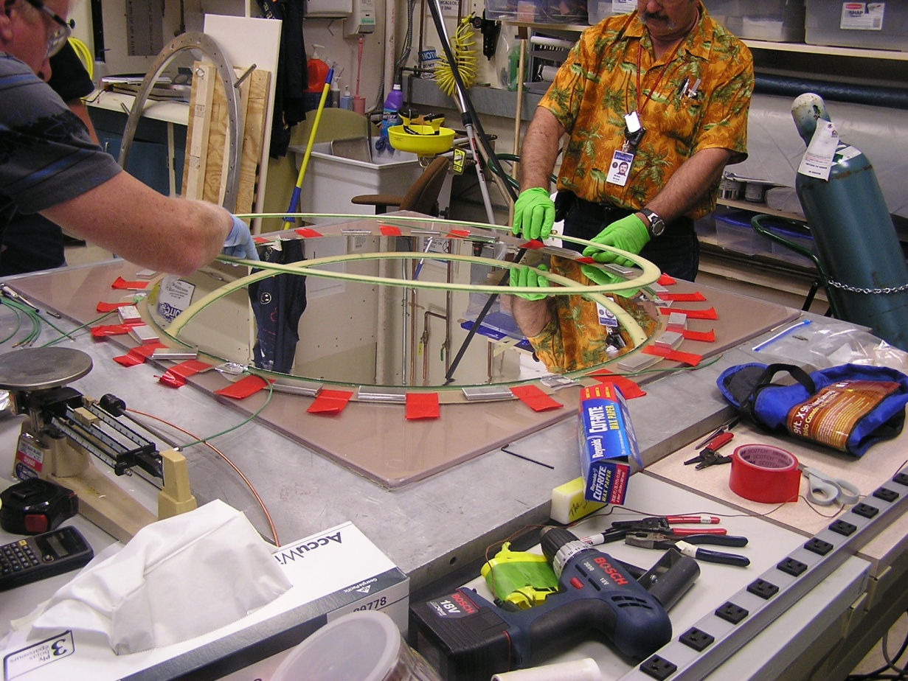

- Install the remaining lamination pins in the end window lamination.

- Weigh down as shown below with the lead blocks. The blocks should be supported by the aluminum shims and the narrow G10 ring. Allow to cure for 24 hours.
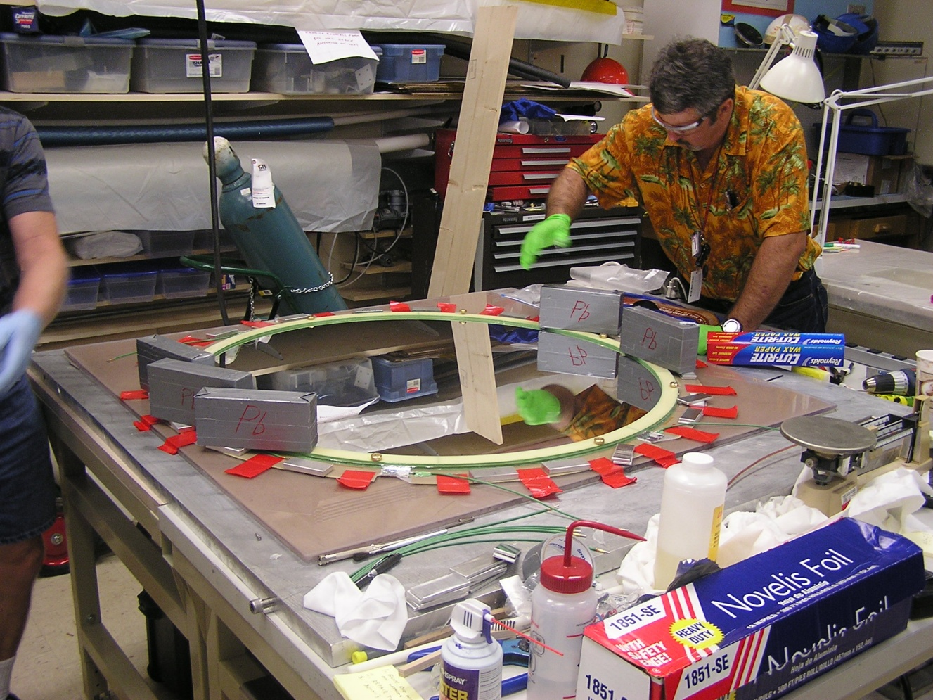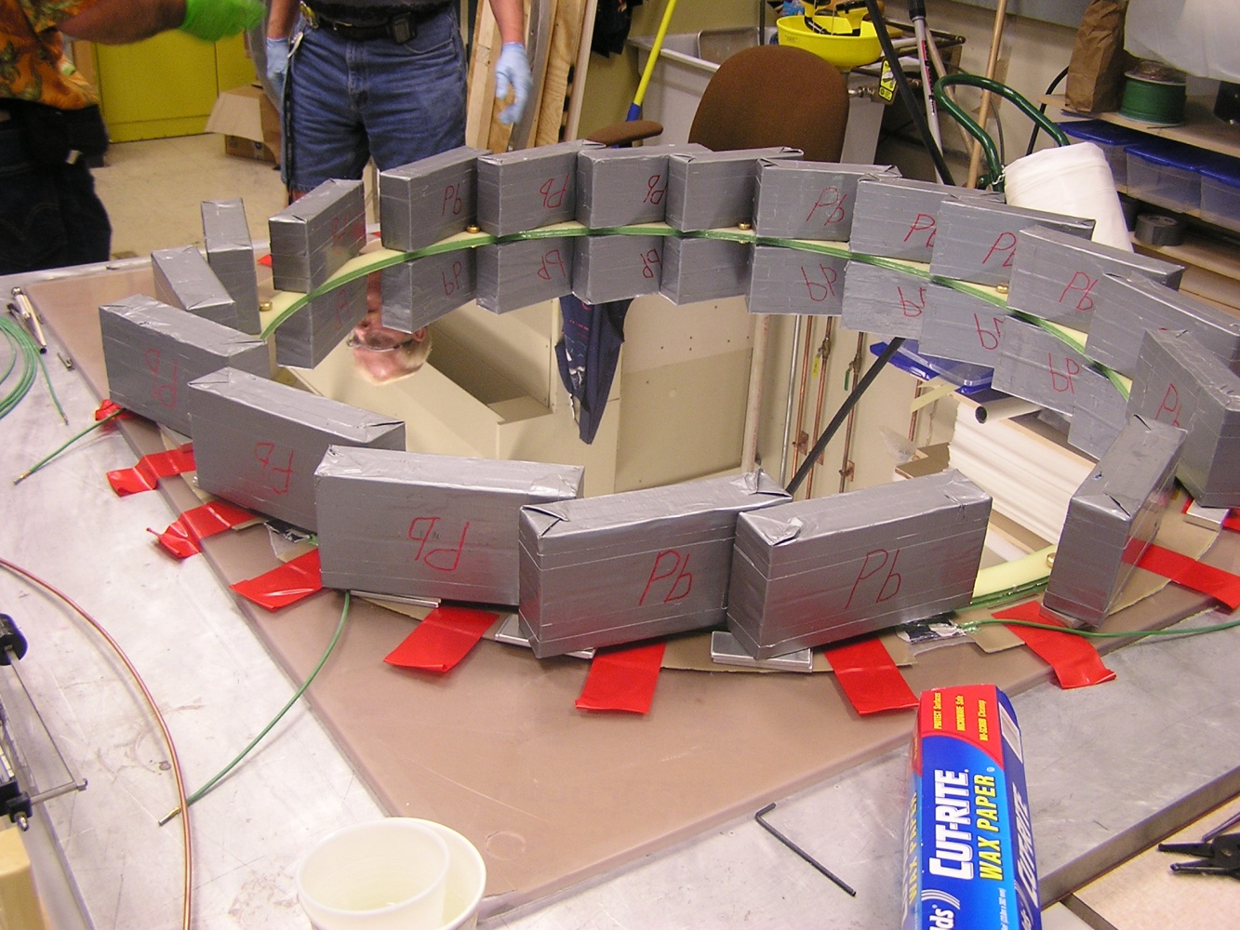

- Attach an Aluminized Mylar sheet to the transfer frame, and tension as previously described (270 N/m). Place the 3/8” shims with .032” G10 pieces as per the type 2 cathode procedure.
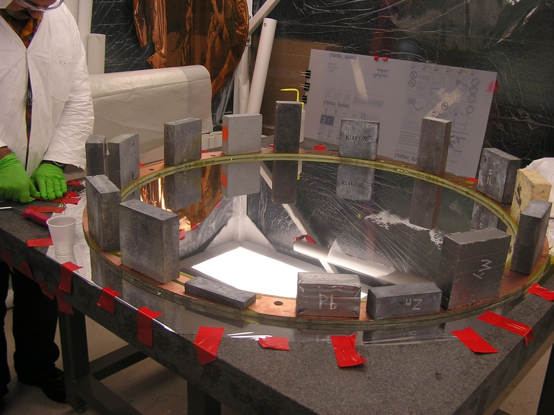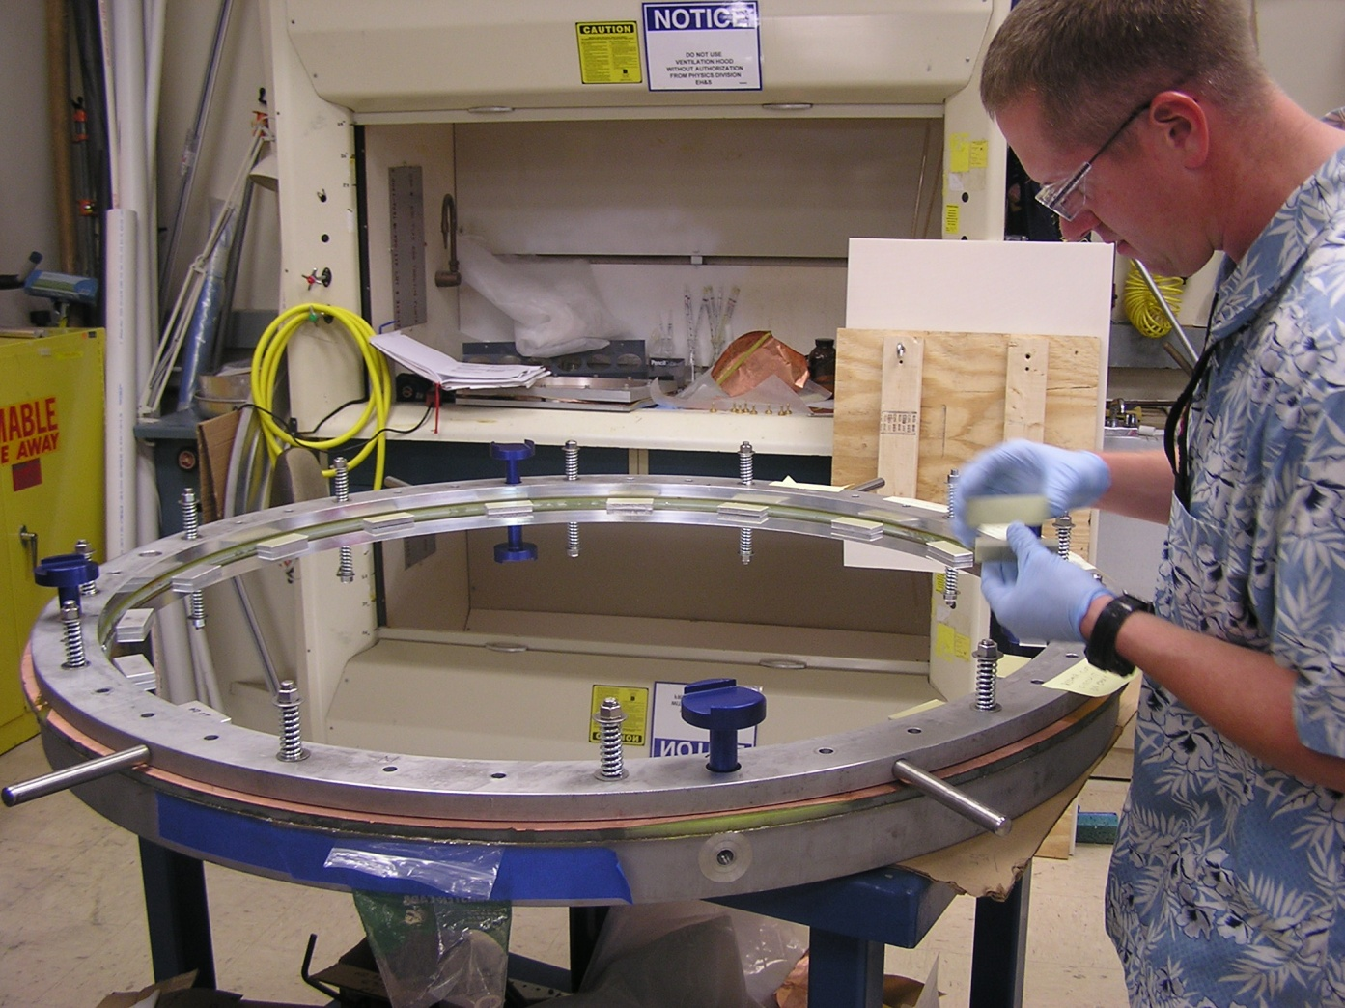

- Coat the lamination with epoxy and place on the tensioned ground plane. Take care not to slide the assembly! Use the lead blocks to weigh down the assembly for curing. Cure for 12 hours.
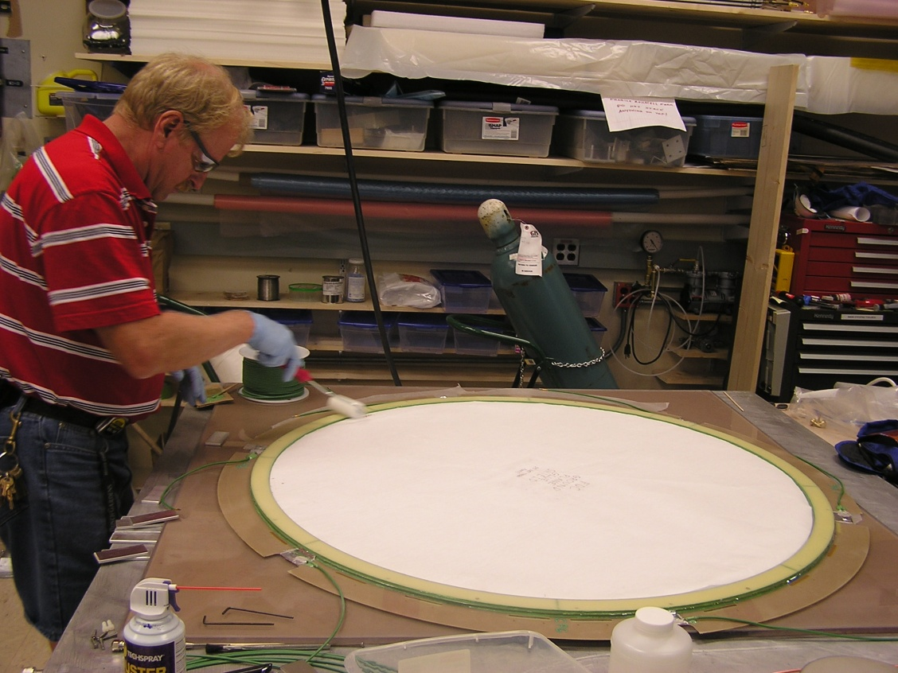
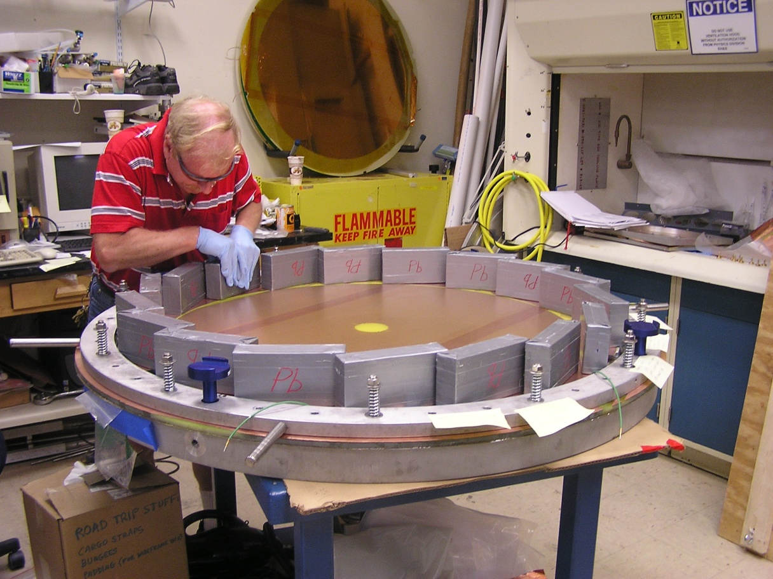
- Remove the lead blocks and the aluminum transfer ring and transfer the assembly to a clean work table membrane side down. Cut the end window ground plane free along the I.D. of the transfer ring as previously described.

Form ground flaps as previously described in the ground plane procedures of the type 2 and 3 cathodes. The locations should be as shown below. Fabricate and attach the required pigtails:
FOR THE SCREWED UP CATHODES SEE THE SECOND PICTURE
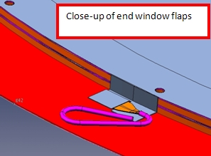
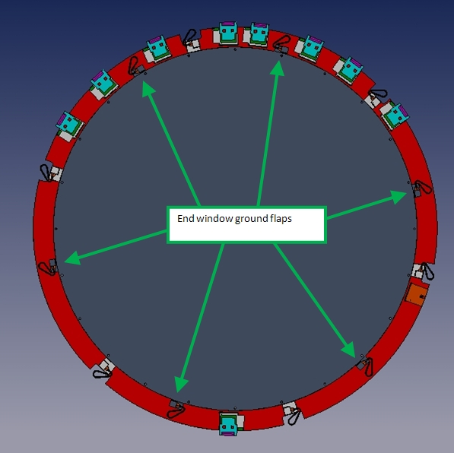
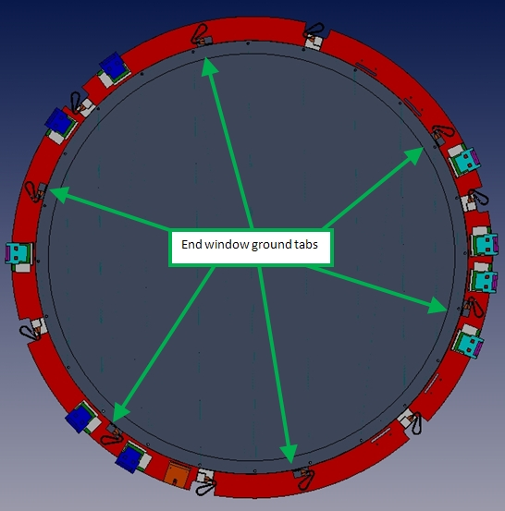
ONE TIME USE PICTURE-THIS IS THE LOCATION OF THE TABS FOR THE SCREWED UP CATHODE.

The daughter board flexible connectors are fed through the corresponding slots, and then soldered to the cathode surface (same for the ground connector card). Care should be taken with the radial location of these cards so that when they are glued, their O.D. will be flush with that of the G10 ring (angular location is not an issue).
Equipment, in depth procedure, pictures

Scotchweld epoxy is used to secure the boards to the back side of the G10 ring. Suggested applicator would be a pop-sickle stick or a syringe as shown below. It is not necessary to coat the entire back of the board; emphasis should be placed on coating the areas behind the large and small connectors.
PictureS applying glue and clamping- we have pictures with a syringe- which would be easier?

Use the special aluminum clamp plates and spring loaded clamps (Wolfcraft microtip #343100) as shown below to secure the boards. Allow to cure for 12 hours.
Picture showing the clamp plate and the clamp. Replace the picture below with the real cathode and only one type of clamp.

THIS COMPLETES FABRICATION OF THE END WINDOW CATHODE .

Procedure 15: Glue cathode pairs together and populate with preamps/ground card.
The type 1 and type 2 cathodes will be assembled on the Lexan jig plate. To glue a cathode pair, the cathodes will be positioned so that the Locator marks applied in procedure 13 appear as shown below. The type 2 cathode must be on the bottom. 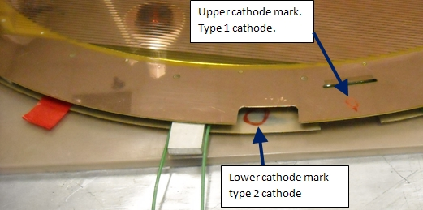
Positions the type 2 cathode over the jig plate holes, and temporarily install two lamination pins (part# D00000-07-01-2006) 180 degrees apart. Apply 8-10 pieces of red Vinyl tape to hold the large G10 ring in position and flat against the plate. Remove the two pins.
Place 3/8” thick shims (.375” x 1” x 2”- 20 required) as shown below on the surface of the wide G10 ring. Note that there should be a gap of at least 5/8” between the shim and the Rohacell edge, and the shims should sit on the bare G10 surface. Try to keep the shims off the red vinyl tape, and DO NOT place them on ground flaps as this would cause the shim to be to “tall”, which would create a gap in the bond line.
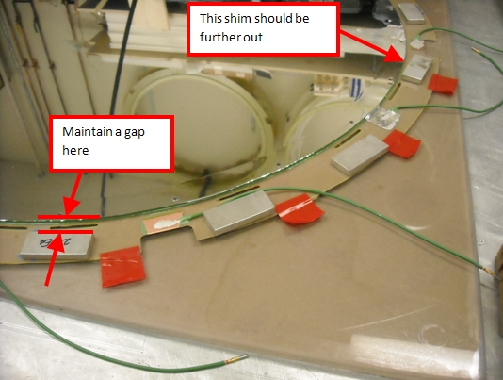

This step requires two people. Place 2 laminations pins in the type 1 cathode, and carefully lower it onto the type 2 cathode, oriented as shown above.
Use a flashlight to inspect the gap, moving shims and wires as needed ensure that all of the shims are in direct contact with the G10 rings.
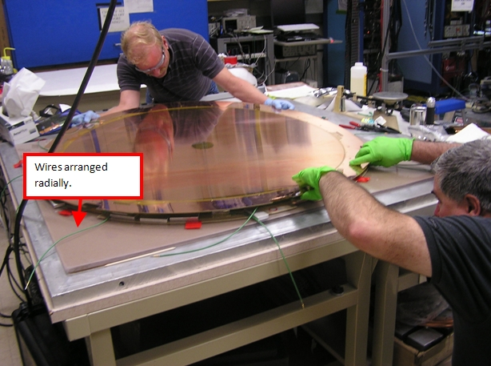
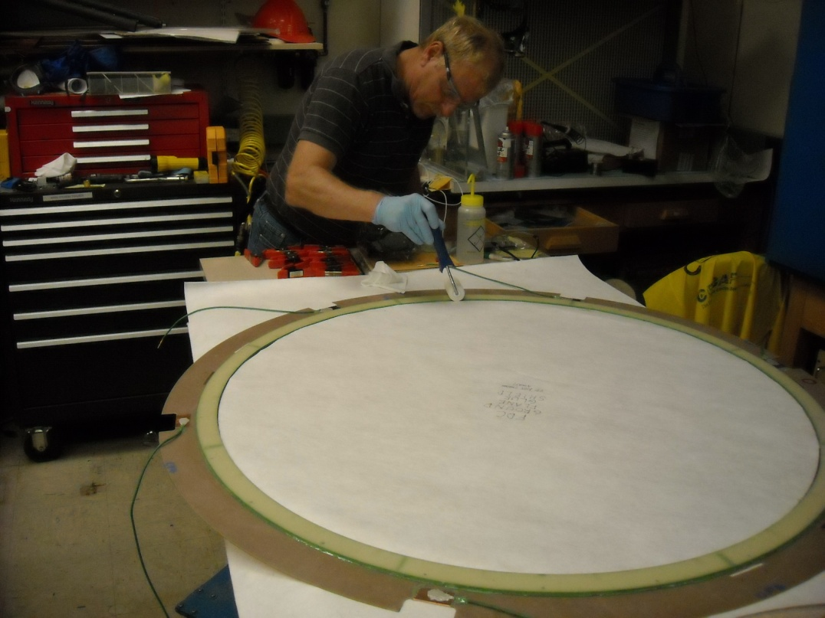
Remove the lamination pins and transfer the type 1 cathode to a clean work table copper side down. Place a circular glue shield (breather material) over the back side of the membrane to catch epoxy splatter as per the type 2 cathode ground plane procedure. Coat the narrow G10 ring with Hysol.

The following operation requires two people. Lift the type 1 cathode off the table and flip it. Install two lamination pins 180 degrees apart.
Repeat the lowering procedure, taking care that the pins engage prior to the cathodes contacting each other.
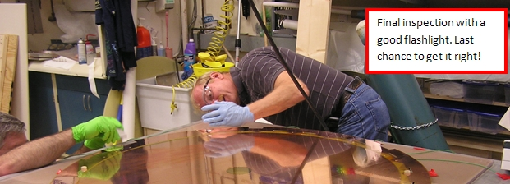
Repeat the edge inspection procedure. Take your time- a gap means two cathodes are scrapped!

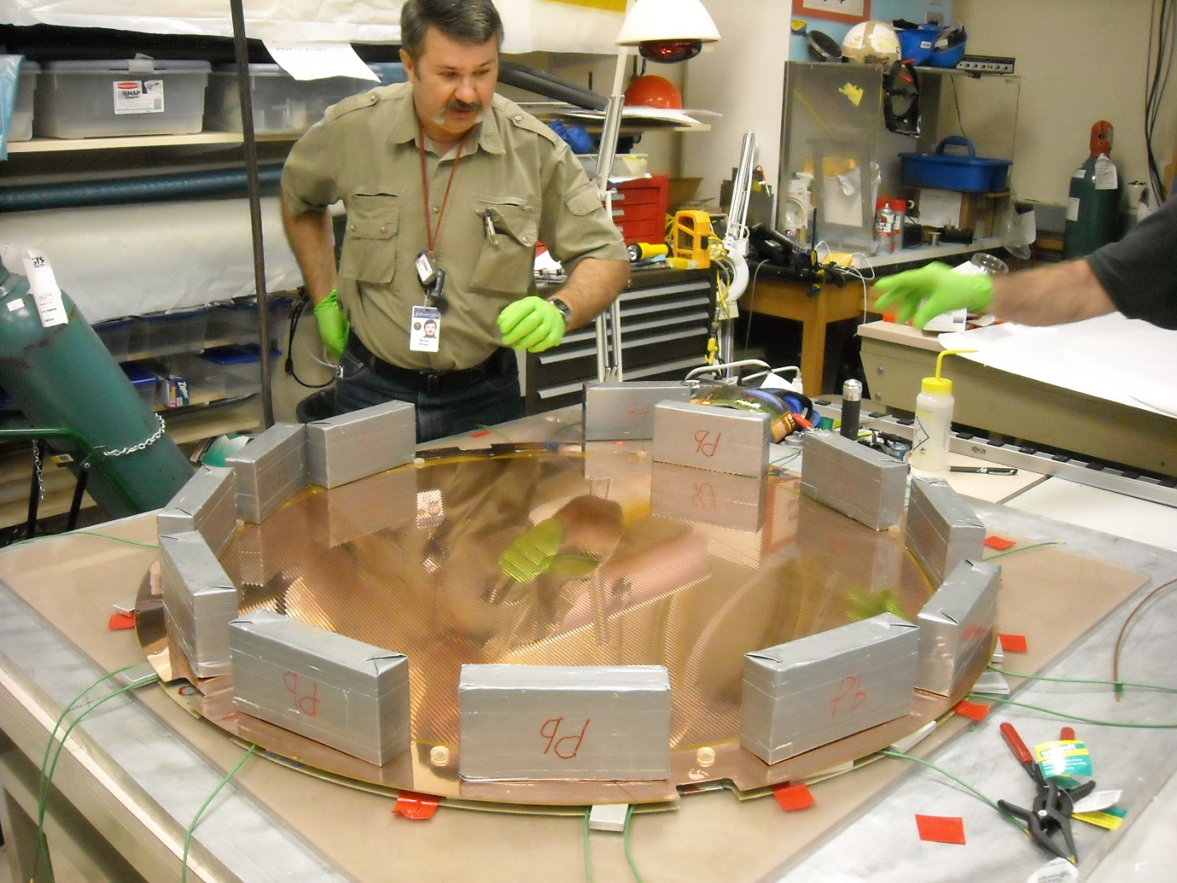
Apply the lead blocks as shown below. Take care that they do not extend inwards of the I.D. of the G10 ring, as this could damage the membrane. Allow to cure for 12 hours.

WARNING: ALL COMPONENTS NEED TO BE INSTALLED ON BOTH THE DAUGHTER BOARDS AND THE GROUND BOARD (THE FASTON TAB) PRIOR TO GLUING! THE BOARDS MUST ALSO BE 100% ELECTRICALLY INSPECTED.

The daughter board flexible connectors are fed through the corresponding slots, and then soldered to the cathode surface (same for the ground connector card). Care should be taken with the radial location of these cards so that when they are glued, their O.D. will be flush with that of the G10 ring (angular location is not an issue).
Equipment, in depth procedure, pictures

Scotchweld epoxy is used to secure the boards to the back side of the G10 ring. Suggested applicator would be a pop-sickle stick or a syringe as shown below. It is not necessary to coat the entire back of the board; emphasis should be placed on coating the areas behind the large and small connectors.
Picture applying glue- we have pictures with a syringe- which would be easier?

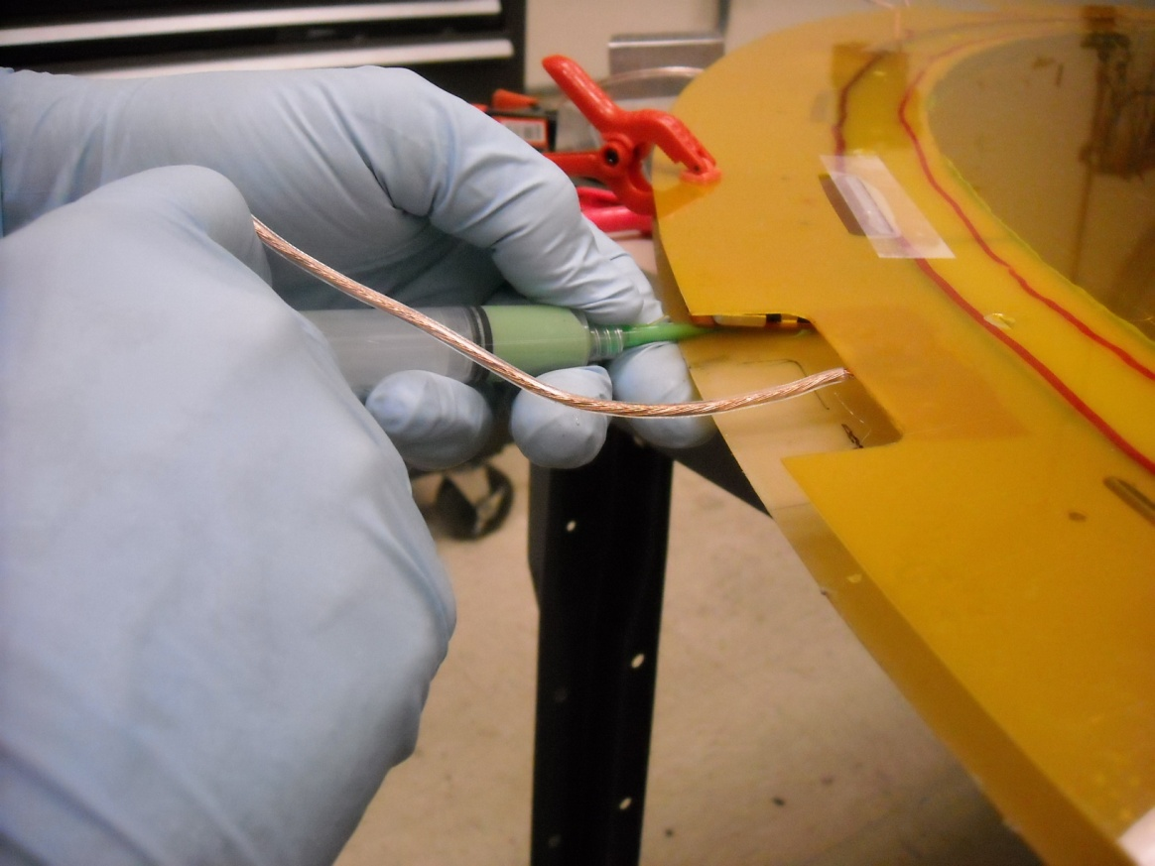

Use the special aluminum clamp plates and spring loaded clamps (Wolfcraft microtip #343100) as shown below to secure the boards. Allow to cure for 12 hours.
Picture showing the clamp plate and the clamp. Replace the picture below with the real cathode and only one type of clamp.

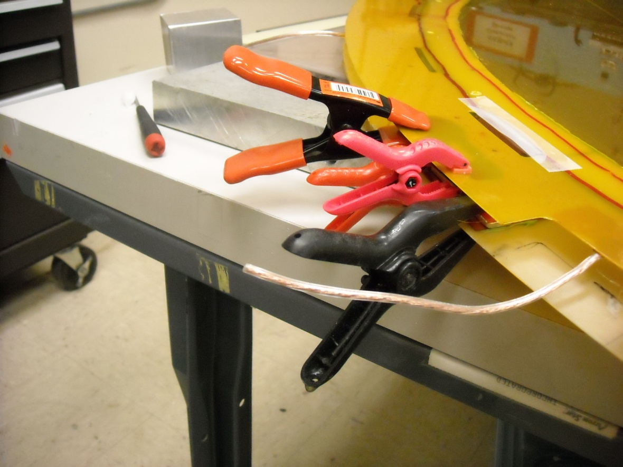

This is the clamp to use in future

