Mark Stevens’ Trip report 5/22/09, picking up 4 FDC wireframes at Indiana University at Bloomington.

On Tuesday, 19 May, late in the afternoon, Simon Taylor and I drove to Hampton and picked up the special Ryder truck. We got back after 5:00. I went to Lowe’s and bought two sheets of ¾” plywood, and had them cut it for me. One sheet I had them make one cut leaving a piece 4’ x 6’, and a piece 4’ x 2’, and the other sheet I had cut in half. I drilled 1 1/2” holes in the corners of the cut pieces, to tie them together with. I laid the two 4’x6’ sheets of memory foam on the floor of the truck. The 4’x6’ piece of plywood went on top of the foam. I lashed the plywood to the truck tie-downs with cargo straps, stretching them several feet to the far corners of the cargo bay in the shape of an X, with the plywood in the center. This immobilized the plywood, but let it “float” on the memory foam. This cushioning was very firm, unfortunately. It would absorb very low frequency/very high rate shocks, but would not attenuate high frequency/low amplitude shocks at all. I loaded up 10 bags of ordinary sand also, to load the truck suspension and make it less “hard”. A bag of sand weighs 50 pounds. I put the plastic wireframe carrier box on top and tied everything down. I drove home, arriving about 9:00 p.m.

On Wednesday, 20 May, I left from my home in Williamsburg on my trip to Indiana. I drove to Richmond, where I stopped at Hudson Industries, a supplier of polyurethane and memory foam products for the upholstery industry. They make a product I was interested in, but unfortunately, it is not made in the Richmond plant. They gave me some scrap polyurethane foam, but were otherwise unable to help me. I got back on the road, and was concerned with how rough the roads were in Richmond. I took I-64 thru downtown Richmond, and found the old concrete was a rough ride in my truck. I decided to take the bypass road on the way back. I also decided I did not have enough weight in the truck to soften the suspension – I needed to at least double the weight. The rest of the trip to Indiana was uneventful, except for the even rougher pavement in West Virginia, parts of the original West Virginia Turnpike, concrete poured in 1952. I decided the return trip should be taken in the late evening/early morning hours in this area, so that I would offend fewer people by driving slowly through this area. I arrived in Bloomington at about 11:40 p.m., and with the aid of my Mapquest maps, stumbled into my hotel. Got to bed at about 12:30.

On Thursday, 21 May, I got up at about 8:00, and got some breakfast. Checked my email, and found the contact information that Brian sent me. Took everything out of my room, but did not check out yet. I gave the problem of cushioning the wireframes some more thought, and decided I needed another layer of cushioning on top of the memory foam. With my laptop, I found I was across the street from both a Bed, Bath and Beyond, and also a Lowe’s store. I decided to go to B, B, and B to get some light weight cushioning, and to Lowes to get some more tie-down straps and screw eyes to finish my suspension system.
I recalled a conversation I had with a WW2 veteran sailor of the Pacific campaign, who said they had a problem with wheel bearings burning up in the F-4U Corsairs. He realized that the wheel bearing grease was not staying in the bearings, and devised a testing method to select a better grease. They ordered every kind of grease that was available, and tested samples. They put a gob of grease on an anvil, an d struck it with a hammer. If the grease was launched away from the anvil, it failed. They settled on the grease that most stayed intact on the anvil, and packed the wheel bearings with it. It worked. No more burned up bearings.

So I devised a test for cushioning materials: I needed something with “loft” or the ability to support a load. But I did not want something that was “live”, like foam rubber, which almost instantly springs back from any load applied. I wanted something like memory foam, a “dead” material that wasn’t bouncy, but I needed something lighter. At B, B, and B, I tested mattress toppers, and didn’t find anything suitable. Then I looked at pillows, and found that old fashioned feather pillows provided both the support, or loft, that I needed, while at the same time were not a “live” support, but rather absorbed considerable energy. I bought six of them, king size. These fit rather nicely under the 48” square piece of plywood that was my top layer of cushioning suspension. Centered on top of the 4’x6’ piece of plywood, the 4’ square piece was anchored to the larger plywood piece by rubber bungees, and floating on the feather pillows. I went to Lowe’s to get some screw eyes, 2x4’s, another 500 pounds of sand, and some cargo straps. I was satisfied with the suspension system for the wireframes, so I checked out of my hotel room. It was lunch time, though, and when I called Allen and Keith, they were gone. So I got some lunch myself.

After lunch, I went looking for a map, so I could find the University, and stopped at a couple of 7=11 type stores before I found one. And as it turned out, the store I found one at was about 2 blocks from the Cyclotron facility at the University, so I drove to that facility and called Allen. He came upstairs to the reception area and we met. Then we drove around to the back/lower part of the building. I met Keith, and asked both of them to take a look at my cushioning/suspension system. Keith said that Dan had also asked for the same evaluation, and I said “That’s great!”. Allen and I cut a 6” hole in the back end of the box at the top. We put the wireframes into the plastic box. One of them was in the winder room, but the other three were in a closet-looking room with the sign on the door that said “darkroom”. They were simply laying up against the wall there. I installed the pieces of foam that Brian had used to cushion the wireframes from each other, and to dampen vibrations.

Allen and I went to work on the load suspension system. We installed 2x4” blocks on the plywood pieces that centered the plastic box on the plywood. Then we drilled holes through them and installed screw eyes to attach the cargo straps to. The plastic box fit nicely, and the cargo straps made it secure. Both Allen and Keith looked over the finished product, and approved. By then it was 3:30 p.m., but I decided to get on the road anyway, because I wanted to pass through West Virginia late at night.

The trip back was uneventful. I checked the load often, and found that the cheap cargo straps I had tended to loosen from vibration. So, I continued to check the load often, and tighten the straps. I got to the West Virginia Turnpike late at night, just like I wanted to. I slowed down to about 40 – 45 mph, and just fit in with the commercial trucks. When I got back onto more modern pavement, I was able to pick up the pace again, to the speed limit. I debated stopping for the night, but I felt wide awake, and so proceeded. I decided when I got tired, I would stop. Well, I didn’t get tired, and so drove through Richmond in the wee hours of the morning, again at a slow pace. I took the bypass road, I-295, but it was no better than I-64 through the center of town. Rough road either way. I just drove slow, there being hardly anyone to offend with my turtle-ness. I kept going, and stopped at my house in Williamsburg at about 5:00 a.m.

On Friday, 22 May, I got up at about noon, and drove to work. I found Simon Taylor, and he helped me unload the wireframes, put away the cushioning system, and return the truck to Hampton. We left the wireframes in the clean room under nitrogen purge. There were no broken wires. Simon and I got back to the lab right at 5:00 p.m., so we put away the keys to the lab minivan, and went home.

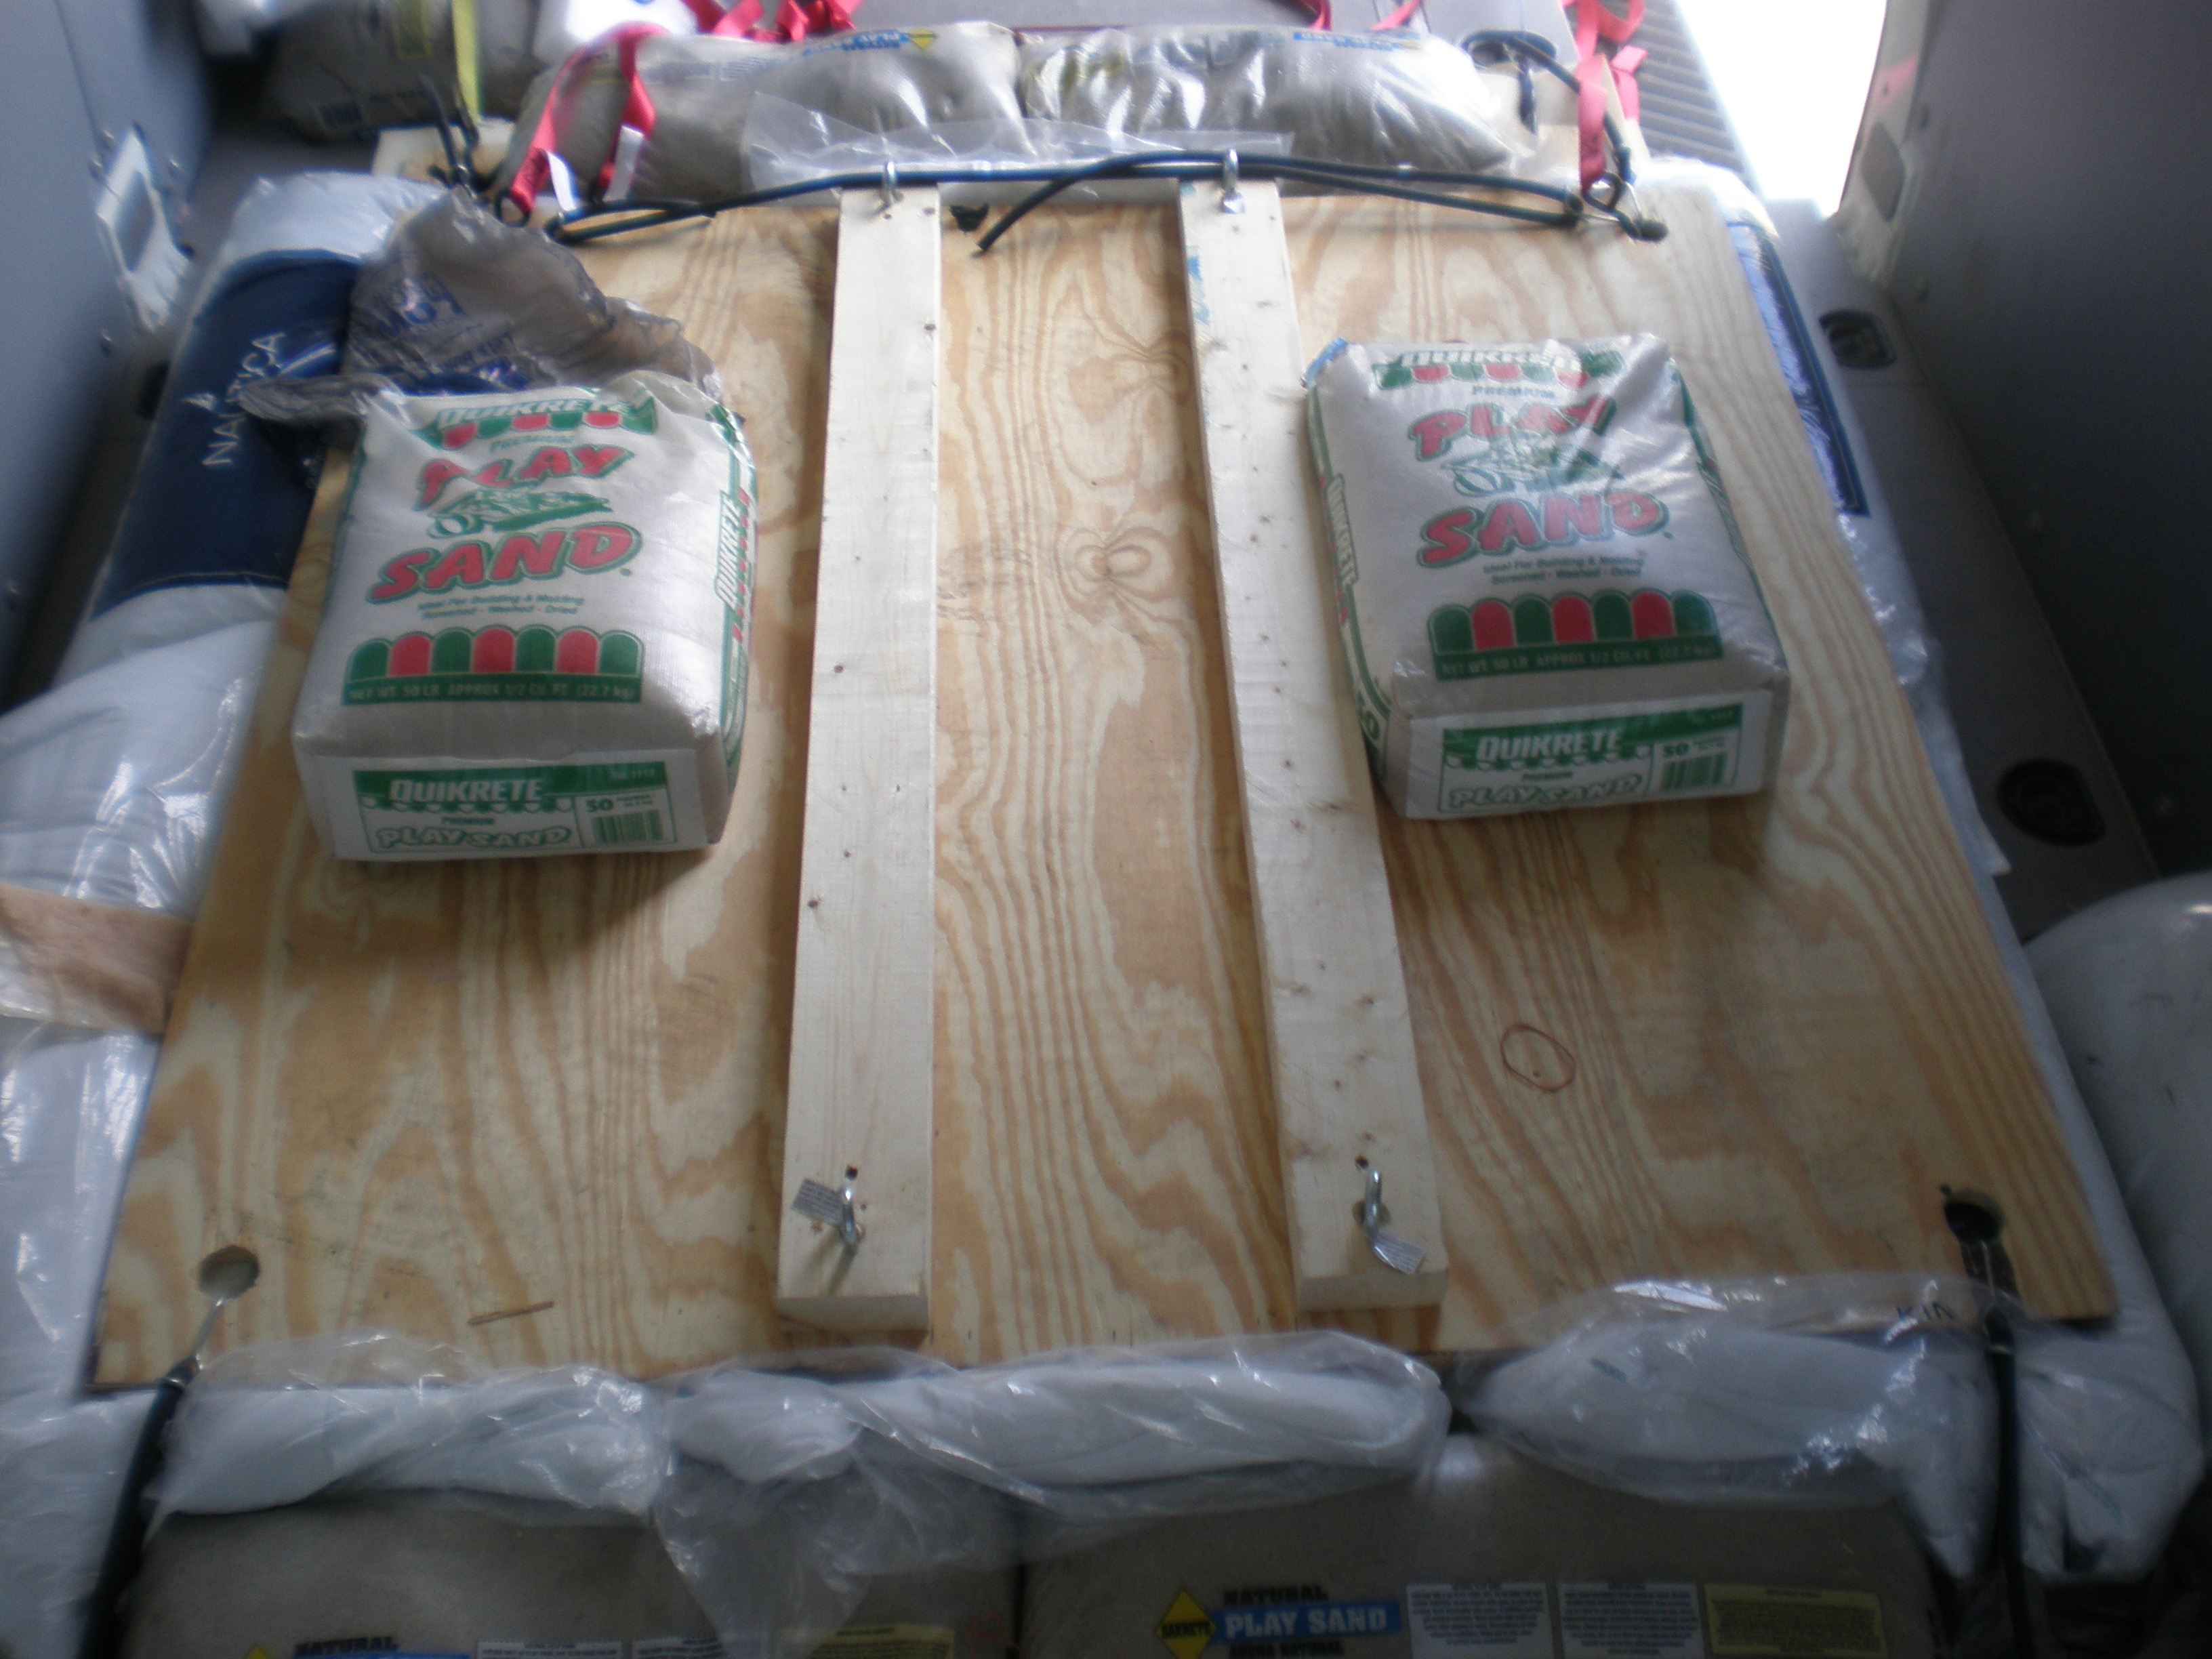
Picture showing 4’ square of plywood, with 2x4’s in place, to hold plastic box. View looking forward from back of truck. Note screw eyes for cargo straps. Note sand bags to give additional mass to suspended load. Note pillows sticking out from the edges of the plywood sheet. Note bungees immobilizing the 4’ square plywood (the other end of the bungees is attached to the 4’x6’ plywood sheet, below.

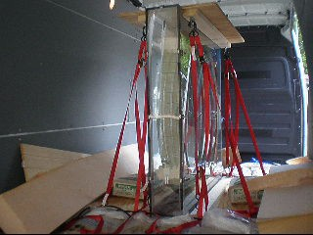

Picture of wireframe carrying case installed in truck. Apologies for image quality, it is a video transfer. Note upper framing member, 24”x48” plywood piece with attached 2”x4”s and eye bolts. Note red cargo straps immobilizing the carrying case on its suspension system.

All of these materials in the cushioning system are now stored in room 126, for future reuse. Some improvements could be made for a few more dollars. At the very least, the red cargo straps need to be replaced with the ratcheting type.

