MEMORANDUM

To: Distribution

From: F. Dylla/grn/gpw

Subject: FEL Upgrade Project Weekly Brief - September 11-15, 2006

Date: September 15, 2006

Highlights:
This week we shutdown as planned for the installation of the cryo-cooled output coupler (OC) mirror. For this we chose a 1.6 micron Hf-oxide coated mirror with 20% outcoupling. The coating was chosen to minimize color-center formation, and the output coupling to lessen the load on the high reflector. This OC mirror is fixed at one location because we have to maintain clearance between the sections that are cryo-cooled and everything else. While it is possible to translate in the future we don't currently have that flexibility in the cryo-lines.
Taking advantage of the shutdown, a number of other key electron beam diagnostic viewer components, rf cables and some mechanical components were also replaced. These should help make the machine more stable and easier to optimize. Of particular note is the successful synchronism of the video cameras and the frame grabbers.

We also started work on reducing the rf resonant character of the optical cavity mirror metrology system (OCMMS). We designed and made a spring finger clip that can short out the free ends of the wiggler chamber extensions to the flanges they face and also plan to add some lossy, glassy carbon chunks to the insides of the OCMMs to damp-out any oscillations.

Management:
Gwyn Williams gave an invited talk at a meeting at Daresbury on "4GLS The Next Steps". This was followed up by meetings at Rutherford Lab with John Wood who is the Chief Executive of the National Labs of the UK (CCLRC); Henry Hutchinson, the Chief Scientist; and Mike Dunn, the head of the Central Laser Facility. Swapan Chattopadhyay from JLab also attended the Daresbury meeting, and John Sutherland, a member of our Program Advisory Committee gave an invited talk.

This week we hosted visits from delegations from Ohio University and Hampton University.

WBS 4 (Injector):
Early in the week we activated the NEG pumps in the injector beamline between the gun and the cryounit. The activation was done slowly to prevent the ion pumps from tripping off. The pressure has recovered to the levels prior to the activation and we expect it to get even lower by early next week.
We continued to make progress assembling the internal components of the new gun, we cleaned up and prepared the IR Demo gun chamber previously NEG coated in preparation to be assembled to the new gun assembly.
Fabrication drawings for the new gun SF6 tank with modifications to fit the load-lock system are almost complete and ready for revision.
The Survey and Alignment group has finished installing reference monuments and marking the location for the gun stand and the high voltage power supply anchors in the Gun Test Stand (GTS).
The end flanges and tube ports have been welded to the main body of new gun vacuum chamber as can be seen in the picture below.
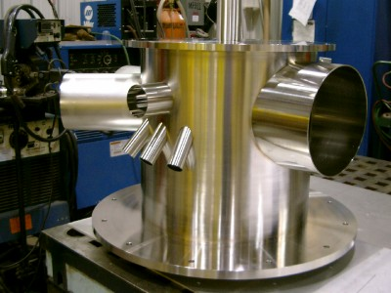

D. Bullard provided support installing hardware for injector phase diagnostics.

WBS 5 SRF:
High-current module project: The body of our copper 1497 MHz 5-cell cavity model has been being welded, along with two extra "dumbbells" so we can measure the HOM performance of 5, 6 and 7 cell versions. The full size 748.5 MHz cavity dies are nearly complete, delivery is expected next week. Waveguide end group pieces have been pressed for both the copper and niobium 1497 MHz cavities and are waiting for e- beam welder time. 1497 MHz niobium cells for two fine-grain and one large grain prototype have been pressed and are out for trimming. Window ceramics are ready to be sent out for metalizing. Our window assembly tooling has arrived and has been titanium nitrided in house. First furnace run with a dummy window ring is under way. An ANSYS RF/ thermal/stress model of the high-power HOM load has been developed. Samples of alternative HOM load material have been ordered for evaluation.
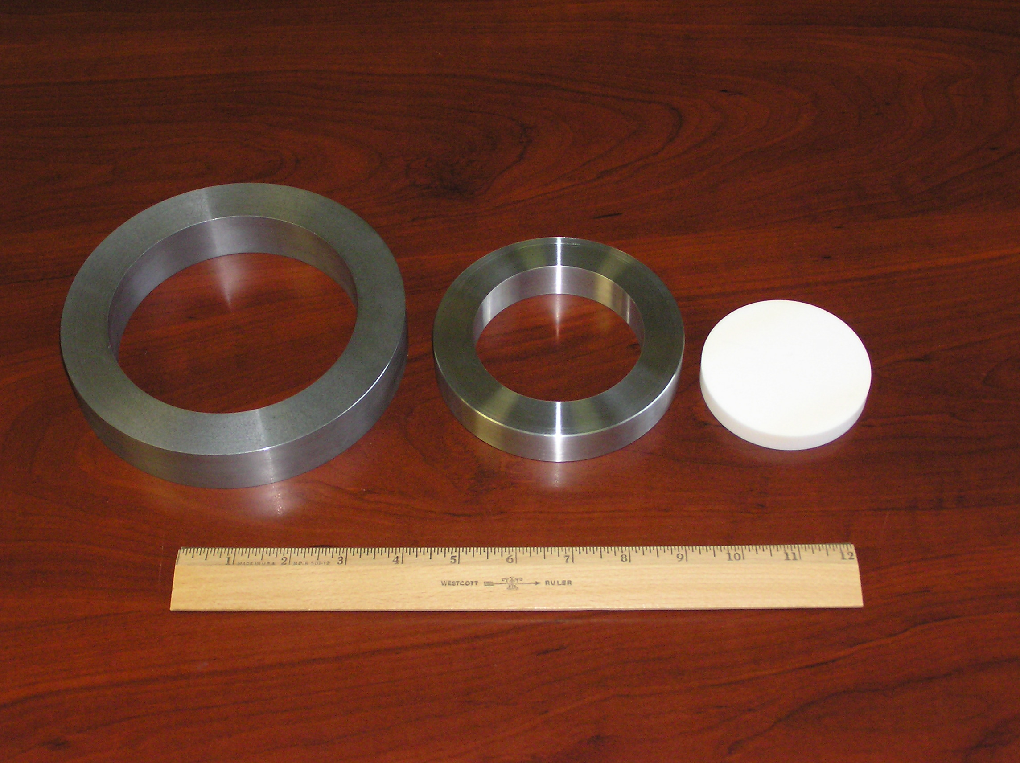
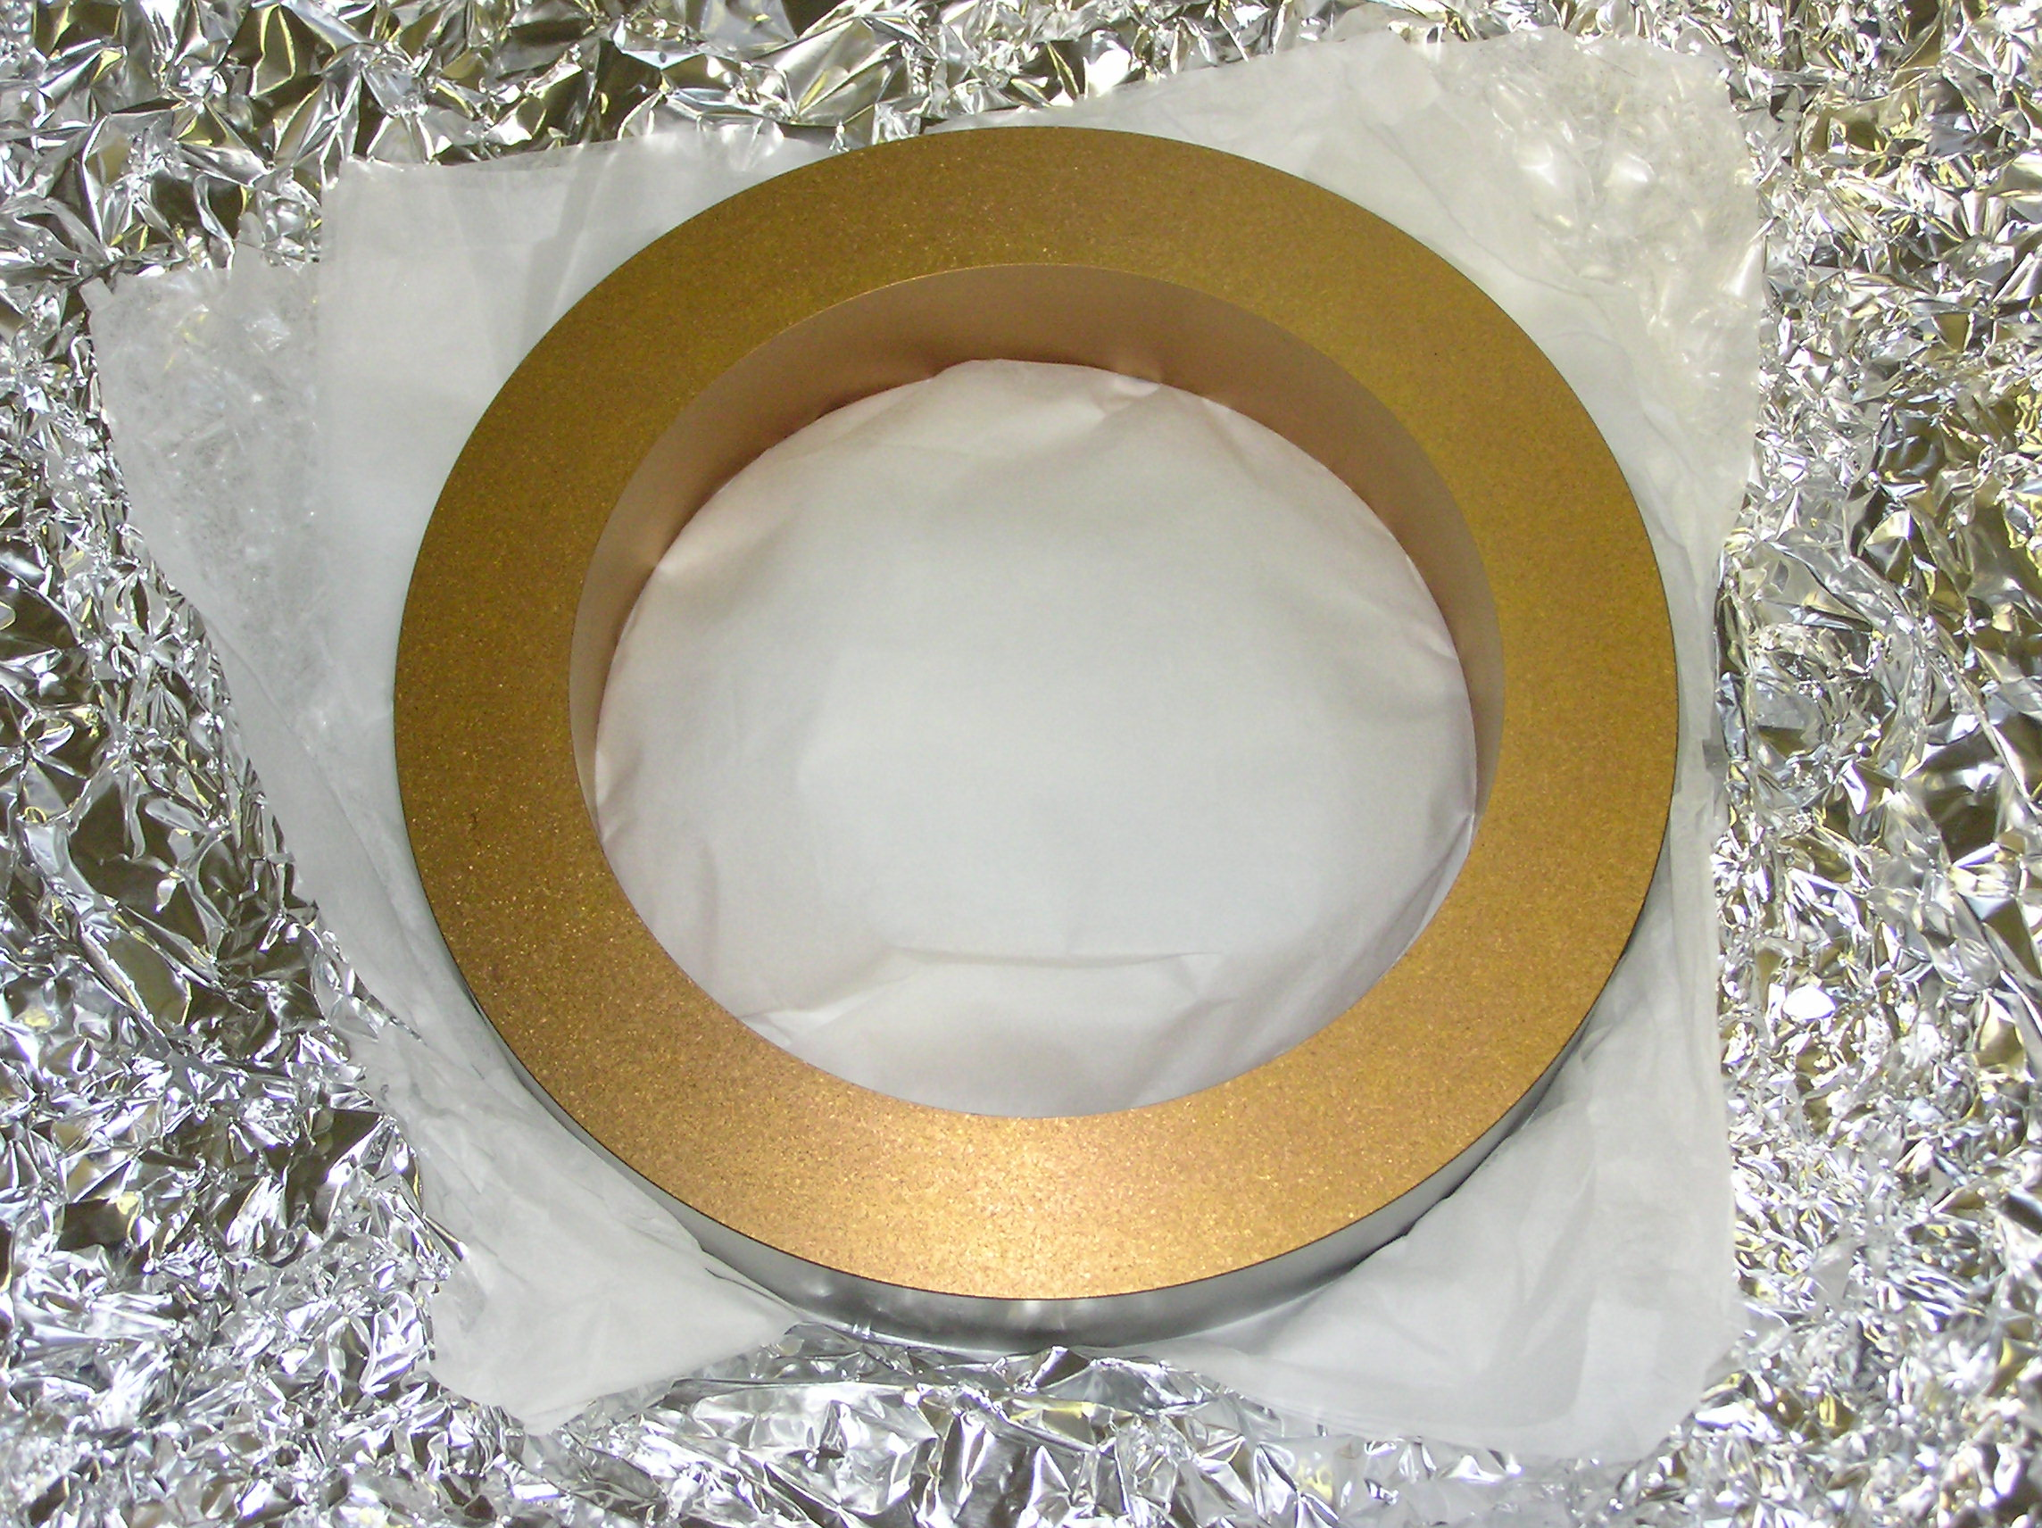

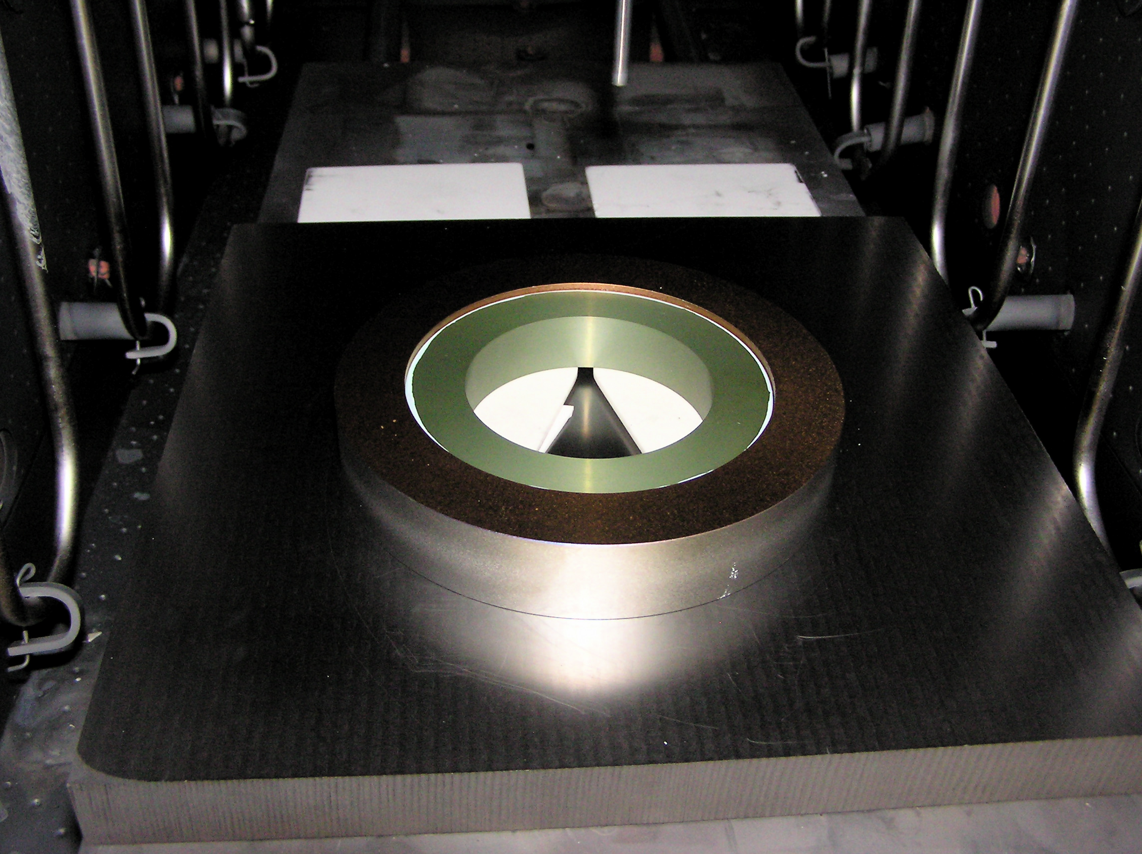
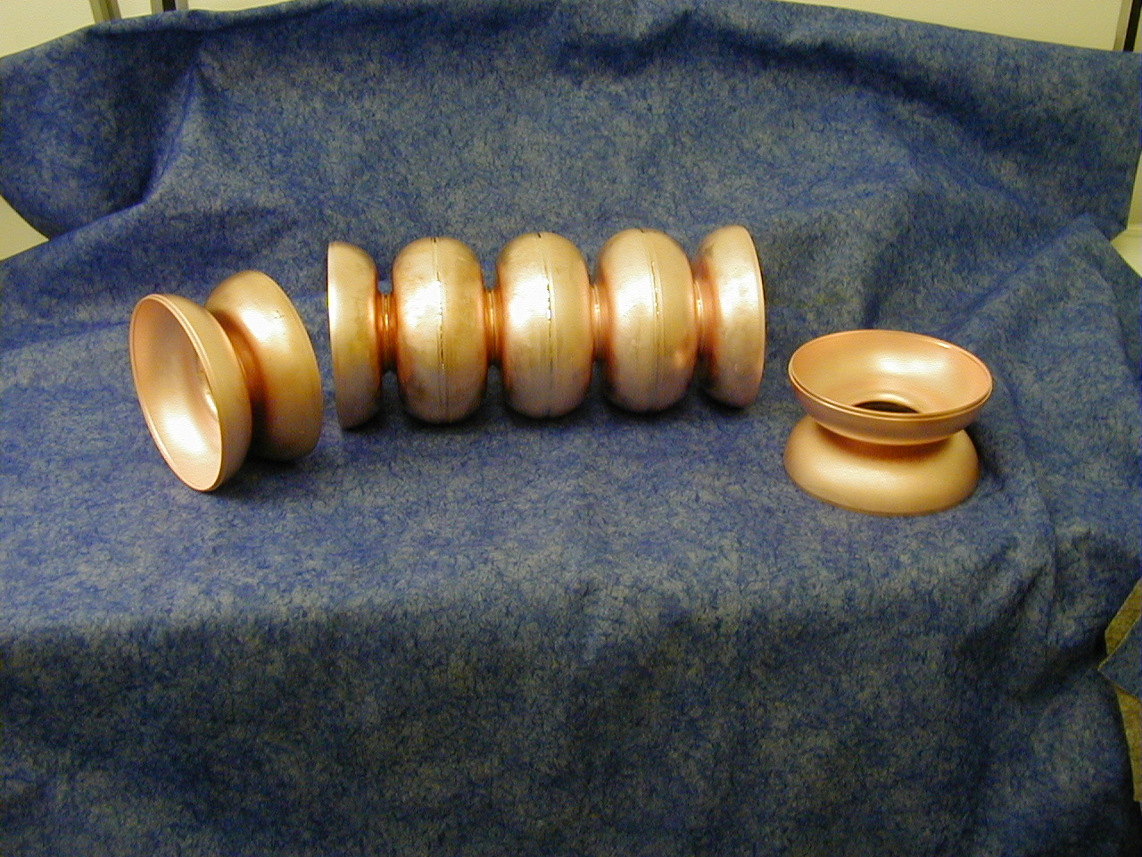

WBS 8 (Instrumentation):
Work this week centered on the shutdown for the installation of the cryo-cooled mirrors. Numerous test fixtures had been made to support/simplify this effort. Two new correctors (MDB4F08H, MDJ4F08V) have been mounted on the beam line in at the 4F08 region for the debunching chicane. Power leads have been pulled back to their respective destinations. After the software has been installed into EPICS, we can perform a functional checkout. The 2 G dump box supply has been moved from the gallery into User Lab 1 in support of the LIPPS experiment. Power and water lines will be installed next week. Additional ion pump HV leads were provided for the new Varian controllers. Wiring has begun on User Lab 5 LPSS with the door interlocks, beacon, maglock and card reader.
Work was done this week on implementing the viewer timing system. The cables are installed for the 3F region and the 4F region cables are going to go in early next week. The hardware for the system is done, and programming of it is going to occur Monday. The system also has been documented.
The cables for the new camera image acquisition system have been run from the control room to the 3F region in the vault. This daisy chained cable has been terminated on each end going into and out of the cameras. All of the 3F cameras have been put back in their place and are ready for Pavel to begin checking them out. Also, cameras have been put back on in the wiggler region.
The new gun chamber UHV ion pump power supply software was successfully tested this week. One more IOC reboot will be required to update the names of the pumps they are controlling. We worked with Carlos to get pumps properly hooked to these new supplies. A user manual is being prepared for the Injector Phasing Script. This will accompany the injector phasing procedure in the FEL Procedures book.

WBS 9 (Beam Transport):

IR Machine Operations
• In work for the New Gun and injector Test Stand, the stalk retraction system is heading for engineering drawing submittal to us. The Riggins Co. gave us an estimate on bringing the tank for the high Voltage Power Supply back to operable condition culminating in a “hydro” test. The order to them is in the system.
• Concerning work on the second wiggler chamber, the shop bent out the small kinks that drove it beyond the wiggler’s narrowest envelope and they removed small concavities at the welded tube intersection regions. The latter gained a half mm of aperture. They removed a long arc bend that will gain back another half mm of aperture over the central region, making it flat to 250 microns. They are now working on removing two last kinks near the ends at the BPM flanges to match the straightness of the central region.
• We have a short term plan to keep the downstream OCMMS from moving due to the heating and expansion of the Wiggler Chamber. We will implement the change at the next cryo mirror removal down period. We will add a simple anchor to the free inside of the Downstream OCMMS to match the outside’s support’s anchor. We will then loosen the restraining clamps at the upstream end and inject anti-seize into the two sliding surfaces between OCMMS flange and its support to allow it to move freely. This free motion will only happen if the periscope portion of the OCMM, presently supported at the floor, is allowed to slide with low friction. To accomplish that function, we will hang it from a cantilever stand that formerly held up the x-ray cross.
• During the down period we want to correct some now obvious features of the OCMMS that promote cavity-like resonances. We designed and made a spring finger clip that can short out the free ends of the wiggler chamber extensions to the flanges they face, significantly reducing the drive for any resonance. We also plan to add some lossy, glassy carbon chunks to the insides of the OCMMS to damp-out any oscillations. Kevin Beard is following up with modeling the regions on the RF Analysis Software the lab recently purchased.
• Magnet Test finished the first SF sextupole measurement series. The reversed hysteresis loop tests showed no improvement to the results, but the entire exercise showed the sensitivity of the stepper stand measurement technique to probe position, showing the perceived errors may be interpreted as probe positioning errors and uncertainty. David Douglas approved the results. We are planning a repeatability test of the same magnet after splitting it apart and putting it back together. (The installation over an existing beam chamber requires this.)
• We added an additional corrector pair in front of the Debunching Chicane.
• The installation of Rexolite windows (to create regions we can fill with helium) into the remaining 7 waveguides of Zone 3’s cryomodule started. The SRF folks removed the waveguide elbows and Dan Oprisko added their gas outlet ports. At the start of next week, the SRF folks will reattach the elbows, mount the new windows and reattach the waveguides in their higher position. We are indebted to Dan Oprisko who agreed to work overtime while maintaining his normal work schedule in the newly acquired “regular position” with the Cryo Group.
• Facilities Management continues working on raising the capacity of that Drive Laser Room’s cooling unit.
• A non-magnetic transfer table over the beam line, rated at 100 lbs (It has held a 400 lb weight) was installed on Monday. This installation solves the safety problem involving lifting items over the beam line while crossing over the line.
• The vacuum group will change out a leaking valve and add an ion pump to a dead headed region in the 5F region starting on Monday.
Experimental program
Experiment to see a pseudoscalar particle that couples to photons
• The Turning mirror stand was mounted to the floor, cooling water was piped to the magnets and the power supply was moved into position. We still need details of how to mount the CCD and make it into a camera on the regenerator magnets and a method of mounting an optical beam dump.

WBS 11 (Optics):

FEL mirrors
Efforts this week were concentrated on assisting with the choice of the best outcoupler for the cryomirror test. To do this, we made use of the UV/VIS/IR spectrophotometer that Old Dominion University (ODU) has at the Applied Research Center. Absorption spectra were taken in the near IR on a number of mirrors. A scan through the VIS/IR was made on the 1.6 micron outcoupler that had been used in the FEL since the late Fall. Its spectrum will be compared with that from an unused mirror to see if any changes in the coating/substrate combination have occurred. The software used by the ODU instrument is the same as that used by our primary coating vendor, so we will be able to compare data quickly.

Substrates were shipped in order to have a low outcoupling (5%) at 1.064 micron coating applied. This will be used, in part, for our work-for-others contract with SAIC to study the higher harmonic content of the FEL.

Other Activities:
This week’s shutdown was eventful. The shutdown this week was primarily for the Optics group to complete three tasks: install a cryo-cooled OC mirror, work on the optical transport system (OTS) and to replace the YLF rod and lamps for the Drive laser.
After one failed attempt at brazing a mirror into the cryo-frame we succeeded in brazing two 1.6um mirrors. We would like to thank Tom Elliott for his help with both the brazing and the gold sputtering. It was decided that the best chance of obtaining 10kW with the two mounted optics is to use the one with the greater output coupling at ~21%. We removed the top three optics from the OC vessel to accommodate the cryo-lines. The two of the optics are pasted and will have to be re-pasted before they are reused. Both the cryo-lines and the cryo-mirror are currently installed. These will be leak checked and aligned today. Four temperature diodes were also fabricated by Steve Dutton (Thanks!) to monitor the temperature of the mirror assembly. It is our goal to have the OC vessel leak checked and under a hot nitrogen purge by COB today.
Three ion pumps where added to the OTS. These additional pumps increased the pumping from the original 160 l/s to over 2100 l/s. The CaF2 Brewster window in Lab 1 was replaced with fused silica. This allows higher laser power to be used in the lab. The mirror cassette translation motor and a limit switch where fixed in Lab 2. The problem with the motor was traced to a broken female pin in the connector. The OTS has been leak checked and is under vacuum. The vacuum at the end of the OTS is now in the low 10-7 torr range, this is an order of magnitude below its previous level.
After many delays by the vendor the Drive laser rod arrived fifteen minutes ago (10:30). The original delivery was scheduled for a month ago. Shukui will mount the rod today and replace it along with the lamps early next week. We expect that the Drive laser will be back to specification by Wednesday of next week.

Terahertz:
There were no THz studies this week in light of the shutdown, but we have used the down time to work on assembling and wiring several new motion control systems. We have several new motorized rotary stages that will provide us the remote control of several wire grid polarizers which will give us computer control over the beam intensity delivered to various experiments and systems. We also have a new long travel linear stage that will initially be used to control the position of the Pyrocam to provide computer control over our THz imaging tests.

Also, we have had some feedback from Nick Agladze on the analysis of the tests from last week on their new holographic interferometer for multichannel sampling of the THz spectrum. They were quite pleased with the results, but there were still some puzzling data from the transmission spectrum of a band pass filter (BPF) that was tested. We will be working with them to run some further tests to better understand the transmission of the BPF and the performance of their new interferometer design.

Finally, we have been reviewing several questions and comments from the Brooks AFB group as they move forward in writing the protocol for the next phase of experiments to determine the safe levels for human exposure to high power THz sources.

Upgrade of the video acquisition system for the beam size measurements
We have been working on an upgrade of the video acquisition system for some time now. The goal is to reduce the time we need to make accurate beam size measurements in the 3F and 4F regions from ~ 2 hours down to ~ 15 minutes or less. One of the reasons for the very good progress to date is that we were able to get detailed documentation of the CCD cameras we use, which was not an easy process due to the poor level of technical support at the manufacturer. Once having the proper documentation we could set up the video cameras in the best way for the measurements we need to do, the key issue being to sync the cameras to the beam and not only to the frame grabber.
After bench testing, on Friday evening last week we tested the new concept with beam and it was very successful. A modified CCD camera was then installed on the 3F07 viewer and synchronized to the beam. The test went very well and essentially we saw what was expected. That is when the camera and the frame grabber are synchronized properly to the beam we see a very clear mean profile as shown in Fig. 1. Moreover the picture is steady even though the beam is pulsed. And as if that would not be enough, one more improvement in the system is that the image contains the beam information on all the lines of the video signal whereas before we would get the beam profile information on every second line of the video signal.
During the shutdown this week a lot of work has been done on upgrading the system. All the cameras have been taken out from zones 3F and 4F, modified and tested on a special test bench. We are re-installing the cameras back in the viewers now. The work will be finished next week. Thus we will be able to start to use the updated system for the beam size measurements right after the shutdown.
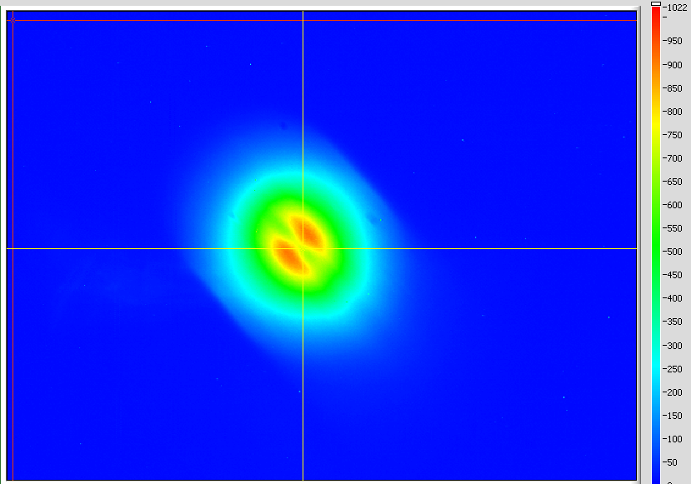
Fig. 1 Beam profile measured at 3F07 with the modified video acquisition system

