LERF Warm-Up Procedure for LCLS-II Cryomodules
V3. 10/16/2018

- Confirm that an ATLis entry for the warm up has been created and reviewed.

- Inform the Cryo group that the Shield lines are going to be closed. Close the Shield Supply valve (CEVCM03SH).

- Verify that the cooldown manual valve (CMVCM0366) is open.

- Set up four Strip Charts with the channels shown in Tables 1, 2, 3, 4 and 5. Note that either the DEV or the OPS archiver may be needed (see subtitles) for the different signals.

Table 1: Channels for GHRP Diodes
Description (Temperature Diodes) | PV
GHRP Average Temperature | GHRPAVE
GHRP Warming/Cooling Rate | GHRPRATE
GHRP Temperature Difference | GHRPDELTAT

Table 2: CM1 Valves, Pressure Gauges, Liquid Level
Description | PV
Helium Pressure 0 – 5000 Torr | CPICM0114
Helium Pressure 0 – 100 Torr | CPICM0113
Cryomodule Upstream Liquid Level | CLLCM0112
Cryomodule Downstream Liquid Level | CLLCM0113
Cryomodule Cooldown Valve | CPVCM01CD
Cryomodule JT Valve | CPVCM01JT

Table 3: CM1 Diodes
Description | PV
Cavity 5 Helium Vessel Top | srfccon3A:cha
Cavity 5 HOM Copper Strap DS | srfccon3A:chc
Cavity 5 HOM Copper Strap US | srfccon3A:chd
Cavity 5 Helium Vessel Bottom | srfccon3A:chb
Cavity 5 HOM Coupler Side | srfccon3A:chc

Table 4: CM2 Valves, Pressure Gauges, Liquid Level
Description | PV
Helium Pressure 0 – 5000 Torr | CPICM0212
Helium Pressure 0 – 100 Torr | CPICM0211
Cryomodule Upstream Liquid Level | CLLCM0210
Cryomodule Downstream Liquid Level | CLLCM0211
Cryomodule Cooldown Valve | CPVCM02CD
Cryomodule JT Valve | CPVCM02JT

Table 5: CM2 Diodes
Description | PV
Cavity 5 Helium Vessel Top | srfccon3B:cha
Cavity 5 HOM Copper Strap DS | srfccon3B:chc
Cavity 5 HOM Copper Strap US | srfccon3B:chd
Cavity 5 Helium Vessel Bottom | srfccon3B:chb
Cavity 5 HOM Coupler Side | srfccon3B:chc

Table 4: Channels for Strip Chart 3
Description | PV
Warm Mix Valve Position | CEVCM03MIX
Warm Gas Flow | CFICM0314

Table 5: Channels for Strip Chart 5
Description | PV
Beamline Vacuum | SRFCMTFBLVAC1
Waveguide Vacuum | SRFCMTFWGVAC1
Insulating Vacuum | SRFCMTFINSULVAC1

- Contact the Cryo group and inform them that warm-up is about to start

- Create a Log Entry in SRFLOG, CLOG and ATLis stating the time of warm-up commencement

- Close the 4.5 K supply valve CEVCM0312

- Close the 2 K return valve CEVCM03RT

- Perform the following valve operations inside the LERF vault:

  - Close the Guard Vacuum manual valve (CMVCM0371)
  - Open the 300 K Helium Supply manual valve (CMVCM0365)
- Open the cooldown bypass valve (CEVCM03CD). This step may be done whenever testing for the CM is complete; the remainder of the warm up operation does not have to be started immediately. Ensure that the return line pressure (CPICM0212) remains below 1.05 atm (798 Torr).

- Close the CM JT valves (CPVCM01JT & CPVCM02JT) and open the CM cooldown valves (CPVCM01CD & CPVCM02CD). Ensure that valves to the cooldown header are open at all times.

- During warm-up, the following must be maintained for the GHRP between 80K to 300K:

  - The upper diode temperature must be within 25K of the lower diode. This quantity can be seen on the Production Cryomodule Instrumentation screen in the Log Book workspace as GHRP DELTA T. It can be plotted as GHRPDELTA1 & GHRPDELTA2.
  - The GHRP temperature should not warm at a rate faster than 10K/hr. This quantity can be seen on the screen on the GHRP image. The “Rate” function of this reading should be set to 5 minutes. It can be plotted as GHRPRATE1 & GHRPRATE2.

- Turn on the heaters on the Helium Vessels to half power (50W). Monitor the CHL Recovery Pressure (CPI0840) to ensure that it stays below 1.09 atm. Slowly raise the heater levels to a maximum of 30 W per heater while monitoring the pressure, until the downstream liquid levels (CLLCM0211 & CLLCM0113) are below 20%. Open the warm mix gas valve (CEVCM03MIX) to 50% to aid in boil-off. The heaters will switch off when the liquid level reaches 20%. System should pressurize to ~1.05 atm.

- Open the warm mix gas valve (CEVCM03MIX) to 100%. The warm gas flow indicator (CFICM0314) should read between 1.0 – 1.5 g/s. Note that the default position for this flow meter is ~0.5 g/s, i.e. a reading of 1.5 g/s is actually only 1.0 g/s.

- Turn on the Heaters on the CM cooldown line to their full power of 150W using the Master Voltage knob on the power supply (Figure 1). This corresponds to a current of 3.60A on the display.

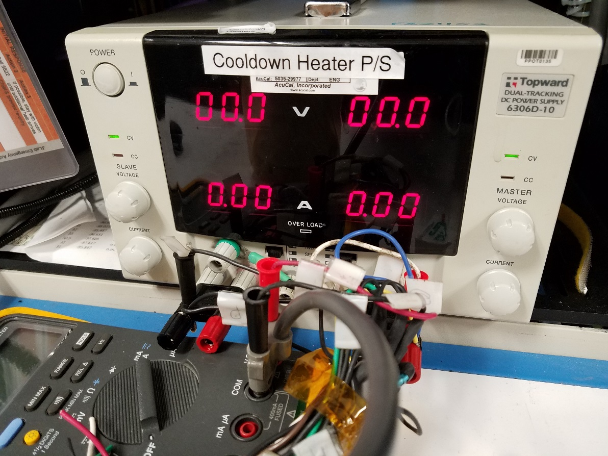
Figure 1: Cooldown Heater Power Supply showing ampere display (circled)

- Increase or decrease the warm gas flow by opening the valve (CEVCM03MIX) as needed. The flow should be between 1.5 – 2.0 g/s. The tables below show the valve set to 50% as an example.

- When temperature of the Cavity 5 Helium Vessel Bottom (srfccon3A:chb & srfccon3B:chb) or the Cavity 5 HOM Coupler (srfccon3A:chc & srfccon3B:chc) rises to 50K, contact the CM assembly group (contact details below) to introduce nitrogen into the insulating vacuum space, bringing the pressure to 1 torr, and turn off the insulating vacuum pump. There will be a change in the GHRP warming rate; allow it to stabilize before making any moves to slow it down. Make a Log Entry listing the new insulating vacuum pressure.

  - John Fischer – x7408, cell: 757-334-2758
  - Frank Humphry – x5291, cell: 757-593-5988
  - Ken Worland – x5697, cell: 757-509-1423

- When the Cavity 5 temperatures reach 100K, ask the CM assembly group to raise the insulating vacuum pressure to 20 torr. Make a Log Entry listing the new insulating vacuum pressure.

- When the Cavity 5 temperatures reaches 200K, ask the CM assembly group to raise the insulating vacuum pressure to 400 torr. Make a Log Entry listing the new insulating vacuum pressure.

- When the average GHRP temperature is above 285K, close the warm mix valve (CEVCM03MIX) and turn off the cooldown line heaters.

- Inform the assembly group that warm-up is complete and that the u-tubes may be pulled.

Cryo Group Contact Information:

Joe Wilson
Extension: 7722
Cell: 757-329-7576

Thilan Wijeratne
Extension: 7058
Cell: 954-554-6329

Sasa Radovic
Extension: 5157
Cell: 757-236-0684

SRF SME Contact Information:

Ed Daly
Extension: 7721
Cell: 757-969-0783

Naeem Huque
Extension: 7485
Cell: 217-721-5422

John Fischer
Extension: 7408
Cell: 757-334-2758

