  - Users with full Maximo access:
Maximo admin, Department Managers, Work Group Coordinators and their alternates. The admin maintains a list of users with full Maximo access.

For those without Maximo access, you can submit a work request, but you will need one of the above users to accept it to create a work order and assign you as the lead for your work. Then you can access the “My Work” tool to update it as shown below:
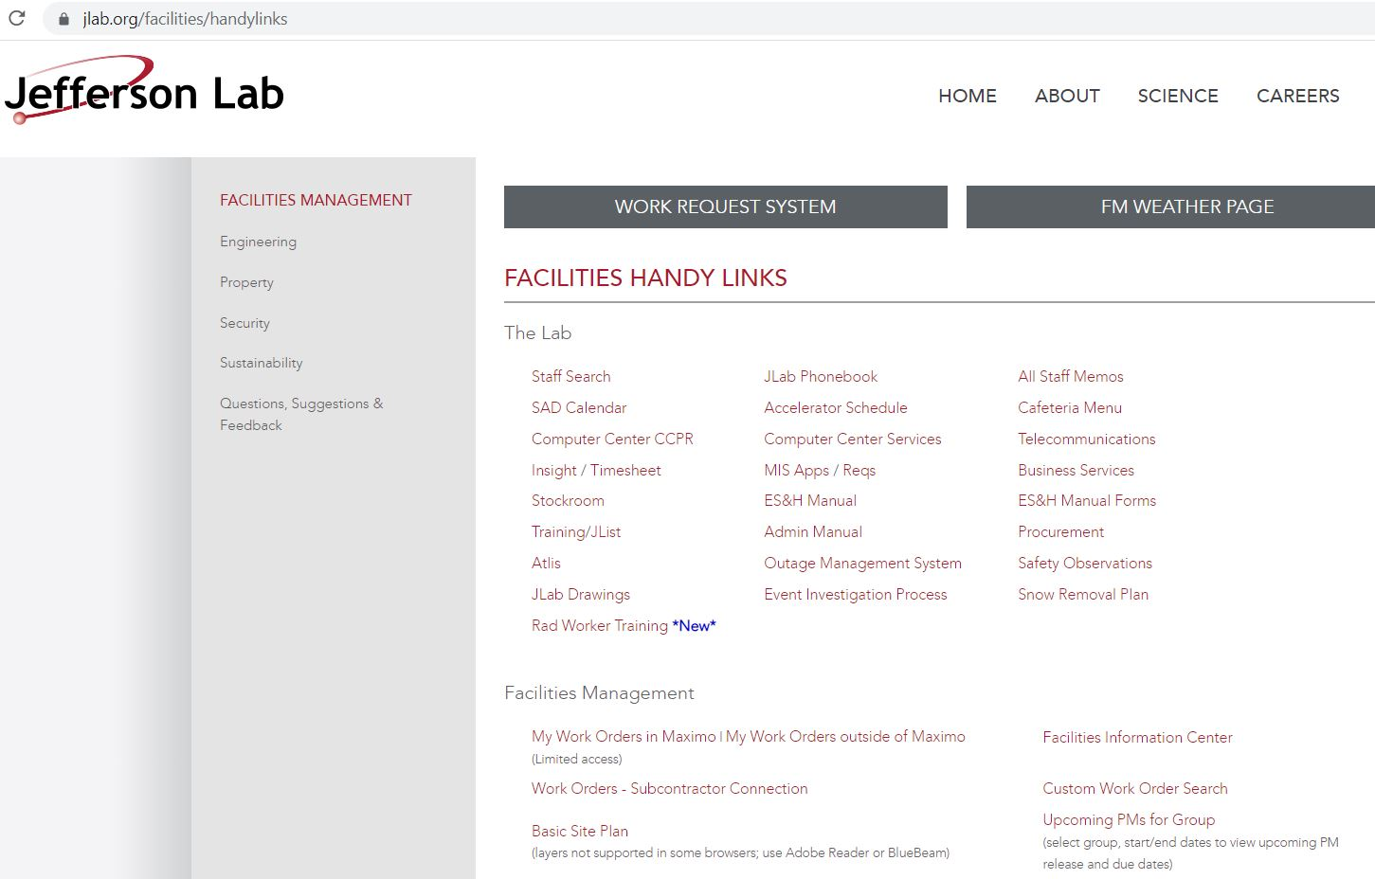
Then click here:

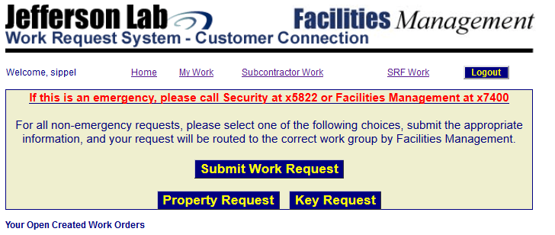

The “My Work” screen lets you fill in/select items in the search boxes. Hold down the “Ctrl” key and press the left mouse button to choose multiple items in a selection box. Hit the “Search” button to display the results. Hit the “Reset” button to clear out the search items. Once you perform a search, you can save your search results by clicking on the “Save Search Results” link below these buttons and reload them at any time later using the “Load Saved Search” link in the left grey panel.

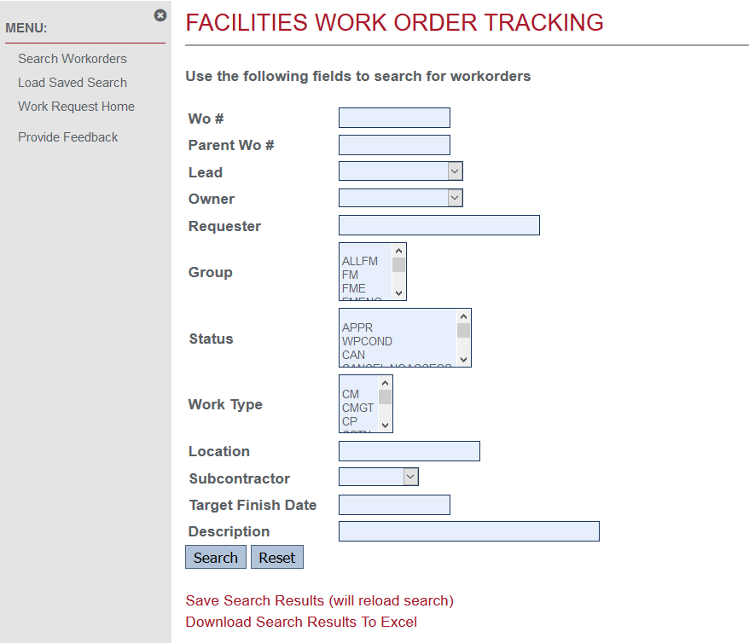

Click on the “Download Search Results To Excel” link to create an excel spreadsheet of the search results.

Here is an example search with the results displayed at the bottom of the screen:
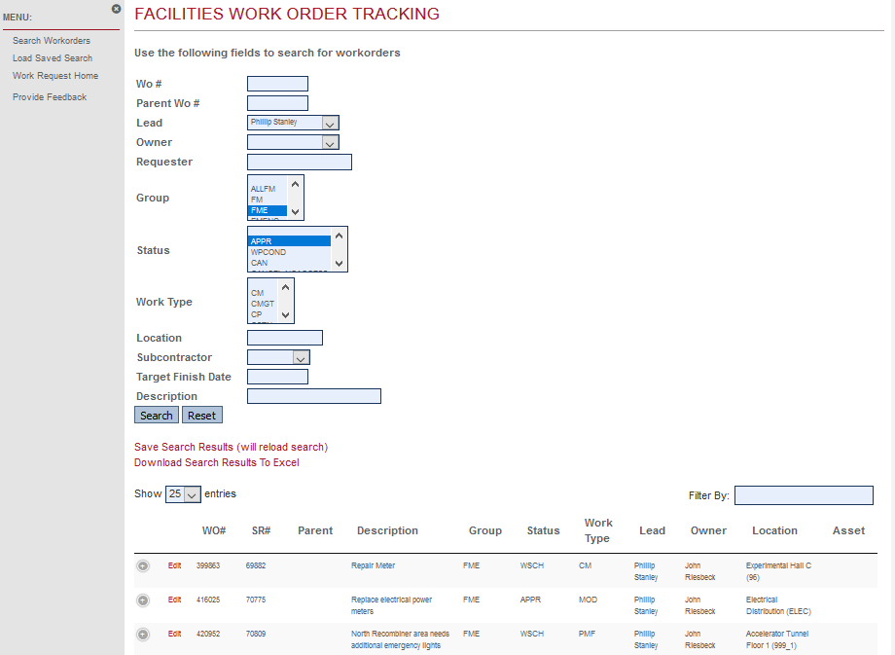
Each of the columns can be sorted. The “Filter By:” box can be used to further narrow down search results, but these results are not able to be included in the “Download Search Results to Excel” link.
Click on the “+” at the left of each work order to see the work order details. Click on the “Edit” link beside it to open it in another window tab. It will display a screen for you to fill in/select items in the search boxes. Fields without boxes are not changeable. If you need one of these fields changed (ie: Target Finish Date), get with your supervisor or work coordinator to have them update it in Maximo. See next page for an example of the work order edit screen.

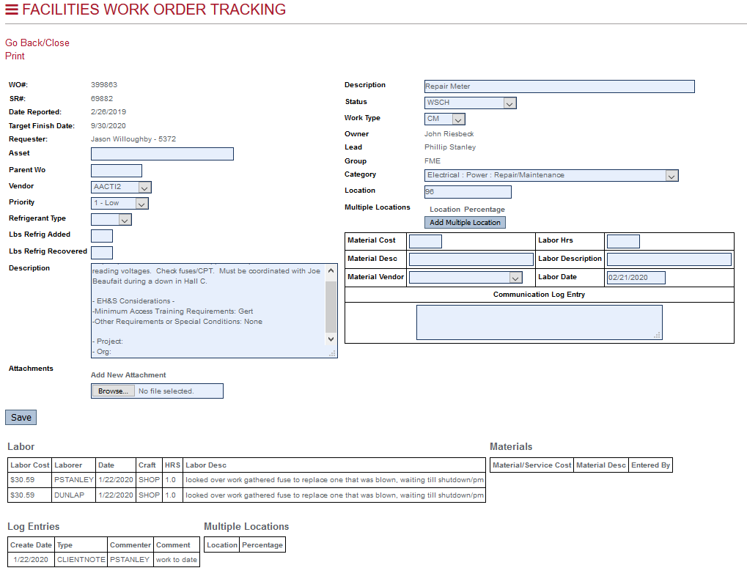

You can attach documents, add or update the asset, vendor, refrigerant information, location, work type and work category, add multiple locations and change the work order status per your group’s workflow procedures.
You can add material costs, labor hours, and log entries. Once saved, they will display lower on the page along with previous entries. If there are child work orders, they will be displayed at the bottom of the page.
Hit the “Save” button to save your changes. Click on the “Go Back/Close” link at the top left corner to exit and remove this window tab.

