www.jlab.org
Website Documentation

Adding new users to website
Management of users requires administrator login.
JLab login page is found at https://www.jlab.org/user
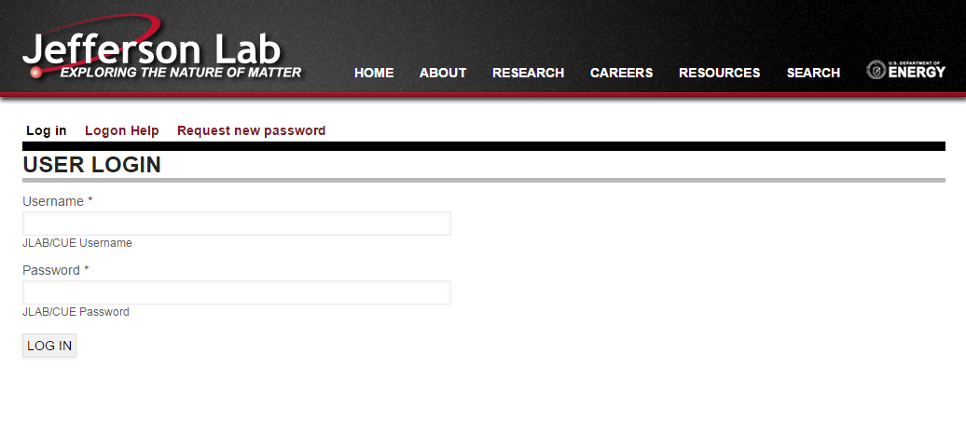

Once logged into the website with administrator credentials, access to user management can be found within the top admin toolbar under “People”.
https://www.jlab.org/admin/people
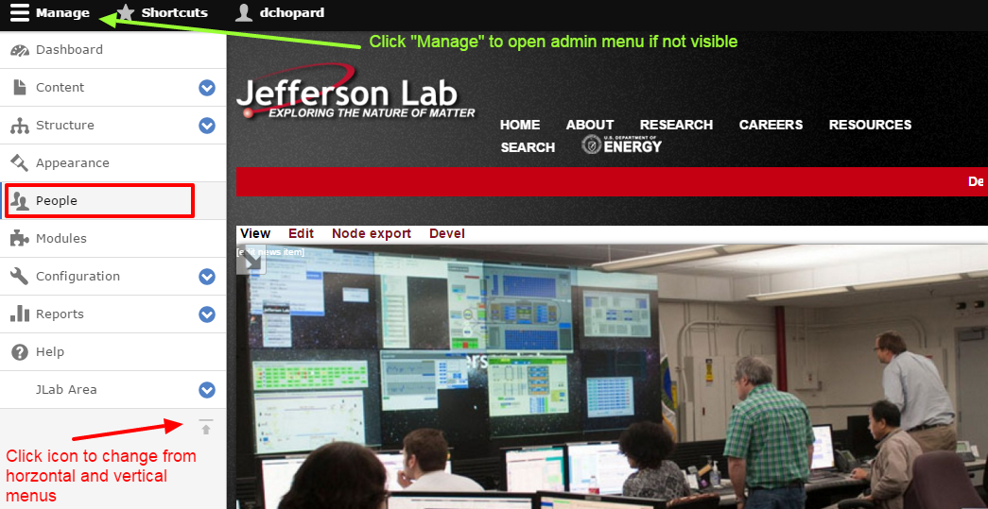

Side Notes:
- If toolbar is not ‘open’, click Manage in the admin toolbar.
  - If toolbar is not present, please login as an administrator
- Screenshot has admin menu anchored to left of screen. Clicking icon at bottom-right of toolbar will toggle the location between horizontal and vertical
  - Vertical allows access to submenus via accordion functionality
- When toolbar is vertical, page content may not format properly due to the spacing taken up by toolbar. Change to horizontal display if vertical causes issues.

The https://www.jlab.org/admin/people page is a listing of all users within the Drupal system.
Access the new user form by clicking “+ Add user” button
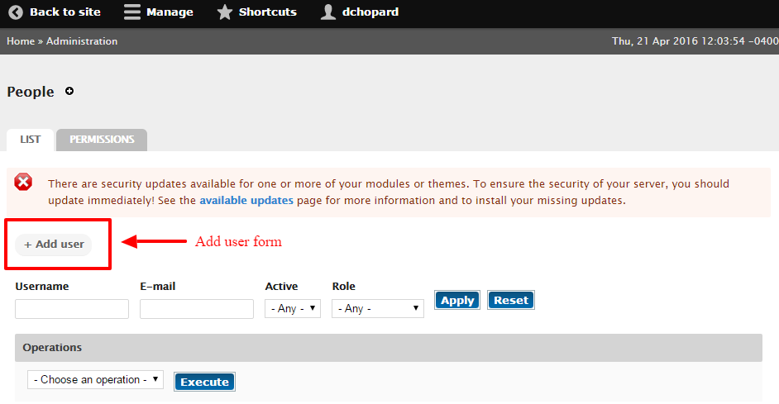

New user form https://www.jlab.org/admin/people/create
Fill in fields with respective information.
Notes:
- Status determines the access state; whether their access to the site is blocked or active.
- The checkbox for “Notify user of new account” will determine if an email is sent to the new user, notifying them of the new account.
