Step-By-Step Instructions on submitting your
Electronic Access Registration Request
Welcome to Jefferson Lab. To prepare you for your upcoming visit, we will walk you through the JLab Site Access Registration process.

First, let’s determine the reason for your visit.
Duration | Reason for Visit | JLab Type
Onsite - My visit is five days or less | Interview, Meeting, Pre-Bid Visit | “Visitor”
Onsite - My visit is five days or less | Open-to-the-Public Tour, Conference, or Workshop | No site access registration needed
Remote Only - visit is five days or less | Virtually attending an Open-to-the-Public Tour, Conference, or Workshop | No registration required.
Remote Only – visit is five days or less. | Virtually attending a Closed Tour, Conference, or Workshop | “Virtual-Visitor”
Onsite - Multiple time frames of varying lengths | Performing work on Accelerator | “User”
Remote Only – Access is longer than five days. | Remote Only - need to have computer access; Not coming to JLab. If a User-Remote” needs to come to the lab, the guest must submit a User Type Registration for that time period and then it will revert to User-Remote after the registration’s end date. | User-Remote
Onsite – My visit is longer than five days and I am from the DOE Offsite. | Working with the DOE Offsite and not attending a tour, conference, nor workshop. | DOE (Reserved for DOE Offsite Employees)
Attending a workshop, tour, or conference
NOTE: Guests may be required to do an Event Registration and/or Tour Registration in addition to the Site Access Registration. The Site Access Registration is ensuring you have approval to visit the JLab Campus.
OPEN-TO-THE PUBLIC:
- Guests are not required to submit a Site Access Registration unless JLab is paying for your travel expenses.
- DOE employees are not required to submit a Site Access Registration unless JLab is paying for your travel expenses. You will want to submit the registration using the JLab Type “Visitor” to eliminate all of the training requirements attached to the JLab Type “DOE”
- DOE Offsite Employees are not required to submit a Site Access Registration.
- Users do not need to register a visit unless they are combining it with performing work. If so, Users will submit a User type Site Access Registration.
CLOSED-TO-THE PUBLIC:
- All participants are required to submit a registration
- Guests (to include DOE employees) are required to submit registrations using the JLab Type “Visitor”
- Users should submit registrations using the JLab Type “User-“.
- DOE “Offsite” Employees will submit a registration using the DOE JLab Type.

Guests attending JLab for interviews
- Candidates interviewing for employment at placed other than JLab which will be “Joint Faculty/Staff” will use the JLab Type “Visitor.”
- Candidates interviewing for employment at JLab will use HREI – Human Resources Employment Interview JLab Type.

JLab Security’s Registration Page:

As you complete the JLab Site Access Registration Process, please feel free to refer to the webpage https://www.jlab.org/facilities/steps-registration.

Guest Access Portal:

Now, we are ready to go to https://misportal.jlab.org/jlabAccess/ to begin the Site Access Registration Process. This is the screen you will come to:

Input the email address you will use to register for Jefferson Lab Site Access Registrations. Select “Enter.”

Create A Guest Account:

Enter your First Name, Middle Name, and Last Name.
Use the dropdown arrow to select your citizenship.
Select “Create”.

Guests will then be given a listing to determine their JLab Type. This is what will appear.

In this example, we have chosen a one-day visit for an interview thus choosing “Visitor” and “HREI.” This is your opportunity to put your JLab Type and what institution you represent. If your institution/employer is not represented, please let us know at fso@jlab.org. Please also place what dates you will be arriving at the lab and what date you will be departing on. Select “Continue.”

Checklist for Visit
This portion may differ based on the registration type selected.

Guest Registration
Please complete each field in the Guest Registration

Name (Last, First, Middle)
Date of Birth
Citizenship
Country of Birth
Email Address
JLab Type
Green Card?
Student?
Dual Citizenship
Scroll down to see the rest of the form.
Scroll down more to complete the Local Address section.
Local Address Section:

Emergency Contacts Section:
The Emergency Contact cannot be left blank. Scroll down to “Visit Information.”

Visit Information:
Complete the section for “Visit Information.” Enter your employer or institution. If you do not see your employer or institution listed, please let us know at fso.jlab.org and we will add it quickly for you. If you are coming to JLab for an employment interview, you will choose HREI for Human Resources Employment Interview.

Start Date
Completion Date
Arrival Information
Instittion/Agency Name
JLab Host/Sponsor
Describer the work you will be doing or reason for needing access.
Payment onus for travel expenses
Dosimeter

Standards of Conduct: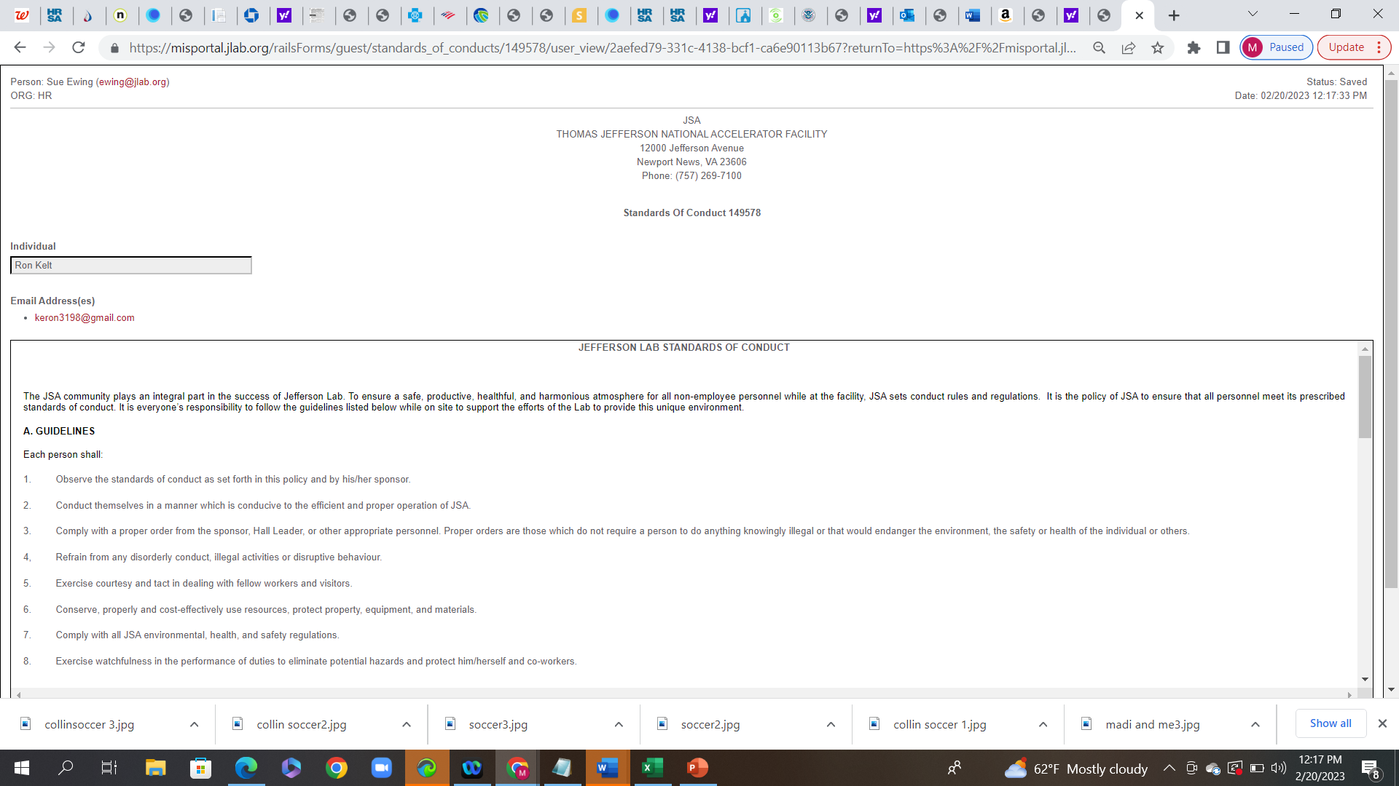

Continue to scroll down to read all of the form.

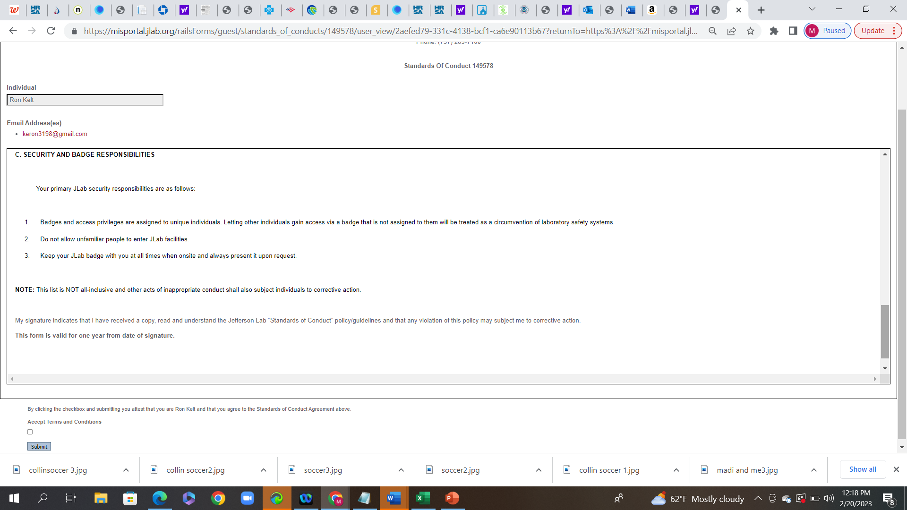

Select the box for “Accept Terms and Conditions” and press “Submit.”

Checklist:

All of the items on the checklist are to be completed. Checklists will be more lengthy depending on your citizenship and the JLab Type selected.

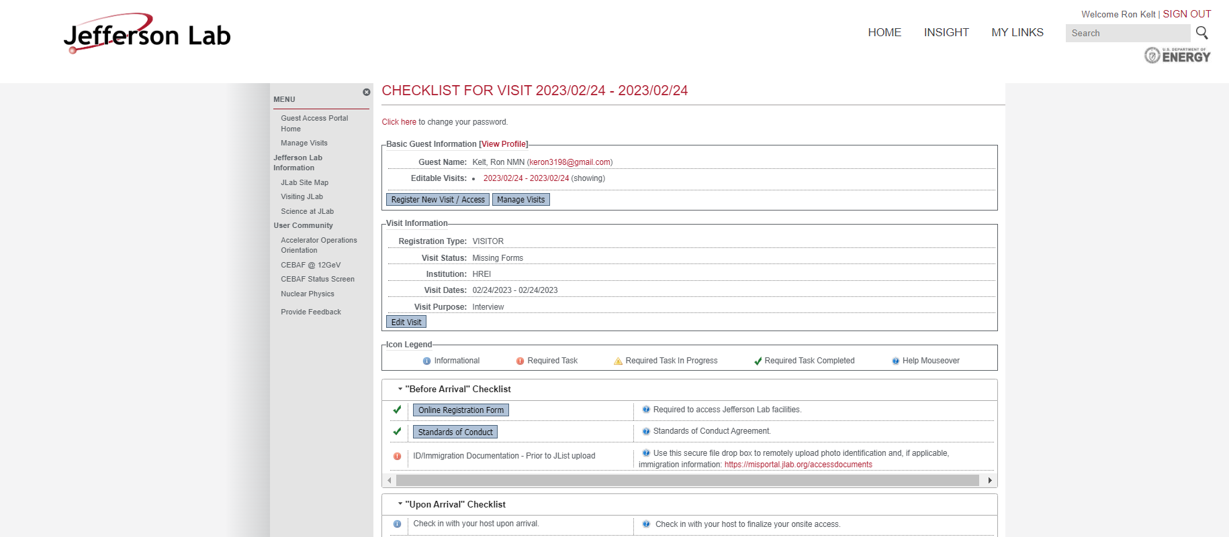

If the checklist directs you to https://misportal.jlab.org/accessdocuments, then you do not already have a record with us and will need to drop any and all related documents into the dropbox. The registration will not be forwarded to the host/sponsor for approval until all items are completed.

Once you have provided all documents, you may still receive an automated message via email advising you have not completed all of the items. The system does not recognize you have provided the documents elsewhere. Please disregard this message as MIS is working to resolve the issue.

Once your registration has gone through the approval process, you will receive an email that you have been approved. A member of our Access Team or your host will contact you via email should there be any items we need for you to complete after submission. Please check your Junk Email and your “Other” Email to ensure you are not missing any emails from JLab. In the interim, please also ensure your training is up to date. The checklist will provide you with your training information.

