JDXpert User Guide
Table of Contents

Adding a New Job Description…page 2
Revise a Job Description…page 18
ADDING A NEW JOB DESCRIPTION TO JDXPERT

Click on Add Job to begin

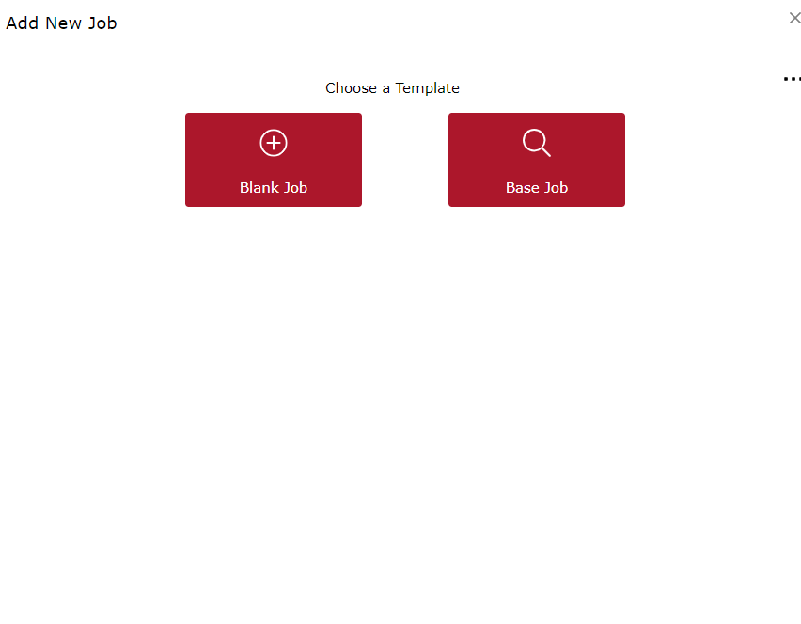
Use a Job Description already in the system from Jefferson Lab, or one of the crowd-sourced jobs in the JDXpert system,
If you want to start a job from scratch, inputting all the Essential Information

There are 2 ways to add a new job. Blank Job starts the process from nothing. You will have to fill out all the information from the beginning. Base job allows you to use an existing Jefferson Lab Job Description, or one of the many thousands of Job Descriptions in the JDXpert Database.

SELECT BASE JOB
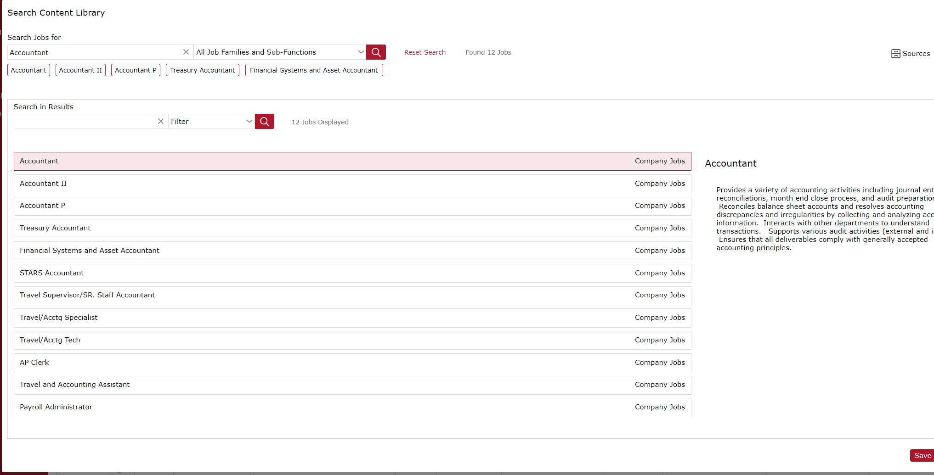

Using Accountant as an example, when you search “Accountant” in the Search Jobs For, you get a lot of results. On the right-hand side, it currently says “Company Jobs” . You can click on Sources in the top right corner to choose the following; Company Jobs (Jefferson Lab), Sample, Crowd-sourced jobs, and job postings.
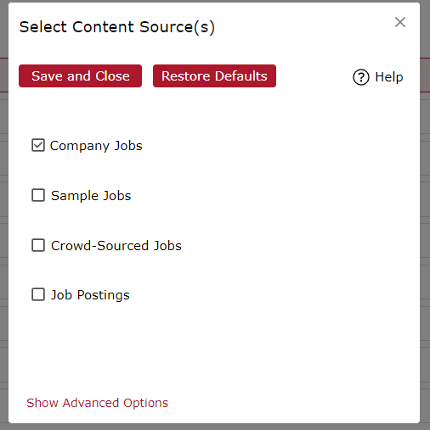

Once you have chosen the Job that you want to use as a template, it will ask the following. Select Yes
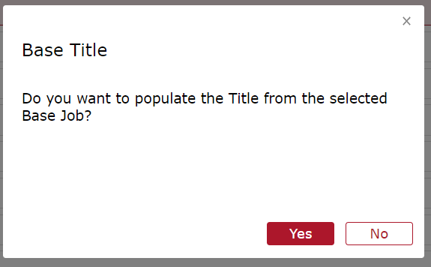

Clicking on BLANK JOB or after choosing a BASE JOB

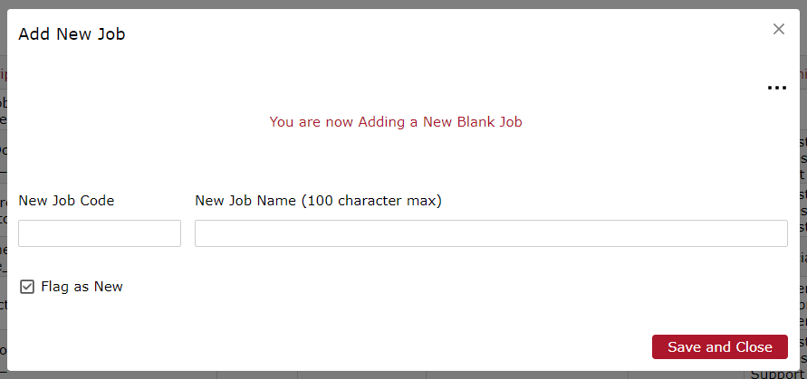

Compensation will give the Job Code for this new position. Fill out the Job Code and the New Job title and hit “Save and Close”

- Complete the Job Information Tab
  - For this example we will be using Staff Administrator I in the Human Resource Division
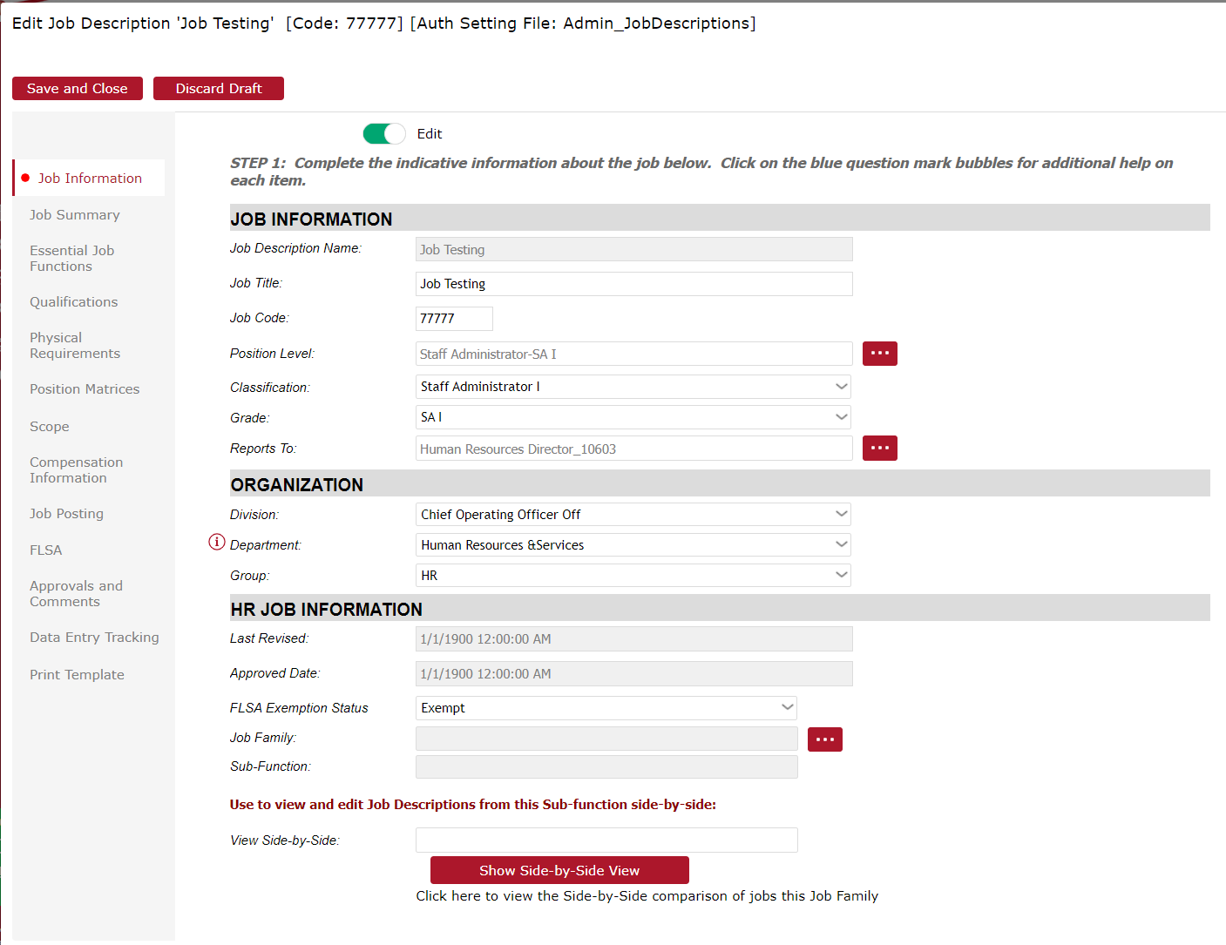
Job Title – Will be the same as Job Description Name
Job Code – Will be pulled in when you created the job code on the previous screen (provided by Compensation)
Position Level – Classification and the Grade combined
Classification – Official title of the Grade (i.e, Staff Scientist, Staff Administrator, Associate Director)
Grade – Abbreviated version of Classification
Reports to – Who will this new position report to. If unsure, refer to your Division Head, HRDP, or Compensation
FLSA Exemption Status - Exempt or Non-Exempt. Compensation does an FLSA Exemption test on every new position, so please refer to them with any questions.
To finish with this page, just hit “Job Summary” on the left-hand side. You do not need to hit save at this moment, but you can if you would like to come back to it later.

JOB SUMMARY

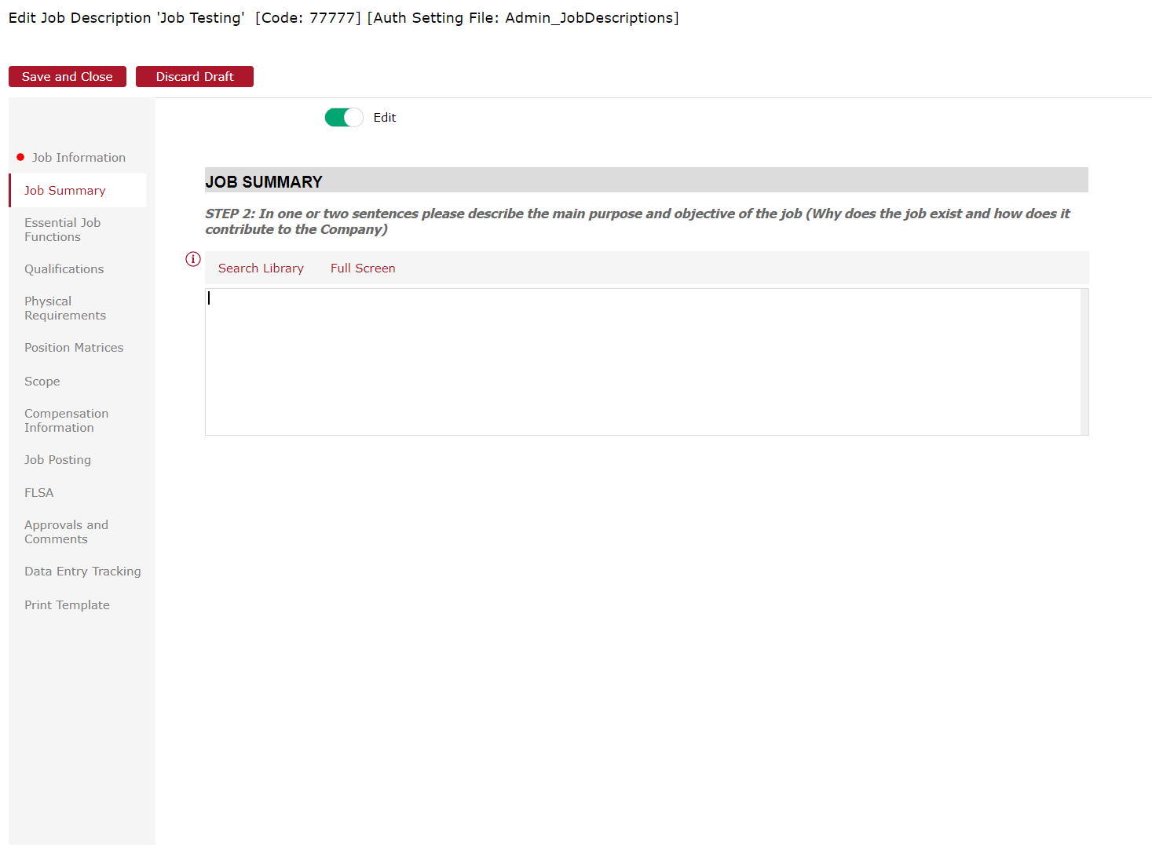

- Complete the Job summary. The system gives a great description of what is needed. One to two sentences saying what the main purpose of the job will be.
Click on Essential Job Functions to move to the next tab

Essential Job Functions
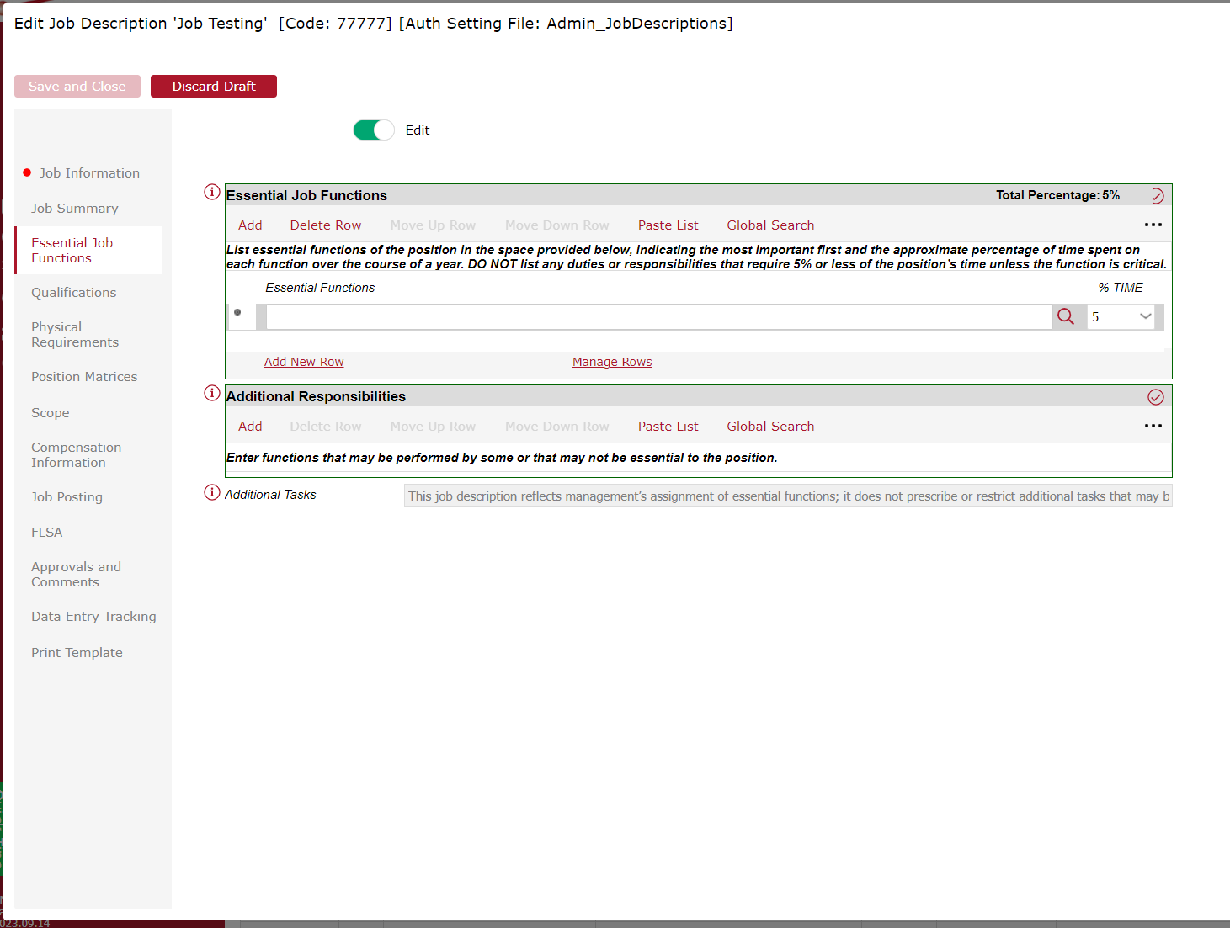

There are 3 ways of completing these boxes:
- If you hit “Add” under Essential Job Functions, you can type out or paste each individual “bullet point” or Essential Function. And then you can add the Time or Weight on the right hand side. For example, if this position will be providing management with Monthly reports, and that is 10% of their time, then you would put 10% under % Time
- The other way is that if you click “Paste List”, you can copy and paste more information at once, and JDXpert does a good job in separating out each function from your pasted list.
- Click on Global Search, and it will give you sample Essential Functions from whatever job you search. For example, type in Accountant, and it will give you sample Job Functions from Jefferson Lab Accountants, and the sample and crowd-sourced Accountant Job Descriptions in the JDXpert Database

GLOBAL SEARCH ESSENTIAL JOB FUNCTIONS (EXAMPLE Accountant)
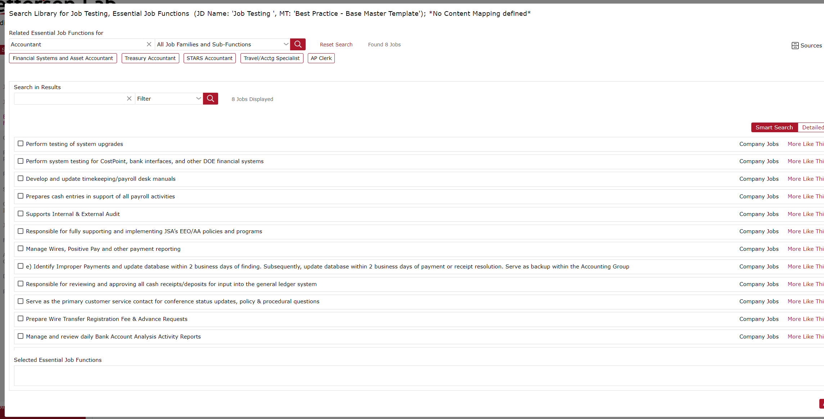

Additional Responsibilities
These can include non-essential functions that may not be necessary for the job, but are included in the description.

Also, if you need additional information, Click on any of the “i” circles next to each box, and JDXpert gives additional information on how to fill out each section.

Qualifications
Refer to the Compensation Website to find the qualifications of each position.
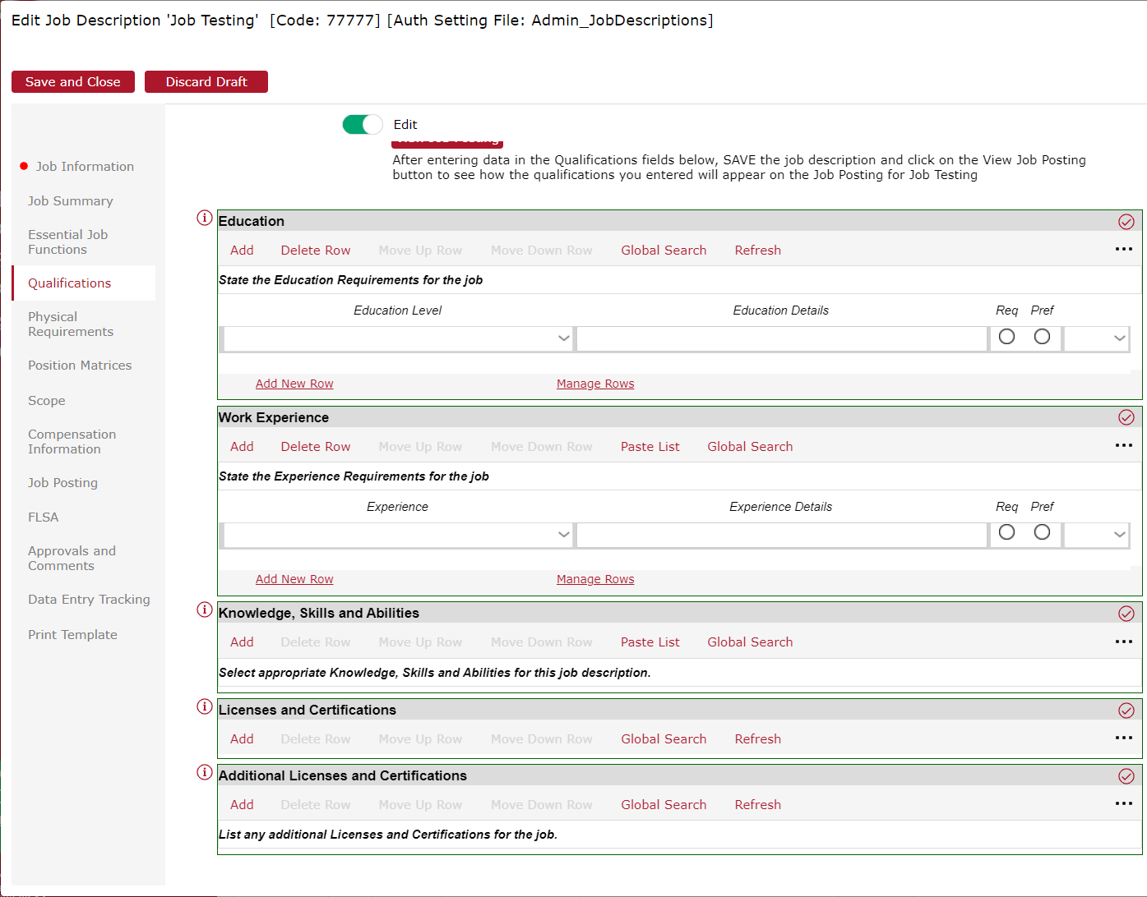
- Education – Click add under Education, and you can select the minimum qualification for this position. The options are High-School up to Ph.D and then also other. You can also click “Req” or “Pref” for Required or Preferred.
- Work Experience – Drop Down menu allows you to select the minimum amount of years required for the job. You can also “Add New Row” if you would like to input something above the minimum like, “5 years of supervisory experience” and then click the Pref circle
- Knowledge, Skills and Abilities - These are the minimum level of skills that the description requires for this position. These do not include Physical and Mental Capabilities.
- Licenses and Certifications – Any license or certification that may be required to complete the job. They have a database of certifications, or you can input your own.

Physical Requirements
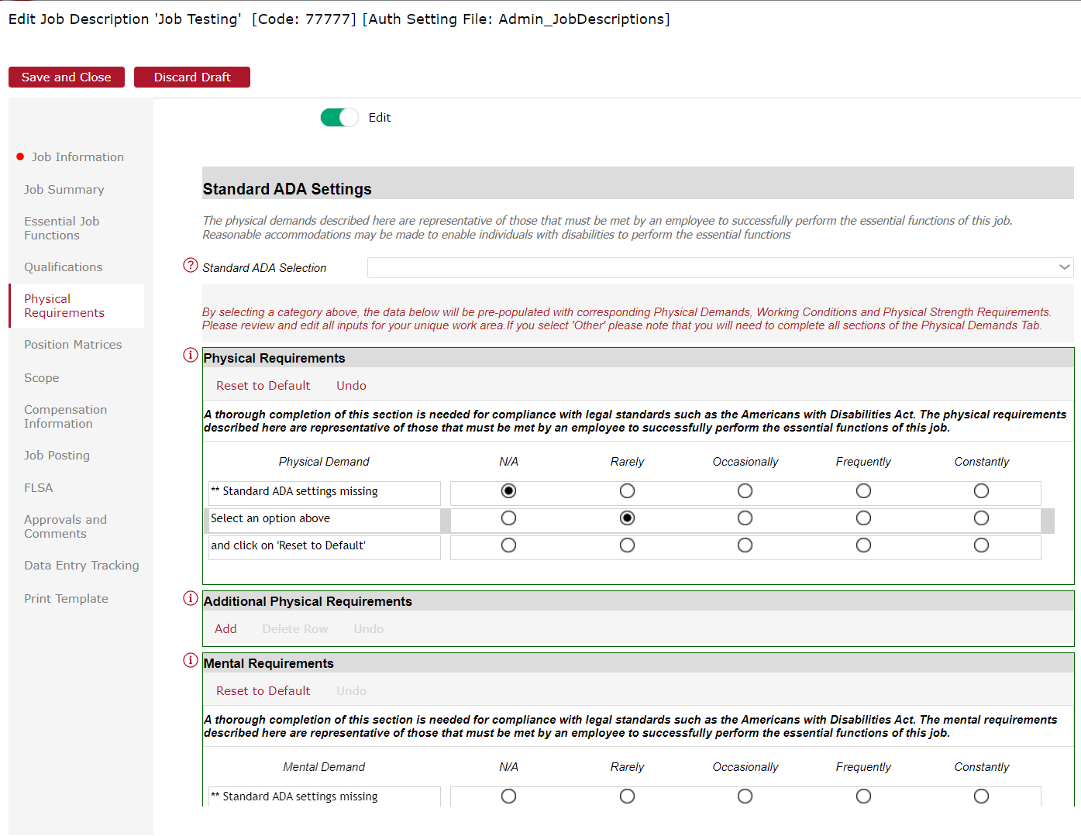

Go through the Physical and Mental Requirements to add any specific requirements needed to complete the job.

Position Matrices
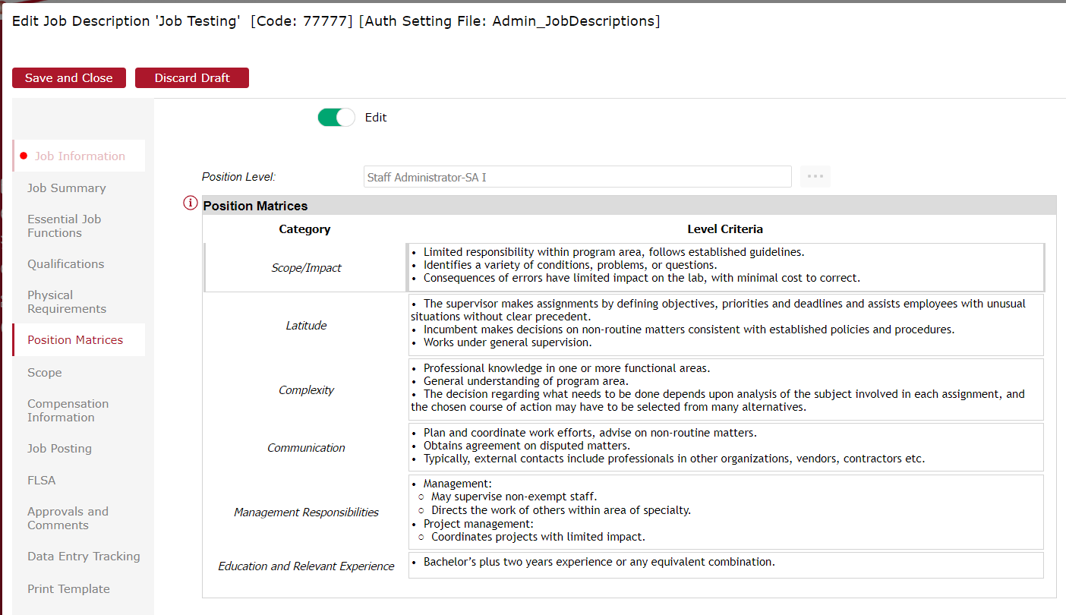

This section has already been filled out and is a general template for the classification. So from our example, you can see the different responsibilities and qualifications that Jefferson Lab has for an SA I level

Scope
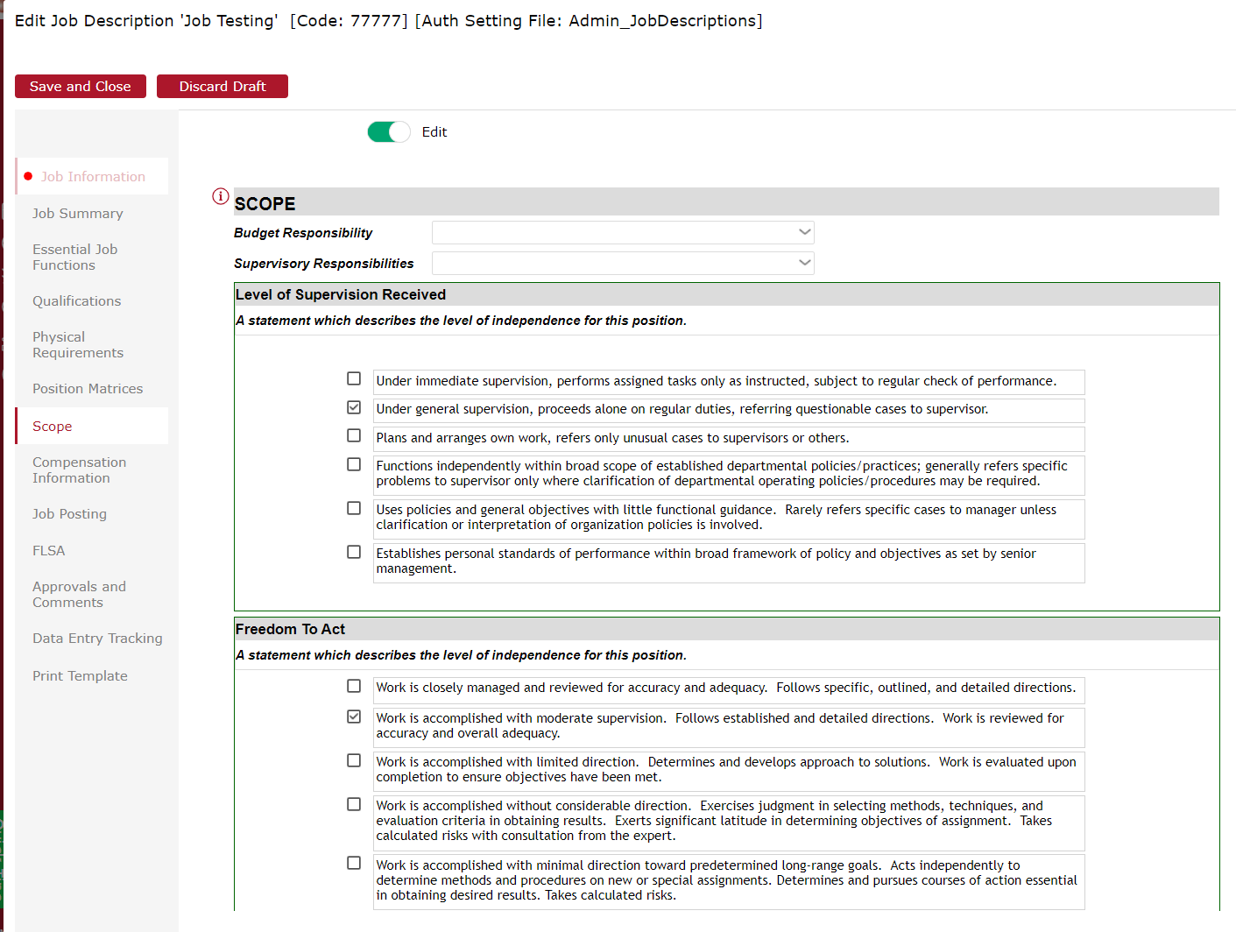

Scope is used to distinguish different levels of responsibility for the position, whether it supervises, has some sort of budget control portion. Higher level positions will more than likely have supervisory or budgetary responsibilities.

Compensation Information
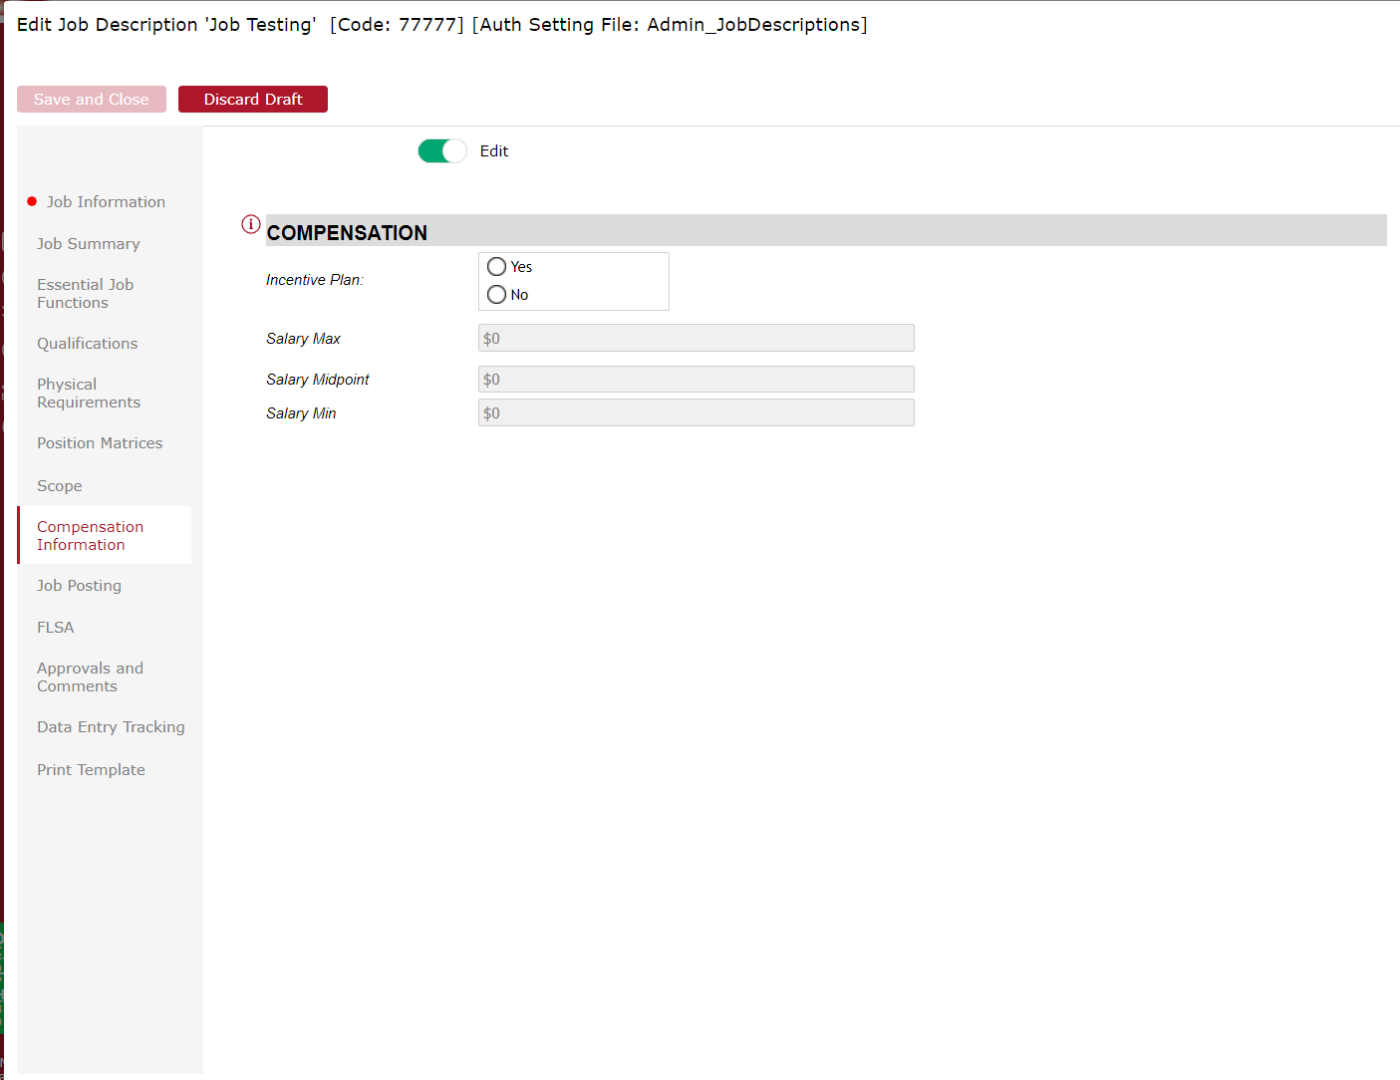

This section is completed by Compensation. Compensation will upload all the salary ranges whenever there is a change to the salary range.

Job Posting
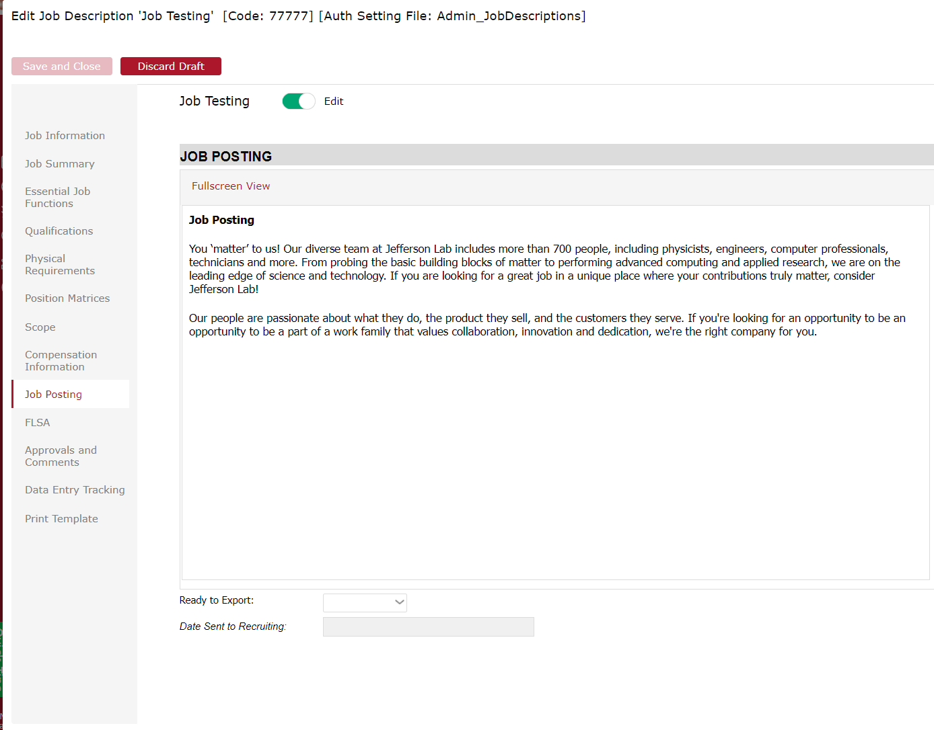Job Posting lets you see what the job will look like based off of the template that we have in the system. This will not be utilized at this point, as PeopleFluent is the platform in which we post jobs.

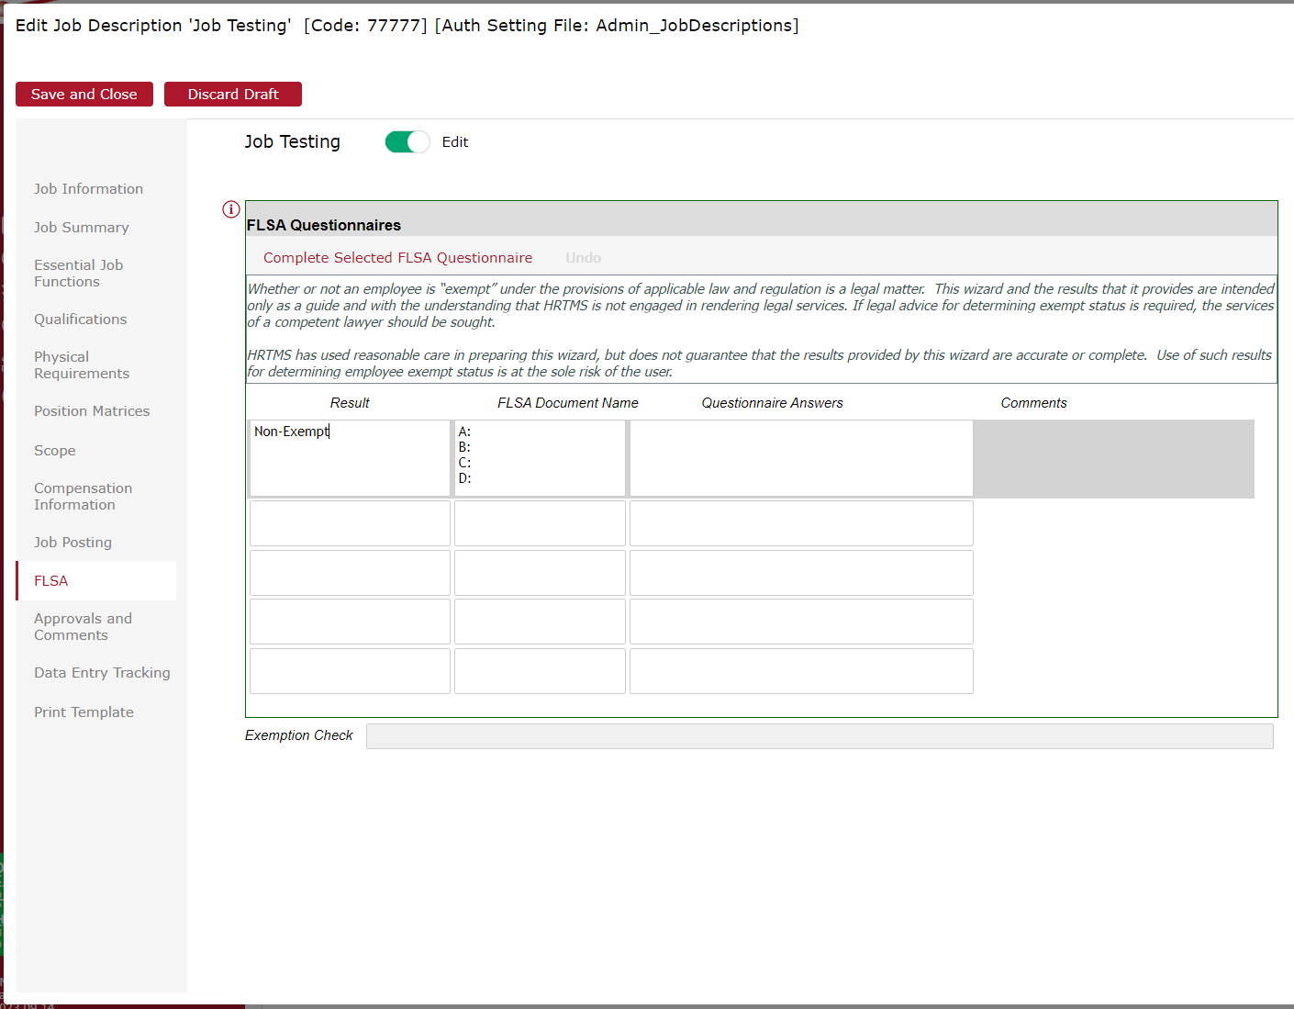

Click on the “Complete Selected FLSA Questionnaire” and complete the questions to the best of your knowledge. This is to determine if the position is Exempt or Non-Exempt. Compensation will also review all FLSA Questionnaires for each Job Description.

Data Entry Tracking
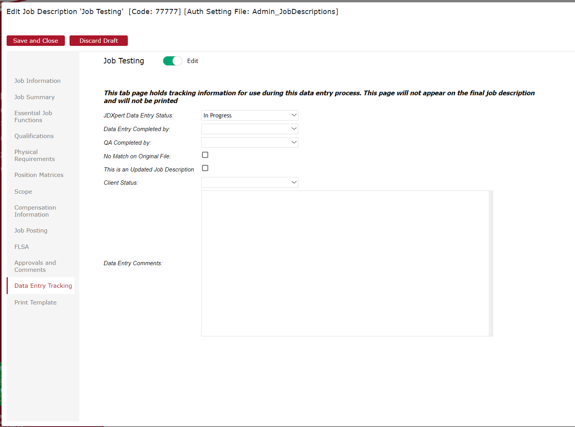
This allows you to track your Job Descriptions, by; In Progress, Completed Data Entry, Incomplete – Needs Attention, or Approved by Client. This allows anyone in the approval flow to check the status on Job Descriptions that may still be outstanding or have been completed.

Once complete, and ready to exit the Job Description, make sure hit Save and Close in the top left corner.

Revising a Job Description
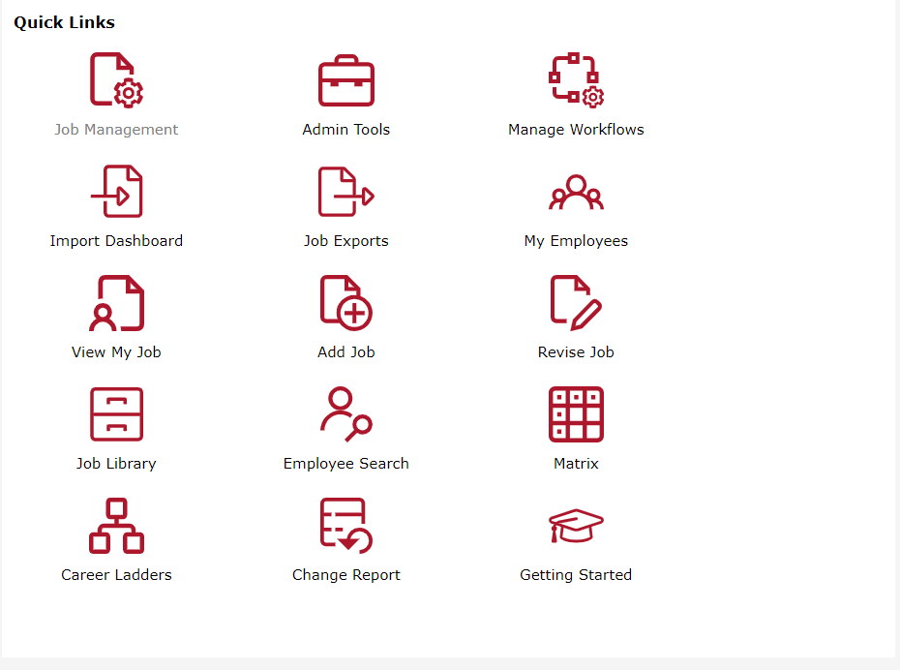

If you want to revise a job, change Admin approval/workflow, start by clicking on Revise Job.

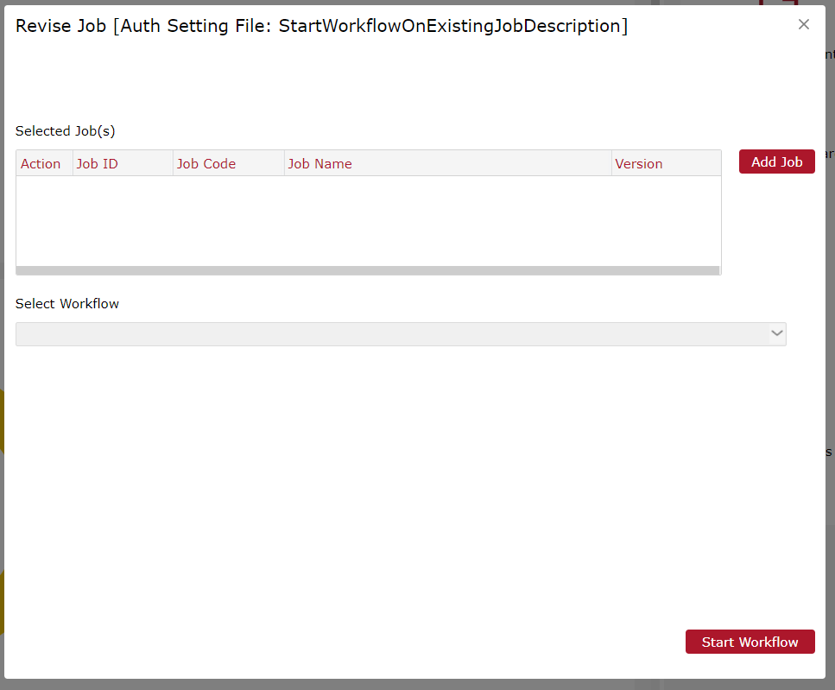

Click on Add job to select the job that you wish to revise

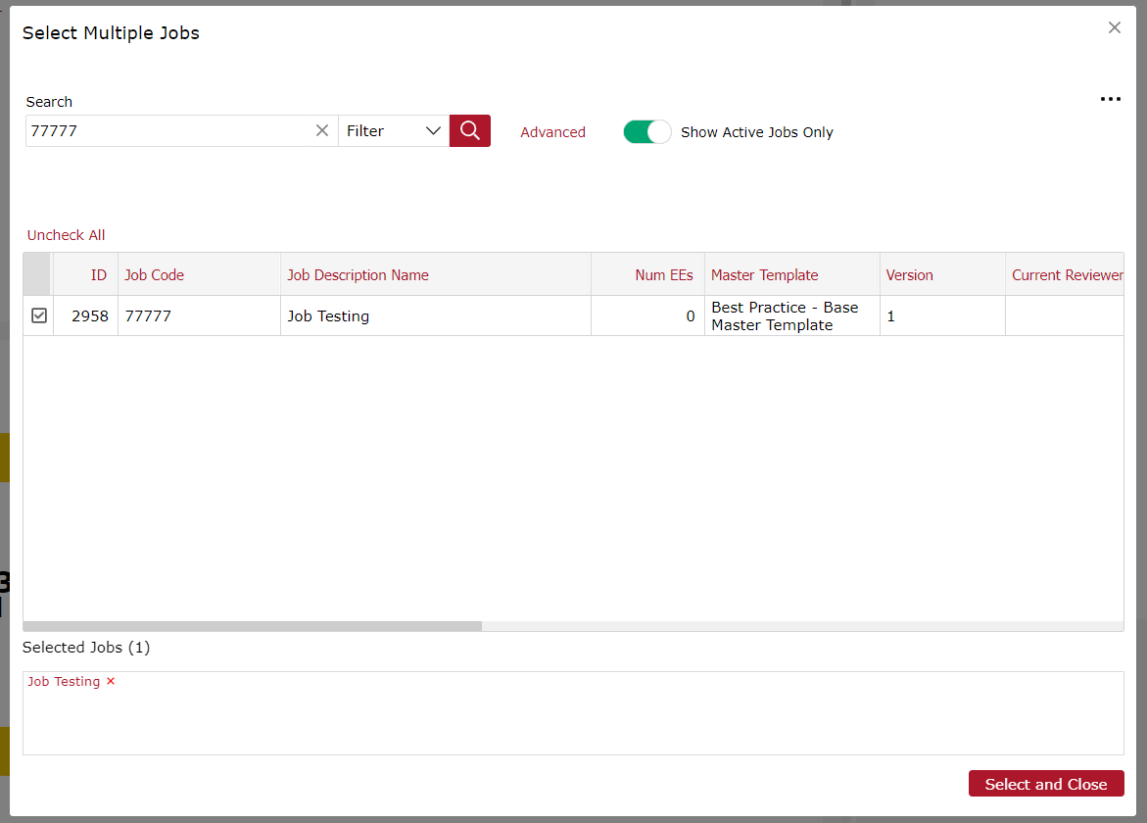
Search for the Job Description by ID or title. Can search and select multiple job Descriptions during this time.

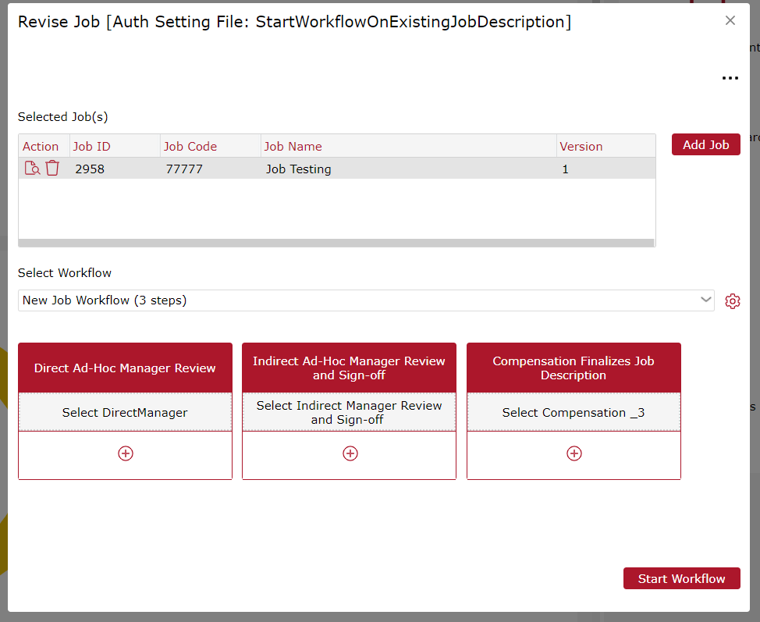

Once selected, you can “View the Job” and it will take you to the edit screen seen in the above manual
Also you can select a New Job Workflow or Stakeholder to review from the dropdown. This will allow you to input the people that will need to be involved in creating and signing off on this Job Description. Compensation will always be the last approver.

