Using the Facilitator Guide Template

This template provides the format and lists the required information for a Web Conference Training (WCT) facilitator guide. Use the template as a starting point for developing your guide. You may wish to supplement the information with course-specific resource lists, activities/exercises, review questions, etc.

* Replace all text in **red** with the information indicated or delete if not applicable. Do **not** replace black text. It is boilerplate and represents NHI’s curriculum-wide approach.
* New sections should always start on an odd-numbered page; leave a blank page with the text “Intentionally Blank” if necessary.
* Change text color to black after making modifications.
* Update the Table of Contents.
  + Select the Table of Contents
  + Press F9
* Reformat as needed, but make sure the document complies with the NHI Style Guide.
* Delete all template instructions.
* The first page of this document is acting as a placeholder for the NHI cover. The template for this cover can be found in the ILT Developer Toolkit.

Note that not all courses have pre-assignments and/or end-of-course exams, and not all courses offer Continuing Education Units (CEUs). Be sure to remove any information that does not apply to your course.

**Note: Delete this page after completing your Facilitator guide.**

Table of Contents

Introduction 1

Course Content 1

Target Audience 1

About This Guide 2

Course Schedule 2

Course Administration 3

Pre-Course Activities 3

A Note about Online Learning 3

Software and Equipment 3

Acrobat Connect Meeting Room 5

WCT Facilitator Toolkit 10

Evaluations 11

Course Evaluation 11

Course Exam 11

Continuing Education Units (CEUs) 11

Course Certificates 11

Updates to the Course Material 11

About Facilitating 12

Training Course Checklist 13

Two Weeks Prior to the Training Event: 13

One Week in Advance, Minimally: 13

Twenty-four Hours in Advance, Minimally: 13

During the Training Event: 14

Two Weeks after the Training Event: 14

Sample Pre-Event e-Mail to Participants 15

WCT Facilitator Icons 16

Course Content 18

Module X: Module Name 18

Learning Outcomes 18

Sample Content 18

Opening 19

Welcome 20

Objectives 21

Poll Pod 22

Phone-In Question 23

Video 24

Wrap-up 25

Next Module Preview 26

Acronyms 27

Bibliography 27

Glossary 27

Websites 27

Attributions 27

# Introduction

This WCT course, course title, provides participants with an introduction to/an understanding of/information about (insert information about content of course).

## Course Content

This course presents material in a series of XX synchronous online modules, supplemented by a self-paced Web-based vignette. The modules are as follows:

Module 1 – module name

Module 2 – module name

Module 3 – module name

Module 4 – module name

Module 5 – module name

Module 6 – module name

Explain how participants will be given the opportunity to demonstrate mastery of course outcomes. If there is an end-of-course exam, state the score required to demonstrate mastery of the course content.

## Target Audience

Provide as much information as possible about the desired audience for the course, including skills they should have and information they should know prior to attending the training. Describe the current job performances or tasks of targeted participants. The more information you can provide, the more likely the participants will have the appropriate skills and knowledge to fully benefit from the training.

The target audience for this course consists of individuals responsible for:

* Responsibility
* Responsibility
* Responsibility

Prior to taking this course, these individuals should be able to:

* Skill/ability
* Skill/ability
* Skill/ability

Prior to taking this course, these individuals should know:

* Information
* Information
* Information

The target audience consists of people in the following positions:

* Job title
* Job title
* Job title

# About This Guide

This facilitator guide has been assembled as a companion to the PowerPoint files for the training course. It has been developed to assist facilitators in leading course presentations and managing communication with NHI and with learners. The facilitator guide mirrors the information presented in the participant workbook, but includes more detail on instruction and specific information about presentation of the material and facilitation of exercises.

The Course Content section of this guide consists of the following items, organized by module:

* Learning outcomes
* A copy of the module pre-assignment, with answer key
* A description of the instructional method
* Layouts and pods used
* Time allocation for each module
* Practice exercises
* End-of-course exam answer key
* Review of learning outcomes

# Course Schedule

The course schedule alternates between self-directed pre-module assignments and Web conference modules. The overall training is the equivalent of XX hours of instruction. Independent completion of the pre-module assignments and the end-of-course exam requires an additional XX hours.

A recommended course delivery schedule is provided, based on starting the course on a insert day and completing XX modules per day for XX days, concluding on a insert day. An alternate schedule can be used, with approval from the NHI Training Program Manager. The recommended schedule below provides the approximate starting time for each module. The actual times for each of these activitiesmay vary slightly.

|  |  |
| --- | --- |
| **Recommended Delivery Schedule** | |
| **Day and Time** | **Event** |
| Prior to day, time | Pre-Module 1 Assignment |
| Day, time | Module 1 Web Conference |
| Prior to day, time | Pre-Module 2 Assignment |
| Day, time | Module 2 Web Conference |
|  |  |
|  |  |
|  |  |
|  |  |
|  |  |
|  |  |
|  |  |
|  |  |

# Course Administration

## Pre-Course Activities

Preparations for the course delivery began long before the first Web conference lesson.

The course developer created all course materials and set up a Web conference virtual classroom; set up layouts and pods as prescribed by the course design; and uploaded participant materials to the virtual classroom. In addition, the course developer created asynchronous segments to supplement the synchronous learning sessions.

The NHI Training Team set up a curriculum in the Adobe online learning system to track participant participation, score, and completion.

Participants enrolled for a course via the NHI Web site (if not FHWA employees) or the DOT learning management system (if FHWA employees). After registering for the course, participants were directed to their My Training page – where they were able to directly launch the course curriculum page (i.e., a listing of the lessons for the course in which they enrolled) from their My Courses table.

Because NHI is committed to making all training programs accessible to all participants, the NHI Training Team may have coordinated with participants’ employers to ensure that they have the adaptive equipment they might need to fully participate in this course. The NHI Training Team notifies the Web conference facilitator if learners with special needs have enrolled.

## A Note about Online Learning

More is required of the participant in an online learning environment. The participant must become an active learner and take responsibility for his/her own learning. As a facilitator, your role also changes. Your primary role is to provide encouragement as well as answer questions. Perhaps the hardest part of teaching adults in an online environment (many of whom have not previously participated in online learning), is maintaining their attention. Remember that the more technical the material being presented, the more the mind seems to wander. Short and concise modules with targeted interactions can help maintain a high level of interest and attentiveness. If you believe participants are not following or interacting with the content as designed, change up the interactivity. In the online environment, modules are designed for no longer than two hours.

## Software and Equipment

The synchronous modules are delivered via Acrobat Connect Professional, FHWA’s Web conferencing system. The tool is used to present the visuals (primarily PowerPoint slides) and participant interactions that explain concepts and engage participants with the content. Ongoing participant interaction with the facilitator takes place via telephone and chat interactions while in the virtual classroom.

The facilitator is responsible for running the Acrobat Connect virtual classroom during the synchronous module(s). Microsoft PowerPoint presentations are uploaded to Acrobat Connect Professional by NHI Training staff. The facilitator connects to Acrobat Connect through an internet connection and a separate telephone connection for the audio portion.

To participate in this course, each participant must have his/her own computer/keyboard, telephone, and internet connection (and adaptive equipment, if needed). In addition, the Flash player must be installed on each participant’s computer. In order to receive CEUs, these equipment requirements must be met. A group of learners may not share one computer/keyboard or one phone line because this greatly limits the participants’ ability to interact with the facilitator, with the other learners, and with the Web conferencing tools.

The asynchronous end-of-course exam is delivered via the FHWA online learning system. No additional equipment or software is needed to access the exam.

### Acrobat Connect Meeting Room

The Acrobat Connect virtual classroom is open 365 days per year, seven days a week, around the clock. In the classroom, the facilitator and participants may find the following layouts:

* Housekeeping – this layout houses all of the administrative items associated with the course (e.g., File Share pods for downloadable files such as the participant workbook and Pre-Module Assignments). This layout should be displayed before and after each session of the course.
* Modules – this layout is used to share the slides for each module, as well as to keep track of attendees and facilitate ongoing chat discussions.
* Layout Title - this layout consists of one Share Pod containing a visual illustration of Blooms Taxonomy.
* Layout Title - this layout is used to quickly access seven Share Pods, each of which contains a short pre-recorded segment created in Adobe Presenter.

Keep in mind that the developer may have changed the titles of the layouts and the content contained therein. The descriptions above are merely suggestions for how the layouts may be labeled and organized.

A representation of each layout used in this course is provided below.

Figure 1 - Sample Housekeeping Layout

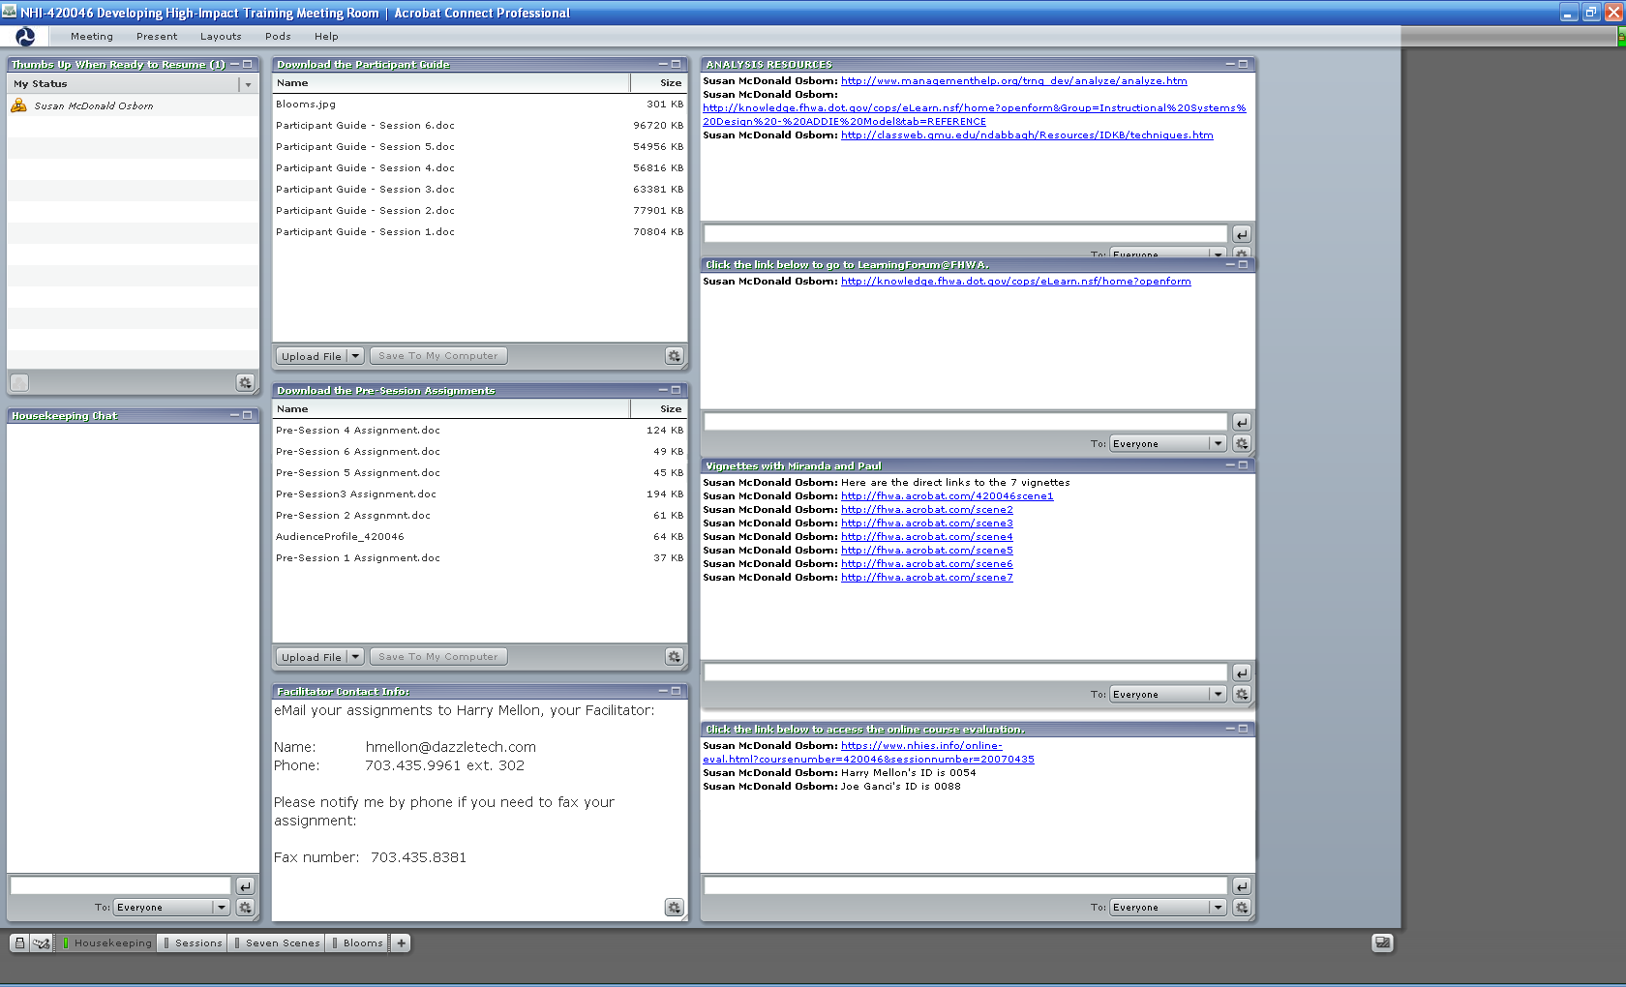

Figure 2 – Sample Module Layout

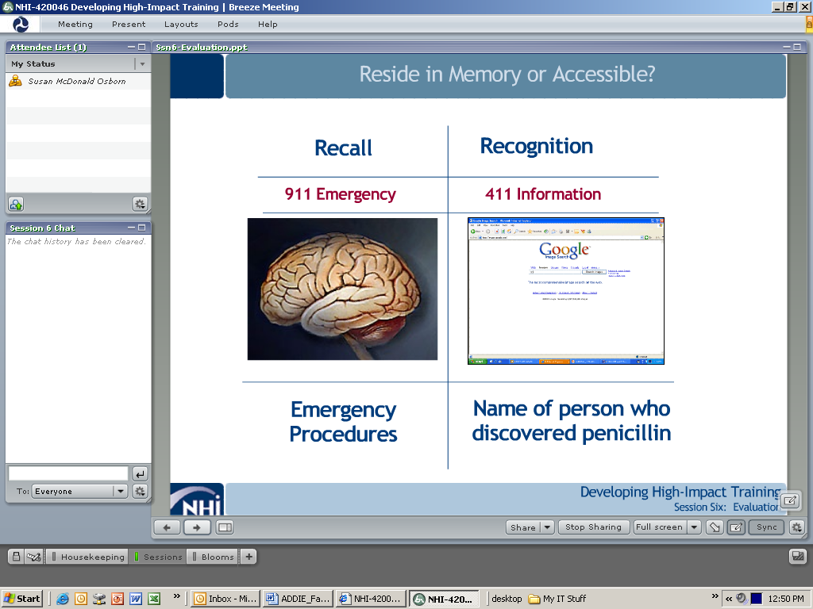

Figure 3 – Sample layout showing one Share Pod

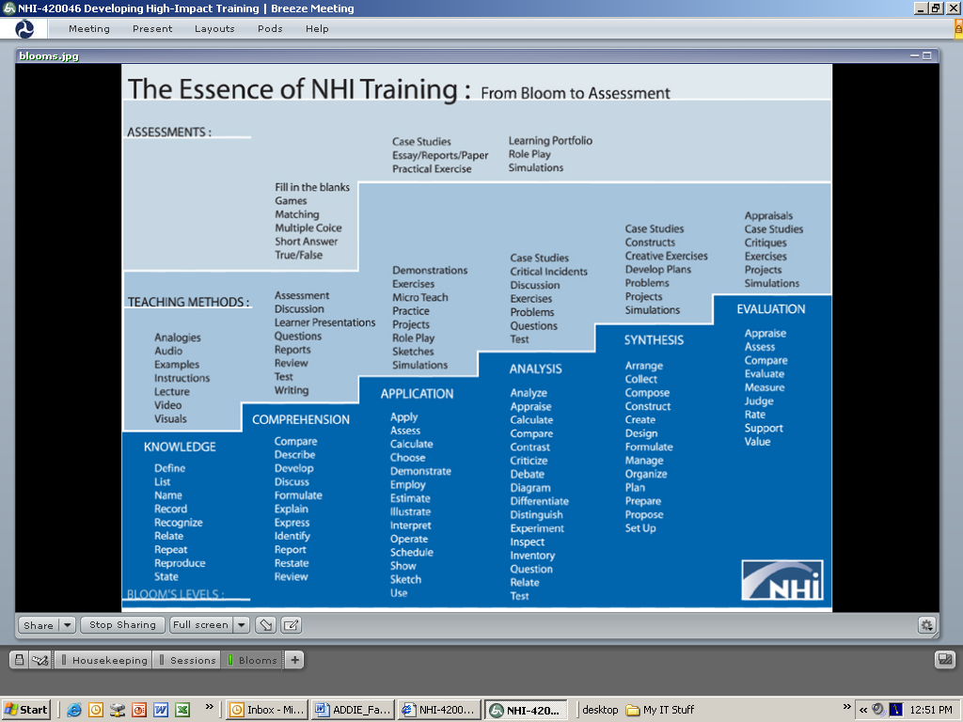Figure 4 – Sample Pre-recorded Segment created in Adobe Presenter

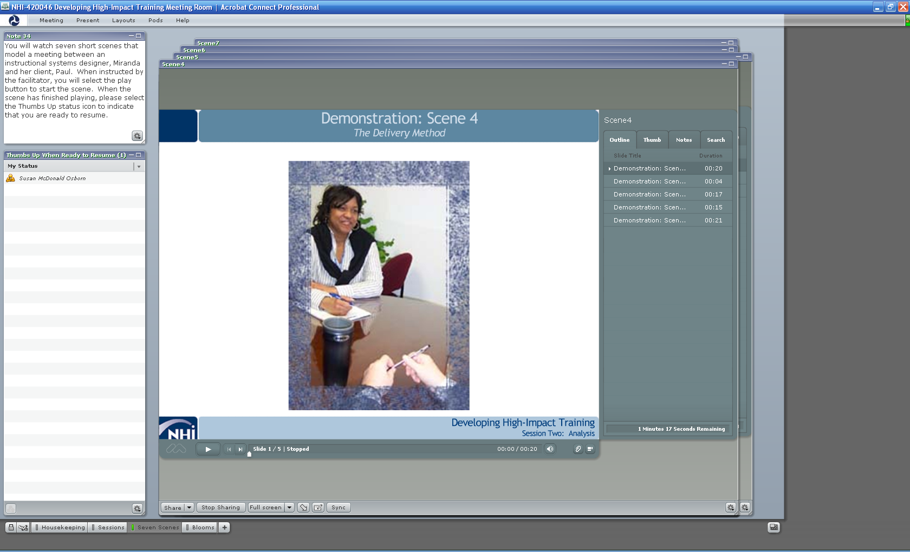

**WCT Facilitator Toolkit**

The [WCT Facilitator Toolkit](http://www.nhi.fhwa.dot.gov/resources/wct_developer.aspx) (<http://www.nhi.fhwa.dot.gov/resources/wct_developer.aspx>)

contains a number of resources for facilitators. Be sure to access the toolkit and, at a minimum, review the tutorials before the course starts.

The toolkit contains:

* Getting Started: Reviews the purpose for each toolkit item and identifies the item users
* NHI Style Guide: Designed to assist our course developers in preparing materials that are consistent in appearance and use.
* NHI WCT Standards Guide: Provides NHI requirements for design and development of WCT
* Accessibility: Section 508. This link provides guidance on compliance with Section 508 of the Rehabilitation Act.
* NHI WCT Resource List: Provides additional resources on the design, development, and delivery of asynchronous online learning
* Web Conferencing Resource Center. Here you can find additional resources on the Adobe Connect Pro tool.
* Templates:
  + Detailed-level Design Plan
  + PowerPoint
  + Facilitation Guide
  + Participant Guide
  + Session Report
  + Classroom Layouts

## Evaluations

NHI collects data at Kirkpatrick’s Level 1 and Level 2. Data are collected in an online format for this course.

### Course Evaluation

Participants link to the online course evaluation form (Level 1) when prompted by the facilitator (prior to the taking the end-of-course exam). Results are collected automatically and reported out to NHI. Provide the following instructions before participants complete the evaluation:

* Name and address are optional.
* Additional feedback helps to improve the course.
* Be sure to submit the form when completed.

Course Exam

At the end of the course, an online examination is given to test participants’ competency. The exam is designed to be completed in XX minutes, but participants may take as much time as necessary to complete it. Participants must work independently, but they may use any of the course materials to prepare their responses to the questions. Participants may only take the final exam once and will be provided their score upon completion of the exam. They will also be provided the opportunity to review the exam. A score of XX must be achieved to pass the course.

Those who score 70% or higher are eligible for Continuing Education Units (CEUs). Participants who do not reach the mastery threshold must re-register for the course and pass the end-of-course exam in order to receive CEUs.

Continuing Education Units (CEUs)

Participants who complete all the following requirements will be awarded CEUs:

* Attend and participate actively in every synchronous module
* Complete all pre-module assignments
* Complete every synchronous module
* Receive a score of 70% or better on the end-of-course exam

Participants may contact NHI at [NHITraining@fhwa.dot.gov](mailto:NHITraining@fhwa.dot.gov) for a transcript of their CEUs.

### Course Certificates

All course participants qualify to receive a certificate for attending the course (even if they do not access, attempt or pass the end-of-course exam). Participants access certificates via their “My Training” page.

## Updates to the Course Material

While a good deal of effort has gone into the development of this training course, it is inevitable that both facilitators and participants will find errors, omissions or other shortcomings that need to be addressed. Please encourage the participants to bring to your attention any problems they experience with the course. You, the facilitator, should communicate any problems that are identified to the NHI Training Program Manager. Corrections can be made in subsequent versions of the course materials.

## About Facilitating

Over the years, a number of observations have been made about the successful presentation of an online NHI course. While all of the information is undoubtedly familiar to the course facilitators, it is repeated here.

1. In an online learning environment, the only indication you are connecting with your participants is by the responses you are getting. Be sure you are giving participants ample opportunity to express their views, share their knowledge and ask questions.
2. Refer to the facilitator guide and rely on the script, *as long as you sound natural*. Rehearse the script several times so that you can paraphrase it in a natural way. To the degree the schedule allows, try to add information that supports or highlights the points being made in the slide (e.g., add examples from your own experience).
3. Don’t be afraid to admit what you don’t know. There may be a lot of questions for which you don’t immediately know the answer. Ask the co-facilitator; see if anyone in the group has an idea; or suggest that you’ll do some research offline and get back to the group with the answer. The worst possible approach is to try to hide your ignorance with an incorrect answer, as it will have the opposite effect.
4. Encourage participation. This can be accomplished by asking questions and by having the participants interact as directed. The proper use and monitoring of the chat feature encourages and engages the participants. The NHI recommendation is that chat be allowed and turned on. When a chat message is sent to all participants, it may help uncover areas of misunderstanding and prompt questions for additional learning opportunities.
5. Encourage participants to speak in turn. As the audio is coming from a teleconference line, common telephone courtesy should prevail. Participants should mute their telephone lines when not speaking.
6. Encourage participants to follow along in the participant workbook. As part of your preparation, become familiar with what is in the workbook and refer to it whenever directed by the facilitator guide.
7. At the end of a module, ask the participants what they remember. Let them summarize the major instructional points, if time permits.
8. Keep the atmosphere informal so that the participants are comfortable asking questions, participating in activities and sharing their knowledge or concerns.

## Training Course Checklist

**Two Weeks Prior to the Training Event:**

* Access your Acrobat Connect virtual classroom.
* Become familiar with the layout as prescribed by the facilitator guide.
* Read the facilitator guide; then read it again.
* Familiarize yourself with the participant workbook.
* Check with host to see if any participant with a disability needs a special accommodation.
* Contact the NHI Training Manager to request:
  + The roster of FHWA-employee-learners **and** external learners for the *current* lesson
  + E-mail addresses for each learner enrolled in the *current* lesson
  + The teleconference number and pass code for the *current* lesson
  + The URL for the online Level 1 evaluation for the *current* lesson
* Ensure that the participant workbook is in the appropriate File Share Pod and available to learners for downloading.
* Communicate with participants via e-mail, to introduce yourself and provide the course schedule (see sample e-mail at end of this section).
* Ensure that all pre-module assignments are in the appropriate File Share Pod and available to learners for downloading.
* Coordinate recording of the session with FHWA Web conferencing if needed ([Webconferening@dot.gov](mailto:Webconferening@dot.gov))

**One Week in Advance, Minimally:**

* Access the course Acrobat Connect virtual classroom.
* Practice conducting the lesson as prescribed by the facilitator guide.
* Contact the NHI Training Manager to request the final roster of names for the lesson.
* Ensure that the employer of any participant with a disability has arranged special accommodations for that participant.
* Set up any pre-module online discussions prescribed by the facilitator guide; participate fully.
* Review and provide feedback to participants for Pre-Module 1 Assignment. You are expected to provide immediate, constructive feedback using MS Word Track Changes. E-mail the file back to the learner as quickly as possible.

**Twenty-four Hours in Advance, Minimally:**

* Ensure that all pods you will need to deliver the WCT course have been set up in the assigned virtual classroom.
* Update the course schedule in the note pod in the Housekeeping layout.
* Ensure that the slides for Modules 2-X are accurate and uploaded to the virtual classroom. Note: you will need to update the schedule at the end of each slide deck.
* Ensure that all items you want to share are either uploaded or ready to share from your desktop.
* Clear every poll; ensure the Broadcast option is not checked.
* Erase all screen highlights that may have been added during a dry run or a previous lesson.
* Test all Web links.
* Make sure you have the correct teleconference number and pass code; post in a Notes Pod.
* Make sure you have the correct URL for the Level 1 evaluation in a File Share Pod.
* Check in with the course host for any last-minute instructions or changes.
* Review and provide feedback to participants for Pre-Module 1 Assignment.

**During the Training Event:**

* Log in to the virtual classroom using your Adobe User ID (your e-mail address) and password.
* Dial in to the teleconference early (at least 15 minutes prior to start time). Give yourself plenty of time to get organized.
* Demonstrate desktop sharing and whiteboard drawing if participants are to use those features.
* Start on time and stay on track. Always start on time, even if only one participant is in the room. Keep exercises within their time limits. End discussions when they cease to be productive. Lead participants away from digressions and tangents, and back to the lesson.
* Be available for questions for a few minutes after synchronous lessons.
* At the beginning of each lesson, review the objectives. Make sure participants are fully aware of the topics to be addressed in the lesson. Then, at the end of each lesson, review the outcomes once again using review questions or an activity/exercise to ensure the outcomes were met.
* Review and provide meaningful feedback to participants for pre-module assignments.

**Two Weeks after the Training Event:**

* Request from NHI a copy of the Level 1 and Level 2 course evaluation data. Review data and discuss results with the Training Program Manager.
* Send an e-mail to course participants to thank them for their participation and feedback.

## Sample Pre-Event e-Mail to Participants

|  |  |  |  |  |  |  |  |  |  |  |  |  |
| --- | --- | --- | --- | --- | --- | --- | --- | --- | --- | --- | --- | --- |
| **From:** {Facilitator Name}  **Sent:** {Date} **To:** {Participants’ e-Mail Addresses} **Subject:** {Course Title}  Hi, everyone,  I’m looking forward to working with you on the {course title} Course that begins {day, mm/dd/yy}.  My name is {your name} and I’ll be your facilitator.  {Short description of relevant experience.}  Currently, I am {position} at {organization.} I look forward to facilitating this course and learning from you.  My co-facilitator for the week will be {co-facilitator Name} of {Organization Name}.  {Short description of relevant experience.}  If you have not already done so, please log in to the Adobe Connect curriculum through your “My Training” page and download:   * + Participant workbook (XX files)   + Pre-Module 1 Assignment (one file)   + Audience Profile Survey   Please e-mail me your completed Pre-Module 1 Assignment and Audience Profile at least two days before the start of Module 1.  The course schedule is shown below.   |  |  | | --- | --- | | **Course Schedule** | | | **Day and Time** | **Event** | | Prior to day, time | Pre-Module 1 Assignment | | Day, time | Module 1 Web Conference | | Prior to day, time | Pre-Module 2 Assignment | | Day, time | Module 2 Web Conference |   Again, I look forward to working with all of you this week.  Thanks,  {Facilitator Name}  {Facilitator Title}  {Facilitator Organization}  {Facilitator Office Number}  {Facilitator Mobile Number}  {Facilitator e-Mail Address}  **Add Course Schedule** |

# WCT Facilitator Icons

The following table shows the icons used in the facilitator guide. The links are to tutorials on how to use the feature. These icons also appear on the slides as a cue to the facilitator and learners.

| **Icon** | **Pod Name** | **Typical Use** |
| --- | --- | --- |
| Camera and Voice icon | Camera and Voice | * Display photo or video image of presenter |
| Attendee Pod icon | Attendee Pod | * Check for understanding or agreement * Survey participants * Solicit feedback on facilitation of meeting   <http://fhwa.acrobat.com/attendeelist> |
| Chat Pod icon | Chat Pod | Ask/answer open-ended question(s)  * Post hyperlinks to Web sites * Provide further info to select attendees * Encourage attendees to share ideas with each other * E-mail contents of the pod   <https://admin.acrobat.com/chat> |
| note | Note Pod | Capture discussion points  * Provide a way for small groups to document their results * E-mail contents of the pod   <http://fhwa.acrobat.com/note> |
| Share Pod icon | Share Pod | * Demonstrate software * Share a view of your computer files * Allow another attendee to access your computer * Collaborate on a document * Navigate through a website   <http://fhwa.acrobat.com/viewshare> |
| Whiteboard Tool icon | Whiteboard Tool | Edit illustrations, such as diagrams, charts, documents, maps, photographs  * Record participant responses * Create visual examples   <http://fhwa.acrobat.com/whiteboard> |
| Poll Pod icon | Poll Pod | Ask multiple choice questions with one, or more, correct answer(s)  * Gather opinions (i.e., conduct a survey) * Prioritize a list of text items   <http://fhwa.acrobat.com/poll> |
| Web Share Pod icon | Web Share Pod | * Share new content or resources * Instruct participants to search for information |
| File Share Pod icon | File Share Pod | Share documents in formats that cannot be displayed in a Share pod (e.g., Word, .pdf, Excel, zip)Post Participant Guide, pre- and post-assignments, agendas, and resource materials <http://fhwa.acrobat.com/fileshare> |
| Phone icon | Phone | * Facilitate introductions * Ask/answer verbal question(s) * Explain new ideas, concepts, methods * Encourage learners to answer each other’s questions |
| **DEMO** | Demo (via Share Pod) | Demonstrate a software application  * Show the process for a task |
| breakoutroomsicon | Breakout Rooms | * Assign small-group activities * Create a customized workspace for each breakout group to differentiate assignments for each group * Monitor breakout room discussions using chat pod and provide feedback  <https://admin.adobe.acrobat.com/_a227210/breakoutroomsintro/> |

# Course Content

This section contains the content for the course. For each module, provide:

* Module description
* Learning outcomes
* Interaction icons
* Slide thumbnails
* Information on facilitator preparation and activities
* Facilitator script
* Module pre-assignment with answer key, if applicable

# Module X: Module Name

This module focuses on ….(purpose of module)

This module will allow participants to… (what participants will do)

## Learning Outcomes

Participants who participate actively in this module will be able to………..:(list learning outcomes for this module)

* Learning Outcome
* Learning Outcome
* Learning Outcome

Sample Content

The tables on the following pages are placeholders for the facilitator guide content. Different content and interaction types are shown, such as opening and welcome, objectives, polling and phone-in, video, wrap-up, and next module preview.

For each slide in your presentation, insert the following in the table:

* Left column: Interaction icon
* Center column: Thumbnail of slide, information for facilitator on preparation and activities
* Right column: Script for facilitator

Opening

|  |  |  |
| --- | --- | --- |
| **Interaction** | **Slide and Notes to Facilitator** | **Script** |
| Share Pod icon  Insert interaction icon | Slide XX    **Preparation**  Insert any instructions the facilitator should follow prior to proceeding, such as clearing out a poll pod or preloading a share pod.  **Facilitator Activities**  Insert any instructions the facilitator should follow for this slide. Additionally, this section can be used to expand on information, such as additional questions the facilitator can pose. |  |

Welcome

|  |  |  |
| --- | --- | --- |
| **Interaction** | **Slide and Instructions** | **Script** |
| Share Pod icon  Insert interaction icon | Slide XX    **Preparation**  Insert any instructions the facilitator should follow prior to proceeding, such as clearing out a poll pod or preloading a share pod.  **Facilitator Activities**  Insert any instructions the facilitator should follow for this slide. Additionally, this section can be used to expand on information, such as additional questions the facilitator can pose. | Welcome to Module One of our six-module series. My name is ______________ and I’ll be your facilitator today.  My co-facilitator is ______________.  This module will last about XX hours and XX minutes.  If you have administrative or logistical questions that you’d like us to answer, please send your questions by using the Ask a Question feature in the bottom right-hand corner of your screen. I will send you a personal reply.  Today’s module focuses on (insert sentence about content of the module). Let’s get started. |

Objectives

|  |  |  |
| --- | --- | --- |
| **Interaction** | **Slide and Instructions** | **Script** |
| Share Pod icon  Insert interaction icon | Slide XX    **Preparation**  Insert any instructions the facilitator should follow prior to proceeding, such as clearing out a poll pod or preloading a share pod.  **Facilitator Activities**  Insert any instructions the facilitator should follow for this slide. Additionally, this section can be used to expand on information, such as additional questions the facilitator can pose. | Take a few moments to read the objectives for today’s module. You should be able to do each of these things at the end of the module.  Any questions before we continue? |

Poll Pod

|  |  |  |
| --- | --- | --- |
| **Interaction** | **Slide and Instructions** | **Script** |
| Poll Pod icon  Insert interaction icon | Slide XX    Thumbnail image of slide  **Preparation**  Ensure the {Poll Pod Title} Poll Pod is built or cleared out from prior modules.  **Facilitator Activities**  Bring up the {Poll Pod Title} Poll Pod. Direct participants to respond.  When participants have finished, publish the results of the responses.  After participants have reviewed results, hide the poll pod. | Let me ask you a quick question.  What was the architect’s biggest error? Was it:   * She designed a two-story house * She chose brick for the exterior * She failed to consult with the family * She designed a house that is too expensive   Select your answer now.  Exactly right. The architect’s biggest error was failing to consult with the family.  Let’s continue. |

Phone-In Question

|  |  |  |
| --- | --- | --- |
| **Interaction** | **Slide and Instructions** | **Script** |
| Phone icon  Insert interaction icon | Slide XX    **Preparation**  Insert any instructions the facilitator should follow prior to proceeding, such as clearing out a poll pod or preloading a share pod.  **Facilitator Activities**  Insert any instructions the facilitator should follow for this slide. Additionally, this section can be used to expand on information, such as additional questions the facilitator can pose. | Summarize responses from the group. If there are no immediate responses, provide a hint, such as…  What questions do you have before we continue? |

Video

|  |  |  |
| --- | --- | --- |
| **Interaction** | **Slide and Instructions** | **Script** |
| Share Pod icon  Insert interaction icon | Slide XX    **Preparation**  Insert any instructions the facilitator should follow prior to proceeding, such as clearing out a poll pod or preloading a share pod.  **Facilitator Activities**  Insert any instructions the facilitator should follow for this slide. Additionally, this section can be used to expand on information, such as additional questions the facilitator can pose. | We’ll now take a look at a short video on…  Please put your phones on mute in order to view the video. |

Wrap-up

|  |  |  |
| --- | --- | --- |
| **Interaction** | **Slide and Instructions** | **Script** |
| Share Pod icon  Insert interaction icon | Slide XX    **Preparation**  Insert any instructions the facilitator should follow prior to proceeding.  **Facilitator Activities**  Insert any instructions the facilitator should follow for this slide. Additionally, this section can be used to expand on information, such as additional questions the facilitator can pose. | It’s time to wrap up Module One.  Thank you for your participation.  You are always welcome to email anyone on the facilitation Team should you have questions. |

Next Module Preview

|  |  |  |
| --- | --- | --- |
| **Interaction** | **Slide and Instructions** | **Script** |
| Share Pod icon  Insert interaction icon | Slide XX    **Preparation**  Insert any instructions the facilitator should follow prior to proceeding, such as clearing out a poll pod or preloading a share pod.  **Facilitator Activities**  Insert any instructions the facilitator should follow for this slide. Additionally, this section can be used to expand on information, such as additional questions the facilitator can pose. | Let’s take a quick look at what we’ll be covering in our next module.  Thank you for your participation. |

# Acronyms

Insert a list of all acronyms used in the guide with their full versions. Example:

|  |  |
| --- | --- |
| AASHTO | American Association of State Highway and Transportation Officials |

# Bibliography

Include a bibliography if necessary. Example:

American Association of State Highway and Transportation Officials (AASHTO). 2002.

*Transportation Asset Management Guide*. American Association of State Highway and Transportation Officials, Washington, DC.

# Glossary

Include terms used in the guide that may require definition. Example:

***Asset***

An asset is a physical item of roadway infrastructure that has value. Assets are sometimes referred to as roadway “furniture” or “features.” An asset may be a single item, such as a sign, or a linear item such as a road or guardrail section. An asset may also be a spatial item such as a rest area or mowable acreage.

# Websites

Include a listing of relevant Web sites. Example:

***AASHTO Highway SCOM Homepage***

<http://maintenance.transportation.org>

# Attributions

Include a listing of the course developer(s) and subject-matter expert(s).