www.jlab.org
Website Documentation

Maintaining URL Aliases
Management of URL Aliases requires administrator login.
JLab login page is found at https://www.jlab.org/user
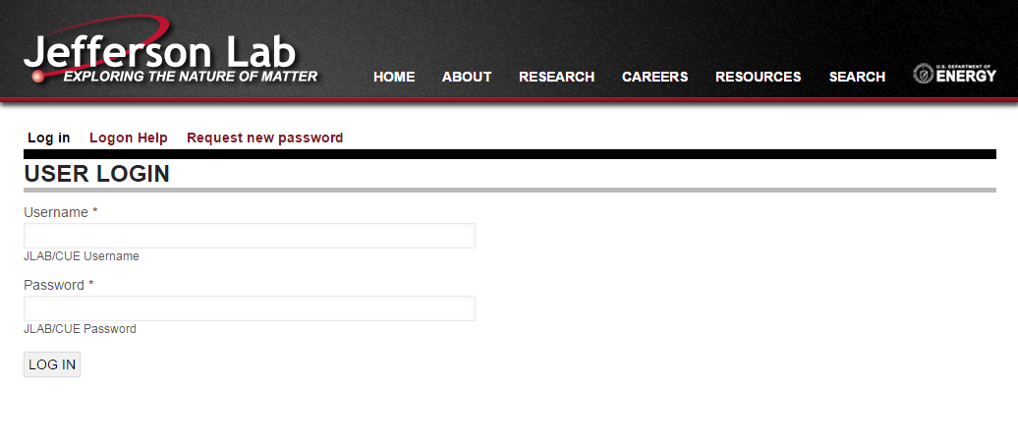

URL aliases can be maintained 2 ways:
- From the URL Alias page within Admin section of website
Admin Toolbar >> Configuration >> Search and Metadata >> URL Aliases
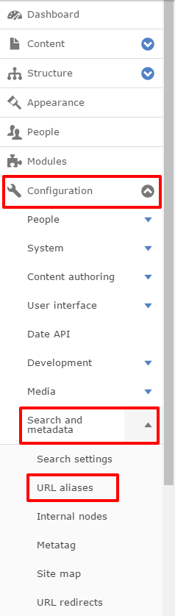
- Directly on an entity (node, taxonomy term, etc...)
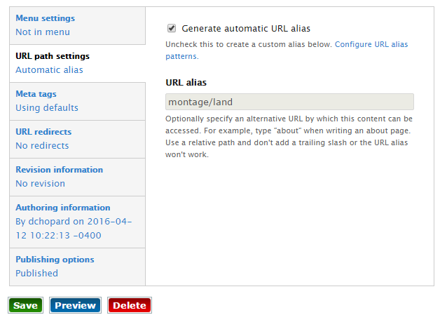
Admin URL Alias Interface
https://www.jlab.org/admin/config/search/path
All URL aliases that are defined within Drupal can be found within the listing on this page.
Create new aliases by clicking the “+ Add alias” button
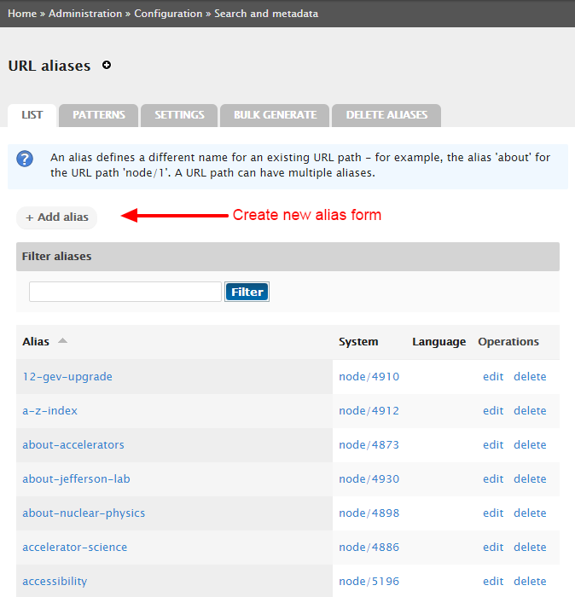
The ‘add new redirect’ form has 2 main fields:
- Existing system path
  - A Drupal internal path that aliases will point too
- Path alias
  - The path alias to be used
  - Can be a single level
    - contact-us
  - Can be multi-level
    - about/location/contact-us
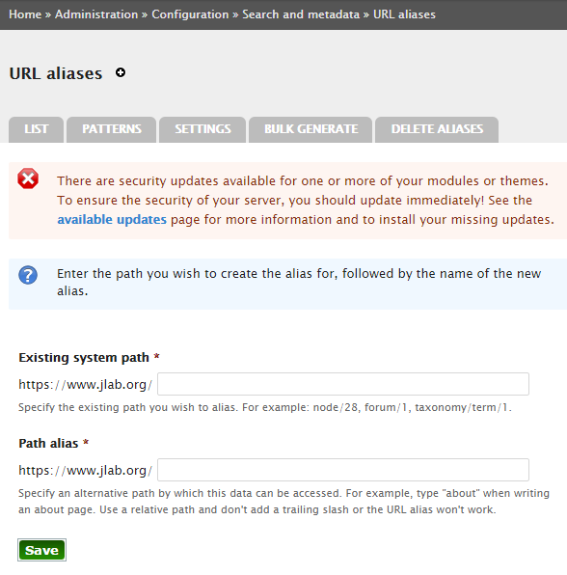

Maintaining an alias from an entity, like a node, is handled on the edit form; down in the vertical tabs.
- “Generate automatic URL alias” checkbox
  - If this checkbox is checked, Drupal will automatically create an alias based upon the alias pattern that is setup.
    - Patterns are setup for all entity types and integrations; they use tokens for various substitutions.
Maintenance of patterns are outside of the scope of this document
  - Uncheck this option to manually override the Pathauto implementation
- “URL alias” field
  - If “Generate automatic URL alias” is checked, this field is read-only and not editable.
  - When unchecked, the you can define the alias as necessary.
- Redirects
  - Drupal has been configured to automatically generate redirects under certain conditions
  - Taking the image below as an example, should you uncheck the Pathauto option, and manually enter a new alias, a redirect will be created from the “montage/land” alias to this system path (node/5874)
  - NOTE:: If you find that, after changing an alias, you get the following message, check that there are no redirect loops defined on the entity.
Just edit and review the vertical tabs for the alias and redirect

