www.jlab.org
Website Documentation

Maintaining Contexts
Management of contexts require administrator or content admin login.
JLab login page is found at https://www.jlab.org/user
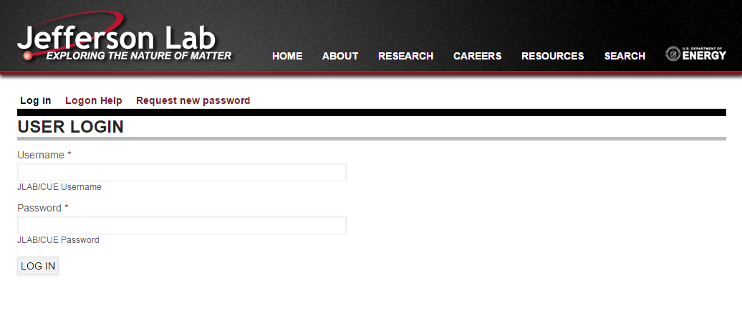

Within the JLab website, Context is used as the mechanism for controlling when content should appear on a page.
NOTE: Contexts control all content on the site. Observe caution when editing.

This tutorial outlines information pertaining to the maintenance of existing contexts. Consult with Parallax before implementing new contexts. The creation of new contexts is out of scope for this tutorial.

Context is found within the Structure section of the Admin menu at:
Admin Toolbar >> Structure >> Context
https://www.jlab.org/admin/structure/context
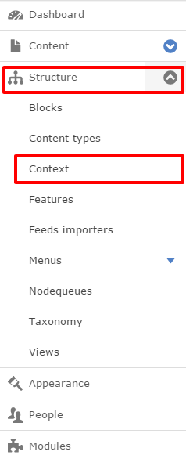

Contexts are grouped based on settings within contexts.
Contexts that are disabled have title greyed out; and include a link to enable.
Key element is finding correct context for the task.
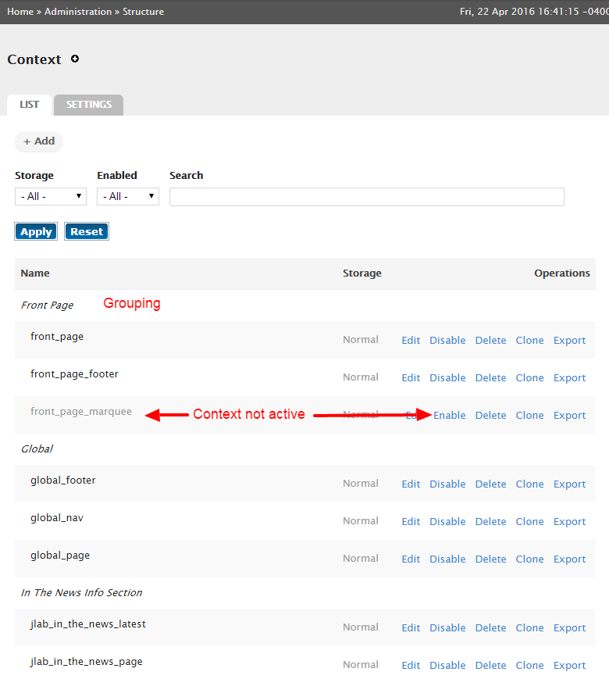

The primary task performed on contexts will be the inclusion/exclusion of blocks and content within the site.
“Conditions” control the conditions that will decide when to use said context
“Reactions” control what will take place during the specific contdition.

This example is defining what blocks are displayed in the Main Content region when the page is the <front> page.
