www.jlab.org
Website Documentation

Maintaining Menus
Management of menus and menu items require administrator login.
JLab login page is found at https://www.jlab.org/user
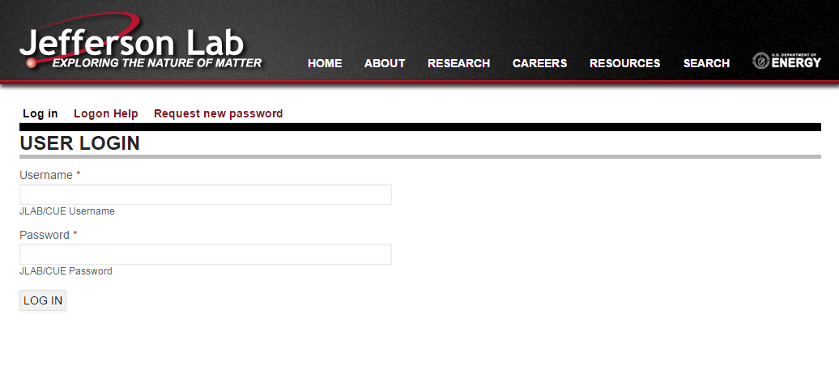

Menus can be maintained 2 ways:
- From the Menu maintenance page within Admin section of website
Admin Toolbar >> Structure >> Menus
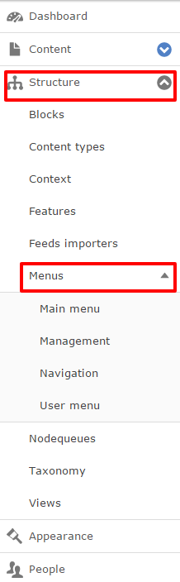
- Directly on an entity (node, taxonomy term, etc...) via Vertical Tabs
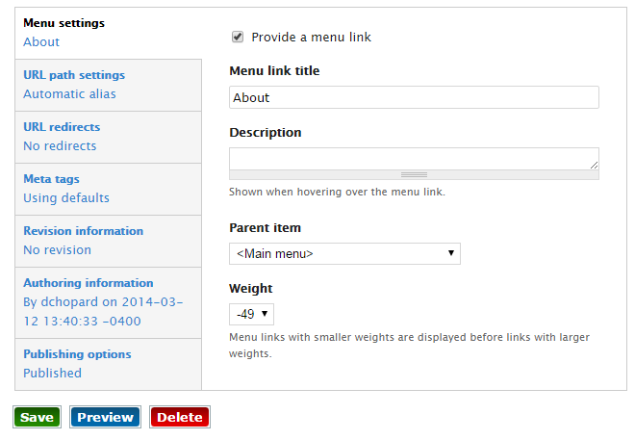

All menu links for Jlab.org are maintained in the “Main menu”.
https://www.jlab.org/admin/structure/menu/manage/main-menu
Menu links are nested and ordered via drag-n-drop interface.
TIP: Menu items can be easily deactivated from listing. Keeping the page in the menu, but deactivated, ensures that the ‘active-trail’ remains in-tact.
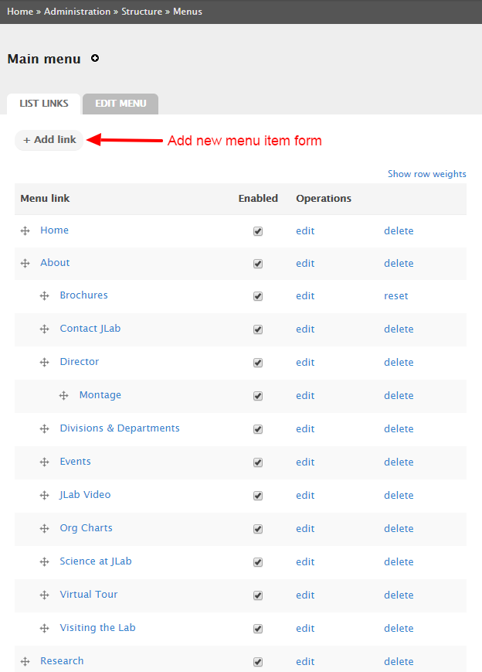

NOTE: Top level menu items (About, Research, etc…) have been optimized for display at all resolution widths. Consult with Parallax before setting or adjusting top menu items.

The ‘+ Add link’ form has 2 main fields, and a few included options:
- Menu link title
  - This is the text as it will appear in the menu
- Path
  - The associated menu link. This can be an internal path, path alias, or external website
- Description
  - Not utilized in JLab
- Enabled
  - Manages the active and visible state of link
- Show as expanded
  - This option is governed in a different manner
- Parent Link
  - When nesting menu items, the parent menu link is set here
- Weight
  - This option is managed via drag-n-drop
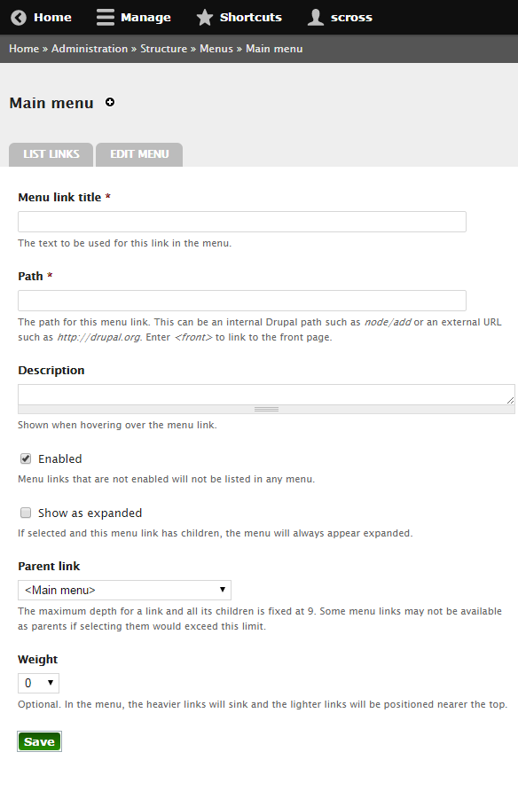

Creating a menu item directly from an entity, like a node, is managed from the entity’s Vertical Tab.
All fields are the same as if created in the Menu Admin page
The menu link is managed by Drupal when created from an entity as the menu link is known.

