www.jlab.org
Website Documentation

Maintaining NodeQueues
Management of nodequeues requires administrator login.
JLab login page is found at https://www.jlab.org/user
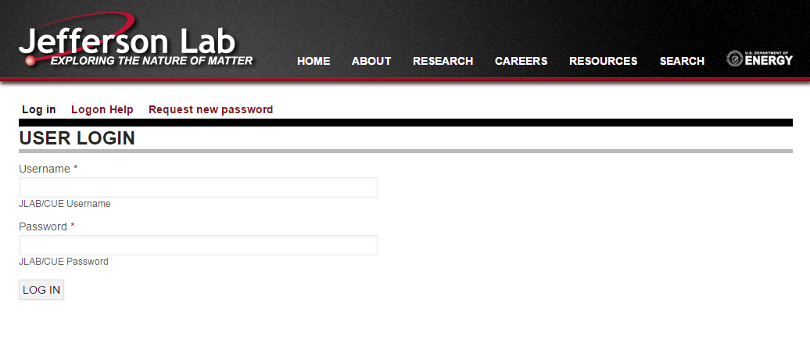

Nodequeues can be maintained 2 ways:
- From the Nodequeue admin page
Admin Toolbar >> Structure >> Nodequeue
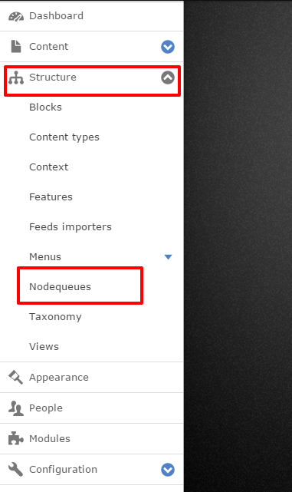
- Directly from contextual links
Note: Due to a bug in the nodequeue module, one that is already fixed and waiting for next release, this link can tend to disappear. Clearing Cache on site will place link back in contextual links as shown.

Nodequeue Admin Page
https://www.jlab.org/admin/structure/nodequeue
This page is a listing of each nodequeue. Click “View” to access individual queues
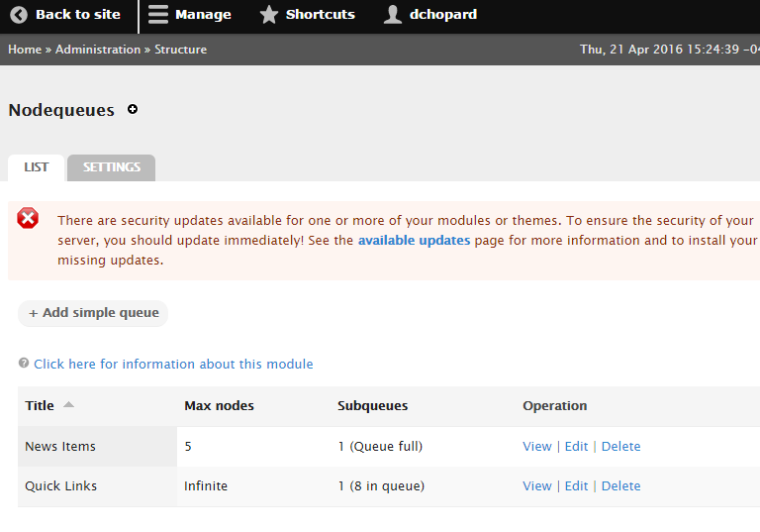

Reorder queue items via drag-and-drop interface.
