www.jlab.org
Website Documentation

Maintaining Redirects
Management of redirects requires administrator login.
JLab login page is found at https://www.jlab.org/user
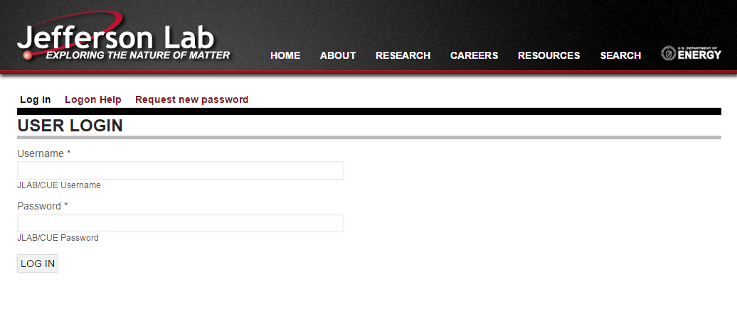

URL redirects can be maintained 2 ways:
- From the URL Redirects page within Admin section of website
Admin Toolbar >> Configuration >> Search and Metadata >> URL Redirects
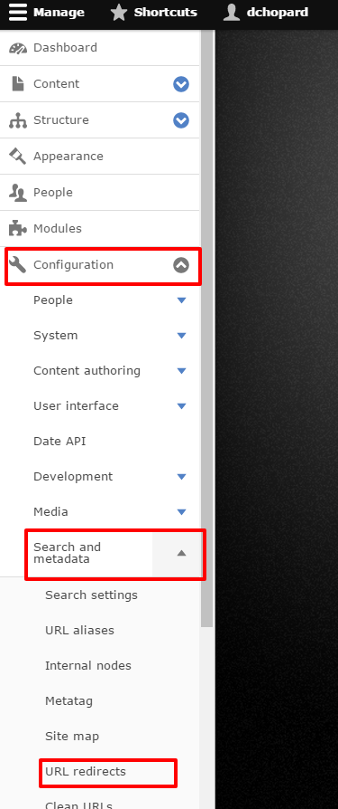
- Directly on an entity (node, taxonomy term, etc...)
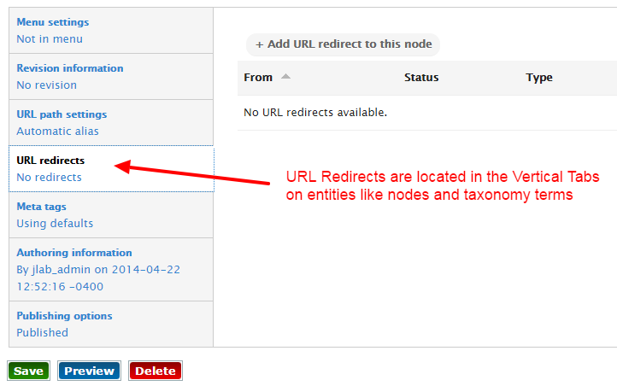

Admin URL Redirect Interface
https://www.jlab.org/admin/config/search/redirect
All URL Redirects that are defined within Drupal can be found within the listing on this page.
Create new redirects by clicking the “+ Add redirect” button
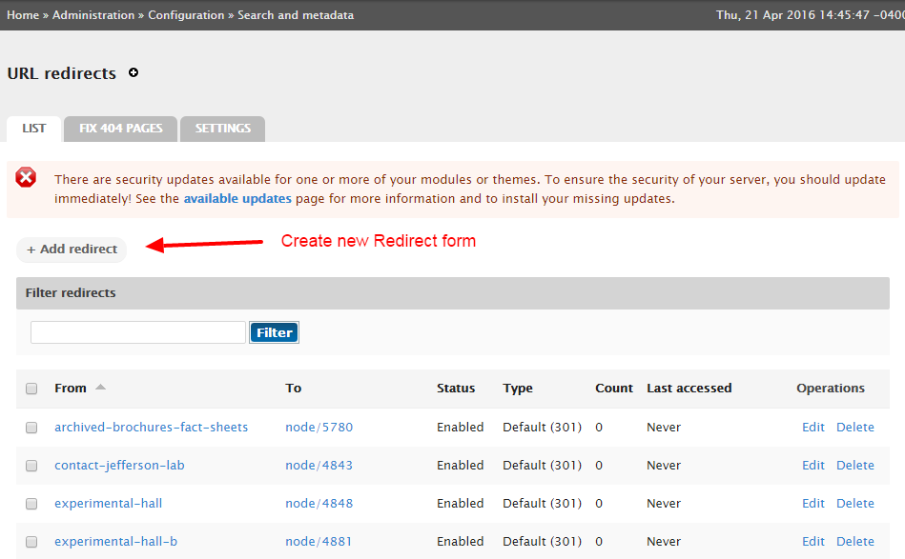
The ‘add new redirect’ form has 3 main fields:
- From
  - The Drupal internal path or alias to be redirected
- To
  - The destination URL.
  - This can be internal path, path alias, or external website
  - Internal Drupal paths (node/123 or taxonomy/term/123) should always be used if available.
- Enabled
  - Determines whether the URL redirect should function
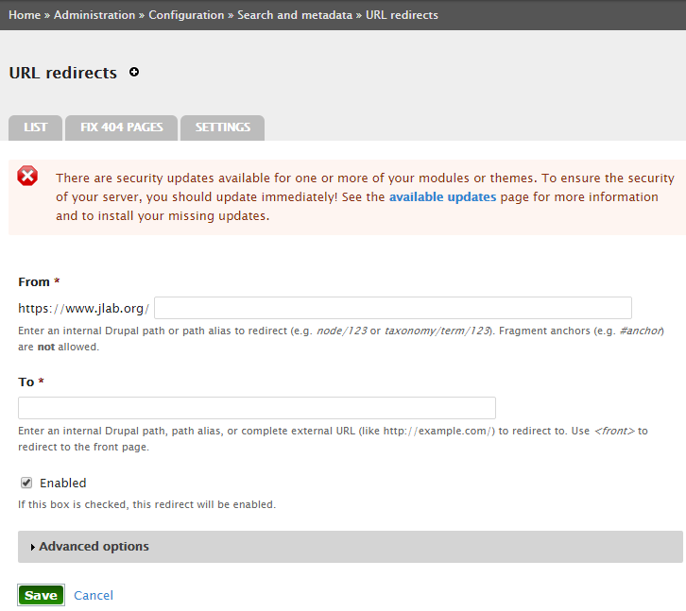

Creating a redirect from an entity, like a node, will prepopulate the “To” option within the form.
