www.jlab.org
Website Documentation

Updating Homepage News Blocks
Management of homepage news block content requires administrator or content admin login.
JLab login page is found at https://www.jlab.org/user
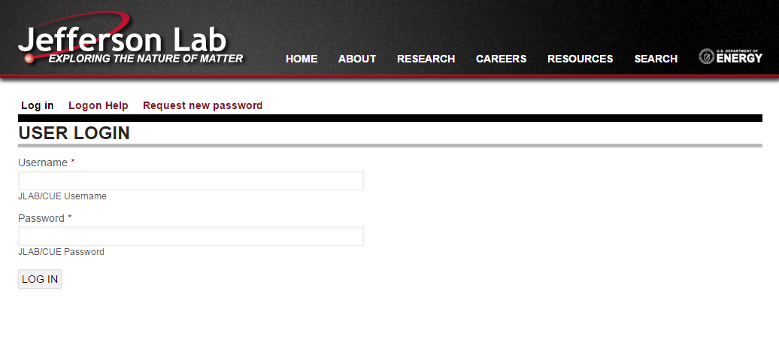

Once logged into the website with proper credentials, hovering on the blocks will expose the block’s “contextual links”.

Clicking the gear will open the list of links available.

When editing the block, all content for the block is maintained in the “Block Body” field. All other fields are not necessary for maintaining content.
There are two modes that the content can be edited in:
- Rich Text (WYSIWYG)
Note: It is perfectly acceptable to update the content in Rich-Text mode. However, should layout issue arise, there is a good chance that the html structure within the editor has changed.
Edit with caution
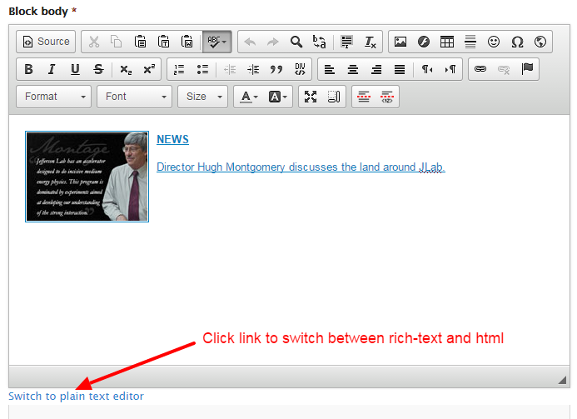
- Plain Text (html)
In the plain text mode, the raw html is shown as it will be used on the site.
Note: there are structural and presentation attributes within the html that must remain.
Edit with caution
