______________________________________________________________

Mini-Phase Procedure (UV Line)

______________________________________________________________

**Document Number:** FEL-PR-08-001

**Revision Number:** Rev. 4, January 13, 2011 *(C. Tennant)*

**Technical Custodian:** Dave Douglas

**Estimated Time to Perform:** 30 minutes

Procedure Overview__________________________________________

A Miniphase of the FEL is required after an overnight shutdown or following a Controlled Access. The Miniphase may also be necessary for machine recovery after degradation due to slow drifts. The Miniphase sets the injector phases, sets the proper charge, phases the linac, optimizes the wiggler and adjusts the pathlength. The procedure is comprised of:

Section 1.0 Verify the Correct Allsave Has Been Loaded

Section 2.0 Set the Charge to 60 pC

Section 3.0 Set the Relative Phase of the Drive Laser and Buncher

Section 4.0 Gang Phase the Laser-Buncher

Section 5.0 Set the Phase of Cavity 1-3

Section 6.0 Gang Phase the Linac

Section 7.0 Optimize the Bunch Length at the Wiggler

Section 8.0 Adjust the PathLength

Section 9.0 Appendix I - Required EPICS/MEDM screens

Prerequisites________________________________________________

1. The FEL Startup Procedure has been completed to the point the Miniphase Procedure is referenced and directed to be performed.

Procedure Steps_____________________________________________

* 1. Verify the Correct All-Save Has Been Loaded

1. Load an appropriate All-Save. Unless specifically instructed otherwise (FLOG or FEL Shift Plan) this should be either:
   1. The “morning miniphase” (if setting up from the previous day), or
   2. The current running setup or what should have been running for access recovery or performance recovery.

**NOTE:** The point is to start with an intelligent All-Save.

2. Verify that all BLMs are unmasked.

3. Verify the DLPC is configured to produce tune-up beam.

**NOTE:** Tune-up beam is defined here as:

* Pulsed mode at 2 Hz
* 250 μs macropulse
* 4.6 MHz micropulse frequency

4. Confirm that tune-up beam exists with acceptable ghost pulses:

a. Inspect the drive laser Tekscope before opening the operator shutter.

b. Any of the SLMs can also be observed when the operator shutter is opened.

c. Is the machine in an acceptable tune-up mode at this point?

**A.** **NO** Stop and contact expert assistance **YES** Continue

5. Mask all BLMs, but **only** if the machine is in a tune-up mode and reasonably clean.

6. Open the Miniphase Combo screen (FEL Main Menu⇒**Development⇒Miniphase Combo**).

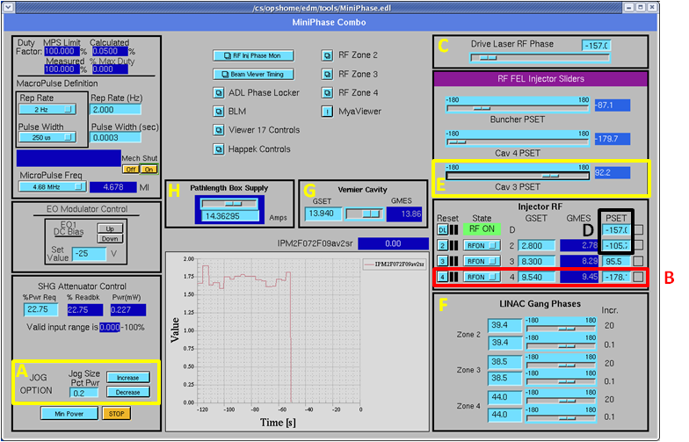

Figure 1-1: Screenshot of the Miniphase Combo screen.

2.0 Set the Charge to 60 pC

1. Set the charge to 60 pC as follows:

a. Adjust the drive laser polarizer (labeled “A” on Figure 1-1) to excite the Unser monitor as observed on Tekscope B (green trace, channel 4) to 140 mV. Is there sufficient charge as measured on Tekscope B?

**A. NO** Stop and contact expert assistance **YES** Continue

3.0 Set the Relative Phase of the Drive Laser and Buncher

1. Open the RF Injector Phase Monitor screen (FEL Main Menu⇒RF⇒Injector Phase Monitor).
2. **B Volts** for **Qtr Cryo 4** should read 0.2275. If it does not, change the gradient in zone 1 cavity 4 by steps of 0.01 MV/m until it does (labeled “B” on Figure 1-1).

**NOTE:** it takes several seconds for the value to update.

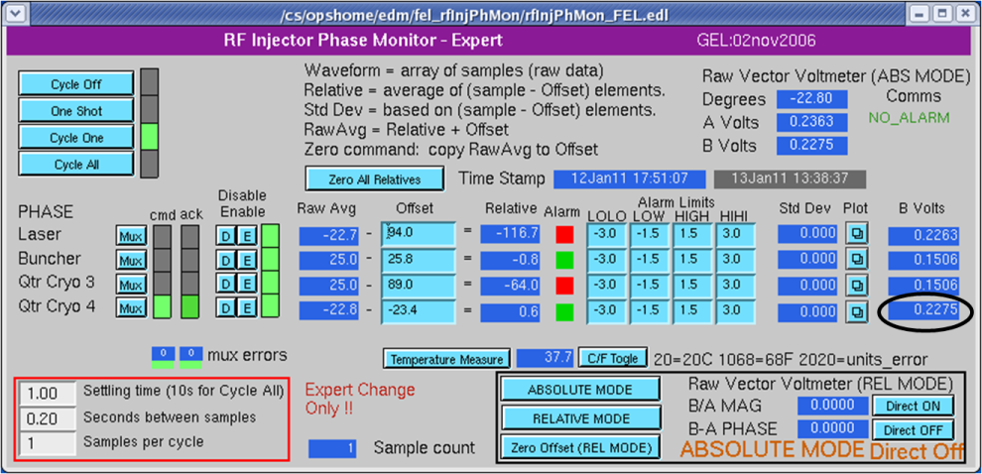

Figure 3-1: Screenshot of the RF Injector Phase Monitor.

3. Check the *Beam Viewer Timing System* (FEL Main Menu⇒Viewer⇒Beamviewer Timing System) for proper configuration. The **Timing Output** button must be in the **On** position for the Beamanizer application.

4. Map viewer **ITV0F06** to Monitor 17.

5. While monitoring the Beamanizer image of **ITV0F06,** adjust the drive laser phase (labeled “C” on Figure 1-1) to restore the beam to the standard **ITV0F06** image (see Figure 3-2).

**NOTE:** To load the standard image click “Off-line” on the Beamanizer and navigate to **C:\Documents and Settings\fella\Desktop\Beam Images\Mini phase images** and select the **ITV0F06** **image (the** file must have the .pnm extension).

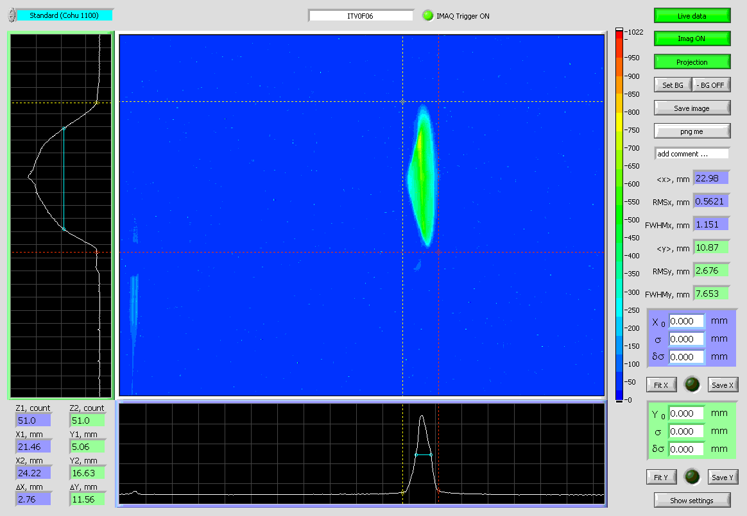

Figure 3-2: ITV0F06 as viewed with the Beamanizer.

6. Remove ITV0F06.

4.0 Gang Phase the Laser-Buncher

**CAUTION:** Do not use the laser-buncher gang phase for adjustment in this section.

1. Insert **ITV0F04.**

2. Map **ITV0F04** to Monitor 17 using the video switcher controls.

3. Take the Beamanizer Off-line and load the proper **ITV0F04** file. The file must have the .pnm extension. Files are located at **C:\Documents and Settings\fella\Desktop\Beam Images\Mini phase images.** The appropriate file will be specified in the Shift Plan.

4. Use the bars to frame the Off-line image.

5. Take the Beamanizer on-line. The present condition of the beam at **ITV0F04** will be displayed (see Figure 4-1).

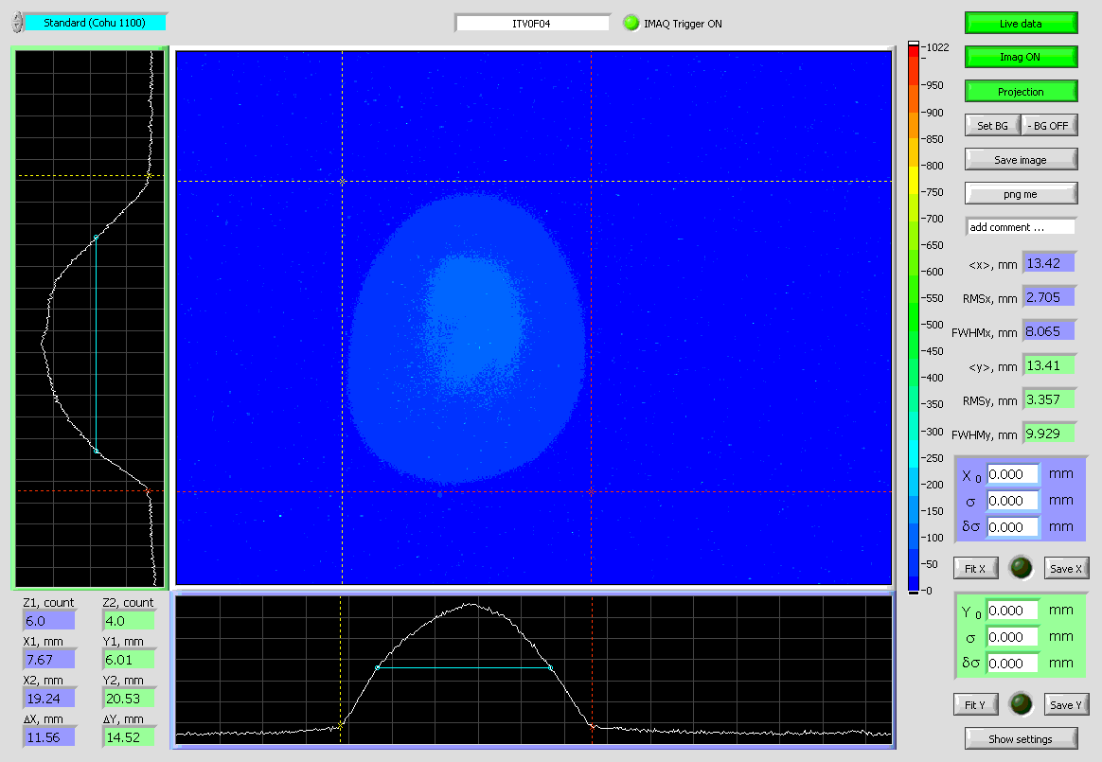

Figure 4-1: ITV0F04 as viewed with the Beamanizer.

6. Adjust the laser phase and buncher phases in 1º increments, remembering to adjust the laser phase 1º for every degree of buncher adjustment (labeled “D” on Figure 1-1). The goal is to adjust the phases such that the spot approximately matches the preloaded shape boundaries.

7. Take the Beamanizer off-line.

8. Withdraw **ITV0F04**.

5.0 Set the Phase of Cavity 1-3

1. Insert **ITV0F06**.

2. Map **ITV0F06** to Monitor 17 using the video switcher controls.

3. Take the Beamanizer Off-line and load the proper **ITV0F06** file. The file must have the .pnm extension. Files are located at **C:\Documents and Settings\fella\Desktop\Beam Images\Mini phase images.** The appropriate file to use will be specified in the Shift Plan.

4. Use the bars to frame the off-line image.

5. Take the Beamanizer on-line. The present condition of the beam at **ITV0F06** will be displayed (see Figure 3-2).

6. Does the beam image match the preloaded image?

**A.** **NO** Set the increment on Cavity 1-3 phase slider to 0.1º (labeled “E” on Figure 1-1) and adjust to match the preloaded image. The goal is to adjust the phase so that the spot approximately matches the preloaded shape boundaries **YES** Continue to Step 7.

**C.** If desired, save the beam image.

**D.** Take the Beamanizer Off-line.

**E.** Withdraw **ITV0F06**.

7. Section 3.0, Section 4.0 and Section 5.0 should be repeated after the completion of Section 5.0 to ensure the symmetry of the drive laser phase is maintained. This may involve an iterative process to achieve an acceptable solu­tion to the three sections.

**CAUTION:** If Cavity 1-3 is changed by more than 0.5°, this section should be repeated because the zero-crossing will be lost.

a. Has the symmetry of the drive laser phase been verified per Section 3.0 and an acceptable solution reached for Sections 3.0, 4.0 and 5.0?

**A.** **NO** Go to Section 3.0, Set the Relative Phase of the Drive Laser and Buncher and check Sections 3.0, 4.0 and 5.0 to ensure the drive laser phase symmetry is maintained and injector phases are satisfactory YES Continue

8. Zero the RF Phase Monitor Relatives by pressing the **Zero All Relatives** on *Injector* *RF Phase Monitor* and add a screen shot of the EPICS screen to the FLOG entry of the Miniphase.

6.0 Gang Phase the Linac

**NOTE:** The average of the relative horizontal positions at **IPM2F07** and **IPM2F09** will be used as an indication of proper phasing. These two BPMs are at dispersive locations. The average of the two rela­tive horizontal positions is an indication of the machine energy.

1. Decrease the gang phase by 20º in Zone 2 (labeled “F” on Figure 1-1).

2. Note the change of the average BPM signal on the striptool. Did the average signal change by less than 0.5 mm?

**A.** NO the XREL average changes more than 0.5 mm as the gang phase is changed by 20º, the module is not properly phased. The relationship between gang phases and linac energy gain is shown below in Figure 6-1. Follow the steps below to phase the module:

* If the XREL average drops when the gang phase is changed by 20º, the gang phase is too negative. Add the 20º back and increase the gang phase by a few tenths of a degree. Go back to Step 1 and repeat the measurement.
* If the XREL average increases when the gang phase is changed by 20º, the gang phase is too positive. Add the 20º back and decrease the gang phase by a few tenths of a degree. Go back to Step 1 and repeat the measurement.



Figure 6-1: Relationships of gang phase, beam position, and energy.

3. Restore the gang phase by adding 20º back and then go to Step 1 at the beginning of this section and repeat for RF zones 3 and 4.

4. Go to Section 7.0, Optimize the Bunch Length at the Wiggler after the three zones are properly phased.

7.0 Optimize the Bunch Length at the Wiggler

1. Change micropulse repetition frequency to 584 kHz and the macropulse length to 20 s (choose 50 s then select “Other” and enter “0.000020”).

2. Insert viewer **ITV8F03**. This is the viewer used with the Happek device.

3. Open the *FEL Happek Interferometer -IR(Upstream)* screen (FEL Main Menu⇒Data Acq⇒ **UV** Happek) and click on the **Setup** button (see Figure 7-1).

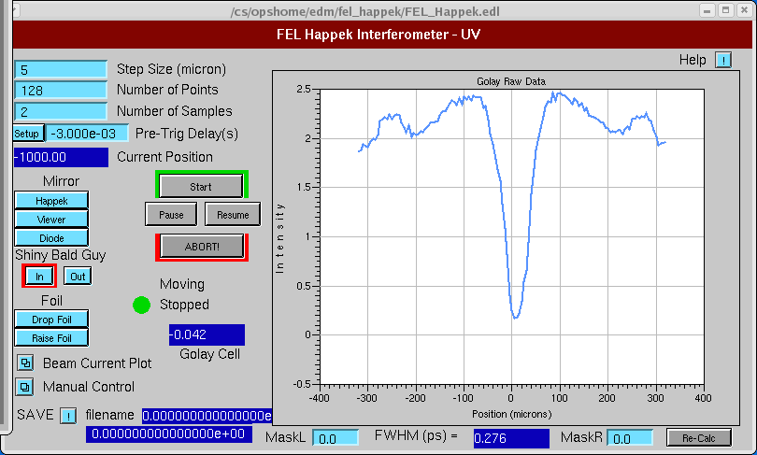

Figure 7-1: Happek device screen.

4. Maximize the output of the Golay cell signal amplitude by adjusting the vernier cavity gradient (labeled “G” on Figure 1-1). A step size of 0.01 MV/m should be used for adjustments. See Figure 7-2 for typical scope display of the Golay cell.

**NOTE:** The output of the Golay cell, which is used in the Happek device, is always connected to channel 1 of *felscope01*. The screen of the scope is usually shown on Monitor 9 in the control room but can be mapped to any of the monitors via the video distribution system (Bank 12). Figure 7-2 shows the typical response of the Golay cell to a macropulse of the beam. This step ensures that the bunch length is minimal at the location of the 8F03 viewer. The following steps ensure the bunch length is minimal in the wiggler.

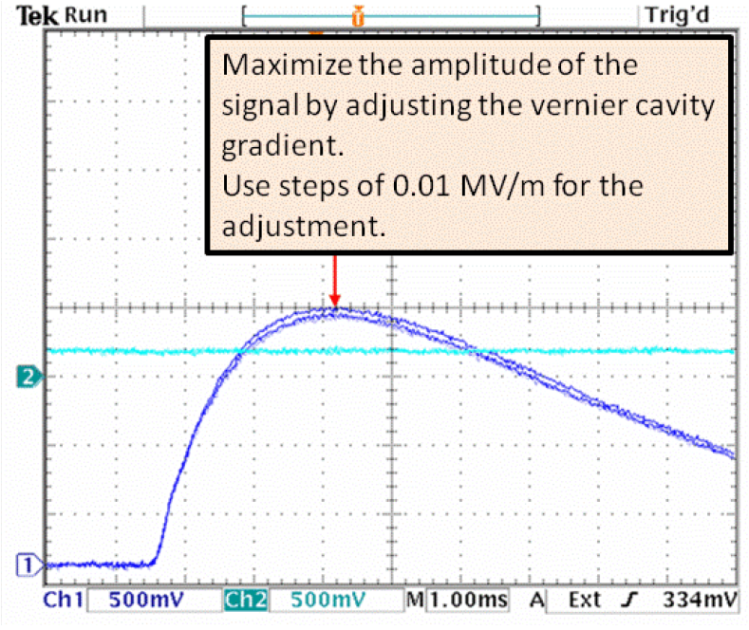

Figure 7-2: Golay signal shown on scope channel 1.

5. Push the **Start** button to perform a scan with the Happek device.

6. Save the data (for off-line analysis) by clicking the SAVE button on the lower left of the Happek EPICS screen. A window will pop-up to add comments; enter the date and any other relevant information pertaining to the scan.

7. Add a screen shot of the EPICS screen to the FLOG entry of the Miniphase.

8. Retract the **ITV8F03** viewer and return the micropulse repetition frequency to 4.68 MHz and macropulse length to 250 s.

9. Adjust the vernier cavity gradient so that the CSR effect starts to show up at the 5F02 SLM. Typical response is to reduce the energy by ~0.2 MeV when maximizing the Golay signal and then typically a fraction of 0.1 MeV to achieve the correct CSR effect on the 5F02 SLM. Figure 7-3 shows the CSR effect “turned off”, and Figure 7-4 shows the CSR effect beginning to show up. There must to be tails on both sides of the bunch beginning to show up as shown in Figure 7-4.

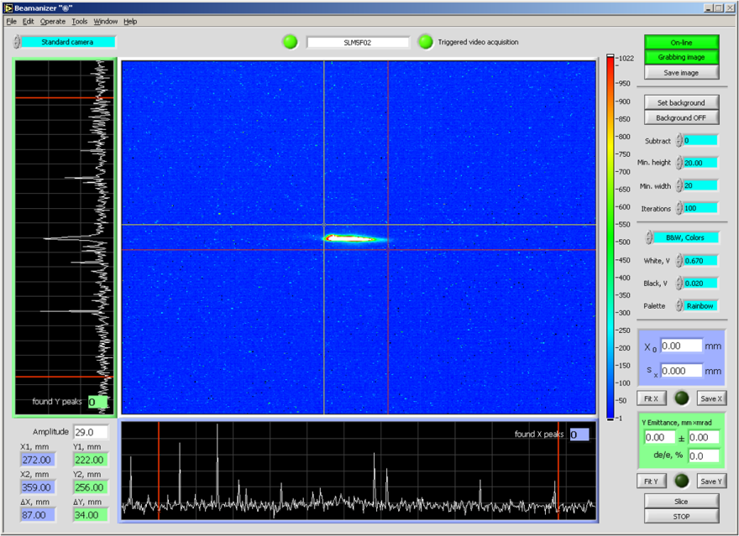

Figure 7-3: SLM5F02image without CSR enhancement.

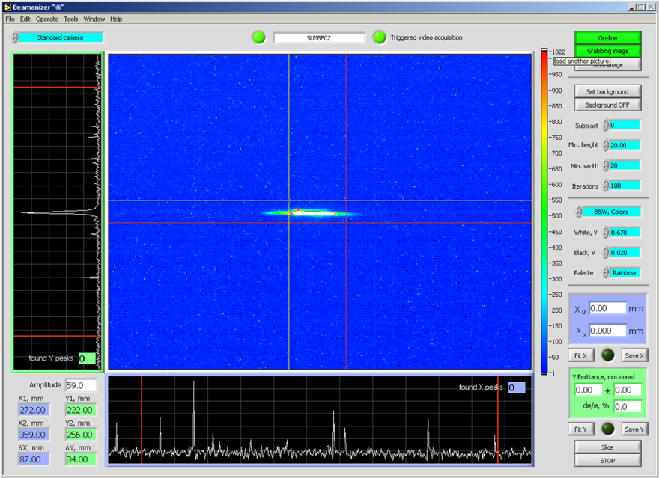

Figure 7-4: SLM5F02image with CSR enhancement.

8.0 Adjust the Path Length

1. Map the 1G01 viewer to a monitor.

**NOTE:** Horizontal motion on this viewer corresponds to vertical motion on the monitor screen.

1. Adjust **Current Setpoint** of the Pathlength Box Supply to set the pathlength (labeled “H” on Figure 1-1). This is accomplished by centering the beam spot vertically on the 1G01 viewer. Adjust the **Current Setpoint** in 0.1 A increments to center the beam spot vertically on the 1G01 viewer. It takes about a 1.2 A change in the current setpoint to move the beam spot from one edge of the screen to another.

3. PROCEDURE COMPLETE.

9.0 Appendix I - Required EPICS/EDM screens *(these have not been thoroughly checked 9/14/2010 C.T.)s*

Useful screens/strip tools/monitors to have open and/or mapped.

1. drive laser parameters striptool

2. drive laser Tekscope scope⇒monitor

3. Drivemaster FEL Main Menu⇒Drive Laser⇒Advanced Drive Laser Master Control⇒*Advanced Drive Laser Master Control*

4. drive laser autocorrelator scope⇒monitor

5. Beamanizer

6. Tekscope B scope⇒monitor

7. Dump charge/current monitor FEL Main Menu⇒Dumps⇒Beam Current/Power⇒*Beam Current*

8. “phasetheinjector” strip tool

9. Injector RF 4-seater FEL Main Menu⇒RF FEL Main Menu⇒Injec­tor Ops⇒Ops 4-seater⇒*R4SEATER*

10. video switcher FEL Main Menu⇒Viewer⇒Video Switcher Control⇒*FEL Video Switching System*

11. Viewer controls FEL Main Menu⇒Viewer

12. RF Combo screens for zones 2,3, and 4 FEL Main Menu⇒RF FEL Main Menu⇒Zone 2 Misc⇒*RF Combo 4L02*

FEL Main Menu⇒RF FEL Main Menu⇒Zone 3 Misc⇒*RF Combo 4L03*

FEL Main Menu⇒RF FEL Main Menu⇒Zone 4 Misc⇒*RF Combo 4L04*

13. BPM combo screens FEL Main Menu⇒BPM⇒BPM Spikes⇒Com­bo⇒*BPM Absolute Spikes*

FEL Main Menu⇒BPM⇒BPM Spikes⇒Combo⇒*BPM Relative Spikes*

14. Happek controls FEL Main Menu⇒Data Acq⇒Hap­pek⇒IR-Upstream⇒*FEL Happek Interfer­meter - IR(Upstream)*

15. 4F and 5F corrector controls FEL Main Menu⇒Magnets⇒Magnet Commander⇒4F⇒4F Correctors⇒*Correc­tors for the (4F) Region* FEL Main Menu⇒Magnets⇒Magnet Commander⇒5F⇒5F Correctors⇒*Correc­tors for the (5F) Region*

16. 5F multipole controls FEL Main Menu⇒Magnets⇒Magnet Commander⇒5F⇒5F Multipoles⇒*Multi­poles for the (5F) Region*

17. MPATH control screen FEL Main Menu⇒Magnets⇒Box Supplies⇒­Pathlength Box Supply⇒*PathLength Power Supply*

18. Beam Viewer Timing control screen FEL Main Menu⇒Viewer⇒Beamviewer Tim­ing System⇒*Beam View Timing System*